# **Alert mechanism in the platform for Below events:**

1.Notebook Run - Success

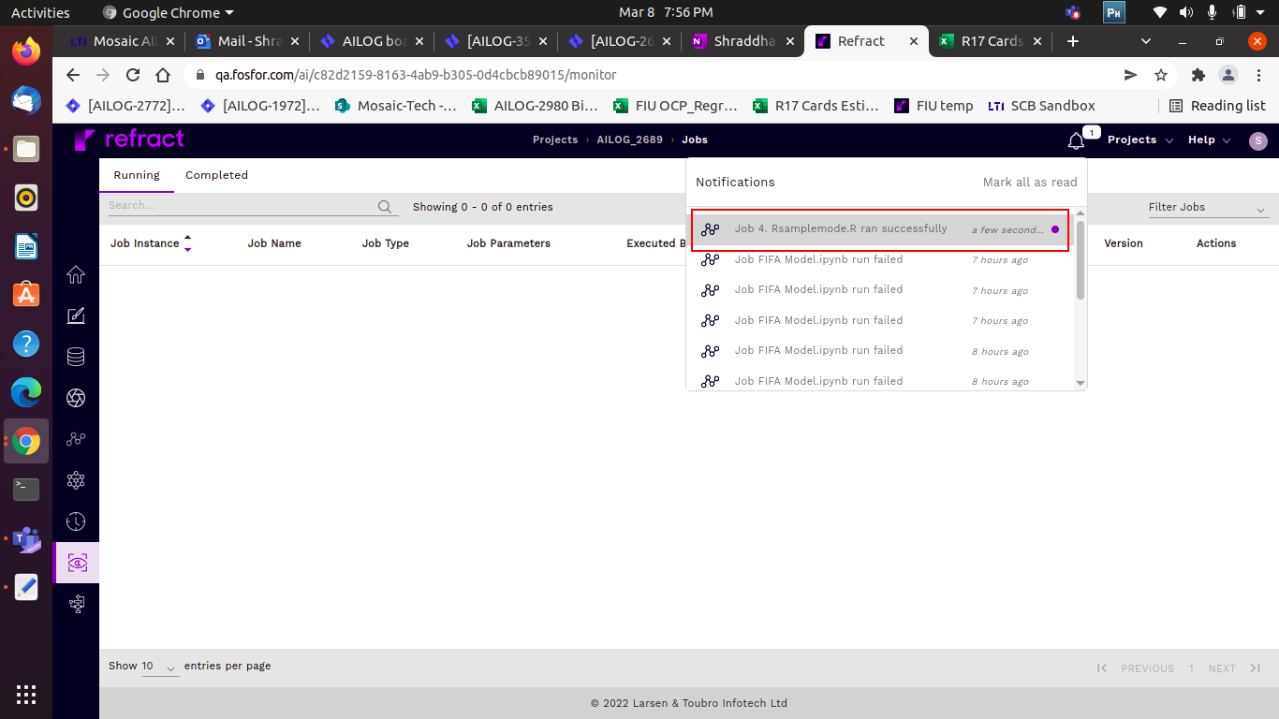

2.Notebook Run - Fail

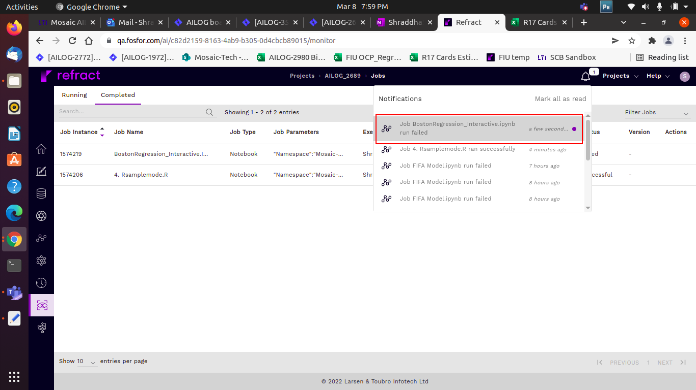

3. AutoML Experiment Run – Started

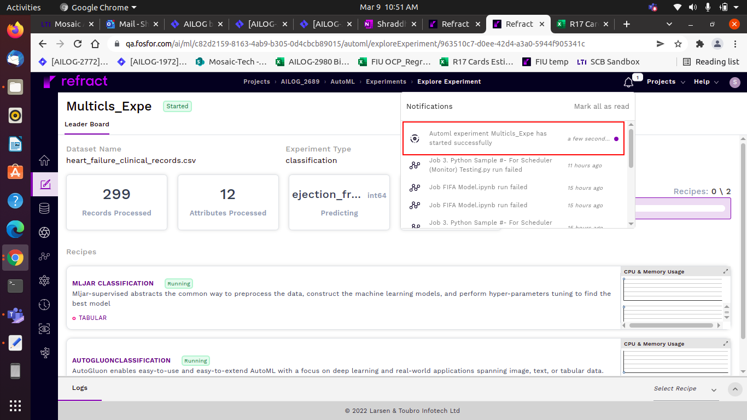

4. AutoML Experiment Run – Completed

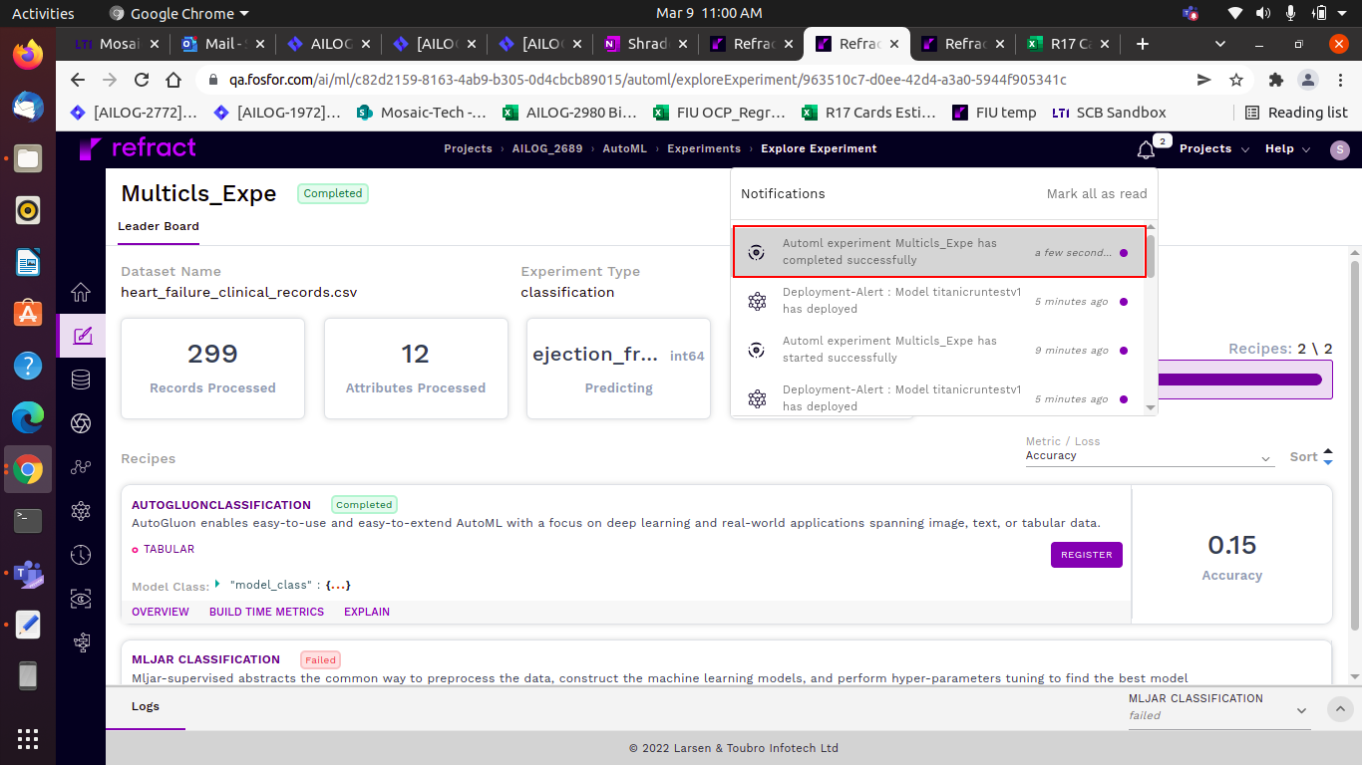

5. Model Deploy – Success/Failure

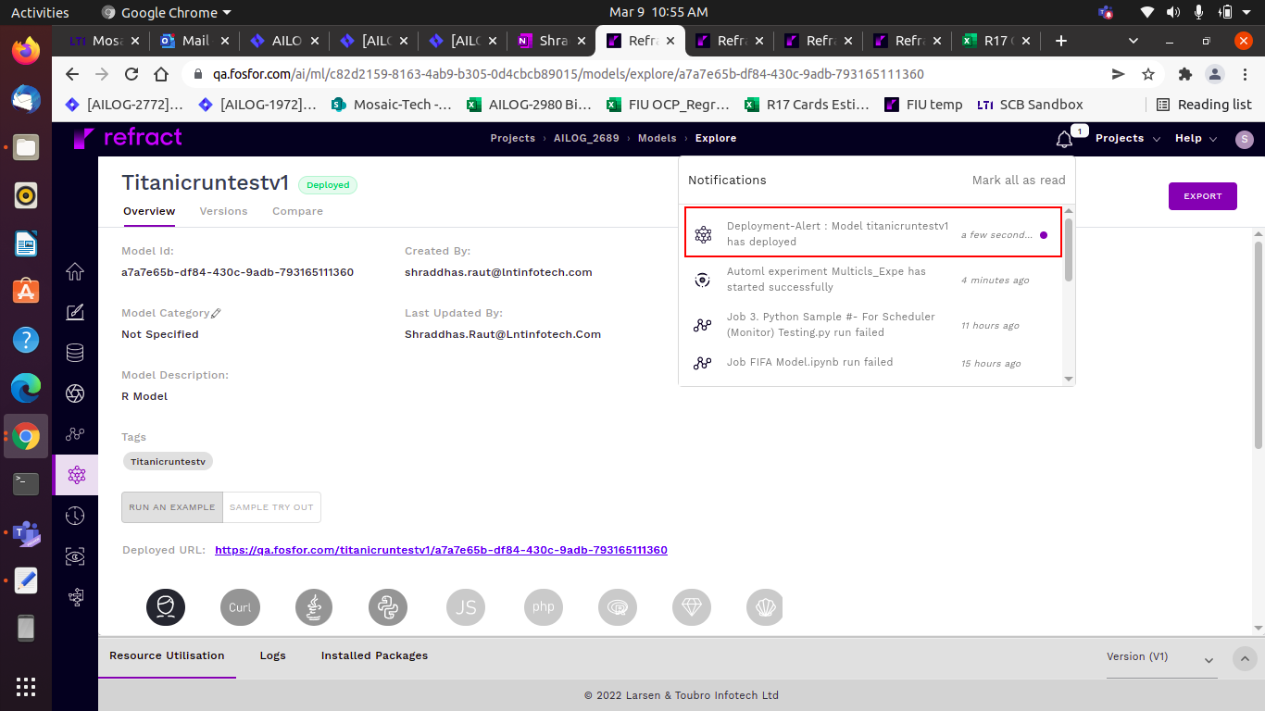

6. Model Undeploy

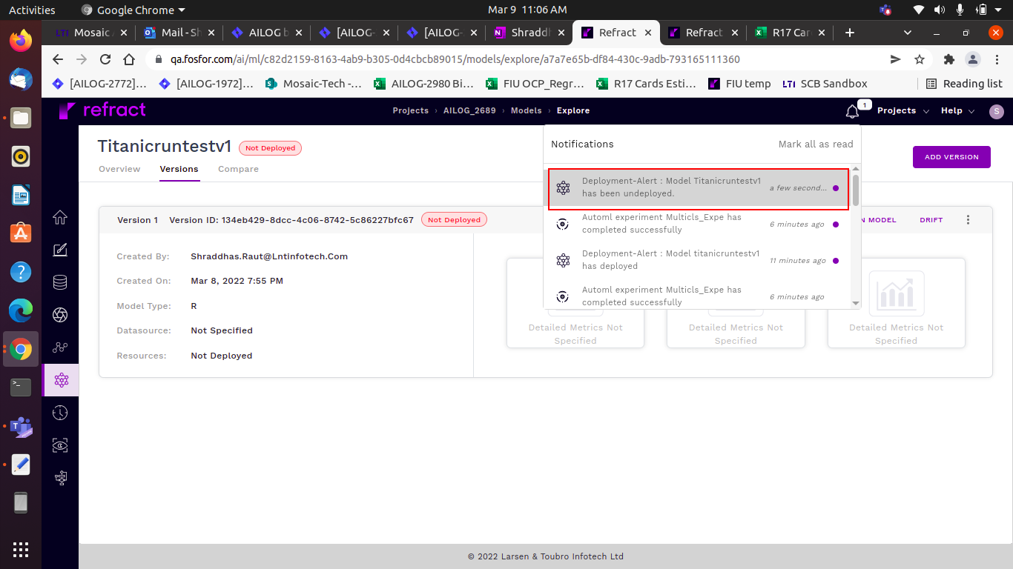

7. Notebook Template – Low Resource Utilization

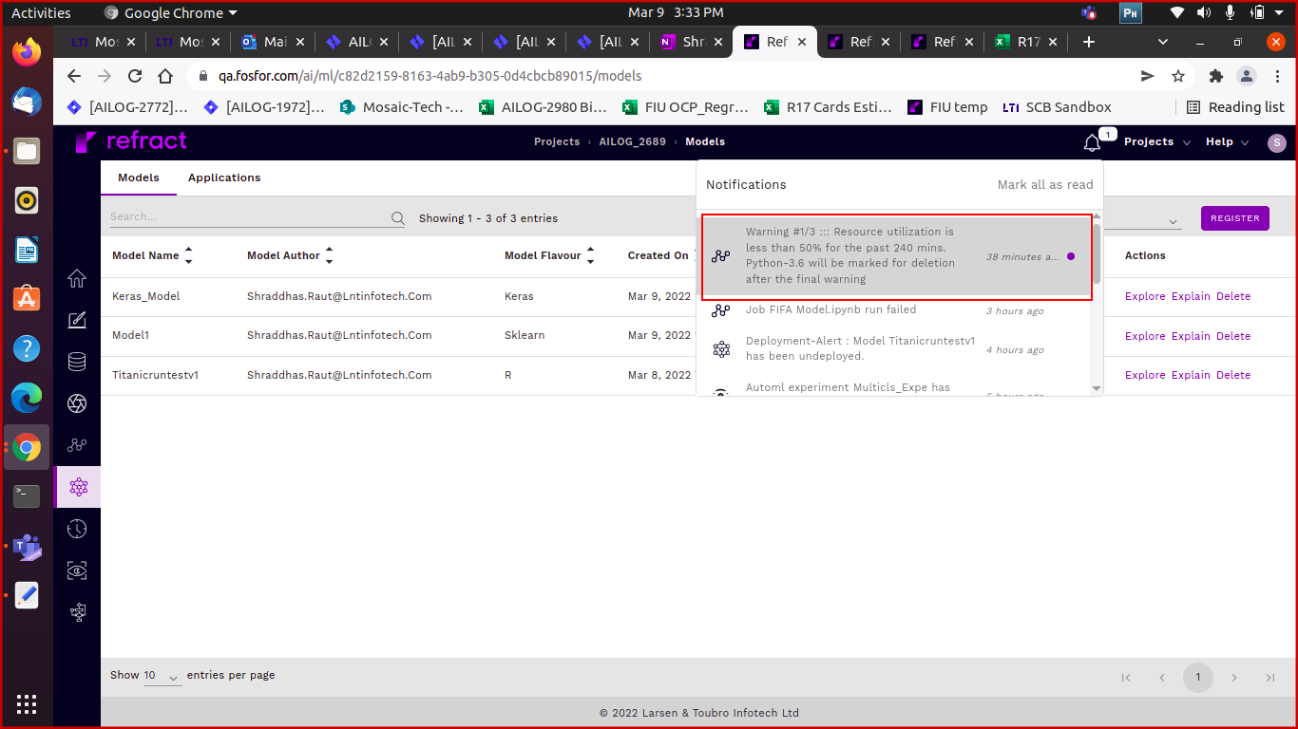

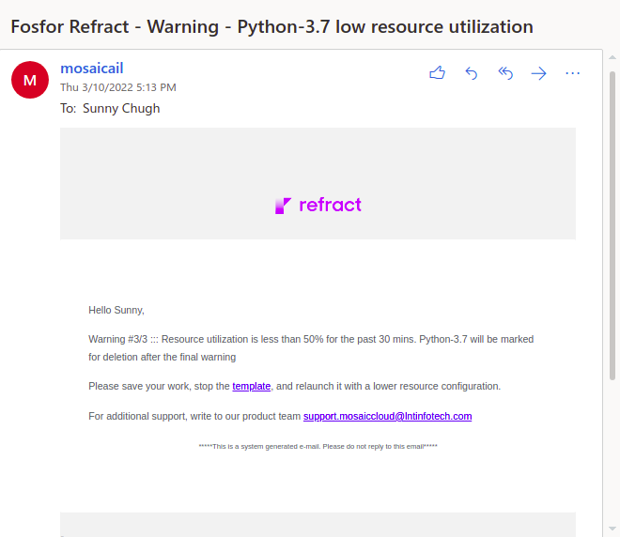

8. Notebook Template – High Resource Utilization

