Product Requirements Document
Con-Call Intelligence — RAG Chatbot for Long-Term Investors
Version 0.1 | Owner: PM (self-authored) | Status: Draft

1. Problem Statement
As a long-term investor tracking a watchlist of stocks, annual report numbers and quarterly results don't capture the qualitative signal in management commentary — tone shifts, forward guidance, recurring risk callouts, and how narratives evolve over time. Reading 15-20 transcripts per stock per year across a watchlist doesn't scale manually.
Core need: A chatbot that has "read" every earnings call transcript for a tracked stock over the last 4-5 years and can answer synthesis questions, not just lookup questions.

2. Goals & Non-Goals

Goals
- Enable natural-language Q&A grounded in actual transcript text (with citations to quarter/speaker).
- Surface trend and change-over-time answers (e.g., "how has debt reduction commentary evolved since FY22?").
- Start with 1 stock, prove retrieval quality, then scale to full watchlist.
- Eventually automate transcript ingestion so new quarters are added with no manual effort.

Non-Goals (for now)
- Not a trading/recommendation engine — no buy/sell signals.
- Not analyzing financial statements/XBRL data (separate future workstream).
- Not real-time / live call transcription — post-call transcripts only.

3. Users
Primary user: the investor themself (single-user tool in Phase 1-3). Multi-user/sharing is out of scope until explicitly prioritized.

4. Phased Roadmap
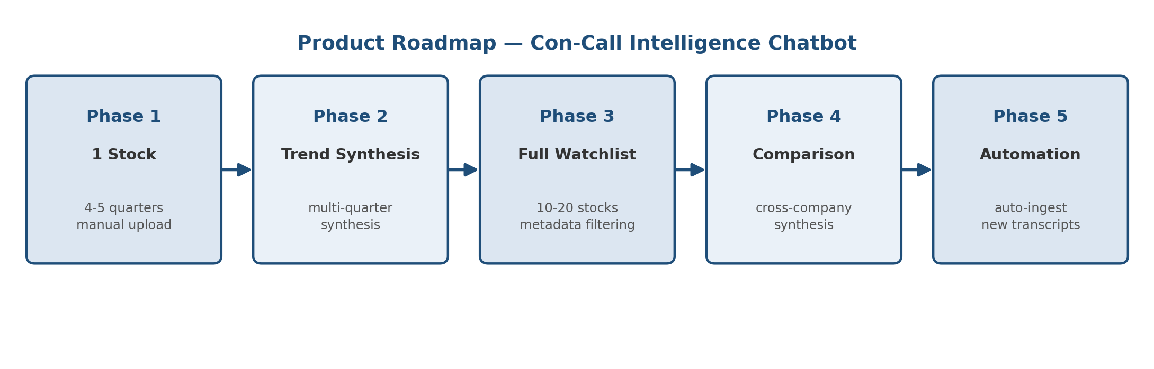
Phase | Scope | Exit Criteria
Phase 1 | 1 stock, 4-5 quarters, manual PDF upload | Accurate Q&A with correct citations on a single stock
Phase 2 | Same stock, add multi-quarter trend queries | Correctly synthesizes across quarters, not just single-chunk retrieval
Phase 3 | Scale to full watchlist (10-20 stocks) | Metadata filtering by ticker/quarter works reliably at scale
Phase 4 | Cross-company comparison queries | Can compare 2+ companies on a theme (e.g., margin commentary)
Phase 5 | Automated transcript ingestion pipeline | New quarter's transcript auto-detected, scraped, chunked, indexed

5. Functional Requirements

5.1 Phase 1 — Single Stock MVP
- Upload/ingest 4-5 quarterly transcripts (PDF/text) for one stock.
- Chunk by speaker turn and Q&A pair (not fixed token windows).
- Tag each chunk with metadata: ticker, quarter, fiscal year, speaker, speaker role, section (prepared remarks vs Q&A).
- Embed chunks and store in a vector DB.
- Chat interface: ask a question, get an answer with inline citation (quarter + speaker).
- Answer only from retrieved context — no hallucinated figures.

5.2 Phase 2 — Trend Synthesis
- Support multi-hop queries: retrieve relevant chunks across all quarters for a topic, then synthesize a timeline-style answer.
- Detect topic-based queries (e.g., "margins", "debt", "capex guidance") and pull matching chunks from every quarter, not just top-k globally.

5.3 Phase 3 — Multi-Stock Scale
- Metadata-filtered retrieval so queries can be scoped to one ticker or run across the watchlist.
- Ability to ask "which of my stocks mentioned supply chain risk in the last 2 quarters?" type cross-portfolio questions.

5.4 Phase 4 — Comparison
- Side-by-side synthesis across 2+ companies on the same theme.

5.5 Phase 5 — Ingestion Automation
- Auto-detect new transcript availability (IR page / aggregator) post-earnings.
- Auto-scrape, clean, chunk, embed, and index with zero manual steps.
- Notify user when a new quarter is indexed and ready to query.

6. Non-Functional Requirements
- Grounded answers only — every claim traceable to a specific transcript chunk.
- Response latency: under ~10s for single-stock queries.
- Data stays private — no transcript data used to train external models.
- Extensible metadata schema so new stocks/quarters don't require re-architecture.

7. Proposed Tech Stack
Layer | Choice | Notes
LLM | Claude (Sonnet for cost, Opus for deep synthesis) | Via Anthropic API
Embeddings | Voyage AI or OpenAI text-embedding-3-large | Voyage recommended by Anthropic
Vector DB | Chroma (Phase 1) -> Qdrant/Weaviate (scale) | Start local, move to managed as watchlist grows
Retrieval | Hybrid: semantic + BM25 keyword | Tickers/names need exact match too
Ingestion (Phase 5) | Scraper + scheduler | Screener.in / Tijori / IR pages

8. Technical Design
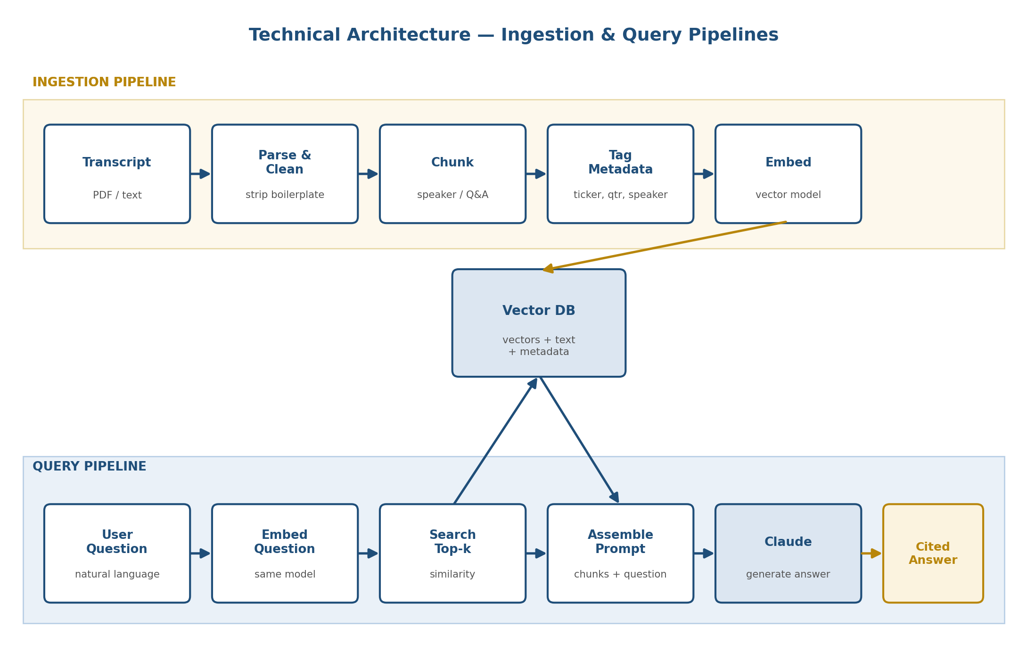

8.1 System Architecture — Two Pipelines
The system has two independent pipelines that run on different triggers: an Ingestion Pipeline (runs once per new transcript) and a Query Pipeline (runs once per user question).
Pipeline | Trigger | Steps
Ingestion | New transcript added | Parse -> Clean -> Chunk (speaker/Q&A) -> Tag metadata -> Embed -> Write to vector DB
Query | User asks a question | Embed question -> Search vector DB (top-k) -> Assemble context -> Call Claude -> Return cited answer

8.2 Ingestion Pipeline — Detail
- Parse: extract raw text from PDF/HTML transcript.
- Clean: strip boilerplate (disclaimers, operator instructions), normalize speaker names.
- Chunk: split by speaker turn and Q&A pair; target ~150-400 tokens per chunk so each chunk is a coherent thought, not a fragment.
- Tag metadata: ticker, fiscal quarter/year, speaker, speaker role, section (prepared remarks vs Q&A).
- Embed: send each chunk to the embedding model; receive back a vector.
- Write: store vector + original text + metadata in the vector DB.

8.3 Query Pipeline — Detail
- Embed the user's question using the same embedding model used for chunks.
- Search the vector DB for the top-k (typically 5-15) most similar chunks, optionally filtered by ticker/quarter metadata.
- Assemble a prompt: retrieved chunks (with citations) + the user's question + instruction to answer only from provided context.
- Call Claude with this prompt; stream back the answer with inline citations to quarter/speaker.

8.4 Latency Profile (per query, Phase 1-3 scale)
Step | Typical Time | Notes
Embed the question | 100-300 ms | Single API call to embedding provider
Vector DB similarity search | 10-50 ms (local) / 50-200 ms (hosted) | Chroma local is near-instant at this scale; hosted DB adds network hop
Prompt assembly | <10 ms | Local string operations, negligible
Claude generation | 2-8 s | Depends on model choice and answer length; Sonnet is a good latency/quality balance
Total end-to-end | ~3-9 s typical | Acceptable for a single-user research tool; not suitable for real-time/sub-second use cases

8.5 Throughput & Scale Boundaries
Phase | Approx. Chunk Volume | Practical Ceiling
Phase 1 (1 stock, 5yr) | ~1,000-3,000 chunks | Chroma local handles this instantly; no scaling concern
Phase 3 (20-stock watchlist) | ~20,000-60,000 chunks | Still fine for Chroma; consider hosted DB (Qdrant/Weaviate) for reliability and backup
Concurrent queries | 1 user, sequential use | Not designed for multi-user concurrent load in Phase 1-4; would need a hosted DB + API rate-limit handling for that
Ingestion rate | Bottlenecked by embedding API rate limits | For a single stock's backlog (~20 quarters), full re-ingestion takes minutes, not hours

8.6 Cost Model (Estimates — validate against live pricing before committing)
Two cost centers: (1) one-time/periodic ingestion (embedding cost) and (2) per-query generation cost (Claude API). Vector DB storage is free at this scale if self-hosted (Chroma).
Item | Basis | Est. Cost
Embedding one stock (5yr, ~20 transcripts) | ~150K-250K tokens total | < $0.10 one-time (embedding providers are priced in cents per million tokens)
Embedding full watchlist (20 stocks) | ~3M-5M tokens total | ~$1-2 one-time
Claude cost per query (Sonnet 5) | ~2K-4K input tokens (retrieved chunks) + ~300-600 output tokens | ~$0.01-0.02 per query at $2/MTok input, $10/MTok output
Claude cost per query (Opus 5, for deeper synthesis) | Same token range, higher rate | ~$0.02-0.05 per query at $5/MTok input, $25/MTok output
Monthly cost, personal use (~200 queries/mo) | Mostly Sonnet, occasional Opus | Roughly $2-8/month in API spend
Claude pricing referenced above (Sonnet 5 $2/$10 per MTok, Opus 5 $5/$25 per MTok) reflects Anthropic's published rates as of Aug 2026 — confirm current rates at claude.com/pricing before finalizing budget, since rates and model versions change over time.

8.7 Known Limitations
- Retrieval quality depends heavily on chunking — poorly split chunks (mid-sentence, no speaker context) degrade answers regardless of model quality.
- The system only knows what's in ingested transcripts — no live market data, no price context, no post-call events unless separately added.
- Semantic search can miss exact-number lookups (e.g., "what was Q3 EBITDA margin exactly") if phrasing differs from the transcript — hybrid keyword search mitigates but doesn't eliminate this.
- Not a fact-checker: Claude will answer based on what management said, not whether it was accurate or later revised.
- Single-user design in Phases 1-4 — not built for concurrent multi-user load or role-based access.
- Automated ingestion (Phase 5) depends on transcript source availability/format stability — source website changes will break scrapers and need maintenance.
- Long-run cost grows with watchlist size and query volume — worth monitoring token usage as usage patterns become clearer.

9. Success Metrics
- Phase 1: >90% of test questions answered with correct, citable source chunk.
- Phase 2: Trend questions correctly reference chunks from multiple distinct quarters.
- Phase 5: Time from transcript publication to searchable in system < 24 hours, zero manual steps.

10. Risks & Open Questions
- Transcript source availability/licensing for automated scraping — needs verification per source.
- Chunking strategy may need tuning per company (call structure varies).
- Cost scaling as watchlist and years of history grow — needs monitoring.
- Open question: single unified index vs per-stock index — decide based on Phase 3 performance testing.

11. Out of Scope (Explicitly)
- Sentiment scoring / tone-scoring models (possible future add-on, not MVP).
- Integration with brokerage/portfolio tools.
- Mobile app — web/CLI chatbot only for now.

