< 2021-Aug-17th >

< IT FDN 110 B Su 21 >

< Assignment_06 >

Assignment_06

# Introduction

# The script developed uses a simple, menu-driven interface allowing the user to load CD inventory data from file, enter CD data, view the inputted inventory data, delete CD data, save the inventory to a data file, and exit out of the program. The script developed is a modification of the script developed in assignment 05. The program explores the script’s ability to use the classes and functions to create and maintain a list / dictionary every time user enters the data.

# Procedure

## Processing – “Let’s learn Classes”

The program starts with the *DataProcessor* class definition that has two functions add_cd and delete_cd functions to process data using dictionaries. Docstrings are added to increase the readability of the functions. See listing 1.

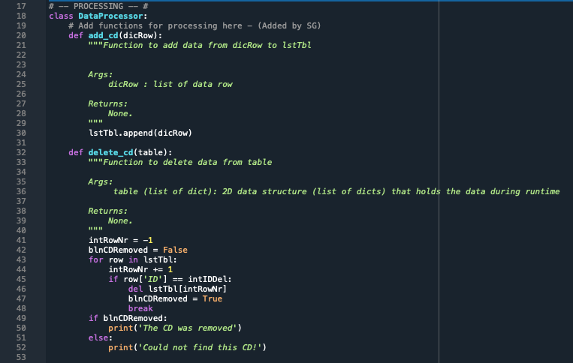

Class *FileProcessor* follows *DataProcessor* and has two functions read_file and write_file to read and write data to CDInventory.txt file. See listing 2.

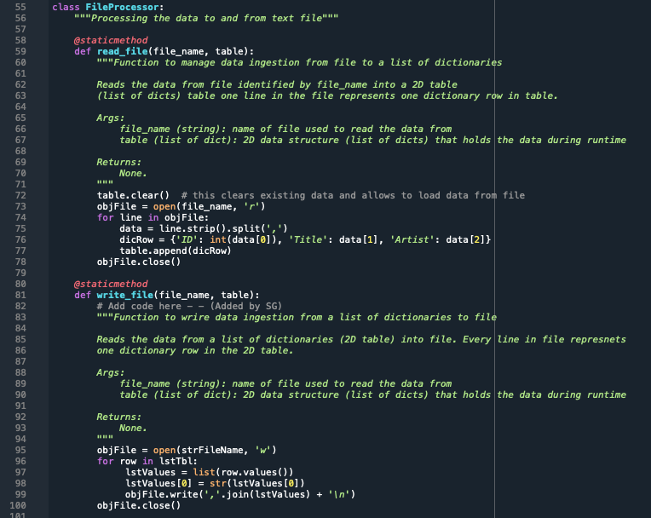

Class IO has functions menu_choice, show_inventory, get_cdInfo. See Listing 3.

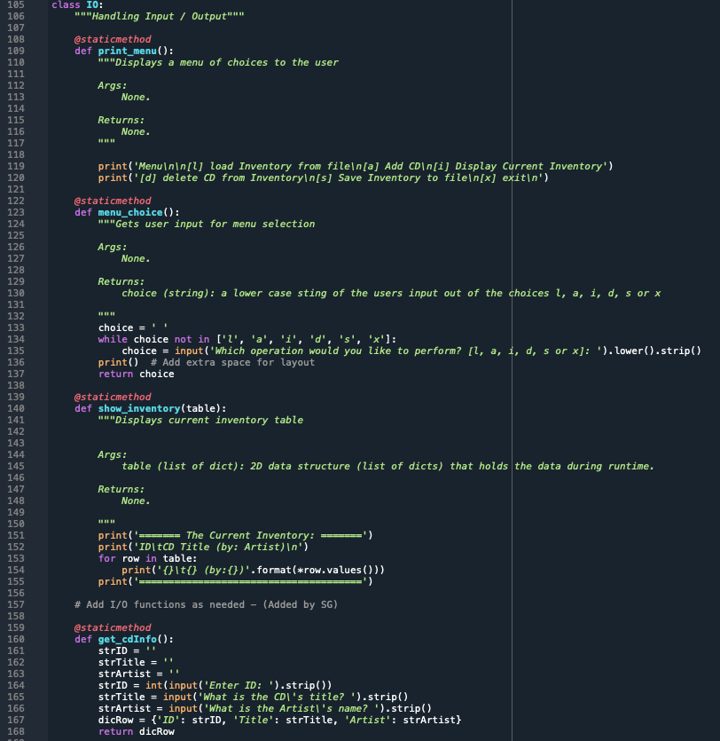

## Data – *“Initialing data is essential”*

The variables (string), list, and dictionaries are initialized and the .txt file is assigned to the variable that’ll be used to manipulate data to and from the file. See listing.

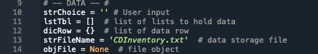

## While Loop – “*Let the program begin”*

Through a While loop, user keeps getting presented the menu until ‘x’ is pressed to exit out the program.

User choice “l” - The function ﻿FileProcessor.read_file gets invoked. The script loops through each row in the .txt file adding as the keys in the *dicRow* dictionary. The data from *dicRow* is further appended to *table* to build the inventory 2D list. See listing.

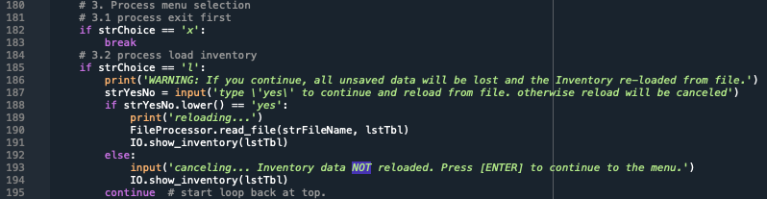

User choice “a” – The returned data in the *dicRow* dictionary is stored in a temporary variable *temp_dict* dictionary. The *temp_dict* is then passed through DataProcessor.add_cd function in line 206. The *lsttable* gets appended with the *dicRow*. I am not sure why I am passing *dicRow* I in the function when I am defining it under Data Processor. I think I could have just passed *temp_dict* up there. Need to clarify.

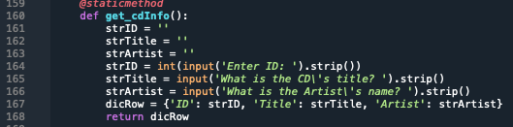

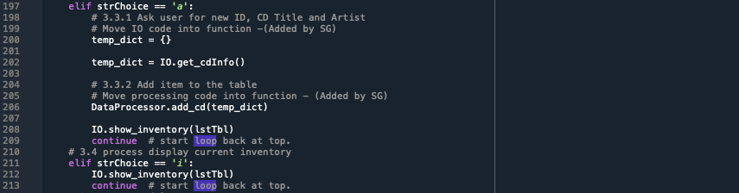

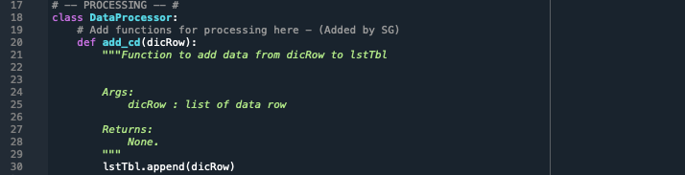

User choice “d” – The For loop loops through list of dictionaries to find the row that matches the user’s entered ID for the purpose of deletion.

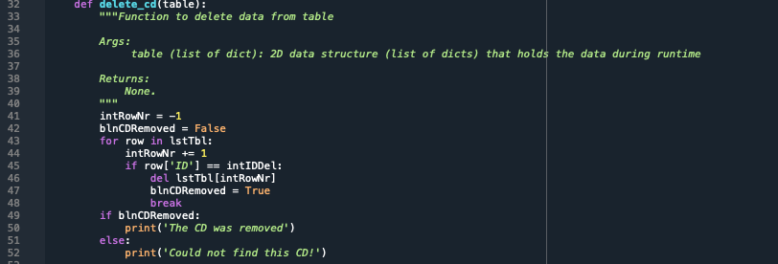

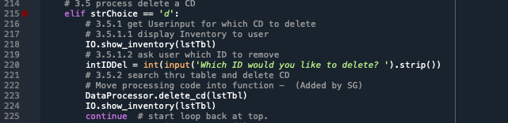

User choice “s” – The For loop loops through *lsttbl* to sav ethe data in the .txt file.

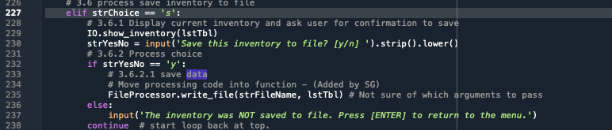

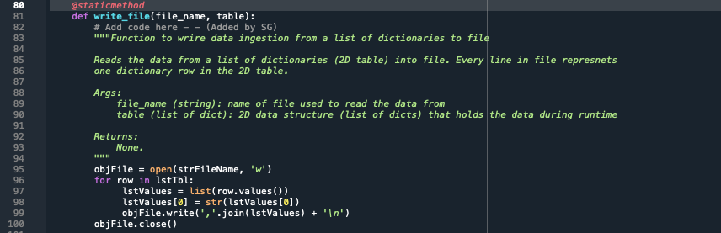

# Summary

In this assignment, I learned how to read and execute changes to the code snippet received from someone else. Next, I learned about the fucntions, classes, SOC and docStrings.

# Appendix

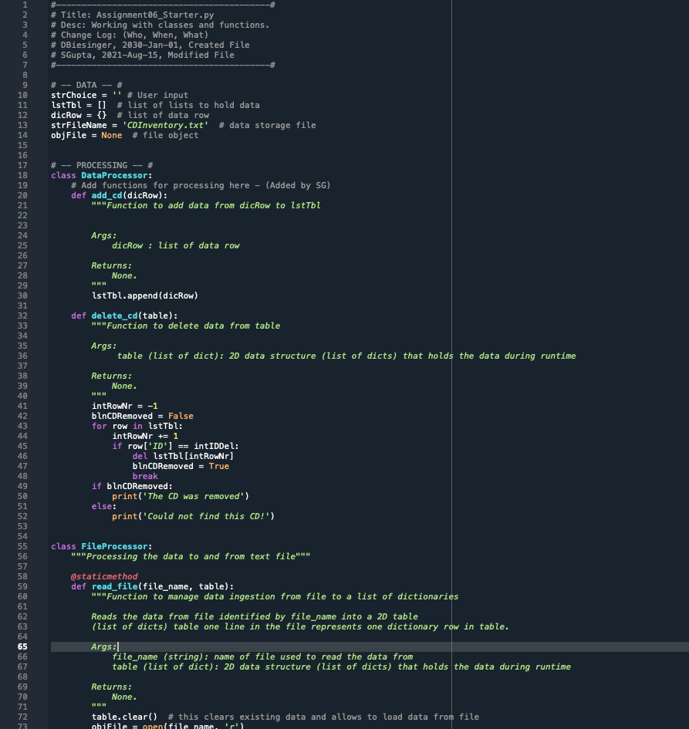

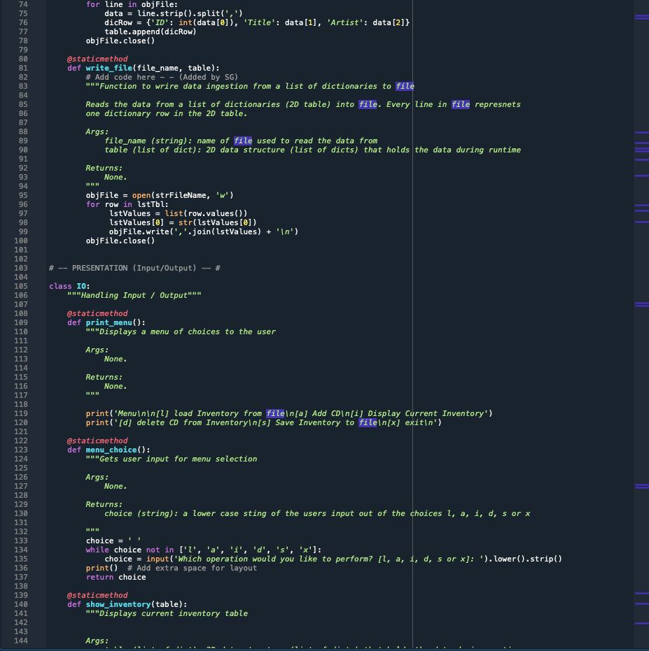

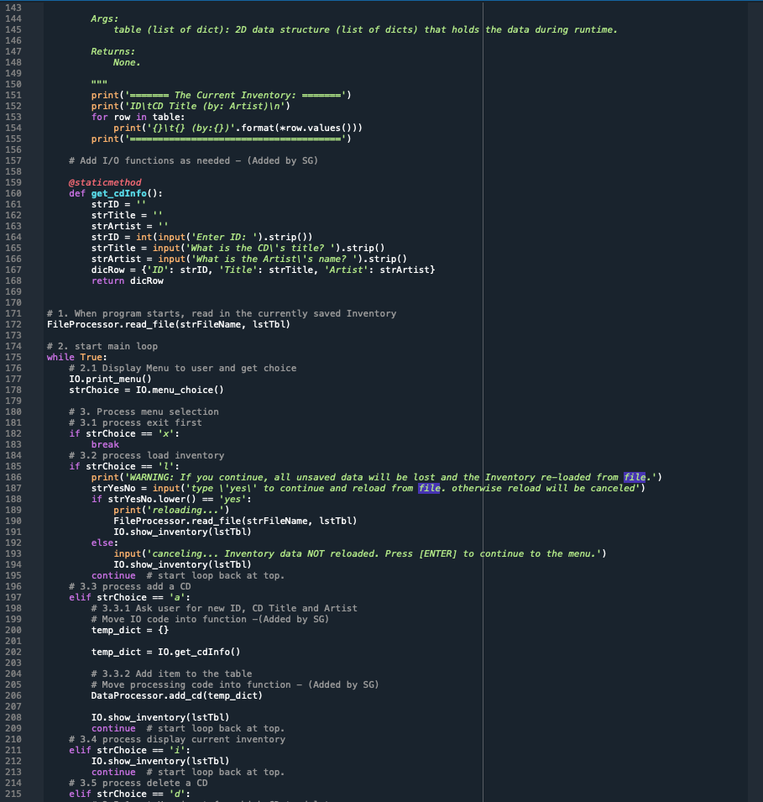

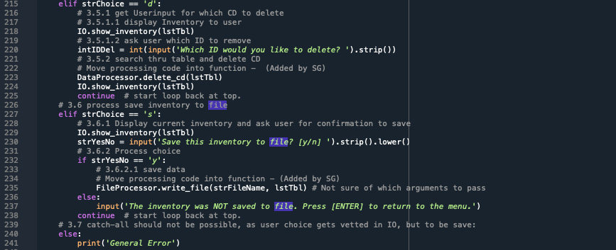

## Console outputs

