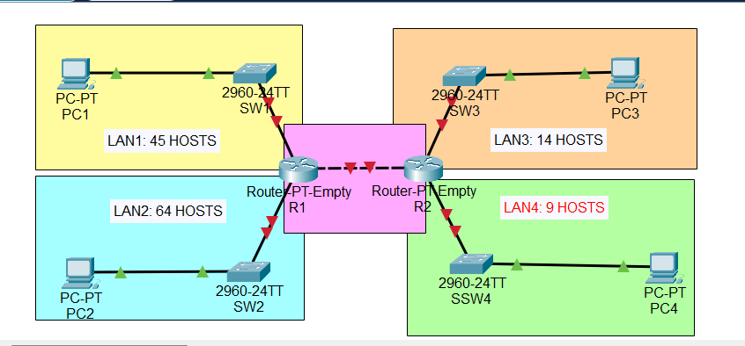

Make setup on your cisco packet tracer:

1. Subnet the 192.168.5.0/24 network to provide sufficient addressing for each LAN.
2. Assign the first usable address to the PC in each LAN.
3. Assign the last usable address to the router’s interface in each LAN.
4. Configure static routes on each router so that all PCs can ping each other.