SOLUTION:

Make setup on your cisco packet tracer:

1. Subnet the 192.168.5.0/24 network to provide sufficient addressing for each LAN.
2. Assign the first usable address to the PC in each LAN.
3. Assign the last usable address to the router’s interface in each LAN.
4. Configure static routes on each router so that all PCs can ping each other.

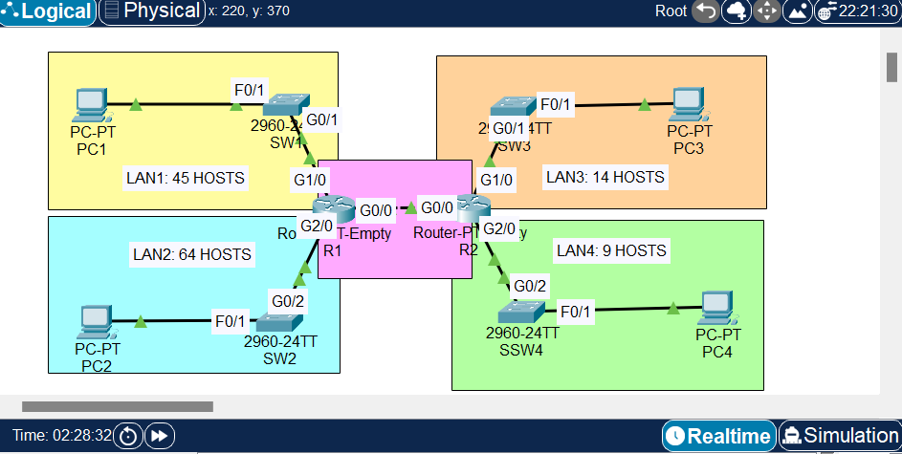

1. LAN2: 64 Hosts

Required 7 hosts bit: 27 -2 = 128 - 2= 126

192.168.5.0/25 – 192.168.5.127/25

1. LAN1: 45 Hosts

Required 6 hosts bit: 26 -2 = 64 - 2= 62

192.168.5.128/26 – 192.168.5.191/26

1. LAN3: 14 Hosts

Required 4 hosts bit: 24 -2 = 16 - 2= 14

192.168.5.192/28 – 192.168.5.207/28

1. LAN4: 9 Hosts

Required 4 hosts bit: 24 -2 = 16 - 2= 14

192.168.5.208/28 – 192.168.5.223/28

1. Router 1 to Router 2: 2 Hosts

Required 2 hosts bit: 22 -2 = 4 - 2= 2

192.168.5.224/30 – 192.168.5.227/30

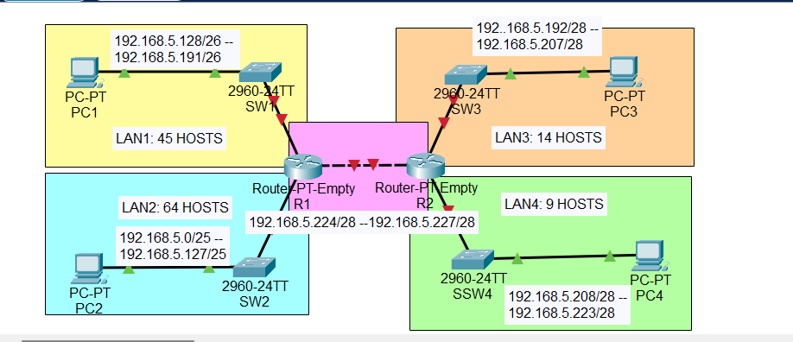

CONFIGURATION OF PC1:

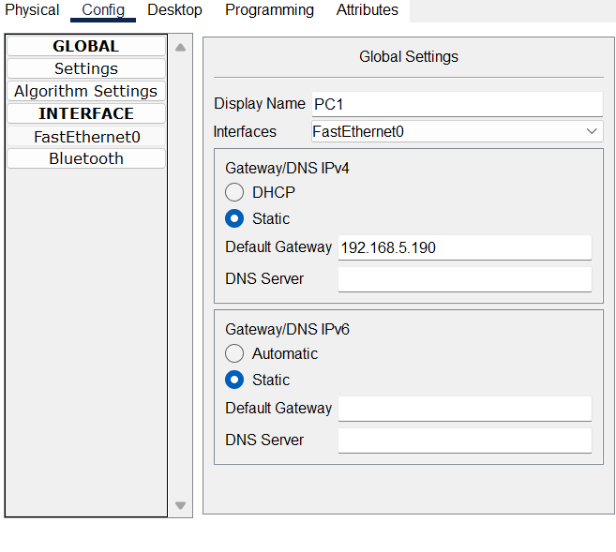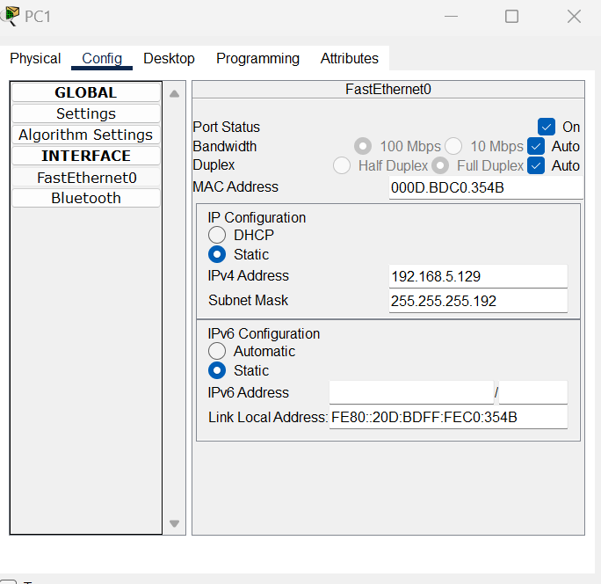

CONFIGURATION OF PC2:

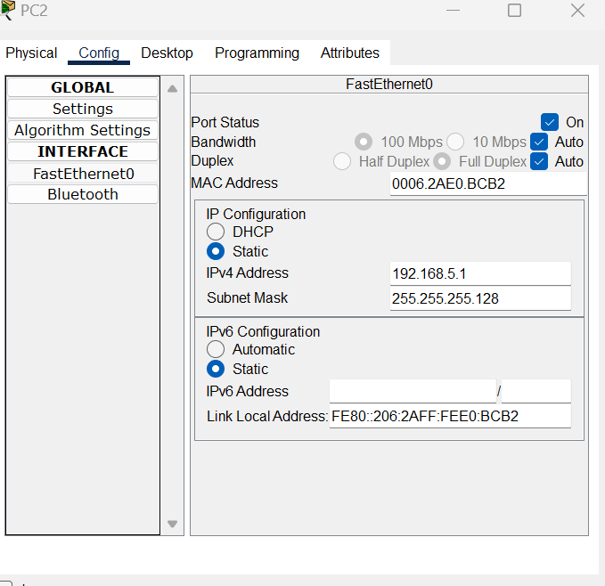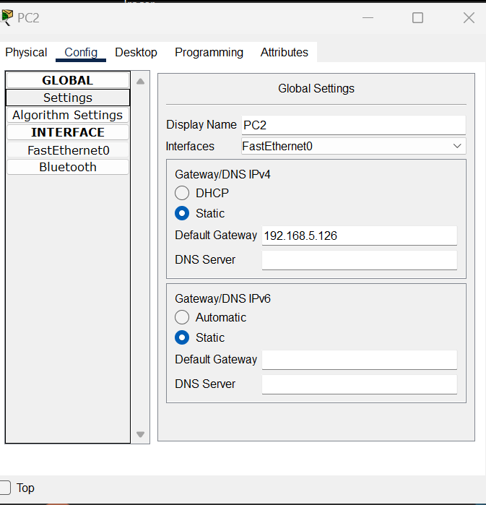

CONFIGURATION OF PC3:

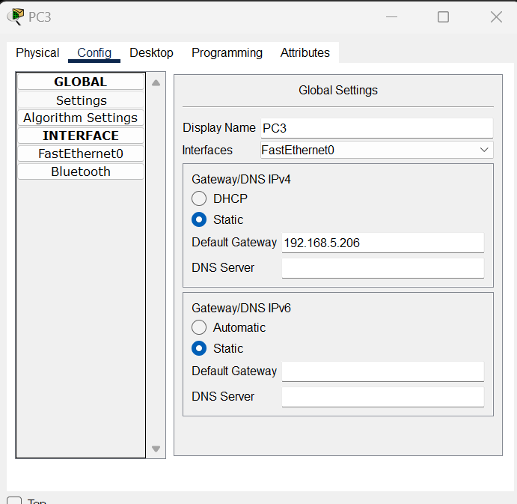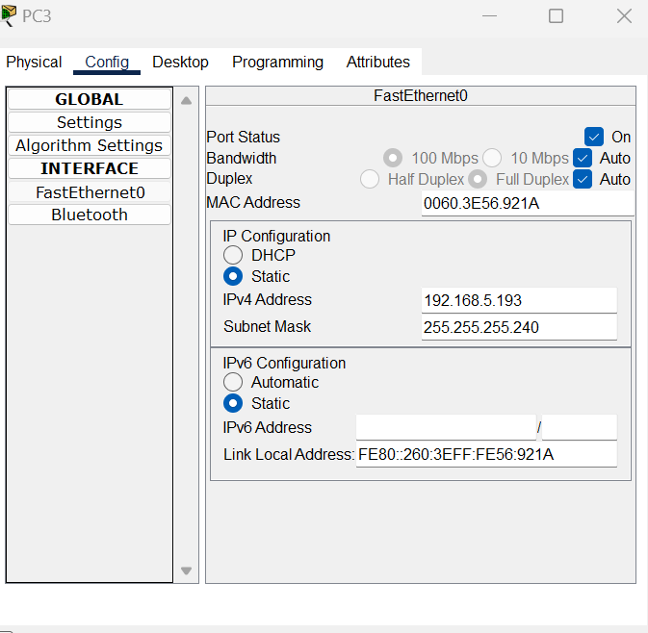

CONFIGURATION OF PC4:

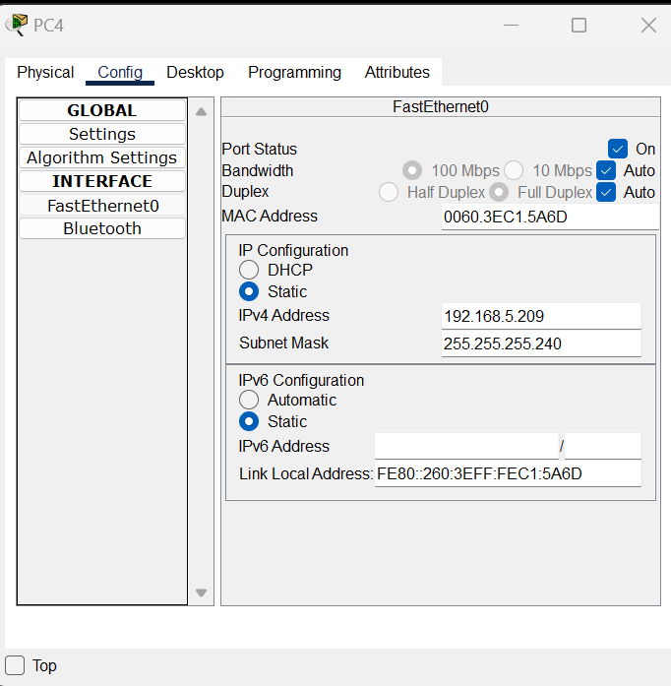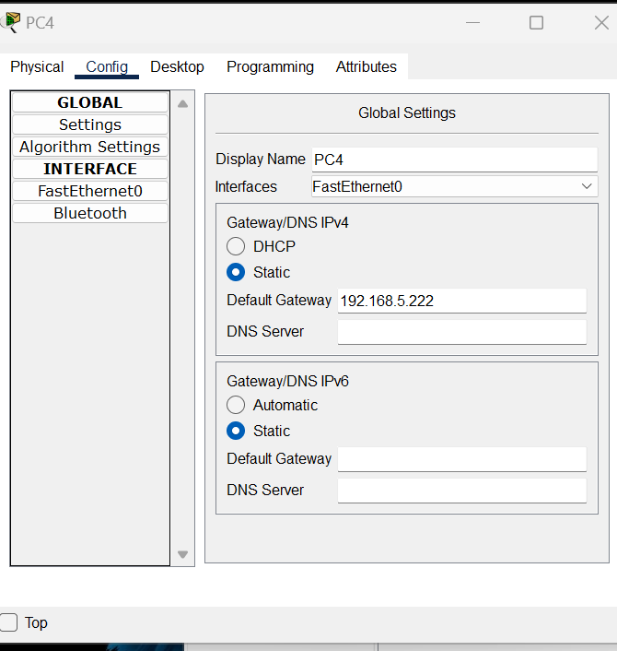

CONFIGURATION OF R1 (ROUTER 1):

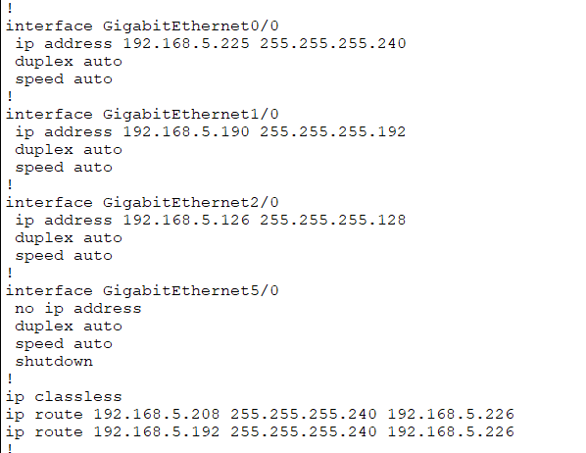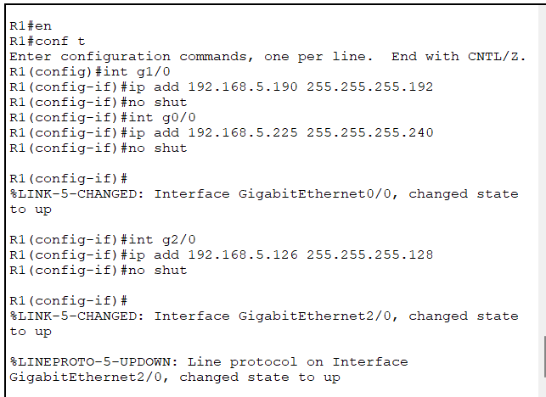

Running configuration terminal

R1# show run

CONFIGURATION OF R2 (ROUTER 2):

