Simple Flask Application using Docker & Docker Compose
Project Overview
This project demonstrates how to:
- Create a simple Python Flask web application
- Containerize the application using Docker
- Manage multi-container applications using Docker Compose
- Push and pull Docker images using Docker Hub
Prerequisites
Make sure the following tools are installed on your machine:
- Docker
- Docker Compose
- Verify Docker Installation
Run the following commands to verify Docker installation:
- docker --version
- docker compose version
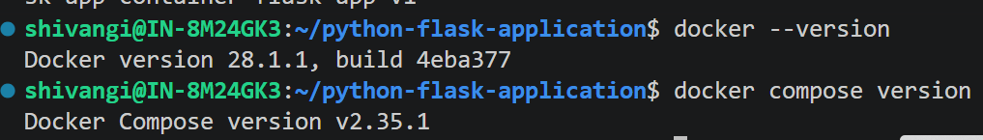
Run a test container:
- docker run hello-world
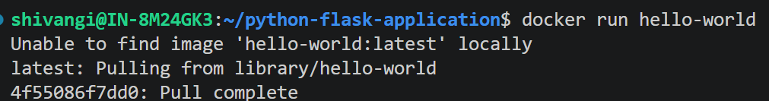
If Docker is installed correctly, you will see a success message.
Project Structure
project-folder/
│
├── app.py
├── requirements.txt
├── Dockerfile
├── docker-compose.yml
└── templates/
└── index.html

Flask Application
The application contains:
Home endpoint → /
Health check endpoint → /health
Dockerfile
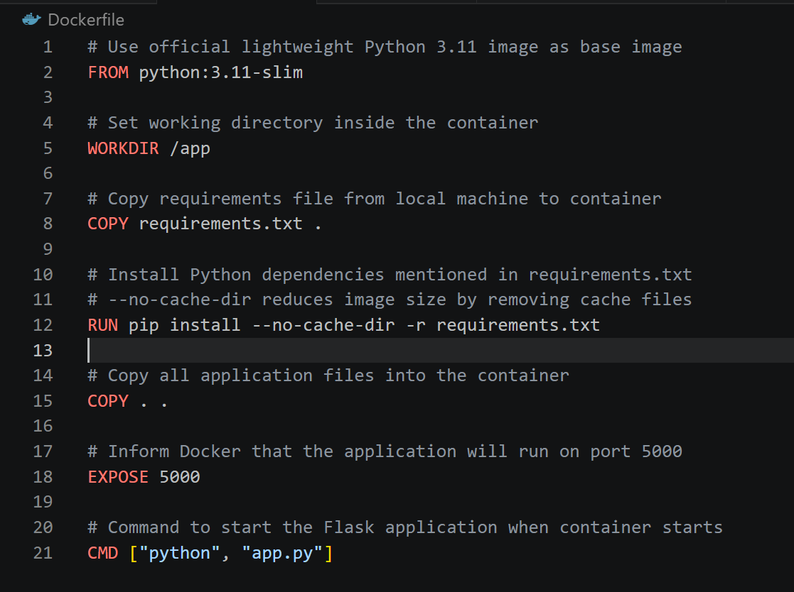
Build Docker Image
Run the following command to build the Docker image:
docker build -t flask-app-v1 .
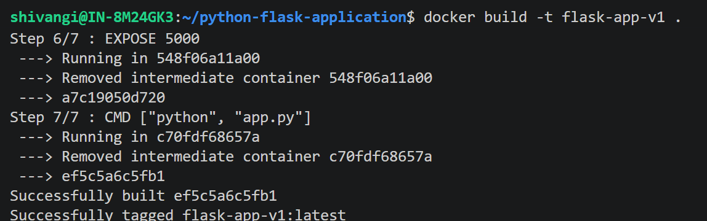
Run Docker Container
Start the container:
docker run -d -p 5000:5000 --name flask-container flask-app
Access the application:
http://localhost:5002/
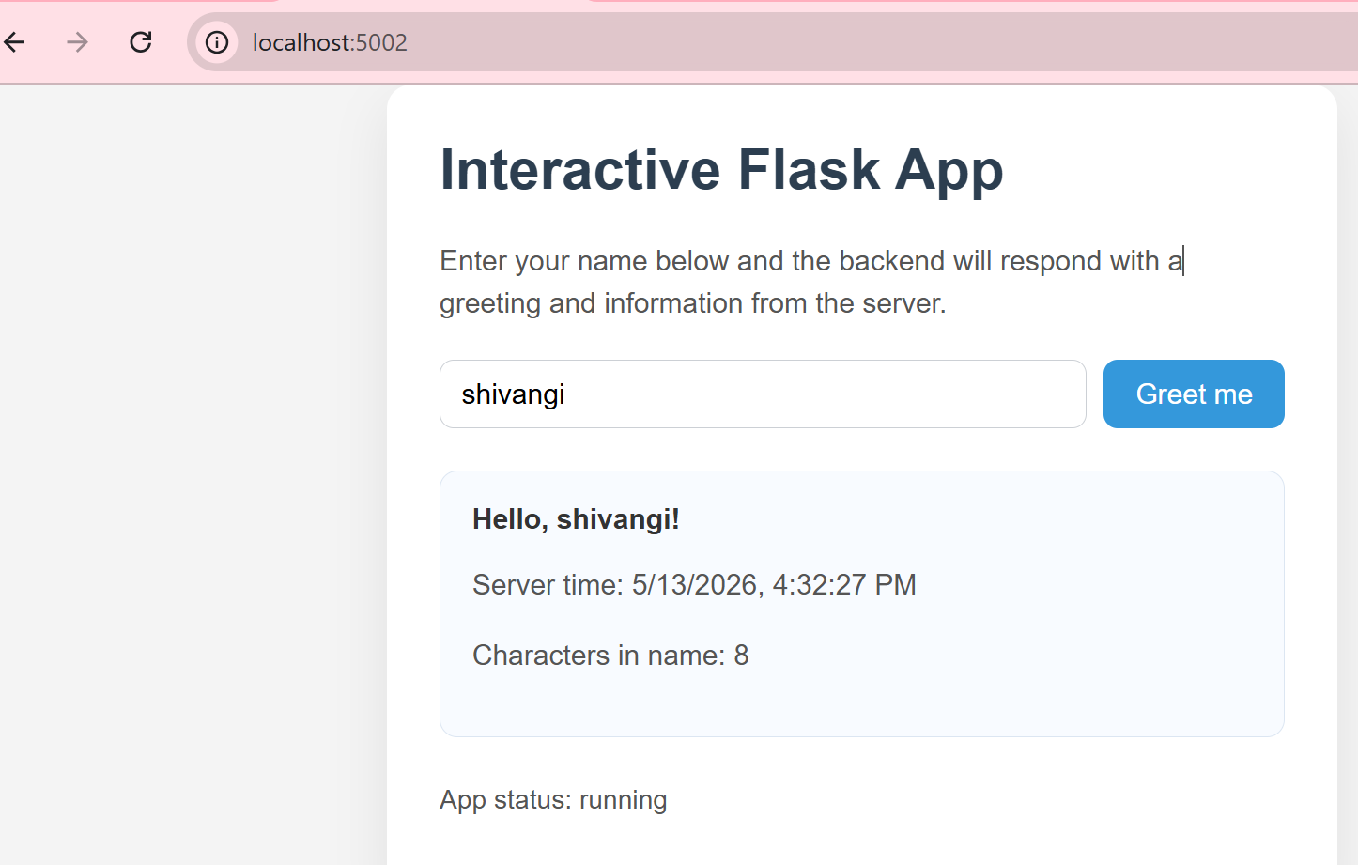
Health endpoint:
http://localhost:5002/health
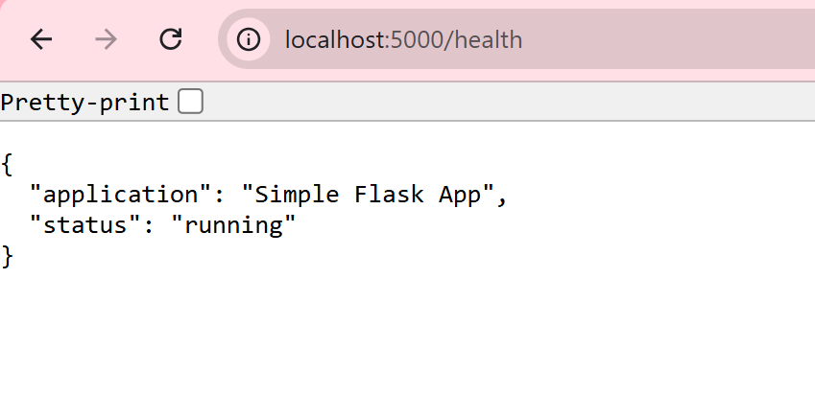
Docker Commands
List Containers
docker ps
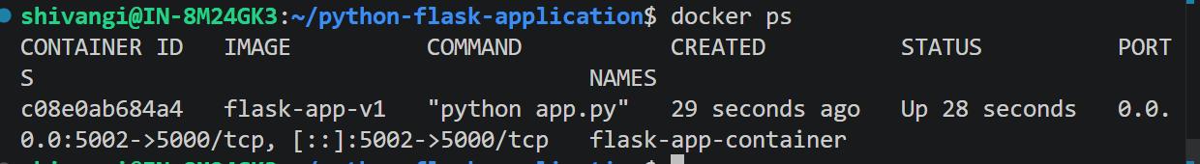
List all containers:
docker ps -a
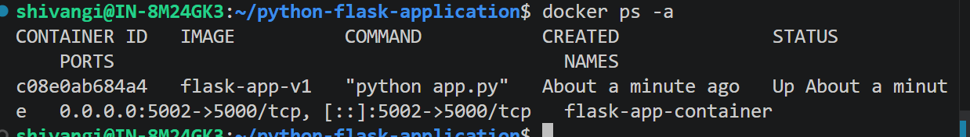
Stop Container
docker stop flask-app-container
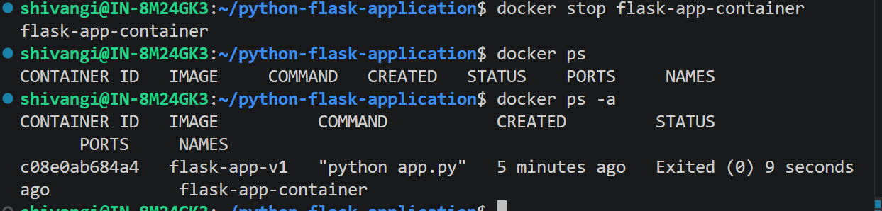

Start Container
docker start flask-app-container
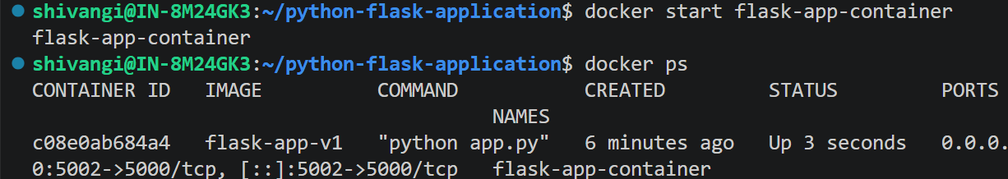
Remove Container
docker rm flask-app-container
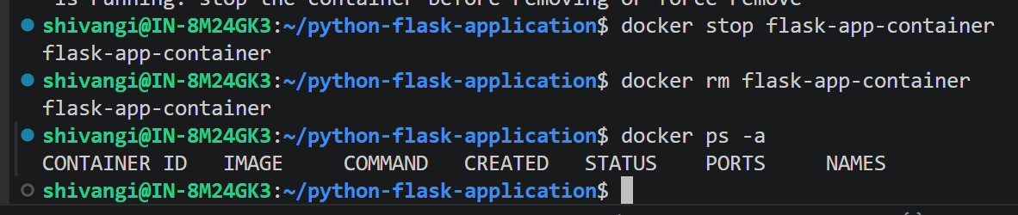
Inspect Running Containers
docker inspect flask-app-container
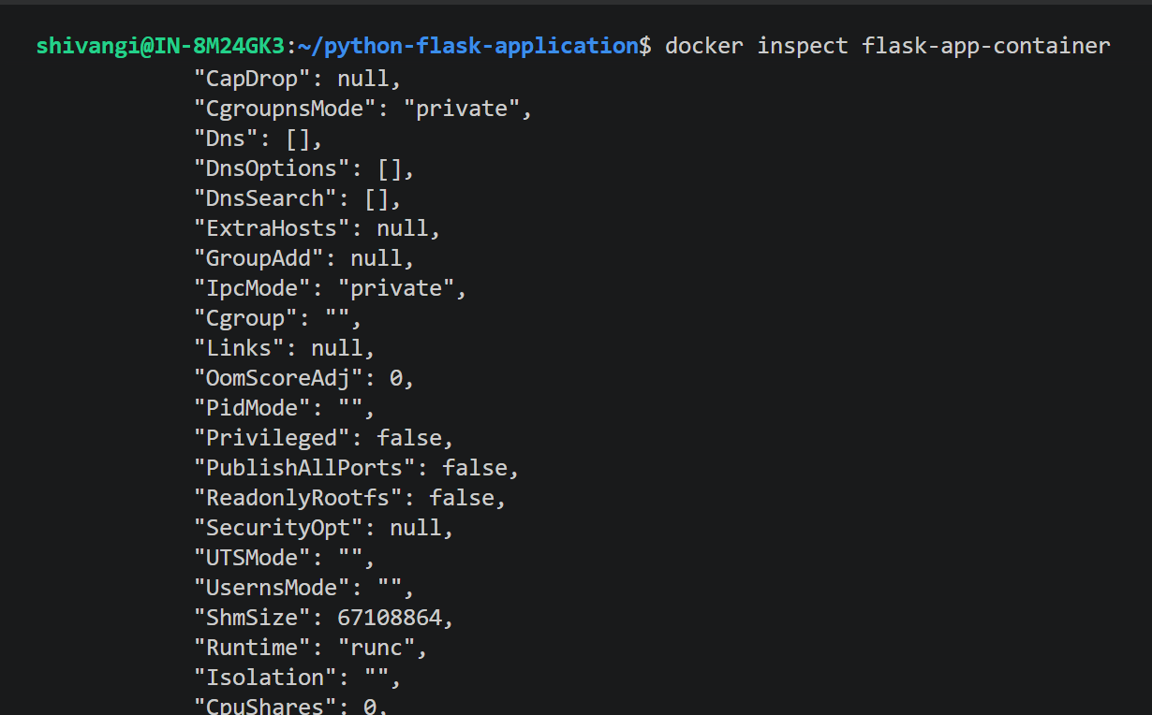
View container logs:
docker logs flask-app-container
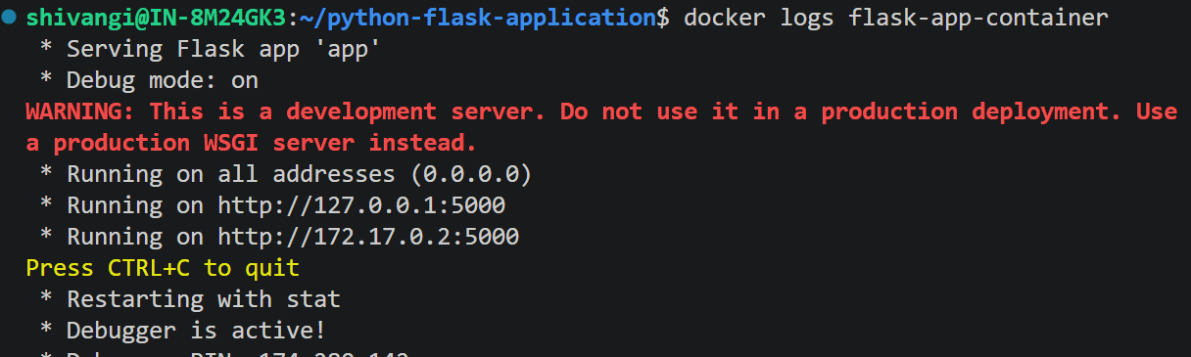
Docker Compose Configuration
docker-compose.yml
version: '3.9'
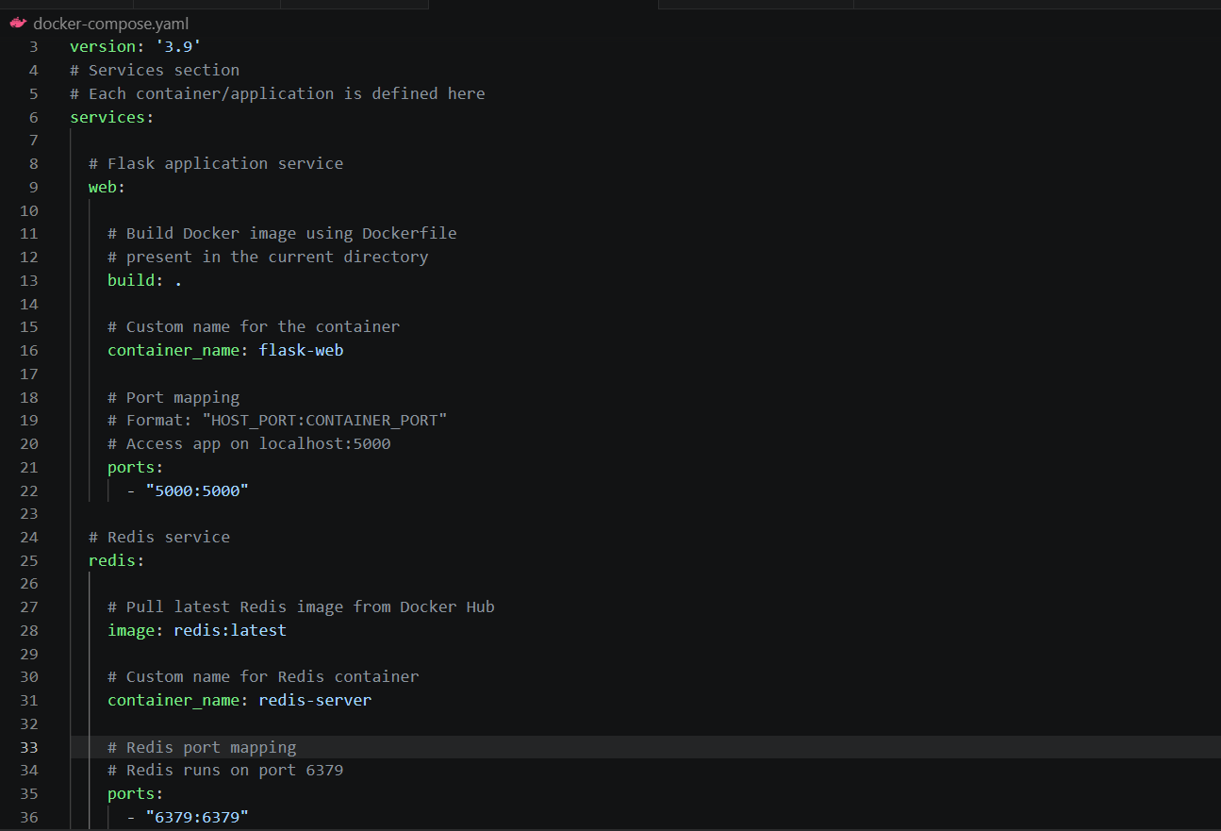
Run Application using Docker Compose
Start all services:
docker compose up -d
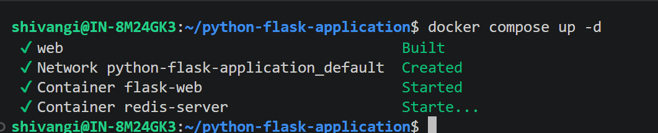
Check running services:
docker compose ps
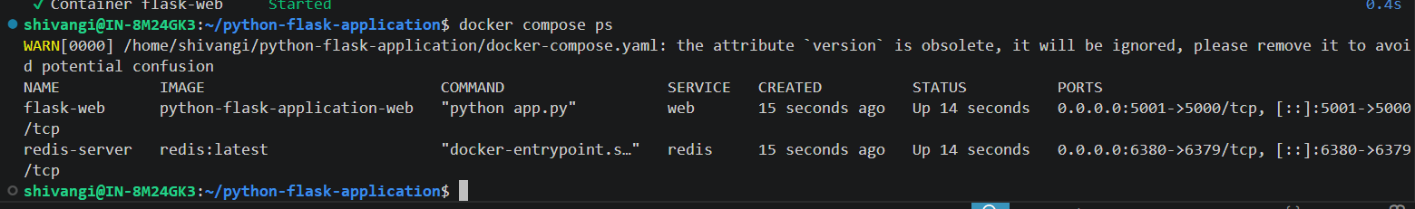

View logs:
docker compose logs
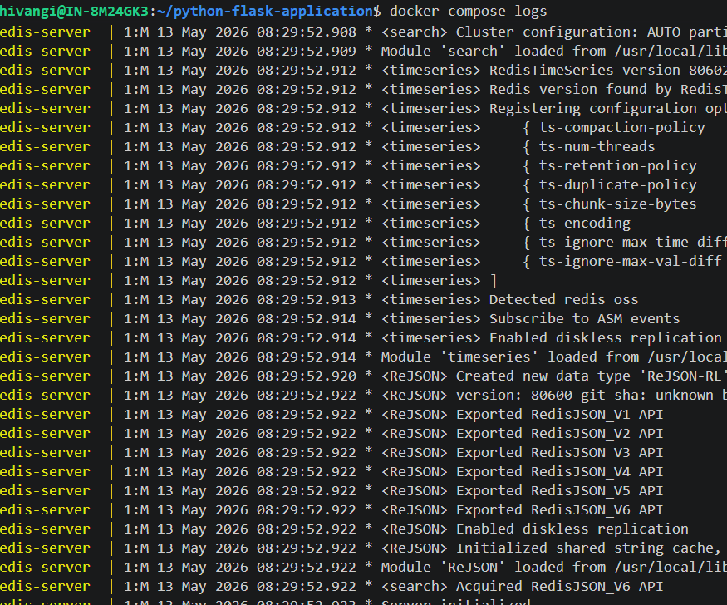

Stop services:
docker compose down
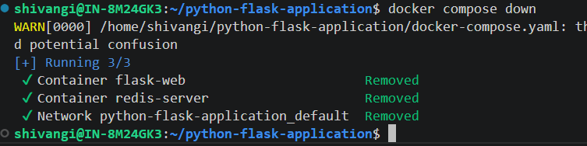
Docker Hub Setup
Login to Docker Hub
Create Dockerhub account and login with username and password.
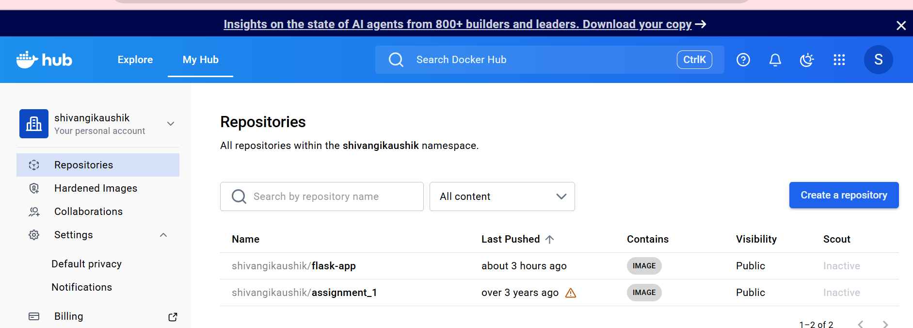
docker login
Enter your Docker Hub username and password/token.
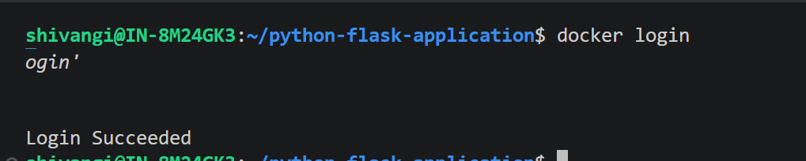
Tag Docker Image
docker tag python-flask-application-web shivangikaushik/flask-app:v2

Push Image to Docker Hub
docker push shivangikaushik/flask-app:v2
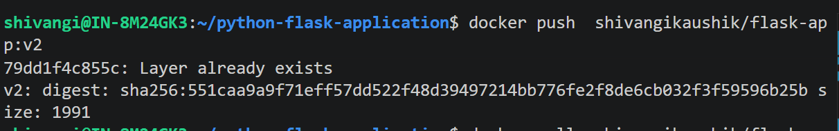
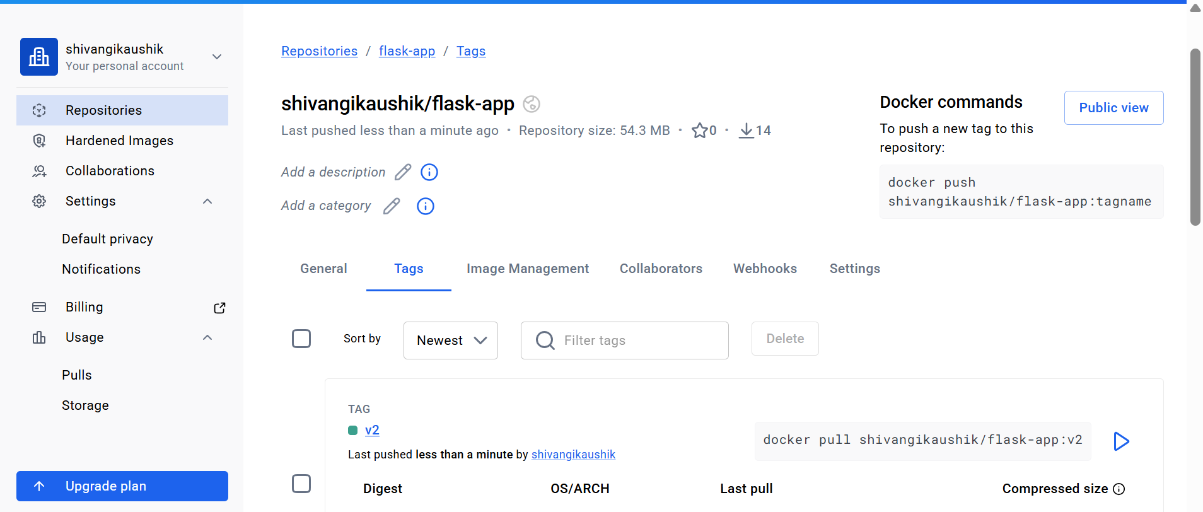

Pull Image from Docker Hub
docker pull shivangikaushik/flask-app:v2
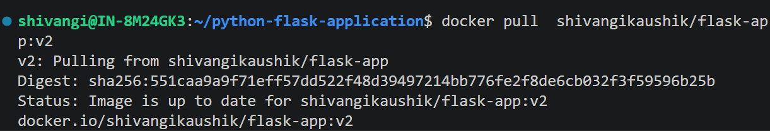
Run Pulled Image
docker run -d -p 4000:5000 shivangikaushik/flask-app:v2
Verify Application
Open browser:
http://localhost:4000
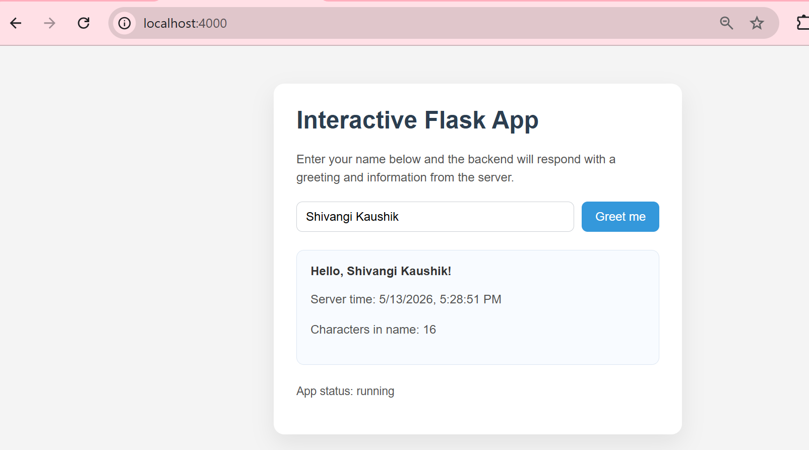

Health check:
http://localhost:4000/health
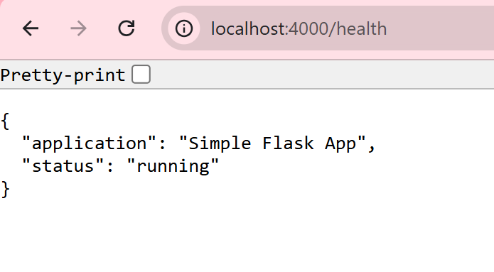
Technologies Used
Python
Flask
Docker
Docker Compose
Redis
Author: Shivangi Kaushik

