|  |  |
| --- | --- |
| **Project Description (What)**   * A new generation coffee maker is needed where customer can provide his/her recipe and get the coffee as per the customer’s liking. * The project is service based also includes user interface. * The project is supposed to be completed by 29 Jan 2021 EOD. * Here is the coffee maker model used for case study. | **Objective/Approach**  **Objective:**   * Handle orders and communicate through UI. * Handle the ingredients used for the coffee. * Handle the orders and customer’s recipe. * Notifying user if coffee can be prepared with the provided recipe or provide ready-made recipe/coffee. * Served food and **coffee** to customers and collected money.   **Approach:**   * Create requirement document. * Design Use cases. * Create analysis and design documents. * Develop generic UI and customer interaction. * Develop coffee maker Service UI. * Test the product. |
| **Schedule**   |  |  | | --- | --- | | Proposal | 25-01-2021 | | Use Case | 25-01-2021 | | Design | 26-01-2021 | | Develop UI | 27-01-2021 | | Test, Bug Report | 28-01-2021 | | Last Submission | 29-01-2021 | | **Benefit**   * Easy to use. * High-perfomance. * Customer satisfaction. * Enhancing the custom model of coffee maker. * Easy addition and deletion of recipes. * Friendly GUI with selection of existing recipes or custom recipes. |

**Use case 1:**

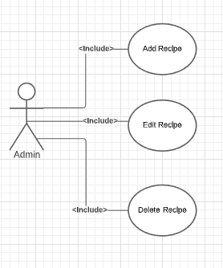

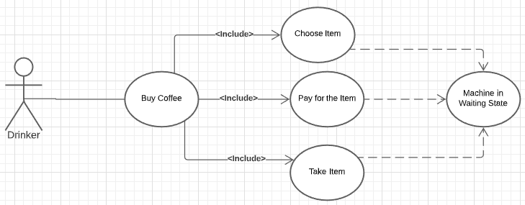

**Use Case 2:**

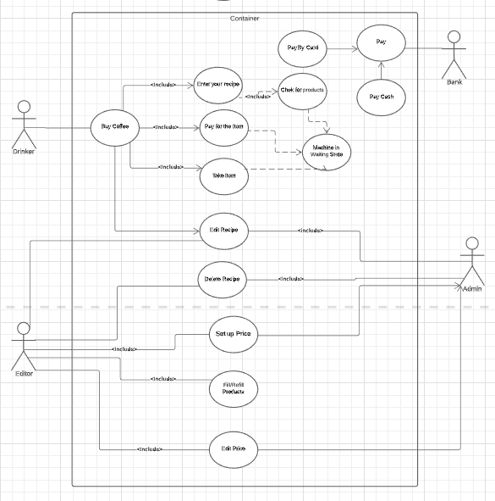

**Use Case 3:**

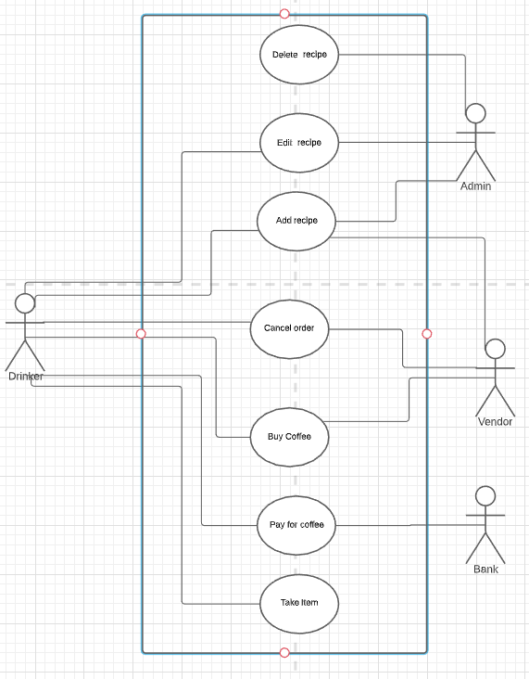

**Use Case 4:**

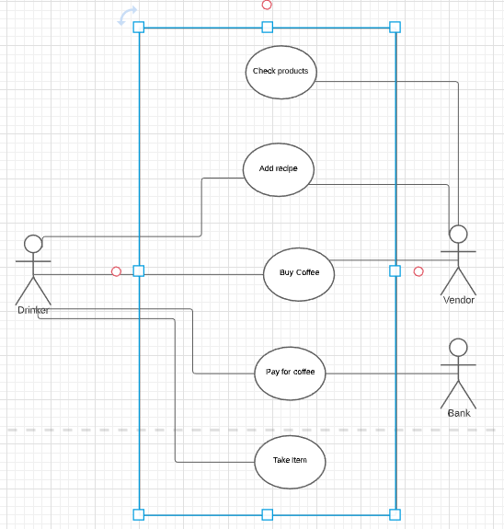

**Description:**

|  |  |  |
| --- | --- | --- |
| Use Case 4 | Buy Coffee with your recipe | |
| Goal in Context | customer issues his recipe in order to get coffee and pay for it. | |
| Scope & level | Summary, Sub-Function | |
| Pre-Condition | We know products are available to make coffer as per customer’s recipe. | |
| Success End Condition | Customer has coffee, coffee vendor has money for coffee | |
| Failed End Condition | Vendor has not delivered coffee, Customer has not paid. | |
| Primary  Secondary Actors | Customer  NA | |
| Trigger | Customer begins the purchase of coffee. | |
| DESCRIPTION | Step | Action |
| 1 | Customer begins the purchase |
| 2 | Customer enters/adds the recipe |
| 3 | Coffee maker checks if products are available. |
| 4 | Displays the price of coffee. |
| 5 | Customer creates order. |
| 6 | Customer pays for the order. |
| 7 | Bank confirms the payment. |
| 8 | Customer takes the Item. |
| Extension | Step | Branching Action |
|  | 1 | Customer enters/adds the recipe |
|  | 2 | Products are not available in vending machine. |
|  | 3 | Buyer can cancel the order. (use case 3) |
| Sub-Variations |  | Branching Action |
|  | 1. | Buyer may use card or cash for payment, check the debit card balance. |
|  | 2. | Vendor d not have products, can cancel the order. (use case 3) |