AMITY UNIVERSITY ONLINE, NOIDA, UTTAR PRADESH

In partial fulfilment of the requirement for the award of the degree of
Master of Computer Applications (Information Technology)

TITLE
Folio: An Educational Stock Recommendation and Investor Onboarding System

Guide Details
Name: Rajan Verma
Designation: Developer and System Architect at Galific with 11+ years of experience

Submitted By
Name of the Student: Shivangi
Enrolment Number: A9929724001979(el)

June 2026

ABSTRACT
This report documents the design and development of Folio, a web based recommendation and onboarding system intended for individuals who are beginning their journey into equity investing in India. A large share of new retail investors enter the market without a structured sense of their own risk capacity, without realistic expectations about the returns equities can deliver, and without an organised way to decide which stocks merit attention. The tools available to them tend to fall into two groups. The first group consists of brokerage platforms built for placing orders, which assume the user already knows what to buy. The second consists of informal tip services and social media channels, which are frequently misleading and operate outside any regulatory framework. Folio was conceived to occupy the space between these two, functioning strictly as an educational companion rather than as a broker or an investment adviser.
The system guides a first time investor through a short structured onboarding sequence that records professional and financial background, prior experience, a financial goal with a target amount and target year, and an attitude towards risk. From these inputs it derives a quantified risk score and an investor archetype. A reality check stage then computes the annual return that the stated goal actually requires, using standard compound interest mathematics, and classifies that requirement as comfortable, realistic, ambitious, or unrealistic. When the requirement is unattainable, the system explains the gap in plain language and offers three concrete adjustments, namely extending the timeline, increasing the monthly contribution, or revising the target. A rules based recommendation engine scores a curated universe of large capitalisation equities on momentum, valuation, quality, and fit with the user profile, then arranges them into risk banded tiers, each accompanied by a written rationale and a clear statement that the output is educational and not advice.
The methodology is that of applied, development oriented work with an evaluative component. Quantitative market data was obtained through an application programming interface that supplies live prices and fundamental ratios, together with a bundled exchange symbol directory used for search. A sample of thirty liquid large capitalisation stocks of the National Stock Exchange was selected by purposive sampling from approximately nine thousand five hundred listed equity symbols. The scoring engine and the compound interest solver, both implemented in JavaScript, served as the principal analysis tools. Functional testing confirmed that the onboarding flow produced consistent risk profiles, that the reality check correctly identified and corrected unrealistic goals, and that the recommendation engine distributed the sampled stocks across appropriate risk tiers. A representative unrealistic goal produced a required return that the system capped and flagged, after which the interactive controls allowed the user to bring the plan back into a realistic range. The work retains a watchlist feature for bookmarking stocks and adds a paper trading environment in which users practise with virtual capital. The report also identifies the next stage of development, which connects a natural language advisory layer powered by a large language model and a server side data and accounts layer, while keeping every recommendation grounded in the deterministic engine.
Keywords: investor onboarding, stock recommendation engine, risk profiling, financial literacy, behavioural finance, reality check, paper trading, educational financial technology.

CERTIFICATE

This is to certify that Shivangi, a student of Amity University Online, has carried out the project work presented in this project report entitled “Folio: An Educational Stock Recommendation and Investor Onboarding System” for the award of the degree of Master of Computer Applications in Information Technology under my guidance. The project report embodies the results of original work, and the studies were carried out by the student. Certified further that, to the best of my knowledge, the work reported herein does not form the basis for the award of any other degree to the candidate or to anybody else from this or any other University or Institution.

Signature
Rajan Verma
Developer and System Architect at Galific with 11+ years of experience
Amity University Online

DECLARATION

I, Shivangi, a student pursuing Master of Computer Applications (Information Technology), Final Semester at Amity University Online, hereby declare that the project work entitled “Folio: An Educational Stock Recommendation and Investor Onboarding System” has been prepared by me during the academic year 2025-2026 under the guidance of Rajan Verma, Developer and System Architect at Galific with 11+ years of experience, Amity University Online. I assert that this project is a piece of original bona fide work done by me. It is the outcome of my own effort and has not been submitted to any other university for the award of any degree.

Signature of Student
Shivangi
Enrolment Number: A9929724001979(el)
TABLE OF CONTENTS
Right click the contents below and choose Update Field to populate page numbers in Microsoft Word.

LIST OF TABLES
Table 4.1 Factor weights used in the recommendation score
Table 4.2 Mapping of risk labels to internal risk bands
Table 4.3 Representative scored stocks from the sample universe
Table 4.4 Feasibility thresholds applied by the reality check
Table 4.5 Worked reality check examples
Table 4.6 Suggested allocation by investor archetype
LIST OF FIGURES
Figure 1.1 Layered architecture of the Folio system
Figure 1.2 Flow from onboarding to recommendations and outputs
Figure 4.1 Distribution of fit scores across the sample universe
Figure 4.2 Realistic goal projection against the target
Figure 4.3 Suggested allocation by investor archetype

CHAPTER 1: INTRODUCTION TO THE TOPIC

1.1 Background
Equity investing in India has moved, within a single decade, from the preserve of a small urban minority to an activity pursued by tens of millions of households. The spread of low cost internet access, the arrival of discount brokerages with simple mobile applications, and a long period of rising markets together encouraged a wave of first time participants. The number of registered investor accounts grew several fold over this period, and a notable proportion of these accounts belong to people in their twenties and thirties who are investing without any formal training in finance. This widening of access is a welcome development for household wealth creation, yet it carries a clear risk. A person who can buy a share with three taps on a phone does not necessarily understand what that share represents, how much it can fall, or whether the return they are hoping for is even arithmetically possible.
The consequence is visible in the behaviour of many new entrants. Studies of retail trading repeatedly find that active individual traders underperform simple buy and hold strategies, largely because of overconfidence, excessive trading, and a tendency to chase recent winners. New investors are particularly vulnerable to promotional messaging that promises rapid multiplication of capital, and they often size positions without regard to their own ability to absorb a loss. The gap, therefore, is not primarily a gap in market access. It is a gap in preparation. The market is open to everyone, but the habits and the mental models that protect an investor are not distributed nearly as evenly.

1.2 The problem this project addresses
Folio addresses the preparation gap rather than the access gap. The central observation behind the project is that a beginner needs three things before the choice of any individual stock becomes meaningful. The beginner needs an honest assessment of how much risk their circumstances and temperament allow, an expectation about returns that is anchored to what markets have historically delivered rather than to what an advertisement suggests, and a shortlist of instruments that suits that risk level rather than the day's most talked about ticker. None of these three needs is served well by an order placement platform, and all three are actively undermined by tip based services.
The project treats recommendation as education. The system never instructs a user to buy or sell, never executes a transaction, and never positions itself as a substitute for a registered investment adviser or for a stock broker. It surfaces ideas, explains why each idea was surfaced, and presents the historical and fundamental context that a careful person would want to examine. This positioning is deliberate and is reinforced throughout the interface, both because it reflects the genuine purpose of the work and because the regulatory framework in India draws a firm line around personalised investment advice.

1.3 The Folio system
Folio is a single page web application. A new user first passes through a short onboarding sequence that records professional and financial background, prior investing experience, a financial goal expressed as a target amount and a target year, and an attitude towards risk. From these answers the system computes a risk score on a scale of one hundred and assigns an investor archetype such as Capital Protector or Balanced Grower. Beginners are deliberately prevented from being pushed into the highest risk category even when they describe themselves as aggressive, because a person who has never invested cannot reliably know how they will react to a sharp decline.
After the profile is formed, a reality check stage computes the annual rate of return that the stated goal would require, given the user's starting capital and monthly contribution, and classifies that requirement against historical benchmarks. A recommendation engine then scores a curated set of large companies and groups them into tiers by risk. A wealth blueprint translates the profile into a suggested asset allocation, a set of practical tips chosen for the user's profession, and a projection of the likely outcome of a disciplined plan. The watchlist allows the user to bookmark and track stocks, and a paper trading module lets the user practise buying and selling with virtual money. A small library of short lessons supports the learning that runs through the whole experience.
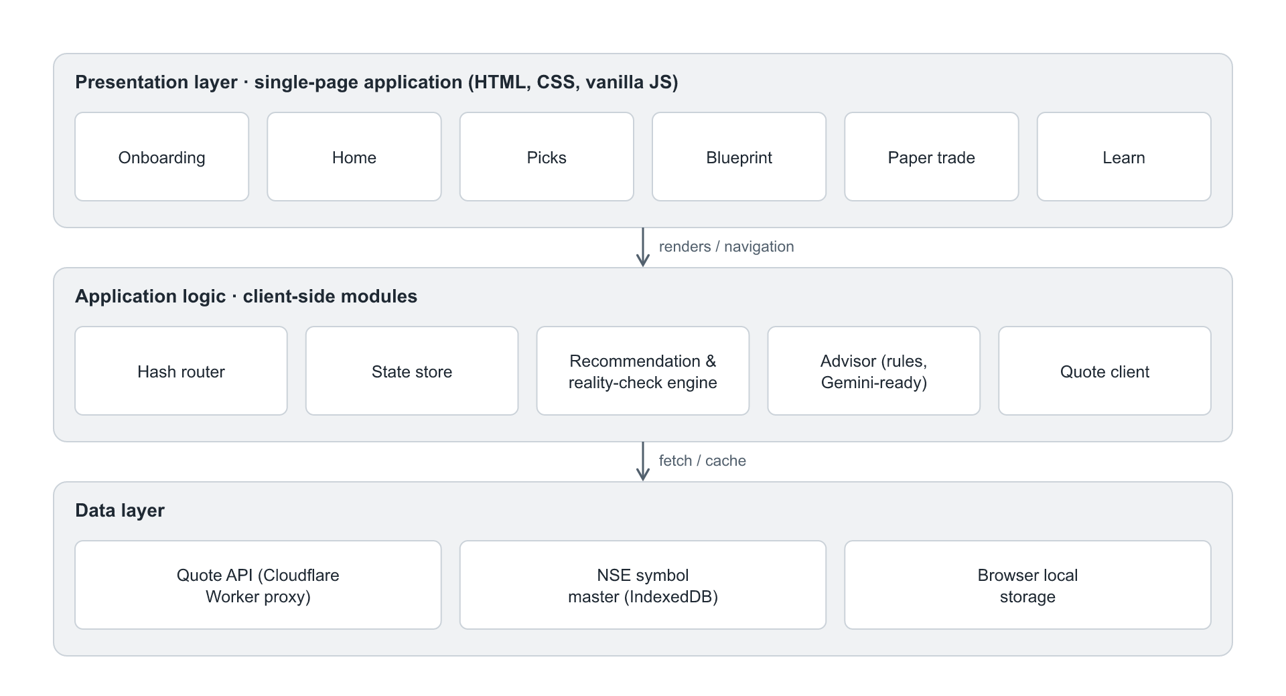
Figure 1.1 Layered architecture of the Folio system
The system is organised in three layers, shown in Figure 1.1. The presentation layer contains the screens the user interacts with. The application logic layer contains the router, the state store, the recommendation and reality check engine, the advisory text generator, and the quote client. The data layer comprises the live quote service, the exchange symbol directory held in the browser database, and the local storage that persists the user's profile, watchlist, and practice portfolio. Figure 1.2 shows how a user moves through the system, from onboarding to a quantified profile, through the reality check and the recommendation engine, and on to the four outputs the system produces.
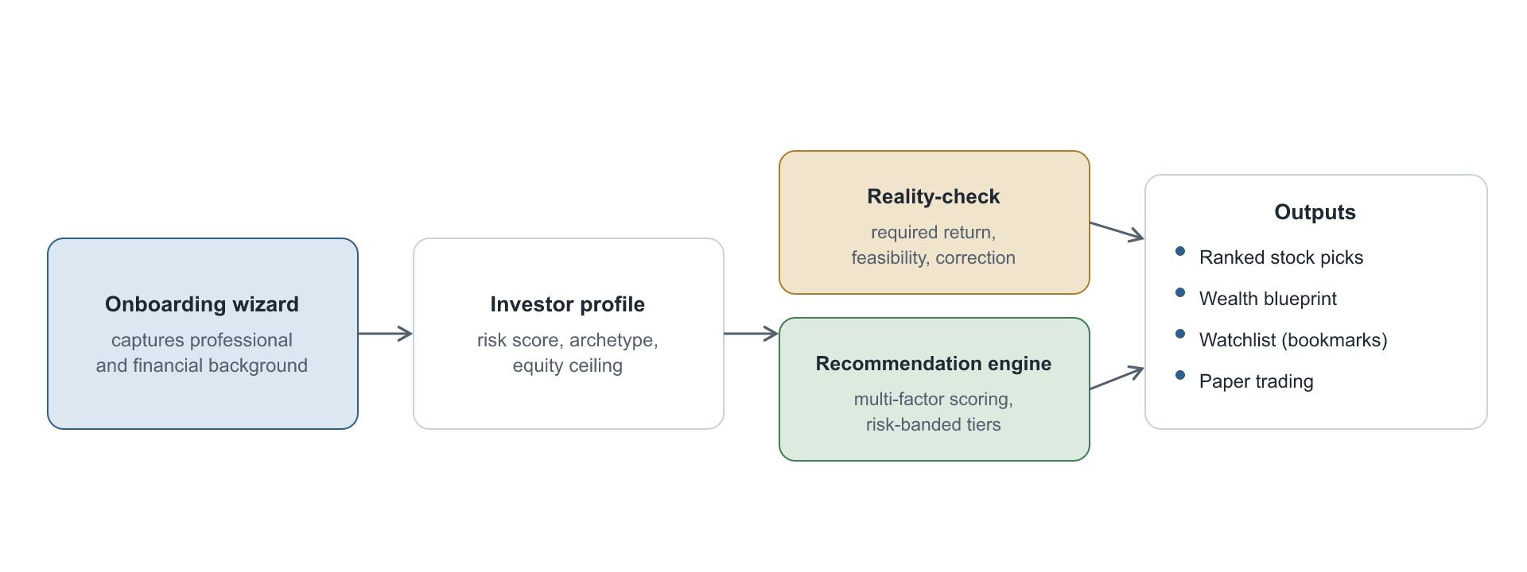
Figure 1.2 Flow from onboarding to recommendations and outputs

1.4 Justification for selecting this topic
The topic was selected for three reasons. The first is relevance. The rapid entry of inexperienced investors into Indian equity markets is a current and consequential phenomenon, and a tool that improves preparation speaks to a real and widespread need rather than to a hypothetical one. The second is the opportunity to combine fields. The project brings together software engineering, quantitative scoring, behavioural finance, and interface design in a single artefact, which makes it a suitable subject for a major project at the postgraduate level. The third is the discipline that the educational framing imposes. Building a system that helps people without crossing into regulated advice forces careful thought about transparency, about how recommendations are justified, and about how a system can correct a user gently rather than simply rejecting an input. These constraints make the work more interesting and more defensible than a generic portfolio tracker would be.

1.5 Scope of the work
The scope of this work is the design and construction of the complete client facing application together with its deterministic engine, and the evaluation of that engine against the project objectives. The recommendation universe is limited to large capitalisation equities of the National Stock Exchange, which is the appropriate starting point for first time investors. The system uses live market data obtained through a quote service for prices and fundamental ratios. Two capabilities are designed and documented but deferred to a later stage of development, namely the natural language advisory layer powered by a large language model and the server side accounts and data layer. The reasons for this boundary, and the plan for crossing it, are set out in Chapter 6.

1.6 Organisation of the report
The remainder of this report is organised as follows. Chapter 2 reviews the relevant literature on behavioural finance, portfolio construction, financial literacy, automated advisory systems, and the regulatory context. Chapter 3 states the research objectives and describes the methodology, including the research design, the data, the sample, and the analysis tools. Chapter 4 presents the scoring model, the results it produced on the sample, and the behaviour of the reality check and the allocation model, supported by tables and figures. Chapter 5 sets out the principal findings and the conclusion. Chapter 6 offers recommendations for further development and states the limitations of the study.

CHAPTER 2: REVIEW OF LITERATURE
The design of Folio draws on several established bodies of work. This chapter reviews the strands most relevant to the project, namely the behavioural tendencies that lead beginners astray, the theory of portfolio construction and the case for low cost diversification, the evidence on financial literacy, the development of automated advisory systems, and the regulatory framework that governs investment advice in India.

2.1 Behavioural finance and the beginner
Classical finance assumed that investors are rational and that prices reflect all available information, a view formalised in the efficient market hypothesis described by Fama (1970). The behavioural tradition that followed showed that real investors depart from this ideal in systematic ways. Kahneman and Tversky (1979) introduced prospect theory, which demonstrated that people weigh losses more heavily than equivalent gains and that their choices depend on how outcomes are framed. This asymmetry helps explain why a beginner who experiences a sharp fall may sell at exactly the wrong moment, and why the framing of a goal matters as much as its substance.
Barber and Odean (2000) studied the trading records of individual investors and found that those who traded most actively earned the lowest net returns, a result they attributed to overconfidence and to transaction costs. Their later work showed that individuals tend to buy attention grabbing stocks, which is precisely the behaviour that tip driven services exploit. Statman (2019) synthesised the second generation of behavioural finance and argued that investors pursue expressive and emotional goals alongside financial ones, which supports the case for a system that engages with a user's stated aspirations rather than treating them as noise. These findings shaped two design decisions in Folio. The reality check exists to counter overoptimistic framing with arithmetic, and the protection that prevents beginners from being placed in the highest risk tier exists to counter overconfidence.

2.2 Portfolio theory and the case for diversification
Markowitz (1952) established that the risk of a portfolio is governed by how its holdings move together as well as by the risk of each individual holding, and that diversification can reduce risk for a given level of expected return. Sharpe (1964) extended this into a model relating expected return to systematic risk. For the present project the practical implication of this tradition is that a beginner should hold a diversified core rather than a concentrated set of individual bets. Bogle (2007) made the influential argument that, because costs compound against the investor and few active managers beat the market consistently, a low cost index fund is a sensible foundation for most people. Graham (2006) had earlier argued for a disciplined, value conscious approach and for treating market fluctuations as the servant rather than the master of the investor. The allocation model in Folio reflects this consensus by placing a low cost index and large capitalisation core at the centre of every suggested allocation, with individual stock selection treated as a smaller satellite around that core.

2.3 Financial literacy
Lusardi and Mitchell (2014) reviewed the evidence on financial literacy and found that a large fraction of the population, in both developed and developing economies, cannot answer basic questions about interest, inflation, and diversification, and that low literacy is associated with poorer financial outcomes. Their work establishes that the knowledge gap Folio addresses is real and measurable. It also suggests that interventions are most effective when they are timely and specific to a decision the person is about to make. This informed the choice to embed short lessons within the application and to deliver guidance at the moment a user sets a goal or considers a stock, rather than as a separate body of material the user must seek out.

2.4 Automated advisory systems
Automated advisory services, often called robo advisers, use questionnaires to assess risk tolerance and then allocate clients to model portfolios. D'Acunto, Prabhala and Rossi (2019) studied the adoption of such a service and found that it improved diversification and reduced some behavioural biases for previously undiversified investors, while noting that the benefits were uneven across user types. The literature on these systems supports the use of a structured questionnaire to derive a risk profile, which Folio adopts, but it also shows that opaque allocation can erode trust. This motivated the decision to make the Folio engine fully transparent and rule based, so that every score and every classification can be explained, and to confine any future language model to rephrasing facts the engine has already computed rather than to generating recommendations of its own.

2.5 Recommendation approaches
Recommendation systems in general span a spectrum from transparent rule based scoring to opaque machine learned models. For a financial education tool aimed at beginners, the balance favours transparency. A beginner benefits more from understanding why a stock appears suitable than from a precise but unexplained ranking, and a transparent model is far easier to defend against the charge that it constitutes unlicensed advice. Folio therefore uses a weighted multi factor score whose components, namely momentum, valuation, quality, and fit with the user profile, are visible and individually interpretable. This choice trades a measure of predictive sophistication for explainability and regulatory safety, which is the correct trade for the intended audience.

2.6 Regulatory context
The provision of investment advice in India is regulated. The Securities and Exchange Board of India administers the SEBI (Investment Advisers) Regulations, 2013, and the SEBI (Research Analysts) Regulations, 2014, which govern who may provide personalised advice and how research recommendations must be made and disclosed. These regulations make it essential for a non licensed educational tool to avoid offering personalised buy or sell advice and to state its limitations clearly. The design of Folio reflects this throughout. The system frames its output as educational, attaches the historical and fundamental basis for every idea, repeats that it does not execute trades or replace a licensed adviser, and stops short of telling any user what to do with their money. The literature and the regulatory framework together point to the same conclusion, namely that a tool for beginners should educate, contextualise, and correct, while leaving the final decision and its execution with the user and the licensed intermediaries who serve them.

CHAPTER 3: RESEARCH OBJECTIVES AND METHODOLOGY

3.1 Research objectives
The objectives of this project summarise what the study set out to achieve. They are as follows.
- To design a step by step onboarding process that captures a user's professional and financial background and derives a quantified risk profile and investor archetype from it.
- To develop a transparent, rule based recommendation engine that ranks equities by past performance, valuation, quality, and fit with the user profile, and presents them in risk banded tiers without acting as investment advice.
- To implement a reality check mechanism that computes the return a stated financial goal requires, classifies its feasibility, and corrects unrealistic expectations using compound interest mathematics.
- To generate a personalised wealth blueprint, comprising a suggested allocation and profession specific guidance, and to provide a paper trading environment that supports risk free practice.
- To retain and improve the existing watchlist capability and to integrate all of the above into a single coherent application.

3.2 Research problem
The research problem is the absence of an accessible, educational, and non advisory system that prepares a first time Indian retail investor for the equity market. Existing platforms assume competence and focus on execution, while informal tip services operate outside any safeguard and frequently mislead. The problem is to determine whether a transparent, rule based system can translate a beginner's background and goals into a quantified risk profile, a realistic expectation of returns, and a suitable shortlist of stocks, in a manner that educates rather than advises.

3.3 Research design
The study follows an applied and development oriented design. The principal activity is the construction of a working software artefact, and the design is therefore constructive in nature. A descriptive element is present in the analysis of market data that the system performs, and an evaluative element is present in the functional testing of the engine against the objectives. The project does not adopt an experimental design involving human participants, because its purpose is to build and verify the system rather than to measure its effect on user behaviour, which is identified as future work in Chapter 6.

3.4 Type of data used
The study uses secondary, quantitative data. The data consists of live market information for listed equities, specifically the traded price, the daily change, the day's range, the fifty two week high and low, market capitalisation, the price to earnings ratio, earnings per share, the sector classification, and a volatility based risk label. A static directory of exchange symbols is also used to support search. No primary data was collected from human subjects, and the system stores nothing on a remote server, since all user information is held in the browser on the user's own device.

3.5 Data collection method
Market data was collected programmatically rather than manually. The application issues requests to a quote service over the network and receives structured responses for each requested symbol. The exchange symbol directory is obtained once as a bundled file and is refreshed periodically from a public source, after which it is cached in the browser database so that search remains fast and works offline. Responses are cached locally for a short interval so that repeated views do not generate redundant network traffic.

3.6 Data collection instrument
The instrument for data collection is the quote client module of the application. This module composes requests, parses the structured responses, and writes them into a local cache. During development it became clear that the upstream quote service limits the number of symbols it will return for a single large request, dropping roughly half of the symbols in a request of twenty. The instrument was therefore designed to issue small requests of four symbols, to keep only two requests in flight at a time, and to retry the symbols that were dropped across several rounds. With this design the system reliably retrieved twenty nine of the thirty stocks in the sample universe from a cold start.

3.7 Sample size
The sample consists of thirty large capitalisation equities listed on the National Stock Exchange. This sample is drawn from a population of approximately nine thousand five hundred equity symbols present in the exchange directory. The sample size was chosen to be large enough to populate the recommendation tiers meaningfully and small enough to retrieve reliably given the constraint of the quote service described above.

3.8 Sampling technique
The sampling technique is purposive, also described as judgmental. The thirty stocks were selected deliberately rather than at random, on the criterion that they are large, liquid, and well known companies of the kind appropriate for a first time investor. Random sampling from the full directory would have included illiquid and speculative instruments that are unsuitable for the intended audience and would have undermined the educational purpose of the system. Purposive sampling aligns the sample with the population that matters for the research problem.

3.9 Data analysis tool
The principal analysis tool is the recommendation engine, a rule based scoring model implemented in JavaScript. The engine computes a weighted multi factor fit score for each stock and assigns it to a risk band. A second analytical component is the compound interest solver, which computes the return a goal requires and the outcomes of alternative plans through numerical methods. The application itself was built with standard web technologies, namely HyperText Markup Language, Cascading Style Sheets, and JavaScript organised into modules, with the browser database used for the symbol directory and browser local storage used for persistence. The figures in this report were produced from the same underlying calculations. The construction of the scoring model and the detailed results it produced are presented in the next chapter.

CHAPTER 4: DATA ANALYSIS, RESULTS, AND INTERPRETATION
This chapter describes how the system analyses market data and presents the results obtained on the sample universe. It covers the scoring model, the risk banding, the recommendation results, the behaviour of the reality check, and the allocation model, and it reports the outcome of functional verification.

4.1 The recommendation scoring model
Each stock receives a fit score between zero and one hundred, formed as the weighted sum of four components. The performance component is derived from the position of the current price within its fifty two week range, which serves as a momentum signal in the absence of a multi year return history. The quality component rewards positive earnings, a sane price to earnings ratio, and a larger market capitalisation. The risk fit component measures how closely a stock's risk band matches the band implied by the user's profile, and it penalises a mismatch more heavily for a beginner. The horizon fit component rewards stocks whose volatility suits the length of the user's time horizon. The weights are given in Table 4.1.
Component | Weight | Basis
Performance (momentum) | 35% | Position in 52 week range
Risk fit | 30% | Profile band versus stock band
Quality | 20% | Earnings, valuation, size
Horizon fit | 15% | Volatility versus time horizon
Table 4.1 Factor weights used in the recommendation score
The weighting places the greatest emphasis on momentum and on risk fit, which together account for sixty five per cent of the score. This reflects the priorities of the intended audience. A beginner is best served by stocks that are performing steadily and that match their capacity for risk, with valuation and horizon acting as refinements rather than as the dominant criteria.

4.2 Risk banding
Every stock is assigned to one of three internal risk bands. The system first reads the volatility based risk label supplied with the market data and maps it to a band, falling back to market capitalisation only when no label is present. An early version of the model overrode the supplied label with a market capitalisation rule, which had the effect of forcing almost every large company into the lowest band and collapsing the tiers into one. Correcting this so that the supplied label is trusted produced a sensible spread across bands. The mapping is shown in Table 4.2.
Supplied risk label | Internal band | Recommendation tier
Low Risk | 1 | Beginner-safe
Moderate Risk | 2 | Steady growers
High or Very High Risk | 3 | Higher risk, higher reward
Table 4.2 Mapping of risk labels to internal risk bands

4.3 Recommendation results
The engine was run for a representative beginner profile, namely a salaried information technology professional aged thirty, with limited prior experience, a balanced attitude to risk, and a ten year horizon. The engine retrieved and scored the sample universe and arranged the stocks into tiers. Table 4.3 lists a representative selection of the scored stocks with their sector, risk band, and fit score, and Figure 4.1 shows the distribution of fit scores across the sample.
Stock | Sector | Risk band | Fit score
JSW Steel | Materials | 2 | 76
Axis Bank | Financials | 1 | 74
Reliance Industries | Energy | 1 | 73
Tata Consultancy Services | Information Technology | 1 | 71
Sun Pharmaceutical | Health Care | 1 | 70
HDFC Bank | Financials | 1 | 70
Tata Steel | Materials | 2 | 69
Hindalco Industries | Materials | 2 | 67
Table 4.3 Representative scored stocks from the sample universe
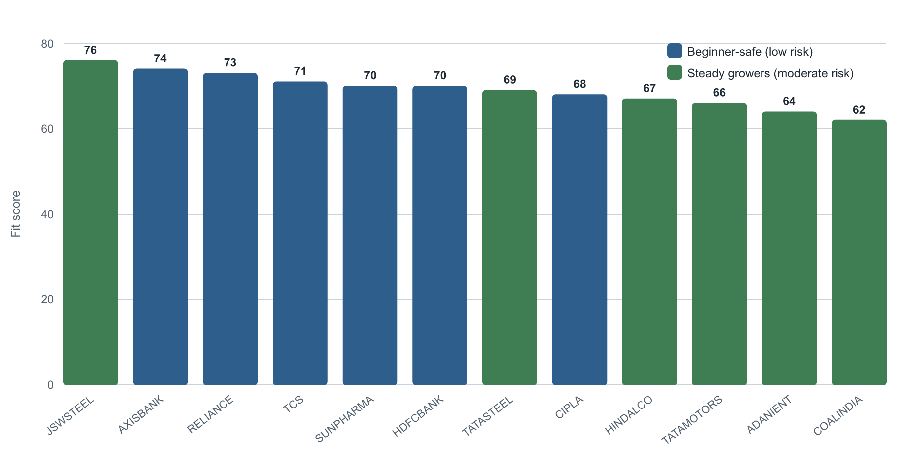
Figure 4.1 Distribution of fit scores across the sample universe
Two observations follow from the results. First, the fit scores cluster in a band roughly between sixty and seventy six, which is expected when the universe consists entirely of large, established companies that differ in degree rather than in kind. Second, the stocks separated cleanly into two populated tiers, namely Beginner-safe for the low risk band and Steady growers for the moderate risk band, with no stock in the sample carrying a high risk label. The highest risk tier therefore did not appear, which is the correct outcome for a universe of large capitalisation companies and a sensible result to present to a beginner.

4.4 Reality check results
The reality check computes the annual return a goal requires from the user's starting capital, monthly contribution, and time horizon, and classifies it against the thresholds in Table 4.4. The thresholds are set with reference to historical benchmarks, in particular the long run average return of broad Indian equity, which sits near twelve per cent, and the higher averages achieved only by strong and sustained portfolios.
Required annual return | Classification | Interpretation
Up to 8% | Comfortable | Safer instruments can suffice
8% to 13% | Realistic | In line with broad equity history
13% to 22% | Ambitious | Demanding, needs discipline
Above 22% | Unrealistic | Rarely sustained, high risk
Table 4.4 Feasibility thresholds applied by the reality check
Two contrasting goals illustrate the behaviour of the mechanism, summarised in Table 4.5. The first is a realistic goal of fifty lakh rupees in ten years, supported by three lakh of starting capital and a monthly contribution of twenty five thousand rupees. The system computed a required return near seven per cent, classified it as comfortable, and projected that a disciplined plan at the historical equity average would reach about sixty seven lakh rupees, comfortably ahead of the target. The second is a deliberately unrealistic goal of five crore rupees in two years, supported by one lakh of capital and five thousand rupees a month. The required return exceeded any plausible figure, the system capped the displayed value and classified it as unrealistic, and it then offered three corrective paths. When the time horizon and the monthly contribution were increased using the interactive controls, the required return fell into the realistic range and the classification changed accordingly.
Parameter | Realistic goal | Unrealistic goal
Target amount | Rs 50 lakh | Rs 5 crore
Time horizon | 10 years | 2 years
Starting capital | Rs 3 lakh | Rs 1 lakh
Monthly contribution | Rs 25,000 | Rs 5,000
Required annual return | about 7% | capped, above 300%
Classification | Comfortable | Unrealistic
Table 4.5 Worked reality check examples
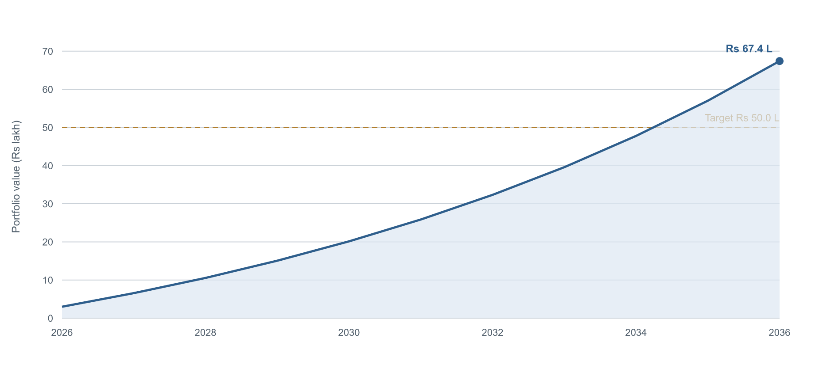
Figure 4.2 Realistic goal projection against the target
Figure 4.2 plots the projected value of the realistic plan year by year against the target. The curve rises above the target line well before the target year, which is the visual counterpart of the comfortable classification. The growth in the later years is markedly steeper than in the early years, which illustrates for the user the effect of compounding and reinforces the value of starting early and staying invested.

4.5 Allocation model
The wealth blueprint converts a profile into a suggested allocation across an index and large capitalisation core, a satellite of individual stocks, debt instruments, and a cash buffer. The equity proportion rises with the risk score, the core is weighted more heavily for beginners, and a cash buffer is always retained. Table 4.6 and Figure 4.3 show the allocations produced for the four archetypes.
Archetype | Core | Satellite | Debt | Cash
Capital Protector | 29% | 17% | 44% | 10%
Steady Builder | 37% | 23% | 30% | 10%
Balanced Grower | 43% | 27% | 20% | 10%
Growth Seeker | 52% | 32% | 6% | 10%
Table 4.6 Suggested allocation by investor archetype
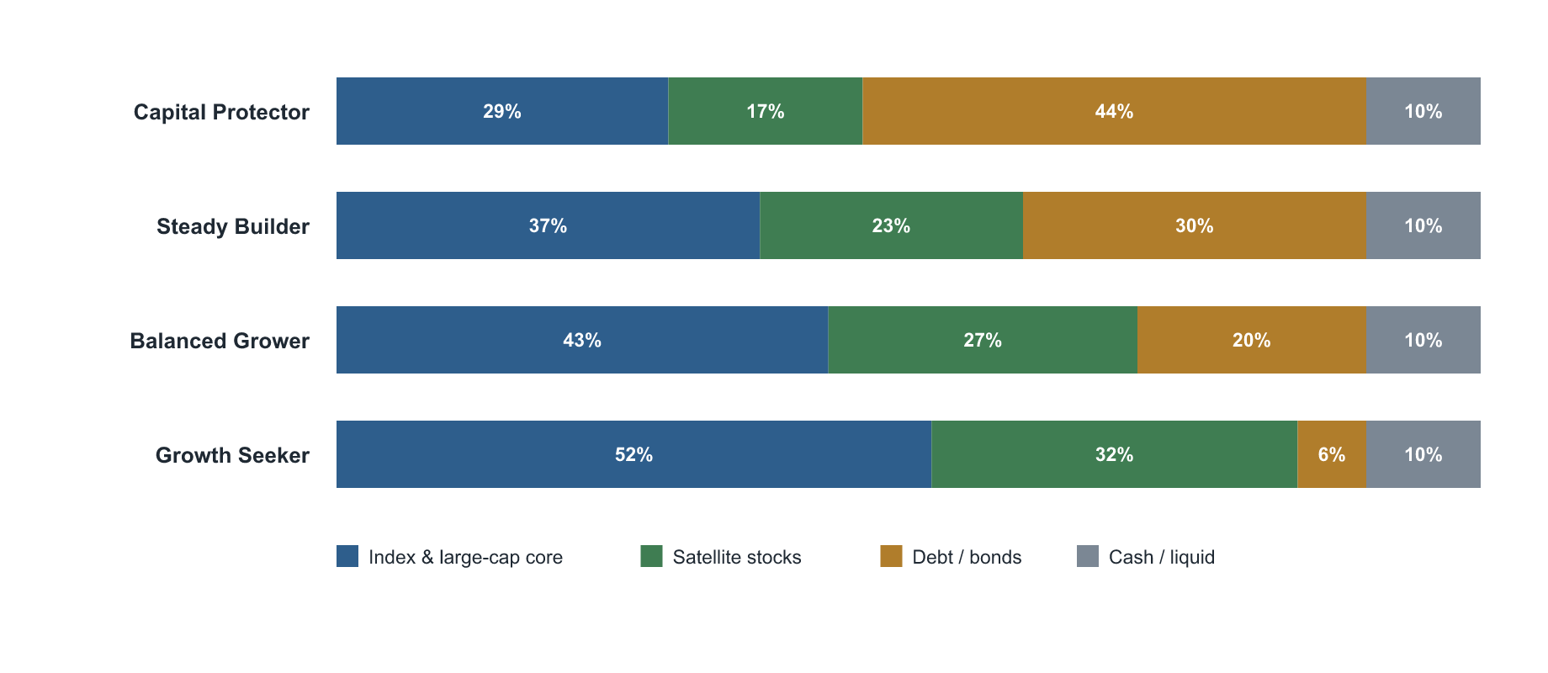
Figure 4.3 Suggested allocation by investor archetype
The progression across the four archetypes is orderly. The equity proportion, which is the sum of the core and the satellite, rises from forty six per cent for the Capital Protector to eighty four per cent for the Growth Seeker, while the debt proportion falls correspondingly. The cash buffer is held constant, which encodes the principle that an emergency reserve is necessary regardless of risk appetite. The core remains larger than the satellite in every archetype, which keeps individual stock selection as a complement to a diversified base rather than as the centre of the portfolio.

4.6 Functional verification
The complete user journey was exercised to confirm that the components behave together as intended. The onboarding sequence produced a consistent risk score and archetype from a given set of answers, and the protection that caps a beginner's risk band operated correctly when an inexperienced user described an aggressive attitude. The reality check produced the values reported above and updated them immediately when the interactive controls were moved. The recommendation engine populated the expected tiers, and the watchlist, the search, and the paper trading module performed their functions, with a simulated purchase correctly debiting virtual cash and recording the holding. The data retrieval design described in Chapter 3 achieved reliable coverage of the sample despite the limitations of the upstream service.

CHAPTER 5: FINDINGS AND CONCLUSION

5.1 Findings
The study produced several clear findings, which are highlighted below.
The onboarding sequence translated a beginner's background into a usable risk profile. A short set of structured questions about profession, finances, experience, goal, and attitude to risk was sufficient to compute a risk score and assign an investor archetype, and the derived equity ceiling moved sensibly with the inputs.
The reality check identified and corrected unrealistic expectations. For a goal of five crore rupees in two years on a small contribution, the required return exceeded three hundred per cent, which the system capped and classified as unrealistic, after which the interactive controls allowed the user to reach a realistic plan that required about eight per cent. The mechanism therefore both detected the problem and guided the user to a solution.
The recommendation engine separated the universe into appropriate risk tiers. Trusting the supplied volatility based risk label produced a clean split between a Beginner-safe tier and a Steady growers tier, with fit scores clustering between sixty and seventy six across the large capitalisation sample, and with the highest risk tier correctly absent.
Protection for inexperienced users functioned as designed. A user who had never invested was prevented from being placed in the highest risk category even after selecting an aggressive attitude, which is the intended safeguard against overconfidence.
The allocation model produced an orderly progression across archetypes. The equity proportion rose from forty six per cent to eighty four per cent across the four archetypes while the core remained larger than the satellite and a constant cash buffer was retained.
Resilient data retrieval overcame an unreliable upstream service. The quote service dropped roughly half the symbols in a large request, and a design based on small requests, limited concurrency, and retries restored reliable coverage of twenty nine of the thirty sampled stocks.

5.2 Conclusion
The project set out to determine whether a transparent, rule based system could prepare a first time investor for the equity market by translating their background and goals into a risk profile, a realistic expectation of returns, and a suitable shortlist of stocks, while remaining educational rather than advisory. The system that was built meets each of these aims. It records a beginner's circumstances, converts them into a quantified profile, anchors their expectations with arithmetic, and surfaces ideas that match their risk level, and it does so without instructing the user to transact and without executing any trade.
The value of the work lies as much in its restraint as in its capability. By keeping the engine fully transparent, by justifying every recommendation, and by correcting rather than rejecting an overoptimistic goal, the system respects both the regulatory boundary around advice and the psychology of a nervous beginner. The decision to retain a deterministic core, with any future language model confined to explanation, means that the system can be made more articulate without becoming less accountable. The watchlist and the paper trading module extend the educational purpose by letting a user observe and practise before committing real capital.
The project also demonstrates that a useful tool of this kind can be built on a modest technical footing, since the entire application runs in the browser and depends on a single external quote service and a public symbol directory. This lightness is an advantage for an educational product that must reach a wide audience, and it leaves a clear path for the heavier capabilities, namely accounts, synchronisation, and a richer data layer, to be added when they are warranted. The conclusion of the study is that the preparation gap faced by new investors can be addressed by software that educates and contextualises, and that doing so responsibly is both technically feasible and, given the regulatory context, the correct approach.

CHAPTER 6: RECOMMENDATIONS AND LIMITATIONS OF THE STUDY

6.1 Recommendations
The following recommendations describe how the system can be strengthened and extended in subsequent work.
- A natural language advisory layer should be connected so that the wealth blueprint, the recommendation rationales, and the reality check messages read in fluent, personalised prose. The layer should call a large language model from a server side component, with the deterministic engine continuing to decide every recommendation and to compute every figure, so that accuracy and accountability are preserved.
- An accounts and synchronisation layer should be introduced so that a user's profile, watchlist, and practice portfolio follow them across devices, replacing the present reliance on storage local to a single browser.
- The dependence on a single third party quote service should be reduced by building a dedicated data service that retrieves and stores prices on a schedule and precomputes a daily ranking table, which would remove the rate limits encountered during this study and make recommendations available instantly.
- Genuine multi year return data should be incorporated so that the performance component of the score reflects long term compound growth rather than the position within the fifty two week range, which is the present proxy.
- A formal compliance review against the relevant SEBI regulations should be obtained before any public release, and the educational disclaimers should be reviewed by a qualified professional.
- The recommendation universe should be expanded in stages beyond the present thirty large capitalisation stocks, with mid capitalisation companies introduced carefully and clearly labelled by risk.
- Portfolio level analytics should be added so that a user can see the concentration, sector exposure, and overall risk of their watchlist, rather than viewing each stock in isolation.
- A configurable alert feature should be provided so that a user can be notified of significant price movements or of progress towards a goal.
- A backtesting facility should be developed so that the historical behaviour of the scoring model can be examined and the factor weights refined with evidence.
- A usability study with real first time investors should be conducted to measure whether the system improves the realism of their expectations and the diversification of their choices.
- The interface should be made fully accessible and should be offered in major Indian languages so that the educational benefit reaches a wider population.
- The application should be packaged as an installable progressive web application so that it works smoothly on mobile devices and offline.
- Read only integration with broker accounts should be explored so that a user can analyse their actual holdings within the same educational frame, without the system ever gaining the ability to transact.

6.2 Limitations of the study
The study has the following limitations, which should be borne in mind when interpreting its results and which themselves motivate the recommendations above.
- The system depends on a single external quote service that is rate limited and whose internal source is not visible, which constrains both the reliability and the transparency of the underlying data.
- The performance component of the score uses the position within the fifty two week range as a proxy, because genuine multi year return data was not available to the project, so the momentum signal is approximate.
- The system is strictly educational and does not provide personalised investment advice, does not execute trades, and is not a substitute for a registered investment adviser or a stock broker.
- User information is stored only in the browser on the user's device, so it is not synchronised across devices and would be lost if the browser data were cleared.
- The recommendation universe is limited to thirty large capitalisation stocks of a single exchange, so the breadth of the recommendations is deliberately narrow.
- No primary data was collected from users and no usability study was conducted, so the study verifies that the system functions as designed but does not measure its effect on real investor behaviour.
- Market prices obtained through the quote service may be delayed and should not be treated as a real time trading feed.
- The advisory text and the accounts layer were designed but not implemented within the period of the study, so the present system reflects the deterministic engine and the rule based guidance rather than the full intended product.

BIBLIOGRAPHY

Research papers and books
Barber, B. M., & Odean, T. (2000). Trading is hazardous to your wealth: The common stock investment performance of individual investors. The Journal of Finance, 55(2), 773-806.
Bogle, J. C. (2007). The little book of common sense investing: The only way to guarantee your fair share of stock market returns. John Wiley & Sons.
D'Acunto, F., Prabhala, N., & Rossi, A. G. (2019). The promises and pitfalls of robo-advising. The Review of Financial Studies, 32(5), 1983-2020.
Fama, E. F. (1970). Efficient capital markets: A review of theory and empirical work. The Journal of Finance, 25(2), 383-417.
Graham, B. (2006). The intelligent investor (Rev. ed.). HarperBusiness.
Housel, M. (2020). The psychology of money: Timeless lessons on wealth, greed, and happiness. Harriman House.
Kahneman, D., & Tversky, A. (1979). Prospect theory: An analysis of decision under risk. Econometrica, 47(2), 263-291.
Lusardi, A., & Mitchell, O. S. (2014). The economic importance of financial literacy: Theory and evidence. Journal of Economic Literature, 52(1), 5-44.
Markowitz, H. (1952). Portfolio selection. The Journal of Finance, 7(1), 77-91.
Sharpe, W. F. (1964). Capital asset prices: A theory of market equilibrium under conditions of risk. The Journal of Finance, 19(3), 425-442.
Statman, M. (2019). Behavioral finance: The second generation. CFA Institute Research Foundation.

Regulations
Securities and Exchange Board of India. (2013). SEBI (Investment Advisers) Regulations, 2013. Securities and Exchange Board of India.
Securities and Exchange Board of India. (2014). SEBI (Research Analysts) Regulations, 2014. Securities and Exchange Board of India.

Websites
National Stock Exchange of India. (2026). Market data and listed company information. https://www.nseindia.com
Association of Mutual Funds in India. (2026). Investor education and historical returns. https://www.amfiindia.com
Securities and Exchange Board of India. (2026). Investor education resources. https://investor.sebi.gov.in
Reserve Bank of India. (2026). Household financial savings and statistics. https://www.rbi.org.in

