# Argocd

## What is ArgoCD?

ArgoCD (**Argo Continuous Delivery**) is a **declarative GitOps CD tool** for Kubernetes.

* It synchronizes Kubernetes clusters with your Git repository (GitOps model).
* Ensures the deployed applications match the Git manifests.
* Provides both **CLI** and **Web UI**.
* Supports Helm, Kustomize, Jsonnet, and plain YAML.

# Argo CD Sync Flow

# Argo CD Installation Guide

# 1. Create a Namespace for Argo CD

Run the following command:

kubectl create namespace argocd

## 2. Install Argo CD

Run the following command:

kubectl apply -n argocd -f <https://raw.githubusercontent.com/argoproj/argo-cd/stable/manifests/install.yaml>

This will create a new namespace, argocd, where Argo CD services and application resources will live.

## ## 3. Access the Argo CD API Server(optional)

By default, the Argo CD API server is not exposed externally. To access the API server, run:

kubectl port-forward svc/argocd-server -n argocd 8080:443

## ## 4. Get the Initial Admin Password(optional)

Retrieve the password with:

kubectl -n argocd get secret argocd-initial-admin-secret -o jsonpath="{.data.password}" | base64 -d && echo

**Download argocd cli**

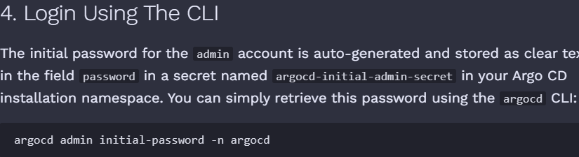





**Login to ArgoCD**

argocd login <ARGOCD_SERVER> --username admin --password <PASSWORD> --insecure

After logging in, click the **+ New App** button as shown below

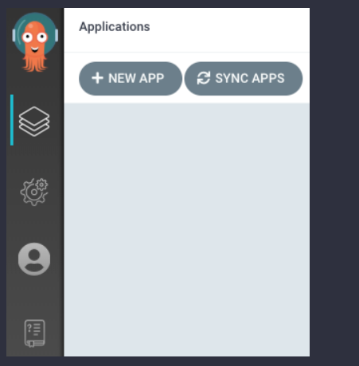

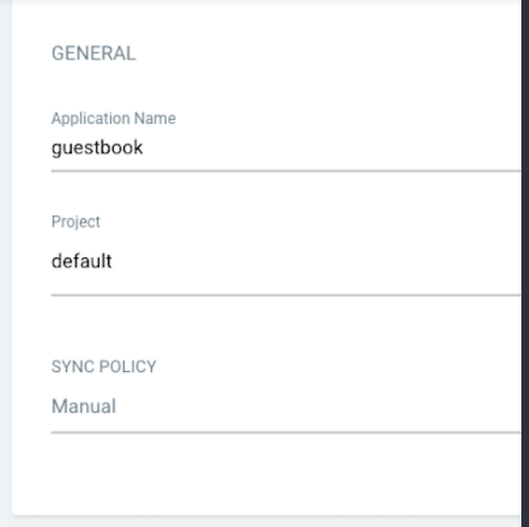

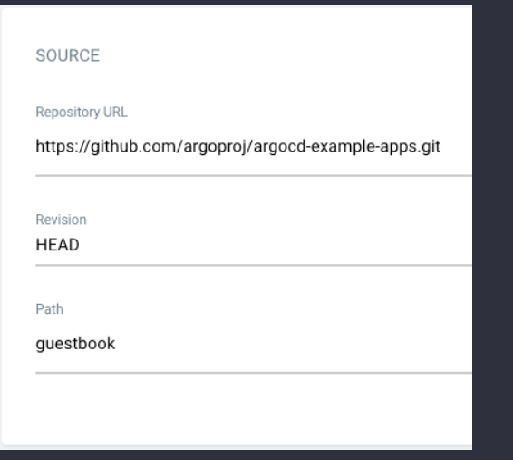

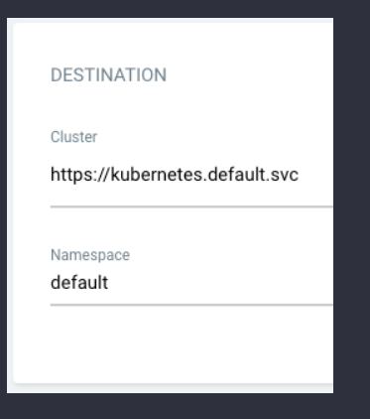

Once the guestbook application is created, you can now view its status:

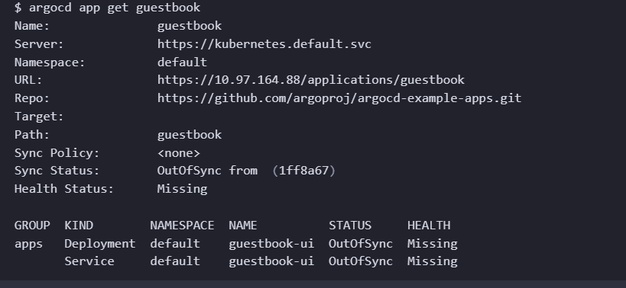

On the Applications page, click on Sync button of the guestbook application:

