Assignment Homework (Module 5)
Shivangi Vipulbhai Borad
University of North Texas
Large Data Visualization: ADTA5250.410(12960)
Fall 2025 8W2
Dr. LeAnn K. Boyce
Due date: November 2, 2025

- Bar Graph:
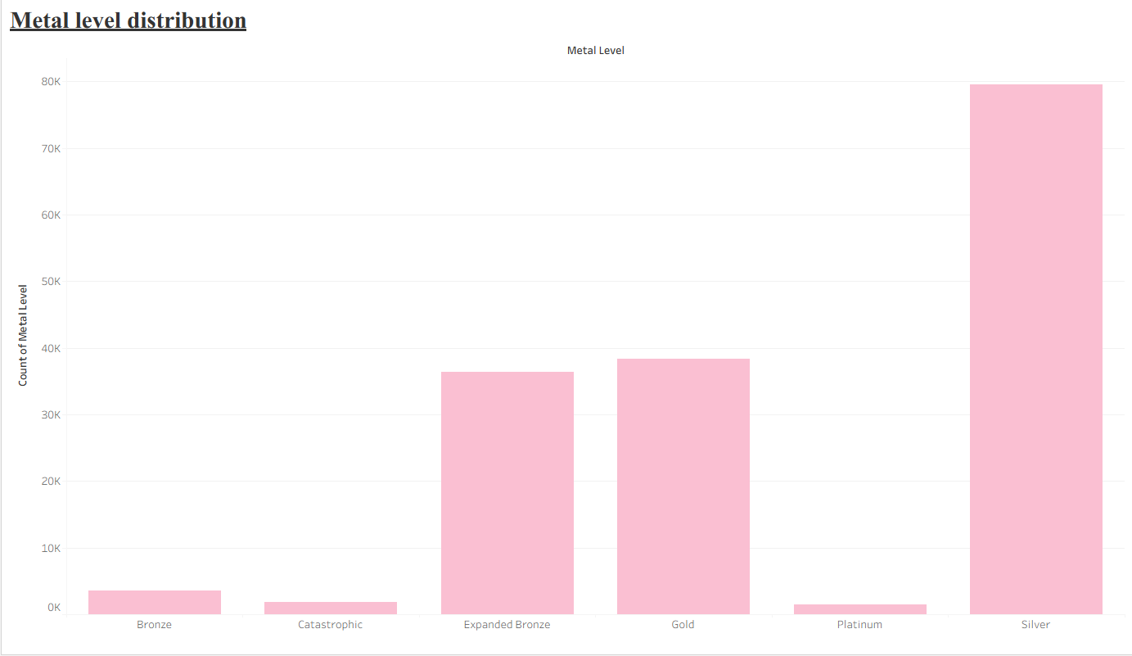
Reason of choosing this graph: I wanted to show a comparison of the metal level categories and for categorical variable bar chart is best to represent details in visual. (Boyce, 2025) Apart from this, I can start the comparison from zero values and also show the proper distribution, which makes it easier for the audience to understand. (Boyce, 2025)

Business insight:
- The major distribution shows in the silver area, followed by Gold and Expanded Bronze, which shows healthcare companies should focus more in this area for growth, as it will prove to be a profitable decision. (Plan Attributes PUF - PY2025, 2025)
- On the other hand, Bronze, Catastrophic, and Platinum show less people are considering these plans, so for that, companies have to think about it carefully if they can improve it in the future and come up with the best solution. (Plan Attributes PUF - PY2025, 2025)

- Line Graph:
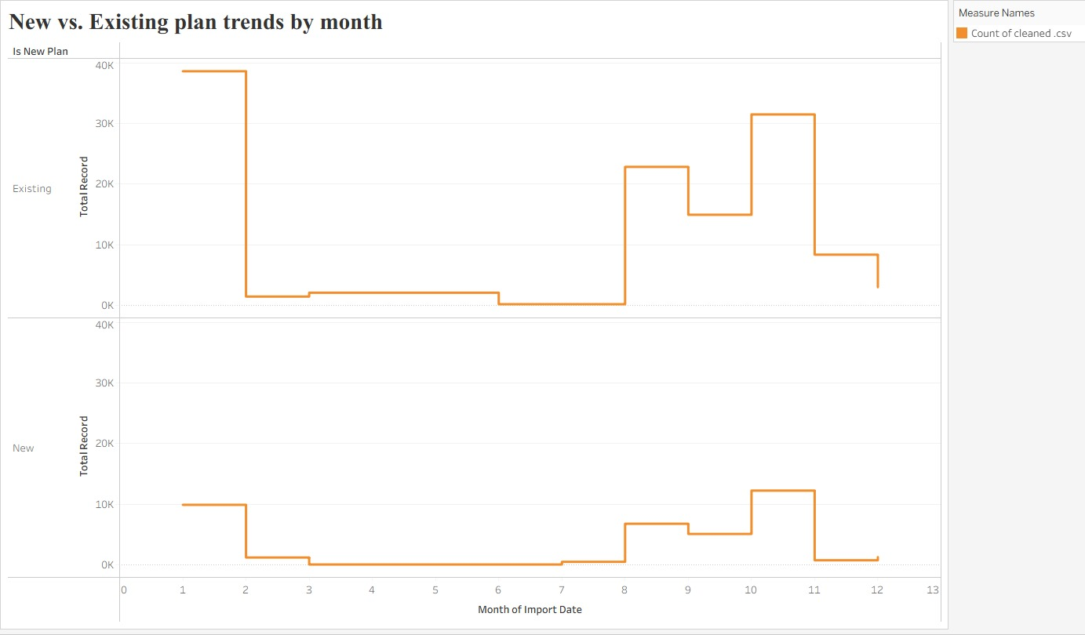
Reason of choosing this graph:
- I wanted to compare new and existing plan taken by consumer over time. To show the trend, a timeline graph is an essential visual graph, as it shows continuous progress within the time period. (Boyce, 2025) It helps to show sudden drastic changes within a particular period. That’s why I chose a line graph. (Boyce, 2025)

Business insight:
- The line graph shows that the busiest time for customer engagement is between January and August to November. During this time, the company should be ready with its IT and operation systems, as it is the busiest time for enrollment and there is a high chance of system errors. Doing this can improve customer satisfaction, which is good for the company. (Plan Attributes PUF - PY2025, 2025)
- On the other hand, the slow months between February and July give the idea that the company can work on new projects to attract customer attention.
- The chart also gives insights into new plans, as customer engagement is lower, which is a sign for the company to bring new changes to prevent loss. (Plan Attributes PUF - PY2025, 2025)

Reference:

Boyce, L. K. (2025, November). Charts for Comparing Categories. https://unt.instructure.com/courses/134787/pages/module-5-content-2?module_item_id=8654043
Boyce, L. K. (2025, November). Charts for Changes Over Time. https://unt.instructure.com/courses/134787/pages/module-5-content-2?module_item_id=8654043

Plan Attributes PUF - PY2025. (2025, August 12). data.healthcare.gov. https://data.healthcare.gov/dataset/ad5c073e-8451-4378-b3d8-4ba189f29cfe#data-table

