Assignment Homework (Module 6)
Shivangi Vipulbhai Borad
University of North Texas
Large Data Visualization: ADTA5250.410(12960)
Fall 2025 8W2
Dr. LeAnn K. Boyce
Due date: November 6, 2025

I used Ai in some area of this assignment, and I attached appendix of that at end. I used it for business insights and cultural value of colors.
Part 1: Which Gestalt Principle could you use?
For first graph, as the text and bar do not share any similarities, we can apply similarities where each comment and its relevant data points can share the same color and connected with arrows which will help the audience to understand and interpret. we can apply the Connection with Similarity principal here. (Boyce, 2025)
The Gestalt Principles mentioned below can be used to show graphs with text content with low cognitive load.
Proximity
This principle focuses on proximity of the elements. Naturally, people think that objects placed together (sharing the same proximity) are related to each other. (Boyce, 2025) As we can see in Graph A, the text labels describing insights about a particular Bar are placed in the same proximity which shows that they are related without drawing any arrows. It helps the audience to connect the textual and visual information naturally. But we can also see that when the two different portions of information are placed nearby, it can create confusion and put more cognitive load on the audience. This works well when the number of things is low and there is enough space between them to avoid cluttering.
Similarity
This principle shows that objects in the same group should share the same attribute. (Boyce, 2025) This attribute should be easily seen by the audience such as consistent colors, shapes or styles. Our brain automatically groups the objects that looks similar to each other. (Boyce, 2025) Graph C clearly implement this principle where the information and the bars relating to that information share the same color. These colors are clear enough for the audience to easily recognize and it is the same within a group. It helps to reduce the efforts to find patterns and avoid confusion that we were getting from proximity. But one thing that must be careful while choosing the similarities, having too many similar colors can again put more cognitive load on the audience for correct choices.
Enclosure + Similarity
This principle adds more clear visual grouping over Similarity by grouping the information visually. (Boyce, 2025) It suggests that objects in the same visual area are naturally seen as a Group. Graph D uses shaded background-colored rectangles to show the related annotations and Data points. The rectangles help to guide the audience whereas color helps to group the object. This way it gives stronger connection than proximity or similarity alone. This helps explain multiple subgroups within a visualization.
Connection + similarity
This principle uses clear connection (lines, arrows) to clearly relate the text to the datapoint based on similarity. (Boyce, 2025) This reduces cognitive stress because the audience may quickly understand which annotation connect to which data point by following the relationship. It does not require the audience to select data points after identifying their similarities. Graph B uses Arrows on top of the colors, which allow a person to easily follow the relationship from annotation to related data point and vice versa with low cognitive load and confusion.
Graph with the Least Cognitive Load- Graph B
While Graph D shows clear visuals and relevance by connecting the information with relative data points, it still depends on Audiences to decide which specific text matches to which data point. Also, for now it looks clearer to interpret because space is used effectively. But when more information comes up and the space is limited, it is clearly difficult to understand the information clearly. On the other side, in Graph B the direct connections clearly guide the audience to reach from annotation to data point and vice versa with low Cognitive load. When combined with uniform colors or styles, it reduces confusion and becomes the most effective approach for explanatory visuals where simplicity and accuracy are important.
Part 2: Color Selection:
- Red:
Red is a warmer color, which makes people feel passionate and energetic, and it can also sign of danger. It immediately catches attention of people in visualization. (Boyce, 2025) But more use of red in a chart can make it look overwhelmed. Red also shows emotions like love and passion, mainly on Valentine's Day, but it may also represent anger and danger. (Boyce, 2025) Because of these strong emotions, red may be more effective when applied correctly. Red has different cultural values in different countries, still it is very important to understand who audience is before using it in a visual.

- Green:
Green is mainly known as a cool color, but when it is combined with a yellow shade, it becomes slightly warmer. (Boyce, 2025) Green helps create a sense of peace and calmness in visualization. It represents development, health, and nature, and evokes feelings of stability and tranquility. (Boyce, 2025) Emotionally, green is a stress-relieving and relaxing color. In cultural beliefs, green is a sign of trustworthiness and also represents spirituality in some religion. (OpenAI, n.d.)
- Yellow:
Yellow is also a warm color. It represents sunshine, happiness, and positivity. Visualizations receive a bright and positive vibe because of this color. It also allows certain variables to pop and capture the audience’s attention. (Boyce, 2025) Warmer colors like yellow are used to highlight the most important information in data visualizations to show the center of attention. (Boyce, 2025) In culture, yellow is used in festivals to represent happiness, and people use it for decorating homes. In my culture, people wear yellow-colored clothes for worship of god too. (OpenAI, n.d.)
PART 3: Properties of Data
Variables | Data Type | Justification
Customer_ID | N (Nominal) | Order & ranking not matter.
Product_Category | N (Nominal) | Categories (count as label), order & rank doesn’t matter.
Satisfaction | O (Ordinal) | Categorial but logical order.
Education_Level | O (Ordinal) | Categorial but logical order.
Temperature_C | Q (Interval) | Numerical, same interval, no true zero
Date_of_Visit | Q (Interval) | Numerical, No true zero
Income | Q (Ratio) | Numerical, true zero, ratio possible.
Purchase_Amount | Q (Ratio) | Numerical, true zero, ratio possible.

Part 4: Create a New Chart in Tableau
- Map:
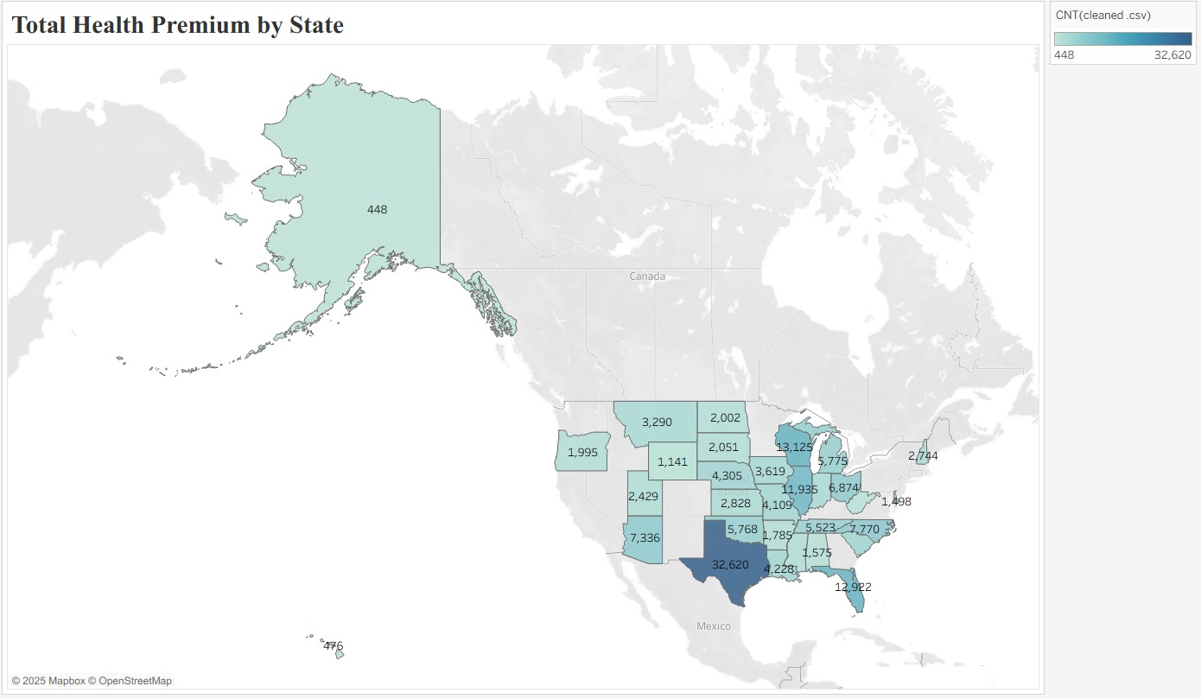
Reason of choosing this graph: For showing total heath premium in every state, I believe map is visually appealing to understand and also it shows notable difference and overall change in geographical area. With map we can easily compare performance of states. . (Boyce, 2025)
Business insight:
The map provides information about which states have higher health premiums and which states have lower premiums for example we can easily identify by slight glance in map that Texas(darker area) has highest insurance count with 32,620 and Alaska(light colour area) has lowest 448 insurance count, which gives business insights into competitors in those areas. (OpenAI, n.d.) In less competitive areas, there is a higher chance of business expansion, and they can attract more consumer attention. State-wise numbers give an idea for better strategic planning to launch new project, targeted marketing, business partnership. (Plan Attributes PUF - PY2025, 2025)

- Tree chart:
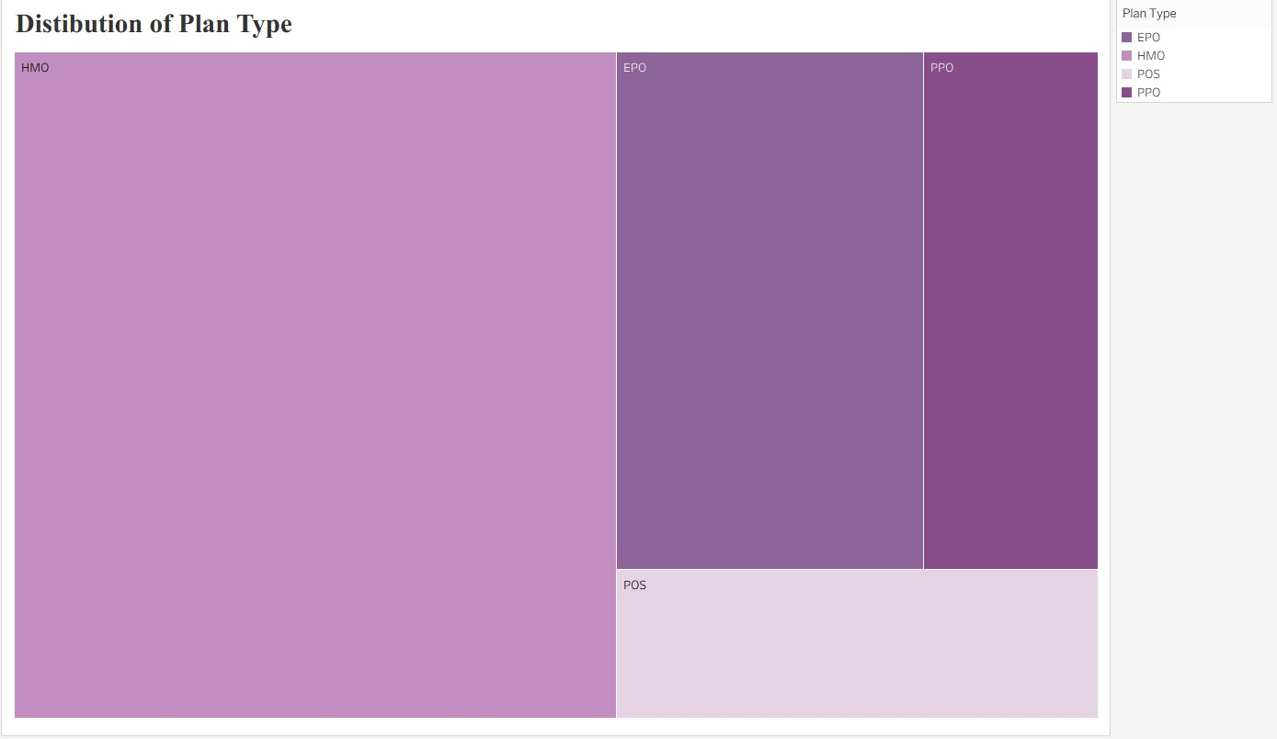
Reason of choosing this graph:
I chose a treemap because it shows all types of insurance plans in a divided form and also shows which are more popular. The audience can easily understand it at first sight. Rectangular divisions allow comparing all types together and also look promising. (Boyce, 2025)

Business insight:
We can get insights into the most popular plans chosen by customers. We may simply get to know about consumer preferences by examining the area of the tree map covered and comparing it to another area. For example, HMO covers about 50% of the area, showing that the majority of consumers choose HMO plans, while PPO is the least popular. (OpenAI, n.d.) (QuillBot Paraphrasing Tool, n.d.) Based on that, companies can implement offers on popular plans. They can divert focus from the least to the most popular plan. (Plan Attributes PUF - PY2025, 2025)

Reference:
Boyce, L. K. (2025, November). Gestalt Principles. https://unt.instructure.com/courses/134787/pages/module-6-content-2?module_item_id=8654047
Boyce, L. K. (2025, November). Color Theory. https://unt.instructure.com/courses/134787/pages/module-6-content-2?module_item_id=8654047
Boyce, L. K. (2025, November). Charts for Distribution and Geospatial Data. https://unt.instructure.com/courses/134787/pages/module-5-content-2?module_item_id=8654043
Boyce, L. K. (2025, November). Charts for Relationships and Parts-to-Whole. https://unt.instructure.com/courses/134787/pages/module-5-content-2?module_item_id=8654043
OpenAI. (n.d.). ChatGPT (GPT-5). Retrieved October 26, 2025, from https://chatgpt.com/
Plan Attributes PUF - PY2025. (2025, August 12). data.healthcare.gov. https://data.healthcare.gov/dataset/ad5c073e-8451-4378-b3d8-4ba189f29cfe#data-table
QuillBot Paraphrasing Tool. (n.d.). QuillBot. https://quillbot.com/paraphrasing-tool

Apendix:

My prompt: how green color is useful in culture??
Chat gpt answer:
Green is a color that carries rich cultural significance across the world. Its meanings can vary depending on region, religion, and context, but there are several common themes in which green is considered useful in culture:

1. Symbol of Nature and Life
- Green is universally associated with nature, growth, and fertility.
- In many cultures, green represents spring, renewal, and abundance.
- Example: In Japanese culture, green tea and greenery are linked to health and calmness.

2. Symbol of Health and Healing
- Green is often linked with healing, medicine, and well-being.
- Hospitals and pharmacies often use green in their logos or interiors because it’s calming and symbolizes recovery.

3. Spiritual and Religious Significance
- In Islam, green is considered a sacred color and symbolizes paradise and life.
- In Hinduism, green represents life, happiness, and harmony.
- In Christianity, green is used in liturgical contexts (like during Ordinary Time) to symbolize growth in faith.

4. Symbol of Prosperity and Luck
- In many cultures, green is associated with wealth, fertility, and prosperity.
- In Western culture, green often represents money, financial success, and luck (e.g., four-leaf clovers).

5. Psychological and Cultural Benefits
- Green is calming and refreshing to the human eye, reducing stress and creating balance.
- It is often used in cultural events, art, and design to symbolize peace, balance, and harmony.

6. Political and Social Symbolism
- Green is sometimes used in flags, movements, or organizations to represent environmentalism, renewal, or social growth.
- Example: Green parties worldwide advocate for ecological awareness.
In short, green is useful in culture because it communicates life, growth, peace, prosperity, and spirituality, making it a versatile and meaningful color across societies.
My prompt: how yellow color useful in culture?
Yellow has a variety of meanings and uses in different cultures. Here’s a concise breakdown:
1. Positive Associations:
- Happiness & Optimism: In many Western cultures, yellow represents joy, sunshine, and energy.
- Wisdom & Knowledge: In some Asian cultures, like China, yellow is linked to intelligence, learning, and scholarly pursuits.
- Royalty & Honor: Historically in China, yellow was the color of emperors, symbolizing power and prosperity.
2. Spiritual & Religious Significance:
- Hinduism & Buddhism: Yellow is sacred and often worn by monks or used in religious ceremonies. It symbolizes knowledge, learning, and peace.
- Egyptian Culture: Yellow was associated with the eternal and indestructible, often used in tombs and artifacts.
3. Warnings & Attention:
- Caution & Safety: In many cultures worldwide, yellow is used in signs and signals to attract attention or indicate caution.
4. Seasonal & Natural Connections:
- Spring & Harvest: Yellow often represents flowers like sunflowers or crops like wheat, symbolizing growth and abundance.
My prompt: this is my 2 visual that i made from my dataset, provide business insights which is useful for my audience healthcare insurance companies, include statistics as well that helpful for them for example in map we can clearly see that Texas state has higher level of insured people.
ChatGpt said:

Business Insights – Total Health Premium by State (Choropleth Map)
From the map, we can clearly observe major geographical differences in the number of insured individuals across the United States.
- Texas stands out with the highest insured count (≈ 32,620) — significantly higher than any other state.
This indicates Texas is a major high-volume market for health insurance carriers.
→ Business Value: Insurance companies can prioritize targeted marketing, competitive pricing, and plan diversification in Texas because the potential customer base is very large.
- States such as Florida (≈ 12,982), Ohio (≈ 11,935), North Carolina (≈ 10,376), and Arizona (≈ 7,336) also show strong insured customer volume.
→ Business Value: These states represent secondary high-potential premium revenue markets. These are ideal for launching new health plan variations (e.g., family plans, chronic disease management bundles).
- Lower-volume states like Alaska (≈ 448) and Hawaii (≈ 476) have significantly smaller insured populations.
→ Business Value: Instead of broad campaigns, companies may focus on niche product offerings or partnerships with local regional health systems.
Overall business implication of chart:
This geographic visualization helps in market segmentation and territory prioritization. Carriers can allocate sales reps, ad budgets, and provider network expansion more efficiently based on demand density.

Business Insights – Distribution of Plan Types (Treemap)
From the treemap, it is clear that plan selection varies significantly by type.
- HMO plans dominate the dataset → they occupy the largest visual proportion.
This suggests customers prefer structured networks with lower premiums.
- EPO and PPO plans have moderate proportion
This indicates a balanced demand for plans that offer some level of provider choice flexibility outside the strict HMO network.
- POS plans have the smallest share
→ customers are less likely to choose POS plans, possibly due to more complex structure or mid-tier costs.
Business Value:
This plan-type distribution helps insurance companies understand consumer preference behavior. Since HMO is the primary preference:
- They can invest in strengthening network provider contracts for HMO offerings.
- Marketing campaigns should highlight HMO price advantages and network benefits.
- For PPO/EPO segment, companies can introduce incentive offers (e.g., wellness credits) to increase adoption.

Final Business Summary
Finding | Business Action
Texas is the highest insured population | Focus more marketing, product launches, and sales operations in TX
FL, OH, NC, AZ are strong secondary markets | New product pilots (bundled preventive care) could work well
HMO most preferred plan type | Highlight low-cost HMO advantages, enhance HMO provider networks
POS least preferred | Investigate reasons for low interest – pricing vs complexity

QuillBoat:
My prompt:
We can easily identify consumer preference by just seeing area of tree map covered and compare it with another other area. For example, HMO covers almost 50% of area which shows most consumer preference is towards HMO plan while PPO is least chosen.
Quill boat:
We may simply detect consumer preferences by examining the area of the tree map covered and comparing it to another area. For example, HMO covers about 50% of the area, showing that the majority of consumers choose HMO plans, while PPO is the least popular.

