Assignment Homework (Module 10)
Shivangi Vipulbhai Borad
University of North Texas
Large Data Visualization: ADTA5250.410(12960)
Fall 2025 8W2
Dr. LeAnn K. Boyce
Due date: November 16, 2025

I used ai for getting basic idea of business insights but write as par my knowledge that shown in visualization.
Graph 1: Interactive Map

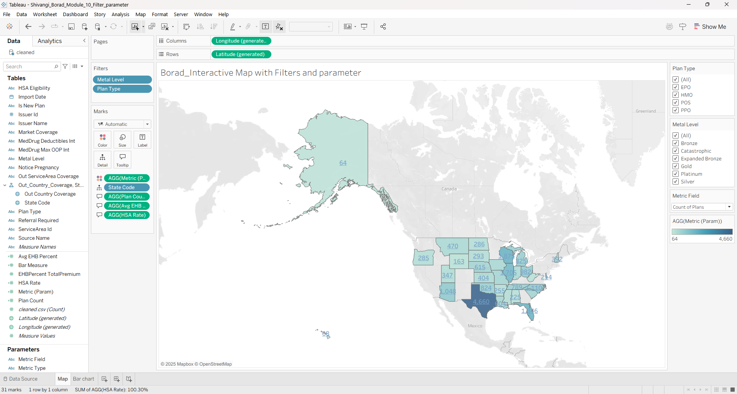
Justification:

I wanted to show the state level distribution of the healthcare plans. I also wanted to use filters to interact with the state level distribution for each Plan Type and Metal Level. I believe for this a geographic map more suitable option. It’s easy to understand and recognize state through location as well as comparison is also easy. Map with filters helps me to identify the distribution of the total enrollment patterns based on the plan type and metal level.

Business Insights:
- Southern states, mainly Texas show high concentration of plans overall. High population states also show major insurance enrollment (like Florida, New York etc). Texas shows the highest Plan count (4660). It’s shaded in the darkest that shows most of the plans are issued in the Texas State. This shows, southern states have a highly competitive insurance market. This helps the companies to focus on different plans and smart network strategies to stand out in the competitive market.

- Alaska and other midwest states show very low plan numbers. These states have 5 to 10 times lower insured people compared to the average. Alaska shows only 64 plans which are less than 2% of Texas. It shows there is a large distribution gap between the high volume and low volume states. These regions are beneficial for a new plan introduction like Bronze / Silver. This enables the companies to enter the market with less expensive and simple plans and new plans that will catch the eye of people who is not taking any insurance plan.

- Plan Type and Metal level filters shows regional differences in behaviors. Some states show higher insured counts with PPO Silver, while others are high under HMO bronze. Regional preferences can be seen under Plan type. Southern states prefer PPO while the Midwest is highly leaning toward HMO. Companies can make network design with popular plan structures in each area. These trends can also help to make the risk adjustment strategies based on the Plan type.

(Google Gemini, 2025)

2. Interactive stack bar graph.

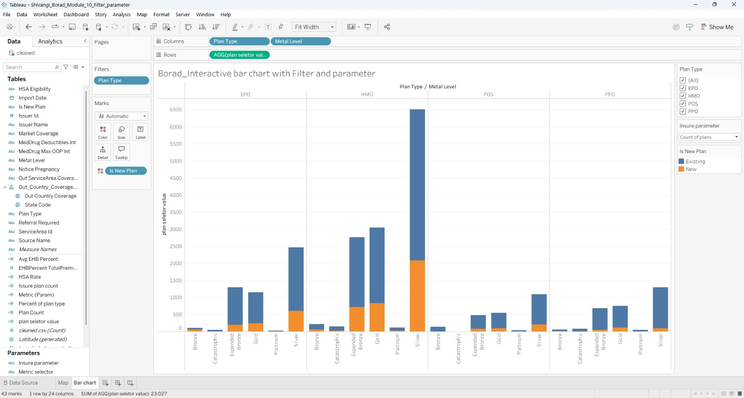
Justification: I wanted to compare all four plan type categories and also wanted to show existing and new plan for the same. As it contains 6 categorical values, I chose stacked bar chart. It allows me to compare all 6 categories for all different plan type. This gives best insights at first glace and reduce cognitive load as well.

Business insights:
- PPO Plans is better than all plan availability in Metal Levels. PPO plan type mainly Silver Metal type makes the highest bar group. It reaches over 6500 in total. PPO plans exceed HMO/POS/EPO by 2 to 4 times. This shows companies to prioritize PPO plans especially with silver metal type, and this combination will give more profit than any other type of plans.
- New Plans form very small amount of the total plan. Orange bars represent the new plans which make up to 10-15% of total plans. This makes existing plans dominating. With this, companies get idea that desired by people, so they can get idea to modify their current strategic planning.
- Higher Metal Levels (Silver/ Gold) are dominant plan in all metal types.
Across all the bar charts, silver plans consistently show the highest counts. This large gap between metal level is clearly shows that, Company is facing loss because of low demanding metal type, they can replace that with new type as it is not much profitable.

(Google Gemini, 2025)

Reference:
Google Gemini. (2025, November 16). Gemini. https://gemini.google.com/app

Appendix:
My prompt: give me business insights for this both graph and my audience is healthcare insurance companies.... also suggest how these insights help them to grow business.
Gemini answer:
Here is a breakdown of three distinct insights from each dashboard, tailored for a healthcare insurance company focused on business growth.

📈 Insights from the Bar Chart (Product & Competitive Landscape)
This chart shows the types of products being offered and where competitors are placing their new bets.
- Insight 1: The PPO/Gold segment is the market's "Center of Gravity."
  - Observation: The "PPO / Gold" bar is the largest in terms of both existing plans (blue) and new plan introductions (orange).
  - Business Value: This is the most crowded, most competitive, and most popular segment. To grow, you have two choices:
    - Compete Directly: Enter this segment with a highly differentiated offering. You cannot win with a "me-too" product. You must compete on price, network size, or supplemental benefits (e.g., dental, vision, wellness perks).
    - Avoid & Differentiate: Concede this "red ocean" to larger players and focus your resources on a less crowded, emerging niche, such as "EPO / Platinum" or "HMO / Silver," which show a healthier, more manageable mix of new and existing plans.
- Insight 2: "Catastrophic" and "Bronze" plans are stagnant, "dead-end" markets.
  - Observation: The "Catastrophic" plans have almost no market presence and zero new entries. Similarly, "Bronze" plans (especially PPO/Bronze) are very small and show almost no new development.
  - Business Value: Stop investing resources here. The market has signaled a clear lack of interest from both consumers and competitors. Any R&D, marketing, or administrative costs tied to these plans should be immediately re-allocated to more promising segments like Silver, Gold, or Platinum, where new product innovation is happening.
- Insight 3: HMOs and EPOs are the key levers for cost-controlled innovation.
  - Observation: While PPO/Gold is the largest, significant new plan (orange) activity is happening in HMO / Silver, HMO / Gold, and EPO / Silver.
  - Business Value: This signals a clear market trend. Competitors are using HMO (Health Maintenance Organization) and EPO (Exclusive Provider Organization) models—which offer more network control and lower premiums—to attract customers in the popular Silver and Gold metal tiers. This is a key strategy for attracting subsidy-eligible members on the ACA marketplace who are price-sensitive but still want strong coverage. Your product team should be actively analyzing this trend for new plan development.

🗺️ Insights from the Map (Geographic Strategy & Market Entry)
This map shows where the competition is, allowing you to build a precise go-to-market strategy.
- Insight 1: The "Big 4" states are high-risk, high-reward battlegrounds.
  - Observation: The market is heavily concentrated. California (1,048 plans), Texas (660), Florida (492), and New York (462) represent the most saturated markets by far.
  - Business Value: A growth strategy must be state-specific. Entering these "Big 4" states requires a massive investment in marketing, network-building, and product differentiation to even be noticed. A smaller or new carrier would be wise to avoid these states and focus on "second-tier" markets.
- Insight 2: "Second-Tier" states offer a more balanced growth opportunity.
  - Observation: There is a clear cluster of states with a "medium-high" number of plans (e.g., states with 150-400 plans, like those in the Midwest and Southeast).
  - Business Value: These states (like Illinois, Ohio, Pennsylvania, Georgia) are the ideal target for strategic expansion. They have a large enough population to be profitable, but they lack the hyper-saturation of California or Texas. A new, well-priced plan can make a significant impact here. This is where you should focus your "market-entry" or "market-share-theft" campaigns.
- Insight 3: The filters are your most powerful strategic tool for finding "white space."
  - Observation: The map currently shows the total count of all plans, which is overwhelming. The true power of this dashboard lies in the "Metal Level" and "Plan Type" filters on the left.
  - Business Value: Use the filters to move from general observation to actionable strategy.
    - Scenario: You want to launch a new EPO / Silver plan (based on Insight 3 from the bar chart).
    - Action: Apply those filters to the map. The map will instantly change, revealing which states are underserved for that specific product. You may find that a state like Texas, which looks saturated, actually has very few EPO/Silver plans, representing a "blue ocean" or "white space" opportunity within a large market. This turns the dashboard into a high-precision tool for market selection.
Would you like to drill down and see what insights we can find by filtering for a specific state or plan type?

