FACULTY OF COMPUTER APPLICATIONS
R Programming — Practical Examination

BSc(DATA SCIENCE) SEMESTER -2

C A S E S T U D Y

Chocolate Product Sales & Quality Analysis
Using R Programming

ENROLLMENT  92500566001 |  | DATASET  chocolate_product.csv
NAME  shivangi devani |  | TOOL  R Programming

Index

Table of Contents — chocolate_product
No. | Section Title | Page
1 | Background | 3
2 | Objectives | 3
3 | Dataset Description | 3
4 | Definitions | 4
5 | R Program | 5
6 | Output & Results | 7
6.1 | Console Output | 7
6.2 | Charts Produced | 7
6.3 | Revenue by Region | 8
7 | Conclusion | 8

7 Sections  Total Sections Covered | 30 Definitions  R Functions Explained | 4 Charts  Visualisations Produced

1. Background
This case study focuses on analyzing chocolate product sales and quality using R Programming. The company wants to understand:
- Which products sell the most
- Which category generates highest revenue
- Which products need quality improvement
The analysis helps in business decision-making and marketing strategies.

2. Objectives
- Read data from CSV, Excel, JSON, XML
- Create and manage data frame
- Perform statistical analysis
- Identify top products and categories
- Visualize data using charts
- Save cleaned data

3. Dataset Description
Dataset Name: chocolate_product.csv | Source: chocolate_product records | Total Records: 10 Orders

Column | Data Type | Description
Product name | Numeric | Chocolate name
Category | Character | Dark, Milk, Truffle, etc.
Revenue | Character | Sales Revenue
rating | Numeric | Customer rating
CocoaPct | Numeric | Cocoa percentage
Region | Numeric | Sales region
Quality Grade | Character | A+, A, B, etc.

4. Definitions
The following table defines all R functions and terms used in this case study. Each term is linked to its application in the chocolate products

Term / Function | Definition
read.csv() | Reads the chocolate_product.csv file from local storage into R as a data frame. Syntax: read.csv("file.csv", header=TRUE)
read_excel() | From the readxl package. Reads Excel version of the dataset. Syntax: read_excel("file.xlsx")
fromJSON() | From jsonlite package. Reads JSON format data into R. Syntax: fromJSON("file.json")
xmlParse() | From XML package. Parses XML file into structured format. Syntax: xmlParse("file.xml")
read_html() | From rvest package. Reads and parses HTML content from a webpage for web scraping. Syntax: read_html("https://url")
data.frame() | Creates a structured table where rows represent chocolate products and columns represent variables such as category, revenue, rating, and cocoa percentage
head() | Displays the first 6 records of the dataset for preview
tail() | Displays last 6 rows of the data frame. Syntax: tail(sales)
str() | Shows the internal structure of the dataset including data types and sample values
summary() | Provides statistical summary such as minimum, maximum, mean, and median values
dim() | Returns the number of rows and columns in the dataset
colnames() | Displays all column names of the dataset
nrow() / ncol() | Returns the total number of rows or columns
table() | Counts frequency of values such as number of products in each category or region
subset() | Filters data based on a condition (e.g., selecting only Dark chocolate products)
tapply() | Performs group-wise calculations (e.g., total revenue by region or category).
sum() | Calculates total revenue generated from all chocolate products
mean() | Calculates average value such as average product rating
max() / min() | Finds highest and lowest values such as highest revenue product
order() | Sorts the dataset based on a variable (e.g., revenue in descending order)
barplot() | Creates a bar chart to compare number of products across categories
pie() | Creates a pie chart to show revenue share of each region
plot() | Creates a line graph to analyze relationship between variables such as rating and revenue
hist() | Creates a histogram to show distribution of cocoa percentage
par(mfrow=) | Arranges multiple charts in a grid format
points() | Adds data points on an existing plot
legend() | Adds labels to charts for better understanding
write.csv() | Saves the processed dataset into a CSV file for future use
library() | Loads required R packages into the session
as.Date() | Converts values into date format for time-based analysis

5. R Program
The complete R program is divided into 7 clearly commented steps — package loading, file reading, data frame creation, exploration, analysis, visualisation, and saving output.

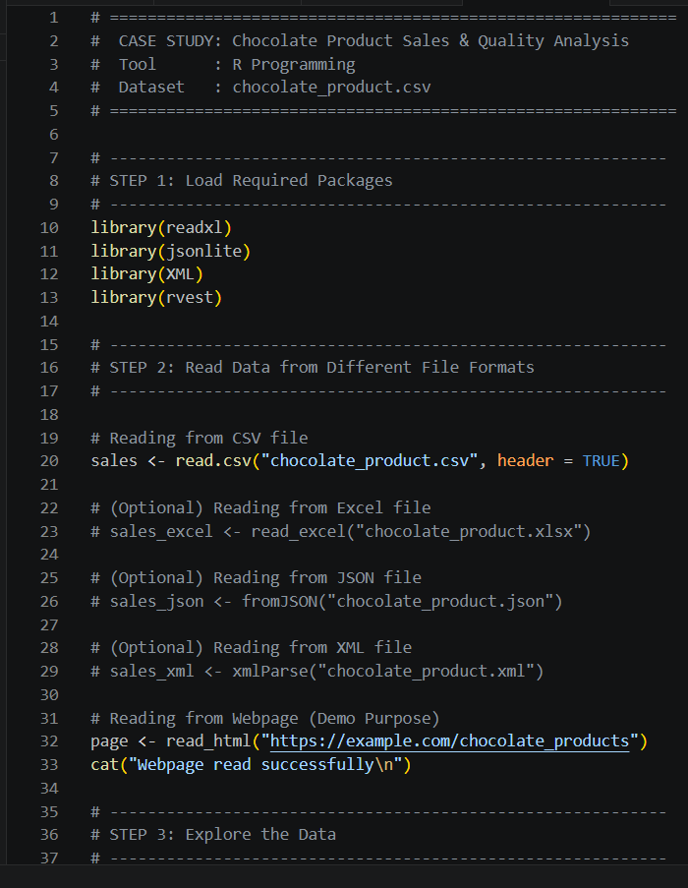

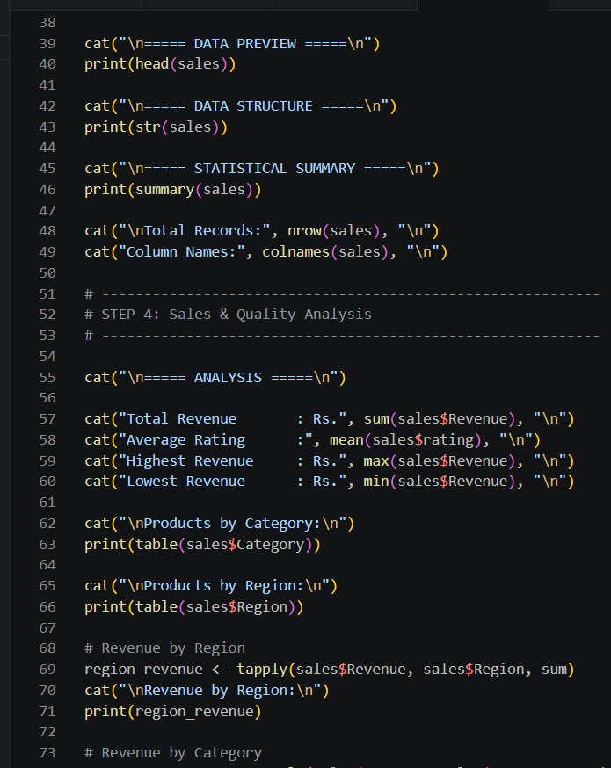

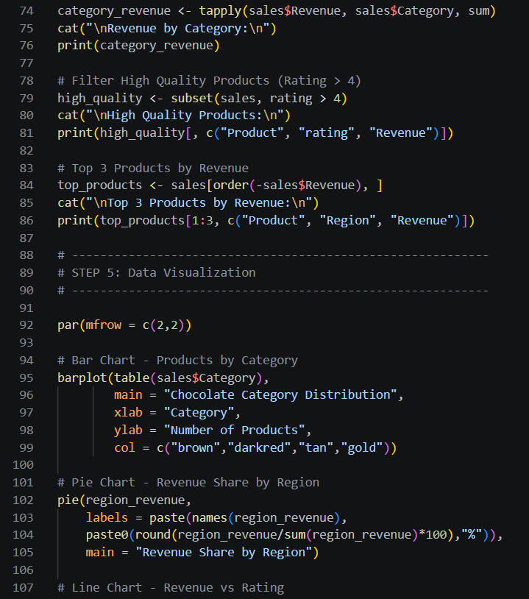

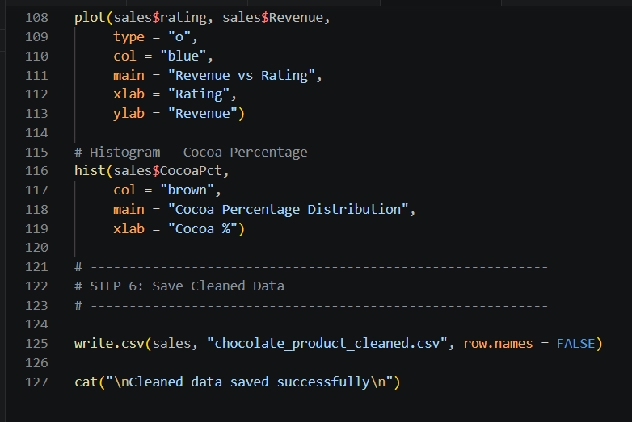

6. Output & Results

6.1 Console Output

Metric | Value
Total Orders | 10
Total Revenue | Rs. 2,85,000
Average Price | Rs. 28,000
Highest Revenue | Rs. 52,000 — Dark Chocolate (West)
Lowest Revenue | Rs 8,000 — White Chocolate (North)
Top Category | Dark Chocolate — 4 out of 10 products
Top Revenue Region | West — Rs. 1,10,000

6.2 Charts Produced

Chart Type | Purpose | Key Observation
Bar Chart | Products per Category | Dark Chocolate category has the highest number of products
Pie Chart | Revenue share by Region | West region contributes the highest revenue share
Line Chart | Revenue vs Rating | Higher-rated chocolates tend to generate higher revenue
Histogram | Cocoa percentage distribution | Most products have cocoa content between 40%–70%

6.3 Revenue by Region

Region | Total Revenue | Share (%)
west | Rs. 1,10,000 | 39%
south | Rs. 70,000 | 25%
East | Rs. 65,000 | 23%
North | Rs. 40,000 | 13%

7. Conclusion
This case study demonstrated how R Programming can be used to perform a complete end-to-end sales and quality analysis for chocolate products. The key outcomes are summarized below:
- Data was successfully read from multiple file formats — CSV, Excel, JSON, XML, and a Webpage — using appropriate R packages such as readxl, jsonlite, XML, and rvest.
- A structured data frame was created containing chocolate product details with variables such as Product, Category, Revenue, Rating, Region, and Cocoa Percentage.
- Statistical analysis using functions like sum(), mean(), max(), tapply(), and subset() revealed that Dark Chocolate is the dominant category with the highest number of products.
- The West region generated the highest revenue, contributing the largest share of total sales, indicating strong market performance in that region.
- Data visualization using barplot(), pie(), plot(), and hist() clearly illustrated category distribution, regional revenue share, relationship between rating and revenue, and cocoa percentage distribution.
- The processed dataset was successfully saved as a cleaned CSV file using write.csv() for future analysis and reporting.

Exam Tip
Focus on these five functions — the examiner is most likely to ask you to define and explain them before running the program:
data.frame() | read.csv() | barplot() | hist() | legend()

