JAVA LAB FILE

***Submitted to:- Submitted by:-***

***Ms.Deepa joshi Shivam Yadav***

***R100215064***

***500046649***

***CS-OSS(B2)***

Experiment-2

Q1) import java.util.Scanner;

public class ques1{

public static void main(String args[]){

Scanner input=new Scanner(System.in);

int a,b,c;

a=input.nextInt();

b=input.nextInt();

c=input.nextInt();

if(a>b && a>c){

System.out.println(" greatest no. is a:"+a);

}

if(b>a && b>c){

System.out.println(" greatest no is b:"+b);

}

if(c>a && c>b){

System.out.println(" greatestno is c:"+c);

}

}

}

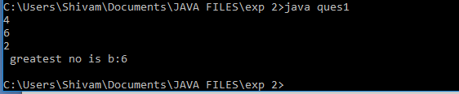

Q2)

public class ques2{

public static void main(String args[]){

int a,b,c;

System.out.println("enter value of a");

a=Integer.parseInt(args[0]);

System.out.println("enter value of b");

b=Integer.parseInt(args[1]);

c=a+b;

System.out.println("sum of a and b is"+(c));

}

}

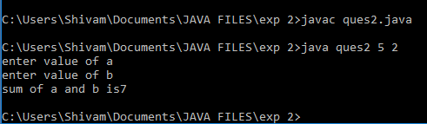

Q3)  
import java.util.Scanner;

public class ques3{

public static void main(String args[]){

Scanner input=new Scanner(System.in);

int a,first,second,next,i;

System.out.println("enter no. of fibnoci numbers");

a=input.nextInt();

first=0;

second=1;

for(i=0;i<a;i++){

if(i<=1)

next=i;

else{

next=first+second;

first=second;

second=next;

}

System.out.println(next);

}

}

}

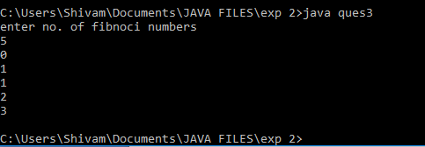

Q4) import java.util.Scanner;

public class ques4{

public static void main(String[] args) {

int a,b;

System.out.println("enter first number");

a=Integer.parseInt(args[0]);

System.out.println("enter second number");

b=Integer.parseInt(args[1]);

char ch;

System.out.print("\n1. Addition\n");

System.out.print("2. Subtraction\n");

System.out.print("3. Multiplication\n");

System.out.print("4. Division\n");

System.out.print("5. Exit\n\n");

System.out.print("Enter Your Choice : ");

ch = args[2].charAt(0);

switch(ch)

{

case '+' :

System.out.print("Result = " +(a+b)+"\n");

break;

case '-':

System.out.print("Result = " + (a-b)+"\n");

break;

case '*' :

System.out.print("Result = " + (a*b)+"\n");

break;

case '/' :

System.out.print("Result = " + (a/b)+"\n");

break;

case '5' : System.exit(0);

break;

default : System.out.print("Wrong Choice!!!");

break;

}

}

}

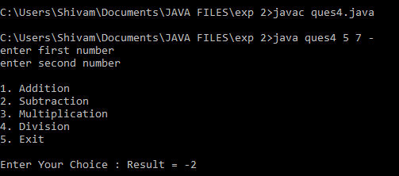

Q5) public class ques5{

int a=10;

static int d=2;

public static void main(String[] args){

System.out.println("differnce between instance and static variable");

ques5 obj=new ques5();

obj.m1();

obj.m2();

}

void m1()

{

System.out.println("instance variable is a" +a);

ques5 obj2=new ques5();

System.out.println(obj2.d);

}

static void m2(){

System.out.println(ques5.d);

ques5 obj3=new ques5();

System.out.println(obj3.a);

}

}

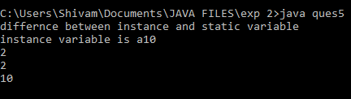

Q6) import java.util.Scanner;

public class ques6{

public static void main(String args[]){

Scanner input=new Scanner(System.in);

int arr[]=new int[10];

System.out.println("enter marks of student");

int i;

for( i=0;i<10;i++){

arr[i]=input.nextInt();

}

for(i=0;i<10;i++){

if(arr[i]>40 && arr[i]<50){

System.out.println(arr[i]+":PASS");

}

else if(arr[i]>51 && arr[i]<75){

System.out.println(arr[i]+":MERIT");

}

else if(arr[i]>75){

System.out.println(arr[i]+":DISTINCTION");

}

else{

System.out.println(arr[i]+":FAIL");

}

}

}

}

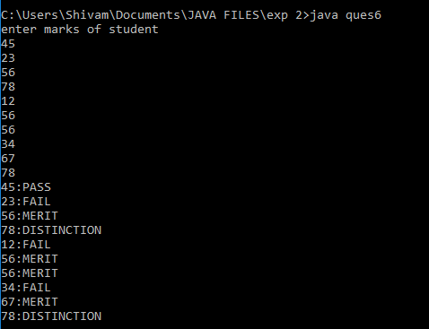

Q7) import java.util.Scanner;

public class ques7{

public static void main(String args[]){

Scanner input=new Scanner(System.in);

int a,b,c;

System.out.println("enter value of a");

a=input.nextInt();

System.out.println("enter value of b");

b=input.nextInt();

System.out.println("enter value of c");

c=input.nextInt();

System.out.println(""+a+""+b+""+c);

System.out.println(""+a+""+c+""+b);

System.out.println(""+b+""+a+""+c);

System.out.println(""+b+""+c+""+a);

System.out.println(""+c+""+a+""+b);

System.out.println(""+c+""+b+""+a);

}

}

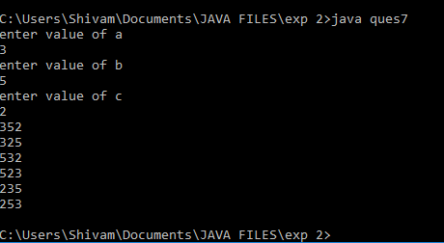

Q8) import java.util.Scanner;

public class ques8{

public static void main(String args[]){

Scanner input=new Scanner(System.in);

int arr[]=new int[10];

System.out.println("enter 10 numbers");

int i,sum=0;

for( i=0;i<10;i++){

arr[i]=input.nextInt();

}

for(i=0;i<10;i++){

sum=sum+(arr[i]*arr[i]);

}

System.out.println("sum of square of 10 numbers are:"+sum);

}

}

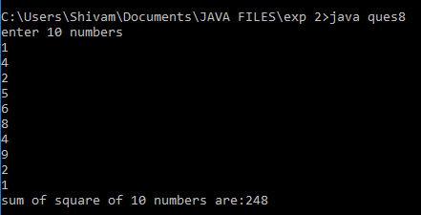

Q9)

import java.util.Scanner;

public class ques9{

public static void main(String args[]){

Scanner input=new Scanner(System.in);

System.out.println("enter no. of month");

int n;

n=input.nextInt();

if(n==1){

System.out.println(n+":january");

}

if(n==1){

System.out.println(n+":january");

}

if(n==1){

System.out.println(n+":january");

}

if(n==2){

System.out.println(n+":february");

}

if(n==3){

System.out.println(n+":march");

}

if(n==4){

System.out.println(n+":april");

}

if(n==5){

System.out.println(n+":may");

}

if(n==6){

System.out.println(n+":jaune");

}

if(n==7){

System.out.println(n+":july");

}

if(n==8){

System.out.println(n+":august");

}

if(n==9){

System.out.println(n+":september");

}

if(n==10){

System.out.println(n+":october");

}

if(n==11){

System.out.println(n+":november");

}

if(n==12){

System.out.println(n+":december");

}

}

}

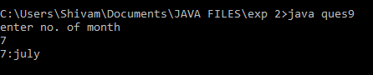

Q10) public class ques10{

public static void main(String args[]){

int i,count=0;

System.out.println("no. divisible by 5 are:");

for(i=40;i<=250;i++){

if(i%5==0){

System.out.println(""+i);

count++;

}

}

System.out.println("no. of numbers divisible by 5 are"+count);

}

}

