***Lab File***

***Java***

***Programming***

Shivangi Goel

500045745

Roll no:-65

CSE-OSS 2nd year

Experiment -2

Q1)Write a program to find greatest of three numbers.

import java.util.Scanner;

public class ques1{

public static void main(String args[]){

Scanner input=new Scanner(System.in);

int a,b,c;

a=input.nextInt();

b=input.nextInt();

c=input.nextInt();

if(a>b && a>c){

System.out.println(" greatest no. is a:"+a);

}

System.out.println(" greatest no is b:"+b);

}

if(c>a && c>b){

System.out.println(" greatestno is c:"+c);

}

}

}



Q2)Write a program to add two numbers using command line argument

import java.util.Scanner;

public class ques2{

public static void main(String args[]){

Scanner input=new Scanner(System.in);

int a,b;

a=(Integer.parseInt(args[0]));

System.out.println("enter value of a:"+a);

b=(Integer.parseInt(args[1]));

System.out.println("enter value of b:"+b);

System.out.println("sum of a and b is"+(a+b));

}

}

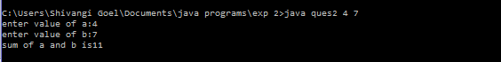

Q3)WAP to print fibonacci series using loop

import java.util.Scanner;

public class ques3{

public static void main(String args[]){

Scanner input=new Scanner(System.in);

int a,first,second,next,i;

System.out.println("enter no. of fibnoci numbers");

a=input.nextInt();

first=0;

second=1;

for(i=0;i<a;i++){

if(i<=1)

next=i;

else{

next=first+second;

first=second;

second=next;

}

System.out.println(next);

}

}

}

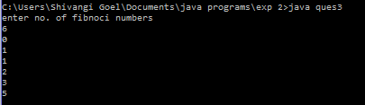

Q4) Write a program to that implement command line calculator.

public class ques4{

public static void main(String[] args){

int a,b;

a=(Integer.parseInt(args[0]));

b=(Integer.parseInt(args[1]));

System.out.println("enter first number"+a);

System.out.println("enter second number"+b);

char c=args[2].charAt(0);

if(c=='+'){

System.out.println("sum is:"+(a+b));

}

else if(c=='-'){

System.out.println("difference is:"+(a-b));

}

else if(c=='*'){

System.out.println("multiplication is:"+(a*b));

}

else if(c=='/'){

System.out.println("divison is:"+(a/b));

}

}

}

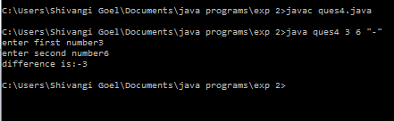

Q5)Write a program using classes and object in java.

public class ques5{

int a=10;

static int d=2;

public static void main(String[] args){

System.out.println("differnce between instance and static variable");

ques5 obj=new ques5();

obj.m1();

obj.m2();

}

void m1()

{

System.out.println("instance variable is a" +a);

ques5 obj2=new ques5();

System.out.println(obj2.d);

}

static void m2(){

System.out.println(ques5.d);

ques5 obj3=new ques5();

System.out.println(obj3.a);

}

}

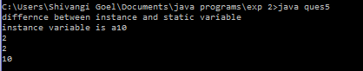

Q6) Write a program to accept 10 students marks in an array, arrange it into ascending 10 order, convert into the following grades and print marks and grades in the tabular form.

Between 40 and 50 : PASS

Between 51 and 75 : MERIT

and above : DISTINCTION

import java.util.Scanner;

public class ques6{

public static void main(String args[]){

Scanner input=new Scanner(System.in);

int arr[]=new int[10];

System.out.println("enter marks of student");

int i;

for( i=0;i<10;i++){

arr[i]=input.nextInt();

}

for(i=0;i<10;i++){

if(arr[i]>40 && arr[i]<50){

System.out.println(arr[i]+":PASS");

}

else if(arr[i]>51 && arr[i]<75){

System.out.println(arr[i]+":MERIT");

}

else if(arr[i]>75){

System.out.println(arr[i]+":DISTINCTION");

}

else{

System.out.println(arr[i]+":FAIL");

}

}

}

}

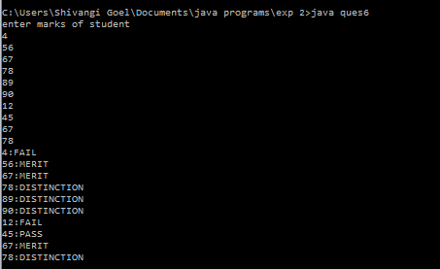

Q7) Write a program to accept three digits (i.e. 0 - 9) and print all its possible combinations. 10

import java.util.Scanner;

public class ques7{

public static void main(String args[]){

Scanner input=new Scanner(System.in);

int a,b,c;

System.out.println("enter value of a");

a=input.nextInt();

System.out.println("enter value of b");

b=input.nextInt();

System.out.println("enter value of c");

c=input.nextInt();

System.out.println(""+a+""+b+""+c);

System.out.println(""+a+""+c+""+b);

System.out.println(""+b+""+a+""+c);

System.out.println(""+b+""+c+""+a);

System.out.println(""+c+""+a+""+b);

System.out.println(""+c+""+b+""+a);

}

}

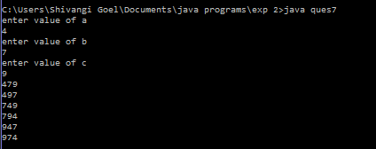

Q8) Write a Java Program to accept 10 numbers in an array and compute the sum of the 10 square of these numbers.

import java.util.Scanner;

public class ques8{

public static void main(String args[]){

Scanner input=new Scanner(System.in);

int arr[]=new int[10];

System.out.println("enter 10 numbers");

int i,sum=0;

for( i=0;i<10;i++){

arr[i]=input.nextInt();

}

for(i=0;i<10;i++){

sum=sum+(arr[i]*arr[i]);

}

System.out.println("sum of square of 10 numbers are:"+sum);

}

}

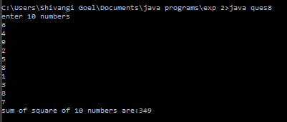

Q9) Write a program to input a number of a month (1 - 12) and print its equivalent name of 10

the month.( e.g 1 to Jan, 2 to Feb. 12 to Dec.)

import java.util.Scanner;

public class ques9{

public static void main(String args[]){

Scanner input=new Scanner(System.in);

System.out.println("enter no. of month");

int n;

n=input.nextInt();

if(n==1){

System.out.println(n+":january");

}

if(n==1){

System.out.println(n+":january");

}

if(n==1){

System.out.println(n+":january");

}

if(n==2){

System.out.println(n+":february");

}

if(n==3){

System.out.println(n+":march");

}

if(n==4){

System.out.println(n+":april");

}

if(n==5){

System.out.println(n+":may");

}

if(n==6){

System.out.println(n+":jaune");

}

if(n==7){

System.out.println(n+":july");

}

if(n==8){

System.out.println(n+":august");

}

if(n==9){

System.out.println(n+":september");

}

if(n==10){

System.out.println(n+":october");

}

if(n==11){

System.out.println(n+":november");

}

if(n==12){

System.out.println(n+":december");

}

}

}



Q10) Write a program to find the number of and sum of all integers greater than 40 and less than250 that are divisible by 5.

public class ques10{

public static void main(String args[]){

int i,count=0;

System.out.println("no. divisible by 5 are:");

for(i=40;i<=250;i++){

if(i%5==0){

System.out.println(""+i);

count++;

}

}

System.out.println("no. of numbers divisible by 5 are"+count);

}

}

