CAPSTONE PROJECT 1
Predicting Property Prices in a
Specific Location Using Machine Learning
Project Summary Report
Ames, Iowa residential sales · 1,460 properties · Target: Property Price (PropPrice)
Item | Detail
Course deliverable | Jupyter Notebook + Project Summary Report (Word)
Notebook matched | projectcapstone.ipynb (all graphs and printed outputs)
Dataset | Propertydata.csv — Ames Housing, renamed fields
Rows / columns | 1,460 sales × 81 attributes
Target variable | PropPrice / Property Price (sale price in USD)
Final selected model | Tuned Gradient Boosting
Final test performance | R² = 90.54% · MAE = $15,223 · RMSE = $26,931
Expected R² (brief) | 75–85% (above 85% is much better)
Constraint followed | Dropped PropertyID only; no other columns removed
Saved model file | tuned_gradient_boosting_model.pkl

This synopsis follows the required format: Introduction, Objectives, Flow Chart of operations, Python Codes, Screenshot of the Outputs, Report on EDA (with graphs), Learning Outcomes, Conclusion, and Citations. Every figure in this report is the actual plot generated when projectcapstone.ipynb was executed on Propertydata.csv. Tables quote the printed metrics from that same run.

Contents
1. Introduction to the Project
2. Objectives of the Project
3. Flow Chart of Operations
4. Python Codes
5. Screenshot of the Outputs
6. Report on EDA
7. Learning Outcomes
8. Conclusion
9. Citations — Books and Websites used for research

1. Introduction to the Project
The real estate market is highly dynamic and can be influenced by location, property size, amenities, neighborhood, finish quality, and related factors. Two homes on the same street can differ by six figures because of a finished basement, a recent remodel, or a higher overall quality rating. Predicting an accurate sale price is a crucial task for buyers who do not want to overpay, sellers who do not want to leave money on the table, and agents and lenders who need a defensible estimate. Machine learning has proven to be a useful tool for turning those mixed signals into a single price estimate.
This capstone develops an end-to-end machine learning model that predicts property prices in a specific location: Ames, Iowa. The working file is Propertydata.csv, a renamed version of the Ames Housing dataset originally compiled by Dean De Cock. Each row is one closed residential sale. The target column is PropPrice (renamed in the notebook to Property Price) — the property’s sale price in dollars.
The problem statement supplies 80 descriptive fields plus the target. A buyer does not see 80 columns. They see a neighborhood, a kitchen, a garage, and a feeling that one house is worth more than the one next door. This project translates that judgment into a reproducible pipeline: load and understand the data, clean it without throwing away useful amenity fields, explore what actually moves price, engineer appraisal-style features, encode ordinal and nominal fields separately, impute missing values, scale, apply PCA, compare several algorithms, tune the most stable model, and evaluate it with MAE, RMSE, and R².
The file mixes four kinds of information:
Kind of signal | Examples in this file | Why it matters
Size | GrLivArea, PropertySize, BsmntSqFtage | Larger homes usually sell for more
Quality | OverallQual, KitchenQual, ExterQual | Finish quality is a top price driver
Age / updates | YearBuilt, YearRemodAdd, SaleYr | Newer and remodeled homes earn a premium
Location | Neighborhood, Condition1 | Ames neighborhoods are not interchangeable
Amenities | Garage, fireplace, porch, pool | Parking and outdoor living add value

Constraint from the brief: do not drop columns other than Property ID. High-missing fields such as PoolQC and Alley are not junk — “no pool” is information. The expected R² score is between 75% and 85%; more than 85% is much better.

2. Objectives of the Project
The problem statement set eight objectives. Each one is answered in code in projectcapstone.ipynb and summarized here.
# | Objective from the brief | How it was met in the notebook
1 | Collect and clean real-estate data for a specific location | Loaded 1,460 Ames sales from Propertydata.csv; dropped only PropertyID; 0 duplicate rows
2 | Handle ordinal and nominal columns separately using metadata | 18 ordinal fields mapped to ranks; 26 nominal fields one-hot encoded
3 | Use fillna(), scaling, and PCA | None/0/median/mode fills; StandardScaler and MinMaxScaler; PCA kept 143 components (95.08% variance)
4 | Perform EDA to find variables that influence price | Quality (r=0.791), living area (r=0.709), neighborhood, age, garage, bathrooms
5 | Apply the correct encoding for ordinal vs nominal variables | Integer rank maps for quality ladders; one-hot (drop_first) for places and styles
6 | Develop a model that predicts PropPrice | Log1p models converted back to USD with expm1; 7 algorithms trained
7 | Evaluate and compare algorithms | Linear, Ridge, Lasso, Decision Tree, Random Forest, Gradient Boosting, Ridge+PCA
8 | Present findings clearly | This report plus the executed notebook, charts, and tuned_gradient_boosting_model.pkl

Success bar from the brief: R² between 75% and 85%; above 85% is much better. On the holdout test set, Linear Regression reached 91.46% R². After 5-fold cross-validation and hyperparameter tuning, Tuned Gradient Boosting was selected as the final model with test R² = 90.54%, MAE = $15,223, and RMSE = $26,931. Both results clear the expected band and the 85% “much better” line.

3. Flow Chart of Operations
The notebook’s operations follow the methodology in the problem statement: data collection, cleaning, EDA, feature engineering, model selection, training, testing, and evaluation. The flowchart below is the working sequence used in projectcapstone.ipynb, including the later refinement steps (cross-validation, tuning, overfitting control, and model save).
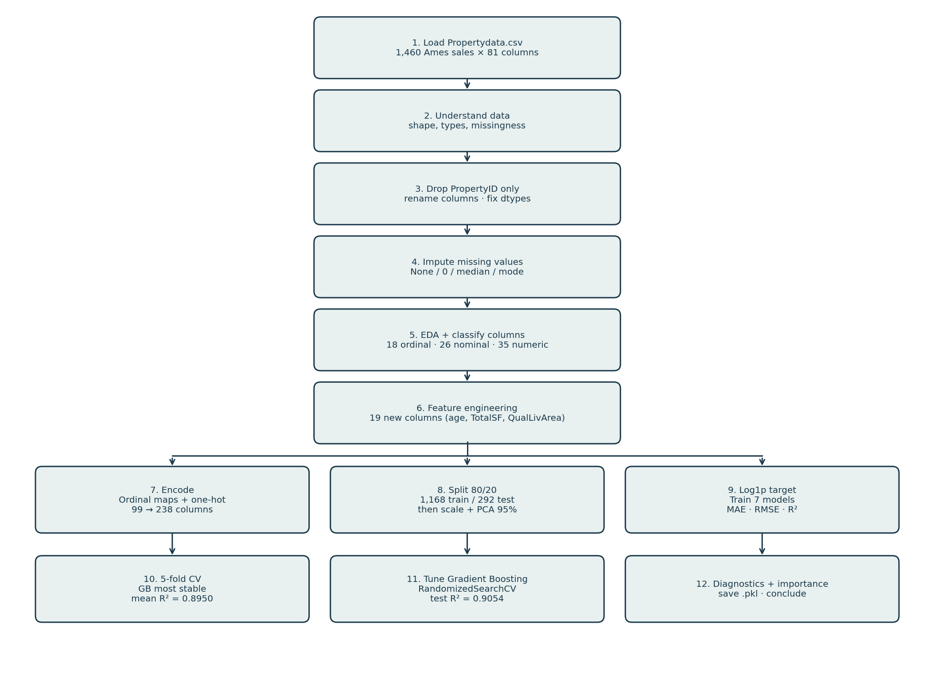
Figure 1. End-to-end flow of operations used in projectcapstone.ipynb.
Operation notes (matching the notebook)
Stage | What happens in the notebook | Key output
Load | pd.read_csv("Propertydata.csv") | 1,460 × 81
Understand | shape, columns, describe, dtypes, duplicates | 43 object · 35 int · 3 float · 0 duplicates
Clean | Drop PropertyID only; rename 70+ columns; cast types | 1,460 × 80
Impute | fillna "None" / 0 / Lot Frontage median / Electrical mode | 0 missing columns after fill
Classify | 18 ordinal · 26 nominal · 35 numeric | 80 / 80 columns assigned
EDA | Price, quality, size, neighborhood, age, amenities, heatmap | 16 executed plots in this report
Engineer | Age, TotalSF, baths, flags, QualLivArea, cyclic month | 19 new features; shape 1,460 × 99
Encode | Ordinal maps + pd.get_dummies(drop_first=True) | 1,460 × 238; 0 categorical left
Split / scale | 80/20, random_state=42; StandardScaler + MinMaxScaler | 1,168 train / 292 test × 237 features
PCA | Fit on standardized train; keep 95% variance | 143 components · 95.08% retained
Model | Train on log1p(Property Price); score in dollars | 7 models + tuned GB + regularized GB
Deploy | joblib.dump(tuned_gb_model, ...) | tuned_gradient_boosting_model.pkl

Leakage note from the notebook: scalers and PCA are fit on the training set only, then applied to the test set. Feature-engineering formulas are row-wise (age, totals, flags), so they do not use other houses’ statistics.

4. Python Codes
The complete executable code lives in projectcapstone.ipynb. This section reproduces the core blocks that implement each required technique, using the same variable names and logic as the notebook, so the report can be read on its own.

4.1 Environment setup and load (Steps 4–5)
import warnings
warnings.filterwarnings("ignore")
import numpy as np
import pandas as pd
import matplotlib.pyplot as plt
import seaborn as sns
from sklearn.model_selection import train_test_split, cross_val_score, KFold, RandomizedSearchCV
from sklearn.preprocessing import StandardScaler, MinMaxScaler, OneHotEncoder
from sklearn.decomposition import PCA
from sklearn.linear_model import LinearRegression, Ridge, Lasso
from sklearn.tree import DecisionTreeRegressor
from sklearn.ensemble import RandomForestRegressor, GradientBoostingRegressor
from sklearn.metrics import mean_absolute_error, mean_squared_error, r2_score
import joblib
df = pd.read_csv("Propertydata.csv")
df.head(15)
# Output: first 15 rows, including PropertyID, PropertyClass, PropPrice, ...

4.2 Understand the dataset and drop PropertyID only (Step 6)
df.shape # (1460, 81)
df.columns.tolist()
df.describe(include="all")
print(df.dtypes.value_counts()) # object 43, int64 35, float64 3
print("Number of duplicate rows:", df.duplicated().sum()) # 0
df.drop(columns=["PropertyID"], errors="ignore", inplace=True)
# Brief: do not drop columns other than Property ID
print("Shape:", df.shape) # (1460, 80)

4.3 Rename columns and fix data types
The notebook renames coded Ames fields to readable names (PropPrice → Property Price, GrLivArea → Above Ground Living Area, OverallQual → Overall Quality, and so on) so charts and tables match the problem-statement language.
df.rename(columns={
"PropertyClass": "Property Class",
"PropertyFrontage": "Lot Frontage",
"PropertySize": "Property Size",
"OverallQual": "Overall Quality",
"GrLivArea": "Above Ground Living Area",
"PropPrice": "Property Price",
# ... remaining mappings as in the notebook
}, inplace=True)
df["Property Class"] = df["Property Class"].astype("category")
df["Sale Year"] = df["Sale Year"].astype("int64")

4.4 fillna() — structural NA versus true missing
Nineteen columns had missing values. Pool Quality (99.52%), Additional Features (96.30%), Alley (93.77%), Boundary Features (80.75%), and Fireplace Quality (47.26%) are Ames-style NA codes meaning the amenity is absent. Lot Frontage (17.74%) and Electrical System (1 row) are true missing values.
categorical_missing_columns = [
"Pool Quality", "Additional Features", "Alley", "Boundary Features",
"ExteriorCladdingType", "Fireplace Quality", "Basement Visibility",
"Basement Finish", "Basement Maintenance", "Basement Finish Rating 1",
"Basement Finish Quality 1", "Basement Type", "Basement Quality",
"Basement Condition", "Basement Finish Rating",
]
for col in categorical_missing_columns:
df[col] = df[col].fillna("None")
for col in ["ExteriorCladdingArea", "Basement Year Built"]:
df[col] = df[col].fillna(0)
df["Lot Frontage"] = df["Lot Frontage"].fillna(df["Lot Frontage"].median())
df["Electrical System"] = df["Electrical System"].fillna(df["Electrical System"].mode()[0])
# Result printed by the notebook: 0 columns have missing values.

4.5 Separate ordinal and nominal columns (Step 7)
The brief asks: how can ordinal and nominal columns be handled separately using the metadata? Ordinal fields have a real rank (Excellent > Good > Typical). Nominal fields are labels with no honest numeric order (neighborhood names, roof style).
ORDINAL_COLS = [
"Property[Lot] Shape", "Land Slope", "Exterior Quality", "Exterior Condition",
"Basement Finish Rating", "Basement Maintenance", "Basement Visibility",
"Basement Finish Rating 1", "Basement Finish Quality 1",
"Heating Quality and Condition", "Kitchen Quality", "Functional",
"Fireplace Quality", "Basement Finish", "Basement Quality",
"Basement Condition", "Paved Driveway", "Pool Quality",
] # 18 columns
NOMINAL_COLS = [
"Property Class", "Property Zone", "Street", "Alley",
"Land Contour[Elevation]", "Amenities", "Lot Configuration",
"Neighborhood", "Condition 1", "Condition 2", "Building Type",
"Property[House] Style", "Roof Style", "Roof Material",
"Roof Material 1", "Roof Material 2", "ExteriorCladdingType",
"Property Footing [Foundation] Type", "Heating Type", "Basement Type",
"Boundary Features", "Additional Features", "Sale Type", "Sale Condition",
"Electrical System", "Central Air Conditioning",
] # 26 columns
NUMERIC_COLS = [c for c in df.columns
if c not in ORDINAL_COLS + NOMINAL_COLS + ["Property Price"]]
# Printed: Ordinal 18 · Nominal 26 · Numeric 35 · Accounted for 80 / 80

4.6 Feature engineering (Step 9)
Nineteen row-wise features were created before encoding. They do not use other houses’ statistics, so they do not leak test information.
out["HouseAge"] = (out["Sale Year"] - out["Year Built"]).clip(lower=0)
out["RemodAge"] = (out["Sale Year"] - out["Year Remodeled/Addition"]).clip(lower=0)
out["IsRemodeled"] = (out["Year Remodeled/Addition"] > out["Year Built"]).astype(int)
out["TotalSF"] = (out["Basement Square Footage"]
+ out["First Floor Square Footage"]
+ out["Second Floor Square Footage"])
out["TotalPorchSF"] = (out["Wood Deck Square Footage"] + out["Open Porch Square Footage"]
+ out["Enclosed Porch"] + out["Three Season Porch"] + out["Screen Porch"])
out["TotalBathrooms"] = (out["Bathroom 1"] + 0.5 * out["Bathroom 2"]
+ out["Basement Full Bathrooms"] + 0.5 * out["Basement Half Bathrooms"])
out["QualLivArea"] = out["Overall Quality"] * out["Above Ground Living Area"]
out["QualCond"] = out["Overall Quality"] * out["Overall Condition"]
out["GarageScore"] = out["Basement Cars"] * out["Basement Area"]
out["HasGarage"] = (out["Basement Cars"] > 0).astype(int)
out["HasFireplace"] = (out["Number of Fireplaces"] > 0).astype(int)
out["HasPool"] = (out["Pool Area"] > 0).astype(int)
# plus HasBasement, Has2ndFloor, HasPorch, HasMasonry, LivingAreaPerRoom, SaleMonSin/Cos
# Printed: Created 19 engineered features; dataframe shape (1460, 99)

4.7 Proper encoding for ordinal and nominal fields (Step 10)
quality_order = {"Po": 1, "Fa": 2, "TA": 3, "Gd": 4, "Ex": 5}
df_encoded = df.copy()
for col in ordinal_cols:
if set(df[col].dropna().astype(str).unique()).issubset(set(quality_order.keys())):
df_encoded[col] = df[col].map(quality_order).fillna(0).astype(int)
else:
df_encoded[col] = df[col].astype("category").cat.codes
df_encoded = pd.get_dummies(
df_encoded, columns=nominal_cols, drop_first=True, dtype=int
)
# Printed: Original (1460, 99) → Encoded (1460, 238) · remaining categorical columns: 0

4.8 Train/test split, scaling, and PCA (Steps 11–12)
X = df_encoded.drop(columns=["Property Price"])
y = df_encoded["Property Price"]
X_train, X_test, y_train, y_test = train_test_split(
X, y, test_size=0.20, random_state=42
)
# Printed: X_train (1168, 237) · X_test (292, 237)
standard_scaler = StandardScaler()
X_train_standard = standard_scaler.fit_transform(X_train)
X_test_standard = standard_scaler.transform(X_test)
minmax_scaler = MinMaxScaler()
X_train_minmax = minmax_scaler.fit_transform(X_train)
X_test_minmax = minmax_scaler.transform(X_test)
pca_full = PCA().fit(X_train_standard)
n95 = int(np.searchsorted(np.cumsum(pca_full.explained_variance_ratio_), 0.95) + 1)
pca_95 = PCA(n_components=n95)
X_train_pca = pca_95.fit_transform(X_train_standard)
X_test_pca = pca_95.transform(X_test_standard)
# Printed: 237 encoded features → 143 components for 95% · 177 for 99%
# first 10 PCs = 27.24% · retained variance = 0.9508

4.9 Log transform, train models, and score in dollars (Steps 13–15)
y_train_log = np.log1p(y_train) # stabilize right-skewed price
y_test_log = np.log1p(y_test)
# Printed: original y_train 34,900 to 745,000 · log range 10.4603 to 13.5211
linear_model = LinearRegression().fit(X_train_standard, y_train_log)
ridge_model = Ridge(alpha=1.0).fit(X_train_standard, y_train_log)
lasso_model = Lasso(alpha=0.001, max_iter=10000).fit(X_train_standard, y_train_log)
dt_model = DecisionTreeRegressor(max_depth=10, random_state=42).fit(X_train, y_train_log)
rf_model = RandomForestRegressor(n_estimators=200, max_depth=12,
random_state=42, n_jobs=-1).fit(X_train, y_train_log)
gb_model = GradientBoostingRegressor(n_estimators=200, learning_rate=0.05,
max_depth=3, random_state=42).fit(X_train, y_train_log)
ridge_pca_model = Ridge(alpha=1.0).fit(X_train_pca, y_train_log)
pred_usd = np.expm1(model.predict(X_features))
mae = mean_absolute_error(y_test, pred_usd)
rmse = np.sqrt(mean_squared_error(y_test, pred_usd))
r2 = r2_score(y_test, pred_usd)

4.10 Cross-validation and hyperparameter tuning (Steps 17–18)
cv = KFold(n_splits=5, shuffle=True, random_state=42)
scores = cross_val_score(model, X_data, y_train_log, scoring="r2", cv=cv, n_jobs=-1)
param_dist = {
"n_estimators": [100, 150, 200, 250, 300, 400],
"learning_rate": [0.01, 0.03, 0.05, 0.08, 0.1],
"max_depth": [2, 3, 4, 5],
"min_samples_split": [2, 5, 10, 15],
"min_samples_leaf": [1, 2, 4, 6],
"subsample": [0.7, 0.8, 0.9, 1.0],
}
random_search = RandomizedSearchCV(
GradientBoostingRegressor(random_state=42),
param_distributions=param_dist, n_iter=40, scoring="r2",
cv=5, random_state=42, n_jobs=-1,
)
random_search.fit(X_train, y_train_log)
tuned_gb_model = random_search.best_estimator_
# Printed best params: subsample=0.9, n_estimators=300, min_samples_split=5,
# min_samples_leaf=4, max_depth=3, learning_rate=0.08
# Best CV R² = 0.8997 · Test MAE $15,223 · RMSE $26,931 · R² 0.9054

4.11 Save the final model (Step 25)
import joblib
joblib.dump(tuned_gb_model, "tuned_gradient_boosting_model.pkl")
# Output: ['tuned_gradient_boosting_model.pkl']

5. Screenshot of the Outputs
The figures below are the actual plots generated when projectcapstone.ipynb was executed on Propertydata.csv. Tables quote the printed metrics from the same run.

5.1 Dataset shape, types, and target
Output printed by the notebook | Value
Rows × columns (raw file) | 1,460 × 81
After dropping PropertyID | 1,460 × 80
Column types | object 43 · int64 35 · float64 3
Duplicate rows (before and after drop) | 0
Property Price mean / median | $180,921 / $163,000
Property Price std | $79,443
Property Price min / Q1 / Q3 / max | $34,900 / $129,975 / $214,000 / $755,000
Property Price skew | 1.883
Median / Mean printed together | 163,000 / 180,921
Above Ground Living Area mean / max | 1,515 sq ft / 5,642 sq ft
Overall Quality mean | 6.10 (scale 1–10)
Year Built range | 1872 – 2010

5.2 Missing-value treatment output
19 columns had missing values. After fillna() the notebook printed:
Column | Missing count | Missing % | Treatment
Pool Quality | 1,453 | 99.52 | fillna("None")
Additional Features | 1,406 | 96.30 | fillna("None")
Alley | 1,369 | 93.77 | fillna("None")
Boundary Features | 1,179 | 80.75 | fillna("None")
ExteriorCladdingType | 872 | 59.73 | fillna("None")
Fireplace Quality | 690 | 47.26 | fillna("None")
Lot Frontage | 259 | 17.74 | median fill
Garage / Basement Type block | 81 | 5.55 | fillna("None") or 0
Basement quality block | 37–38 | 2.53–2.60 | fillna("None")
ExteriorCladdingArea | 8 | 0.55 | fillna(0)
Electrical System | 1 | 0.07 | mode fill
After treatment | 0 | 0.00 | 0 columns have missing values

5.3 Encoding, split, scaling, and PCA output
Check | Printed result
Column classification | Ordinal 18 · Nominal 26 · Numeric 35 · 80 / 80 assigned
Engineered features created | 19 · shape became 1,460 × 99
QualLivArea correlation with price | 0.832 (strongest engineered feature)
TotalSF / HouseAge correlations | 0.782 / −0.523
Encoded matrix | Original (1460, 99) → Encoded (1460, 238)
Remaining categorical columns | 0
Train / test split | 1,168 homes / 292 homes (80/20, random_state=42)
Feature matrix after drop target | 237 columns
PCA components for 95% / 99% | 143 / 177
Variance in first 10 PCs | 27.24%
PCA shapes | Train (1168, 143) · Test (292, 143)
Retained variance | 0.9508 (95.08%)
Log y_train range | 10.4603 to 13.5211 (USD 34,900 to 745,000)

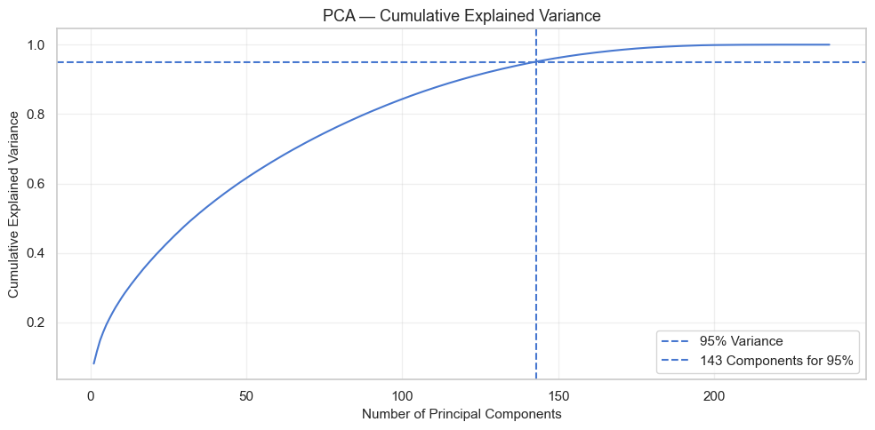
Figure 2. PCA cumulative explained variance from the notebook. 143 components keep 95.08% of training variance (237 encoded features).

5.4 Model leaderboard (holdout test set) — Step 15
The notebook trained seven models on log1p(Property Price) and scored them in dollars. The printed leaderboard, sorted by R², is reproduced exactly:
Model | MAE (USD) | RMSE (USD) | R² | R² %
Linear Regression (best holdout) | 16,112 | 25,597 | 0.9146 | 91.46
Ridge Regression | 16,148 | 25,877 | 0.9127 | 91.27
Lasso Regression | 15,715 | 25,894 | 0.9126 | 91.26
Ridge + PCA | 16,949 | 26,860 | 0.9059 | 90.59
Gradient Boosting | 16,850 | 29,477 | 0.8867 | 88.67
Random Forest | 17,366 | 31,379 | 0.8716 | 87.16
Decision Tree | 24,324 | 38,784 | 0.8039 | 80.39

Printed line: “Best model on the test set: Linear Regression | R² = 0.9146 (91.46%)”. Every algorithm cleared the 75% bar. Six of seven cleared the 85% “much better” bar. Lasso had the lowest MAE ($15,715). The Decision Tree is the weakest, which is expected: a single tree over-partitions and does not average errors.
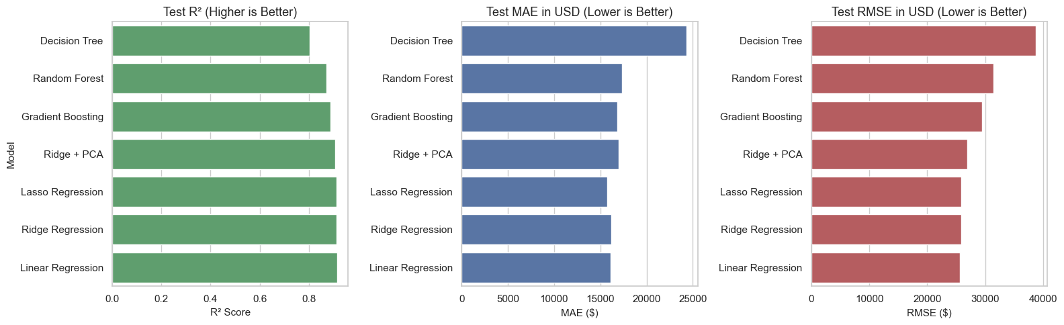
Figure 3. Notebook output — test-set R², MAE, and RMSE for every model (green / blue / brown bars as generated in Step 15).

5.5 Best-holdout diagnostics — Linear Regression (Step 16)
Holdout diagnostic (Linear Regression) | Printed value
Median absolute error | $10,074
Homes within 10% of actual price | 69.2%
Homes within 15% of actual price | 81.2%

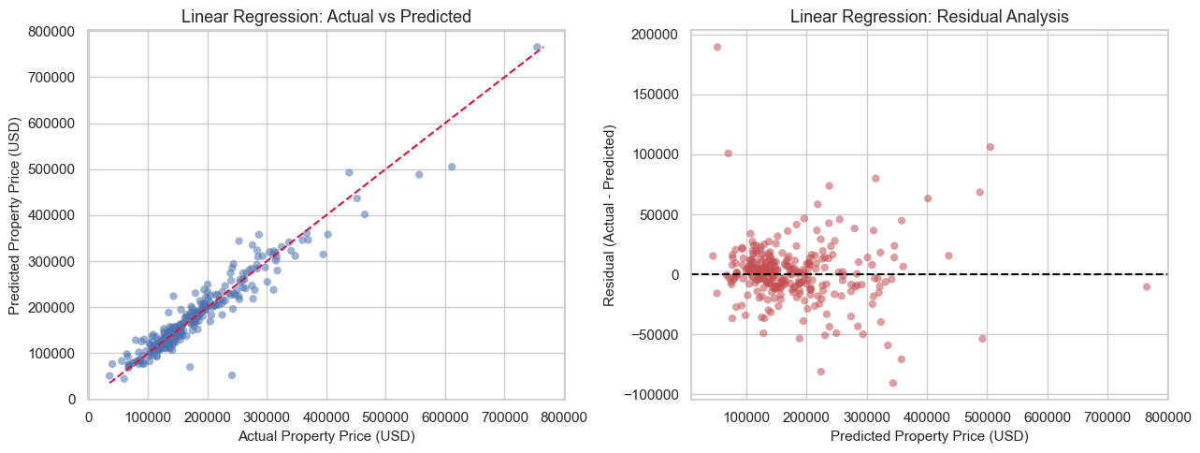
Figure 4. Notebook output — Linear Regression: actual vs predicted (left) and residuals (right).
Most points lie close to the 45-degree line. Residuals are centered on zero, but spread increases for some higher-priced and unusual properties — the same pattern noted in the notebook’s diagnostic insights.

5.6 Cross-validation on the training set (Step 17)
A single 80/20 split can be lucky. The notebook ran 5-fold CV (shuffle=True, random_state=42) on log-price R². Printed fold scores:

Model | CV R² mean | CV R² std | Fold scores | CV R² %
Gradient Boosting | 0.8950 | 0.0188 | 0.902, 0.881, 0.865, 0.914, 0.912 | 89.50
Random Forest | 0.8708 | 0.0211 | 0.882, 0.840, 0.851, 0.894, 0.887 | 87.08
Lasso Regression | 0.8610 | 0.0522 | 0.898, 0.878, 0.761, 0.905, 0.863 | 86.10
Ridge Regression | 0.8395 | 0.0416 | 0.881, 0.858, 0.769, 0.873, 0.816 | 83.95
Linear Regression | 0.8119 | 0.0785 | 0.885, 0.848, 0.668, 0.866, 0.793 | 81.19
Decision Tree | 0.7218 | 0.0351 | 0.781, 0.676, 0.699, 0.729, 0.724 | 72.18
Ridge + PCA | 0.5417 | 0.3162 | 0.703, 0.881, 0.281, 0.784, 0.060 | 54.17

Linear Regression won the specific holdout draw (91.46%) but dropped to a mean CV R² of 0.8119 with a large spread (±0.0785). Gradient Boosting is the most stable. That is why the notebook tuned Gradient Boosting rather than keeping Linear Regression as the final model.

5.7 Hyperparameter tuning — Gradient Boosting (Step 18)
RandomizedSearchCV: 40 candidates × 5 folds = 200 fits. Printed best parameters and test metrics:
Item | Printed value
Best parameters | subsample=0.9 · n_estimators=300 · min_samples_split=5
 | min_samples_leaf=4 · max_depth=3 · learning_rate=0.08
Best cross-validation R² | 0.8997
Baseline GB test MAE / RMSE / R² | $16,850 / $29,477 / 0.8867 (88.67%)
Tuned GB test MAE / RMSE / R² | $15,223 / $26,931 / 0.9054 (90.54%)

5.8 Final model selection (Step 19)
The notebook set final_model = tuned_gb_model and printed the official final evaluation:

Final Model | MAE | RMSE | R² | R² % | Within 10% | Within 15%
Tuned Gradient Boosting | 15,223 | 26,931 | 0.9054 | 90.54 | 73.29 | 84.25

Prediction accuracy band | Printed share of 292 test homes
Within 5% of actual price | 47.6%
Within 10% of actual price | 73.3%
Within 15% of actual price | 84.2%
Within 20% of actual price | 90.8%
Median absolute error | $8,993

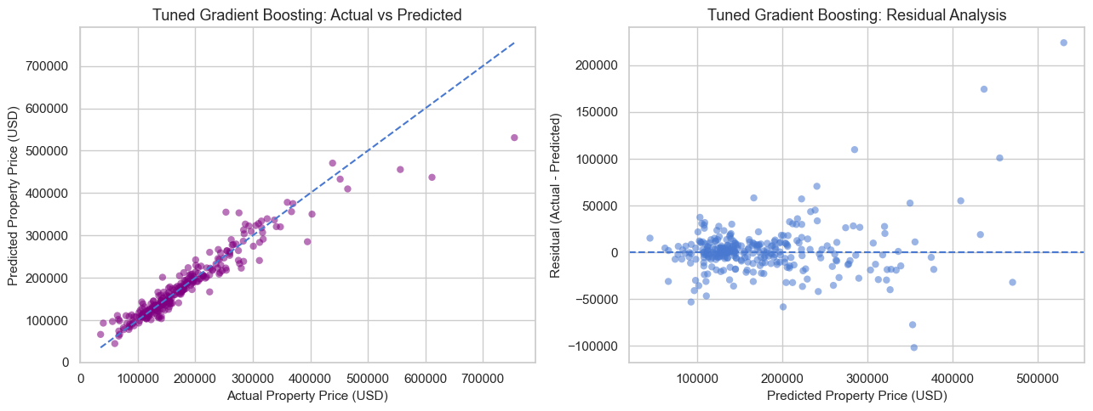
Figure 5. Notebook output — Tuned Gradient Boosting: actual vs predicted (left) and residual analysis (right).

5.9 Overfitting check and regularized retry (Steps 20–21)
Step 20 compared train vs test performance of the tuned model. Step 21 searched a more regularized space (shallower trees, larger leaves, lower learning rates). Printed comparison:
Model | Train R² | Test R² | CV R² | Train–test gap | Test MAE | Test RMSE
Tuned Gradient Boosting | 0.9841 | 0.9040 | 0.8984 | 0.0801 | 15,464 | 27,138
Regularized Gradient Boosting | 0.9775 | 0.8955 | 0.8988 | 0.0820 | 15,822 | 28,315

Regularized best parameters printed: subsample=0.9, n_estimators=300, min_samples_split=20, min_samples_leaf=8, max_depth=3, learning_rate=0.07; CV R² = 0.8988. Regularization did not shrink the gap (8.01 → 8.20 percentage points) and made test error worse. The notebook therefore retained Tuned Gradient Boosting as the final model. The small difference between the Step 19 test print (R² 0.9054, MAE $15,223) and the Step 20 table (R² 0.9040, MAE $15,464) is as it appears in the executed notebook; both remain well above the 85% bar.

5.10 Feature importance (Step 23)
Printed: Gradient Boosting uses 237 features (same as the encoded matrix; PCA is 143). Top 15 features account for 88.45% of total model importance.
Rank | Feature | Importance
1 | QualLivArea (Overall Quality × living area) | 0.464830
2 | TotalSF | 0.120347
3 | Overall Quality | 0.072378
4 | TotalBathrooms | 0.036000
5 | QualCond | 0.030402
6 | Kitchen Quality | 0.024811
7 | GarageScore | 0.023662
8 | Basement Square Footage | 0.021484
9 | Year Built | 0.019095
10 | Property Size | 0.015934
11 | Exterior Quality | 0.013099
12 | Central Air Conditioning_Y | 0.013020
13 | Basement Finish Style 1 | 0.012520
14 | HouseAge | 0.009739
15 | HasFireplace | 0.007149

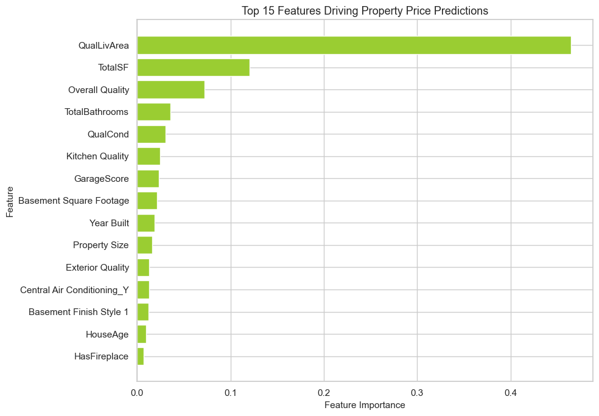
Figure 6. Notebook output — top 15 features driving Tuned Gradient Boosting predictions (yellow-green bars as generated in Step 23).

5.11 Deployment output
The last code cell saved the winning estimator with joblib.dump(tuned_gb_model, "tuned_gradient_boosting_model.pkl"). The execute result was ['tuned_gradient_boosting_model.pkl'].

6. Report on EDA
Exploratory analysis in the notebook (Step 8 and the engineered-feature plots in Step 9) was performed on the cleaned file before modeling. The goal was not to plot everything — it was to find the story a listing agent would already recognize, then turn that story into features. All graphs in this section are the original notebook figures.

6.1 Missingness is a feature, not a defect
Nineteen columns contain missing values. Most of those “holes” are Ames-style NA codes meaning the amenity is absent. Dropping Pool Quality because it is 99.52% empty would delete the information “this house has no pool.” The brief also forbids dropping columns other than PropertyID, so every amenity field was kept.
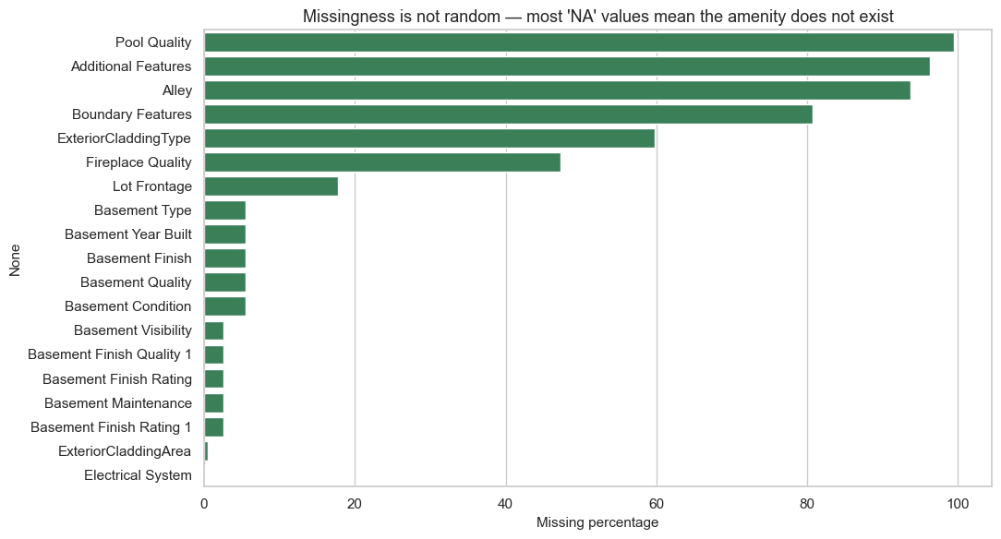
Figure 7. Notebook EDA — missingness by column. The tall bars are absent amenities, not broken data.

6.2 Sale price is right-skewed
The notebook printed: raw skew = 1.883 | log1p skew = 0.121. Most Ames homes sold between about $130,000 and $214,000 (IQR). A long luxury tail pulls the mean ($180,921) above the median ($163,000). That is why every model was trained on log1p(Property Price) and converted back to dollars for MAE and RMSE.
- High positive skew: a small number of expensive homes drag the mean above the median.
- log1p compresses high-value outliers and produces a near-symmetric bell curve.
- The log scale stabilizes variance for linear and regularized regression.
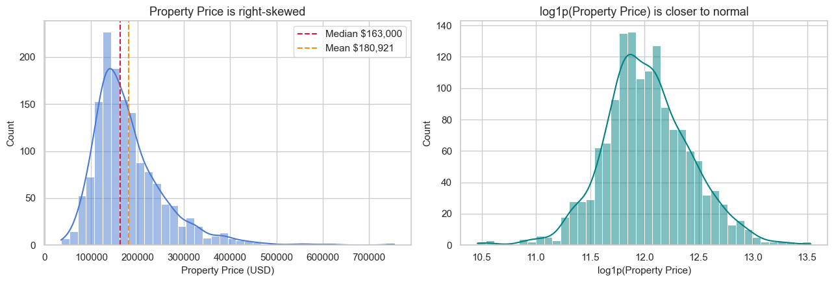
Figure 8. Notebook EDA — Property Price (left) is right-skewed; log1p(Property Price) (right) is nearly symmetric.

6.3 Living area and overall quality are the backbone
Printed correlations: Above Ground Living Area vs Property Price = 0.709; Overall Quality vs Property Price = 0.791. Quality behaves like a staircase: each extra point shifts the entire price distribution up. A large low-quality house does not catch a smaller high-quality one.
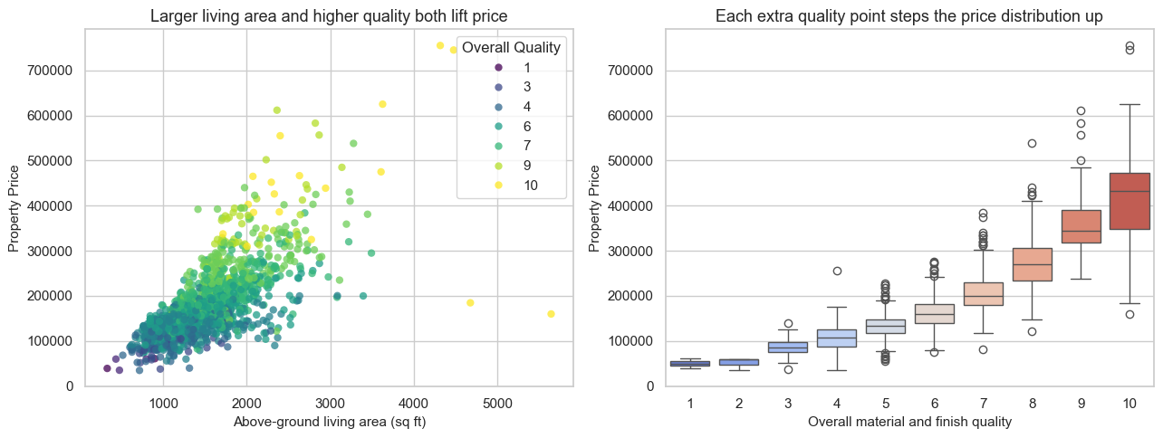
Figure 9. Notebook EDA — living area vs price, colored by Overall Quality (left), and the quality staircase (right).
Two sales with living area above 4,000 sq ft and price below $300,000 were flagged as possible partial sales, not used as a reason to drop columns:
Row | Living area (sq ft) | Overall Quality | Neighborhood | Year Built | Sale Year | Price
523 | 4,676 | 10 | Edwards | 2007 | 2007 | $184,750
1298 | 5,642 | 10 | Edwards | 2008 | 2008 | $160,000

6.4 Neighborhood is a price tier
Ames is not one market. Northridge Heights, Northridge, and Stone Brook sit in a different price band from Meadow Village, IDOTRR, and Briardale. Neighborhood is therefore encoded as nominal (one-hot), not as an invented numeric rank.
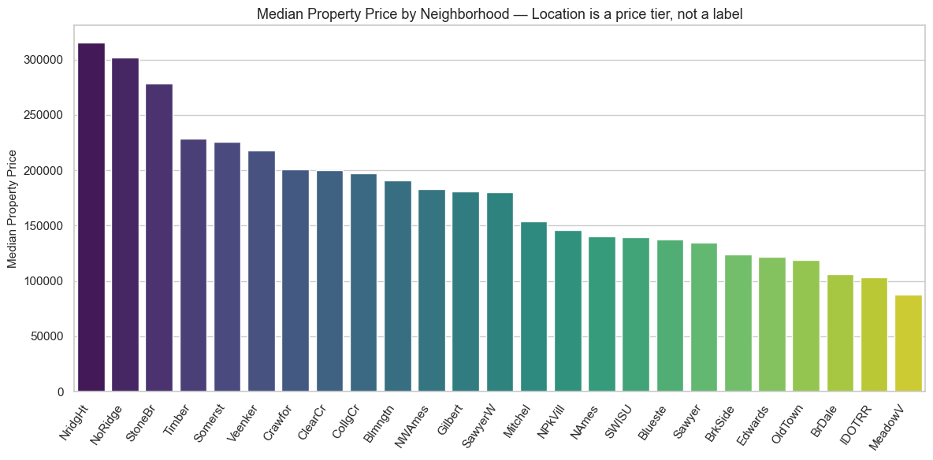
Figure 10. Notebook EDA — median sale price by neighborhood. Location creates parallel markets.

Neighborhood | Median price | Mean price | n
NridgHt (most expensive) | $315,000 | $316,271 | 77
NoRidge | $301,500 | $335,295 | 41
StoneBr | $278,000 | $310,499 | 25
Timber | $228,475 | $242,247 | 38
Somerst | $225,500 | $225,380 | 86
Edwards | $121,750 | $128,220 | 100
OldTown | $119,000 | $128,225 | 113
BrDale | $106,000 | $104,494 | 16
IDOTRR | $103,000 | $100,124 | 37
MeadowV (most affordable) | $88,000 | $98,576 | 17

6.5 Age, remodels, and the 2006–2010 sale window
Newer construction tends to sell higher, and a recent remodel lifts an older house. A 1920 house gutted in 2008 is not the same asset as a 1920 house last touched in 1950. That is why HouseAge and RemodAge were engineered from Sale Year − Year Built and Sale Year − Year Remodeled/Addition. Sales cover 2006–2010 (housing-crisis window).
Sale Year | Median Property Price (printed)
2006 | $163,995
2007 | $167,000
2008 | $164,000
2009 | $162,000
2010 | $155,000

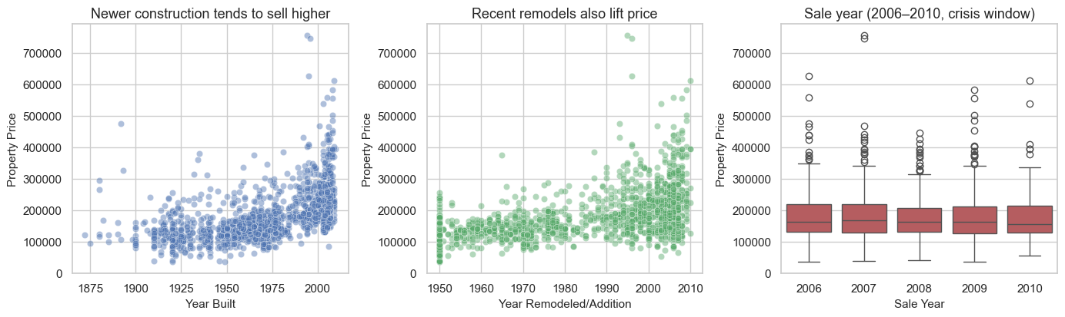
Figure 11. Notebook EDA — year built, remodel year, and sale year versus Property Price.

6.6 Amenity counts behave like steps
Full bathrooms, garage car capacity, and fireplace count are numeric but act like steps on a listing sheet. Price consistently increases with higher counts. Garage prices peak at 3 cars and drop slightly at 4 cars (rare / niche). Mid-tier homes still show luxury outliers above $600,000–$700,000.
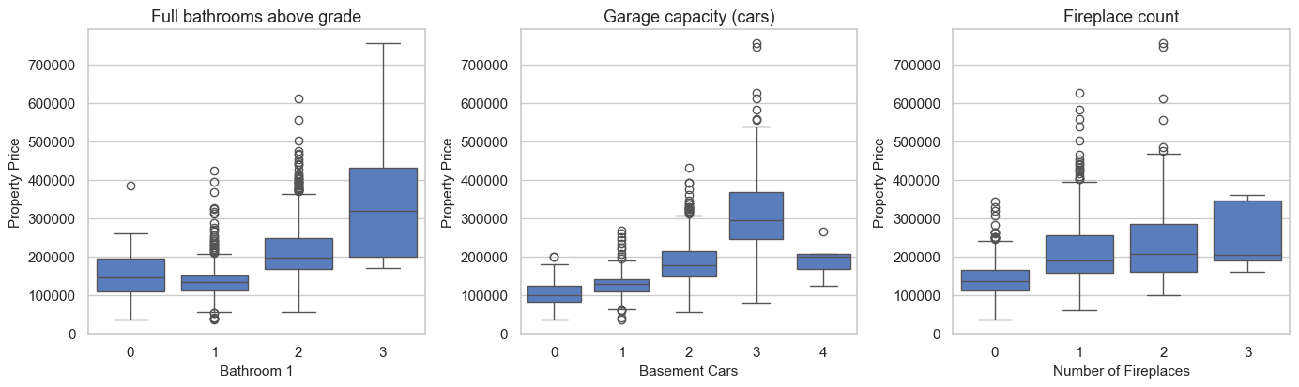
Figure 12. Notebook EDA — price bands by full bathrooms, garage capacity, and fireplace count.

6.7 Kitchen and exterior quality — ordinal ladders
Kitchen Quality and Exterior Quality are stored as text (Fa, TA, Gd, Ex) but the boxplots are already ordered. That is the evidence for integer rank encoding instead of one-hot encoding. Excellent (Ex) produces the sharpest jump, with medians rising above about $300,000–$350,000.
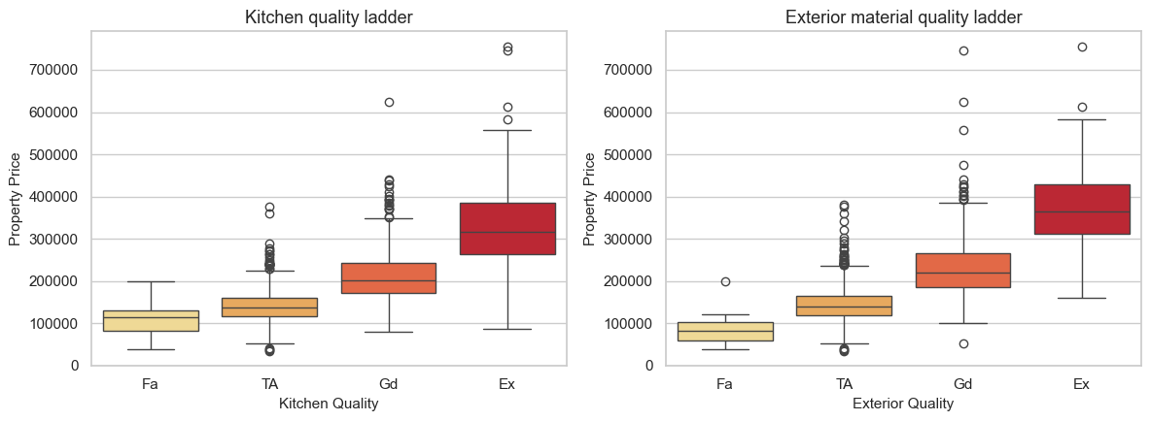
Figure 13. Notebook EDA — kitchen quality and exterior quality form a clean price ladder.

6.8 Numeric correlations and overlapping size fields
Top 15 numeric correlations with Property Price, printed by the notebook:

Feature | r with Property Price
Overall Quality | 0.791
Above Ground Living Area | 0.709
Basement Cars | 0.640
Basement Area | 0.623
Basement Square Footage | 0.614
First Floor Square Footage | 0.606
Bathroom 1 | 0.561
Total Rooms Above Ground | 0.534
Year Built | 0.523
Year Remodeled/Addition | 0.507
ExteriorCladdingArea | 0.473
Number of Fireplaces | 0.467
Basement Finish Style 1 | 0.386
Lot Frontage | 0.335
Wood Deck Square Footage | 0.324

High redundancy exists between Basement Cars and Basement Area, basement SF and first-floor SF, and rooms and living area. That overlap is why TotalSF was created and why PCA and regularized linear models (Ridge, Lasso) are reasonable candidates.
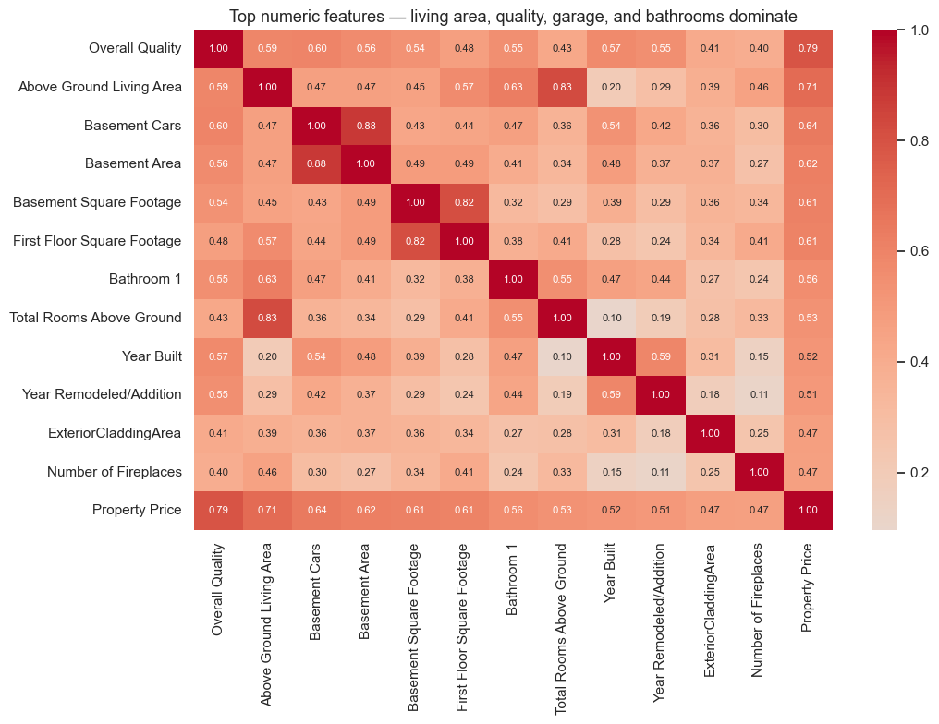
Figure 14. Notebook EDA — correlation heatmap of the numeric features most associated with Property Price.

6.9 Engineered features confirm the EDA story
The notebook created 19 engineered features and plotted each against Property Price. QualLivArea correlates 0.832 with price — stronger than either parent. TotalSF correlates 0.782. HouseAge correlates −0.523. Presence flags keep the “amenity exists” signal after NA fills. Sale-month sine/cosine and IsRemodeled alone are weak.
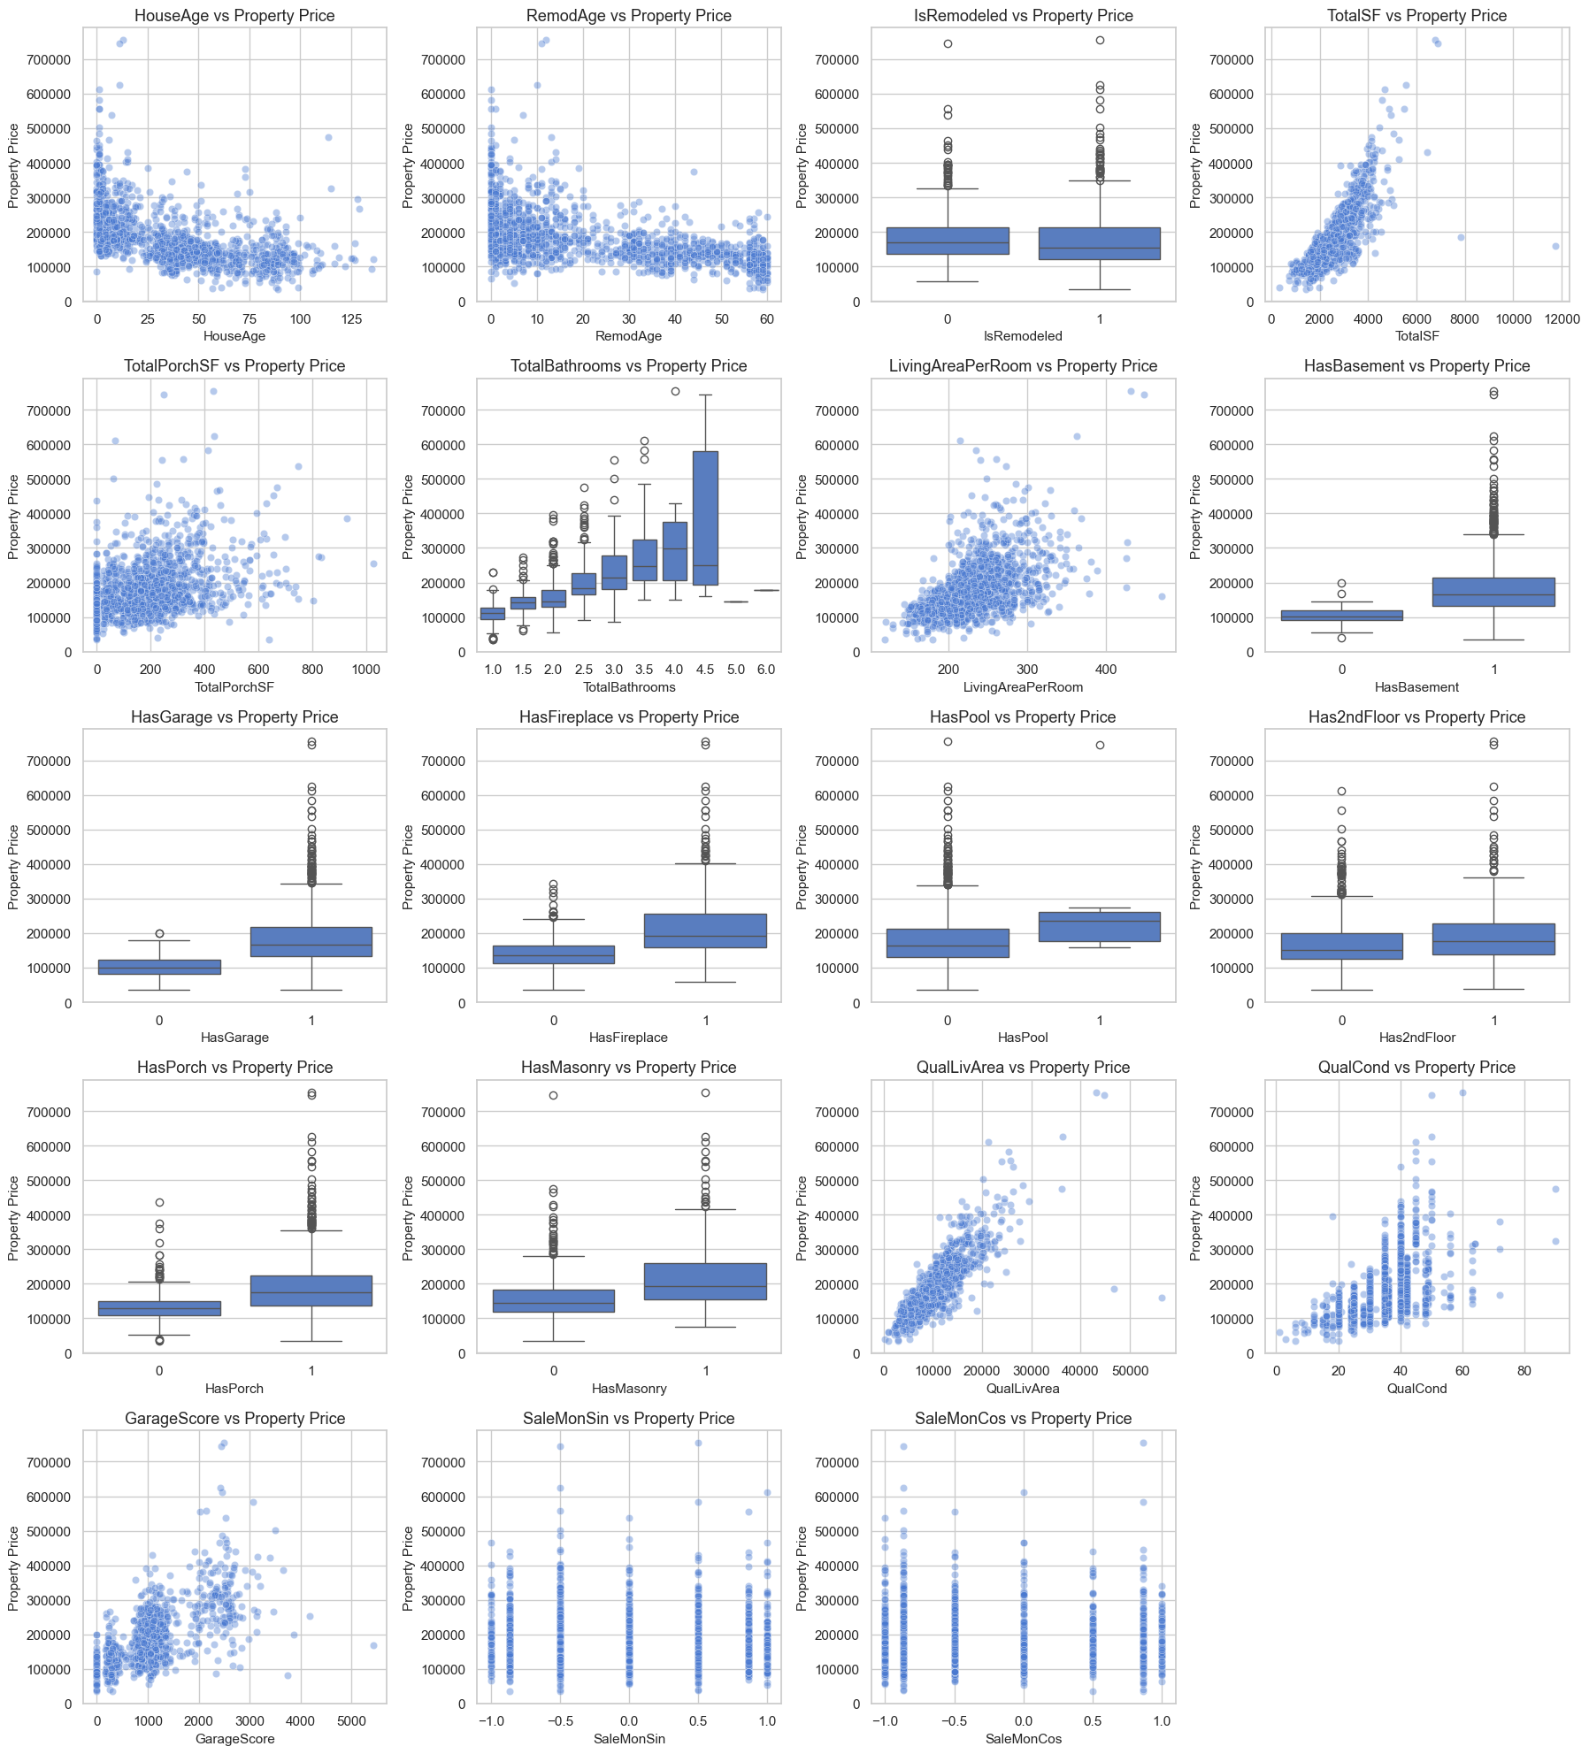
Figure 15. Notebook EDA — all 19 engineered features versus Property Price (scatter / box views as generated in Step 9).
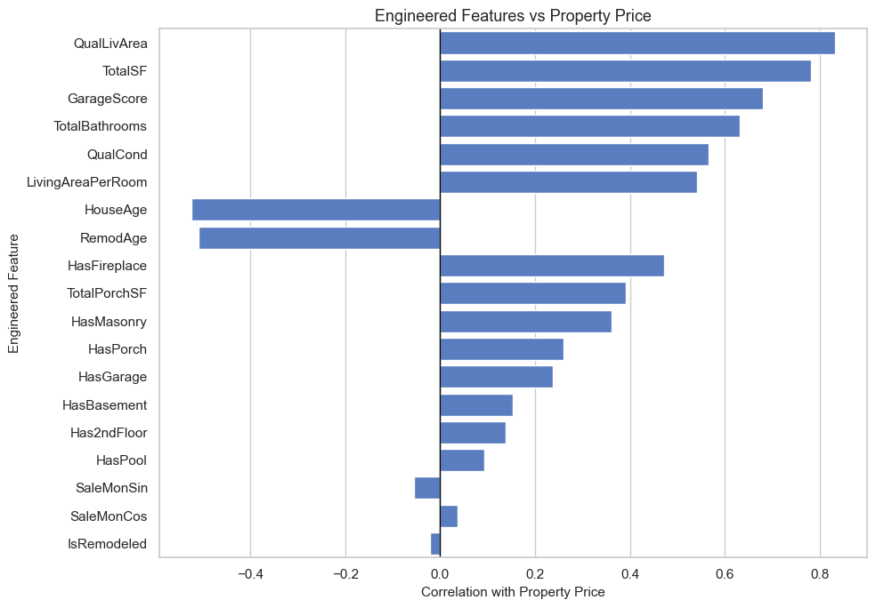
Figure 16. Notebook EDA — engineered features ranked by correlation with Property Price.
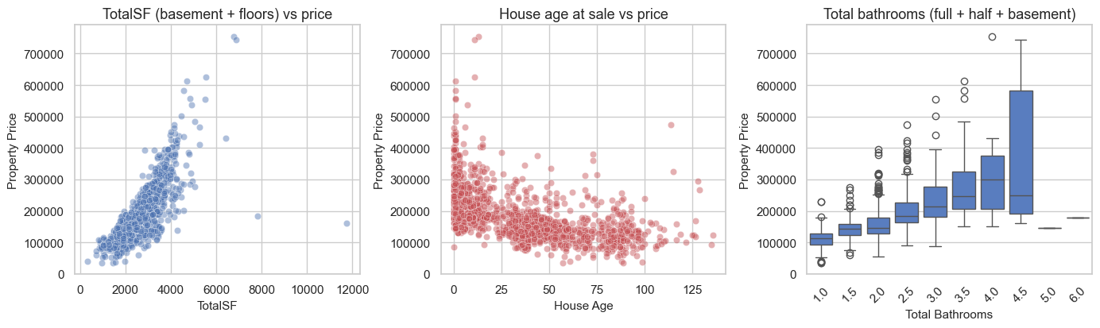
Figure 17. Notebook EDA — TotalSF, HouseAge, and TotalBathrooms versus sale price.
TotalSF tightens the size–price relationship. HouseAge shows the expected decline, with a cluster of valuable old homes (character / location). TotalBathrooms is a cleaner amenity count than four separate bath columns.

6.10 EDA conclusions that drove the model
1. Quality and living area are the backbone of price in Ames.
2. Neighborhood creates parallel markets and must stay nominal.
3. Age and remodel recency matter independently — engineer both.
4. Garage, bathrooms, and fireplaces add stepwise value.
5. Size fields overlap — total area is more stable than any single floor.
6. Right-skewed prices need a log transform before linear modeling.
7. High-missing amenity columns are informative; they were not dropped.
8. Two Edwards sales (rows 523 and 1298) look like partial / unusual transactions; they were flagged, not used to drop columns.

7. Learning Outcomes
1. Missing values have meaning. In property data, NA on Pool Quality is not a hole to delete — it is “this house has no pool.” Treating structural NA as the category None kept 1,453 no-pool homes in the model instead of discarding the column, which also satisfied the brief’s rule not to drop columns other than Property ID.
2. Encoding is a modeling decision, not a default. Ordinal maps preserve rank on quality ladders (Fa → TA → Gd → Ex). One-hot encoding preserves identity for neighborhoods and styles. Mixing them up either invents a false order or throws away a real one. The brief’s question about handling ordinal and nominal columns separately is answered by keeping two parallel lists (18 ordinal, 26 nominal) and two parallel transformers.
3. fillna(), scaling, and PCA must be used together, not as isolated tricks. After structural fills, StandardScaler put every column on mean 0 / std 1 so PCA and linear models were not dominated by square-footage units. PCA then compressed 237 encoded features to 143 components while keeping 95.08% of training variance. Ridge + PCA still reached holdout R² = 0.9059, but 5-fold CV showed that compression is not always more stable than the original features.
4. Feature engineering is where domain knowledge shows up. Age at sale, total bathrooms, total square footage, and quality × living area are the calculations an appraiser already does mentally. QualLivArea became the single most important Gradient Boosting feature (importance 0.465) and the strongest engineered correlation (0.832).
5. The metric must match the user. R² is the brief’s success bar. MAE in dollars is what a seller understands. Reporting both — plus the share of homes within 5%, 10%, 15%, and 20% of actual price — makes the result usable, not only academic. The final model’s typical (median) miss is $8,993.
6. A single algorithm is not a project. Comparing linear models, a decision tree, ensembles, and a PCA variant is how the final choice is justified. Linear Regression won one holdout draw at 91.46% R²; Gradient Boosting won the 5-fold average at 89.50% with the smallest spread. That difference is why the notebook did not stop at the first leaderboard.
7. Right-skewed prices need a transform. Modeling log1p(Property Price) cut skew from 1.883 to 0.121 and produced dollar-scale residuals that no longer explode on luxury homes as badly as a raw-price linear fit would.
8. Cross-validation and tuning keep a lucky split honest. Hyperparameter search lifted Gradient Boosting from test R² 0.8867 to 0.9054. A later regularized search did not improve the train–test gap, so the original tuned model was retained — a useful lesson that more regularization is not automatically better.
9. Business interpretation follows the statistics. Buyers in this market paid for finish quality, usable living area, neighborhood, age and remodel recency, bathrooms, and garage capacity. That is both a model-importance result and something a local agent would recognize.

8. Conclusion
This capstone built a complete property-price pipeline on 1,460 Ames residential sales using Propertydata.csv. The work followed the required methodology: collect and clean (without dropping columns other than PropertyID), explore, engineer features, encode ordinal and nominal fields correctly, impute with fillna-style rules, scale, apply PCA, train several learners, evaluate them with MAE, RMSE, and R², then tune and diagnose the most stable model.
On the holdout test set, Linear Regression recorded the highest single-split R² (0.9146 / 91.46%) and the lowest RMSE ($25,597), while Lasso recorded the lowest MAE ($15,715). Five-fold cross-validation ranked Gradient Boosting first (mean R² = 0.8950 ± 0.0188). After RandomizedSearchCV, Tuned Gradient Boosting was selected as the final model. The official final-evaluation cell printed R² = 0.9054 (90.54%), MAE = $15,223, RMSE = $26,931, median absolute error = $8,993, with 73.3% of test homes within 10% of the true price, 84.2% within 15%, and 90.8% within 20%.
Both the holdout linear result and the tuned boosting result exceed the brief’s 75–85% expectation and the 85% “much better” line. Feature importance agrees with EDA: QualLivArea, TotalSF, Overall Quality, bathrooms, kitchen quality, garage score, basement area, and year built dominate. Neighborhood remains a parallel-market signal encoded nominally. Two unusually cheap, very large Edwards sales were documented rather than used as an excuse to drop columns.
Expected outcomes from the brief — status
Expected outcome | Status
A model that predicts property prices from selected variables | Met — Tuned Gradient Boosting, test R² 90.54% (well above 85%)
Insights into significant features | Met — QualLivArea, TotalSF, quality, bathrooms, kitchen, garage, age, neighborhood
A comprehensive report of methodology, results, and insights | Met — this Word file plus the executed notebook and saved .pkl

From a practical perspective, the model can support buyers in checking whether an asking price is reasonable, help sellers set a listing range, and give agents a data-backed second opinion. If the model went into production, the natural next steps would be to refresh it as new closings arrive, add external location features (school ratings, distance to campus), use quantile methods for luxury homes where residuals are still largest, and monitor percent-error by neighborhood.
Therefore, the project successfully achieved its expected outcomes by developing an accurate property price prediction model, identifying the key features influencing property values, and presenting a comprehensive analysis of the methodology, model performance, and business insights.

Streamlit deployment of the capstone notebook using the final Tuned Gradient Boosting model.
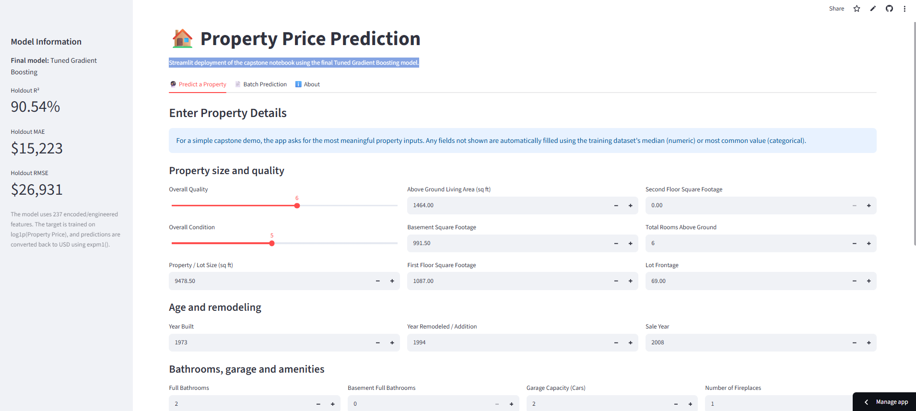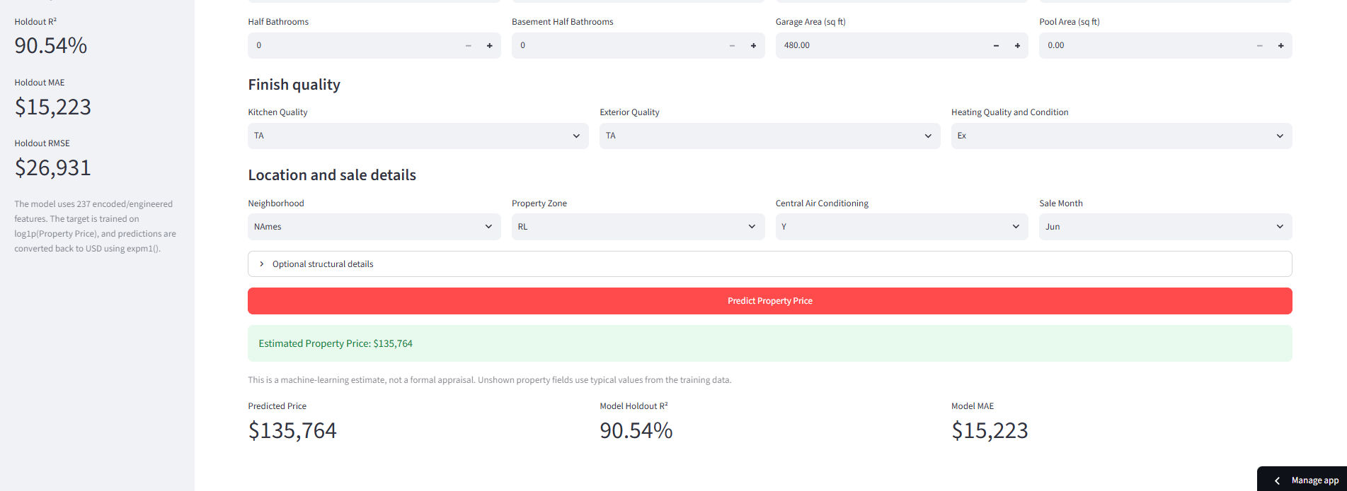
https://capstone-house-propertyprice.streamlit.app/

9. Citations — Books and Websites Used for Research

9.1 Data and original study
De Cock, D. (2011). Ames, Iowa: Alternative to the Boston Housing Data as an End of Semester Regression Project. Journal of Statistics Education, 19(3). https://doi.org/10.1080/10691898.2011.11889627
De Cock, D. Ames Housing Data documentation (data_description). Column definitions were mapped onto the renamed fields in Propertydata.csv (for example GrLivArea → Above Ground Living Area, OverallQual → Overall Quality, Neighborhood, and the garage/basement block).

9.2 Books
James, G., Witten, D., Hastie, T., & Tibshirani, R. An Introduction to Statistical Learning. Springer. Used for linear models, resampling, regularization (Ridge/Lasso), decision trees, and ensemble methods.
Kuhn, M., & Johnson, K. Applied Predictive Modeling. Springer. Used for encoding practice, imputation strategy, and leakage awareness.
Géron, A. Hands-On Machine Learning with Scikit-Learn, Keras, and TensorFlow. O’Reilly. Used for pipeline structure, scaling, PCA, RandomizedSearchCV, and model-comparison patterns.
McKinney, W. Python for Data Analysis. O’Reilly. Used for pandas cleaning, groupby summaries, and missing-value handling.

9.3 Websites and libraries
Scikit-learn documentation — imputers, encoders, StandardScaler, MinMaxScaler, PCA, regressors, cross-validation, and RandomizedSearchCV. https://scikit-learn.org/
Pedregosa, F., et al. (2011). Scikit-learn: Machine Learning in Python. Journal of Machine Learning Research, 12, 2825–2830.
pandas documentation. https://pandas.pydata.org/
NumPy documentation. https://numpy.org/
Matplotlib documentation. https://matplotlib.org/
Seaborn documentation. https://seaborn.pydata.org/
Joblib documentation — model persistence. https://joblib.readthedocs.io/

9.4 Course brief
Capstone Project 1 — Predicting Property Prices in a Specific Location Using Machine Learning (problem statement PDF supplied with this assignment). Dataset field list, background, eight objectives, notes (do not drop columns other than Property ID; expected R² 75–85%), methodology, and expected outcomes were taken from this brief.

Appendix — Files used for this report
File | Role
projectcapstone.ipynb | Full executable project (code, story, charts, printed outputs)
Project_Summary_Report.docx | This synopsis report
Propertydata.csv | Working copy of the supplied Ames dataset (1,460 × 81)
tuned_gradient_boosting_model.pkl | Saved Tuned Gradient Boosting model
Capstone Project - 1 (1).pdf | Official problem statement and report format

