I have used email-Eu-core network data for this assignment. This data contains information about email exchange between two member in a research organization. I have used gephi to visualize this network.
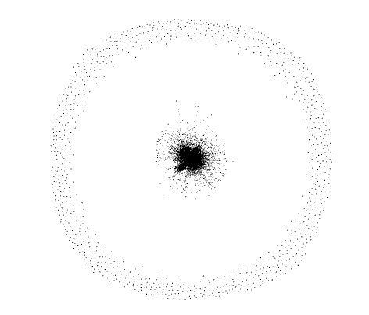
The raw data is plotted below. There exists an edge if a member sends an email to another member of the organization. The data also contains department label for each member.
This visualization has been plotted with degree range more than 1. The outer data points even though they have not sent emails to other member , but have sent emails to themselves and hence still show up in the visualization. This data contains 1005 nodes and 25571 edges. In order to get some insight into the data, I am interested in visualizing the inner network of data. By increasing the minimum degree range to 120 (only select nodes with more than 120 nodes), the out data points are removed. The green dashed circle has been added on top of the plot to separate two different regions in the plot.

Next I look into the network at the center (inside the green dashed circle) of this plot in more detail.
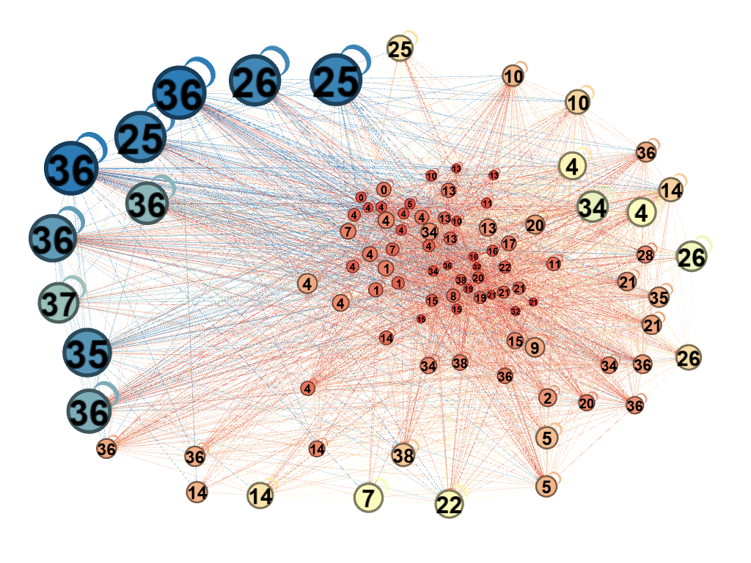
I have assigned the node size based on betweenness centrality with larger size node having higher betweennss centrality. Also the color has been assigned based on same, with blue being higher and red being lower betweenness centrality. The above plot shows that member with department label 25, 26, 36, 37 send emails to members across all departments. Also, it shows that these members CC themselves in their email.

I also looked at another aspect of this data by just selecting the out-degree range above 100, which means members who have sent more than 100 emails. Again the members with department ID 25, 26, 36, 35, 37 are selected. It is indicating that these members might be at a higher position or administrative position.

