**CPSC 535 – Advance Algorithms**

**Project 1 – Savvy Traveller**

**Report**

**Team Members**

**Shivangi Shakya**

**Nicholas Bidler**

**Saoni Mustafi**

**Prof. Doina Bein**

**California State University, Fullerton**

**800 N State College Blvd, Fullerton, CA 92831**

**Summary**

This report contains details about the work done to solve the Savvy Traveller – a weighted directed graph problem as a part of our project. We were given a graph, denoting various cities a traveller could fly to from every other city with a certain probability of on-time arrival. We had to compute the path with the highest probability of on-time arrival and the most reliable travel destination.

We were provided with the below graph as one of the examples –

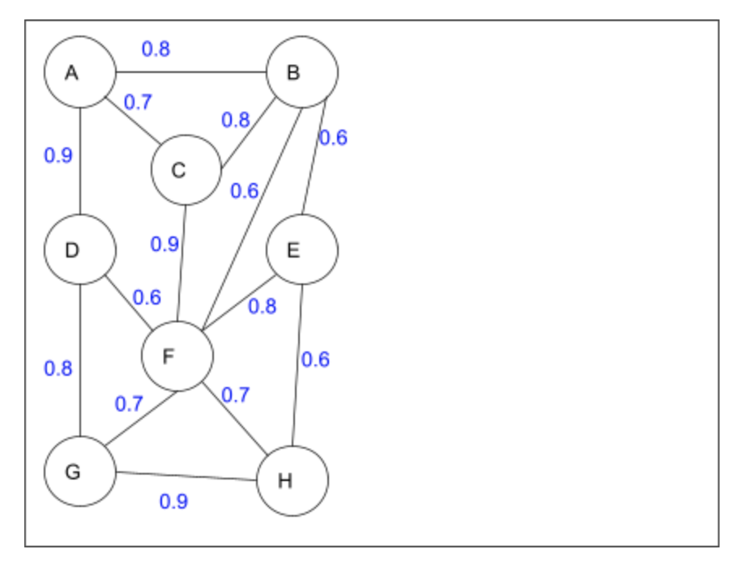

We were given to compute the following:

**(i)** what route will maximize the probability to arrive on time between any two cities, for example, city A and city F.

**(ii)** what city among {A, B, C, D, E, F, G, H} is the most reliable travel destination.

To compute **(i)**, we considered all the routes that could lead to city F from city A. Below are the probable routes and their corresponding-

|  |  |
| --- | --- |
| Path from city A to city F | Probability of on-time Arrival |
| A->B->C->F | 0.576 |
| A->B->E->F | 0.384 |
| A->B->E->G->D->F | 0.0 |
| A->B->E->G->F | 0.0 |
| A->B->E->G->H->F | 0.0 |
| A->B->E->H->F | 0.2016 |
| A->B->E->H->G->D->F | 0.124416 |
| A->B->E->H->G->F | 0.18144 |
| A->B->F | 0.48 |
| A->C->B->E->F | 0.2688 |
| A->C->B->E->G->D->F | 0.0 |
| A->C->B->E->G->F | 0.0 |
| A->C->B->E->G->H->F | 0.0 |
| A->C->B->E->H->F | 0.14112 |
| A->C->B->E->H->G->D->F | 0.0870912 |
| A->C->B->E->H->G->F | 0.127008 |
| A->C->B->F | 0.336 |
| A->C->F | 0.63 |
| A->D->F | 0.54 |
| A->D->G->F | 0.504 |
| A->D->G->H->E->B->C->F | 0.1679616 |
| A->D->G->H->E->B->F | 0.139968 |
| A->D->G->H->E->F | 0.31104 |
| A->D->G->H->F | 0.4536 |

We see that the highest is that of A->C->F (highlighted) with a probability of 0.63. Hence the answer to the first question is A->C->F.

We firstly created a *graph1.txt* file which contains the on-time arrival probabilities of cities for their adjacent ones in a dictionary format. We provide this file name and then enter the source and destination vertex we want to find the best route for.

To implement this task, we created a function named – *printBestRoute()* which takes source and destination cities as its parameters. This function prints the best route based on the maximum probability value computed by the function *BestRoute()* which takes the same source and destination parameters. The *BestRoute()* keeps a track of the visited cities and appends that to a list called *‘path’*. It then checks if the source has reached its destination, if yes, it takes the probabilities of the cities that have been added to the *‘path’* list and finds the product *‘prod’.*

***prod = prod * float(graph[self.path[i-1]][self.path[i]])***

Once, this calculation is complete for one route, it pops the last element and finds another possible route to the destination from the same source. These probabilities of all the routes and the routes themselves are stored in a dictionary named *‘list1’.*

When all probabilities of all the routes have been calculated, *printBestRoute()* provides the routes with the highest probability, in our case, it is A->C->F with a probability of 0.63.

To compute **(ii)**, we find out the maximum probabilities of all cities from every other city and the city with the highest probability among all is considered to be the most reliable city. We do the same calculation as we did above for every city and then return the result. Below is the calculation for the given cities-

|  |  |  |
| --- | --- | --- |
| **City A** |  |  |
| Source City | Max Probability | Max Prob Path |
| From B | 0.8 | B->A |
| From C | 0.7 | C->A |
| From D | 0.9 | D->A |
| From E | 0.504 | E->F->C->A |
| From F | 0.63 | F->C->A |
| From G | 0.72 | G->D->A |
| From H | 0.648 | H->G->D->A |
| **Sum** | **4.902** |  |

|  |  |  |
| --- | --- | --- |
| **City B** |  |  |
| Source City | Max Probability | Max Prob Path |
| From A | 0.8 | A->B |
| From C | 0.8 | C->B |
| From D | 0.72 | D->A->B |
| From E | 0.6 | E->B |
| From F | 0.72 | F->C->B |
| From G | 0.576 | G->D->A->B |
| From H | 0.51 | H->G->D->A->B |
| **Sum** | **4.726** |  |

|  |  |  |
| --- | --- | --- |
| **City C** |  |  |
| Source City | Max Probability | Max Prob Path |
| From A | 0.7 | A->C |
| From B | 0.8 | B->C |
| From D | 0.63 | D->A->C |
| From E | 0.72 | E->F->C |
| From F | 0.9 | F->C |
| From G | 0.63 | G->F->C |
| From H | 0.63 | H->F->C |
| **Sum** | **5.01** |  |

|  |  |  |
| --- | --- | --- |
| **City D** |  |  |
| Source City | Max Probability | Max Prob Path |
| From A | 0.9 | A->D |
| From B | 0.72 | B->A->D |
| From C | 0.63 | C->A->D |
| From E | 0.48 | E->F->D |
| From F | 0.6 | F->D |
| From G | 0.8 | G->D |
| From H | 0.72 | H->G->D |
| **Sum** | **4.85** |  |

|  |  |  |
| --- | --- | --- |
| **City E** |  |  |
| Source City | Max Probability | Max Prob Path |
| From A | 0.504 | A->C->F->E |
| From B | 0.6 | B->E |
| From C | 0.72 | C->F->E |
| From D | 0.48 | D->F->E |
| From F | 0.8 | F->E |
| From G | 0.56 | G->F->E |
| From H | 0.6 | H->E |
| **Sum** | **4.264** |  |

|  |  |  |
| --- | --- | --- |
| **City F** |  |  |
| Source City | Max Probability | Max Prob Path |
| From A | 0.63 | A->C->F |
| From B | 0.72 | B->C->F |
| From C | 0.9 | C->F |
| From D | 0.6 | D->F |
| From E | 0.8 | E->F |
| From G | 0.7 | G->F |
| From H | 0.7 | H->F |
| **Sum** | **5.05** |  |

|  |  |  |
| --- | --- | --- |
| **City G** |  |  |
| Source City | Max Probability | Max Prob Path |
| From A | 0.72 | A->D->G |
| From B | 0.576 | B->A->D->G |
| From C | 0.63 | C->F->G |
| From D | 0.8 | D->G |
| From E | 0.56 | E->F->G |
| From F | 0.7 | F->G |
| From H | 0.9 | H->G |
| **Sum** | **4.886** |  |

|  |  |  |
| --- | --- | --- |
| **City H** |  |  |
| Source City | Max Probability | Max Prob Path |
| From A | 0.648 | A->D->G->H |
| From B | 0.5184 | B->A->D->G->H |
| From C | 0.63 | C->F->H |
| From D | 0.72 | D->G->H |
| From E | 0.6 | E->H |
| From F | 0.7 | F->H |
| From G | 0.9 | G->H |
| **Sum** | **4.7164** |  |

From these calculations, we see that city F is the most reliable destination to travel to from any other city.

To implement this, we used a function named – *ReliableDest()* which does the computation shown above for every city. This function declares a dictionary *‘dict’* and a list *‘vertices’*. The *‘vertices’* stores all the cities present in the graph. A nested *‘for loop’* is then run over all the cities in the *‘vertices’*. The inner *‘for loop’* runs the *BestRoute()* function to compute the maximum probability between any two cities. Once, the entire loop runs for a particular source and destination, it computes the maximum of all probabilities computed for the different routes between a specific source and destination and stores it in a variable called *‘sum’*. As already mentioned, the probabilities of all the routes and the routes themselves are stored in a dictionary named *‘list1’.* Below is the computation of *‘sum’* we are doing -

***sum = sum + max(self.list1.values())***

This maximum sum of probabilities for all possible routes from a specific source is then stored in the *‘dict’* dictionary. In the end, we print the maximum probabilities with which all other cities can be reached from a particular source city.

Considering **example 2** given below -

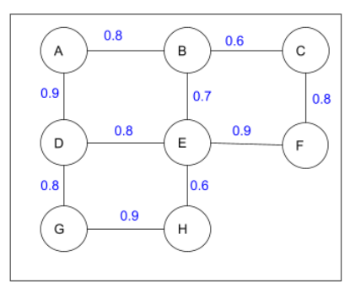

**(i)** what route will maximize the probability to arrive on time between C and A, and

**(ii)** what city among {A, B, C, D, E, F, G, H} is the most reliable travel destination.

With the same implementation as discussed for example 1, we get the answer to **(i)** is - path C->F->E->D->A with a probability of probability 0.5184 and city D as the highest reliable city among all for **(ii)**

For **example 3** below, we compute the following -

**(i)** what route will maximize the probability to arrive on time between E and C, and

**(ii)** what city among {A, B, C, D, E, F, G, H} is the most reliable travel destination.

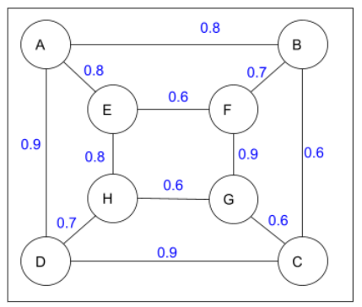

With the same implementation, the answer to **(i)** is path E-A-D-C with a probability of 0.648 and for **(ii)** city A is the most reliable city.

**Pseudocode -**

create a *Graph* class

initialize the class with *graph* and empty *list1{},* *path[]*, *visited{}*

set the *visited* list = *False* for all other vertices

define a function *printGraph(self):*

print *graph*

define function *BestRoute(self, src, dest):*

set the *visited[i]* for the src = *True*

append this *src* in *path[]*

set *prod = 1*

if the *dest* is found:

for *i* in the range *0* to length*(path):*

*prod = prod \** probability of the path between the current and previous city

store the *prod* and the path in *list1{}*

set prod = 1

else:

for city in *graph[src]:*

if *visited[src][*city*]* = *False* and *graph[src][*city*]* is not = 0:

*BestRoute(*city*,dest)*

pop the last element from the *path[]*

set *visited[src] = False*

define *printBestRoute(src,dest):*

call *BestRoute(src,dest)*

print *list1* containing the path and probability

retrieve the maximum probability and its corresponding path in *max_path* and *max_value*

print *max_path* and *max_value*

define function *ReliableDest(self):*

create empty dictionary *dict{}* and list *vertices[]*

store the *cities* from graph into *vertices[]*to access them

for *i* in the range *0* to *length(vertices):* # Access destination in *vertices[]*

set sum = 0

for *j* in the range *0* to *length(vertices):* # Access source in *vertices[]*

if destination is present in *dict* of source and *i* is not = *j*:

call *BestRoute(vertices[j], vertices[i])*

store the maximum probability for the paths obtained in *list1{}* in *sum*

set the *visited[]* list for source cities traversed as *False*

empty *list1{}* and *path[]*

store the *sum* in *dict[dest]*

print *dict*

print the most reliable city *dict.get* with the maximum *dict.values()*

inside the *main()* function

take the file name as input from the user

read the content of the input file

close the file and print the file content

take the source city *src* as input from the user for the graph

take the destination city *dest* as input from the user for the graph

create an object of the graph and call the functions *printBestRoute(src, dest)* and *ReliableDest()*

**Instructions to run the Code:**

The code has been implemented in Python. The name of the file is *‘SavvyTraveller.py’*. The three examples have been incorporated in three separate files – *graph1.txt* (for example1), *graph2.txt* (for example 2), and *graph3.txt* (for example 3).

1. Save the SavvyTraveller.py, graph1.txt, graph2.txt, and graph3.txt in your desired location.

2. In the terminal, change the directory to the folder where you have saved these files using the command *cd <pathname>.*

3. Type *‘python3 SavvyTravller.py’.*

4. Enter the file name you want to run the program for – *‘graph1.txt’* to execute for the graph provided in example 1, *‘graph2.txt’* for example 2 graph and *‘graph3.txt’* for graph in example 3.

5. Enter source city and destination city for the graph you just provided as input.

**Screenshots -**

Below are the screenshots of the three examples’ code execution output and the team.

Screenshot of example 1:

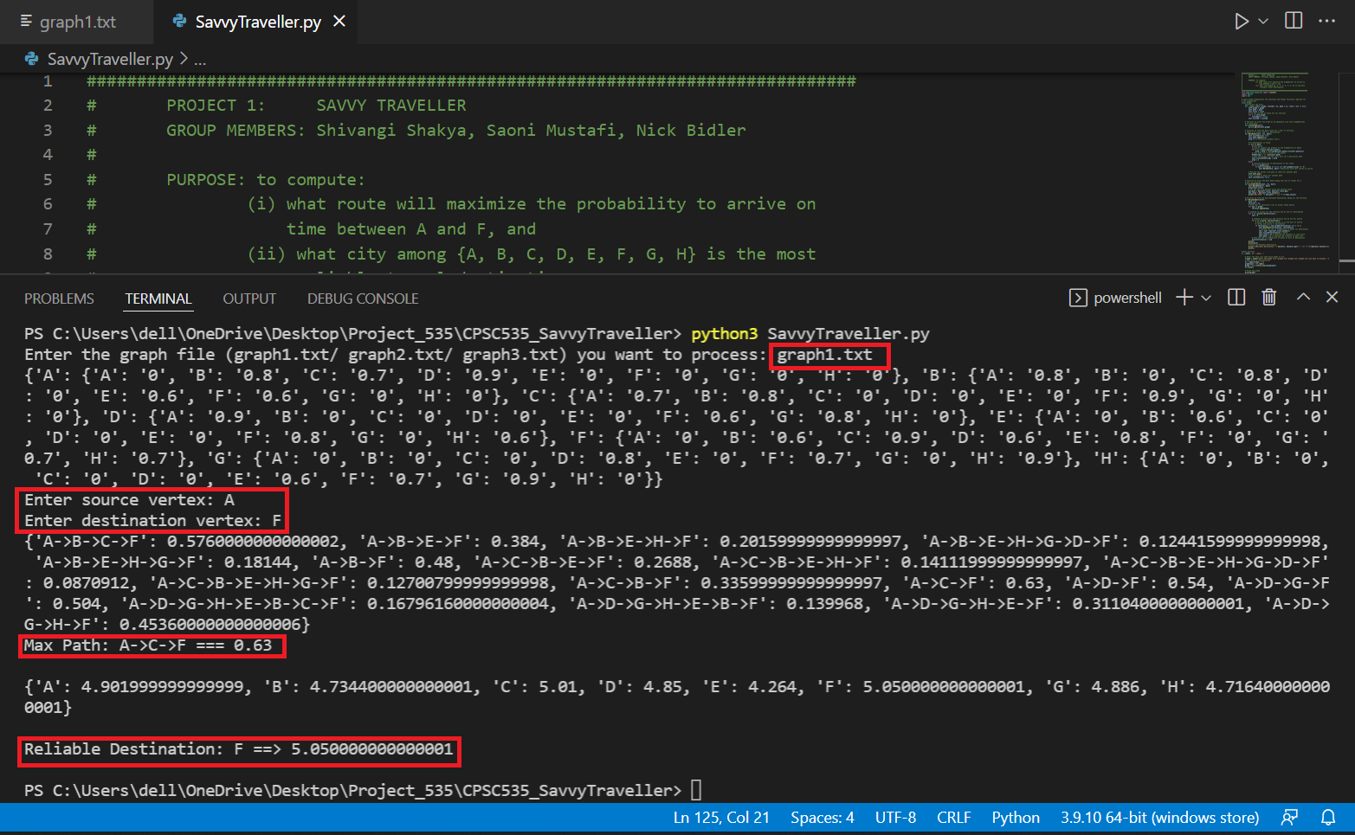

Screenshot of example 2:

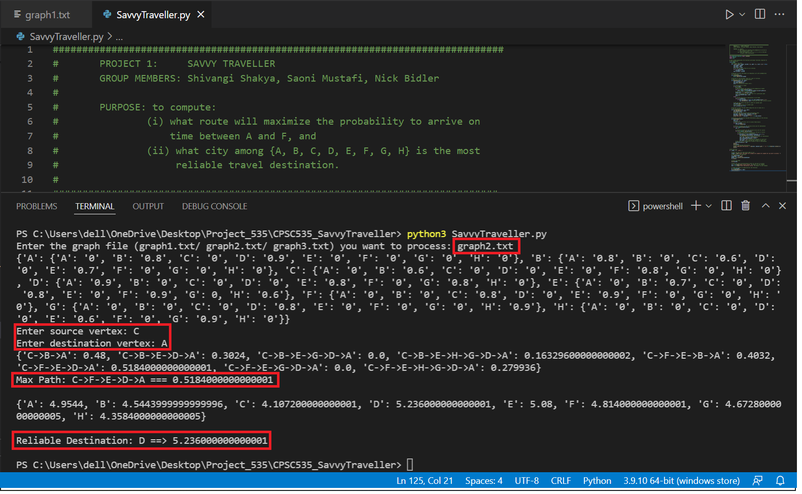

Screenshot of example 3:

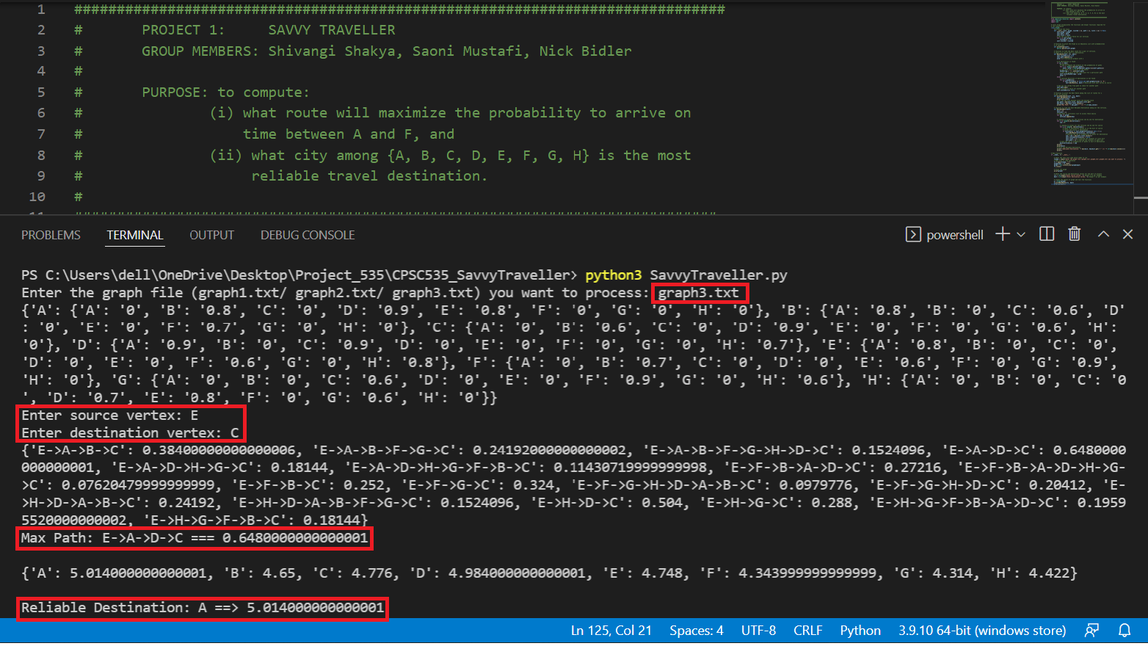

Screenshot of the Group: