INTERVENTIONAL PAIN PROCEDURES
Fluoroscopy-Guided Techniques

— Hinglish mein Complete Guide —

Dr. VARUN KUMAR VARSHNEY
Interventional Pain Specialist
Pain Management | Fluoroscopy-Guided Procedures
First Edition — 2025

Preface (Prastavna)

Yeh book un sabhi doctors, residents aur pain fellows ke liye likhi gayi hai jo interventional pain procedures seekhna chahte hain. Maine is book mein Hinglish (Hindi + English mix) ka use kiya hai taaki medical concepts asaani se samajh mein aayein aur yaad rakhna aasaan ho.
Fluoroscopy-guided procedures mein C-arm X-ray machine ka use karke real-time imaging ki jaati hai. Is se needle ko bilkul sahi jagah par rakhna possible ho jaata hai. Bina fluoroscopy ke ye procedures 'blind' hoti hain aur complications ka risk bahut zyada hota hai.
Is book mein hum detailed step-by-step sikhenge:
- Spine ki anatomy aur fluoroscopy basics
- Har procedure ke step-by-step diagrams (clear illustrations ke saath)
- Common interventional procedures ki technique
- Complications aur unse kaise bachein
- Drugs, doses aur quick reference tables

Aasha hai ye book aapke liye ek useful bedside reference bane.
— Dr. Varun Kumar Varshney

Chapter 1: Spine Anatomy aur Fluoroscopy Basics

1.1 Reedh Ki Haddi (Spine) ki Banawat
Hamari reedh ki haddi 33 vertebrae (choti haddiyon) se bani hoti hai. In ke beech rubber cushion jaisi discs hoti hain. Spinal cord is column ke andar hoti hai aur brain se signals le jaati hai. Fluoroscopy mein hum in structures ko real-time X-ray se dekhte hain aur needle guide karte hain.

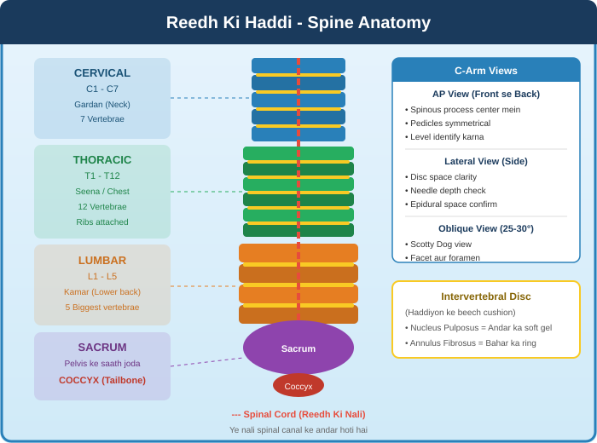
Figure 1.1: Spine Anatomy - Cervical, Thoracic, Lumbar, Sacrum aur C-Arm Views

1.2 Vertebra ke Important Parts
Fluoroscopy mein needle rakhne ke liye in landmarks ko pehchanna zaroori hai:
- Vertebral Body: Sabse bada part (front). Cement yahan fill hoti hai (vertebroplasty mein).
- Pedicle: AP view mein oval shape - 'Owl Eye'. Entry point for many procedures.
- Spinous Process: Midline mein hona chahiye. Seedha AP view confirm karta hai.
- Facet Joint: Do adjacent vertebrae ke articular processes milkar banate hain. Arthritis ka common source.
- Transverse Process: Medial branch block ke liye landmark.
- Foramen: Opening jahan se nerve nikalti hai. Transforaminal ESI ka target.

1.3 C-Arm Fluoroscopy - Teen Main Views
C-Arm ke Teen Zaroori Views:
1. AP (Anteroposterior) View: Seedha front-to-back view. Spinous process center mein honi chahiye. Level identify karne ke liye. Starting position.
2. Lateral View (Side View): Disc space aur needle depth dekhne ke liye. Epidural space confirm karna. Vertebroplasty mein cement spread dekhna.
3. Oblique View (25-30 degrees): 'Scotty Dog View' - Facet joints aur foramen ke liye. Medial Branch Block ki target position.
RADIATION SAFETY: Lead apron + thyroid shield + glasses hamesha. ALARA principle follow karo.

Chapter 2: Epidural Steroid Injection (ESI)

2.1 ESI kya hoti hai aur kab di jaati hai?
Epidural Steroid Injection mein anti-inflammatory steroid aur local anesthetic ko spinal cord ki outer covering (dura mater) ke aas-paas ke space - 'epidural space' - mein inject kiya jaata hai. Jab disc herniate hoti hai ya spinal stenosis hoti hai, inflammatory chemicals nerves ko irritate karte hain. Steroid injection in chemicals ko suppress karti hai.

ESI ke Indications (Kab deni chahiye):
Disc herniation with radiculopathy (Leg mein dard jaana - Sciatica)
Lumbar spinal stenosis (Nali ka tang hona)
Cervical radiculopathy (Haath mein dard/numbness)
Foraminal stenosis
Degenerative disc disease with radicular symptoms
Post-laminectomy syndrome (Surgery ke baad bhi dard)

2.2 Step-by-Step Procedure (Interlaminar ESI)
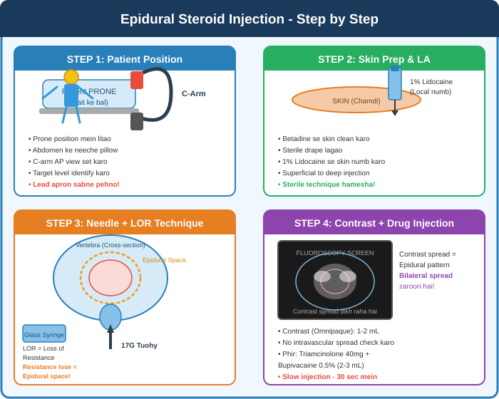
Figure 2.1: Epidural Steroid Injection - Charon Steps (Patient Position, LA, Needle+LOR, Contrast+Drug)

2.3 Epidural Space ki Anatomy (Cross Section)
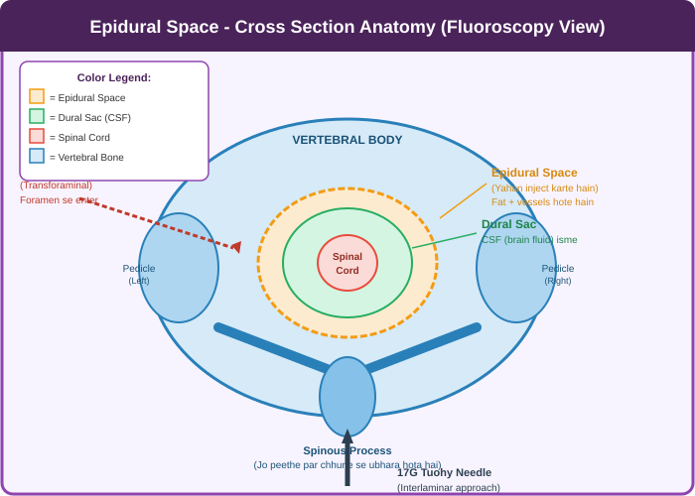
Figure 2.2: Epidural Space Cross Section - Spinal Canal, Dural Sac, Needle Approaches

2.4 Transforaminal ESI - Targeted Approach
Transforaminal ESI mein needle ko vertebral foramen ke through, specific nerve root ke paas rakhte hain. Ye 'safe triangle' mein jaati hai. Zyada targeted hai isliye kam drug chahiye aur zyada effective hai.
- Safe Triangle: Pedicle ke inferior border, nerve root ke lateral border aur lateral bony border se bana triangle
- Contrast: 'Sleeve' pattern dikhna chahiye - nerve root ke around
- CAUTION: Artery of Adamkiewicz (T8-L1 level par) - Real-time fluoroscopy MUST hai
- Non-particulate steroid (Dexamethasone) safer for TF-ESI - no embolic risk
LOR Technique - Yaad Rakhein:
Glass Syringe: Saline filled. Constant gentle pressure maintain karo.
Ligamentum Flavum: Resistance feel hoti hai yahan.
Epidural Space: Resistance suddenly LOSE hoti hai - ye 'LOR' hai!
Confirm: Lateral view mein depth dekhein. Phir contrast inject karo.
NEVER inject without fluoroscopic confirmation!

Chapter 3: Facet Joint Injection aur Medial Branch Block

3.1 Facet Pain ki Pehchaan
Facet joints (zygapophyseal joints) spinal column ke posterior joints hain. Arthritis, inflammation ya injury se yahan pain hoti hai. Ye dard axial hoti hai (seedha back/neck mein, leg mein nahi jaati typically), sone se better hoti hai, activities se worse hoti hai.

3.2 Step-by-Step Procedure
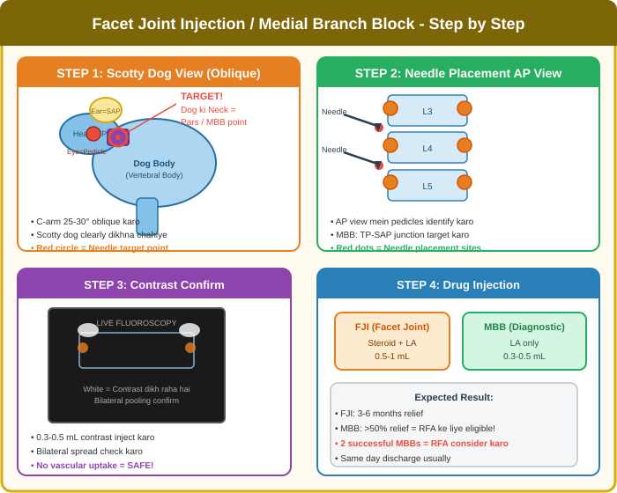
Figure 3.1: Facet Joint Injection / MBB - Scotty Dog View, Needle Placement, Contrast, Drug Injection

3.3 Scotty Dog View - Detail mein
Scotty Dog Anatomy (Oblique Fluoroscopy):
Dog ki Aankhein (Eyes) = PEDICLE - sabse important landmark
Dog ka Sir (Head) = TRANSVERSE PROCESS
Dog ke Kaan (Ear) = SUPERIOR ARTICULAR PROCESS
Dog ki Gardan (Neck) = PARS INTERARTICULARIS - MBB target!
Dog ka Aagla Paaon (Front leg) = INFERIOR ARTICULAR PROCESS
Dog ka Pichla Paaon (Back leg) = Transverse process (lower level)
MBB TARGET: Neck par needle rakho - TP aur SAP ke junction par

3.4 Medial Branch Block (MBB) vs Facet Joint Injection (FJI)
- FJI: Directly facet joint cavity mein steroid + LA. Therapeutic. 0.5-1 mL. 3-6 months relief.
- MBB: Medial branch nerve block. Mainly DIAGNOSTIC. LA only (0.3-0.5 mL). Agar 2 baar >50% relief to RFA consider karo.
- Each facet joint = 2 medial branches. L3-4 joint = L3 MB + L2 MB. Isliye 2 levels treat karte hain.
- Cervical MBB: C-pillar view mein, concave junction of pillar. More complex.

Chapter 4: Radiofrequency Ablation (RFA)

4.1 RFA Kya Hai?
Radiofrequency Ablation mein high-frequency electric current se heat generate ki jaati hai. Is heat (80-90 degrees Celsius) se medial branch nerve permanently destroy hoti hai. Ye facet joint ka dard convey karti thi - ab nahi karegi. Duration of effect: 6-18 months (nerve regenerate ho sakti hai baad mein).

RFA ke liye Zaruri Pre-requisite:
2 separate Diagnostic MBBs karna zaroori hai pehle
Dono MBBs mein >50% pain relief milni chahiye
Relief temporary (hours se days) - sirf confirm karta hai ki pain facet joint se aa rahi hai
Phir hi RFA ka decision lena chahiye - permanent procedure hai!

4.2 Step-by-Step RFA Procedure
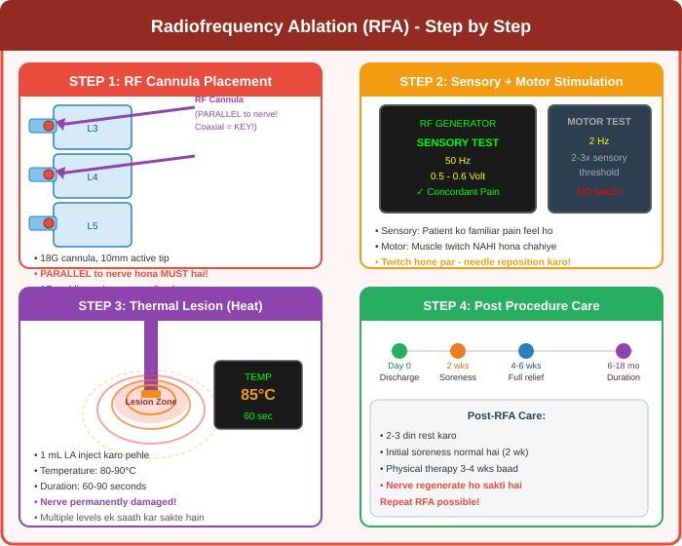
Figure 4.1: RFA - Cannula Placement (Parallel!), Sensory/Motor Test, Thermal Lesion, Post Care

4.3 Sensory aur Motor Testing - Bahut Zaroori Hai!
Sensory test se confirm hota hai ki needle correct nerve ke paas hai. Motor test se confirm hota hai ki adjacent motor nerve damage nahi hogi.
- Sensory Test: 50 Hz, 0.5-0.6 Volt par patient ko familiar/concordant pain feel honi chahiye
- Motor Test: 2 Hz, 2-3 times sensory threshold par - muscle twitch NAHI hona chahiye
- Agar twitch ho to: Needle reposition karo. Motor nerve damage hone se weakness ho sakti hai!
- Impedance: 200-400 ohms normal range. Check karo pehle.

4.4 Pulsed RFA (PRF) - Gentler Option
PRF mein continuous heat nahi dete - pulses mein energy dete hain. Temperature 42 degrees Celsius se kam rehti hai. Nerve destroy nahi hoti, sirf modulated hoti hai. DRG (Dorsal Root Ganglion) blocks ke liye safer. Peripheral nerve injuries mein use.

Chapter 5: Vertebroplasty aur Kyphoplasty

5.1 Compression Fracture - Kya Hoti Hai?
Compression fracture mein vertebral body ki height kam ho jaati hai - ye haddi crush ho jaati hai. Mainly osteoporosis (haddi kamzor) ki wajah se hoti hai. Post-menopausal women mein common. Cancer mein bhi ho sakti hai (pathological fracture). Suddenly severe back pain hoti hai.

5.2 Step-by-Step Kyphoplasty
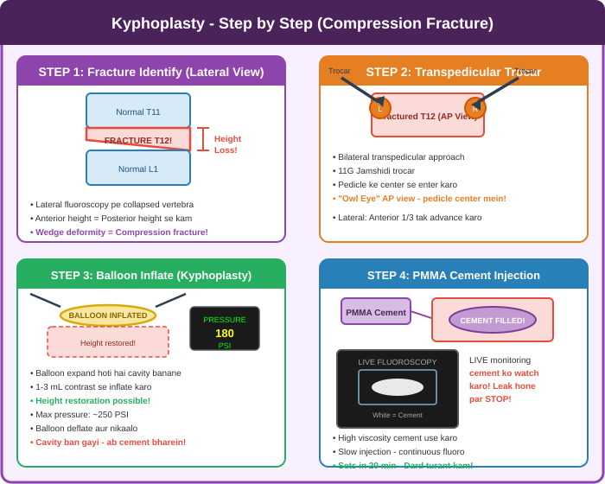
Figure 5.1: Kyphoplasty Steps - Fracture Identify, Transpedicular Trocar, Balloon Inflate, Cement Fill

5.3 Cement Injection - Safety Tips
CRITICAL Safety Rules for Cement Injection:
BIPLANE fluoroscopy prefer karein - ek saath AP aur Lateral dekhein
LIVE real-time fluoroscopy during cement injection - aankhein screen par rakho!
Posterior wall ke paas cement aate dekhein - STOP immediately
Spinal canal mein cement = EMERGENCY - neural compression
Disc mein cement = adjacent fracture risk badh jaata hai
High viscosity PMMA use karo - leakage kam hoti hai
Cement 20 minutes mein set ho jaata hai - irreversible!
Bilateral pedicle approach se better fill hoti hai

- Vertebroplasty: Directly cement inject (no balloon). Faster, cheaper. Height restore nahi hoti.
- Kyphoplasty: Balloon pehle inflate (cavity banao), phir cement. Height partial restore. Safer.
- Result: Pain turant (24-48 hours mein) significantly kam ho jaati hai!

Chapter 6: Spinal Cord Stimulation (SCS)

6.1 SCS kya hai?
Spinal Cord Stimulation ek advanced neuromodulation technique hai jisme epidural space mein electrical leads implant ki jaati hain. Ye leads mild electrical impulses deliver karte hain spinal cord ko. Pain signals brain tak nahi pahunchte - 'Gate Control Theory'. Patient ko tingling/buzzing feel hoti hai jo dard replace kar deti hai.

6.2 Lead Placement - Fluoroscopic Technique
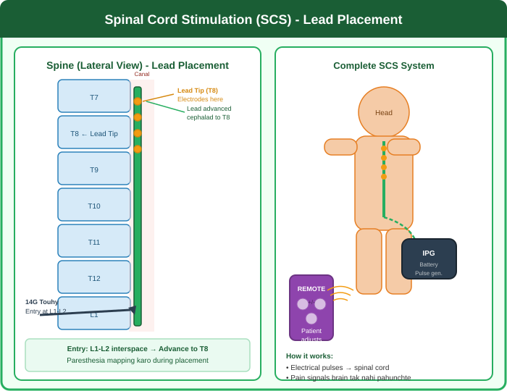
Figure 6.1: SCS Lead Placement - Epidural entry at L1-L2, Lead advance to T8-T9, IPG system

6.3 Trial Period - Bahut Important!
SCS ek 2-stage procedure hai. Pehle 7-day TRIAL hoti hai. Agar trial successful ho (>50% pain relief) tab permanent implant consider karte hain.
SCS Trial ke Dौरaan:
Lead externalized rahti hai - extension wire se external stimulator connected
Patient normal activities kare (ghar jaaye) - real-world testing
Pain diary: Har din VAS score record karo, activities note karo
Paresthesia mapping: Dard wali jagah cover ho rahi hai? (Traditional SCS)
Success criterion: >50% pain reduction on 2 consecutive days
Modern SCS (HF10, Burst): No paresthesia - subthreshold stimulation

6.4 SCS Indications
- Failed Back Surgery Syndrome (FBSS): Surgery ke baad bhi dard - best evidence
- Complex Regional Pain Syndrome (CRPS): Burning, allodynia - excellent results
- Refractory Angina: Cardiac pain jo medications se control nahi
- Neuropathic leg/arm pain
- Peripheral Vascular Disease

Chapter 7: Celiac Plexus Block aur Neurolysis

7.1 Celiac Plexus - Location aur Importance
Celiac plexus L1 vertebra ke level par aorta ke aas-paas nerve fibers ka ek cluster hai. Yeh upper abdominal organs (stomach, liver, gallbladder, pancreas, small bowel) se dard ke signals convey karta hai. Pancreatic cancer mein yeh bahut severe pain ka source hota hai.

7.2 Bilateral Paravertebral Approach
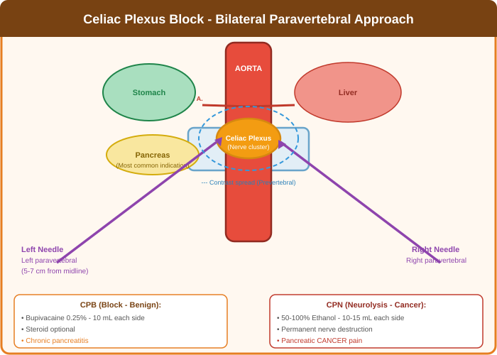
Figure 7.1: Celiac Plexus Block - Bilateral Needles, Aorta, Celiac Plexus, Organs

7.3 CPB vs CPN
- Celiac Plexus Block (CPB): Bupivacaine + Steroid. Chronic pancreatitis ke liye. Temporary effect. 10 mL per side.
- Celiac Plexus Neurolysis (CPN): 50-100% Ethanol. Pancreatic CANCER. Permanent destruction. 10-15 mL per side.
- AP + Lateral views: Prevertebral smooth spread confirm karo ('butterfly' pattern).
- Orthostatic hypotension: IV fluids pehle dein. Post-procedure 24 hours monitor karo.
- Diarrhea: Sympathetic block se. Usually 1-2 weeks mein theek ho jaati hai.

Chapter 8: Complications aur Safety

8.1 Serious Complications - Pehchaan aur Prevention
VASCULAR - Sabse Dangerous!
Intravascular Injection: Drug directly blood vessel mein jaaye. Seizure, cardiac arrest. Prevention: Real-time fluoroscopy + contrast ALWAYS.
Hematoma: Anticoagulants band karein pehle (ASRA guidelines follow karein).
Arterial Puncture: Contrast check. Yeh never inject without confirming position.

NEUROLOGICAL Complications:
Dural Puncture (PDPH): Accidental CSF leak - positional headache. Treatment: Bed rest, caffeine, blood patch.
Nerve Root Injury: Paresthesia during injection - STOP! Needle reposition karo.
Spinal Cord Injury: Most feared. Never inject if needle position unconfirmed.
Epidural Hematoma: Emergency! MRI + neurosurgical consultation.

INFECTIOUS Complications:
Epidural Abscess: Severe pain + fever + neurological symptoms. MRI. Urgent surgery.
Prevention: Strict sterile technique. Fever mein procedure postpone karo.
Discitis: Disc infection post-discography. Prevention: Prophylactic antibiotics.

8.2 Radiation Safety - ALARA Principle
- Lead apron (0.5mm Pb equivalent) + thyroid collar + lead glasses - HAMESHA
- Source-to-patient: C-arm source neeche (floor facing) - scatter radiation kam
- Distance: Double distance = Quarter radiation (Inverse Square Law)
- Last Image Hold (LIH) use karo - continuous fluoroscopy avoid karo
- Dosimeter badge monthly check karo
- Pregnant staff: Extra lead apron + fetal dosimeter

Chapter 9: Quick Reference Tables

9.1 Procedure Summary Table
Procedure | Target | C-Arm View | Drug | Duration
IL-ESI | Epidural Space | AP + Lateral | Steroid+LA | 4-6 weeks
TF-ESI | Nerve Root | Oblique+AP+Lat | Steroid+LA | 4-8 weeks
Caudal ESI | Sacral Epidural | AP + Lateral | Steroid+LA | 4-6 weeks
Facet Inj. | Joint Cavity | Oblique View | Steroid+LA | 3-6 months
MBB | Medial Branch | Oblique View | LA only | Diagnostic
RFA | Medial Branch | AP + Oblique | Heat 80-90C | 6-18 months
Celiac Block | Celiac Plexus | AP + Lateral | LA / Alcohol | Months
Kyphoplasty | Vertebral Body | AP + Lateral | PMMA Cement | Permanent
SCS | Epidural Lead | AP + Lateral | Electrical | Permanent
SI Joint | SI Joint | AP Oblique | Steroid+LA | 3-6 months

9.2 Drug Doses Quick Reference
Common Drugs aur Doses:
Triamcinolone acetonide: 20-80 mg (Facet: 20mg | Epidural: 40-80mg)
Dexamethasone: 4-10 mg (Particulate nahi - TF-ESI ke liye safer)
Methylprednisolone: 40-80 mg (Kenalog)
Bupivacaine 0.25%: 1-3 mL per point | 0.5% ke saath epidural
Lidocaine 1-2%: Diagnostic blocks + skin infiltration
Omnipaque 240: Epidural + facet | Omnipaque 300: Discography
Botulinum Toxin A: 50-200 units (piriformis, trigger points)
Ethanol 100%: 5-15 mL per side (celiac neurolysis)

9.3 Pre-Procedure Checklist
- Informed consent liya? Patient ne samjha aur sign kiya?
- Anticoagulation status check: ASRA guidelines follow karo
- Allergies: Contrast, LA, steroids - history leni hai
- IV access established? Resuscitation equipment ready?
- Lead apron + thyroid shield + glasses - sabne pehne?
- Time-Out: Correct patient? Correct side? Correct level?
- C-arm calibrated? Correct position mein?
- Contrast syringe ready? Non-ionic, correct concentration?
- Sterile field prepare kiya? Drape lagaaya?
- Post-procedure: 30 minutes monitoring minimum

Conclusion
Interventional pain procedures mein mastery ke liye teen cheezein zaroori hain: anatomy ki gehri samajh, fluoroscopy ka skilled use aur patient safety ka unwavering commitment. Ye book ek starting point hai - practical training aur supervised procedures se hi true expertise aati hai.
Hamesha yaad rakhein: 'Primum Non Nocere' - Pehle Harm Mat Karo. Procedure se pehle sochein, plan karein, aur phir execute karein sab safety checks ke saath.
Pain patients ko relief dena ek noble kaam hai. Technical skill ke saath-saath empathy bhi utni hi zaroori hai.

Dr. Varun Kumar Varshney
Interventional Pain Specialist

—— Dard Se Azaadi ——

