

PROJECT TITLE:
ROCK PAPER SCISSOR GAME

SAP ID-590022331
NAME-SHIVANG RATURI
BATCH-46
SUBMITTED TO-MRS DOLLY DAS
GITHUB REPO FOR CODE-
https://github.com/shivangraturii/PROJECT-1

ABSTRACT
This project presents the design and implementation of the classic Rock Paper Scissors game using the C programming language. The goal is to simulate a simple two-player game where the user competes against the computer. The computer makes its selection using random number generation, and the program compares both choices to determine the winner. This project demonstrates fundamental programming concepts such as conditional statements, loops, functions, and random number generation.
PROBLEM DEFINITION
Rock Paper Scissors is a widely known hand game played between two players. Each player selects one of the three shapes: Rock, Paper, or Scissors. The winner is determined based on predefined rules:
- Rock vs Paper → Paper wins
- Rock vs Scissors → Rock wins
- Paper vs Scissors → Scissors wins
The objective of this project is to create an interactive C program that:
- Accepts the user's choice.
- Generates a random choice for the computer.
- Compares both choices.
- Displays the winner.
SYSTEM DESIGN
FLOWCHART
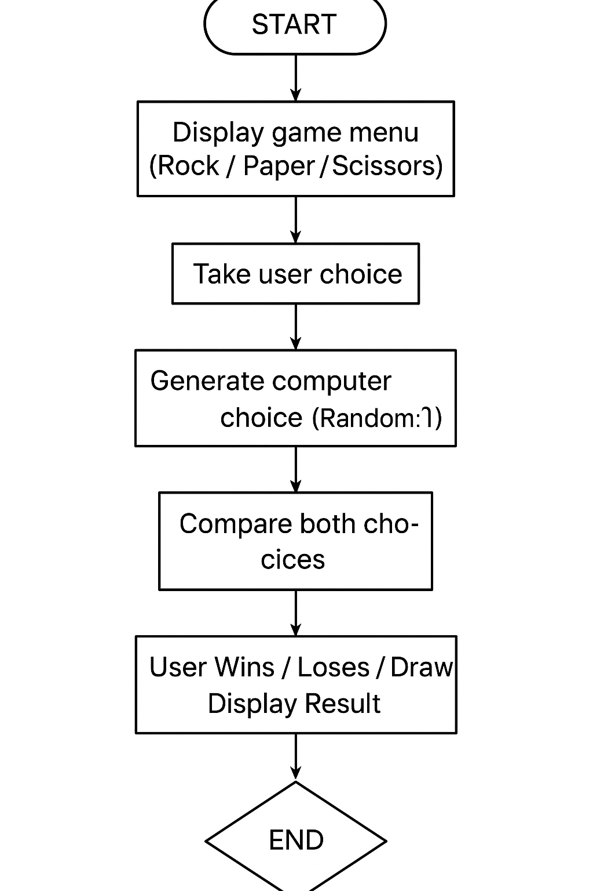

ALGORITHM

- Start the program.
- Display the choice menu: 1–Rock, 2–Paper, 3–Scissors.
- Input the user's choice.
- Generate a random number between 1 and 3 for the computer.
- Compare both choices based on the rules.
- Declare the result: Win, Lose, or Draw.
- End the program.

IMPLEMENTATION DETAILS
SNIPPET: rock_paper_scissors.c

#include <stdio.h>
#include <stdlib.h>

int main() {
int userChoice, compChoice;

printf("=== Rock Paper Scissors Game ===\n");
printf("1. Rock\n2. Paper\n3. Scissors\n");
printf("Enter your choice (1-3): ");
scanf("%d", &userChoice);

// Validate user choice
if (userChoice < 1 || userChoice > 3) {
printf("Invalid choice! Please enter 1, 2, or 3.\n");
return 0;
}

// Generate computer choice randomly
compChoice = (rand() % 3) + 1;

// Display choices
printf("\nYou chose: ");
if (userChoice == 1) printf("Rock");
else if (userChoice == 2) printf("Paper");
else printf("Scissors");

printf("\nComputer chose: ");
if (compChoice == 1) printf("Rock");
else if (compChoice == 2) printf("Paper");
else printf("Scissors");
printf("\n\n");

// Determine the winner
if (userChoice == compChoice) {
printf("Result: It's a Draw!\n");
}
else if ((userChoice == 1 && compChoice == 3) ||
(userChoice == 2 && compChoice == 1) ||
(userChoice == 3 && compChoice == 2)) {
printf("Result: You Win!\n");
}
else {
printf("Result: Computer Wins!\n");
}

return 0;
}

EXPLANATION
- rand() generates the computer's selection.
- Conditional logic determines the outcome.
- The program uses standard input/output libraries.

TESTING RESULTS

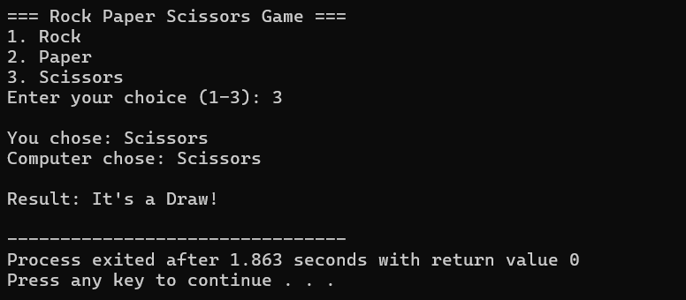

Conclusion & Future Work

Conclusion

The Rock Paper Scissors game effectively demonstrates the use of decision-making structures and random number generation in C. The program fulfills all problem requirements and provides an interactive user experience.

Future Enhancements

- Add multiple rounds with score tracking.
- Use graphical user interface (GUI).
- Implement multiplayer mode.
- Add sound effects or animations

REFERNCES
- Programming in ANSI C – E. Balaguruswamy
- www.cprogramming.com
- C Standard Library documentation

