**LAB 1**

// 110 Substring

#include<stdio.h>

#include<string.h>

int main()

{

int i=0,j=0,n;

char v[100];

printf("Enter the string over the alphabet {1,0} : ");

gets(v);

n=strlen(v);

printf("\nThe string length is : %d",n);

do

{

switch(j)

{

case 0: if(v[i]=='1')

{

j=1;

printf("\nThe state is changed to state 1.");

i++;

}

else if(v[i]=='0')

{

j=0;

printf("\nThe state is changed to state 0.");

i++;

}

break;

case 1: if(v[i]=='1')

{

j=2;

printf("\nThe state is changed to state 2.");

i++;

}

else if(v[i]=='0')

{

j=0;

printf("\nThe state is changed to state 0.");

i++;

}

break;

case 3: printf("\nIt is in state 3 - The Final State.");

i++;

break;

case 2: if(v[i]=='1')

{

j=2;

printf("\nThe state is changed to state 2.");

i++;

}

else if(v[i]=='0')

{

j=3;

printf("\nThe state is changed to state 3 - Final State.");

i++;

}

break;

}

}while(i<n);

printf("\nIt is in the %d state in the end.",j);

if(j==3)

{

printf("\nHence the string is selected.");

}

return 0;

}

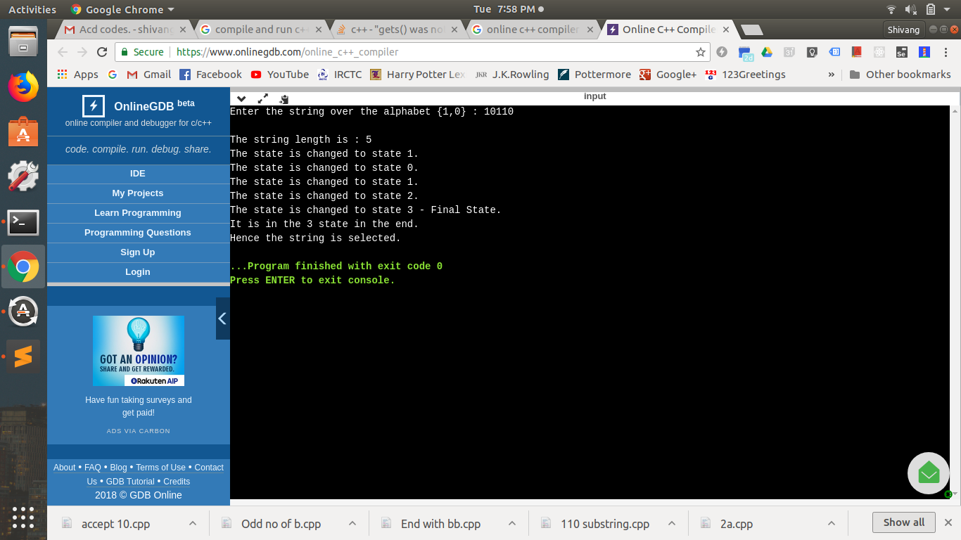

// DFA State machine over {a & b}

#include<stdio.h>

#include<string.h>

int main()

{

int i=0,j=0,n;

char v[100],a,b;

printf("Enter the string over the alphabet {a,b} : ");

gets(v);

n=strlen(v);

printf("\nThe string length is : %d",n);

do

{

switch(j)

{

case 0: if(v[i]=='a')

{

j=1;

printf("\nThe state is changed to state 1 - Final State.");

i++;

}

else if(v[i]=='b')

{

j=2;

printf("\nThe state is changed to state 2 - Dead State.");

i++;

}

break;

case 1: if(v[i]=='a')

{

j=1;

printf("\nThe state is changed to state 1 - Final State.");

i++;

}

else if(v[i]=='b')

{

j=3;

printf("\nThe state is changed to state 3.");

i++;

}

break;

case 2: printf("\nIt is in state 2 - The Dead State.");

i++;

break;

case 3: if(v[i]=='a')

{

j=1;

printf("\nThe state is changed to state 1 - Final State.");

i++;

}

else if(v[i]=='b')

{

j=3;

printf("\nThe state is changed to state 3.");

i++;

}

break;

}

}while(i<n);

printf("\nIt is in the %d state in the end.",j);

if(j==1)

{

printf("\nHence the string is selected.");

}

return 0;

}

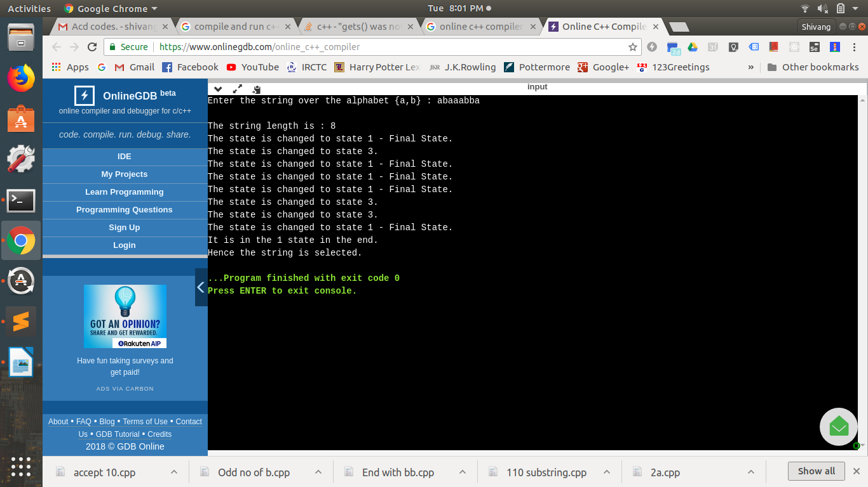

// Accept 10

#include<stdio.h>

#include<string.h>

int main()

{

int i=0,j=0,n;

char v[100];

printf("Enter the string over the alphabet {1,0} : ");

gets(v);

n=strlen(v);

printf("\nThe string length is : %d",n);

do

{

switch(j)

{

case 0: if(v[i]=='1')

{

j=1;

printf("\nThe state is changed to state 1.");

i++;

}

else if(v[i]=='0')

{

j=3;

printf("\nThe state is changed to state 3 - Dead State.");

i++;

}

break;

case 1: if(v[i]=='1')

{

j=3;

printf("\nThe state is changed to state 3 - Dead State.");

i++;

}

else if(v[i]=='0')

{

j=2;

printf("\nThe state is changed to state 2 - Final State.");

i++;

}

break;

case 3: printf("\nIt is in state 3 - The Dead State.");

i++;

break;

case 2: if(v[i]=='1')

{

j=3;

printf("\nThe state is changed to state 3 - Dead State.");

i++;

}

else if(v[i]=='0')

{

j=3;

printf("\nThe state is changed to state 3 - Dead State.");

i++;

}

break;

}

}while(i<n);

printf("\nIt is in the %d state in the end.",j);

if(j==2)

{

printf("\nHence the string is selected.");

}

return 0;

}

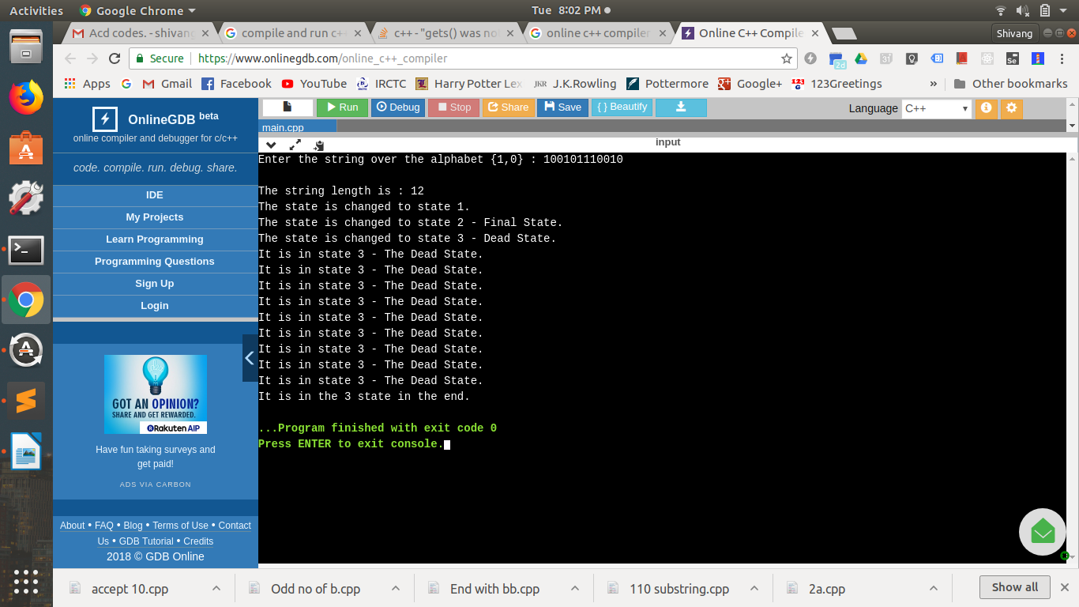

// Ends with bb

#include<stdio.h>

#include<string.h>

int main()

{

int i=0,j=0,n;

char v[100],a,b;

printf("Enter the string over the alphabet {a,b} : ");

gets(v);

n=strlen(v);

printf("\nThe string length is : %d",n);

do

{

switch(j)

{

case 0: if(v[i]=='a')

{

j=0;

printf("\nThe state is changed to state 0.");

i++;

}

else if(v[i]=='b')

{

j=1;

printf("\nThe state is changed to state 1.");

i++;

}

break;

case 1: if(v[i]=='a')

{

j=0;

printf("\nThe state is changed to state 0.");

i++;

}

else if(v[i]=='b')

{

j=2;

printf("\nThe state is changed to state 2 - Final State.");

i++;

}

break;

case 2: if(v[i]=='a')

{

j=0;

printf("\nThe state is changed to state 0.");

i++;

}

else if(v[i]=='b')

{

j=2;

printf("\nThe state is changed to state 2 - Final State.");

i++;

}

break;

}

}while(i<n);

printf("\nIt is in the %d state in the end.",j);

if(j==2)

{

printf("\nHence the string is selected.");

}

return 0;

}

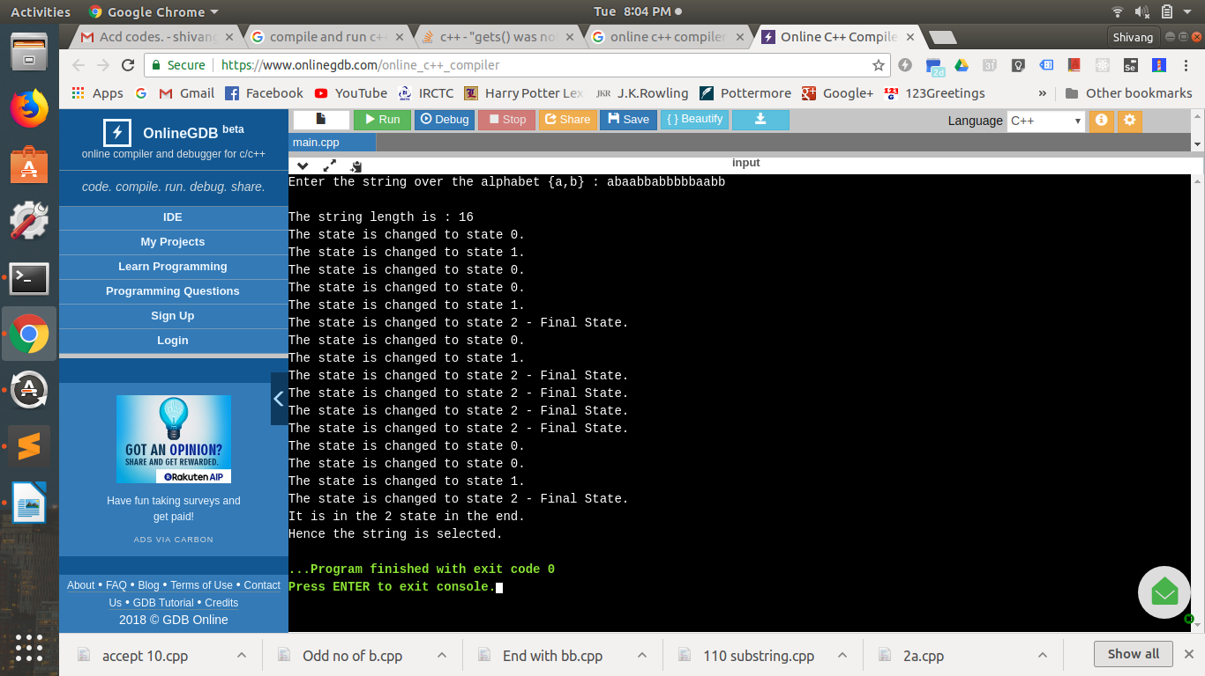

// Odd Numbers of b

#include<stdio.h>

#include<string.h>

int main()

{

int i=0,j=0,n;

char v[100],a,b;

printf("Enter the string over the alphabet {a,b} : ");

gets(v);

n=strlen(v);

printf("\nThe string length is : %d",n);

do

{

switch(j)

{

case 0: if(v[i]=='a')

{

j=0;

printf("\nThe state is changed to state 0.");

i++;

}

else if(v[i]=='b')

{

j=1;

printf("\nThe state is changed to state 1 - Final State.");

i++;

}

break;

case 1: if(v[i]=='a')

{

j=1;

printf("\nThe state is changed to state 1 - Final State.");

i++;

}

else if(v[i]=='b')

{

j=0;

printf("\nThe state is changed to state 0.");

i++;

}

break;

}

}while(i<n);

printf("\nIt is in the %d state in the end.",j);

if(j==1)

{

printf("\nHence the string is selected.");

}

return 0;

}

