**LAB 1**

// Binary Search by Iteration

#include<stdio.h>

void main()

{

/* code */

int arr[100], n, i, key, mid, test, x, first, last;

printf("Enter Number of test array\n");

scanf("%d", &n);

printf("Enter Sorted test Array\n");

for(i=0; i<n; i++){

scanf("%d", &arr[i]);

}

printf("Enter Number to Search\n");

scanf("%d", &test);

first = 0;

last = n-1;

mid = (first + last)/2;

x = 1;

while(x == 1 || first == last){

if(test == arr[mid]){

printf("%d is in %dth index\n", test, mid+1);

x = 0;

}

else if(test > arr[mid]){

first = mid;

mid = (first + last)/2;

}

else if(test < arr[mid]){

last = mid;

mid = (first + last)/2;

}

}

}

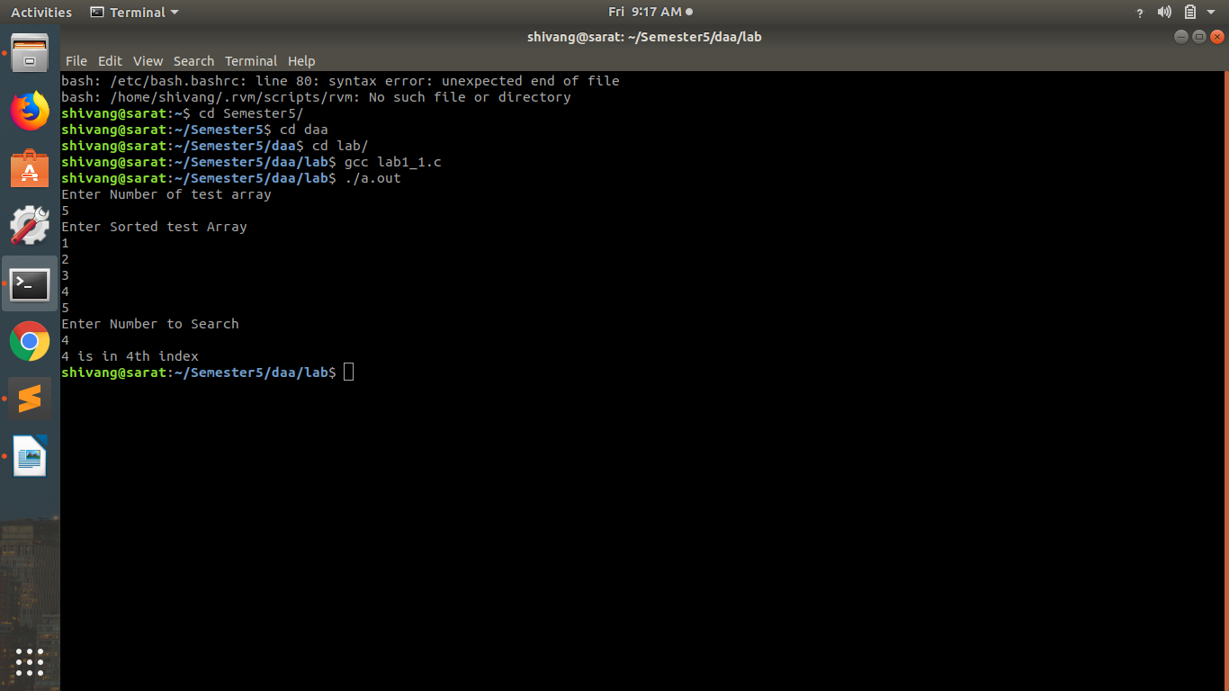

// Binary Search by Recursion

#include<stdio.h>

int arr[100], n, test,result, i;

int bin(int first1, int last1, int mid1,int n1){

if (test == arr[mid1]){

result = mid1;

return result+1;

}

else if(test > arr[mid1]){

first1 = mid1+1;

mid1 = (first1+last1)/2;

result = bin(first1, last1,mid1,n1);

}

else if(test < arr[mid1]){

last1 = mid1-1;

mid1 = (first1+last1)/2;

result = bin(first1, last1,mid1,n1);

}

//return result;

}

void main(){

int mid, first, last;

printf("N\n");

scanf("%d", &n);

printf("Array\n");

for (i = 0; i < n; ++i)

{

/* code */

scanf("%d", &arr[i]);

}

printf("Test\n");

scanf("%d", &test);

first = 0;

last = n-1;

mid = (first+last)/2;

result = bin(first, last,mid,n);

printf("%d is in %dth position\n", test, result);

}

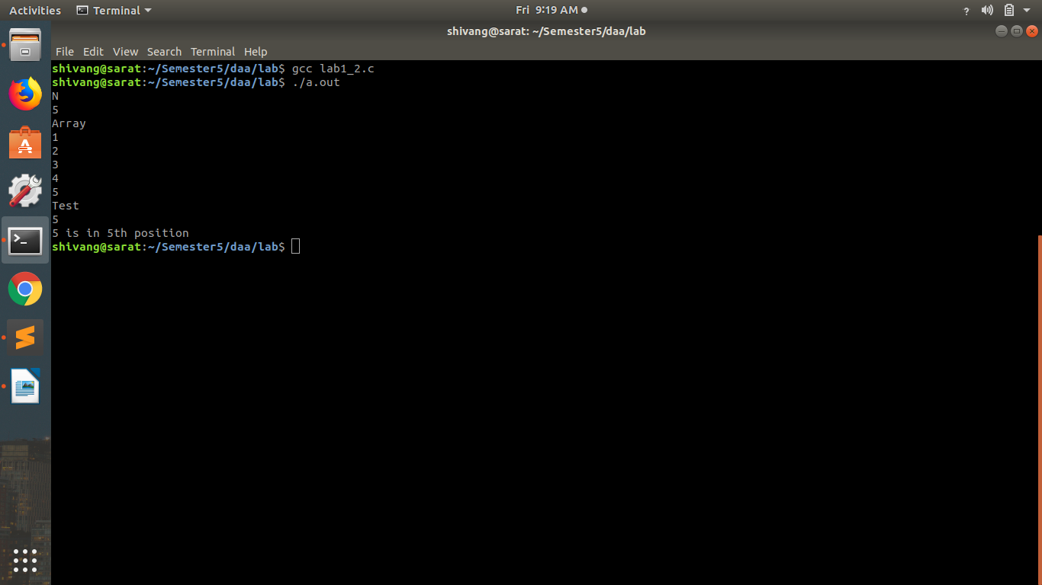

// Selection Sort

#include <stdio.h>

void main(){

int arr[100],n, min, diff, temp;

printf("Number\n");

scanf("%d", &n);

printf("--------------------------------------------------------------------------------\n");

printf("Array\n");

for (int i = 0; i < n; ++i)

{

/* code */

scanf("%d", &arr[i]);

}

printf("--------------------------------------------------------------------------------\n");

for (int i = 0; i < n; ++i)

{

/* code */

for (int j = i; j < n; ++j)

{

/* code */

if(arr[i] > arr[j]){

temp = arr[j];

arr[j] = arr[i];

arr[i] = temp;

}

}

}

printf("--------------------------------------------------------------------------------\n");

printf("Result\n");

printf("--------------------------------------------------------------------------------\n");

for (int i = 0; i < n; ++i)

{

/* code */

printf("%d\n", arr[i]);

}

}

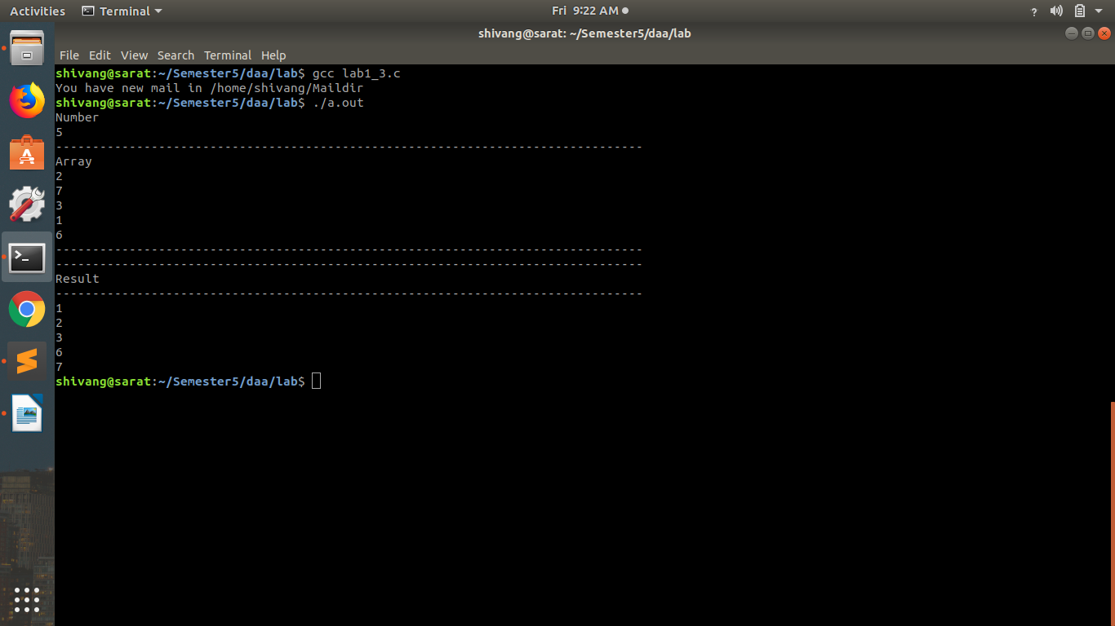

// Bubble sort

#include <stdio.h>

void main(){

int arr[100],n, min, i, j, temp;

printf("Number\n");

scanf("%d", &n);

printf("--------------------------------------------------------------------------------\n");

printf("Array\n");

for (int i = 0; i < n; ++i)

{

/* code */

scanf("%d", &arr[i]);

}

printf("--------------------------------------------------------------------------------\n");

for (i = 0; i < n; i++){

for(j = 0; j < n; j++) {

if(arr [j] > arr [i]){

temp = arr [j];

arr[j]=arr[i];

arr[i]=temp;

}

}

}

printf("--------------------------------------------------------------------------------\n");

printf("Result\n");

printf("--------------------------------------------------------------------------------\n");

for (int i = 0; i < n; ++i)

{

/* code */

printf("%d\n", arr[i]);

}

}

