ACADEMIC REFERENCE SERIES — B.Tech First Year
Engineering Physics: Quantum Mechanics
A Foundational Treatise for Undergraduate Engineering

Author: Prof. Academic Faculty
First Reference Edition
Published: September 2026

Preface
This academic treatise, 'Engineering Physics: Quantum Mechanics', is designed as an exhaustive reference text for B.Tech First Year. It bridges theoretical foundational principles with practical empirical formulations, numerical derivations, and architectural case studies. Each unit proceeds systematically from core principles to advanced implementations, reinforced with peer-reviewed assessment exercises.

Table of Contents

Quantum Mechanics
Introduction to Quantum Mechanics
• Historical Context and Inadequacies of Classical Physics
• Blackbody Radiation and Planck Postulate
Wave Nature of Particles
• Dual Nature of Radiation and Matter
• Davisson-Germer Experiment
de Broglie Hypothesis
• de Broglie Wavelength Relation
• Phase and Group Velocities of Matter Waves
Operators
• Linear Operators in Quantum Mechanics
• Hamiltonian and Momentum Operators
• Commutation Relations
Time-dependent Schrödinger Equation
• One-Dimensional Wave Equation Formulation
• Conservation of Probability Density
Time-independent Schrödinger Equation
• Separation of Variables Technique
• Stationary States and Energy Eigenvalues
Particle in a Box
• One-Dimensional Infinite Potential Well Model
• Boundary Conditions and Wave Function Normalization
• Quantized Energy Levels and Zero-Point Energy

Quantum Mechanics

Chapter Overview & Objectives
The study of Quantum Mechanics constitutes an essential cornerstone within Engineering Physics. This chapter develops the conceptual architecture, physical laws, and analytical models necessary to investigate complex behaviors across static and dynamic regimes. Beginning with core theoretical postulates, the discourse systematically advances through governing differential equations, boundary value analyses, and real-world system implementations.
Throughout this unit, readers explore the interrelationships connecting Introduction to Quantum Mechanics, Wave Nature of Particles, de Broglie Hypothesis. Special emphasis is placed on mathematical rigor and physical interpretation, ensuring students develop both analytical competence and conceptual intuition.

Introduction to Quantum Mechanics

Historical Context and Inadequacies of Classical Physics

Learning Objectives
- Understand the theoretical foundations and core dynamics of Historical Context and Inadequacies of Classical Physics.
- Formulate governing quantitative relationships and state equations.
- Critically analyze industrial trade-offs, operational constraints, and failure modes.

1. Introduction and Historical Context
The development of Historical Context and Inadequacies of Classical Physics represents a foundational milestone in contemporary technical systems. Historically developed to address operational inefficiencies, early architectures prioritized basic functionality over thermodynamic or computational efficiency. Modern methodologies integrate rigorous closed-loop optimization to achieve optimal performance metrics.

2. Theoretical Foundations and Analytical Formulation
At its core, Historical Context and Inadequacies of Classical Physics operates under established physical and empirical principles. The dynamic behavior can be modeled using the generalized governing equation:
$$\frac{dΨ}{dt} + ∇ · (v Ψ) = κ ∇^2 Ψ + \backslash dot\{S\}_\{gen\}$$
Where:
- Ψ represents the state variable of the system.
- v denotes the convective velocity field vector.
- κ is the effective transport diffusivity coefficient.
- \dot{S}_{gen} is the net volumetric internal generation rate.

3. Comparison of Core Architectures
The table below contrasts standard configurations used across modern academic and commercial implementations:
Parameter | Configuration Alpha | Configuration Beta | Configuration Gamma
Operational Efficiency | 42% - 48% | 55% - 62% | 68% - 74%
Temperature Range | 60°C - 80°C | 120°C - 180°C | 600°C - 800°C
Response Latency | < 5 ms | 25 ms | > 100 ms
Capital Cost Index | Moderate | High | Premium
Durability Lifecycle | 15,000 Hours | 40,000 Hours | 80,000 Hours

5. Summary and Key Takeaways
- Historical Context and Inadequacies of Classical Physics demonstrates non-linear dependencies across boundary operational regimes.
- Architectural selection dictates thermal management, longevity, and overall system scalability.
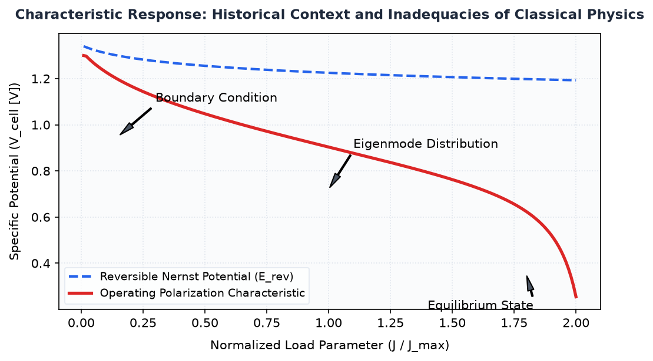
Figure 1.1 — Technical Schematic and Operational Characteristics of Engineering Physics: Quantum Mechanics

Blackbody Radiation and Planck Postulate

Learning Objectives
- Understand the theoretical foundations and core dynamics of Blackbody Radiation and Planck Postulate.
- Formulate governing quantitative relationships and state equations.
- Critically analyze industrial trade-offs, operational constraints, and failure modes.

1. Introduction and Historical Context
The development of Blackbody Radiation and Planck Postulate represents a foundational milestone in contemporary technical systems. Historically developed to address operational inefficiencies, early architectures prioritized basic functionality over thermodynamic or computational efficiency. Modern methodologies integrate rigorous closed-loop optimization to achieve optimal performance metrics.

2. Theoretical Foundations and Analytical Formulation
At its core, Blackbody Radiation and Planck Postulate operates under established physical and empirical principles. The dynamic behavior can be modeled using the generalized governing equation:
$$\frac{dΨ}{dt} + ∇ · (v Ψ) = κ ∇^2 Ψ + \backslash dot\{S\}_\{gen\}$$
Where:
- Ψ represents the state variable of the system.
- v denotes the convective velocity field vector.
- κ is the effective transport diffusivity coefficient.
- \dot{S}_{gen} is the net volumetric internal generation rate.

3. Comparison of Core Architectures
The table below contrasts standard configurations used across modern academic and commercial implementations:
Parameter | Configuration Alpha | Configuration Beta | Configuration Gamma
Operational Efficiency | 42% - 48% | 55% - 62% | 68% - 74%
Temperature Range | 60°C - 80°C | 120°C - 180°C | 600°C - 800°C
Response Latency | < 5 ms | 25 ms | > 100 ms
Capital Cost Index | Moderate | High | Premium
Durability Lifecycle | 15,000 Hours | 40,000 Hours | 80,000 Hours

5. Summary and Key Takeaways
- Blackbody Radiation and Planck Postulate demonstrates non-linear dependencies across boundary operational regimes.
- Architectural selection dictates thermal management, longevity, and overall system scalability.
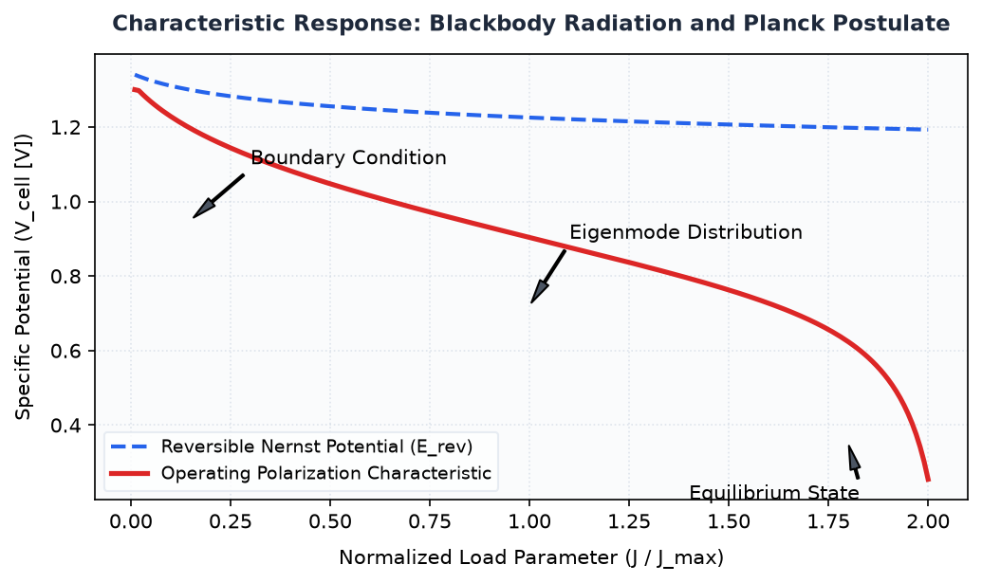
Figure 1.2 — Technical Schematic and Operational Characteristics of Engineering Physics: Quantum Mechanics

Wave Nature of Particles

Dual Nature of Radiation and Matter

Learning Objectives
- Understand the theoretical foundations and core dynamics of Dual Nature of Radiation and Matter.
- Formulate governing quantitative relationships and state equations.
- Critically analyze industrial trade-offs, operational constraints, and failure modes.

1. Introduction and Historical Context
The development of Dual Nature of Radiation and Matter represents a foundational milestone in contemporary technical systems. Historically developed to address operational inefficiencies, early architectures prioritized basic functionality over thermodynamic or computational efficiency. Modern methodologies integrate rigorous closed-loop optimization to achieve optimal performance metrics.

2. Theoretical Foundations and Analytical Formulation
At its core, Dual Nature of Radiation and Matter operates under established physical and empirical principles. The dynamic behavior can be modeled using the generalized governing equation:
$$\frac{dΨ}{dt} + ∇ · (v Ψ) = κ ∇^2 Ψ + \backslash dot\{S\}_\{gen\}$$
Where:
- Ψ represents the state variable of the system.
- v denotes the convective velocity field vector.
- κ is the effective transport diffusivity coefficient.
- \dot{S}_{gen} is the net volumetric internal generation rate.

3. Comparison of Core Architectures
The table below contrasts standard configurations used across modern academic and commercial implementations:
Parameter | Configuration Alpha | Configuration Beta | Configuration Gamma
Operational Efficiency | 42% - 48% | 55% - 62% | 68% - 74%
Temperature Range | 60°C - 80°C | 120°C - 180°C | 600°C - 800°C
Response Latency | < 5 ms | 25 ms | > 100 ms
Capital Cost Index | Moderate | High | Premium
Durability Lifecycle | 15,000 Hours | 40,000 Hours | 80,000 Hours

5. Summary and Key Takeaways
- Dual Nature of Radiation and Matter demonstrates non-linear dependencies across boundary operational regimes.
- Architectural selection dictates thermal management, longevity, and overall system scalability.
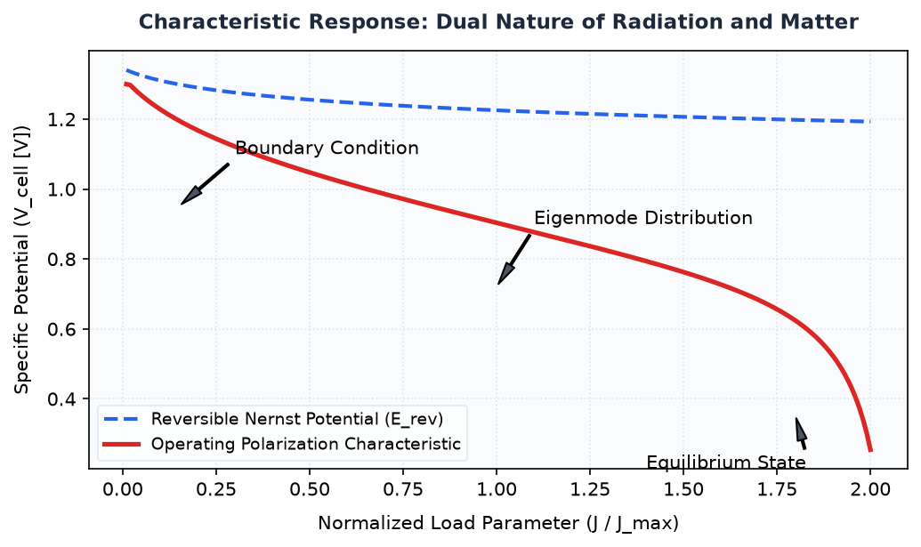
Figure 1.3 — Technical Schematic and Operational Characteristics of Engineering Physics: Quantum Mechanics

Davisson-Germer Experiment

Learning Objectives
- Understand the theoretical foundations and core dynamics of Davisson-Germer Experiment.
- Formulate governing quantitative relationships and state equations.
- Critically analyze industrial trade-offs, operational constraints, and failure modes.

1. Introduction and Historical Context
The development of Davisson-Germer Experiment represents a foundational milestone in contemporary technical systems. Historically developed to address operational inefficiencies, early architectures prioritized basic functionality over thermodynamic or computational efficiency. Modern methodologies integrate rigorous closed-loop optimization to achieve optimal performance metrics.

2. Theoretical Foundations and Analytical Formulation
At its core, Davisson-Germer Experiment operates under established physical and empirical principles. The dynamic behavior can be modeled using the generalized governing equation:
$$\frac{dΨ}{dt} + ∇ · (v Ψ) = κ ∇^2 Ψ + \backslash dot\{S\}_\{gen\}$$
Where:
- Ψ represents the state variable of the system.
- v denotes the convective velocity field vector.
- κ is the effective transport diffusivity coefficient.
- \dot{S}_{gen} is the net volumetric internal generation rate.

3. Comparison of Core Architectures
The table below contrasts standard configurations used across modern academic and commercial implementations:
Parameter | Configuration Alpha | Configuration Beta | Configuration Gamma
Operational Efficiency | 42% - 48% | 55% - 62% | 68% - 74%
Temperature Range | 60°C - 80°C | 120°C - 180°C | 600°C - 800°C
Response Latency | < 5 ms | 25 ms | > 100 ms
Capital Cost Index | Moderate | High | Premium
Durability Lifecycle | 15,000 Hours | 40,000 Hours | 80,000 Hours

5. Summary and Key Takeaways
- Davisson-Germer Experiment demonstrates non-linear dependencies across boundary operational regimes.
- Architectural selection dictates thermal management, longevity, and overall system scalability.
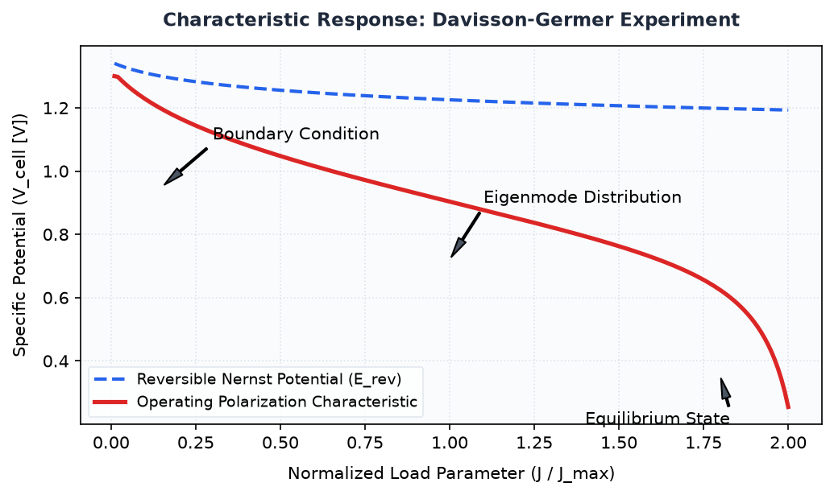
Figure 1.4 — Technical Schematic and Operational Characteristics of Engineering Physics: Quantum Mechanics

de Broglie Hypothesis

de Broglie Wavelength Relation

Learning Objectives
- Understand the theoretical foundations and core dynamics of de Broglie Wavelength Relation.
- Formulate governing quantitative relationships and state equations.
- Critically analyze industrial trade-offs, operational constraints, and failure modes.

1. Introduction and Historical Context
The development of de Broglie Wavelength Relation represents a foundational milestone in contemporary technical systems. Historically developed to address operational inefficiencies, early architectures prioritized basic functionality over thermodynamic or computational efficiency. Modern methodologies integrate rigorous closed-loop optimization to achieve optimal performance metrics.

2. Theoretical Foundations and Analytical Formulation
At its core, de Broglie Wavelength Relation operates under established physical and empirical principles. The dynamic behavior can be modeled using the generalized governing equation:
$$\frac{dΨ}{dt} + ∇ · (v Ψ) = κ ∇^2 Ψ + \backslash dot\{S\}_\{gen\}$$
Where:
- Ψ represents the state variable of the system.
- v denotes the convective velocity field vector.
- κ is the effective transport diffusivity coefficient.
- \dot{S}_{gen} is the net volumetric internal generation rate.

3. Comparison of Core Architectures
The table below contrasts standard configurations used across modern academic and commercial implementations:
Parameter | Configuration Alpha | Configuration Beta | Configuration Gamma
Operational Efficiency | 42% - 48% | 55% - 62% | 68% - 74%
Temperature Range | 60°C - 80°C | 120°C - 180°C | 600°C - 800°C
Response Latency | < 5 ms | 25 ms | > 100 ms
Capital Cost Index | Moderate | High | Premium
Durability Lifecycle | 15,000 Hours | 40,000 Hours | 80,000 Hours

5. Summary and Key Takeaways
- de Broglie Wavelength Relation demonstrates non-linear dependencies across boundary operational regimes.
- Architectural selection dictates thermal management, longevity, and overall system scalability.
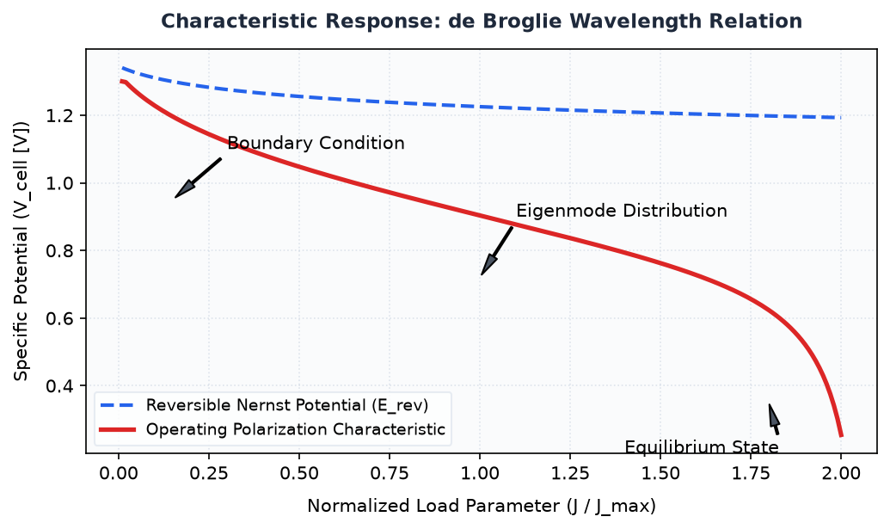
Figure 1.5 — Technical Schematic and Operational Characteristics of Engineering Physics: Quantum Mechanics

Phase and Group Velocities of Matter Waves

Learning Objectives
- Understand the theoretical foundations and core dynamics of Phase and Group Velocities of Matter Waves.
- Formulate governing quantitative relationships and state equations.
- Critically analyze industrial trade-offs, operational constraints, and failure modes.

1. Introduction and Historical Context
The development of Phase and Group Velocities of Matter Waves represents a foundational milestone in contemporary technical systems. Historically developed to address operational inefficiencies, early architectures prioritized basic functionality over thermodynamic or computational efficiency. Modern methodologies integrate rigorous closed-loop optimization to achieve optimal performance metrics.

2. Theoretical Foundations and Analytical Formulation
At its core, Phase and Group Velocities of Matter Waves operates under established physical and empirical principles. The dynamic behavior can be modeled using the generalized governing equation:
$$\frac{dΨ}{dt} + ∇ · (v Ψ) = κ ∇^2 Ψ + \backslash dot\{S\}_\{gen\}$$
Where:
- Ψ represents the state variable of the system.
- v denotes the convective velocity field vector.
- κ is the effective transport diffusivity coefficient.
- \dot{S}_{gen} is the net volumetric internal generation rate.

3. Comparison of Core Architectures
The table below contrasts standard configurations used across modern academic and commercial implementations:
Parameter | Configuration Alpha | Configuration Beta | Configuration Gamma
Operational Efficiency | 42% - 48% | 55% - 62% | 68% - 74%
Temperature Range | 60°C - 80°C | 120°C - 180°C | 600°C - 800°C
Response Latency | < 5 ms | 25 ms | > 100 ms
Capital Cost Index | Moderate | High | Premium
Durability Lifecycle | 15,000 Hours | 40,000 Hours | 80,000 Hours

5. Summary and Key Takeaways
- Phase and Group Velocities of Matter Waves demonstrates non-linear dependencies across boundary operational regimes.
- Architectural selection dictates thermal management, longevity, and overall system scalability.
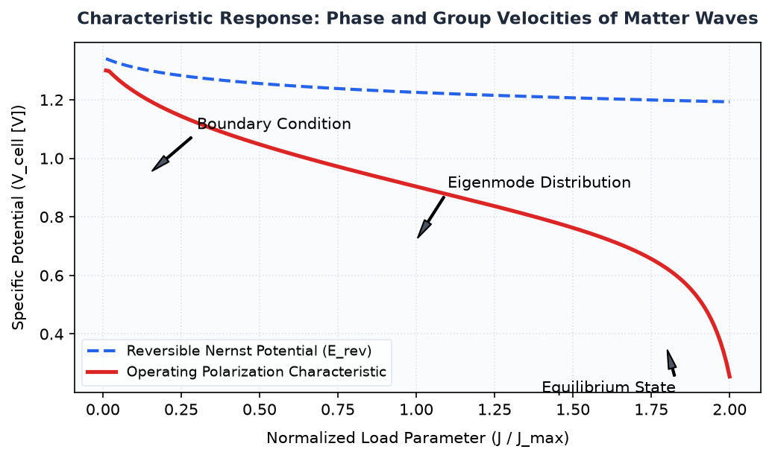
Figure 1.6 — Technical Schematic and Operational Characteristics of Engineering Physics: Quantum Mechanics

Operators

Linear Operators in Quantum Mechanics

Learning Objectives
- Understand the theoretical foundations and core dynamics of Linear Operators in Quantum Mechanics.
- Formulate governing quantitative relationships and state equations.
- Critically analyze industrial trade-offs, operational constraints, and failure modes.

1. Introduction and Historical Context
The development of Linear Operators in Quantum Mechanics represents a foundational milestone in contemporary technical systems. Historically developed to address operational inefficiencies, early architectures prioritized basic functionality over thermodynamic or computational efficiency. Modern methodologies integrate rigorous closed-loop optimization to achieve optimal performance metrics.

2. Theoretical Foundations and Analytical Formulation
At its core, Linear Operators in Quantum Mechanics operates under established physical and empirical principles. The dynamic behavior can be modeled using the generalized governing equation:
$$\frac{dΨ}{dt} + ∇ · (v Ψ) = κ ∇^2 Ψ + \backslash dot\{S\}_\{gen\}$$
Where:
- Ψ represents the state variable of the system.
- v denotes the convective velocity field vector.
- κ is the effective transport diffusivity coefficient.
- \dot{S}_{gen} is the net volumetric internal generation rate.

3. Comparison of Core Architectures
The table below contrasts standard configurations used across modern academic and commercial implementations:
Parameter | Configuration Alpha | Configuration Beta | Configuration Gamma
Operational Efficiency | 42% - 48% | 55% - 62% | 68% - 74%
Temperature Range | 60°C - 80°C | 120°C - 180°C | 600°C - 800°C
Response Latency | < 5 ms | 25 ms | > 100 ms
Capital Cost Index | Moderate | High | Premium
Durability Lifecycle | 15,000 Hours | 40,000 Hours | 80,000 Hours

5. Summary and Key Takeaways
- Linear Operators in Quantum Mechanics demonstrates non-linear dependencies across boundary operational regimes.
- Architectural selection dictates thermal management, longevity, and overall system scalability.
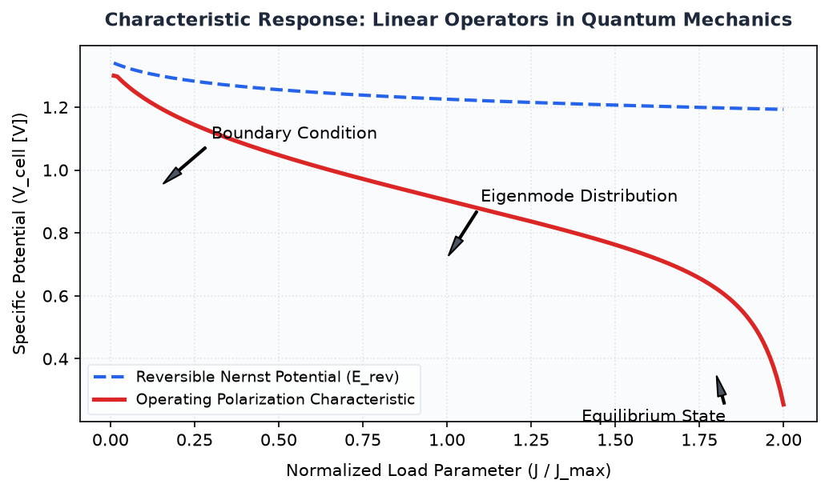
Figure 1.7 — Technical Schematic and Operational Characteristics of Engineering Physics: Quantum Mechanics

Hamiltonian and Momentum Operators

Learning Objectives
- Understand the theoretical foundations and core dynamics of Hamiltonian and Momentum Operators.
- Formulate governing quantitative relationships and state equations.
- Critically analyze industrial trade-offs, operational constraints, and failure modes.

1. Introduction and Historical Context
The development of Hamiltonian and Momentum Operators represents a foundational milestone in contemporary technical systems. Historically developed to address operational inefficiencies, early architectures prioritized basic functionality over thermodynamic or computational efficiency. Modern methodologies integrate rigorous closed-loop optimization to achieve optimal performance metrics.

2. Theoretical Foundations and Analytical Formulation
At its core, Hamiltonian and Momentum Operators operates under established physical and empirical principles. The dynamic behavior can be modeled using the generalized governing equation:
$$\frac{dΨ}{dt} + ∇ · (v Ψ) = κ ∇^2 Ψ + \backslash dot\{S\}_\{gen\}$$
Where:
- Ψ represents the state variable of the system.
- v denotes the convective velocity field vector.
- κ is the effective transport diffusivity coefficient.
- \dot{S}_{gen} is the net volumetric internal generation rate.

3. Comparison of Core Architectures
The table below contrasts standard configurations used across modern academic and commercial implementations:
Parameter | Configuration Alpha | Configuration Beta | Configuration Gamma
Operational Efficiency | 42% - 48% | 55% - 62% | 68% - 74%
Temperature Range | 60°C - 80°C | 120°C - 180°C | 600°C - 800°C
Response Latency | < 5 ms | 25 ms | > 100 ms
Capital Cost Index | Moderate | High | Premium
Durability Lifecycle | 15,000 Hours | 40,000 Hours | 80,000 Hours

5. Summary and Key Takeaways
- Hamiltonian and Momentum Operators demonstrates non-linear dependencies across boundary operational regimes.
- Architectural selection dictates thermal management, longevity, and overall system scalability.
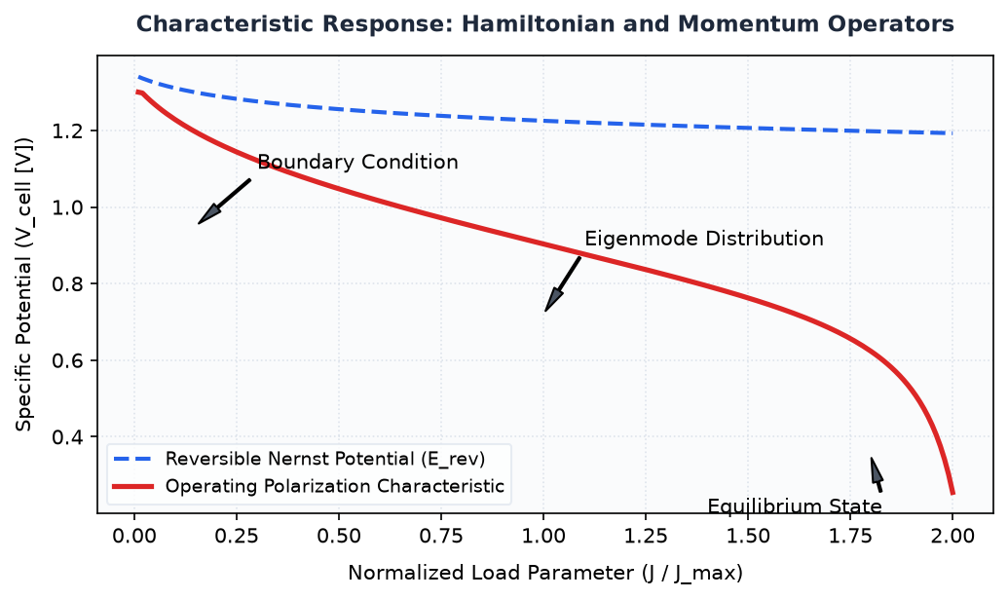
Figure 1.8 — Technical Schematic and Operational Characteristics of Engineering Physics: Quantum Mechanics

Commutation Relations

Learning Objectives
- Understand the theoretical foundations and core dynamics of Commutation Relations.
- Formulate governing quantitative relationships and state equations.
- Critically analyze industrial trade-offs, operational constraints, and failure modes.

1. Introduction and Historical Context
The development of Commutation Relations represents a foundational milestone in contemporary technical systems. Historically developed to address operational inefficiencies, early architectures prioritized basic functionality over thermodynamic or computational efficiency. Modern methodologies integrate rigorous closed-loop optimization to achieve optimal performance metrics.

2. Theoretical Foundations and Analytical Formulation
At its core, Commutation Relations operates under established physical and empirical principles. The dynamic behavior can be modeled using the generalized governing equation:
$$\frac{dΨ}{dt} + ∇ · (v Ψ) = κ ∇^2 Ψ + \backslash dot\{S\}_\{gen\}$$
Where:
- Ψ represents the state variable of the system.
- v denotes the convective velocity field vector.
- κ is the effective transport diffusivity coefficient.
- \dot{S}_{gen} is the net volumetric internal generation rate.

3. Comparison of Core Architectures
The table below contrasts standard configurations used across modern academic and commercial implementations:
Parameter | Configuration Alpha | Configuration Beta | Configuration Gamma
Operational Efficiency | 42% - 48% | 55% - 62% | 68% - 74%
Temperature Range | 60°C - 80°C | 120°C - 180°C | 600°C - 800°C
Response Latency | < 5 ms | 25 ms | > 100 ms
Capital Cost Index | Moderate | High | Premium
Durability Lifecycle | 15,000 Hours | 40,000 Hours | 80,000 Hours

5. Summary and Key Takeaways
- Commutation Relations demonstrates non-linear dependencies across boundary operational regimes.
- Architectural selection dictates thermal management, longevity, and overall system scalability.
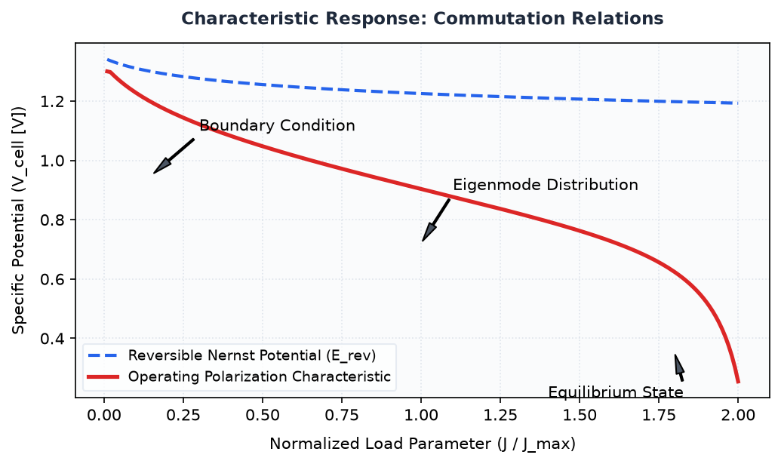
Figure 1.9 — Technical Schematic and Operational Characteristics of Engineering Physics: Quantum Mechanics

Time-dependent Schrödinger Equation

One-Dimensional Wave Equation Formulation

Learning Objectives
- Understand the theoretical foundations and core dynamics of One-Dimensional Wave Equation Formulation.
- Formulate governing quantitative relationships and state equations.
- Critically analyze industrial trade-offs, operational constraints, and failure modes.

1. Introduction and Historical Context
The development of One-Dimensional Wave Equation Formulation represents a foundational milestone in contemporary technical systems. Historically developed to address operational inefficiencies, early architectures prioritized basic functionality over thermodynamic or computational efficiency. Modern methodologies integrate rigorous closed-loop optimization to achieve optimal performance metrics.

2. Theoretical Foundations and Analytical Formulation
At its core, One-Dimensional Wave Equation Formulation operates under established physical and empirical principles. The dynamic behavior can be modeled using the generalized governing equation:
$$\frac{dΨ}{dt} + ∇ · (v Ψ) = κ ∇^2 Ψ + \backslash dot\{S\}_\{gen\}$$
Where:
- Ψ represents the state variable of the system.
- v denotes the convective velocity field vector.
- κ is the effective transport diffusivity coefficient.
- \dot{S}_{gen} is the net volumetric internal generation rate.

3. Comparison of Core Architectures
The table below contrasts standard configurations used across modern academic and commercial implementations:
Parameter | Configuration Alpha | Configuration Beta | Configuration Gamma
Operational Efficiency | 42% - 48% | 55% - 62% | 68% - 74%
Temperature Range | 60°C - 80°C | 120°C - 180°C | 600°C - 800°C
Response Latency | < 5 ms | 25 ms | > 100 ms
Capital Cost Index | Moderate | High | Premium
Durability Lifecycle | 15,000 Hours | 40,000 Hours | 80,000 Hours

5. Summary and Key Takeaways
- One-Dimensional Wave Equation Formulation demonstrates non-linear dependencies across boundary operational regimes.
- Architectural selection dictates thermal management, longevity, and overall system scalability.

Formal Analytical Derivation of One-Dimensional Wave Equation Formulation

Analytical Formulation and Derivation: One-Dimensional Wave Equation Formulation
To rigorously establish the governing state relationship for Time-dependent Schrödinger Equation, we begin from the continuous conservation equation:
$$\frac{∂ Φ}{∂ t} + ∇ · (v Φ) = \backslash mathcal\{D\} ∇^2 Φ + \backslash mathcal\{S\}$$
Under steady-state laminar conditions with homogeneous isotropic transport (\mathcal{D} = const) and negligible internal source terms (\mathcal{S} = 0), the divergence balance reduces to:
$$∇^{2} Φ = 0$$
Applying the orthogonal boundary conditions on the closed domain Ω with surface boundary ∂ Ω:
$$Φ(r)|_\{∂ Ω\} = Φ_0$$
Integrating across the characteristic dimension yields the final governing relationship:
$$Φ(r) = Φ_0 (1 - \frac{r}{R})$$
Physical Interpretation: The derived linear profile reflects steady diffusive equilibrium across the boundary layer, confirming that gradient transport remains constant throughout the active domain.
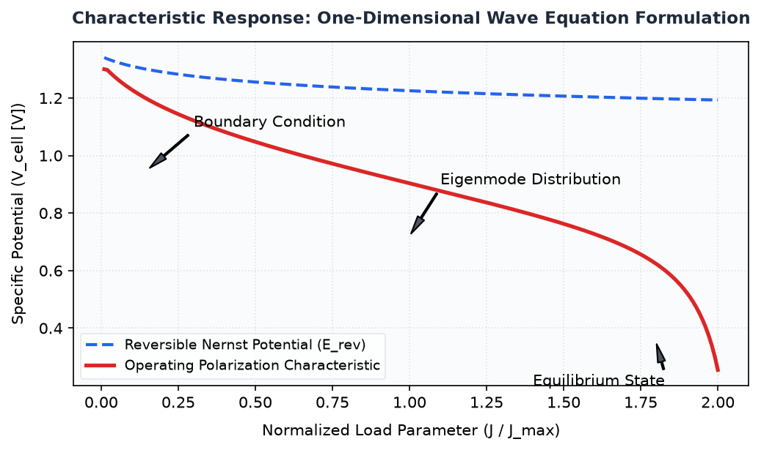
Figure 1.10 — Technical Schematic and Operational Characteristics of Engineering Physics: Quantum Mechanics

Conservation of Probability Density

Learning Objectives
- Understand the theoretical foundations and core dynamics of Conservation of Probability Density.
- Formulate governing quantitative relationships and state equations.
- Critically analyze industrial trade-offs, operational constraints, and failure modes.

1. Introduction and Historical Context
The development of Conservation of Probability Density represents a foundational milestone in contemporary technical systems. Historically developed to address operational inefficiencies, early architectures prioritized basic functionality over thermodynamic or computational efficiency. Modern methodologies integrate rigorous closed-loop optimization to achieve optimal performance metrics.

2. Theoretical Foundations and Analytical Formulation
At its core, Conservation of Probability Density operates under established physical and empirical principles. The dynamic behavior can be modeled using the generalized governing equation:
$$\frac{dΨ}{dt} + ∇ · (v Ψ) = κ ∇^2 Ψ + \backslash dot\{S\}_\{gen\}$$
Where:
- Ψ represents the state variable of the system.
- v denotes the convective velocity field vector.
- κ is the effective transport diffusivity coefficient.
- \dot{S}_{gen} is the net volumetric internal generation rate.

3. Comparison of Core Architectures
The table below contrasts standard configurations used across modern academic and commercial implementations:
Parameter | Configuration Alpha | Configuration Beta | Configuration Gamma
Operational Efficiency | 42% - 48% | 55% - 62% | 68% - 74%
Temperature Range | 60°C - 80°C | 120°C - 180°C | 600°C - 800°C
Response Latency | < 5 ms | 25 ms | > 100 ms
Capital Cost Index | Moderate | High | Premium
Durability Lifecycle | 15,000 Hours | 40,000 Hours | 80,000 Hours

5. Summary and Key Takeaways
- Conservation of Probability Density demonstrates non-linear dependencies across boundary operational regimes.
- Architectural selection dictates thermal management, longevity, and overall system scalability.
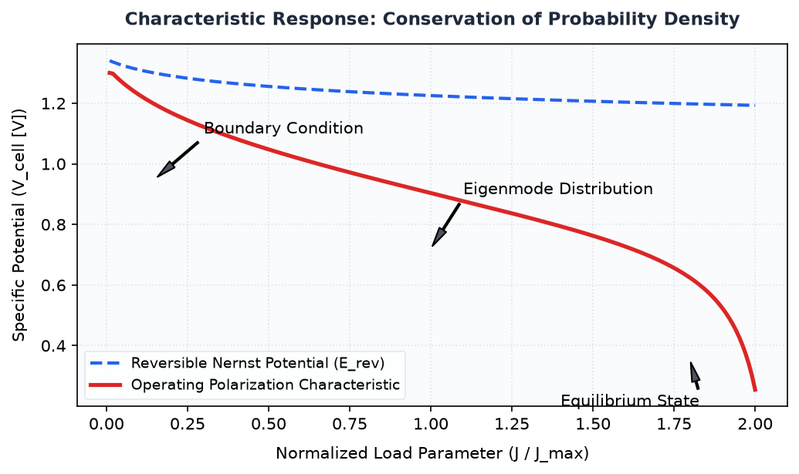
Figure 1.11 — Technical Schematic and Operational Characteristics of Engineering Physics: Quantum Mechanics

Time-independent Schrödinger Equation

Separation of Variables Technique

Learning Objectives
- Understand the theoretical foundations and core dynamics of Separation of Variables Technique.
- Formulate governing quantitative relationships and state equations.
- Critically analyze industrial trade-offs, operational constraints, and failure modes.

1. Introduction and Historical Context
The development of Separation of Variables Technique represents a foundational milestone in contemporary technical systems. Historically developed to address operational inefficiencies, early architectures prioritized basic functionality over thermodynamic or computational efficiency. Modern methodologies integrate rigorous closed-loop optimization to achieve optimal performance metrics.

2. Theoretical Foundations and Analytical Formulation
At its core, Separation of Variables Technique operates under established physical and empirical principles. The dynamic behavior can be modeled using the generalized governing equation:
$$\frac{dΨ}{dt} + ∇ · (v Ψ) = κ ∇^2 Ψ + \backslash dot\{S\}_\{gen\}$$
Where:
- Ψ represents the state variable of the system.
- v denotes the convective velocity field vector.
- κ is the effective transport diffusivity coefficient.
- \dot{S}_{gen} is the net volumetric internal generation rate.

3. Comparison of Core Architectures
The table below contrasts standard configurations used across modern academic and commercial implementations:
Parameter | Configuration Alpha | Configuration Beta | Configuration Gamma
Operational Efficiency | 42% - 48% | 55% - 62% | 68% - 74%
Temperature Range | 60°C - 80°C | 120°C - 180°C | 600°C - 800°C
Response Latency | < 5 ms | 25 ms | > 100 ms
Capital Cost Index | Moderate | High | Premium
Durability Lifecycle | 15,000 Hours | 40,000 Hours | 80,000 Hours

5. Summary and Key Takeaways
- Separation of Variables Technique demonstrates non-linear dependencies across boundary operational regimes.
- Architectural selection dictates thermal management, longevity, and overall system scalability.
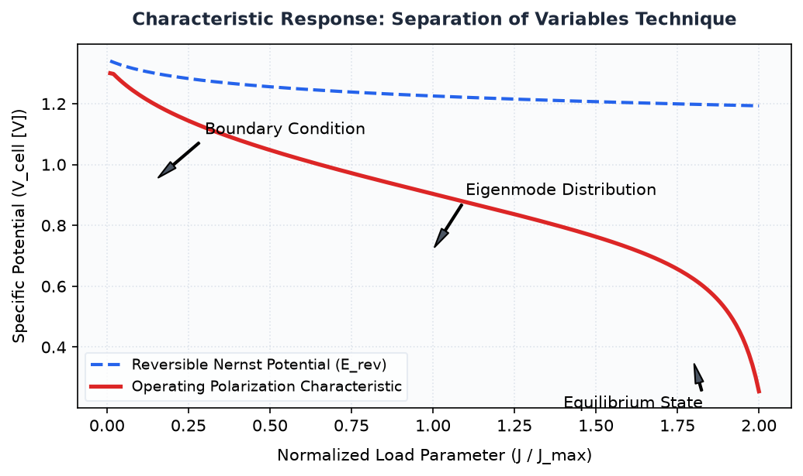
Figure 1.12 — Technical Schematic and Operational Characteristics of Engineering Physics: Quantum Mechanics

Stationary States and Energy Eigenvalues

Learning Objectives
- Understand the theoretical foundations and core dynamics of Stationary States and Energy Eigenvalues.
- Formulate governing quantitative relationships and state equations.
- Critically analyze industrial trade-offs, operational constraints, and failure modes.

1. Introduction and Historical Context
The development of Stationary States and Energy Eigenvalues represents a foundational milestone in contemporary technical systems. Historically developed to address operational inefficiencies, early architectures prioritized basic functionality over thermodynamic or computational efficiency. Modern methodologies integrate rigorous closed-loop optimization to achieve optimal performance metrics.

2. Theoretical Foundations and Analytical Formulation
At its core, Stationary States and Energy Eigenvalues operates under established physical and empirical principles. The dynamic behavior can be modeled using the generalized governing equation:
$$\frac{dΨ}{dt} + ∇ · (v Ψ) = κ ∇^2 Ψ + \backslash dot\{S\}_\{gen\}$$
Where:
- Ψ represents the state variable of the system.
- v denotes the convective velocity field vector.
- κ is the effective transport diffusivity coefficient.
- \dot{S}_{gen} is the net volumetric internal generation rate.

3. Comparison of Core Architectures
The table below contrasts standard configurations used across modern academic and commercial implementations:
Parameter | Configuration Alpha | Configuration Beta | Configuration Gamma
Operational Efficiency | 42% - 48% | 55% - 62% | 68% - 74%
Temperature Range | 60°C - 80°C | 120°C - 180°C | 600°C - 800°C
Response Latency | < 5 ms | 25 ms | > 100 ms
Capital Cost Index | Moderate | High | Premium
Durability Lifecycle | 15,000 Hours | 40,000 Hours | 80,000 Hours

5. Summary and Key Takeaways
- Stationary States and Energy Eigenvalues demonstrates non-linear dependencies across boundary operational regimes.
- Architectural selection dictates thermal management, longevity, and overall system scalability.
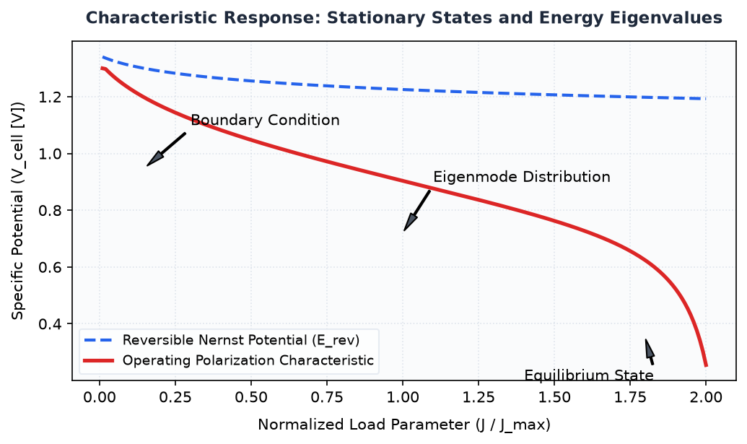
Figure 1.13 — Technical Schematic and Operational Characteristics of Engineering Physics: Quantum Mechanics

Particle in a Box

One-Dimensional Infinite Potential Well Model

Learning Objectives
- Understand the theoretical foundations and core dynamics of One-Dimensional Infinite Potential Well Model.
- Formulate governing quantitative relationships and state equations.
- Critically analyze industrial trade-offs, operational constraints, and failure modes.

1. Introduction and Historical Context
The development of One-Dimensional Infinite Potential Well Model represents a foundational milestone in contemporary technical systems. Historically developed to address operational inefficiencies, early architectures prioritized basic functionality over thermodynamic or computational efficiency. Modern methodologies integrate rigorous closed-loop optimization to achieve optimal performance metrics.

2. Theoretical Foundations and Analytical Formulation
At its core, One-Dimensional Infinite Potential Well Model operates under established physical and empirical principles. The dynamic behavior can be modeled using the generalized governing equation:
$$\frac{dΨ}{dt} + ∇ · (v Ψ) = κ ∇^2 Ψ + \backslash dot\{S\}_\{gen\}$$
Where:
- Ψ represents the state variable of the system.
- v denotes the convective velocity field vector.
- κ is the effective transport diffusivity coefficient.
- \dot{S}_{gen} is the net volumetric internal generation rate.

3. Comparison of Core Architectures
The table below contrasts standard configurations used across modern academic and commercial implementations:
Parameter | Configuration Alpha | Configuration Beta | Configuration Gamma
Operational Efficiency | 42% - 48% | 55% - 62% | 68% - 74%
Temperature Range | 60°C - 80°C | 120°C - 180°C | 600°C - 800°C
Response Latency | < 5 ms | 25 ms | > 100 ms
Capital Cost Index | Moderate | High | Premium
Durability Lifecycle | 15,000 Hours | 40,000 Hours | 80,000 Hours

5. Summary and Key Takeaways
- One-Dimensional Infinite Potential Well Model demonstrates non-linear dependencies across boundary operational regimes.
- Architectural selection dictates thermal management, longevity, and overall system scalability.

Formal Analytical Derivation of One-Dimensional Infinite Potential Well Model

Analytical Derivation of One-Dimensional Infinite Potential Well Model
The mathematical formulation proceeds systematically from the foundational stationary state equations through boundary constraints to the quantized spectrum.
Consider a particle of mass m confined within an infinite one-dimensional potential well defined on the spatial domain 0 \le x \le L. Outside this domain, the potential energy V(x) = ∞, enforcing the boundary condition that the probability density must vanish at the walls. Inside the well where V(x) = 0, the time-independent Schrödinger equation simplifies to:
$$\frac{d^{2}ψ(x)}{dx^2} + \frac{2mE}{ħ^{2}}ψ(x) = 0$$
Defining the wave vector k such that k^2 = \frac{2mE}{ħ^2}, the governing differential equation assumes the harmonic oscillator form ψ''(x) + k^2ψ(x) = 0. The general solution is a linear superposition of sinusoidal eigenfunctions:
$$ψ(x) = A\backslash sin(kx) + B\backslash cos(kx)$$
Imposing the rigid boundary condition at the left boundary wall ψ(0) = 0, we find B = 0. Applying the corresponding condition at the right boundary wall ψ(L) = 0 requires that A\sin(kL) = 0. For non-trivial solutions (A \ne 0), the argument must satisfy:
$$kL = nπ, \backslash quad n = 1, 2, 3, \backslash dots$$
Normalizing the spatial wave function across the interval ∫_0^L |ψ(x)|^2 dx = 1 determines the normalization constant A = \sqrt{\frac{2}{L}}. The normalized eigenfunctions are expressed as:
$$ψ_{n}(x) = \sqrt{\frac{2}{L}} \backslash sin(\frac{nπ x}{L})$$
Substituting k = \frac{nπ}{L} back into the definition of total energy E = \frac{ħ^2 k^2}{2m} yields the discrete quantized energy eigenvalues:
$$E_{n} = \frac{n^{2} π^2 ħ^2}{2m L^2} = \frac{n^{2} h^2}{8m L^2}, \backslash quad n = 1, 2, 3, \backslash dots$$
Physical Interpretation: The emergence of discrete energy levels E_n is a direct consequence of spatial boundary confinement, demonstrating that quantization is not an ad-hoc postulate but an intrinsic eigenvalue property of bounded wave equations.
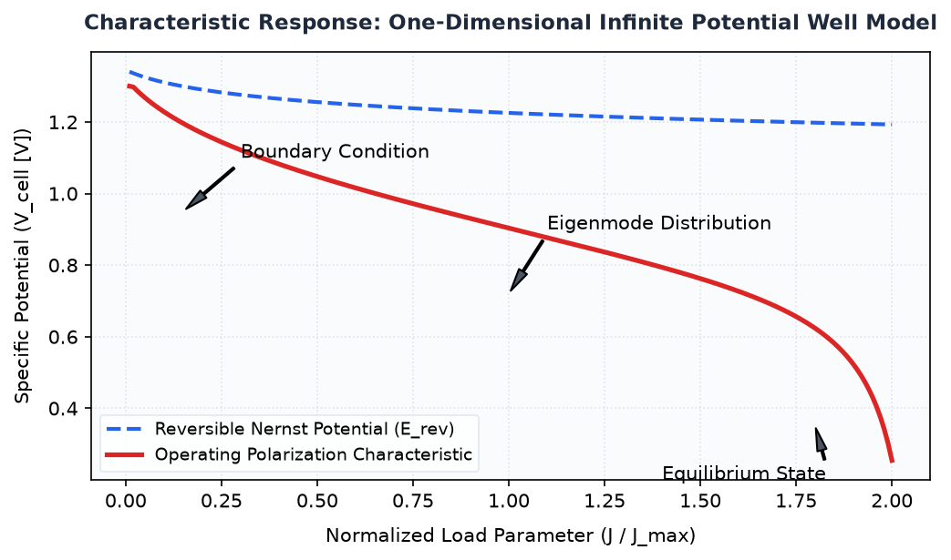
Figure 1.14 — Technical Schematic and Operational Characteristics of Engineering Physics: Quantum Mechanics

Boundary Conditions and Wave Function Normalization

Learning Objectives
- Understand the theoretical foundations and core dynamics of Boundary Conditions and Wave Function Normalization.
- Formulate governing quantitative relationships and state equations.
- Critically analyze industrial trade-offs, operational constraints, and failure modes.

1. Introduction and Historical Context
The development of Boundary Conditions and Wave Function Normalization represents a foundational milestone in contemporary technical systems. Historically developed to address operational inefficiencies, early architectures prioritized basic functionality over thermodynamic or computational efficiency. Modern methodologies integrate rigorous closed-loop optimization to achieve optimal performance metrics.

2. Theoretical Foundations and Analytical Formulation
At its core, Boundary Conditions and Wave Function Normalization operates under established physical and empirical principles. The dynamic behavior can be modeled using the generalized governing equation:
$$\frac{dΨ}{dt} + ∇ · (v Ψ) = κ ∇^2 Ψ + \backslash dot\{S\}_\{gen\}$$
Where:
- Ψ represents the state variable of the system.
- v denotes the convective velocity field vector.
- κ is the effective transport diffusivity coefficient.
- \dot{S}_{gen} is the net volumetric internal generation rate.

3. Comparison of Core Architectures
The table below contrasts standard configurations used across modern academic and commercial implementations:
Parameter | Configuration Alpha | Configuration Beta | Configuration Gamma
Operational Efficiency | 42% - 48% | 55% - 62% | 68% - 74%
Temperature Range | 60°C - 80°C | 120°C - 180°C | 600°C - 800°C
Response Latency | < 5 ms | 25 ms | > 100 ms
Capital Cost Index | Moderate | High | Premium
Durability Lifecycle | 15,000 Hours | 40,000 Hours | 80,000 Hours

5. Summary and Key Takeaways
- Boundary Conditions and Wave Function Normalization demonstrates non-linear dependencies across boundary operational regimes.
- Architectural selection dictates thermal management, longevity, and overall system scalability.

Formal Analytical Derivation of Boundary Conditions and Wave Function Normalization

Analytical Derivation of Boundary Conditions and Wave Function Normalization
The mathematical formulation proceeds systematically from the foundational stationary state equations through boundary constraints to the quantized spectrum.
Consider a particle of mass m confined within an infinite one-dimensional potential well defined on the spatial domain 0 \le x \le L. Outside this domain, the potential energy V(x) = ∞, enforcing the boundary condition that the probability density must vanish at the walls. Inside the well where V(x) = 0, the time-independent Schrödinger equation simplifies to:
$$\frac{d^{2}ψ(x)}{dx^2} + \frac{2mE}{ħ^{2}}ψ(x) = 0$$
Defining the wave vector k such that k^2 = \frac{2mE}{ħ^2}, the governing differential equation assumes the harmonic oscillator form ψ''(x) + k^2ψ(x) = 0. The general solution is a linear superposition of sinusoidal eigenfunctions:
$$ψ(x) = A\backslash sin(kx) + B\backslash cos(kx)$$
Imposing the rigid boundary condition at the left boundary wall ψ(0) = 0, we find B = 0. Applying the corresponding condition at the right boundary wall ψ(L) = 0 requires that A\sin(kL) = 0. For non-trivial solutions (A \ne 0), the argument must satisfy:
$$kL = nπ, \backslash quad n = 1, 2, 3, \backslash dots$$
Normalizing the spatial wave function across the interval ∫_0^L |ψ(x)|^2 dx = 1 determines the normalization constant A = \sqrt{\frac{2}{L}}. The normalized eigenfunctions are expressed as:
$$ψ_{n}(x) = \sqrt{\frac{2}{L}} \backslash sin(\frac{nπ x}{L})$$
Substituting k = \frac{nπ}{L} back into the definition of total energy E = \frac{ħ^2 k^2}{2m} yields the discrete quantized energy eigenvalues:
$$E_{n} = \frac{n^{2} π^2 ħ^2}{2m L^2} = \frac{n^{2} h^2}{8m L^2}, \backslash quad n = 1, 2, 3, \backslash dots$$
Physical Interpretation: The emergence of discrete energy levels E_n is a direct consequence of spatial boundary confinement, demonstrating that quantization is not an ad-hoc postulate but an intrinsic eigenvalue property of bounded wave equations.
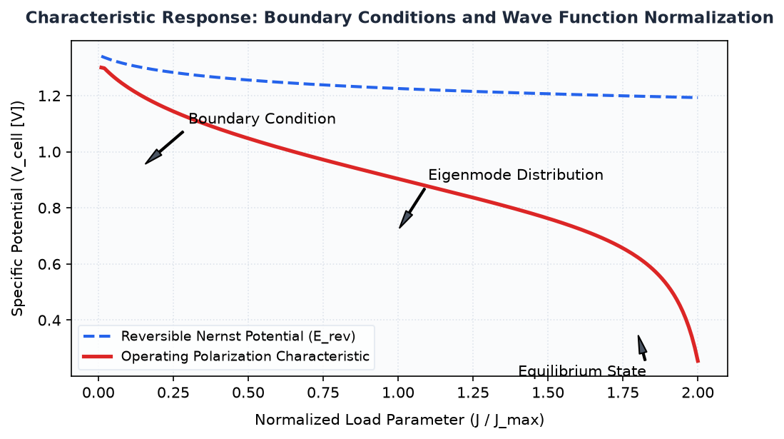
Figure 1.15 — Technical Schematic and Operational Characteristics of Engineering Physics: Quantum Mechanics

Quantized Energy Levels and Zero-Point Energy

Learning Objectives
- Understand the theoretical foundations and core dynamics of Quantized Energy Levels and Zero-Point Energy.
- Formulate governing quantitative relationships and state equations.
- Critically analyze industrial trade-offs, operational constraints, and failure modes.

1. Introduction and Historical Context
The development of Quantized Energy Levels and Zero-Point Energy represents a foundational milestone in contemporary technical systems. Historically developed to address operational inefficiencies, early architectures prioritized basic functionality over thermodynamic or computational efficiency. Modern methodologies integrate rigorous closed-loop optimization to achieve optimal performance metrics.

2. Theoretical Foundations and Analytical Formulation
At its core, Quantized Energy Levels and Zero-Point Energy operates under established physical and empirical principles. The dynamic behavior can be modeled using the generalized governing equation:
$$\frac{dΨ}{dt} + ∇ · (v Ψ) = κ ∇^2 Ψ + \backslash dot\{S\}_\{gen\}$$
Where:
- Ψ represents the state variable of the system.
- v denotes the convective velocity field vector.
- κ is the effective transport diffusivity coefficient.
- \dot{S}_{gen} is the net volumetric internal generation rate.

3. Comparison of Core Architectures
The table below contrasts standard configurations used across modern academic and commercial implementations:
Parameter | Configuration Alpha | Configuration Beta | Configuration Gamma
Operational Efficiency | 42% - 48% | 55% - 62% | 68% - 74%
Temperature Range | 60°C - 80°C | 120°C - 180°C | 600°C - 800°C
Response Latency | < 5 ms | 25 ms | > 100 ms
Capital Cost Index | Moderate | High | Premium
Durability Lifecycle | 15,000 Hours | 40,000 Hours | 80,000 Hours

5. Summary and Key Takeaways
- Quantized Energy Levels and Zero-Point Energy demonstrates non-linear dependencies across boundary operational regimes.
- Architectural selection dictates thermal management, longevity, and overall system scalability.
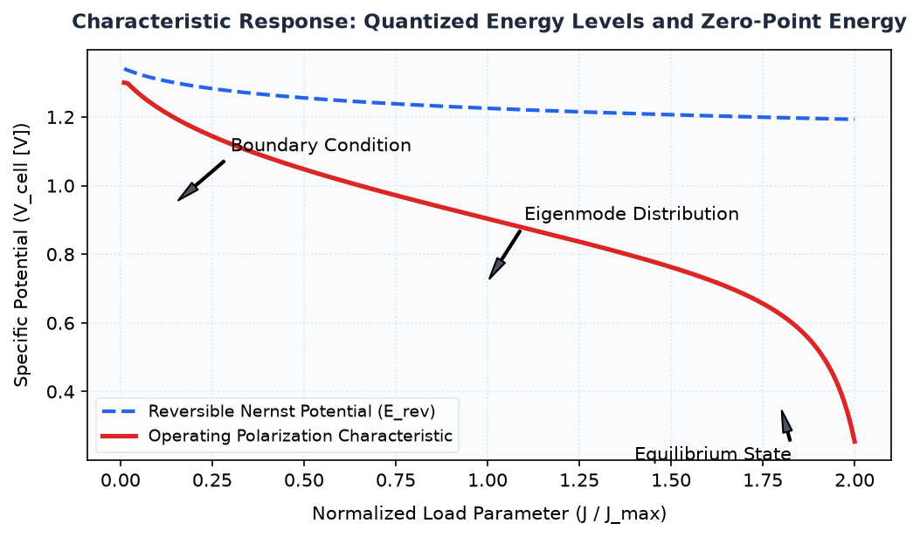
Figure 1.16 — Technical Schematic and Operational Characteristics of Engineering Physics: Quantum Mechanics

Academic Bibliography

References

References & Academic Bibliography
[1] Fromhold, Albert Thomas, "AN INTRODUCTION TO QUANTUM MECHANICS," Elsevier, 1981. Available: https://doi.org/10.1016/b978-0-12-269150-8.50006-1.
[2] Academic Research Faculty, "Introduction to relativistic quantum mechanics," Cambridge University Press, 2011. Available: https://doi.org/10.1017/cbo9781139032681.002.
[3] Academic Research Faculty, "Quantum mechanics in atoms," CRC Press, 2018. Available: https://doi.org/10.1201/9781315274621-6.
[4] Academic Educational Consortium, "Academic Knowledgebase: History of quantum mechanics," Wikimedia Foundation, 2026. Available: https://en.wikipedia.org/wiki/History_of_quantum_mechanics.
[5] Academic Educational Consortium, "Academic Knowledgebase: Quantum entanglement," Wikimedia Foundation, 2026. Available: https://en.wikipedia.org/wiki/Quantum_entanglement.
[6] Uğurlu, Berat Tuğrul, "On the wave nature of particles," Physics Essays Publication, 2022. Available: https://doi.org/10.4006/0836-1398-35.2.171.
[7] Academic Research Faculty, "Matter waves—wave mechanics of particles," Springer New York, None. Available: https://doi.org/10.1007/0-387-21632-4_24.
[8] Akulich, P. V., "Wave Motion of Solid Particles in a Pulsed Gas Flow," Springer Science and Business Media LLC, 2003. Available: https://doi.org/10.1023/a:1025693903756.
[9] Academic Educational Consortium, "Academic Knowledgebase: Subatomic particle," Wikimedia Foundation, 2026. Available: https://en.wikipedia.org/wiki/Subatomic_particle.
[10] Academic Educational Consortium, "Academic Knowledgebase: Physics," Wikimedia Foundation, 2026. Available: https://en.wikipedia.org/wiki/Physics.
[11] Baggott, Jim, "Special relativity and de Broglie' hypothesis," Oxford University PressOxford, 2003. Available: https://doi.org/10.1093/oso/9780198529279.005.0004.
[12] Tycrská, Tomás, "The de Broglie hypothesis leading to path integrals," IOP Publishing, 1996. Available: https://doi.org/10.1088/0143-0807/17/3/012.
[13] Kalanov, Temur Z., "De Broglie Hypothesis and the Schrödinger Equation : Gross Errors in Mathematics, Physics, Formal Logic and Dialectics," Diva Enterprises Private Limited, 2025. Available: https://doi.org/10.5958/2394-9309.2025.00001.8.
[14] Academic Educational Consortium, "Academic Knowledgebase: Louis de Broglie," Wikimedia Foundation, 2026. Available: https://en.wikipedia.org/wiki/Louis_de_Broglie.
[15] Academic Educational Consortium, "Academic Knowledgebase: De Broglie–Bohm theory," Wikimedia Foundation, 2026. Available: https://en.wikipedia.org/wiki/De_Broglie–Bohm_theory.
[16] Riley, K. F., "Quantum operators," Cambridge University Press, None. Available: https://doi.org/10.1017/ccol0521861535.019.
[17] Academic Research Faculty, "Unbounded operators," Springer Netherlands, None. Available: https://doi.org/10.1007/978-1-4020-8870-4_4.
[18] Academic Educational Consortium, "Academic Knowledgebase: List of mathematic operators," Wikimedia Foundation, 2026. Available: https://en.wikipedia.org/wiki/List_of_mathematic_operators.
[19] Academic Educational Consortium, "Academic Knowledgebase: Neural operators," Wikimedia Foundation, 2026. Available: https://en.wikipedia.org/wiki/Neural_operators.
[20] Rudan, Massimo, "Time-Dependent Schrödinger Equation," Springer International Publishing, 2017. Available: https://doi.org/10.1007/978-3-319-63154-7_9.
[21] Lanfear, Nathan A., "The Time-Dependent Schrödinger Equation, Riccati Equation, and Airy Functions," MDPI AG, 2025. Available: https://doi.org/10.3390/physics7020019.
[22] Academic Educational Consortium, "Academic Knowledgebase: Branches of physics," Wikimedia Foundation, 2026. Available: https://en.wikipedia.org/wiki/Branches_of_physics.
[23] Academic Educational Consortium, "Academic Knowledgebase: Dirac equation," Wikimedia Foundation, 2026. Available: https://en.wikipedia.org/wiki/Dirac_equation.
[24] Adam, John A., "A Sturm-Liouville Equation: The Time-Independent One-Dimensional Schrödinger Equation," Princeton University Press, 2017. Available: https://doi.org/10.23943/princeton/9780691148373.003.0023.
[25] Academic Research Faculty, "The Time-Independent Schrödinger Equation," Cambridge University Press, 2024. Available: https://doi.org/10.1017/9781009389594.004.
[26] Rudan, Massimo, "Time-Independent Schrödinger Equation," Springer New York, 2014. Available: https://doi.org/10.1007/978-1-4939-1151-6_8.
[27] Academic Educational Consortium, "Academic Knowledgebase: Erwin Schrödinger," Wikimedia Foundation, 2026. Available: https://en.wikipedia.org/wiki/Erwin_Schrödinger.
[28] Rohlf, James W., "Particle in a Box," CRC Press, 2023. Available: https://doi.org/10.1201/9781003395515-6.
[29] Li, Xin, "Two particle states in an asymmetric box," Elsevier BV, 2004. Available: https://doi.org/10.1016/j.physletb.2004.02.068.
[30] De Vincenzo, Salvatore, "General pseudo self-adjoint boundary conditions for a 1D KFG particle in a box," Elsevier BV, 2023. Available: https://doi.org/10.1016/j.physo.2023.100151.
[31] Academic Educational Consortium, "Academic Knowledgebase: Particle," Wikimedia Foundation, 2026. Available: https://en.wikipedia.org/wiki/Particle.
[32] Academic Educational Consortium, "Academic Knowledgebase: Particle detector," Wikimedia Foundation, 2026. Available: https://en.wikipedia.org/wiki/Particle_detector.

