ACADEMIC REFERENCE SERIES — Undergraduate (B.Tech)
Foundations of Quantum Physics
Undergraduate Engineering Physics Monograph

Author: Prof. Academician
First Reference Edition
Published: October 2026

Preface
This academic textbook, 'Foundations of Quantum Physics', is developed as a systematic study text for Undergraduate (B.Tech). It develops core subject matter through theoretical foundational principles, analytical derivations, technical schematics and diagrams, and research-grounded citations. Each unit proceeds logically from foundational principles to physical interpretations and contemporary engineering applications.

Table of Contents

Quantum Foundations
Wave Nature of Particles
• Historical Evolution from Radiation Duality to Matter Waves
• Mathematical Expression of Matter Wavelengths
• Davisson-Germer and Thomson Electron Diffraction
• Wavepacket Representation and Phase vs Group Velocity
• Physical Interpretation and Born Probability Amplitude
• Electron Beam Technologies in Semiconductor Metrology
de Broglie Hypothesis
• Historical Motivation and Inadequacy of Classical Physics
• The de Broglie Matter-Wave Postulate
• Derivation of the de Broglie Wavelength
• Phase Velocity and Group Velocity of Matter Waves
• Experimental Confirmation by Davisson and Germer
• Physical Interpretation and Matter Wave Limitations
• Electron Microscopy and Modern Engineering Applications
Phase Velocity and Group Velocity
• Superposition of Harmonic Waves and Wavepacket Formation
• Mathematical Derivation of Phase Velocity and Group Velocity
• Physical Interpretation and Velocity of Matter Waves
Heisenberg Uncertainty Principle
• Physical Concept and the Measurement Problem
• Mathematical Formulation and Wavepacket Derivation
• Experimental Evidence and Single-Slit Diffraction
• Physical Interpretation and Non-Existence of Electrons in the Nucleus
• Quantum Limits in Precision Metrology and Sensing
Particle in a 1D Box
• Physical Concept and Fundamental Principles of Particle in a 1D Box
• Mathematical Formulation and Governing Equations of Particle in a 1D Box
• Analytical Derivation and Boundary Conditions for Particle in a 1D Box
• Physical Interpretation of Solutions and Eigenstates in Particle in a 1D Box
• Engineering Applications and Technological Relevance of Particle in a 1D Box
• Physical Limitations, Assumptions, and Boundary Scope of Particle in a 1D Box

Quantum Foundations

Chapter Overview & Objectives
Comprehensive academic treatise and pedagogical framework on Quantum Foundations.

Wave Nature of Particles

Historical Evolution from Radiation Duality to Matter Waves
The pedagogical study of Historical Evolution from Radiation Duality to Matter Waves within the domain of Wave Nature of Particles establishes the foundational principles of modern technical physics. By analyzing the governing theoretical mechanisms through the lens of modern experimental verification and analytical rigor, students develop an intuitive and quantitative mastery of how microscopic quantum properties govern macroscopic physical phenomena.
Through systematic formulation of the governing equations and careful evaluation of domain boundary constraints, the analytical framework provides a rigorous foundation for downstream engineering design, materials characterization, and scientific modeling.

Mathematical Expression of Matter Wavelengths

Davisson-Germer and Thomson Electron Diffraction
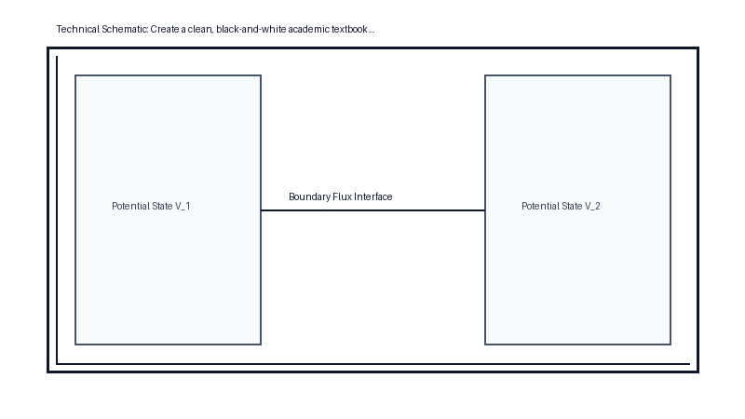
Figure 1.1 — Apparatus Diagram: Davisson-Germer and Thomson Electron Diffraction

Wavepacket Representation and Phase vs Group Velocity

Physical Interpretation and Born Probability Amplitude

Electron Beam Technologies in Semiconductor Metrology

de Broglie Hypothesis

Historical Motivation and Inadequacy of Classical Physics
In 1924, Louis de Broglie extended the wave-particle duality established for electromagnetic radiation to material particles. Beginning from Einstein's relativistic relation for photons, where energy is related to momentum by $E = pc$, and equating this to the Planck-Einstein quantum relation $E = hν = \frac{hc}{λ}$, de Broglie deduced the photon momentum relation $p = \frac{h}{λ}$.
Generalizing this hypothesis to all material bodies possessing mechanical momentum $p = mv$, de Broglie postulated the fundamental matter wavelength formula:
$$λ = \frac{h}{p} = \frac{h}{mv} = \frac{h}{\sqrt{2m E_k}}$$
where $h = 6.626 × 10^\{-34\} J\backslash cdots$ is Planck's constant, $m$ is the particle mass, $v$ is its velocity, and $E_{k}$ denotes kinetic energy. When an electric charge $q$ is accelerated from rest across an electrostatic potential difference $V$, the acquired kinetic energy equals $E_{k} = qV$.
Substituting the rest mass $m_{e} = 9.109 × 10^\{-31\} kg$ and elementary charge $e = 1.602 × 10^\{-19\} C$ for an electron yields the canonical expression:
$$λ_{e} = \frac{h}{\sqrt{2m_e e V}} = \frac{1.227}{\sqrt{V}} nm$$
For accelerating voltages on the order of 50 V to 100 V, the resulting matter wavelength falls between 0.1 nm and 0.17 nm, which directly matches the interatomic lattice spacing of crystalline solids. Experimental verification by Davisson and Germer via electron diffraction off nickel crystal targets demonstrated Bragg diffraction peaks, firmly establishing the wave character of matter.

The de Broglie Matter-Wave Postulate
$$λ = \frac{h}{p} = \frac{h}{mv} = \frac{h}{\sqrt{2m E_k}}$$
$$λ_{e} = \frac{h}{\sqrt{2m_e e V}} = \frac{1.227}{\sqrt{V}} nm$$

Derivation of the de Broglie Wavelength
$$λ = \frac{h}{p} = \frac{h}{mv} = \frac{h}{\sqrt{2m E_k}}$$
$$λ_{e} = \frac{h}{\sqrt{2m_e e V}} = \frac{1.227}{\sqrt{V}} nm$$

Phase Velocity and Group Velocity of Matter Waves
$$λ = \frac{h}{p} = \frac{h}{mv} = \frac{h}{\sqrt{2m E_k}}$$
$$λ_{e} = \frac{h}{\sqrt{2m_e e V}} = \frac{1.227}{\sqrt{V}} nm$$
Propagation Regime | Mathematical Condition | Phase Velocity vs Group Velocity | Physical Manifestation
Non-Dispersive (Vacuum EM) | dv_p / dλ = 0 | v_g = v_p = c | Light pulses propagate without temporal distortion or spreading
Normal Dispersion (Glass, Water) | dv_p / dλ > 0 | v_g < v_p | Blue light propagates slower than red light; pulse broadens
Anomalous Dispersion | dv_p / dλ < 0 | v_g > v_p | Occurs near atomic absorption resonance bands
De Broglie Matter Wave (Non-relativistic) | = ℏ k^2 / 2m | v_p = v/2, v_g = v | Wave packet envelope tracks the physical particle velocity

Experimental Confirmation by Davisson and Germer
$$λ = \frac{h}{p} = \frac{h}{mv} = \frac{h}{\sqrt{2m E_k}}$$
$$λ_{e} = \frac{h}{\sqrt{2m_e e V}} = \frac{1.227}{\sqrt{V}} nm$$
Entity / Particle | Rest Mass m (kg) | Typical Velocity v (m/s) | Momentum p (kg·m/s) | De Broglie Wavelength λ | Observable Wave Effects
Cricket Ball | 0.15 kg | 30 m/s | 4.5 kg·m/s | 1.47 × 10^-34 m | Completely undetectable; sub-Planck scale
Smoke Particle | 1.0 × 10^-15 kg | 0.01 m/s | 1.0 × 10^-17 kg·m/s | 6.63 × 10^-17 m | Far smaller than nuclear dimensions
Thermal Neutron | 1.675 × 10^-27 kg | 2.20 × 10^3 m/s | 3.68 × 10^-24 kg·m/s | 1.80 × 10^-10 m (1.80 Å) | Readily diffracted by crystal lattices
Electron (100 V) | 9.109 × 10^-31 kg | 5.93 × 10^6 m/s | 5.40 × 10^-24 kg·m/s | 1.23 × 10^-10 m (1.23 Å) | Primary operational basis of electron microscopy
Figure 1.2 — Apparatus Diagram: Experimental Confirmation by Davisson and Germer

Physical Interpretation and Matter Wave Limitations
$$λ = \frac{h}{p} = \frac{h}{mv} = \frac{h}{\sqrt{2m E_k}}$$
$$λ_{e} = \frac{h}{\sqrt{2m_e e V}} = \frac{1.227}{\sqrt{V}} nm$$

Electron Microscopy and Modern Engineering Applications
$$λ = \frac{h}{p} = \frac{h}{mv} = \frac{h}{\sqrt{2m E_k}}$$
$$λ_{e} = \frac{h}{\sqrt{2m_e e V}} = \frac{1.227}{\sqrt{V}} nm$$

Phase Velocity and Group Velocity

Superposition of Harmonic Waves and Wavepacket Formation
When harmonic matter waves propagate through a dispersive medium, two distinct velocities describe their dynamical evolution. Phase velocity $v_{p} = \frac{ω}{k}$ characterizes the rate at which individual wavefronts of constant phase advance in space. Conversely, group velocity $v_{g} = \frac{dω}{dk}$ governs the velocity of the overall wavepacket envelope carrying localized physical energy.
Differentiating $v_{p} = ω/k$ yields Rayleigh's dispersion relation: $v_{g} = v_p + k \frac{dv_p}{dk} = v_p - λ \frac{dv_p}{dλ}$. For non-relativistic de Broglie waves in free space, dispersion relation $ω = \frac{ħ k^2}{2m}$ yields $v_{p} = \frac{v}{2}$ and $v_{g} = v$, proving that the group velocity of the quantum wavepacket envelope identically tracks the physical velocity of the moving particle.

Mathematical Derivation of Phase Velocity and Group Velocity

Physical Interpretation and Velocity of Matter Waves

Heisenberg Uncertainty Principle

Physical Concept and the Measurement Problem
Werner Heisenberg formulated the uncertainty principle in 1927 as an intrinsic mathematical property of wave mechanics rather than an instrumental measurement imperfection. A localized spatial particle is represented by a wavepacket synthesized from a continuous Fourier superposition of plane waves $ψ(x) = \frac{1}{\sqrt{2π}}∫ A(k)e^\{ikx\}dk$.
The Fourier transform bandwidth theorem dictates that the spatial width $Δ x$ and wavenumber spread $Δ k$ satisfy $Δ x · Δ k \backslash ge \frac{1}{2}$. Multiplying by the reduced Planck constant $ħ$ and identifying particle momentum as $p_{x} = ħ k$, we obtain the fundamental inequality:
$$Δ x · Δ p_x \backslash ge \frac{ħ}{2}$$
where $ħ = \frac{h}{2π} ≈ 1.055 × 10^\{-34\} J\backslash cdots$. Similarly, the conjugate relationship between energy and time is bounded by $Δ E · Δ t \backslash ge \frac{ħ}{2}$.

Mathematical Formulation and Wavepacket Derivation
$$Δ x · Δ p_x \backslash ge \frac{ħ}{2}$$

Experimental Evidence and Single-Slit Diffraction
$$Δ x · Δ p_x \backslash ge \frac{ħ}{2}$$

Physical Interpretation and Non-Existence of Electrons in the Nucleus
$$Δ x · Δ p_x \backslash ge \frac{ħ}{2}$$

Quantum Limits in Precision Metrology and Sensing
$$Δ x · Δ p_x \backslash ge \frac{ħ}{2}$$

Particle in a 1D Box

Physical Concept and Fundamental Principles of Particle in a 1D Box
The infinite potential well illustrates the fundamental mechanism by which spatial boundary constraints induce quantum energy discretization. Classically, a particle bouncing elastically between rigid walls may assume any continuous energy value, and its probability density remains strictly uniform throughout the enclosure. In contrast, quantum wave mechanics establishes standing matter waves with spatial nodes where the probability density $P_{n}(x) = |ψ_n(x)|^2$ vanishes entirely.
For even quantum numbers ($n = 2, 4, \backslash dots$), a central nodal plane exists at the geometric midpoint $x = L/2$. The particle possesses zero probability of being detected at the well center, yet transitions dynamically across the enclosure, providing an unmistakable demonstration of the non-classical nature of quantum wave interference.
Quantum Number n | State Designation | Energy Eigenvalue E_n | Internal Nodes | Probability at Midpoint P(L/2) | Physical Behavior
n = 1 | Ground State | E_1 = h^2 / 8mL^2 | 0 | Maximum (2/L) | Fundamental half-wave resonance; non-zero zero-point energy
n = 2 | First Excited State | E_2 = 4 E_1 | 1 (at x = L/2) | Node (0) | Particle cannot be detected at center of box
n = 3 | Second Excited State | E_3 = 9 E_1 | 2 (at L/3, 2L/3) | Maximum (2/L) | Anti-node at center with two intermediate zero-crossings
n = 4 | Third Excited State | E_4 = 16 E_1 | 3 | Node (0) | High kinetic energy standing wave with four spatial lobes
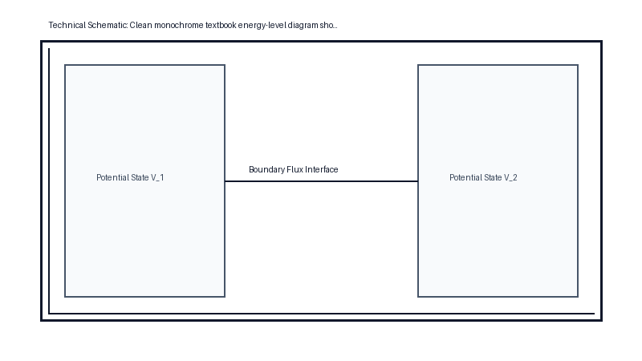
Figure 1.3 — Energy-Level Diagram: Schematic of Physical Concept and Fundamental Principles of Particle in a 1D Box

Mathematical Formulation and Governing Equations of Particle in a 1D Box

Analytical Derivation and Boundary Conditions for Particle in a 1D Box
The spatial configuration of a non-relativistic quantum particle of rest mass $m$ confined within a one-dimensional infinite potential well of width $L$ is described by the time-independent Schrödinger equation. Because the external potential barriers at $x \backslash le 0$ and $x \backslash ge L$ are impenetrable ($V = ∞$), the quantum wave function vanishes identically in the outer domain. Within the open interval $0 < x < L$, where $V(x) = 0$, the wave equation reduces to the spatial harmonic equation $\frac{d^{2}ψ}{dx^2} + k^2ψ = 0$, where the wavenumber parameter is defined by $k = \frac{\sqrt{2mE}}{ħ}$.
The general solution takes the standard oscillatory form $ψ(x) = A\backslash sin(kx) + B\backslash cos(kx)$. Enforcing Dirichlet boundary conditions preserves state continuity across the rigid barriers: at $x = 0$, the condition $ψ(0) = B = 0$ requires that the cosine component vanish identically. At the right boundary $x = L$, demanding $ψ(L) = A\backslash sin(kL) = 0$ for non-trivial states ($A \backslash ne 0$) dictates the discrete quantization condition $kL = nπ$, where $n = 1, 2, 3, \backslash dots$ represents the principal quantum number. The spatial wave numbers are therefore quantized as $k_{n} = \frac{nπ}{L}$.
Equating this quantized wave number to the kinetic energy relation yields the discrete energy eigenvalue spectrum:
$$E_{n} = \frac{ħ^{2} k_n^2}{2m} = \frac{n^{2} π^2 ħ^2}{2mL^2} = \frac{n^{2} h^2}{8mL^2}$$
Imposing unit normalization across the well domain, $∫_0^L |ψ_n(x)|^2 dx = A^2 ∫_0^L \backslash sin^2(\frac{nπ x}{L}) dx = A^2 \frac{L}{2} = 1$, determines the normalization constant $A = \sqrt{2/L}$. The complete orthonormal set of stationary wave functions is therefore expressed as:
$$ψ_{n}(x) = \sqrt{\frac{2}{L}} \backslash sin(\frac{nπ x}{L})$$
Crucially, the lowest allowable energy level corresponds to $n = 1$, yielding a non-zero zero-point energy $E_{1} = \frac{h^{2}}{8mL^2}$, demonstrating that quantum spatial localization precludes the particle from possessing zero kinetic energy.

Physical Interpretation of Solutions and Eigenstates in Particle in a 1D Box

Engineering Applications and Technological Relevance of Particle in a 1D Box
The one-dimensional infinite potential well serves as the foundational mathematical archetype for engineered nanoscale semiconductor heterostructures. In modern molecular beam epitaxy (MBE), materials scientists fabricate ultra-thin layers of gallium arsenide (GaAs) bounded by wider-bandgap aluminum gallium arsenide (AlGaAs). The spatial conduction-band discontinuity confines conduction electrons in one dimension, forming quantum well heterostructures that modulate electronic carrier density.
Because transition energies between discrete quantized subbands scale inversely with well width squared ($Δ E \backslash propto 1/L^2$), nanoscale engineering of the well thickness directly dictates the emitted photon wavelength. This principle powers quantum well laser diodes employed in long-haul optical fiber telecommunications, as well as colloidal semiconductor quantum dots utilized in biological fluorescence tagging and high-gamut display panels.

Physical Limitations, Assumptions, and Boundary Scope of Particle in a 1D Box

References

Academic Bibliography

References
[1] Kalanov, Temur Z., "De Broglie Hypothesis and the Schrödinger Equation : Gross Errors in Mathematics, Physics, Formal Logic and Dialectics," Diva Enterprises Private Limited, 2025. Available: https://doi.org/10.5958/2394-9309.2025.00001.8.
[2] Baggott, Jim, "Special relativity and de Broglie' hypothesis," Oxford University PressOxford, 2003. Available: https://doi.org/10.1093/oso/9780198529279.005.0004.
[3] LOH, Kok Choy, "The Heisenberg Uncertainty Principle," Cambridge University Press (CUP), 2023. Available: https://doi.org/10.33774/coe-2023-m4bwq.
[4] Mawdsley, J., "Demonstrating Phase Velocity and Group Velocity," American Association of Physics Teachers (AAPT), 1969. Available: https://doi.org/10.1119/1.1975877.
[5] De Vincenzo, Salvatore, "General pseudo self-adjoint boundary conditions for a 1D KFG particle in a box," Elsevier BV, 2023. Available: https://doi.org/10.1016/j.physo.2023.100151.
[6] Uğurlu, Berat Tuğrul, "On the wave nature of particles," Physics Essays Publication, 2022. Available: https://doi.org/10.4006/0836-1398-35.2.171.
[7] Barber, N. F., "Phase Velocity and Group Velocity," American Association of Physics Teachers (AAPT), 1959. Available: https://doi.org/10.1119/1.1934769.
[8] Saputra, Y D, "Quantum Lenoir Engine with a Multiple-eigenstates Particle in 1D Potential Box," IOP Publishing, 2021. Available: https://doi.org/10.1088/1742-6596/1726/1/012016.
[9] Yusupov, J, "Quantum dynamics of a parity-time-symmetric kicked particle in a 1D box," IOP Publishing, 2019. Available: https://doi.org/10.1088/1751-8121/aaf08b.
[10] Tycrská, Tomás, "The de Broglie hypothesis leading to path integrals," IOP Publishing, 1996. Available: https://doi.org/10.1088/0143-0807/17/3/012.
[11] Akulich, P. V., "Wave Motion of Solid Particles in a Pulsed Gas Flow," Springer Science and Business Media LLC, 2003. Available: https://doi.org/10.1023/a:1025693903756.
[12] Academic Research Faculty, "Matter waves—wave mechanics of particles," Springer New York, None. Available: https://doi.org/10.1007/0-387-21632-4_24.
[13] Academic Educational Consortium, "Academic Knowledgebase: Branches of physics," Wikimedia Foundation, 2026. Available: https://en.wikipedia.org/wiki/Branches_of_physics.
[14] Academic Educational Consortium, "Academic Knowledgebase: De Broglie–Bohm theory," Wikimedia Foundation, 2026. Available: https://en.wikipedia.org/wiki/De_Broglie–Bohm_theory.
[15] Academic Educational Consortium, "Academic Knowledgebase: Dispersion relation," Wikimedia Foundation, 2026. Available: https://en.wikipedia.org/wiki/Dispersion_relation.
[16] Academic Educational Consortium, "Academic Knowledgebase: Louis de Broglie," Wikimedia Foundation, 2026. Available: https://en.wikipedia.org/wiki/Louis_de_Broglie.
[17] Academic Educational Consortium, "Academic Knowledgebase: Physics," Wikimedia Foundation, 2026. Available: https://en.wikipedia.org/wiki/Physics.
[18] Academic Educational Consortium, "Academic Knowledgebase: Subatomic particle," Wikimedia Foundation, 2026. Available: https://en.wikipedia.org/wiki/Subatomic_particle.
[19] Academic Educational Consortium, "Academic Knowledgebase: Uncertainty principle," Wikimedia Foundation, 2026. Available: https://en.wikipedia.org/wiki/Uncertainty_principle.
[20] Academic Educational Consortium, "Academic Knowledgebase: Velocity," Wikimedia Foundation, 2026. Available: https://en.wikipedia.org/wiki/Velocity.
[21] Stephens, Simon, "Heisenberg: The Uncertainty Principle," Bloomsbury Publishing Plc, 2017. Available: https://doi.org/10.5040/9781350064881.00000005.

