
COMPUTER NETWORKS
Exp.2-NETWORK TOPOLOGY CREATION USING SCILAB

Experiment: Hybrid Network Topology

NAME:SHIVANG SINGH
REG NO. -24BCE1428
DATE :18TH DECEMBER 2025

Aim:
To create and analyze a hybrid network topology using Scilab by combining three basic network topologies.

Software and Tools Used:
- Scilab 6.0.0
- Windows Operating System

Theory:
A network topology defines the arrangement of nodes and connections in a computer network. A hybrid topology combines two or more basic topologies such as Star, Ring, and Tree to achieve better scalability, reliability, and fault tolerance.

PROCEDURE
- Download Scilab 6.0.0 (64-bit) from the official Scilab website and install it on the system.
- Launch Scilab after successful installation.
- Open Applications → Module Manager (ATOMS) and install the NARVAL Toolbox under the Graphs category.
- Restart Scilab to load the installed toolbox properly.
- Create a new Scilab script file and save it with the name hybrid_topology.sce.
- Write the Scilab program to create a hybrid network topology by combining Star, Ring, and Mesh topologies with a minimum of 25 nodes.
- Assign node positions and define edges to represent connections between nodes.
- Execute the program to display the created hybrid network topology.
- Number the nodes and edges and apply visual representation using different colors.
- Calculate and display the total number of nodes and edges.
- Compute and print the degree of each node.
- Identify and display the node with the maximum number of edges.
- Capture the output graph and console results.
- Create a Word document containing the procedure, code, output screenshots, and result.
- Upload the Scilab code and Word document to a GitHub repository and submit the repository link.

Code:

clc;
clear;
clf;

// ---------------- BASIC SETTINGS ----------------
n = 25;
A = zeros(n,n);

// ---------------- STAR TOPOLOGY (1–10) ----------------
for i = 2:10
A(1,i)=1; A(i,1)=1;
end

// ---------------- RING TOPOLOGY (11–18) ----------------
for i = 11:17
A(i,i+1)=1; A(i+1,i)=1;
end
A(18,11)=1; A(11,18)=1;

// ---------------- TREE TOPOLOGY (19–25) ----------------
A(19,20)=1; A(20,19)=1;
A(19,21)=1; A(21,19)=1;
A(20,22)=1; A(22,20)=1;
A(20,23)=1; A(23,20)=1;
A(21,24)=1; A(24,21)=1;
A(21,25)=1; A(25,21)=1;

// ---------------- CONNECT TOPOLOGIES ----------------
A(1,11)=1; A(11,1)=1;
A(1,19)=1; A(19,1)=1;

// ---------------- NODE POSITIONS ----------------
x = zeros(n,1);
y = zeros(n,1);

// STAR (center + circle)
theta = linspace(0,2*%pi,9);
x(1)=0; y(1)=0;
for i=2:10
x(i)=cos(theta(i-1));
y(i)=sin(theta(i-1));
end

// RING
theta = linspace(0,2*%pi,8);
for i=11:18
x(i)=3+cos(theta(i-10));
y(i)=sin(theta(i-10));
end

// TREE
x(19)=6; y(19)=0;
x(20)=5; y(20)=1;
x(21)=5; y(21)=-1;
x(22)=4; y(22)=1.5;
x(23)=4; y(23)=0.5;
x(24)=4; y(24)=-0.5;
x(25)=4; y(25)=-1.5;

// ---------------- DRAW GRAPH ----------------
scf(1);
clf(1);

// Draw edges
for i=1:n
for j=i+1:n
if A(i,j)==1 then
plot([x(i) x(j)], [y(i) y(j)], 'b-');
end
end
end

// Draw nodes
plot(x, y, 'ro');

// Node labels
for i=1:n
xstring(x(i)+0.05, y(i)+0.05, "N"+string(i));
end

xtitle("Hybrid Network Topology (Star + Ring + Tree)");

// ---------------- DEGREE CALCULATION ----------------
deg = sum(A,"r");
disp("Node Degrees:");
for i=1:n
disp("Node "+string(i)+" : "+string(deg(i)));
end

[mx, node] = max(deg);
disp("Node with maximum edges: N"+string(node));
disp("Total Nodes: "+string(n));
disp("Total Edges: "+string(sum(A)/2));

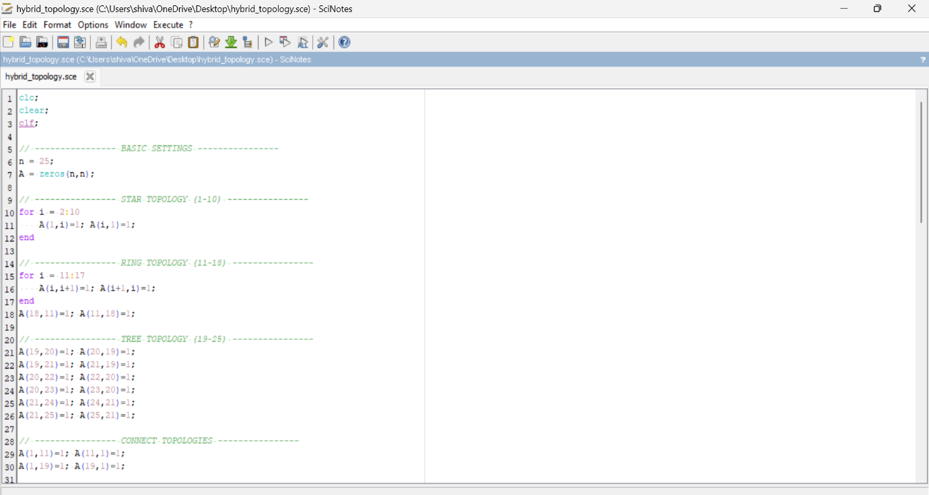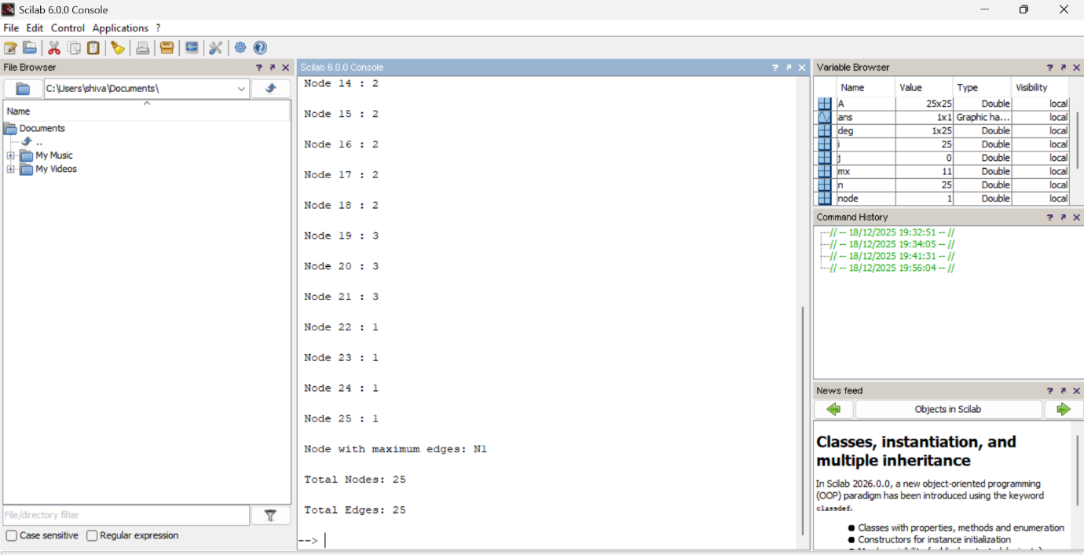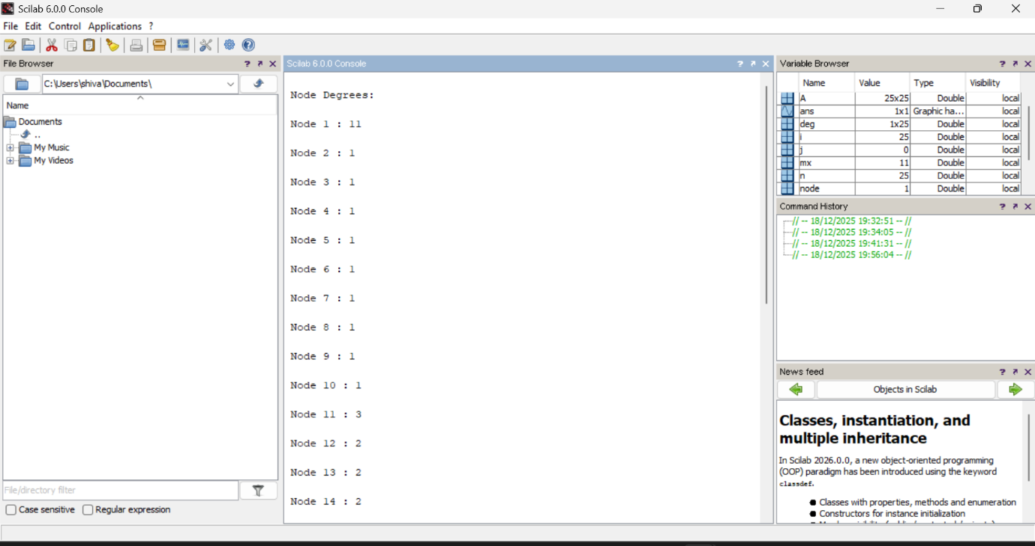
OUTPUT:
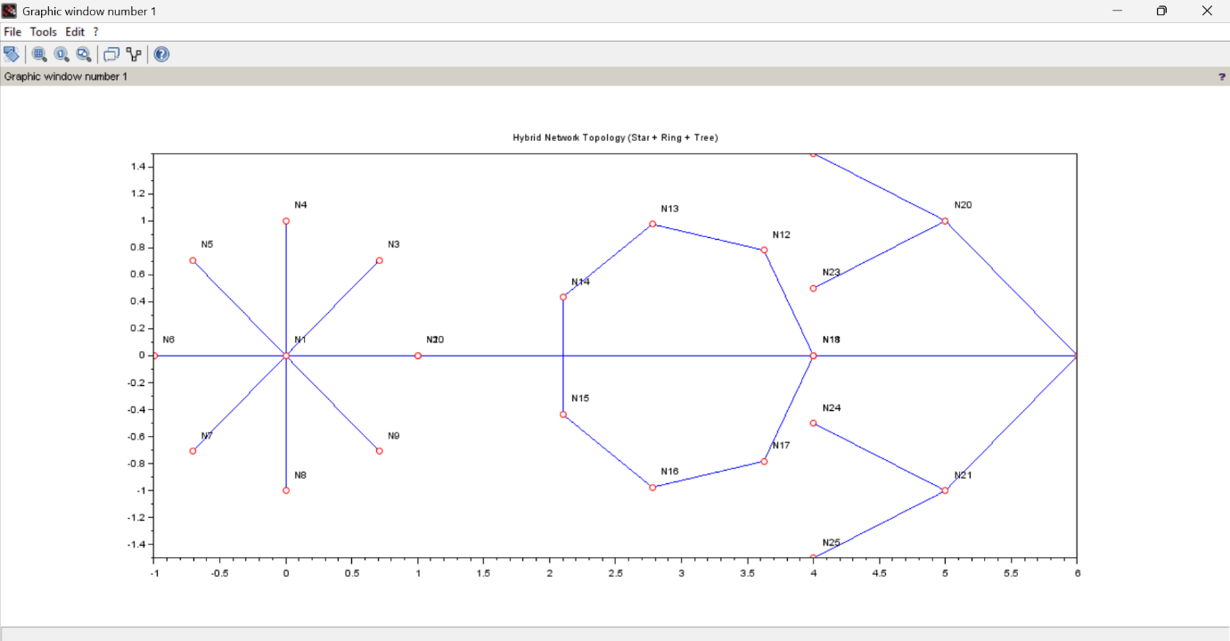

OBSERVATION :
- A hybrid topology consisting of Star, Ring, and Tree was successfully created.
- Node N1 has the maximum number of edges.
- The total number of nodes is 25 and total edges is 25.

Scenario Description :
Consider a University Campus Network where:
- The Administration Building uses a Star topology with a central server (Node N1) to manage student records and administration services.
- The Hostel Network is connected in a Ring topology to provide equal bandwidth access to all hostel blocks.
- The Academic Blocks follow a Tree topology to represent hierarchical communication between departments and classrooms.
These three networks are interconnected to form a Hybrid Network Topology.

Question 1
If the central node (N1) of the star topology fails, which parts of the network will still function and why?
Answer:
If the central node N1 fails, only the star-connected administration nodes will be affected.
The ring topology (hostels) and tree topology (academic blocks) will continue to function independently because they are not fully dependent on the star’s central node.

Question 2
Why is a hybrid topology suitable for a university campus network?
Answer:
A hybrid topology is suitable because it combines the advantages of different topologies.
It provides centralized control (star), equal data access (ring), and hierarchical communication (tree), resulting in better scalability, reliability, and fault tolerance.

Conclusion:
The hybrid network topology was successfully implemented using Scilab.
It demonstrates improved flexibility, scalability, and fault tolerance by combining multiple topologies.
Github link:

