Que 2.

a) x = randperm(200);

This generate a vector of size 200 with random values from 1 to 200.

b.)
a = [1,2,3; 4 5 6; 7 8 9];
b = a(2,:);

The above code snippet in part b denotes “a” is a 3X3 matrix and b here denotes a vector which contains the 2nd row of matrix “a”.

c.)
a = [1,2,3; 4 5 6; 7 8 9];
b = a(:);

The above code snippet in part c “a” is a 3X3 matrix and b denotes a column vector having elements arranged column wise i.e. 1st column then 2nd column and so on.

d.)

f = randn(5,1);
g = f(find(f > 0));

The above code snippet in part d will generate a random “column vector f” and randn function will generate a vector having “mean = 0” and some fixed standard deviations “S.D = X”

e.)

x = zeros(1,8)+0.5;
y = 0.5.*ones(1,length(x));
z = x + y;

Here “zeros(1,8)” denotes a vector with 1 row and 8 columns having 0 value. X here is a vector with 8 values each corresponding to magnitude 0.5. Similarly, function ones also work but output value 1 instead of zero. The output for x is equivalent to y. Then z is vector of 8 columns each having value 1.

f.)
a = [1:5];
b = a([end:-1:1]);

Here “a” is a vector of values from 1 to 5. “b” is again a vector which has similar value as “a” but in reverse order. We can interpret “a([end:-1:1])” like vector a starts from end and decrement every step under it reaches 1.

Que 3.

a.)
Use rand to write a function that returns the roll of a six-sided die.

Solution (a.)

p = roll_die();
p

function a = roll_die()
a = ceil(rand(1,1)*6);
end

b.)Let y be the vector: y = [1 2 3 4 5 6]’. Use the reshape command to form
a new matrix Z that looks like this: Z = [1 3 5;2 4 6]

Solution (b.)

y = [1 2 3 4 5 6]';
Z = reshape(y,2,3);

c.)
Use the min and find functions to set x to the minimum value that occurs in Z
(above), and set r to the row it occurs in and c to the column it occurs in.

Solution (c.)

minValue = min(Z(:));
[row, column] = find(Z == minValue);

d.)
Let v be the vector: v = [1 8 3 2 1 8 1 8]. Set a new variable x to be the
number of 8’s in the vector v.

Solution (d.)

v = [1 8 3 2 1 8 1 8];
count=sum(v==8);

Que 4.)
a.)

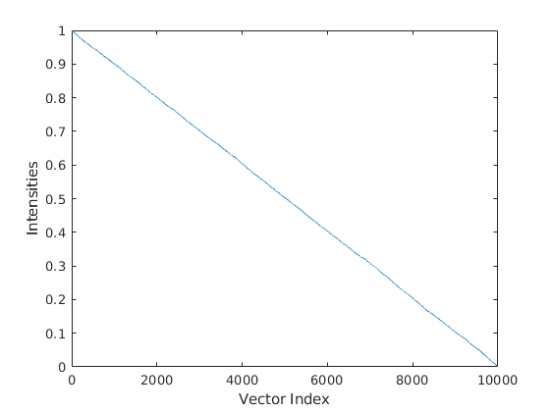
Figure 1: Vector with Decreasing Intensity Values

b.)

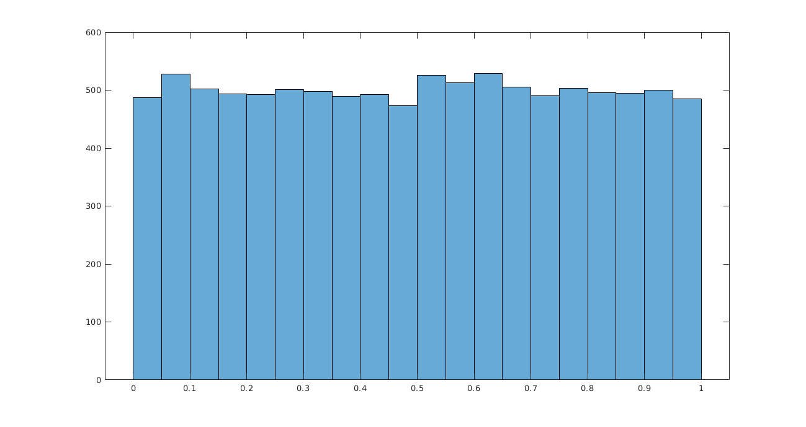
Figure 2: Histogram with 20 Bins

c.)
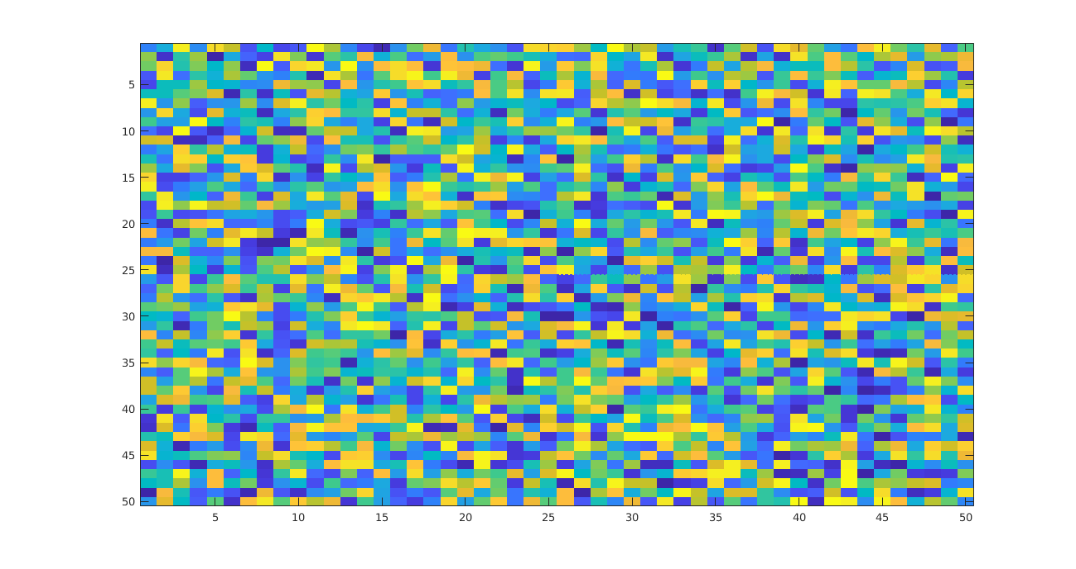
Figure 3: 3rd Quadrant Image of matrix A

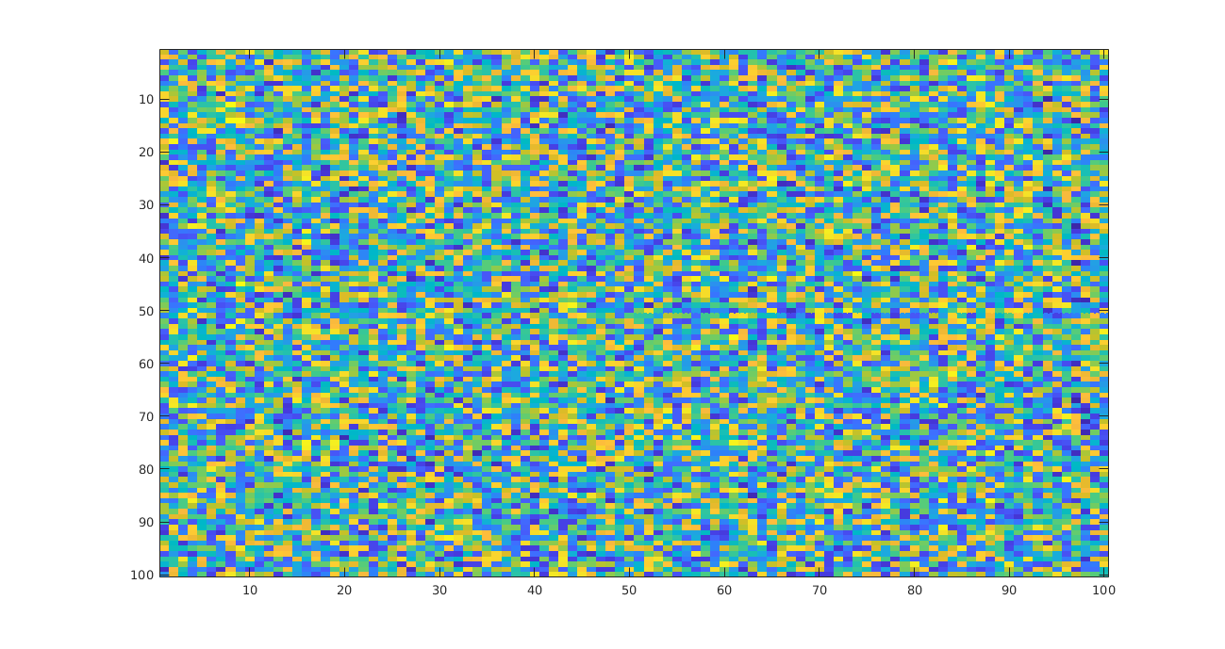
Figure 4: Subtract A with its mean

e.)
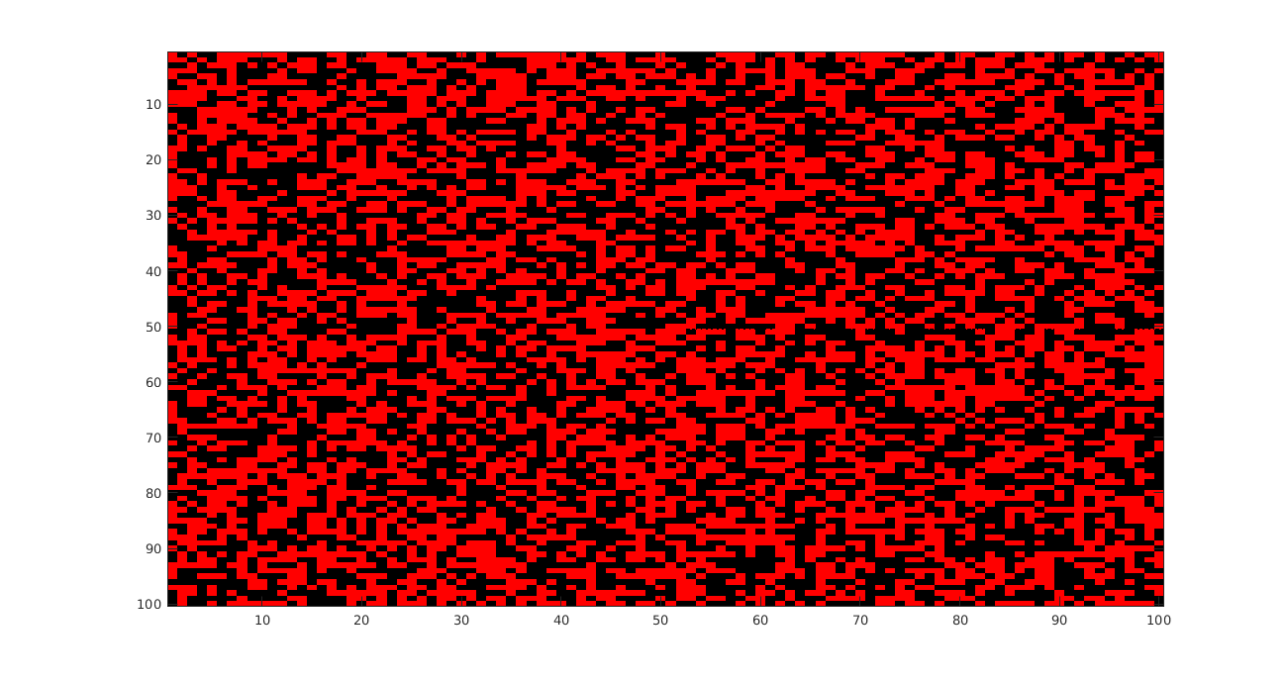
Figure 5: Matrix in part d >0 then red pixel else black

Short Answer:

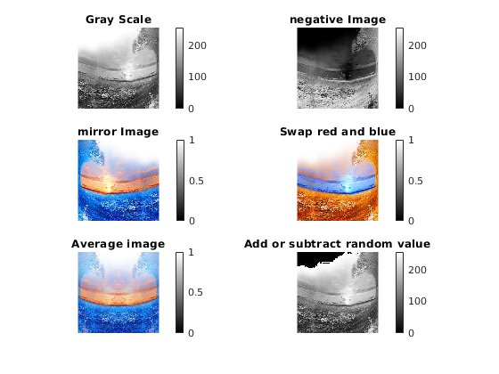
Figure 6: Short Answer Images

