Short answer problems [24 points]

Que1.
Given an example of how one can exploit the associative property of convolution to more efficiently filter an image.

Solution1.
Example: suppose there are two filters f,h and which has to be applied on an image g
In this case by the associative property of convolution we can write

(f*g)*h = (f*h)*g
Both operation on LHS and RHS produces the same result but the computational complexity of the operations are different.

Computational Complexity:
Suppose f → x*y matrix.
Suppose h → x*y matrix.
and g is an image matrix → X*Y matrix.

Then the computational complexity for RHS is
O((x*y)*(x*y)) + O((x*y)*(X*Y))

And the computational complexity of LHS is
2*O((x*y)*(X*Y)) i.e. 1st convolving image with filter then again convolving the output image obtained with another filter.

As the size of filters f,h are much smaller as compared to the image size so
Computation complexity of RHS is less as compared to that of LHS.

So RHS is considered as the most efficient way of convolution i.e. by convolving all filters first then convolve the image.

Que2.
This is the input image: [1 0 1 1 1 1 1 1]. What is the result of erosion with a structuring element [1 1 1]?

Solution2.
Output obtained after applying erosion:- [0 0 0 1 1 1 1 1]

Que3.
Describe a possible flaw in the use of additive Gaussian noise to represent image noise.

Solution3.
The noise in the real world images can be caused due to various factor like: wind,sand fire and also the orientation of the camera. So this is the reason why modeling of noise with Gaussian may not describe the real world applications.

Que4.
Design a method that takes video data from a camera perched above a conveyor belt at an automotive equipment manufacturer, and reports any flaws in the assembly of a part. Your response should be a list of concise, specific steps, and should incorporate several techniques covered in class thus far. Specify any important assumptions your method makes.
Solution4.

Assumptions:
1.)The camera is fixed at a particular place above the conveyor belt.
2.)There is no type of noise which can affect the photo taken by the camera.
3.)The time passed while taking image of 2 equipments are fixed. So that from video the unwanted frames can be removed.
4.) Has an ideal image from which we can compare the equipment image to find flaw in the particular image.

We can subtract the ideal image with the currently taken equipment image. On evaluating the output if the output pixels are examined to be above the certain threshold value we consider the image to be defective else not.

Testing of the below functions can be done through testing.m script file.

Programming Problems [76 marks:]

1.)
Write a script called seam_carving_decrease_width.m which does the following by
using the functions defined above:
a) Loads a color input image called inputSeamCarvingPrague.jpg. Download the image from
http://web.cs.ucdavis.edu/~yjlee/teaching/resources/inputSeamCarvingPrague.jpg
b) Reduces the width of the image by 100 pixels using the above functions.
c) Saves the resulting image as outputReduceWidthPrague.png. Submit it. Display this output
in your answer sheet. Submit the script.
d) Repeat the steps for an input image called inputSeamCarvingMall.jpg. Download the image
from http://web.cs.ucdavis.edu/~yjlee/teaching/resources/inputSeamCarvingMall.jpg. Save the output
as outputReduceWidthMall.png. Submit it. Display the output in your answer sheet.

Solution 1:
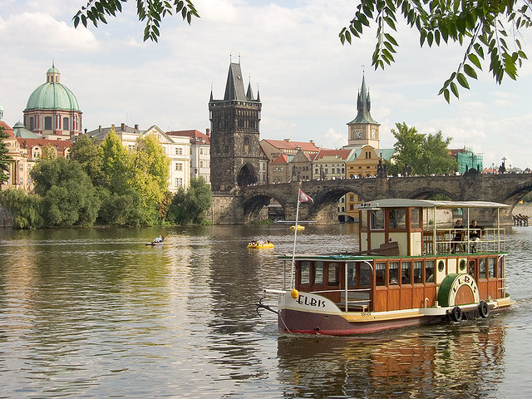
Figure1: InputSeamCarvingPrague

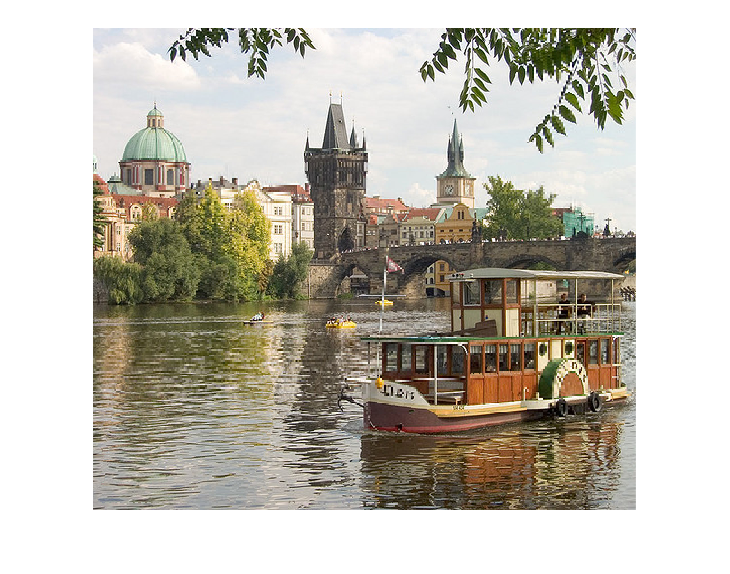
Figure 2: OutputSeamCarvingReducedWidthPrague

The image in figure2 is the output obtained from the Seam Carving after reducing 100 pixels in the width of the image.

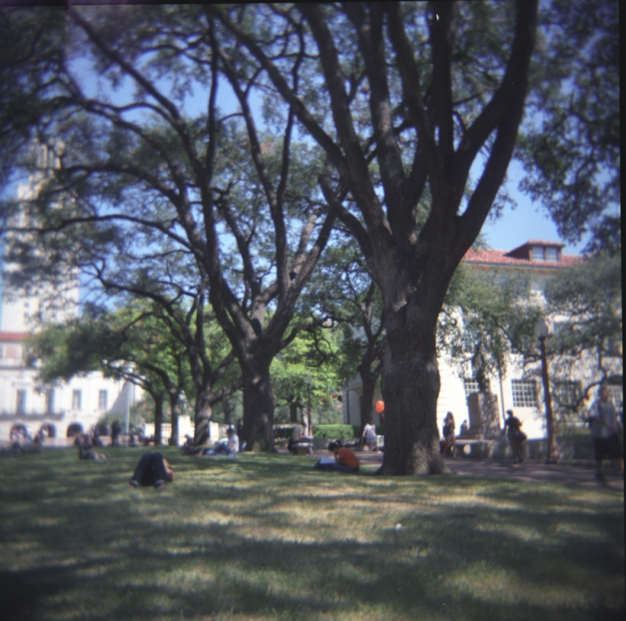
Figure 3: inputSeamCarvingMall

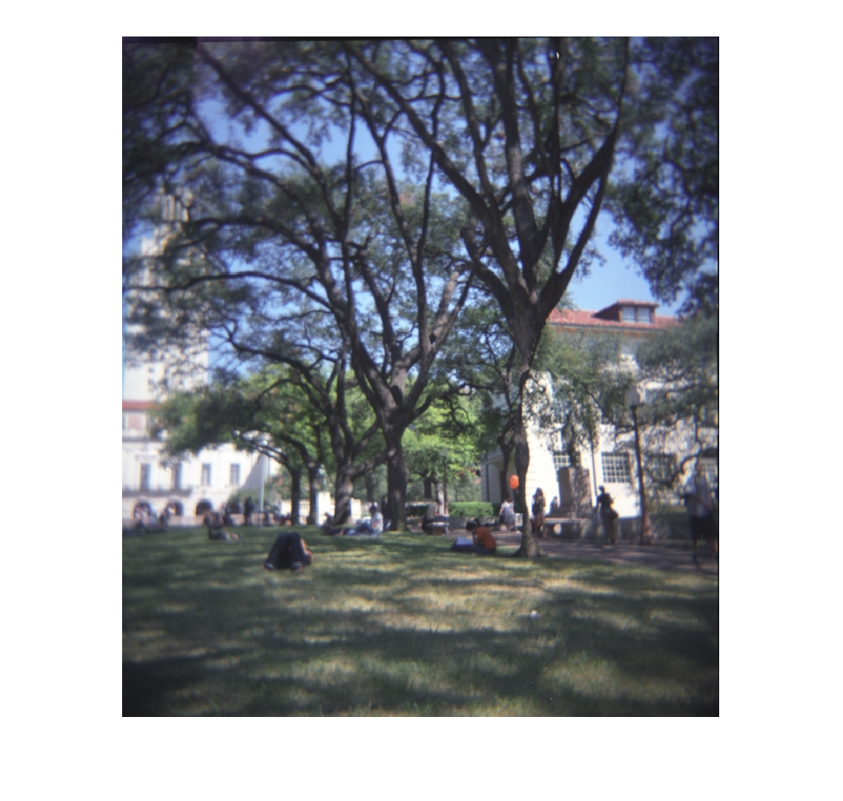
Figure4 : OutputSeamCarvingReducedWidthMall

The above image Figure4 is of OutputSeamCarvingMall with reduced 100 pixels.

2.)[11 points] Repeat the above steps for both input images, but reduce the height by 50 pixels. Call the script
seam_carving_decrease_height.m, and save the output images as
outputReduceHeightPrague.png and outputReduceHeightMall.png, respectively. Display
both outputs in your answer sheet. Submit the script for image inputSeamCarvingPrague.jpg

Solution 2:
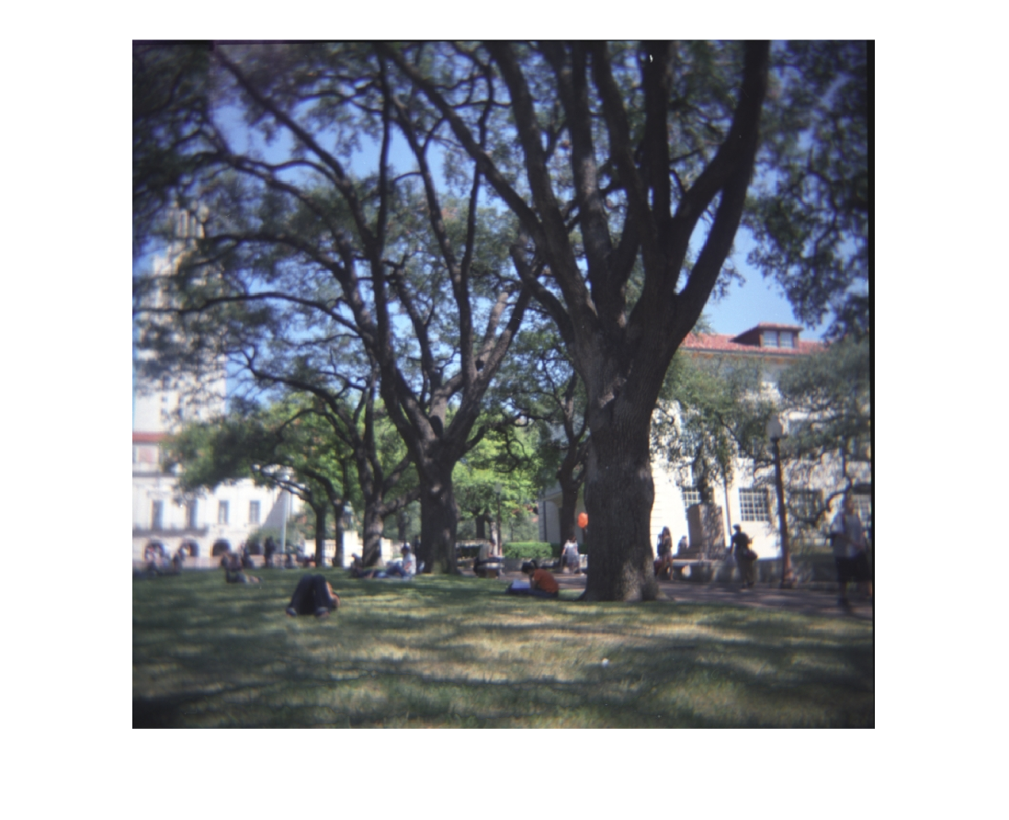
Figure5 : outputReducedHeightMall

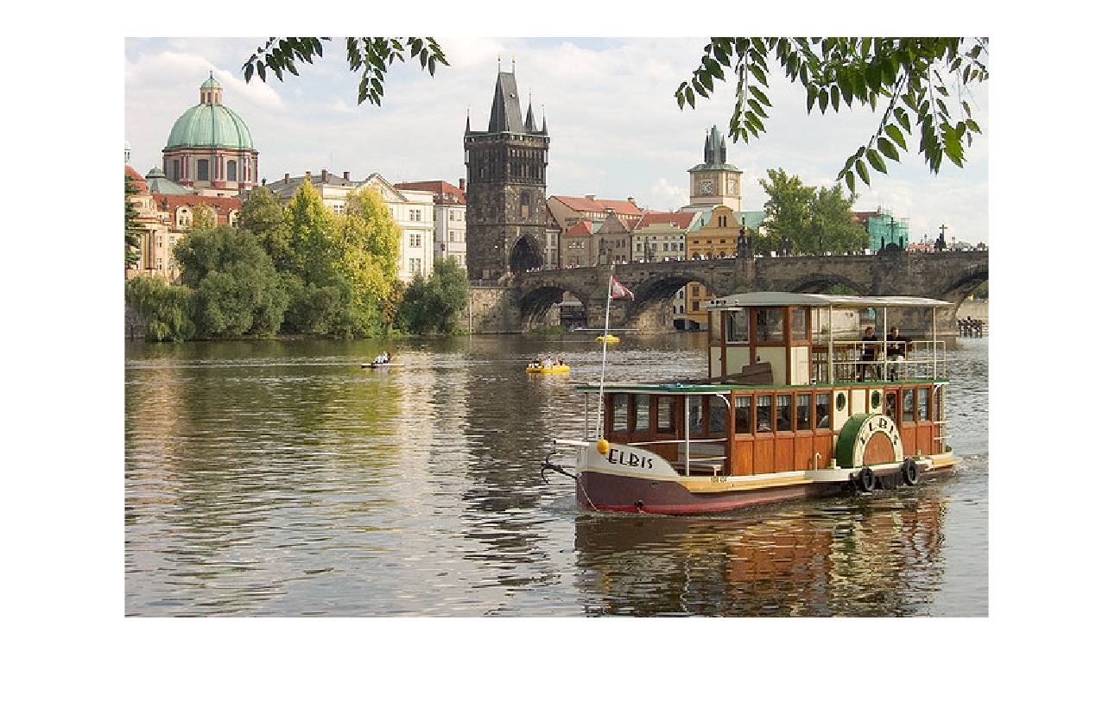
Figure 6 : outputReducedHeightPrague

3.) [11 points] Display in your answer sheet: (a) the energy function output for the provided image inputSeamCarvingPrague.jpg, and (b) the two corresponding cumulative minimum energy maps for the seams in each direction (use the imagesc function). Explain why these outputs look the way they do given the original image’s content.

Solution 3.)
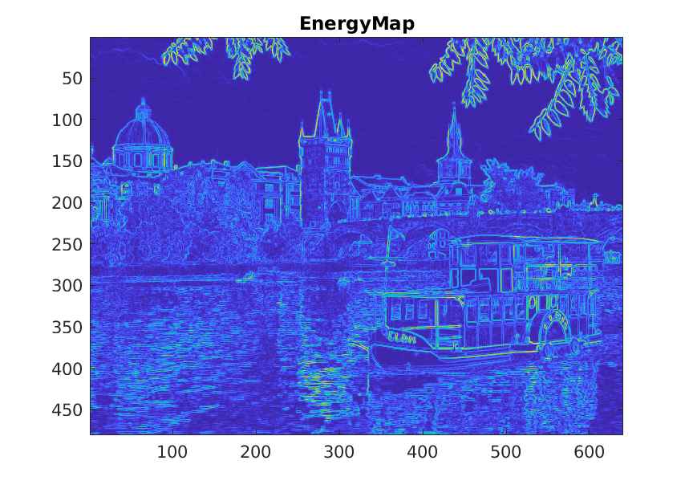
Figure7 : EnergyMapPrague

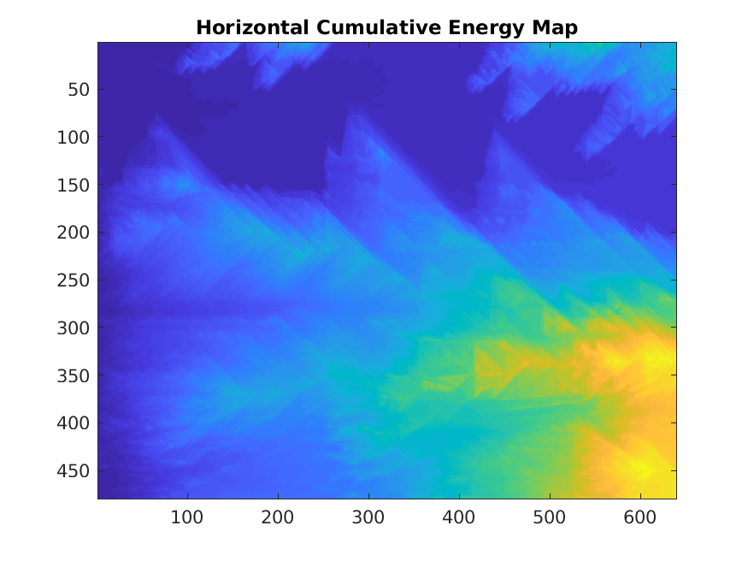
Figure8 : CumulativeEnergyHorizontalPrague

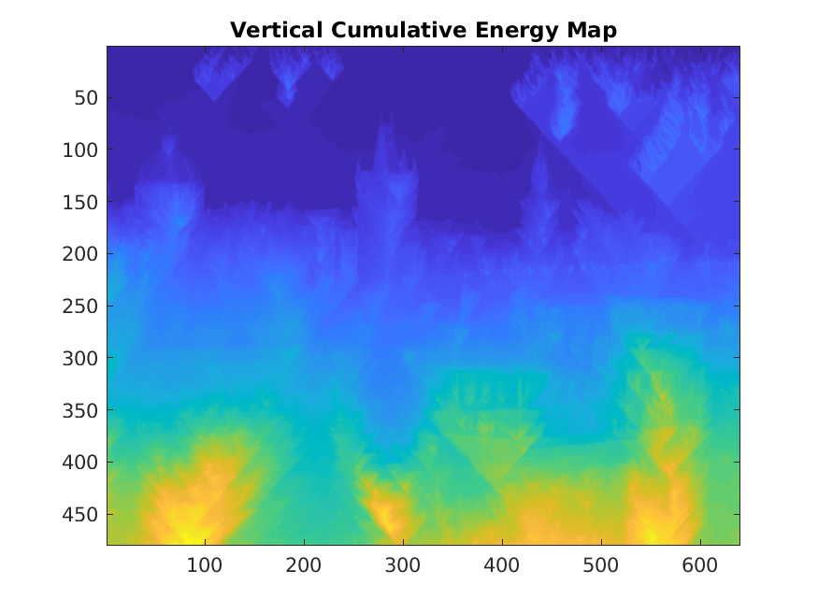
Figure 9: VerticalCumulativeEnergyMapPrague

Explanation for Figure 7: As the energy map is computed by Gx =(P(x+1) -P(x))/1
and similarly Gy = (P(y+1)-P(y))/1 so as we can see in the energy map that where ever we can find sharp change in pixel intensity i.e. on the boundaries or on the edges at those points the pixel intensities are very high. As well as the regions for which the nearby pixels are almost same we can see that those part are having very low intensity.

Explanation for Figure 8:
As the M matrix we computed for using dynamic programming will add up as we move from left to right that is one of the reasons for right most pixels having higher intensity as compared to the left most pixels. Another reason is we can see or note high intensity change for the regions for which intensities varies rapidly. For example in the above mentioned image the leaves. For these leaves the boundary of the leaves will vary with the high intensity so we can clearly able to see these area in the Horizontal Cumulative Energy Map.

Explanation for Figure 9:
As the M matrix we computed for using dynamic programming will add up as we move from top to bottom that is one of the reasons for bottom most pixels having higher intensity as compared to the top most pixels. Another reason is if we see the the lake water we can notice that due to sudden change in the intensity because of the shadow of the building and sunlight we can see those area as high intensity zones.

4.)
[11 points] For the same image inputSeamCarvingPrague.jpg, display the original image together with (a) the first selected horizontal seam and (b) the first selected vertical seam. Explain why these are the optimal seams for this image.

Solution 4.)
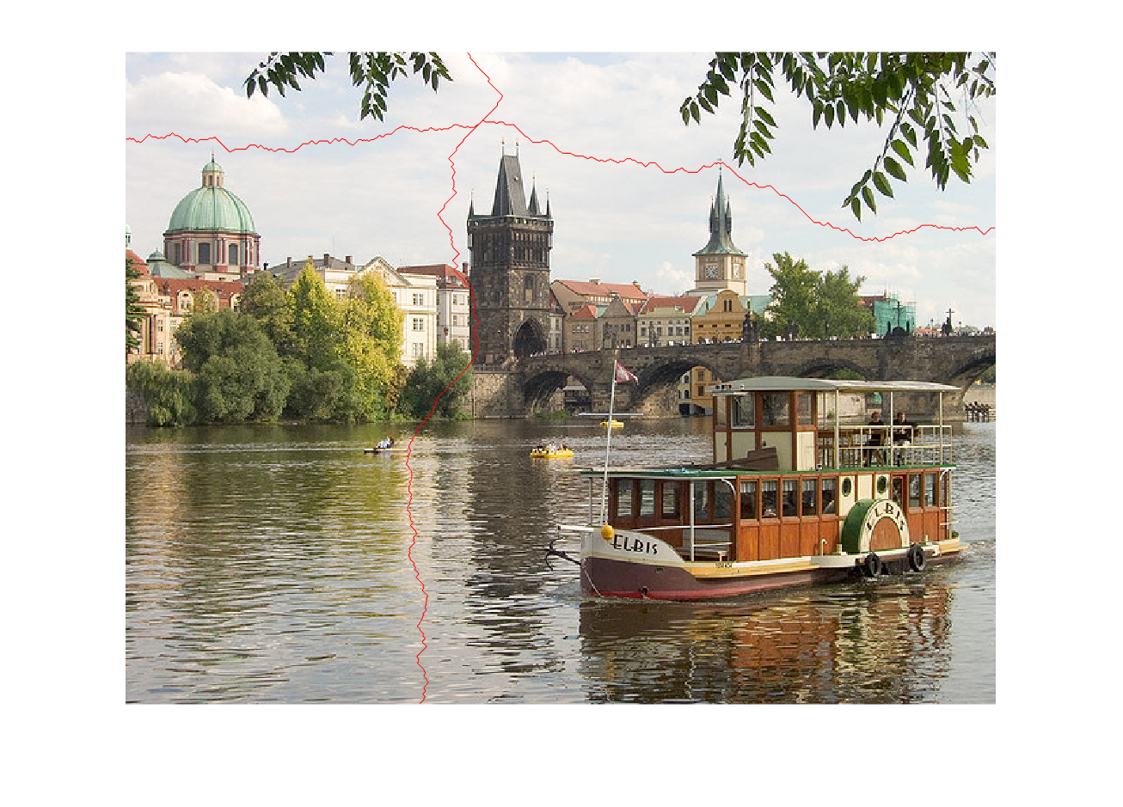
Figure10 : VerticalAndHorizontalSeam
As per the algorithm which runs from right to left for the horizontal seam and bottom to top for the vertical seam. We can say that the pixel considered before i.e. at the right most row and the bottom most column have the lowest intensity. And continuing from there we move by seeing the neighboring pixels of the lowest intensity range and make our horizontal and vertical seam to pass through those points. That’s how we obtain the vertical and horizontal Seam for a given image. Removing or adding pixels at that point will not affect the complete image.

5.)
[11 points] Make some change to the way the energy function is computed (i.e., filter used, its parameters, or incorporating some other prior knowledge). Display the result and explain the impact on the results for some example. You need not submit this code.

Solution 5.)

There are several techniques for calculating the energy function i.e. either by thresholding or by using filters i.e. Gaussian and Laplacian

1.) Using thresholding to calculating energy map:
This means that we will only be keeping the pixels having the intensities more than a particular threshold and will be removing the pixels with the intensities less then threshold.

2.) Using filters for smoothing the image by using Gaussian filter to calculate makes the image less aware of the best optimal seam. On noticing Figure 14 we can tell that due to filtering the optimal positing of the seam in the image has changed.

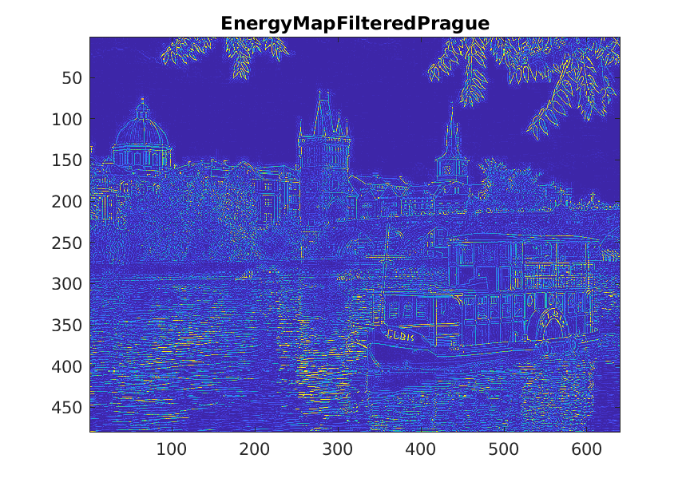
Figure11 : Filtered Energy Map

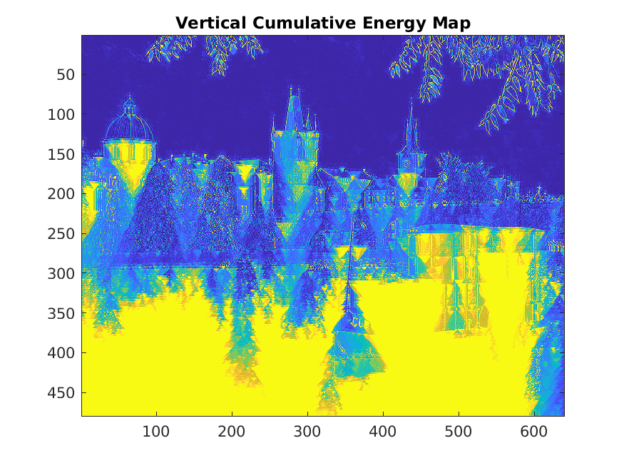 . F igure12: Filtered Vertical Cumulative Energy Map

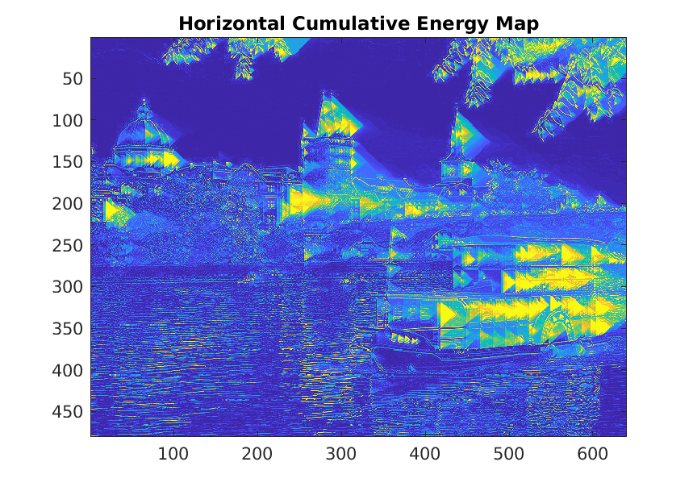
Figure13 : Filtered Horizontal Cumulative Energy Map

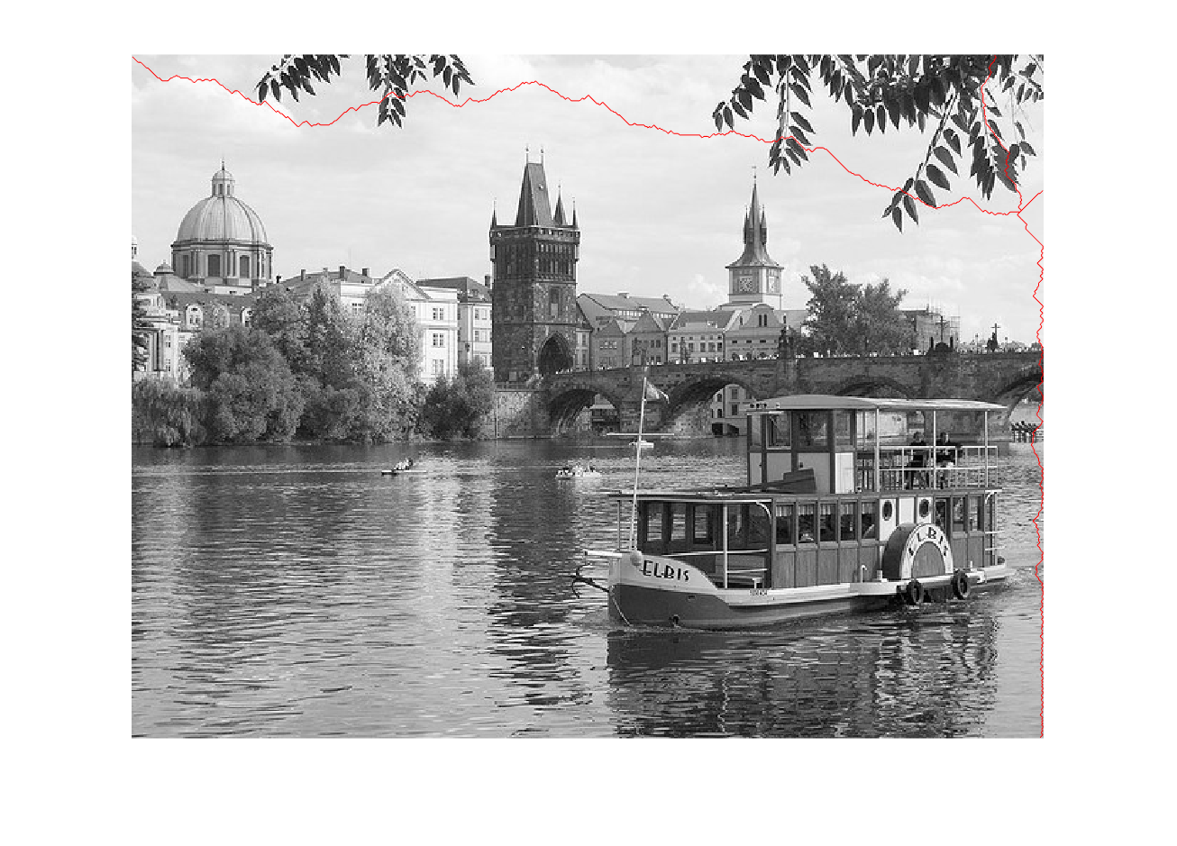
Figure14 : Filtered Image Seam

