**Homework Assignment 4**

**STA 141A A02**

**Submitted By:**

**Question1:** Write a function simulate_monopoly() that simulates n turns by a player in a game of Monopoly using two d-sided dice. The inputs to your function should be n and d. The output of your function should be a length n + 1 vector of positions, encoded as numbers from 0 to 39.

**Solution1:** The function stimulate monopoly takes two input from the user and based on that how the sum of the dies varies the position of the player playing also varies accordingly. The game starts with position 0 i.e. go and continue in the same order until "CC" or "CH" occurs. If more than 3 consecutive same number on the die occurs then to current player position change to "Jail"

**Question 2:** Write a function estimate_monopoly() that uses your simulation to estimate the long-term probabilities of ending a turn on each Monopoly square. What are the 3 most likely squares to end a turn on if you play Monopoly with 6-sided dice? What if you play with 4-sided dice? Display graphically the long-term probabilities for 3, 4, 5, and 6-sided dice.

**Solution 2:**a.)The function estimate_monopoly() takes two argument takes two argument i.e. one current position vector of player and another is sample size. This function in turn calculate probabilities

for ending up on particular square. This is for sample size **n=1000**.

b.) 5th,10th and 38th position as clearly seen from the graphs below are the 3 most-likely square to turn in as they have high probability occurrence

c). 10th,5th and 35th are the positions having high probability occurrence for a 4 sided die.

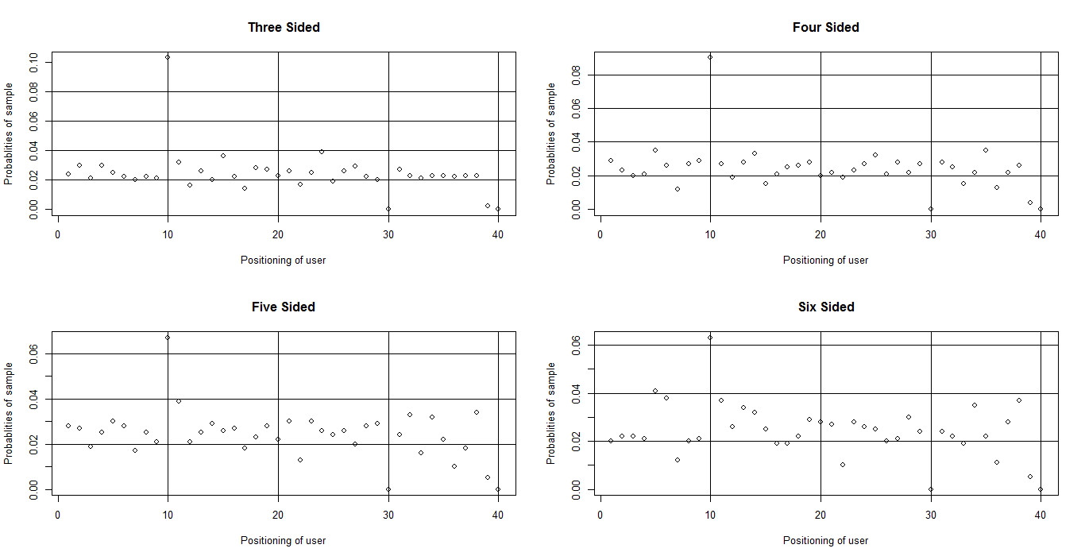

Figure 1:Probablities on landing on specific position on dashboard

**Question 3:** Use k = 1000 simulations with n = 10000 turns each to estimate the standard error for the long-term probability of ending a turn in jail.

**Solution 3:** For doing this above mentioned simulation a loop which a loop is written which iterates over the whole position vector and find the number of occurrence of position 11 in vector and then calculate its std. error accordingly. The standard error for the long term probability for ending in the jail is **4.544519e-05.**

**Question 4:** Use the non-parametric bootstrap with b = 1000 samples from a simulation of n = 10000 turns to estimate the standard error for the long-term probability of ending a turn in jail.

(a) How does the bootstrap estimate compare to the simulation estimate? Which do you think is more accurate? Explain.

(b) Which is faster to compute: the bootstrap estimate or the simulation estimate? Explain why there is a difference.

**Solution 4:**(a).

|  |  |  |
| --- | --- | --- |
| Original | Bias | std. error |
| 0.008298873 | -1.817805e-07 | 2.100255e-05 |

Table 1:Bootstrap Statistics

Bootstrap is more accurate as compared to simulation as less std error. in the bootstrap. I think stimulation will always be more accurate as this is due to taken into consideration many different sample whereas in case of bootstrap there is only re-sampling happening for only one sample.

b) **Comparison with time**: As in bootstrap the re-sampling is done for the current given sample as compare to the stimulation. As the re-sampling is done for the same sample so time taken for bootstrap execution is way less then as compared to that of stimulation.

**Question 5:** Display graphically the standard errors for the long-term probabilities for 3, 4, 5, and 6-sided dice (use the same settings you used in question 2). Discuss why some probabilities have much larger standard errors than others.

**Solution 5:**

**a.)**

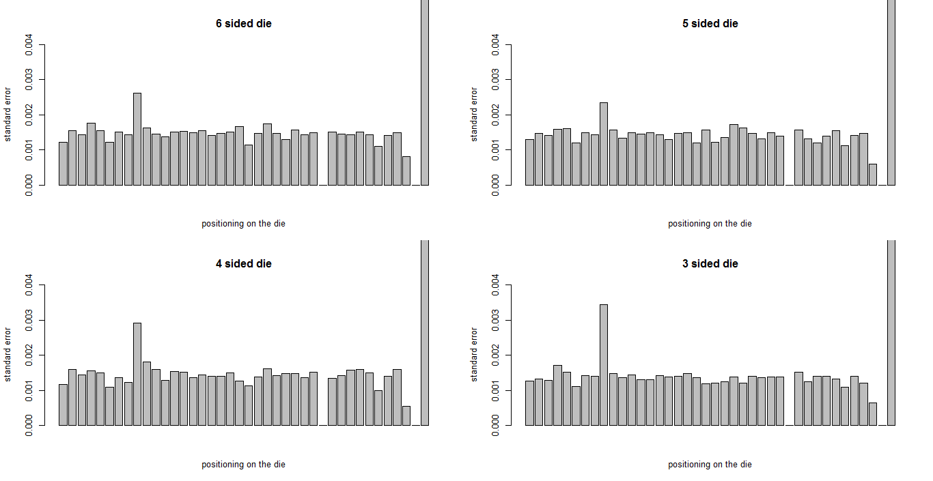

Figure 2:Standard error representation for 3,4,5 and 6 sided die.

**b.)** Some of the probabilities like that of position 39 have very high standard error. This is due to the variability of the rolling die if considered. Position 9 too as compared to the nearby positioning has high standard error.

**Question 6:** What happens to the standard errors for the long-term probability estimates as n increases? Why does this happen?

**Solution 6:**On increasing the value on n from the standard errors tend to decrease. A standard error is the [standard deviation](https://www.investopedia.com/terms/s/standarddeviation.asp) of the [sampling distribution](https://www.investopedia.com/terms/s/sampling-distribution.asp) of a statistic. The standard error is also inversely proportional to the sample size; the larger the sample size, the smaller the standard error because the statistic will approach the actual value.

**REFERENCES:**

**1.)** https://github.com/iansealy/projecteuler/blob/master/84.R

Reference for implementation for stimulate_monopoly function.

**2.)** Prof. S. Gupta: For knowing how to approach following problem of stimulate_monopoly.

**3.)** Piazza: For data interpretation in Que2 i.e. either drawing a dot plot or bar plot.

|  |
| --- |
| **List of Names of Final Project Group mates:** |
| **1. Shivang Soni.** |
| **2. Min Ji Kim.** |
| **3. Neva He.** |