TASK1:
What kind of model does this PCFG implement? Give your thoughts.
./cfgparse.pl grammar2 lexicon < examples.sen

Solution: After carefully examining the files lexicon and grammer2
The conclusion can be drawn that the PCFG is an extension of the HMM because as for an productions like: riding to Camelot is hard .
The parse tree can be drawn as follows:
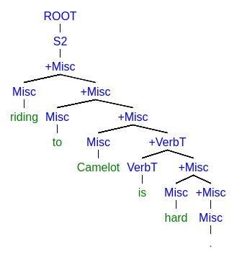
Figure1: ParseTree for a sentence

The Figure1 denotes this parse tree is the result of best possible parse that is:
i.e. given by max probablity obtained from the best tree parses.
P(Net_For_the_parse_tree) =
P(ROOT→S2)*P(S2→+Misc)*P(+Misc → Misc +Misc)* P(+Misc → Misc +Misc)* P(+Misc →Misc +VerbT)*P(+VerbT → VerbT +Misc)*P(+Misc → Misc +Misc)*P(+Misc → Misc)*P(Misc → .).

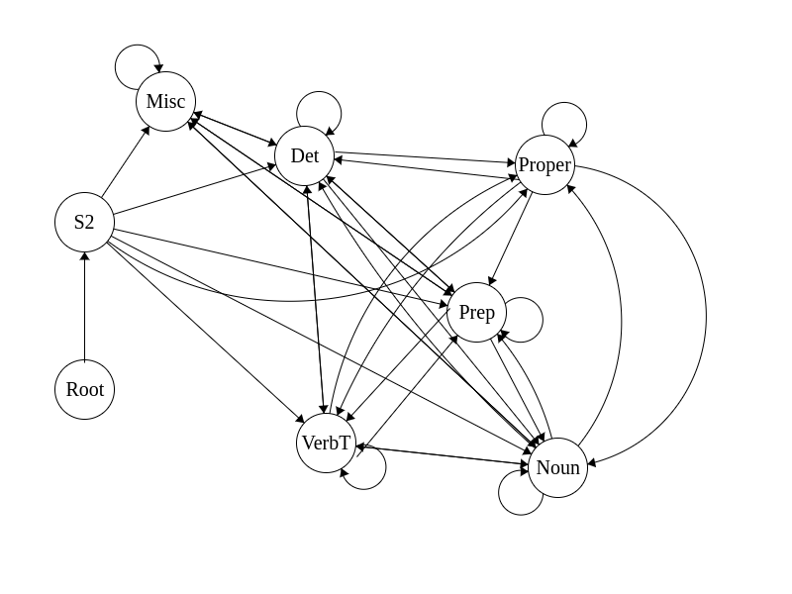
Figure2: FSM for grammer2

Here all these states have many terminals for example:
Det → a
Det → another
Det → any
Det → each
Det → every
Det → no
Det → that
Det → the
Det → this
so probablity of choosing a single word will be (1/9) if all the words are equally likely to occur.
This is similar case as we studied in HMM.
So these can be called as n-grams HMM as other then unigram other Languages Models can be used to generate the above FSM.

Task2:
Compare the outcome of
./cfgparse.pl grammar1 lexicon < examples.sen

./cfgparse.pl grammar1 grammar2 lexicon < examples.sen

And give your’s opinion about what is going on?

Solution2:
On executing ./cfgparse.pl grammar1 lexicon < examples.sen command in the terminal the parse fails as the grammer1 productions and productions in lexicon does not match to each other for parsing.

While on executing ./cfgparse.pl grammar1 grammar2 lexicon < examples.sen on terminal The merged grammar for grammar1 and grammar2 produces an output with a wider range of grammar rules. It depends on the context of how we are using your merged grammar. If we want to cover a wider range of words and sentences then using merged grammar is better. However, it may be worse to use merged grammar in some cases also where the total probability of some parse will decrease.

Task3:
./cfggen.pl --text <N> grammar1 lexicon
./cfggen.pl --text <N> grammar2 lexicon
./cfggen.pl --text <N> grammar1 grammar2 lexicon

Explain what is going on??

Solution3:
Due to presence of different types of grammar and also the productions the sentences formation will take place differently, so this is main reason for different sentence being produced when different grammars are used for production. Also we need to take into account the probabilities of the parse trees i.e. the parse tree probabilities also differ from grammar to grammar.

By executing the above commands we can able to generate the sentences and based on sentences been generated we can conclude which is better grammar among the above given grammars. The good grammar generate more grammatically correct sentences.

In above case in terms of grammar performance Grammar1<Grammar2<Merged Grammar.
Based on how much grammatically correct sentences they produce.

Task4:

I implemented the grammar which is placed in file mygrammar and also the modified lexicon file is named as mylexicon .

I can able to parse all the sentences without any failure and have low score as compared to merged grammar as well as grammar2

Score for grammars:

These cross-entropy calculations are done based on observing the values from the generated sentences and are present in files:
1.Evaluategrammar2.py
2.Evaluatemergedgrammar.py
3.Evaluatemygrammar.py

Also find the script file to calculate cross-entropy named as test.py and input to be given
in file named temp.

Grammars | Summation(P(s)) | Cross Entropy
Grammar2 | 46.9979934737 | 1.40541884176e+14
MergedGrammar | 50.156373688 | 1.25479550367e+15
MyGrammar | 45.1104941953 | 3.79849773701e+13

Thus my grammar performs better than merged grammar due to less cross entropy values.
I used Penn Treebank dataset to attach appropriate POS tags with words.

Task5:

Test for ungrammatical sentences:

3.017e-06 6.033e-06 0.500 (ROOT (S1 (NP (Det any) (Nbar (Noun fruit))) (VP (VerbT carries) (NP (Det that) (Nbar (Noun defeater)))) .))

1.448e-11 2.895e-11 0.500 (ROOT (S1 (NP (Det a) (Nbar (Noun sun))) (VP (VerbT drinks) (NP (Det them) (Nbar (Nbar (Noun swallow)) (PP (Prep at) (NP (Det a) (Nbar (Noun home))))))) .))

1.508e-06 3.017e-06 0.500 (ROOT (S1 (NP (Det another) (Nbar (Noun corner))) (VP (VerbT covers) (NP (Det any) (Nbar (Noun story)))) .))

1.508e-06 3.017e-06 0.500 (ROOT (S1 (NP (Det every) (Nbar (Noun Holy Grail))) (VP (VerbT rides) (NP (Det them) (Nbar (Noun coconut)))) .))

2.969e-06 5.939e-06 0.500 (ROOT (S1 (NP (Proper Arthur)) (VP (VerbT is) (NP (Det there) (Nbar (Noun Holy Grail)))) .))

2.969e-06 5.939e-06 0.500 (ROOT (S1 (NP (Proper Sir Bedevere)) (VP (VerbT covers) (NP (Det a) (Nbar (Noun chalice)))) .))

1.508e-06 3.017e-06 0.500 (ROOT (S1 (NP (Det there) (Nbar (Noun chalice))) (VP (VerbT carries) (NP (Det them) (Nbar (Noun husk)))) .))

3.017e-06 6.033e-06 0.500 (ROOT (S1 (NP (Det each) (Nbar (Noun home))) (VP (VerbT is) (NP (Det that) (Nbar (Noun castle)))) .))

1.508e-06 3.017e-06 0.500 (ROOT (S1 (NP (Det them) (Nbar (Noun quest))) (VP (VerbT rides) (NP (Det a) (Nbar (Noun fruit)))) .))

1.508e-06 3.017e-06 0.500 (ROOT (S1 (NP (Det every) (Nbar (Noun fruit))) (VP (VerbT is) (NP (Det no) (Nbar (Noun master)))) .))

6.033e-06 1.207e-05 0.500 (ROOT (S1 (NP (Det that) (Nbar (Noun sovereign))) (VP (VerbT has) (NP (Det that) (Nbar (Noun Camelot)))) .))

5.700e-11 1.140e-10 0.500 (ROOT (S1 (NP (Det no) (Nbar (Nbar (Noun story)) (PP (Prep from) (NP (Proper Arthur))))) (VP (VerbT carries) (NP (Det that) (Nbar (Noun master)))) .))

1.508e-06 3.017e-06 0.500 (ROOT (S1 (NP (Det every) (Nbar (Noun king))) (VP (VerbT drinks) (NP (Det every) (Nbar (Noun Holy Grail)))) .))

3.017e-06 6.033e-06 0.500 (ROOT (S1 (NP (Det them) (Nbar (Noun Round Table))) (VP (VerbT has) (NP (Det that) (Nbar (Noun master)))) .))

3.017e-06 6.033e-06 0.500 (ROOT (S1 (NP (Det there) (Nbar (Noun Round Table))) (VP (VerbT is) (NP (Det that) (Nbar (Noun Camelot)))) .))

5.700e-11 1.140e-10 0.500 (ROOT (S1 (NP (Det no) (Nbar (Nbar (Noun story)) (PP (Prep through) (NP (Det that) (Nbar (Noun land)))))) (VP (VerbT rides) (NP (Proper Sir Lancelot))) .))

1.508e-06 3.017e-06 0.500 (ROOT (S1 (NP (Det there) (Nbar (Noun chalice))) (VP (VerbT rides) (NP (Det them) (Nbar (Noun Holy Grail)))) .))

1.508e-06 3.017e-06 0.500 (ROOT (S1 (NP (Det there) (Nbar (Noun coconut))) (VP (VerbT is) (NP (Det the) (Nbar (Noun pound)))) .))

3.017e-06 6.033e-06 0.500 (ROOT (S1 (NP (Det that) (Nbar (Noun Round Table))) (VP (VerbT has) (NP (Det them) (Nbar (Noun king)))) .))

1.508e-06 3.017e-06 0.500 (ROOT (S1 (NP (Det this) (Nbar (Noun winter))) (VP (VerbT is) (NP (Det every) (Nbar (Noun England)))) .))

This output is obtained from keeping 20 sentence generated in generated.txt and then
running the command to compute probabilities for these sentences obtained.

Grammatically correct sentences are provided I file named generated-grammatical.txt

From the above probabilities we can conclude the ungrammatical sentences are those which have very low probabilities for its generation.
In the above case there are 3 sentences which are grammatically incorrect as they have low probabilities for there generation.

P(grammatically correct sentences) = 17/20

