Create a 2 Linux instances and enable password less authentication between them and username should be eranki and make sure that user is forced to change his initial login password

User Creation :

1. sudo useradd eranki
2. passwd eranki (to change password of user)
3. cat /etc/passwd (to check users)
4. su eranki (to switch to particular user)

PasswordLess remote login:

1. ssh-keygen (to generate key)
2. cd .ssh/
3. ls (to list the created key)
4. ssh-copy-id remote_user_ip (to copy key to remote user)
5. ssh remote_user_ip (login to remote user)

NOTE: use private ip address to login

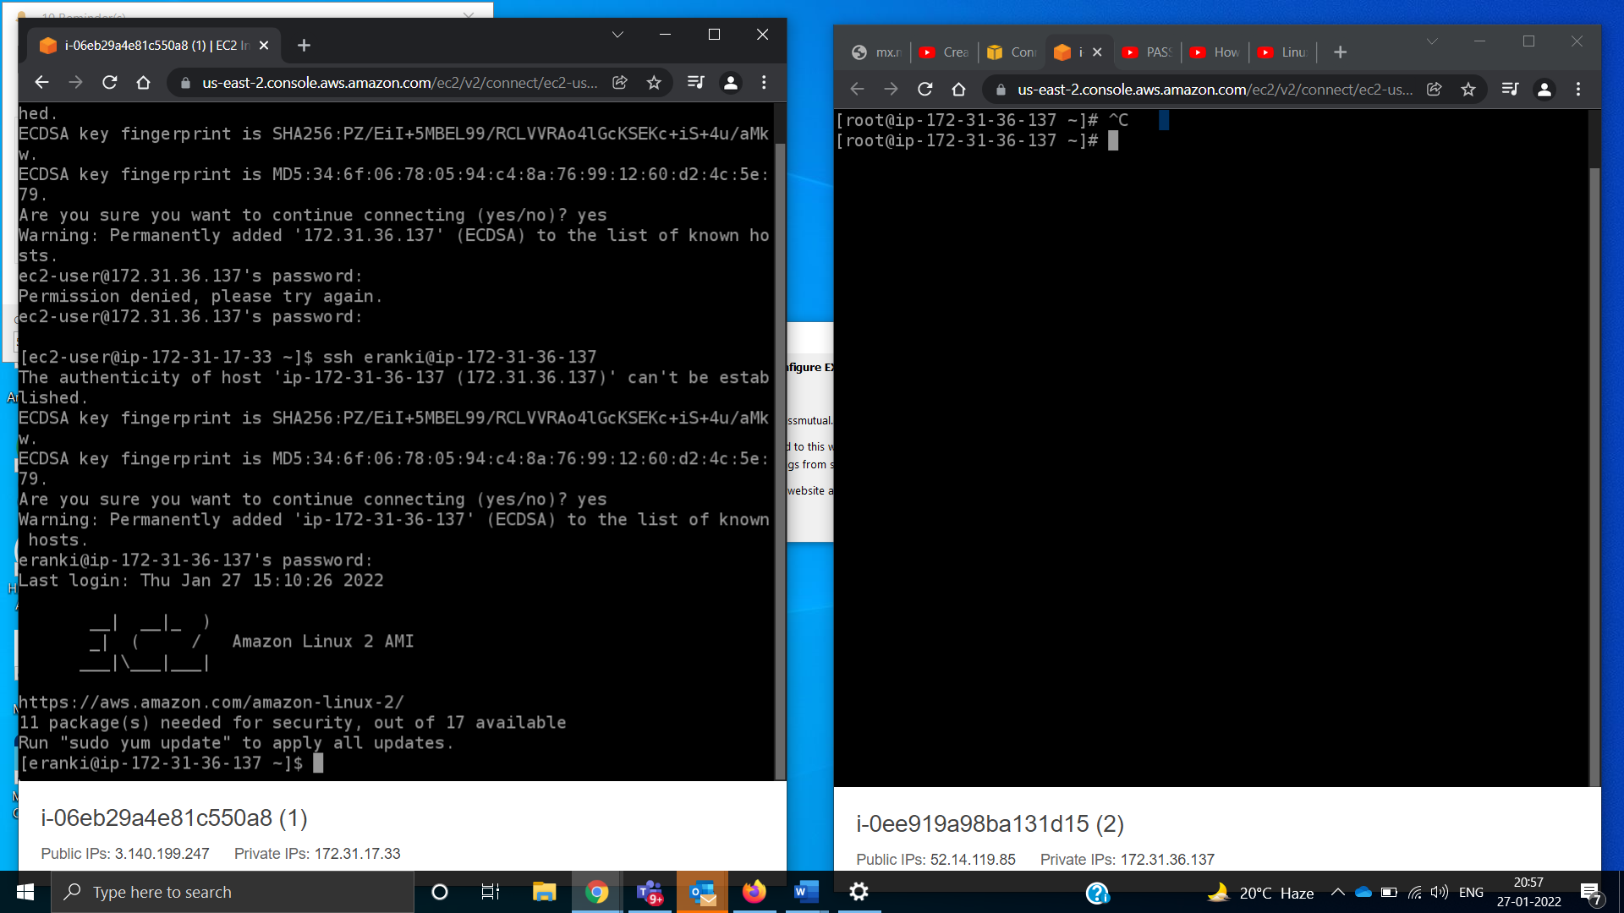 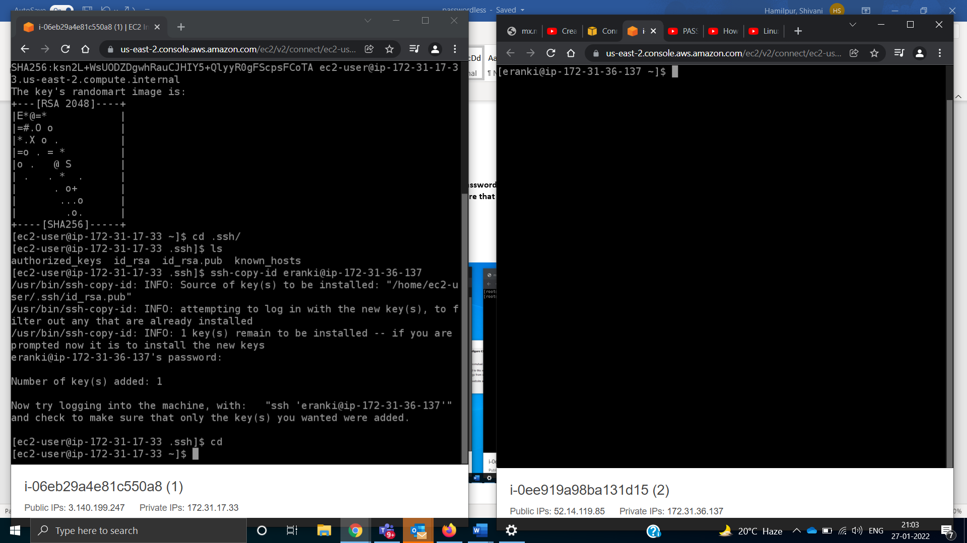 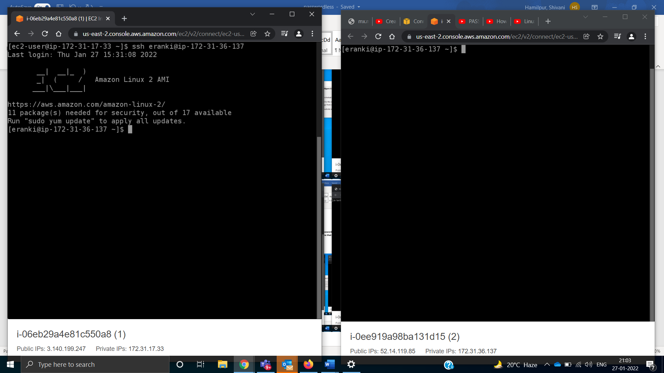 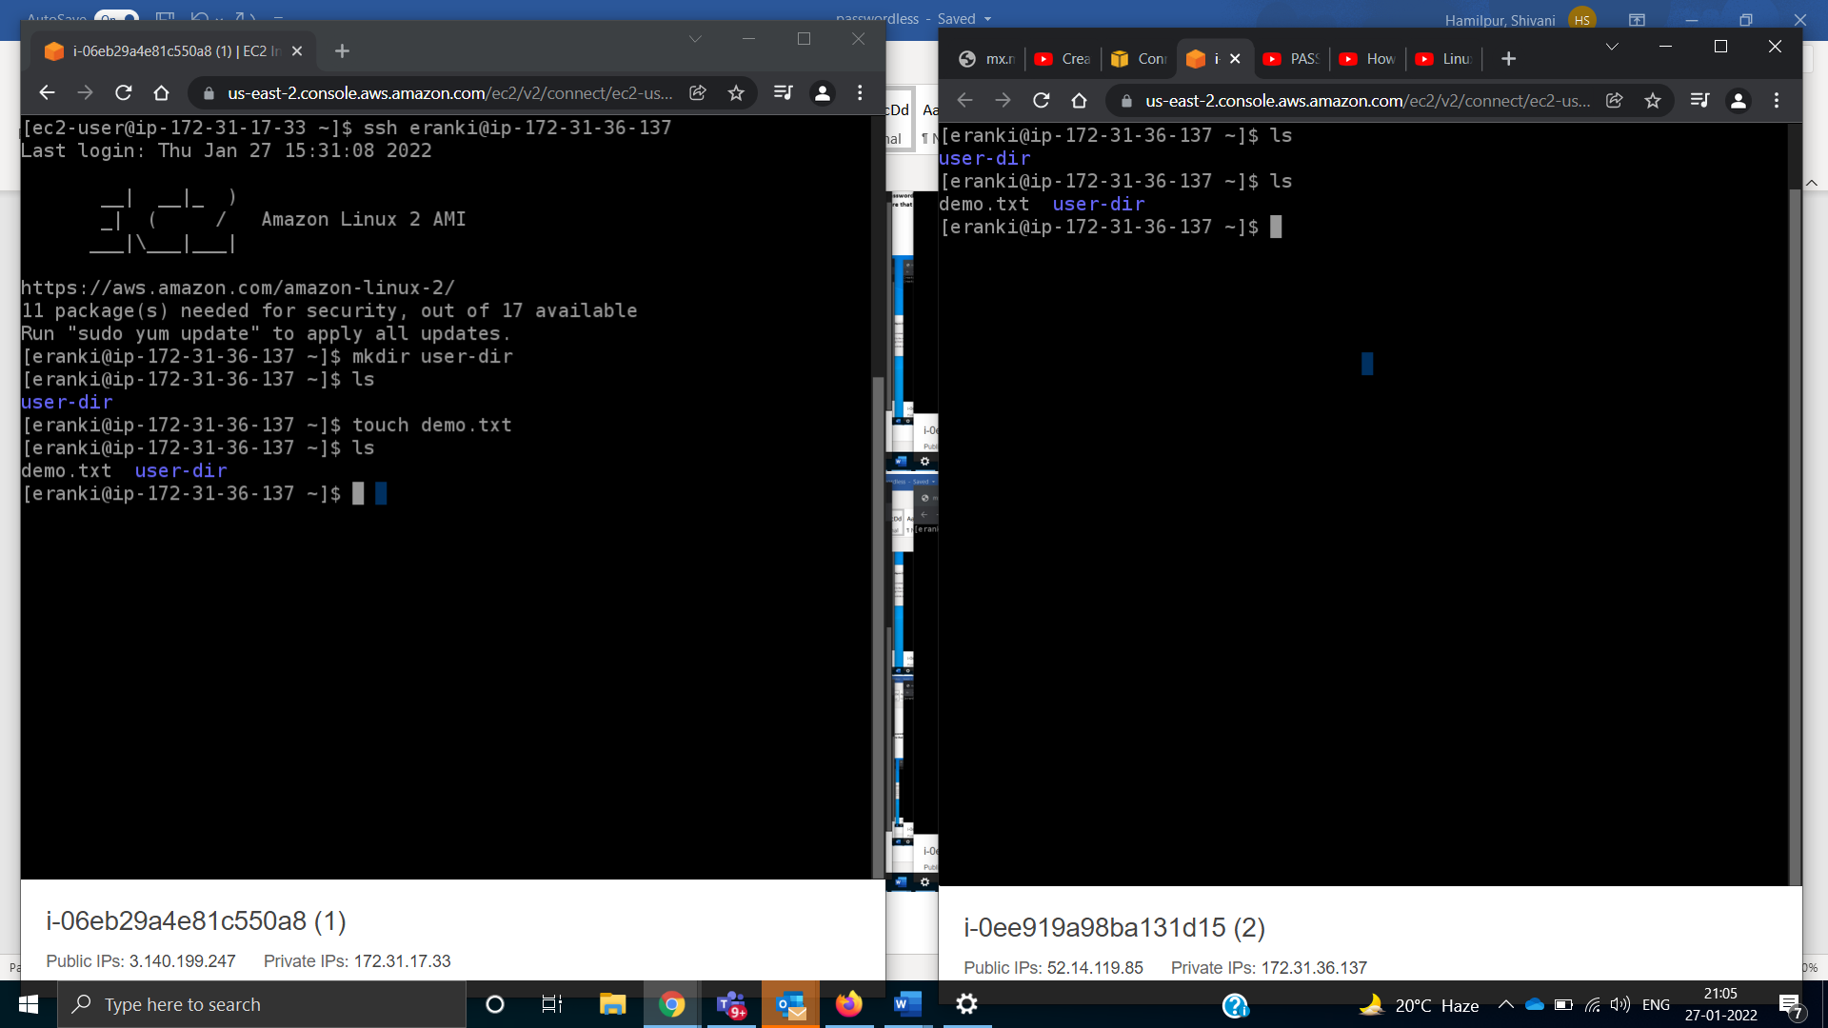

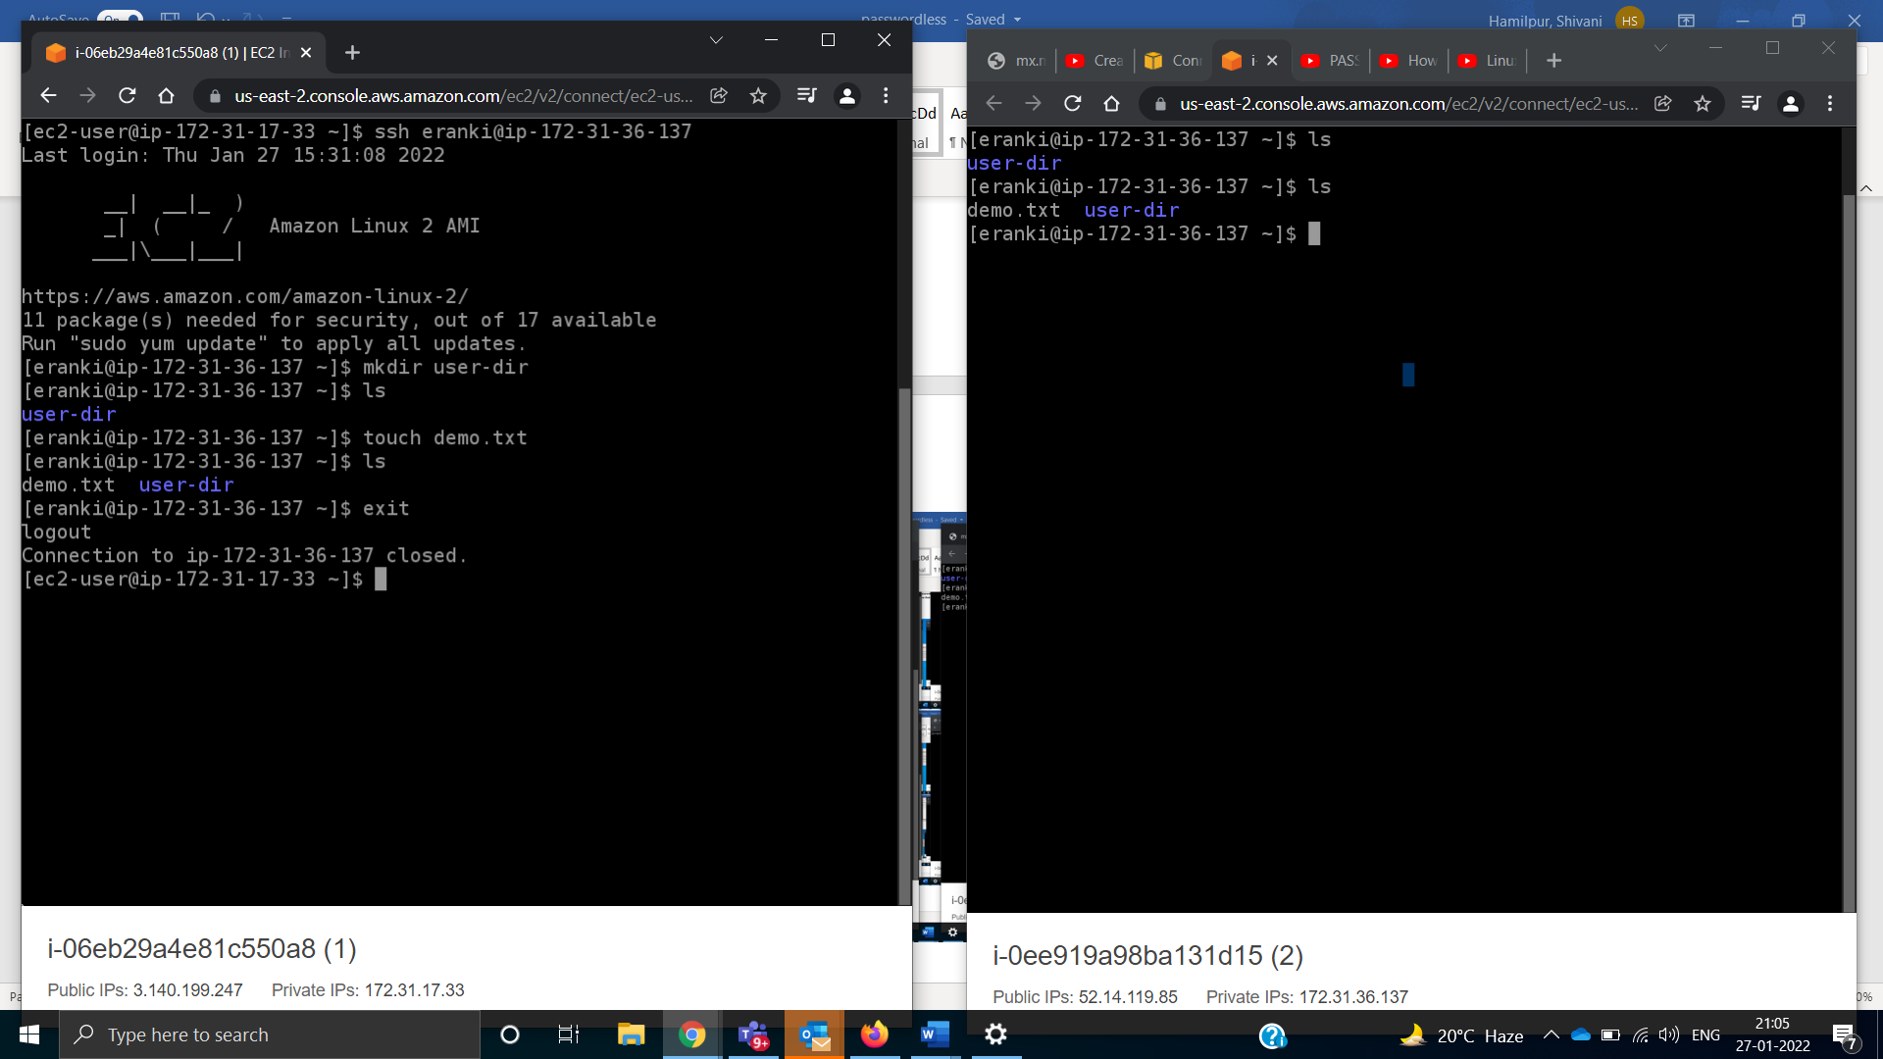

References:

Passwordless login steps:

<https://youtu.be/LlH0MVsv1-A>

Create and switch to particular user:

<https://youtu.be/_6pnaczM86U>

<https://youtu.be/UqgyNmQX9Bw>