**Low Level Design Document**

**Big Game Census Data Visualization**

**-shivanireddy**

|  |  |
| --- | --- |
| **Written By** | Author 1-  Shivanireddy |
| **Document Version** | 0.1 |
| **Last Revised Date** |  |

# DOCUMENT CONTROL

Change Record:

|  |  |  |  |
| --- | --- | --- | --- |
| **VERSION** | **DATE** | **AUTHOR** | **COMMENTS** |
| 0.1 | 8- june- 2023 | Author 1 |  |
|  |  |  |  |
|  |  |  |  |
|  |  |  |  |

**Reviews:**

|  |  |  |  |
| --- | --- | --- | --- |
| **VERSION** | **DATE** | **REVIEWER** | **COMMENTS** |
| 0.1 | 8-6-2023 | Author 1 | Unit test cases to be added |

# Contents

1. **Introduction 04**
   1. **What is Low-Level Design Document? 04**

|  |  |  |
| --- | --- | --- |
|  | **1.2** | **Scope 04** |
| **2.** | **Architecture 05**   * 1. **Tableau Server Architecture 05**   2. **Components of power bi Server Architecture 06**   3. **Summary 07** | |
| **3.** | **Architecture Description 08** | |
|  | **3.1** | **Data Description 08** |
|  | **3.2** | **Web Scrapping 09** |
|  | **3.3** | **Data Transformation 09** |
|  | **3.4** | **Data insertion into database 09** |
|  |
|  | **3.5** | **Export Data from database 10** |
|  | **3.6** | **Deployment 10** |
| **4.** | **Unit** | **test cases 11** |

# INTRODUCTION

## What is Low-Level design document?

The goal of the LDD or Low-level design document (LLDD) is to give the internal logic design of the actual program code for the House Price Prediction dashboard. LDD describes the class diagrams with the methods and relations between classes and programs specs. It de4scribes the modules sothat the programmer can directly code the program from the document.

## Scope

Low-level design (LLD) is a component-level design process that follows a step-by-step refinement process. The process can be used for designing data structures, required software architecture, source code and ultimately, performance algorithms. Overall, the data organization may be defined during requirement analysis and then refined during data design work.

4

# ARCHITECTURE

* 1. **Power bi Server Architecture**

powerbi has a highly scalable, n-tier client-server architecture that serves mobile clients, web clients and desktop-

installed software. Powerbi Server architecture supports fast and flexible deployments.

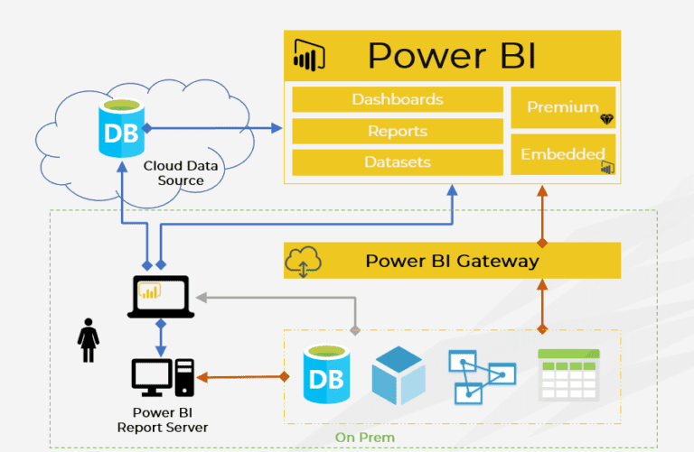

Powerbi Architecture Diagram

5

### Components of Power BI

### **Power Query**

Power Query is one of the important components of Power BI. This can be included in your Excel or can be used as a component of the [Power BI Desktop](https://intellipaat.com/blog/power-bi-desktop/). Using Power Query, you can delete data from numerous data sources and extract data from a wide range of different databases like Oracle, SQL Server, MySQL, and other different databases. You can also fetch data from records like text files, CSV files, or Excel files.

### **Power Pivot**

Power Pivot is a data modeling and calculation engine. It is used for modeling simple and complex data. In Power Pivot, you can set or create relationships between different tables and calculate values that can be viewed in Pivot tables. It provides you with a huge space to createyourdesign.  
The language used by Power BI Pivot is [Data Analysis Expression](https://intellipaat.com/blog/dax-power-bi/) (DAX), which is a strongly functional language, and all your calculations are done here.

### **Power View**

Power View is the fundamental [data visualization](https://intellipaat.com/blog/tutorial/data-science-tutorial/data-visualization/) component of Power BI. It is an interactive component that connects to data sources and retrieves metadata that can be utilized for data analysis. There are many blueprints for visualization in the Power View lists. With Power View, you can filter data for each visualization component or even for the entire report. Slicers can be used for better slicing and dicing of data.

### **Power Map**

Power Map is used to visualize geospatial data in 3D mode. As soon as the visualization renders in 3D mode, it provides another dimension to it. In Power Map, you can assume one attribute as the length of a column in 3D and another attribute as a heatmap view. Based on a geographical location, the data can be highlighted. Geographical locations can be a country, state, city, or street address.  
To get the best visualization, Power Map works with the Bing Maps based on the geographical latitude or longitude or a country, state, city, or street address data.

6

# Summary

Power BI is a collection of software services, apps, and connectors that work together to turn your unrelated sources of data into coherent, visually immersive, and interactive insights. Your data might be an Excel spreadsheet, or a collection of cloud-based and on-premises hybrid data warehouses. Power BI lets you easily connect to your data sources, visualize and discover what's important, and share that with anyone or everyone you want.

7

# Architecture Description

## Data Description

The Dataset of Big Game Census data visualization contains the data about the game, teams, players, their birthplaces and population of their birthplaces, etc. Dataset contains the following columns:

* + 1. Player Name- contains the name of the player
    2. Player Jersey Number- contains the jersey number of each player
    3. Player Position- Player at which the player plays in the team
    4. Player Age- Age of each player
    5. Player Weight (lbs.)- Weight of each player in pounds
    6. Years Played- Number of years the player has played
    7. Player Birthplace (city,town,etc.)- Birthplace, including city and town, of each player.
    8. Player Birth State- State of birth of each player
    9. Player Birthplace (Combo)- City and State of birth of each player
    10. Player College-Name of the college the player went to
    11. Player Team-Name of the team the player plays for
    12. Conference- Has 2 values, AFC and NFC 8
    13. 2016 Population Estimates (except where otherwise noted)- Estimated population of all birthplaces for the year 2016
    14. State GEO ID- Last 2 digits of the corresponding full GEO ID is the state GEO ID
    15. Full GEO ID- GEO ID of all the birthplaces
    16. Latitude (player birthplace)- contains the latitude of the birthplace of the player
    17. Longitude (player birthplace)- contains the longitude of the birthplace of the player
    18. Number from city- Contains the number of entries from all cities
    19. Number of Records-conatins the number of records
    20. American Factfinder link for more census data points-contains the link to more census data point
    21. Quickfacts Link-contains the quick facts link for all cities
    22. State Data Link-contains the state data link of all states
    23. Source (Population States 2017)-contains the name of the source from where the population is extracted for all states for the year 2017
    24. Birthplace (Population Data Source)- contains the name of the source from where the population is extracted for all birthplaces

## Web Scrapping

Web scraping is a technique to automatically extract content and data from websites using bots.It is also known as web data extraction or web harvesting. Web scrapping is made simple now days, many tools are used for web scrapping. Some of python libraries used for web scrapping areBeautiful Soup, Scrapy, Selenium, etc.

## Data Transformation

In the Transformation Process, we will convert our original datasets with other necessary attributes format. And will merge it with the Scrapped dataset.

## Data Insertion into Database

1. Database Creation and connection - Create a database with name passed. If the database is already created, open the connection to the database.
2. Table creation in the database.
3. Insertion of files in the table

9

## Export Data from Database

Data Export from Database - The data in a stored database is exported as a CSV file to be used forData Pre- processing.

## Deployment.

Once you’ve completed your dashboard, follow these steps:**- Server, Tableau Public, Save toTableau Public As**

You may be prompted to log into your Tableau Public profile first if this is your first timepublishing.

10

|  |  |
| --- | --- |
| **TEST CASE DESCRIPTION** | **EXPECTED RESULTS** |
| Is someone from your hometown in the game? | When hovered over the map, one can see the number of players from a particular state along with the team to which  they belong. |
| Average Player Age vs Player Birth State | When hovered over the visualization, all States with number of players, player teams & average player age is shown. |
|  |  |
| All teams information | A table is used to here which displays the player teams, avg. player age, avg. years played, median player weight and conference to which the players belong. |
| Player birthplace with  population estimates | A treemap shows all the birthplaces having big population estimates with big and dark coloured squares and states having small population estimates are shown with small and light  coloured squares. |

# 3. Unit Test Cases

11

Screenshot of dashboard:

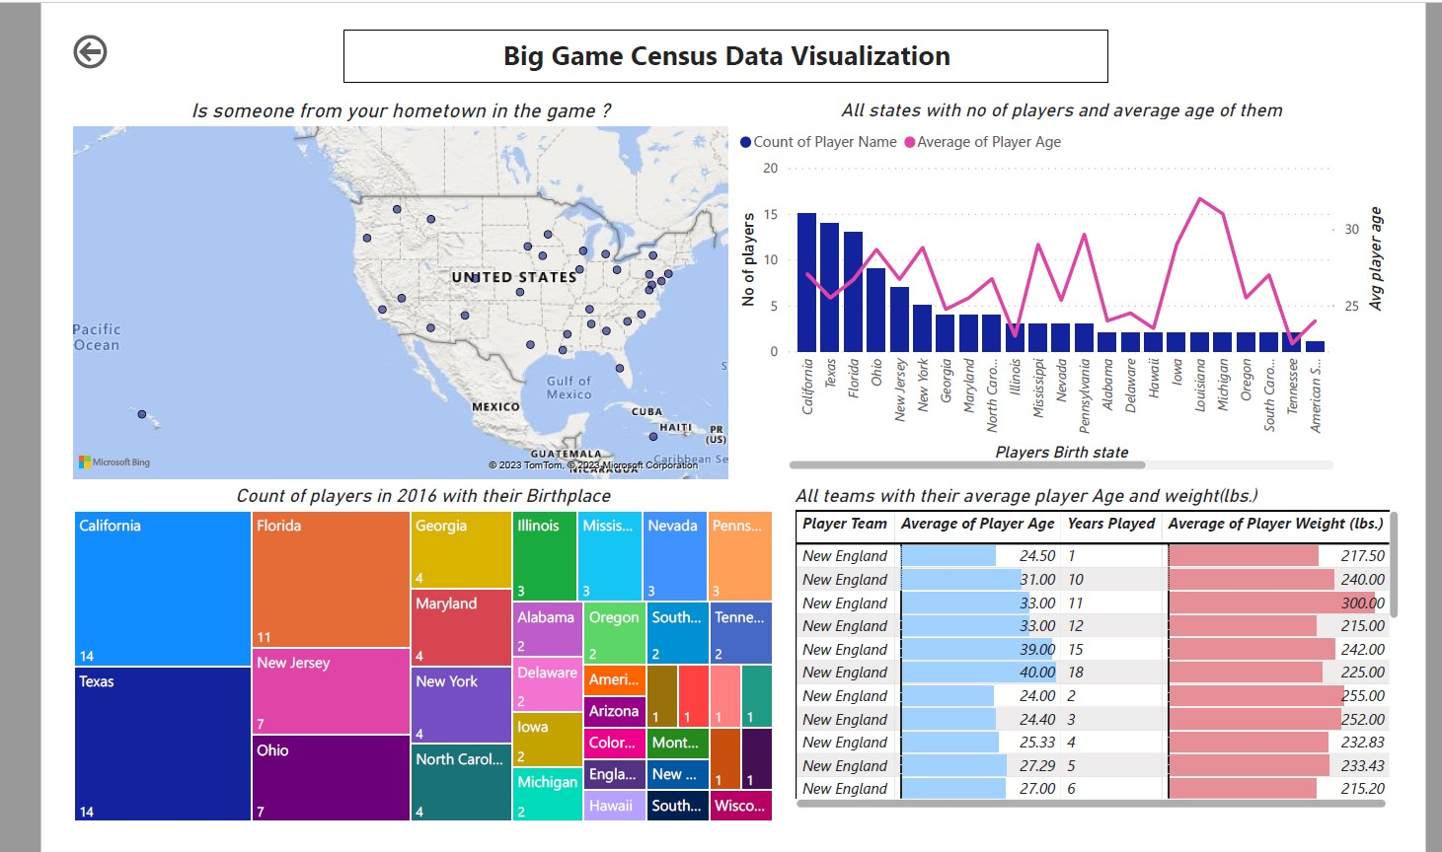

12