Detecting Supply Chain and Dependency Confusion Attacks in Open-Source Ecosystems

Table of Contents
Chapter 2: Literature Review 5
2.1 Introduction 5
2.2 Advantages and Disadvantages of Existing Detection Approaches 5
2.3 Open-Source Software Ecosystems and Software Supply Chain Security 6
2.4 Dependency Confusion Attacks 8
2.5 Typosquatting Attacks 9
2.6 Metadata-Based Detection Approaches 10
2.7 Detection Methods Used in Existing Literature 11
2.8 Challenges in Existing Research 13
2.9 Literature Gaps and Research Contribution 14
2.10 Conceptual Framework 16
2.11 Summary Table of Authors 16
References 20

List of Figures
Figure 1: Applications of Diagram Software 6
Figure 2: Eight Software Supply Chain Practices 7
Figure 3: Dependency Confusion Attack Sequence 8
Figure 4: Types of Metadata 11
Figure 5: Types of Security Testing 12
Figure 6: Conceptual Framework Image 16

List of Tables
Table 1: Summary Table of Authors 16

Chapter 2: Literature Review

2.1 Introduction
The literature review highlights the increasing need for ensuring software supply chain security. Cox (2025) explains that with the increase in the usage of OSS and the availability of software packages such as PyPI and npm, there is an increasing trend towards the use of third-party components. Gokkaya et al. (2025) note that such reliance has resulted in security threats in software supply chains. Williams et al. (2025) list dependency confusion and typosquatting as major security threats against the open-source ecosystem. Adem et al. (2026) focus on the importance of having efficient detection techniques. This literature review focuses on reviewing current studies concerning software supply chain security, attack methods, detection methodologies, challenges, and existing research gaps, which inspire the proposed research study.

2.2 Advantages and Disadvantages of Existing Detection Approaches
Advantages
- Early Threat Detection: These metadata-based techniques allow early assessment of threats without the need to perform resource-consuming code analysis (Halder et al., 2024).
- Scalability: Automation in detection allows effective analysis of larger package archives, making it useful for bigger systems (Zhang et al., 2024).
- Improved Detection Accuracy: By using different detection tools based on risk assessment procedures, the process of recognising suspicious parcels will be improved (Wang et al., 2025).
- Enhanced Software Supply Chain Security: The current solutions will help recognise threats much quicker and make decisions about software security issues easier.
Disadvantages
- The use of metadata analysis methods may yield inaccurate outcomes due to incomplete or manipulated data on packages (Halder et al., 2024).
- Activity on repositories and the involvement of contributors may not be an accurate measure of software trustworthiness (Lew et al., 2024).
- False positives are likely to occur using similarity-based detection because such detection systems are prone to mislabeling innocent software packages as viruses (Vu et al., 2025).
- Relying on one method alone will not produce accurate results.

2.3 Open-Source Software Ecosystems and Software Supply Chain Security
Open source software (OSS) has emerged as an essential element in software development because of its potential to offer reusable software components that help speed up application development processes. According to Cox (2025), OSS environments allow the use of freely available libraries and frameworks, instead of starting from scratch while writing software. This methodology has spurred the emergence of major repository services like PyPI and npm, which function as primary portals to distribute and manage dependencies within software applications. Since companies have started relying heavily on these repositories, software supply chain management has emerged as a key part of modern software engineering.
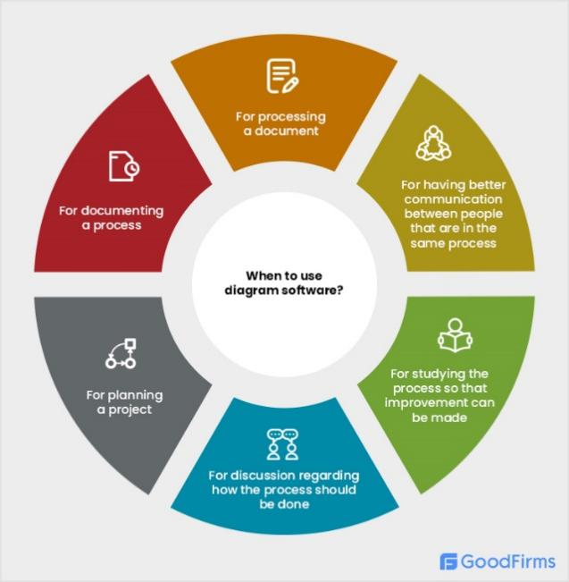
Figure 1: Applications of Diagram Software
Source: (Cox, 2025)
This diagram provides examples of common uses of diagramming software in documentation, planning, communication, analysis, improvement, and collaboration.

2.3.1 Advantages of Open-Source Ecosystems
There are many advantages that OSS brings to the table, such as less development time, reusability of code, and lower costs of development. According to Jallow et al. (2024), the efficiency aspect is the main one, but Amft et al. (2024) state that community-driven improvements are ongoing.

Figure 2: Eight Software Supply Chain Practices
Source: (Amft et al., 2024)
The following diagram provides eight important software supply chain security practices to ensure package integrity, vulnerability management, monitoring, compliance, maintenance, and risk mitigation.
2.3.2 Disadvantages and Security Risks
The OSS ecosystem raises security risks. According to Gokkaya et al., the heavy reliance on third-party modules exposes software to vulnerabilities or the inclusion of malicious code packages. Due to external maintainers, companies may not know much about the security or reliability of their software. The lack of information on the reliability of the software can be used by attackers to distribute malware through trusted means.
Critical Discussion
With the growing adoption of OSS, there have been security risks in relation to the software supply chain. Williams et al. (2025) emphasise attacks targeting repositories, whereas Adem et al. (2026) point out that as the software supply chain becomes more complex, detecting and mitigating threats will become increasingly challenging.

2.4 Dependency Confusion Attacks
The dependency confusion attack takes advantage of flaws within dependency management systems by manipulating package managers to install malicious packages rather than legitimate ones. (Gokkaya et al., 2025) state that the dependency confusion attack happens when an attacker uploads malicious packages with names that are very close to those used by their private or organisation-specific packages. Because the package managers consider public repositories first when resolving dependencies, malicious packages can be installed by an attacker without the developer knowing about it. With the increasing use of dependency managers in businesses, dependency confusion has become a serious risk in open source projects.
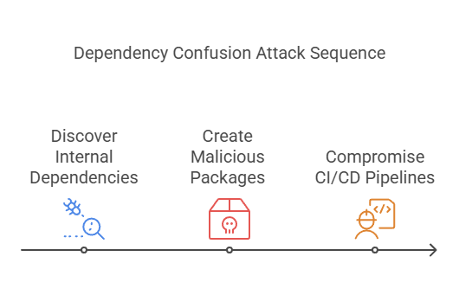
Figure 3: Dependency Confusion Attack Sequence
Source: (Gokkaya et al., 2025)
2.4.1 Advantages for Attackers
Williams et al. (2025) note that such attacks work effectively due to the ease of publishing malicious packages on public repositories. Using trusted development procedures and utilising third-party packages, a single malicious package could affect different firms, which would make the attack scalable, affordable, and hard to spot.
2.4.2 Impact on Organisations
Dependency confusion attacks can result in serious repercussions for organisations. According to Gokkaya et al. (2025), malicious software packages used in dependency confusion can cause several issues for the affected parties, such as illegal access to the system, theft of data, infection with viruses, and disruption of services. These packages are usually part of software dependencies in a secure development environment.
These attacks may cause monetary losses, a bad reputation, and non-compliance with regulations. Many different industries rely on the same dependences, the effects of such attacks become greater.
Critical Analysis
Dependency confusion attacks have been recognised by many people, but current security solutions cannot solve such problems. Adem et al. (2026) claim that due to the increasing complexity of software supply chains, software dependencies are not always authentic. The existing methods concentrate on managing vulnerabilities instead of analysing the trustworthiness of the packages, leaving gaps open for attacks on dependency resolution operations. There is a great demand for early detection tools that will help spot dubious packages in advance.

2.5 Typosquatting Attacks
A software supply chain attack called typosquatting involves creating malware packages by perpetrators with package names similar to the popular names of legitimate software packages. In Vu et al. (2025), it is stated that typosquatting takes advantage of human error as well as knowledge among developers on popular packages. As open source repositories keep growing, it is becoming more challenging to determine what packages are malicious and what are legitimate, especially when package names vary from one another by just one or two characters.
2.5.1 Common Typosquatting Techniques
There are a number of strategies that are used by hackers for the purpose of forging package names. Character omission is one such strategy that involves the omission of one letter from an existing well-known package name. The other strategy involved is that of character insertion. There is also the use of substitution, where the attackers substitute the letters with letters that resemble them. Another way they use is transposition of characters by changing their position. This type of attack relies on similarities between characters in various alphabets to come up with packages that look like the original ones.
2.5.2 Impact on Open-Source Ecosystems
Typosquatting attacks pose a risk to open-source software, as similarities in package names are used to spread malware and steal sensitive information, breaking the confidence in software repositories (Gokkaya et al., 2025). Current detection methods focus mainly on detecting known malware, where attackers keep evolving with the naming methods to avoid detection. Hence, the mechanism of automated pre-installation detection based on the similarity of package names is crucial in reducing upcoming typosquatting attacks (Vu et al., 2025; Gokkaya et al., 2025).

2.6 Metadata-Based Detection Approaches
The rapid growth of open-source repositories has made manual package inspection impractical, increasing the need for automated detection methods. Metadata-based approaches enable early identification of suspicious packages using package attributes without executing source code, making them computationally efficient and scalable for software supply chain security. These techniques support proactive risk assessment during the software development process (Halder et al., 2024; Zhang et al., 2024).
2.6.1 Package Metadata Features
Package metadata gives useful data to evaluate the trustworthiness of software without looking at source code. The package name, description, author information, release frequency, version, and download popularity are some of the features that can be used to differentiate between legitimate and suspicious packages (Halder et al., 2024). Abnormal naming conventions or anomalous update operations can be a sign of malicious behaviour, and metadata analysis can help to identify threats in the software supply chain early (Wang et al., 2025).
2.6.2 Repository Metadata Features
Metadata on repositories gives information about the development and maintenance context of software projects, in addition to package-level metadata. Features like frequency of reviewing commits, activity of contributors, maintenance of repositories, signing of packages, and governance can be used to assess the credibility and reliability of software (Lew et al., 2024; Schorlemmer et al., 2024).
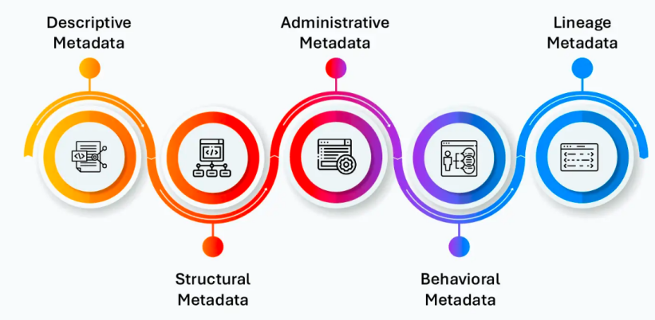
Figure 4: Types of Metadata
Source: (Lew et al., 2024)
The figure represents major metadata categories used for organising, managing, tracking, analysing behaviour, and governing data. The analysis of relationships between packages and repositories enhances the knowledge of software ecosystem risks as well (Wu et al., 2024). Metadata-based detection can be made to scale to large open-source repositories and is computationally efficient, but attackers can also use metadata to evade detection, diminishing the accuracy of single metadata features (Halder et al., 2024; Zhang et al., 2024). Combining package and repository metadata is a more thorough and precise solution towards detecting rogue packages and enhancing the security of software supply chains.

2.7 Detection Methods Used in Existing Literature
Some strategies have been suggested by researchers to identify any suspicious activity related to the package name and metadata, among other things. The strategies are concerned with the identification of malicious packages in the software supply chain within open-source ecosystems. Some of the widely used strategies will be discussed below.
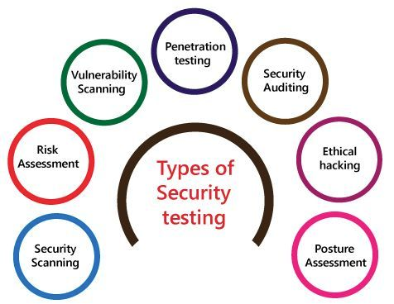
Figure 5: Types of Security Testing
Source: (Zhang et al., 2024)
This figure depicts the main security testing approaches used to discover security flaws, measure risk, analyse security control systems, and improve the security of the entire system.
Method 1: String Similarity Analysis
String Similarity Techniques are commonly employed in identifying typosquatting and package impersonation threats. According to Vu et al. (2025), string similarity techniques are used to compare strings and detect possible imitation of genuine packages by comparing package strings. Popular methods for achieving this are Levenshtein Distance, Jaro-Winkler Similarity, and many more fuzzy matching algorithms that evaluate the extent to which package names are similar. According to Halder et al. (2024), string similarity matching proves to be highly effective for the detection of such attacks. In many cases, malicious code is quite similar to the legitimate one, with just slight differences between their names, which consist of only a couple of characters.
Method 2: Metadata Analysis
The study of metadata is geared towards analysing the characteristics of the packages, looking out for anything suspicious. Halder et al. (2024) have shown how attributes of metadata, like the names of the packages, authors, releases, description, and download rates, can be helpful. In the same way, Zhang et al. (2024) point out that analysing the metadata characteristics of packages allows differentiation between benign and potentially malicious packages without the need to run any source code. It should be noted that metadata is easily accessible from package repositories.
Method 3: Repository Analysis
Repository analysis assesses the reliability of software based on repository-specific metrics, such as activity of contributors, history of maintenance, frequency of commits, package signing, and governance (Lew et al., 2024; Schorlemmer et al., 2024). The study of the connections between packages and their repositories can offer useful background on the risks of a software ecosystem, and it can enhance the understanding of the reliability of specific packages (Wu et al., 2024).
Method 4: Risk Scoring Approaches
Risk scoring systems use multiple indicators for determining how likely it is for the package to be a threat to the security of the repository. According to Gokkaya et al. (2025), risk scoring systems take into consideration many different factors in order to generate the overall risk score. Wang et al. (2025) also show that using various features together will be beneficial in enhancing the accuracy of detecting the threat since less dependency would be placed on each indicator individually.
Comparative Evaluation and Critical Discussion
The current detection techniques have their advantages and disadvantages. String similarity is effective in detecting typosquatting but is unable to detect other forms of attack, whereas metadata analysis is scalable, but can be manipulated (Vu et al., 2025). Repository analysis enhances the assessment of trust and risk scoring, which combines several indicators to be more accurate. As a result, the combination of these methods will offer an integrated system to identify malicious packages (Lew et al., 2024; Wang et al., 2025).

2.8 Challenges in Existing Research
Challenge 1: Large Package Ecosystems
The fast growth of repositories of open-source projects has led to numerous issues regarding software supply chain protection. According to Zhang et al. (2024), there are currently millions of packages in repositories like PyPI and npm. Ensuring the security of such a large number of items becomes increasingly difficult.
Challenge 2: Metadata Manipulation
Methods that involve using metadata are highly dependent on package data. Halder et al. (2024) observe that the attacker may deliberately tamper with the fields of the metadata by using a name, description, and author that are similar to those of genuine software.
Challenge 3: False Positives
The problem of false positives is very relevant for identifying malicious packages. As mentioned by Vu et al. (2025), there is a chance that packages similar in name to malware may be considered malware, causing an unwanted alert and extra work for analysts.
Challenge 4: False Negatives
The threat posed by a false negative may be even greater. According to Wang et al. (2025), highly sophisticated adversaries continually evolve methods to circumvent current detection systems, enabling malware to operate undetected.
Challenge 5: Dataset Imbalance
Another problem relates to an imbalance in datasets. As pointed out by Zhou et al. (2024), malicious packages make up a relatively smaller percentage of packages, and this adversely affects the efficacy and effectiveness of detection models.
Challenge 6: Limited Repository Information
Repository-based analysis relies on accurate data being available from the repository. According to Wu et al. (2024), data from the repository may not always be complete, up-to-date, and available.
Challenge 7: Evolving Attack Techniques
Software supply chain attacks are changing very quickly. Williams et al. (2025) note that attackers constantly change their approaches to circumvent security defences, whereas Adem et al. (2026) stress that the ability to detect such attacks requires adaptable methods to counter new challenges.

2.9 Literature Gaps and Research Contribution
Gap 1: Limited Pre-Installation Detection for Dependency Confusion Attacks
Zhang et al. (2024) identify malicious packages based on the semantics of the static code and dynamic runtime behaviour, which involves analysing code post-acquisition of packages. However, there is a limited study on detecting suspicious packages prior to installing them based on package metadata, repository metadata, and package name similarity. This paper fills this knowledge gap by suggesting a pre-installation system to pre-detect dependency confusion and typosquatting attacks.
Gap 2: Package Metadata Analysed Independently
A number of works based on metadata detection techniques have been attracting much research interest due to their efficiency and scalability. Halder et al. (2024) mainly concentrate on the metadata characteristics of packages. These metrics have value; package metadata alone might not be enough to gauge software trustworthiness. Insufficient inclusion of data from repositories is a critical weakness in the present literature.
Gap 3: Limited Risk Scoring Frameworks
Risk assessments have a significant impact on the security of software supply chains. According to Gokkaya et al. (2025), many current methodologies are based on separate indicators as opposed to risk assessment processes.
Developers and security researchers will face difficulty in understanding and prioritising security threats. Lack of any practical method for risk scoring makes current security detection systems less effective.
Gap 4: Limited Practical Implementation
While there has been growing research into software supply chains' security problems, there is a considerable amount of literature that fails to move beyond purely theoretical concepts. According to Williams et al. (2025), much existing research tends to discuss various attacks, threats, and proposals for tackling the issue without developing any actual detection tools.
Gap 5: Lack of Visualisation Support
Most current detection techniques typically output their findings through technical reports and/or classifications. According to Wang et al. (2025), insufficient visualisation abilities might lower the readability of security evaluations by developers and security experts. As a result, package vulnerabilities could be more difficult to understand and handle. The proposed research project tries to overcome these deficiencies by concentrating solely on attacks related to dependency confusion and typosquatting attacks in open-source communities. This differs from existing work, since it integrates both package-level metadata and repository-level metadata to evaluate package trustworthiness. The research includes a scoring system that helps with threat assessment and visualisation through Streamlit. The proposed framework in the research is more applicable and efficient for use in ensuring software supply chain security.

2.10 Conceptual Framework
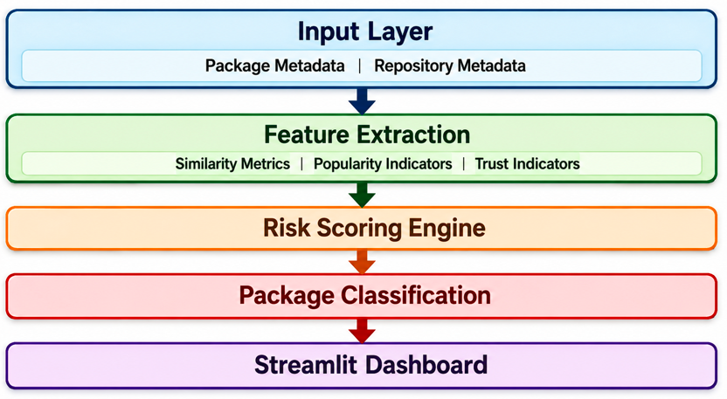
Figure 6: Conceptual Framework Image
The suggested framework identifies suspicious packages by combining package and repository metadata, extracting security features, calculating similarity and trust measures, generating risk scores, and classifying risk levels of packages. Findings are in the form of an interactive Streamlit dashboard to provide a good pre-installation security assessment and decision-making.

2.11 Summary Table of Authors
Table 1: Summary Table of Authors
Author(s) | Year | Research Outcome | Research Limitation | Research Gap | The Proposed Study Overcomes the Gap
Halder et al. | 2024 | Metadata-Based Detection of Malicious Packages Using Package Characteristics. | Relied primarily on package metadata. | Repository-level trust factors were not considered. | Uses both package and repository metadata for better threat analysis.
Zhang et al. | 2024 | Created techniques for detecting malware packages. | The study mostly focused on the analysis of the behavior of the malware. | Limited focus on dependency confusion attacks. | Targeted towards the prevention of dependency confusion and typosquatting attacks.
Lew et al. | 2024 | Evaluated software supply chain security using indicators that pertain to repositories. | Focused on software integrity, not just package threats. | Fails to detect malicious packages. | Uses repository metrics to determine the risks associated with packages.
Wu et al. | 2024 | Investigated relationship between software ecosystems and repositories. | Focussed on level of analysis of software ecosystem. | Package trust assessment mechanisms limited. | Repositories used as trust measure for packages within.
Schorlemmer et al. | 2024 | Conducted research on trust within repositories via signing and governance techniques. | Focused on security controls within repositories. | Did not present package-level detection techniques. | Used repository trust data for generating risk scores.
Amft et al. | 2024 | Emphasized the contribution of OSS communities in maintaining and securing the software. | Focused on the community activities. | Limited attention is paid to detecting any malicious packages. | Use of community related metrics in evaluating package trust.
Jallow et al. | 2024 | OSS ecosystem benefits and deployment examined. | Examining OSS adoption as opposed to any threats posed. | Limited software supply chain security analysis. | Investigates security risks associated with OSS package ecosystems.
Wang et al. | 2025 | Proposed risk-oriented approaches for malicious package detection. | Limited visualization and interpretability. | Lack of user-friendly security assessment tools. | Introduces a Streamlit dashboard for visualization and analysis.
Adem et al. | 2026 | Identified major software supply chain security challenges. | Highlighted challenges without proposing a detection framework. | Need for adaptive and practical security solutions. | Develops a comprehensive framework for identifying suspicious packages.
Zhou et al. | 2024 | Proposed malware detection approaches for software supply chains. | Focused on malware classification. | Limited attention to dependency confusion attacks. | Targets dependency confusion and typosquatting attacks directly.
These studies make substantial contributions to ensuring that the software supply chain is secure, especially in the detection of malicious packages, evaluation of repository trustworthiness, examination of software ecosystems, and attack categorisation. The majority of the studies look at one aspect of the topic at once. There is not much evidence of work that incorporates the above aspects into one model. This study tries to bridge this gap by proposing a framework that addresses risks associated with dependency confusion and typo squatting attacks in an open source ecosystem.

References
Adem, A., Erman Çakıt, Metin Dağdeviren, Mrugalska, B. and Karwowski, W. (2026). Understanding security challenges in the software supply chain through causal relationships. PLoS ONE, 21(3), pp.e0344098–e0344098. doi: https://doi.org/10.1371/journal.pone.0344098.
Amft, S., Höltervennhoff, S., Panskus, R., Marky, K. and Fahl, S. (2024). Everyone for Themselves? A Qualitative Study about Individual Security Setups of Open Source Software Contributors. 2022 IEEE Symposium on Security and Privacy (SP), [online] 17(Date of Conference: 19-23 May 2024), pp.1065–1082. doi: https://doi.org/10.1109/sp54263.2024.00214.
Cox, R. (2025). Fifty Years of Open Source Software Supply Chain Security. Queue, 23(1), pp.84–107. doi: https://doi.org/10.1145/3722542.
Gokkaya, B., Aniello, L. and Halak, B. (2025). Software supply chain: A taxonomy of attacks, mitigations and risk assessment strategies. Journal of Information Security and Applications, [online] 97(104324), p.104324. doi: https://doi.org/10.1016/j.jisa.2025.104324.
Halder, S., Bewong, M., Arash Mahboubi, Jiang, Y., Islam, M.R., Islam, M.Z., Ip, R.H., Ahmed, M.E., Ramachandran, G.S. and Babar, M.A. (2024). Malicious Package Detection using Metadata Information. Proceedings of the ACM Web Conference 2022, May 13–17(ISBN 979-8-4007-0171-9/24/0), pp.1779–1789. doi: https://doi.org/10.1145/3589334.3645543.
Huang, Y., Wang, R., Zheng, W., Zhou, Z., Wu, S., Ke, S., Chen, B., Gao, S. and Peng, X. (2024). SpiderScan: Practical Detection of Malicious NPM Packages Based on Graph-Based Behavior Modeling and Matching. SpiderScan: Practical Detection of Malicious NPM Packages Based on Graph-Based Behavior Modeling and Matching, 26(Pages 1146 - 1158), pp.1146–1158. doi: https://doi.org/10.1145/3691620.3695492.
Jallow, A., Schilling, M., Backes, M. and Bugiel, S. (2024). Measuring the Effects of Stack Overflow Code Snippet Evolution on Open-Source Software Security. 2024 IEEE Symposium on Security and Privacy (SP), Date of Conference: 19-23 May 2024(ISBN:979-8-3503-3131-8), pp.1083–1101. doi: https://doi.org/10.1109/sp54263.2024.00022.
Lew, K., Sarker, A., Wuthier, S., Kim, J., Kim, J. and Chang, S.-Y. (2024). Distributed Software Build Assurance for Software Supply Chain Integrity. Applied Sciences, 14(20), p.9262. doi: https://doi.org/10.3390/app14209262.

Li, K., Zhang, J., Chen, S., Liu, H., Liu, Y. and Chen, Y. (2024). PatchFinder: A Two-Phase Approach to Security Patch Tracing for Disclosed Vulnerabilities in Open-Source Software. Proceedings of the 33rd ACM SIGSOFT International Symposium on Software Testing and Analysis, Pages 590 - 602(Published: 11 September 2024), pp.590–602. doi: https://doi.org/10.1145/3650212.3680305.
None Olubunmi Adeolu Adenekan, None Chinedu Ezeigweneme and None Excel Great Chukwurah (2024). Strategies for protecting IT supply chains against cybersecurity threats. International journal of management & entrepreneurship research, 6(5), pp.1598–1606. doi: https://doi.org/10.51594/ijmer.v6i5.1125.
Schorlemmer, T.R., Kalu, K.G., Chigges, L., Ko, K.M., Ishgair, E.A., Bagchi, S., Torres-Arias, S. and Davis, J.C. (2024). Signing in Four Public Software Package Registries: Quantity, Quality, and Influencing Factors. 2024 IEEE Symposium on Security and Privacy (SP), 19-23 May 2024(05 September 202), pp.1160–1178. doi: https://doi.org/10.1109/sp54263.2024.00215.
Shiri Harzevili, N., Boaye Belle, A., Wang, J., Wang, S., Jiang, Z.M. (Jack) and Nagappan, N. (2024). A Systematic Literature Review on Automated Software Vulnerability Detection Using Machine Learning. ACM Computing Surveys, Volume 57(Issue 3). doi: https://doi.org/10.1145/3699711.
Vu, M.-K., Nguyen, T.-C. and Vu, D.-L. (2025). POSTER:TYPOSQUATTING ATTACKS ON THE RUST ECOSYSTEM. Proceedings of the 20th ACM Asia Conference on Computer and Communications Security, ASIA CCS ’25(Pages 1791 - 1793), pp.1791–1793. doi: https://doi.org/10.1145/3708821.3735340.
Wang, J., Li, Z., Qu, J., Zou, D., Xu, S., Xu, Z., Wang, Z. and Jin, H. (2025). MalPacDetector: An LLM-based Malicious NPM Package Detector. IEEE Transactions on Information Forensics and Security, [online] Volume: 20(Page(s): 6279 - 6291), pp.1–1. doi: https://doi.org/10.1109/tifs.2025.3580336.
Williams, L., Benedetti, G., Hamer, S., Ranindya Paramitha, Rahman, I., Mahzabin Tamanna, Tystahl, G., Nusrat Zahan, Morrison, P., Acar, Y., Cukier, M., Kästner, C., Alexandros Kapravelos, Dominik Wermke and Enck, W. (2025). Research Directions in Software Supply Chain Security. ACM Transactions on Software Engineering and Methodology, Vol. 34(No. 5). doi: https://doi.org/10.1145/3714464.
Williams, L., Hamer, S. and Zahan, N. (2025). Can the Rising Tide of Software Supply Chain Attacks Raise All Software Engineering Boats? Proceedings of the 33rd ACM International Conference on the Foundations of Software Engineering, Pages 18 - 26(Published: 28 July 2025), pp.18–26. doi: https://doi.org/10.1145/3696630.3734200.
Wu, S., Song, W., Huang, K., Chen, B. and Peng, X. (2024). Identifying Affected Libraries and Their Ecosystems for Open Source Software Vulnerabilities. Identifying Affected Libraries and Their Ecosystems for Open Source Software Vulnerabilities, Article No.: 162(Published: 12 April 2024). doi: https://doi.org/10.1145/3597503.3639582.
Zhang, J., Huang, K., Huang, Y., Chen, B., Wang, R., Wang, C. and Peng, X. (2024). Killing Two Birds with One Stone: Malicious Package Detection in NPM and PyPI using a Single Model of Malicious Behavior Sequence. ACM Transactions on Software Engineering and Methodology, Vol. 34(No. 4). doi: https://doi.org/10.1145/3705304.
Zhou, S., Li, H., Fu, X. and Jiao, Y. (2024). A Novel Malware Detection Model in the Software Supply Chain Based on LSTM and SVMs. Applied Sciences, 14(15), p.6678. doi: https://doi.org/10.3390/app14156678.

