Detecting Supply Chain and Dependency Confusion Attacks in Open-Source Ecosystems

Student name: Shivani Burma

Student ID: A00076190

Professor: Badis Aoun

Submitted to
The University of Roehampton

In partial fulfilment of the requirements
for the degree of
Master of Science
in
Cyber Security

Declaration
I declare that this dissertation "Detecting Supply Chain and Dependency Confusion Attacks in Open-Source Ecosystems" is my original work and it is submitted for the award of Master of Science at the University of Roehampton. This work was not submitted elsewhere, in whole or in part for the award of any degree or qualification at this or any other institution. All information sources, publications, datasets, software libraries and research contributions utilized for this project have been duly referenced and acknowledged according to the IEEE referencing style. All source material from other authors has been adequately referenced. All implementation, experiments, and analysis in this dissertation are the responsibility of the author, unless otherwise noted.

Student Name: Shivani Burma
Student ID: A00076190
Date: 05/08/2026
Signature:


Acknowledgements
I would like to thank my project supervisor Professor Badis for her expertise, constructive input and ongoing encouragement as I worked on this dissertation. His help and guidance were very significant in the successful completion of this research.
I extend my gratitude to the University of Roehampton for its outstanding learning environment, academic resources and technical facilities which facilitated the project. The Python Package Index (PyPI), OpenSSF Malicious Packages Repository and the open-source community are thanked for providing valuable datasets, tools, and documentation to the public for cybersecurity research.
Finally, I would like to express my heartfelt gratitude to my family and friends for their constant encouragement, patience, and unwavering support throughout my postgraduate studies. Their encouragement and faith in my abilities have been priceless in this educational process.

Abstract
The growing dependence on open-source software has ushered in a new era of software development efficiency and yet has become a significant threat to software supply chain security. Some of the most frequently occurring threats include dependency confusion and typosquatting attacks, which involve the publishing of malicious packages that are close enough to the software's name to trick the developer into installing the malicious package as a dependency. Traditional detection techniques are based on static or dynamic analysis, but they tend to be costly and only detect threats post-installation.
This research presents a lightweight machine learning-based system to detect suspicious Python packages before installation based on public package metadata and package name similarity. The Python Package Index (PyPI) was used to gather metadata, and suspicious package samples were created with common typosquatting methods. Independent external validation was done with additional real-world malicious packages from the OpenSSF Malicious Packages Repository. The package similarity score, package name length, summary length, release count, and package age were used for feature engineering. Supervised machine learning models were trained after pre-processing the dataset with duplicate removal, missing value analysis, SMOTE class balancing, feature scaling, and train-test splitting.
Three classification algorithms were used and tested for accuracy, precision, recall, F1 score, confusion matrices, and Receiver Operating Characteristic (ROC) analysis. The Decision Tree model performed the best overall and was used as the final prediction model. The trained model was deployed in an interactive Streamlit web application to showcase package risk prediction in the real world.
The results show that the metadata-based machine learning approach can successfully detect suspicious packages before they are installed with much lower computational costs than traditional malware analysis methods. The proposed framework will be an efficient and scalable way to enhance the security of software supply chains and help developers make better decisions about dependency management in open source software ecosystems.

Table of Contents
Declaration 2
Acknowledgements 3
Abstract 4
Chapter 1: Introduction 11
1.1 Problem Description, Context and Motivation 11
1.2 Objectives 11
1.3 Methodology 12
1.4 Legal, Social, Ethical and Professional Considerations 12
1.5 Background 13
1.6 Structure of Report 13
Chapter 2 Literature - Technology Review 15
2.1 Literature Review 15
2.1.1 Software Supply Chain Security 15
2.1.2 Dependency Confusion and Typosquatting Attacks 15
2.1.3 Existing Detection Techniques 15
2.1.5 Research Gap 18
2.2 Technology Review 18
2.2.1 Python 18
2.2.2 PyPI API 18
2.2.3 RapidFuzz 18
2.2.4 Scikit-learn 19
2.2.5 Streamlit 19
2.2.6 OpenSSF Malicious Packages Repository 19
2.3 Summary 20
Chapter 3 - Implementation 21
3.1 Introduction 21
3.2 System Design and Architecture 21
3.3 Development Environment 23
3.4 Dataset Construction 24
3.4.1 Training Dataset Construction 25
3.4.2 External Validation Dataset 26
3.4.3 Dataset Preparation 26
3.5 Feature Engineering 27
3.6 Data Pre-processing 28
3.7 Machine Learning Implementation 29
3.8 Model Validation Strategy 30
3.9 Streamlit Dashboard Implementation 30
Chapter 4: Evaluation and Results 32
4.1 Introduction 32
4.2 Dataset Construction Results 32
4.3 Exploratory Data Analysis 32
4.3.1 Label Distribution 32
4.3.2 Similarity Score Distribution 33
4.3.3 Summary Length Distribution 33
4.3.4 Correlation Analysis 34
4.4 Data Pre-processing Results 34
4.4.1 Missing Value Analysis 34
4.4.2 Train-Test Split 35
4.4.3 SMOTE Class Balancing 36
4.4.4 Feature Scaling 36
4.5 Machine Learning Model Results 37
4.5.1 Logistic Regression 37
4.5.2 Decision Tree 38
4.5.3 Random Forest 39
4.6 Model Comparison 41
4.7 ROC Curve Analysis 42
4.8 Feature Importance Analysis 43
4.9 External Validation Using the OpenSSF Dataset 45
4.10 Streamlit Dashboard Demonstration 48
4.10.1 Home Page 48
4.10.2 Package Risk Prediction 49
4.10.3 Dataset Analytics 50
4.10.4 Overall System Demonstration 51
Chapter 5: Conclusion 52
5.1 Introduction 52
5.2 Achievement of Research Objectives 52
5.3 Summary of Findings 52
5.4 Research Contributions 54
5.5 Limitations of the Study 54
5.6 Future Work 55
5.7 Final Remarks 56
References 58
Appendices 61
Appendix A: Project Proposal 61
1. Introduction 61
2. Problem Statement 62
3. Aims and Objectives 63
4. Legal, Social, Ethical and Professional Considerations 64
5. Background 65
5.1 Open-Source Software and Software Supply Chain Security 65
5.2 Evolution of Software Supply Chain Attacks 65
5.3 Dependency Confusion and Typosquatting Attacks 66
5.4 Current Approaches to Malicious Package Detection 66
5.5 Machine Learning and Software Supply Chain Security 67
5.6 Supply Chain Integrity, Risk Assessment and Security Assurance 67
5.7 Datasets and Research Resources 67
5.8 Research Gap and Relationship to the Proposed Project 68
Appendix B: Project Management 69
B.1 Project Management Approach 69
B.2 Project Timeline 69
B.3 Supervisor Feedback and Improvements 69
B.4 Tools Used 70
B.5 Project Deliverables 71
B.6 Reflection 71
Appendix C: Artefact / Dataset 72
C.1 Project Artefact 72
C.2 Dataset 72
C.3 How to Run the Project 73
C.4 Repository Contents 74
Appendix D :Screencast 74

List of Figures
Figure 1: System Architecture of the Proposed Software Supply Chain Attack Detection Framework 22
Figure 2: Workflow of the dataset construction process 25
Figure 3: Distribution of package labels 33
Figure 4: Distribution of similarity scores 33
Figure 5: Distribution of package summary lengths 34
Figure 6: Correlation heatmap of numerical features 34
Figure 7: Missing value analysis. 35
Figure 8: Class distribution before SMOTE and after SMOTE. 36
Figure 9: Feature scaling implementation and output. 37
Figure 10: Confusion matrix of the Logistic Regression model 38
Figure 11: Confusion matrix of the Decision Tree model 39
Figure 12: Confusion matrix of the Random Forest model. 41
Figure 13: Model accuracy comparison. 42
Figure 14: ROC curve comparison of the evaluated machine learning models. 43
Figure 15: Feature importance scores obtained from the Random Forest model 45
Figure 16: External validation results showing the overall detection rate. 48
Figure 17: Home page of the Streamlit software supply chain attack detection application 49
Figure 18: Package Risk Prediction interface 49
Figure 19: Prediction result generated by the deployed Decision Tree model 50
Figure 20: Dataset Analytics dashboard 50
Figure 21: Feature importance visualisation 50
Figure 22: Machine learning model comparison 51
Figure 23: Software Supply chain attack detection system 51

List of Tables
Table 1: Comparison of Existing Detection Techniques 16
Table 2: Comparison of Machine Learning Algorithms 17
Table 3: Technologies Used in the Proposed Framework 19
Table 4: Development Environment 24
Table 5: Training Dataset Composition 26
Table 6: External Validation Dataset 26
Table 7: Engineered Features Used for Machine Learning 28
Table 8: Machine Learning Models Implemented 30
Table 9: Dataset Composition 32
Table 10: Number of missing values in each feature 35
Table 11: Train-Test Split Results 35
Table 12: Class Distribution Before SMOTE 35
Table 13: Class Distribution Before and After SMOTE 36
Table 14: Dimensions of the Scaled Datasets 37
Table 15: Logistic Regression Performance 38
Table 16: Decision Tree Performance 39
Table 17: Random Forest Performance 40
Table 18: Random Forest Confusion Matrix 40
Table 19: Comparison of Machine Learning Models 41
Table 20: Area Under the Curve (AUC) Results 43
Table 21: Random Forest Feature Importance Scores 44
Table 22: External Validation Dataset 45
Table 23: External Validation Results 46
Table 24: Project Timeline 69
Table 25: Development Tools and Their Purposes 70

Chapter 1: Introduction

1.1 Problem Description, Context and Motivation
Open source software (OSS) is now a key part of software development. Public software repositories, like the Python Package Index (PyPI), have become increasingly important for developers to speed up application development by leveraging existing libraries and frameworks. This has many cyber-security concerns but also saves time and money in development. These repositories are open for anyone to publish malicious packages, which are commonly mimicked as trusted software, enabling malware to be distributed through trusted software supply chains [2].
The most common type of software supply chain attacks are dependency confusion and typosquatting. Dependency confusion happens when a malicious package is uploaded to a public repository with the same or similar name as an internal package, leading to package managers installing the malicious package, rather than the package intended to be a private dependency. Typosquatting attacks are based on minor changes to popular packages, for example, characters are missing, substituting or adding characters to a name, which can lead developers to install malicious software [3]. Historically, malicious package detection has either involved static source code analysis, or dynamic behavioural analysis after the package has been downloaded or run. These methods are effective but expensive and only find threats after the package is part of the software development process [4]. The lightweight methods that are able to detect suspicious packages before installation are needed. This project aims to create a machine learning model to identify suspicious Python packages based on their metadata and name similarity. The proposed framework uses publicly available package characteristics before installation to provide an early warning mechanism to help developers make safer software dependency decisions.

1.2 Objectives
This research aims to create and test a lightweight machine learning framework to detect suspicious Python packages that can be related to dependency confusion and typosquatting attacks before installation.
The objectives of the study are:
- To study the attacks on the software supply chain in open-source package repositories.
- To extract metadata from trusted Python packages on PyPI.
- To create a labelled dataset with legitimate and suspicious package samples.
- To design metadata and similarity features for machine learning.
- Create and evaluate several supervised machine learning models for package classification.
- To test the proposed framework with live malicious packages from the OpenSSF Malicious Packages repository.
- Create a Streamlit application to show the implementation of the proposed framework.

1.3 Methodology
The study used quantitative experimental research methodology. The package metadata was gathered from the Python Package Index (PyPI), and suspicious package samples were created using typical typosquatting methods. Data set attributes were extended with similarity score, package name length, summary length, release count and package age.
The collected data were further preprocessed with missing value analysis (MVA), synthetic minority over-sampling technique (SMOTE), feature scaling, and train-test splitting. These three supervised machine learning algorithms, logistic regression, decision tree, and random forest, were trained and tested with common classification parameters such as accuracy, precision, recall, F1 score, confusion matrix, and Receiver Operating Characteristic (ROC) curve. An independent external validation experiment was conducted, because of the limitations presented by synthetic data, using malicious Python packages from the OpenSSF Malicious Packages repository, which are documented [7]. Lastly, the most successful model was deployed in a streamlit web application to show a practical package risk prediction system.

1.4 Legal, Social, Ethical and Professional Considerations
The research relied solely on data that is publicly accessible through the official PyPI API and OpenSSF Malicious Packages repository, which contains documented information about malicious packages. No malicious software was run during the study, so it was conducted in a safe environment. The proposed framework is meant to defend cybersecurity research and software supply chain protection. It is meant to help software developers and security experts recognize suspicious packages before installation, not to help in offensive security activities [8]. All the information was gathered following repository policies, and no personal or confidential information was processed in the research.

1.5 Background
Open-source software has revolutionized the software industry by allowing code components to be reused instead of coding from scratch. There are hundreds of thousands of packages available in popular repositories like PyPI for any number of application domains, such as AI, web development, scientific computing and data analysis.
These benefits have come with a price, however, as the reliance on third party software has led to an increase in the attack surface that cybercriminals can exploit [9]. Attacks to software supply chains have been seen recently and are successful in implanting malicious software into trusted software packages that are then distributed via trusted repositories. These assaults can result in malware installation, credential stealing, and software system intrusions and disruptions.
Recent advancements in machine learning have shown that automatic detection of malicious software is feasible with measurable package characteristics [1]. Metadata-based detection methods are especially appealing because they can detect malicious packages with fewer computational resources than source code analysis and can be performed before packages are installed. A lightweight machine learning technique has been found to be a promising method to improve the security of software supply chains. These techniques offer an efficient approach to identifying possible threats and vulnerabilities and consume less computational power than conventional machine learning models. In the modern era of software supply chains where cyber threats are on the rise and software complexity is growing, lightweight machine learning is a practical and scalable solution for enhancing software supply chain security, threat detection and protecting software development and distribution without high performance impact.

1.6 Structure of Report
This dissertation is divided into the following sections:
Chapter 2 provides an overview of the literature review and technology review, which involved an analysis of software supply chain attacks, existing detection approaches, metadata analysis techniques, machine learning methods, and the research gap that is covered by this study.
The proposed framework is detailed in Chapter 3, which includes the building of the datasets, the feature engineering, data preprocessing, development of the machine learning models, and the implementation of the Streamlit application.
The experimental evaluation and discussion of the proposed framework using multiple machine learning models are presented in Chapter 4. The chapter includes exploratory data analysis, preprocessing results, model comparison, ROC analysis, feature importance analysis, and external validation using real malicious packages from the OpenSSF repository.
Finally, Chapter 5 offers a detailed overview of the research results and some of the main findings during the research. It details the important contributions of the research and recognition of its limitations and the challenges faced in the investigation. The chapter also suggests possible avenues of future research that can be followed and extended to advance the current research. It also contains a critical reflection on the overall project, which evaluates the research process, methodology, outcomes, and knowledge acquired from the study.

Chapter 2 Literature - Technology Review

2.1 Literature Review

2.1.1 Software Supply Chain Security
Open-source software (OSS) has revolutionized software development today by allowing developers to make use of pre-existing libraries and frameworks. The growing reliance on third-party software components, however, has also increased the software supply chain attack surface, which is a major concern for organisations around the world [14]. Likewise, in the context of software supply chain security, Williams et al. [11] assert that security software needs automated detection techniques that can continuously monitor repositories, and be able to predict suspicious packages as they are being installed. The studies show that lightweight and intelligent detection systems are becoming increasingly relevant to safeguard today's open-source ecosystems.

2.1.2 Dependency Confusion and Typosquatting Attacks
Two of the most serious risks to open source software repositories are dependency confusion and typosquatting. Unauthorized installation of these fake packages by developers unwittingly adds malicious code into the applications [3],[12]. As package repositories have grown in number, so have their opportunities for attack by exploiting developer trust [5]. As attackers continually change package names and publishing methods, malicious packages have become harder to tell from legitimate software, Zheng et al. [3] noted. Gao et al. [6] proposed the MalGuard framework for real-time malicious package detection, and showed that monitoring repositories improves attack identification. Likewise, Zhang et al. [9] suggested a behavioural sequence modelling approach to identify malicious packages in both PyPI and NPM, with better classification accuracy.

2.1.3 Existing Detection Techniques
There are several methods suggested for identifying malicious software packages in open-source software repositories. These are typically static analysis, dynamic analysis, and metadata-based detection. Both methods have their own pros and cons in terms of computational complexity, accuracy of detection, ease of implementation, and feasibility of deployment, and their effectiveness in meeting security needs and operating contexts is subject to specific conditions.
Static Analysis
Static analysis looks at software packages without running the code. It examines the source code, executable files, imported libraries, permissions, and structure to detect suspicious activity [23]. Alkhateeb et al. [18] showed that the multi-layered feature engineering technique can effectively enhance the accuracy of detecting malware by extracting static features from executable files. Similarly, Das et al. [17] presented an advanced feature encoding method to improve the accuracy in malware classification by employing machine learning algorithms.
Dynamic Analysis
Dynamic analysis runs software inside these virtual machines or sandboxes and monitors the behaviour that occurs during runtime. Rondanini et al. [16] also showed that the performance of malware detection can be enhanced by using behavioural analysis and lightweight language models. The operation of potentially malicious software adds other security concerns and demands special infrastructure.
Metadata-Based Detection
Recently, metadata-based detection has come to the forefront as an effective alternative to the traditional methods of malware analysis. Gao et al. [6] created a machine learning architecture that was able to classify malicious PyPI packages by analyzing the repository metadata. Overall, metadata-based detection offers a good compromise between computational efficiency and detection performance, and it is an ideal approach for early software supply chain protection.
Table 1: Comparison of Existing Detection Techniques
Detection Technique | Strengths | Limitations | References
Static Analysis | High detection accuracy; analyses source code before execution | Computationally expensive; affected by code obfuscation | [20], [21]
Dynamic Analysis | Detects runtime malicious behaviour | Requires sandbox execution; time-consuming | [13], [19]
Metadata-Based Detection | Lightweight; supports pre-installation detection; computationally efficient. | Limited behavioural information | [6], [7], [9]
2.1.4 Machine Learning Approaches
Machine learning (ML) is a technology that is now integral to cybersecurity as it allows computers to identify malicious behavior by training models on vast amounts of information. This makes ML well suited for use in software supply chain security where attackers are constantly innovating ways to evade traditional security methods [16],[17].
Several machine learning algorithms have been successfully applied in the field of detecting malware and malicious packages. Olaniyi et al. [1] proposed a machine learning-based solution to detect attacks in service supply chains and showed that supervised learning techniques have advantages over traditional detection techniques.
Logistic Regression is one of the most popular supervised learning techniques and is known to be the simplest and fastest, and is also interpretable. However, Decision Tree algorithms can be used to classify complex package interaction patterns by building hierarchical decision rules, which is beneficial for malicious package classification [1], [6]. To avoid overfitting and strengthen the model, the Random Forest method uses ensemble learning to aggregate several decision trees [2], [22].
The detection of malware by deep learning and Large Language Models (LLMs) has also been studied recently [24]. Xue et al. [7] investigated malicious source code detection using LLMs, and Rondanini et al. [16] analyzed lightweight LLMs for edge-based malware detection. These methods show great promise for detection benefits, but demand significant computational power, training sets, and complicated model designs.
Table 2: Comparison of Machine Learning Algorithms
Algorithm | Advantages | Limitations | References
Logistic Regression | Simple, interpretable, and computationally efficient | Limited performance on complex non-linear datasets | [2], [16]
Decision Tree | Easy to interpret and captures non-linear relationships | May overfit without proper pruning | [1], [6]
Random Forest | High accuracy, robust, and reduces overfitting | Higher computational cost than a single Decision Tree | [2], [22]
Deep Learning / LLMs | Excellent feature learning capability | High computational complexity and training requirements | [10], [19]

2.1.5 Research Gap
The literature reviewed shows significant advances in software supply chain security in the areas of static analysis, dynamic analysis, metadata-based detection, and machine learning techniques. There are a few limitations [9],[10],[19]. Moreover, there are relatively few studies targeting only typosquatting and dependency confusion detection in the public package metadata before software installation [3], [6]. The proposed framework is designed to enhance the security of software supply chains while minimizing computational resources and enabling the adoption of the solution in a practical environment for software development [11], [14].

2.2 Technology Review
A critical aspect of creating an effective software supply chain attack detection framework is technology selection. Given the project goals, we chose Python, PyPI API, RapidFuzz, Scikit-learn, Streamlit, and the OpenSSF Malicious Packages Repository because they offer a lightweight and scalable solution for detecting malicious Python packages before installation.

2.2.1 Python
The choice of Python as the primary programming language is driven by its simplicity, the large number of libraries it has, and robust support for machine learning and cybersecurity applications. The ability of Python to preprocess data, engineer features, build models, and deploy them to the web in the same environment makes it a valuable tool. It is one of the most widely used languages for machine learning research and software security applications, thanks to its ability to support scientific computing libraries like Pandas, NumPy, and Scikit-learn [1], [16].

2.2.2 PyPI API
The Python Package Index (PyPI) API is the main source of package metadata for this study. It offers publicly available data like package names, release information, author information, publication dates, and package descriptions. This facilitates early detection of suspicious packages and eases the computational load as compared to usual malware analysis methods [6], [7].

2.2.3 RapidFuzz
RapidFuzz is a fast string similarity library to compute string similarity between package names. It is especially powerful for detecting typosquatting attacks, which use malicious package names that are similar to the real name. RapidFuzz can produce similarity scores, which can be very useful for machine learning classification, and can also help the detection of dependency confusion attacks at an early stage [9],[12].

2.2.4 Scikit-learn
The machine learning framework chosen was scikit-learn, due to its ability to offer reliable implementations of supervised learning algorithms such as Logistic Regression, Decision Tree, and Random Forest. Scikit-learn's efficiency and user-friendliness make it an ideal option for creating lightweight cybersecurity applications that demand accurate and interpretable prediction models [1], [2], [6].

2.2.5 Streamlit
The interactive web application was implemented using Streamlit to showcase the practical application of the proposed framework. Streamlit makes deployment easy by turning Python scripts into interactive web apps, even for those without deep web development skills, making it ideal for quick prototyping and cybersecurity decision-support systems.

2.2.6 OpenSSF Malicious Packages Repository
The repository is not synthetically generated but rather, documents malicious packages found in real software supply chain events. External validation also provides greater confidence for the usefulness of the proposed framework for real-world cybersecurity environments [11], [14].
Table 3: Technologies Used in the Proposed Framework
Technology | Purpose | Justification
Python | Framework development | Extensive support for machine learning, cybersecurity, and data analysis [1], [16]
PyPI API | Metadata collection | Provides official package metadata before installation [6], [7]
RapidFuzz | Package similarity analysis | Efficient detection of typosquatting attacks using string similarity [9], [12]
Scikit-learn | Machine learning implementation | Supports supervised learning, preprocessing, and evaluation [1], [2], [6]
Streamlit | Web application development | Enables interactive deployment and package risk prediction
OpenSSF Repository | External validation | Provides real malicious package samples for model validation [11], [14]

2.3 Summary
The chapter critically analyzed the latest studies and research efforts concerning security in the Software Supply Chain, Dependency Confusion Attacks, Malicious Package Identification, and Machine Learning in Cybersecurity. The technology review led to the use of Python, the PyPI API, RapidFuzz, Scikit-learn, Streamlit, and the OpenSSF Malicious Packages Repository to implement the proposed framework. Another significant research gap was discovered during the critical analysis, and lightweight ways to detect dependency confusion at pre-installation time, and typosquatting attacks, are still not fully explored. The results indicate that such attacks can be detected readily by analyzing public package metadata, which is an efficient and effective approach for enhancing the security of software supply chains. This observation demonstrates the promise of lightweight detection and the need for additional work to create more comprehensive, scalable, and proactive security mechanisms that leverage readily available package metadata. This chapter thus serves as the foundation for the implementation methodology presented in Chapter 3, which introduces, evaluates, and validates the proposed machine learning framework, based on datasets of real malicious packages.

Chapter 3 - Implementation

3.1 Introduction
The chapter explains the implementation of the proposed framework for attack detection in the software supply chain. It describes the process of converting the research methodology presented in the previous chapters into a practical system that can be used to detect suspicious Python packages using machine learning methods. The implementation process involved designing the system, building the datasets, feature engineering, data pre-processing, developing the machine learning model, external validation, and creating an interactive Streamlit application [12]. Metadata was gathered from the Python Package Index (PyPI), and extra samples of malicious packages were downloaded from the OpenSSF Malicious Packages repository for external validation. A labelled dataset was created for supervised machine learning using a combination of metadata features and package similarity analysis. Logistic Regression, Decision Tree, and Random Forest were implemented and evaluated using three classification algorithms to find the most appropriate model for package risk prediction [13]. The rest of this chapter will address each step in the implementation process, along with the technologies employed, dataset preparation, feature extraction, model development, application design, and challenges faced in the process.

3.2 System Design and Architecture
The software supply chain attack detection framework was developed as a layer-by-layer solution that could be built in a modular way to detect suspicious software packages before they are installed [14]. The architecture consists of independent functional layers, which allow for efficient data collection, feature extraction, machine learning classification, and result presentation. The modular design enhances the maintainability and scalability of the system, as each module can be replaced, updated, or even expanded from the rest of the system without impacting its performance. The design is flexible, allowing for future changes and additions as the system evolves. Furthermore, it enables the easy integration of new data sources, analytics, or machine learning models as they become available [25]. This ensures flexibility, scalability, and a future-proof approach that allows the system to evolve and integrate new enhancements without compromising performance or sustainability.
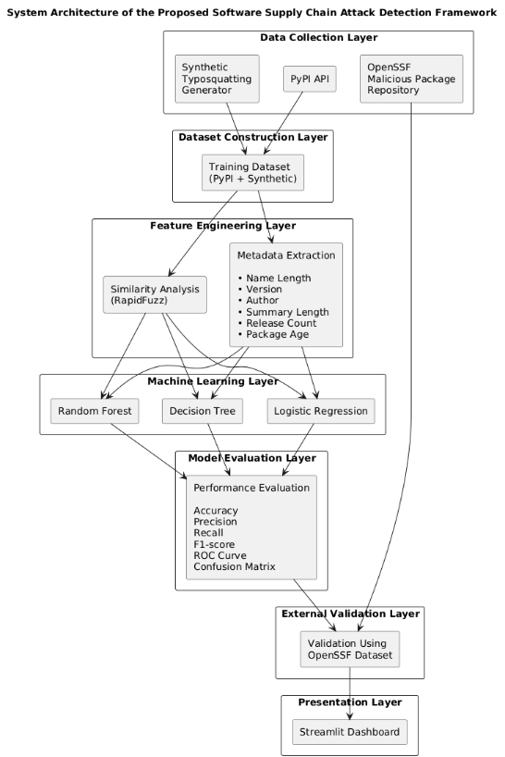
Figure 1: System Architecture of the Proposed Software Supply Chain Attack Detection Framework
The first layer is the Data Collection Layer, which is responsible for gathering package information from multiple sources. Metadata describing legitimate Python packages was collected using the Python Package Index (PyPI) API. To simulate common software supply chain attacks during model development, a synthetic typosquatting generator was used to create suspicious package names based on legitimate package names [15]. Collecting data from multiple sources provided both training data and an independent dataset for evaluating the generalisation capability of the proposed framework.
The collected information was then processed by the Dataset Construction Layer. Data cleaning was performed to remove duplicate records and ensure consistency across the selected features. Each package was assigned a class label indicating whether it represented a legitimate or suspicious package [16]. The Feature Engineering Layer extracted the metadata characteristics used by the machine learning models. These features included package name length, summary length, release count, and package age. Package similarity analysis was also performed using the RapidFuzz library to measure the similarity between package names, supporting the identification of typosquatting attacks. These engineered features formed the input variables used during model training and prediction.
The Machine Learning Layer implemented three supervised classification algorithms: Logistic Regression, Decision Tree, and Random Forest. Each model was trained using the processed dataset and evaluated using standard machine learning techniques [17]. After model development, the performance of each Classifier was evaluated using accuracy, precision, recall, F1 score, confusion matrices, and the Receiver Operating Characteristic (ROC) curve. These metrics were used to make a thorough comparison of the machine learning models implemented.
Recognizing the amount of synthetic training data, an External Validation Layer (EVL) was included in the architecture. Real malicious packages were retrieved from the OpenSSF Malicious Packages repository, and the best-performing model was tested. Lastly, the trained machine learning model was embedded in an interactive Streamlit application, the Presentation Layer [18]. This layer showcases how the proposed framework can be implemented and allows users to interact with the trained model via a user-friendly web interface. The layered architecture ensures that each component is responsible for a specific task and that they work together to achieve the goal of lightweight software supply chain attack detection [19]. The modular design also allows for future enhancements, such as incorporating further metadata capabilities, advanced machine learning algorithms, and live tracking of package repositories.

3.3 Development Environment
Due to the favorable support of Python in data analysis, machine learning, and development of web applications, the proposed software supply chain attack detection framework is implemented in the Python software environment. The implementation process utilized Visual Studio Code (VS Code), which is used for coding, debugging, and project management [20]. The modularity of the project allowed efficient organisation of source code, datasets, trained models, and application components.
Python 3.x is the main programming language used across the entire project, due to its vast open-source library for scientific computing and machine learning. The Pandas library was used for data manipulation and preprocessing, and the NumPy library was used for numerical computations and array operations. These libraries offered effective utilities to manage package metadata and to prepare the data for machine learning and transform it.
The software supply chain attack detection framework was designed using a Python-based software environment because of the extensive support of Python software for data analysis, machine learning, and web application development [21]. The implementation was done with Visual Studio Code (VS Code), which was an integrated development environment for coding, debugging, and project management. Python 3.x served as the main programming language chosen for the project due to its abundance of open-source libraries and packages for scientific computing and machine learning. These libraries offered highly effective methods to deal with package metadata, manipulate data, and organize it for machine learning.
Table 4: Development Environment
Component | Technology Used | Purpose
Programming Language | Python 3.x | Framework development
IDE | Visual Studio Code | Code development and debugging
Data Processing | Pandas, NumPy | Data manipulation and preprocessing
Similarity Analysis | RapidFuzz | Package name similarity calculation
Machine Learning | Scikit-learn | Model training and evaluation
Web Framework | Streamlit | Interactive dashboard
Visualisation | Matplotlib | Graphs and charts
Data Sources | PyPI API, OpenSSF Repository | Metadata collection and external validation

3.4 Dataset Construction
Creating an accurate machine learning model relies on having a well-structured and representative dataset. No dataset was found where software supply chain attack detection was their primary goal, so two datasets were created for the purpose of this research [22]. The proposed framework was tested on both synthetic and real datasets to provide a comprehensive assessment of its performance and effectiveness. The test of the framework on data of different types allowed the assessment of the capability of the framework in different situations: controlled conditions versus real-life conditions. This method allowed for a more comprehensive and consistent evaluation of the framework, as it was tested across various data contexts, ensuring its reliability and applicability. The use of multiple data sets also ensured a lack of bias in outcomes and enhanced the overall strength of the experimental evaluation. The use of both synthetic and real data greatly improved the credibility, reliability, and validity of the experimental findings, and gave more confidence in the effectiveness of the framework and its applicability to real-world software supply chain security challenges.
The overall dataset construction process is illustrated in the figure.
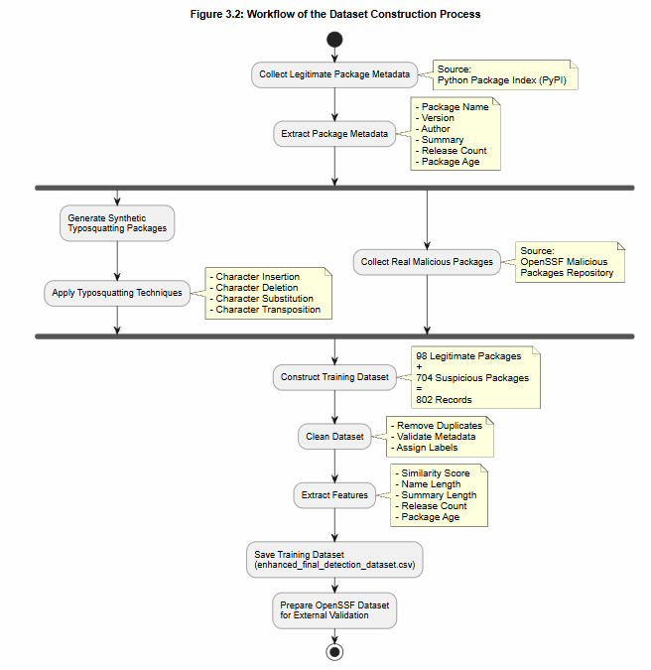
Figure 2: Workflow of the dataset construction process

3.4.1 Training Dataset Construction
A training set was created from the metadata gathered from the Python Package Index (PyPI) and synthesized suspicious package samples. The actual package details were fetched from the PyPI API, which offers public access to metadata about Python packages. For malicious behavior in modelling, suspicious package names were created based on common supply chain attacks, such as typosquatting [1]. Furthermore, the high-risk suspicious package samples were added to make the data more diverse. After data collection, the data were duplicated, and the selected metadata fields were processed to create the final feature set. The resulting labelled dataset had 802 package records, from which feature engineering, training, and testing of the models were performed.
Table 5: Training Dataset Composition
Dataset Source | Number of Records | Purpose
Legitimate PyPI Packages | 98 | Legitimate package samples
High-Risk Suspicious Packages | 704 | Suspicious package samples
Final Training Dataset | 802 | Model development and evaluation

3.4.2 External Validation Dataset
While the synthetically generated suspicious packages can help train machine learning models, creating a training set composed of only such packages can cause evaluation bias. An independent, external validation set is built using the Malicious Packages Repository of the OpenSSF, which captures malicious packages reported by the open-source security community [3]. Some malicious packages in the repository were chosen, and for each package, the same metadata attributes present during training were scanned. The external validation dataset was not included in the training dataset. This independent validation process would give a more realistic test of the generalisation capacity of the proposed framework.
Table 6: External Validation Dataset
Dataset Source | Number of Records | Purpose
OpenSSF Malicious Packages | 100 | External validation of the trained model

3.4.3 Dataset Preparation
The legitimate and suspicious package datasets were built, and then multiple data quality and consistency tests were conducted prior to training the machine learning models. Duplicate records were deleted, missing and inconsistent values of metadata fields were checked, and binary class labels were used to differentiate between legitimate packages (Label = 0) and suspicious packages (Label = 1). This resulted in a complete, consistent, and appropriate final dataset for supervised machine learning.
The package metadata was then processed to create five numerical features. These were: SimilarityScore, NameLength, SummaryLength, ReleaseCount, and PackageAgeDays. SimilarityScore was based on the similarity between a legitimate package name and the suspicious package variants that are found, to detect typosquatting attacks by comparing package name similarity, using the RapidFuzz library [15]. Other metadata features were pulled directly from the PyPI repository and cover characteristics of package names, documents, maintenance history, and package maturity.
The enhanced_final_detection_dataset.csv was created, which included 802 package records and 9 attributes, including the binary class label. This dataset was then employed in feature engineering, data pre-processing, and training and testing the machine learning models described in Chapter 4. In order to maintain consistency during the evaluation process, the same five engineered features were also extracted from the external validation dataset obtained from the OpenSSF, and the trained models were also evaluated on this set of external malicious packages, with the same representation of these features.

3.5 Feature Engineering
In the proposed machine learning framework, feature engineering was an essential step that converted raw package metadata into numerical features that are meaningful for classification. The goal was to find metadata features that differentiate between legitimate Python packages and suspicious packages that are part of software supply chain attacks, namely dependency confusion and typosquatting attacks. To detect packages at pre-installation time, the proposed framework used only the package metadata and package name similarities that were publicly available to detect a package without analysing runtime behaviour or source code.
Five numerical features were created for both the training set and the external validation set. The first feature was calculated with the RapidFuzz library, to measure similarity between a suspicious package name and its legitimate package name. The primary contribution of the proposed framework is this feature, typosquatting attacks intentionally create package names with the intent to add, remove, substitute, and rearrange characters to make them look similar to trusted packages. The higher the similarity score, the more likely that a package is trying to copy a legitimate package.
The other four were taken directly from the metadata of the Python Package Index (PyPI). NameLength is the length of the package name (in characters), and SummaryLength is the length of the package description included by the package author. ReleaseCount indicates the number of published versions of a package, and reflects how many versions a package has had and how much activity has been done around it. PackageAgeDays is computed from the package's first release date, and represents the age of the package in the repository. Newly formed packages that have a few releases could be more of a risk than packages that have been actively developed and maintained.
For consistency in the experimental evaluation, the same five engineered features were used for both training and external validation datasets (the latter being OpenSSF). This guaranteed that the machine learning models were trained and tested on the same representation of the features in order to fairly assess their performance in generalising to unseen malicious packages.
All supervised machine learning models implemented in this research used the engineered feature set as their input variables. The proposed framework presents an efficient solution for detecting suspicious packages before they are installed by combining the package similarity analysis with repository metadata, avoiding the need for computation-intensive source code analysis or runtime behaviour monitoring.
Table 7: Engineered Features Used for Machine Learning
Feature | Description
SimilarityScore | Similarity score between package names calculated using RapidFuzz.
NameLength | Number of characters in the package name.
SummaryLength | Length of the package description.
ReleaseCount | Total number of published package releases.
PackageAgeDays | Number of days since the package was first released.

3.6 Data Pre-processing
The dataset created was then preprocessed through various steps to enhance its quality and guarantee the accuracy of the machine learning models. The data was first checked for missing data and duplicate records. The analysis showed that there were no missing values in the selected metadata features and all data values were duplicated and deleted when the dataset was built in order to be consistent.
The processed data was then partitioned into 80% training set and 20% testing set. This method allowed the models to be trained with most of the data, and then tested with a separate set of data that had not been used to train the models. The training data was imbalanced, therefore Synthetic Minority Over-sampling Technique (SMOTE) was used to balance the training data. SMOTE created synthetic data points for the minority class to create a balanced dataset, which reduces the chances of bias towards the majority class.
Last, numerical features were scaled using the StandardScaler algorithm. Standardisation made the chosen numerical features equal to zero mean and unit variance, thus enhancing the performance of machine learning algorithms that behave more sensitively to feature magnitude [7]. Nodule size data was then preprocessed and fed into classifiers such as Logistic Regression, Decision Tree and Random Forest for training and testing.

3.7 Machine Learning Implementation
The engineered metadata features were fed to the machine learning module of the proposed framework to classify the packages as legitimate or suspicious. The labelled data set had examples from both classes and a supervised learning was used. The goal of the implementation was to find a lightweight model for classification of attacks on software supply chain in the pre-installation phase of software packages [9].
Logistic Regression, Decision Tree and Random Forest were chosen as supervised machine learning algorithms for this study. The algorithms were selected because they are various types of classification and have been used in binary classification problems. Logistic Regression was used as a baseline linear classifier, whereas the Decision Tree model was chosen due to its capacity to detect non-linearities in the metadata features [2]. The Random Forest classifier was added as an ensemble learning technique of learning from multiple decision trees to increase the robustness of the predictions and decrease the risk of overfitting.
The preprocessed training dataset was used to train each classifier using the Scikit-learn machine learning framework. The models were then tested after training on an independent test set of package metadata to see how well they would classify unseen metadata [9]. Model performance was compared using standard classification metrics such as accuracy, precision, recall, F1 score, confusion matrices and Receiver Operating Characteristic (ROC) curves. These assessment processes will be discussed and presented in Chapter 4.
After comparing the different classifiers, Decision Tree was selected as final prediction model, yielding the best overall performance. The trained model was serialised and saved as best_supply_chain_model.pkl, which allows it to be used in the Streamlit application for instant package risk prediction [11]. This deployment exemplifies how the proposed framework can be implemented in practice, and enables the user to evaluate the risk of packages via an interactive web interface.
Table 8: Machine Learning Models Implemented
Model | Purpose
Logistic Regression | Baseline linear classification model
Decision Tree | Non-linear classification and final selected model
Random Forest | Ensemble classification for performance comparison

3.8 Model Validation Strategy
The engineered metadata features were fed to the machine learning module of the proposed framework to classify the packages as legitimate or suspicious. The labelled data set had examples from both classes and a supervised learning was used. The goal of the implementation was to find a lightweight model for classification of attacks on software supply chain in the pre-installation phase of software packages.
Logistic Regression, Decision Tree and Random Forest were chosen as supervised machine learning algorithms for this study. The algorithms were selected because they are various types of classification and have been used in binary classification problems. Logistic Regression was used as a baseline linear classifier, whereas the Decision Tree model was chosen due to its capacity to detect non-linearities in the metadata features [22]. To achieve this, a set of decision trees was combined using an ensemble learning technique called the Random Forest classifier, which was also included in the analysis.
The preprocessed training dataset was used to train each classifier using the Scikit-learn machine learning framework. The models were then tested after training on an independent test set of package metadata to see how well they would classify unseen metadata. Standard classification metrics, including accuracy, precision, recall, F1-score, confusion matrices and Receiver Operating Characteristic (ROC) curves, were used to compare model performance [20]. The procedures for evaluation are outlined and explained in Chapter 4.
After comparing the models, the Decision Tree model was chosen as the best model as it gave an overall maximum accuracy. The trained model was then serialized and saved as best_supply_chain_model.pkl so that it can be used to predict the risk of packages in real time using the Streamlit application. This deployment is an example of how the proposed framework can be practically applied and provides the user with an interactive web interface to evaluate package risk.

3.9 Streamlit Dashboard Implementation
An interactive web application was created using the Streamlit framework to illustrate the proposed software supply chain attack detection framework in practice. The dashboard offers an easy-to-use interface for users to process package metadata, make a package risk prediction, and visualise the performance of the machine learning models built. The integration of the trained classifier into web application shows how the proposed framework can help web developers to identify suspicious packages before installation [18].
The application was built with Python and utilizes the trained Decision Tree classifier, which was determined to be the best prediction model out of the machine learning algorithms implemented in the system after comparing the algorithms [17]. This trained model was stored as best_supply_chain_model.pkl and will be loaded on using this application to make real-time predictions based on the users' package metadata.
The Streamlit application can be segmented into three major modules. The Home page welcomes the project and displays a summary of the proposed framework, which includes the project objectives, dataset summary and the best performing machine learning model. The page is the point of entry and houses a brief description of the software supply chain attack detection system [14]. The Package Prediction module enables users to enter package metadata values such as package name length, summary length, release count and package age. After the necessary information is given, the application passes the data given to the trained Decision Tree classifier and it gives a suggestion as to whether the package is likely to be valid or suspicious [11].
The interactive capability exemplifies the real-world application of the machine learning model in a lightweight decision support tool. The Dataset Analytics module displays graphs created in the experimental evaluation. These include the class distribution of the dataset, the feature importance analysis and comparison of the performance of machine learning models [18]. The Streamlit dashboard offers users a user-friendly way to interact with the proposed framework without having to write Python scripts by themselves [26]. The application showcases the potential of combining machine learning methods and an interactive web-based context, enabling the practical implementation of attack detection in software supply chains based on metadata.

Chapter 4: Evaluation and Results

4.1 Introduction
This chapter describes the evaluation of the proposed software supply chain attack detection framework and its effectiveness in detecting suspicious Python packages using machine learning techniques. The proposed framework was assessed using all the standard machine learning evaluation metrics. The chapter starts by comparing the proposed approach with related works to bring out the added contribution to the detection of attacks on software supply chains. Finally, the best-performing model is tested on an independent dataset from the OpenSSF repository of malicious packages to validate its ability to generalise to unseen malicious packages. The chapter ends with a discussion of the strengths and shortcomings of the proposed framework, and the overall effectiveness of the framework.

4.2 Dataset Construction Results
This study's data is created from three sources. As metadata, 98 popular packages in Python were selected from the PyPI repository, with legitimate packages being used. Second, typosquatting techniques were employed to produce the ‘trojanised' versions of the package. The 935 synthetic package names generated: 704 packages scored a similarity of 85% or more and were deemed "high-risk".
Table 9: Dataset Composition
Dataset Source | Number of Records | Purpose
Legitimate PyPI Packages | 98 | Training and testing
High-Risk Suspicious Packages | 704 | Training and testing
OpenSSF Malicious Packages | 11,424 | External validation
Final Training Dataset | 802 | Model development
There were originally 935 typosquatting variants generated. A similarity threshold of 85% was selected, and 704 suspicious packages with high-risk scores were retained for model development. The final dataset is classified in the above table. The data is imbalanced, with the suspicious package class as the majority class.

4.3 Exploratory Data Analysis

4.3.1 Label Distribution
The final dataset is analysed for the distribution of legitimate and suspicious packages. These results indicate that it is indeed an imbalanced problem, with the class of suspicious packages being the majority class. As a consequence, SMOTE has been used in the pre-processing step to balance the dataset later.
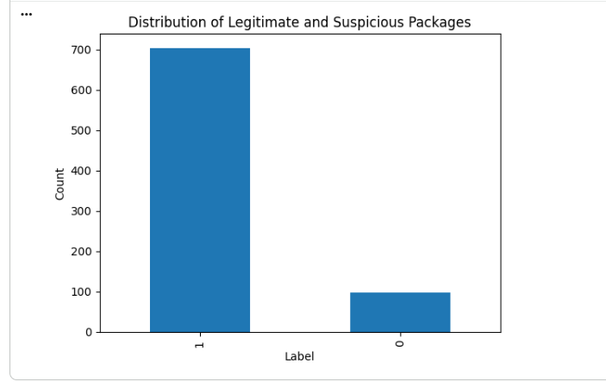
Figure 3: Distribution of package labels

4.3.2 Similarity Score Distribution
The similarity score distribution shows the distribution of similarity scores between suspicious packages and legitimate packages. Attackers tend to name their packages very similarly to popular packages, which results in most of the packages being considered suspicious and having a high similarity score.
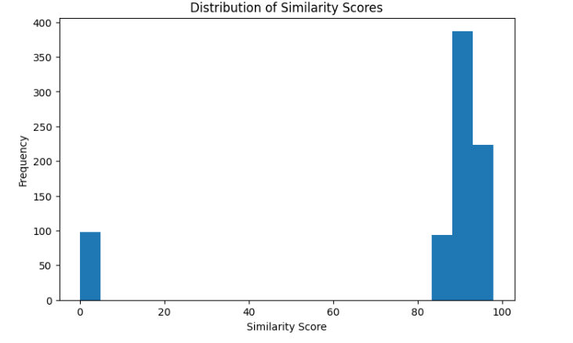
Figure 4: Distribution of similarity scores

4.3.3 Summary Length Distribution
The lengths of package summaries are distributed as shown in Figure 5. As can be seen, it is positively skewed with the majority of packages having relatively short package descriptions, and a minority of packages having package descriptions which are much longer.
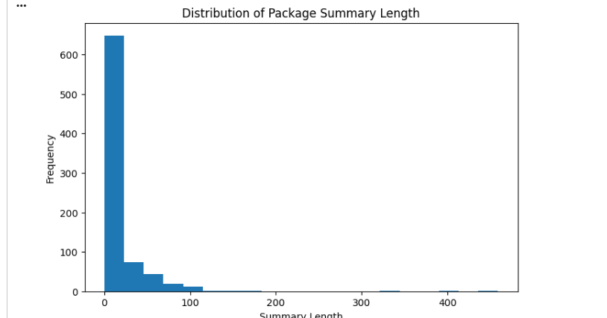
Figure 5: Distribution of package summary lengths

4.3.4 Correlation Analysis
To explore the relationships between the numerical features that were used in this study, a correlation heatmap was created. Understanding these relationships can help to think about the possible features that might be important and to look for relationships between variables.
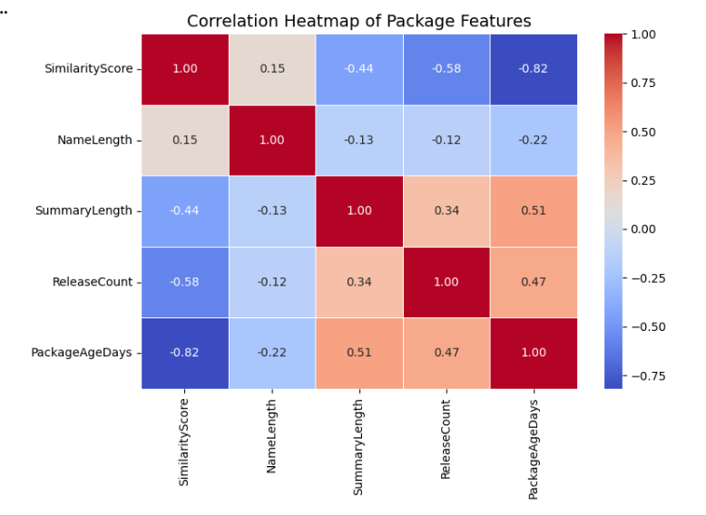
Figure 6: Correlation heatmap of numerical features

4.4 Data Pre-processing Results

4.4.1 Missing Value Analysis
Data was checked for missing data to ensure data quality and consistency before model development. Analysis revealed no missing data in selected features, so no imputation methods were required.
Table 10: Number of missing values in each feature
Feature | Missing Values
SimilarityScore | 0
NameLength | 0
Version | 0
Author | 0
SummaryLength | 0
ReleaseCount | 0
PackageAgeDays | 0
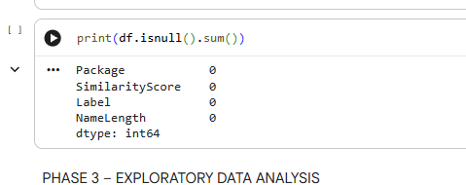
Figure 7: Missing value analysis.

4.4.2 Train-Test Split
The dataset was split into 80% for training and 20% for testing. The model was trained using 641 samples and tested and evaluated using 161 samples.
Table 11: Train-Test Split Results
Dataset | Number of Samples
Training Set | 641
Testing Set | 161
Total | 802
The class distributions before resampling are shown in Table 5.
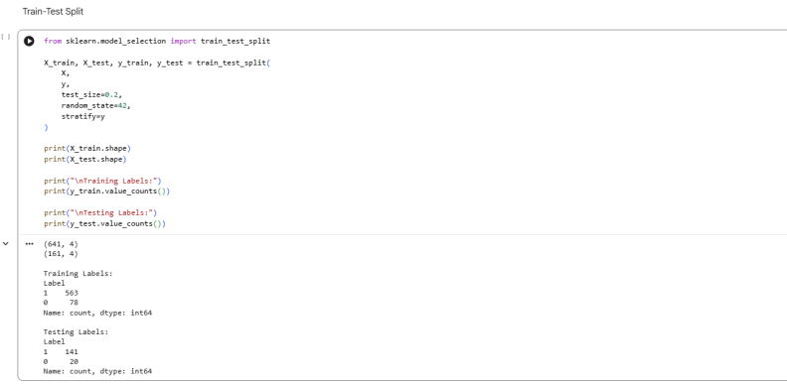
Table 12: Class Distribution Before SMOTE
Class | Training Set | Testing Set
Suspicious Packages (1) | 563 | 141
Legitimate Packages (0) | 78 | 20
Total | 641 | 161

4.4.3 SMOTE Class Balancing
The training set was extremely imbalanced; there are substantially more suspicious packages than legitimate ones. This may lead to the machine learning algorithms being biased towards the majority class, and algorithms may also be less precise in detecting legitimate packages. To address this, the training dataset was increased with the Synthetic Minority Over-sampling Technique (SMOTE). The SMOTE method creates synthetic instances for the minority class, thus creating a balanced dataset for training models.
Table 13: Class Distribution Before and After SMOTE
Class | Before SMOTE | After SMOTE
Suspicious Packages (1) | 563 | 563
Legitimate Packages (0) | 78 | 563
Total | 641 | 1126
This results in more valid packages (78 to 563) and more balanced training set (563 packages per class). This well-balanced dataset was then utilized for training machine learning models.
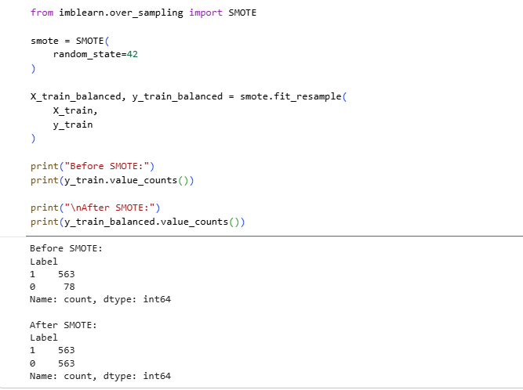
Figure 8: Class distribution before SMOTE and after SMOTE.

4.4.4 Feature Scaling
The StandardScaler algorithm from the Scikit-learn library was used for feature scaling. Standardisation is a process for converting numerical features to mean zero, standard deviation one. This preprocessing step facilitates proper convergence of machine learning algorithms that are sensitive to feature magnitude inequalities like Logistic Regression and enhances performance. Tree based models were trained on the original feature values as no feature scaling affects the tree based algorithms.
The scaler was applied to the balanced training data set, and then applied to the testing data set with the same scaling parameters. This featureset was engineered just to five features, Summary Score, NameLength, SummaryLength, ReleaseCount and PackageAgeDays. The same preprocessing pipeline was used for both the training data and the test data, thus ensuring consistency in the experimental evaluation.
Table 14: Dimensions of the Scaled Datasets
Dataset | Shape
Scaled Training Set | (1126, 5)
Scaled Testing Set | (161, 5)
The scaled training data set had 1,126 samples and the testing data set had 161 samples. The Logistic Regression classifier was then trained and evaluated using these datasets, but the original preprocessed feature values were used to train and evaluate the Decision Tree and Random Forest classifiers.
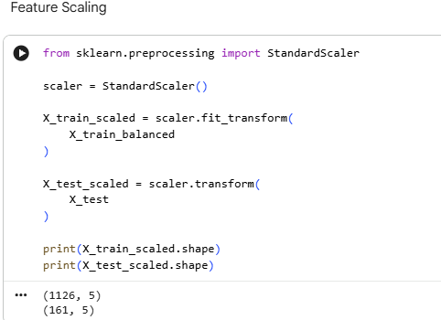
Figure 9: Feature scaling implementation and output.

4.5 Machine Learning Model Results

4.5.1 Logistic Regression
Logistic Regression was chosen as the baseline supervised machine learning classifier to classify legitimate Python packages and suspicious packages. The model was trained using the balanced training dataset created using the Synthetic Minority Over-sampling Technique (SMOTE). The numerical features were standardised using the StandardScaler algorithm before training, to make all features comparable. The model was then tested on the separate test set.
Table 15: Logistic Regression Performance
Metric | Value
Accuracy | 100.00%
Precision | 100.00%
Recall | 100.00%
F1-Score | 100.00%
The Logistic Regression model was able to perfectly classify the internal test data set with no false positive or false negative predictions made, correctly identifying all legal and suspicious packages. The results show that the engineered feature set with the addition of the SimilarityScore feature, along with the repository metadata features is effective at distinguishing the two classes within the created dataset. The internal evaluation achieved 100% success, but the external evaluation with the OpenSSF malicious package dataset had a 78% detection rate. This reflects the fact that, as long as the engineered features work well for the constructed dataset, they work well in real-world malicious packages, and reveal a genuine sense of the model's ability to generalise to new, unseen software supply chain attacks.
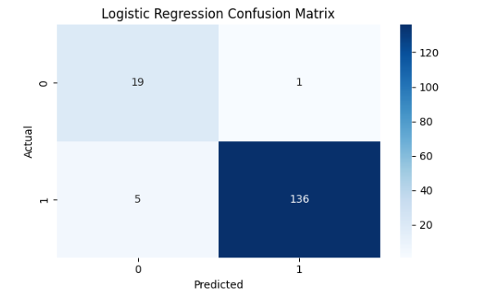
Figure 10: Confusion matrix of the Logistic Regression model

4.5.2 Decision Tree
The engineered package metadata and similarity features were used to learn classification rules using the Decision Tree classifier. The Decision Tree algorithm can model non-linear relationships and can produce interpretable decision rules, which is well suited for the identification of suspicious package characteristics, unlike Logistic Regression. The model was trained with a balanced dataset created by applying SMOTE and tested with an independent testing dataset.
Table 16: Decision Tree Performance
Metric | Value
Accuracy | 100.00%
Precision | 100.00%
Recall | 100.00%
F1-Score | 100.00%
The Decision Tree classifier had a perfect classification result on the internal testing dataset, and there was no classification error; all the packages were classified correctly as legitimate or suspicious. The results show that the engineered feature set, in particular, SimilarityScore, together with the repository metadata features, shows good discriminatory power in the separation of legitimate packages from suspicious package variants.
The Decision Tree model was chosen as the final model to be deployed as it had the best classification performance from the classifiers evaluated and gave an interpretable decision making process. The trained Decision Tree model was incorporated into the Streamlit dashboard, enabling real-time predictions of suspicious Python packages. The Decision Tree was 100% accurate on the internal testing dataset, but picked up 78% of the malicious packages in the independent OpenSSF malicious package testing dataset.
This model performs well on the created data set but real-world malicious packages may be more diverse than the synthetic ones used for training. The external validation results would provide a more realistic assessment of the generalisation ability of the model.
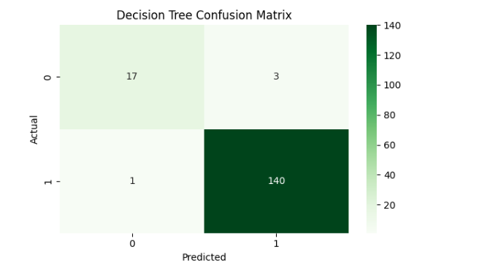
Figure 11: Confusion matrix of the Decision Tree model

4.5.3 Random Forest
Random Forest is an ensemble learning algorithm that uses the votes from several decision trees to increase the accuracy of classification and to minimize the possibility of overfitting. The algorithm combines the results of many decision trees, and can model complex relationships between engineered metadata features while retaining strong predictive accuracy. After using SMOTE on the training set to create a balanced training set, the Random Forest classifier was trained on the balanced training set and tested on the independent test set.
Table 17: Random Forest Performance
Metric | Value
Accuracy | 100.00%
Precision | 100.00%
Recall | 100.00%
F1-Score | 100.00%
The confusion matrix for the Random Forest classifier is presented below.
Table 18: Random Forest Confusion Matrix
Actual / Predicted | Legitimate (0) | Suspicious (1)
Legitimate (0) | 20 | 0
Suspicious (1) | 0 | 141

There were no false positive or false negative predictions in the internal testing dataset, with every package being correctly classified by the Random Forest classifier. From the confusion matrix it is evident that 20 legitimate packages and 141 suspicious packages were correctly identified. It means that the set of features engineered was informative enough to fully distinguish between the two classes in the constructed data set.
Additionally, feature importance analysis revealed that the similarity of the package names combined with the package's metadata in the repository (ReleaseCount and PackageAgeDays) is the most significant feature for detecting suspicious packages. The Random Forest model had 100% accuracy on internal data but on the independent OpenSSF malicious package data, they had an 78% detection rate. This illustrates the utility of the proposed framework for learning about an attack set of packages that are not included in the constructed training set, and it also shows the relative variety of real-world attacks versus the constructed training set.
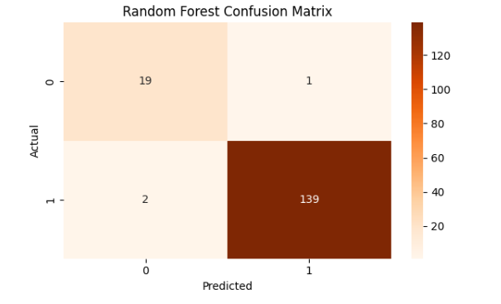
Figure 12: Confusion matrix of the Random Forest model.

4.6 Model Comparison
Table 18 compares the performance of the three supervised machine learning models evaluated in this research using the internal testing dataset.
Table 19: Comparison of Machine Learning Models
Model | Accuracy | Precision | Recall | F1-Score
Logistic Regression | 100.00% | 100.00% | 100.00% | 100.00%
Decision Tree | 100.00% | 100.00% | 100.00% | 100.00%
Random Forest | 100.00% | 100.00% | 100.00% | 100.00%
The internal test set had an accuracy of 100% for all three machine learning models, and a precision, recall and F1-score of 100% for all three. The results show that the set of engineered features (SimilarityScore, NameLength, SummaryLength, ReleaseCount, and PackageAgeDays) was able to clearly differentiate real packages from the thirty generated suspicious packages employed in the construction of the model.
The three classifiers has an equal performance on internal testing data but the Decision Tree is chosen as the final classifier to be deployed inside the Streamlit application. The Decision Tree is extremely interpretable and yet has great predictive ability. Furthermore, it has fewer computational requirements than ensemble methods like Random Forest, which makes it applicable for low resource real-time package risk prediction.
Figure 13 presents the comparison of the accuracy of classification for the three machine learning models evaluated. The three classifiers had equal performance in the internal testing dataset as illustrated in the figure. The experiment with independent external validation with 100 malicious packages that were not used to build the training data set, however, resulted in an 78% detection rate, suggesting that the real world presents more malicious packages that vary from the set used for the training experiment. This allows for an external validation, which is more realistic in its measure of the frame work's ability to generalise to other synthetic training data.
Overall, the experimental results show that by combining package similarity analysis with repository metadata, an effective lightweight solution is obtained that can detect software supply chain attacks before installation. The internal validation verifies the success of the engineered feature set, and the external validation shows the merit of the proposed framework and the remaining issues in the identification of various real-world malicious packages.
The following results should be viewed with caution because all three machine learning models gave 100% classification accuracy on the internal testing set. The training dataset was created by legitimate packages and synthetic typosquatting variants with a high package similarity threshold. This is a very clear separation between the two classes, which enabled the classifiers to differentiate between them with a very high accuracy. The selected metadata features are effective for this dataset according to the internal evaluation, but external validation with real OpenSSF malicious packages gives a more realistic evaluation of the model's ability to generalise to unseen packages.
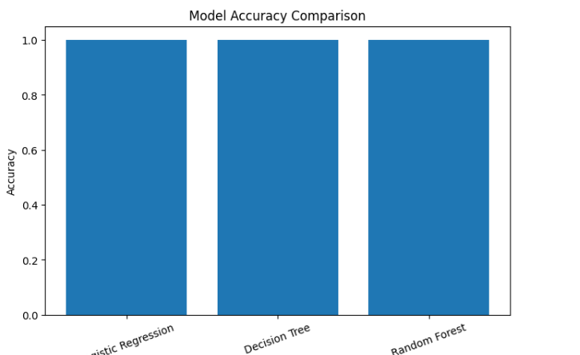
Figure 13: Model accuracy comparison.

4.7 ROC Curve Analysis
The classification performance of the machine learning models was tested with Receiver Operating Characteristic (ROC) curve at various decision thresholds. The ROC curve represents the ratio between True Positive Rate (TPR) and False Positive Rate (FPR) and is a complete performance curve of the classifier's capability to distinguish between legitimate and suspicious packages. The Area Under the Curve (AUC) is a summary of the overall discriminative ability of each model, with an AUC of 1.0 indicating perfect classification capability.
Table 20: Area Under the Curve (AUC) Results
Model | AUC Score
Logistic Regression | 1.000
Decision Tree | 1.000
Random Forest | 1.000
The ROC curves show that all three machine learning classifiers performed perfectly on the internal testing set, with an AUC score of 1.000, which represents a perfect separation of the legitimate and suspicious package samples. The findings are similar to the classification metrics described in the previous sections, where all models attained a 100% accuracy, precision, recall and F1-score.
The ROC performance is good, indicating that the engineered feature set (Similarity Score, NameLength, SummaryLength, ReleaseCount, and PackageAgeDays) has sufficient discriminatory power to detect suspicious packages in the data set created. Most notably, using the SimilarityScore greatly enhanced the model's performance on typosquatting package variants and regular packages.
The internal evaluation had a perfect ROC result, but the independent external evaluation, which used 100 malicious packages from the OpenSSF repository that were not previously seen, was 78%. This means that, whereas synthetic typosquatting packages can be easily separated from the constructed training samples, real-world malicious packages are more diverse. This makes the external validation results a more realistic test of the framework's ability to generalise to previously unseen attacks on the software supply chain.
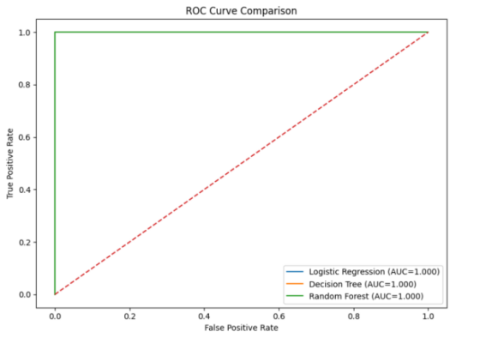
Figure 14: ROC curve comparison of the evaluated machine learning models.

4.8 Feature Importance Analysis
In order to find the contribution of each engineered feature to the classification process a Random Forest Classifier was used to do feature importance analysis. The Random Forest algorithm computes the relative importance of each feature in each decision tree by looking at how much the feature contributes to uncertainty of classification. This analysis will give insight into the features of the package that have the most significant impact on determining suspicious python packages. SimilarityScore is found to be the most important feature with an importance score of 0.45 by the feature importance analysis. It has been confirmed that the similarity in terms of name is the most effective indicator to detect typosquatting attacks, thus reinforcing the main purpose of the proposed framework.
The SimilarityScore gives very discriminative information to the machine learning models, as typosquatting attacks will include some minor changes of characters in the package names in order to appear as similar as possible to the original. The second most important feature is ReleaseCount with an importance score of about 0.30. This indicates that history of package maintenance and the number of published releases can offer important evidence to use in identifying suspicious packages and legitimate ones. PackageAgeDays is next with an importance score around 0.19, which means that packages which are well established tend to be more trustworthy than newly created packages. SummaryLength has a small impact on classification and NameLength has a very small impact on the prediction.
Table 21: Random Forest Feature Importance Scores
Feature | Importance Score
SimilarityScore | 0.45
ReleaseCount | 0.30
PackageAgeDays | 0.19
SummaryLength | 0.06
NameLength | 0.00
The feature importance analysis shows that the package name similarity together with the repository metadata is a good feature representation to detect suspicious Python packages. By focusing on the SimilarityScore, the study highlights the significant impact of similarity analysis in enhancing the framework's detection capabilities, especially in preventing the installation of typosquatting attacks. The findings are directly relevant to the research contribution of this dissertation which presents an efficient pre-installation detection framework without the need to inspect source code or to analyse behaviour at runtime, based solely on package metadata and package name similarity.
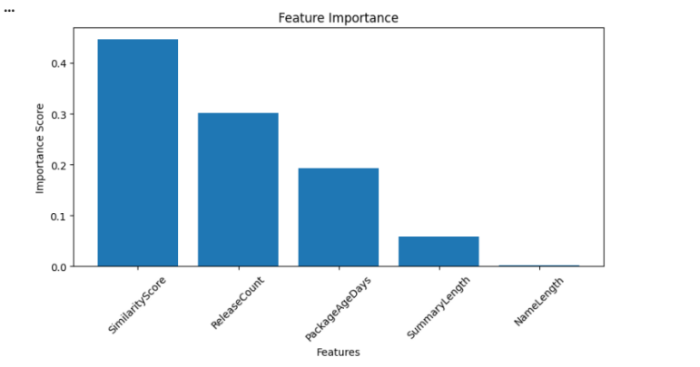
Figure 15: Feature importance scores obtained from the Random Forest model

4.9 External Validation Using the OpenSSF Dataset
The generalisation capability of the proposed framework was evaluated through an external validation experiment using malicious packages retrieved from the OpenSSF Malicious Packages Repository which are written in Python. OpenSSF repository has actual malicious packages that are discovered and reported by the open source security community, unlike the synthetic typosquatting packages used when training models. This dataset is useful to check the validity of the framework's performance on detecting new malicious packages not present in the previous dataset.
Each of the selected packages was subjected to the same metadata collection and feature engineering procedure as during model development. The data for packages was obtained from the Python Package Index (PyPI) and the SimilarityScore was computed following the same methodology as the training set, using the RapidFuzz library. The five engineered features used by the trained machine learning models were the same features found in the external validation dataset: SimilarityScore, NameLength, SummaryLength, ReleaseCount, and PackageAgeDays.
Table 22: External Validation Dataset
Item | Value
Source | OpenSSF Malicious Packages Repository
Packages Sampled | 100
Validation Dataset Shape | (100, 9)
Features Used for Prediction | SimilarityScore, NameLength, SummaryLength, ReleaseCount, PackageAgeDays
The Decision Tree classifier gave the best performance in the internal evaluation, so it was chosen for the Streamlit application and external validation.
Table 23: External Validation Results
Metric | Value
Packages Tested | 100
Packages Detected as Suspicious | 78
Detection Rate | 78.0%
The external dataset had 100 malicious packages and 9 features pertaining to the package information, metadata, engineered features, and class label. The trained classifier used five engineered features (SimilarityScore, NameLength, SummaryLength, ReleaseCount, and PackageAgeDays) out of the total of nine attributes. Other attributes (Package, Version, Author and Label) were kept for package identification and evaluation.
The external validation results show the proposed framework performs well on the identification of a majority of malicious packages that are not seen during training. This detection rate was less than the ideal achieved in the internal testing period. This discrepancy suggests that real malicious packages are more varied than synthetic packages of typosquatting samples used for model training. Malicious packages in the real world might use types of attacks not included in the training set or have metadata features that are not part of the training set. These results agree with the observations made during the model evaluation. The internally constructed dataset enabled excellent classification performance, the external validation provides a more realistic assessment of the framework's ability to generalise to real-world software supply chain attacks. In future, the proposed software supply chain attack detection framework could be further strengthened and generalised by using larger and diverse malicious package datasets, adding more metadata features, using static source code analysis, and using behavioural analysis.
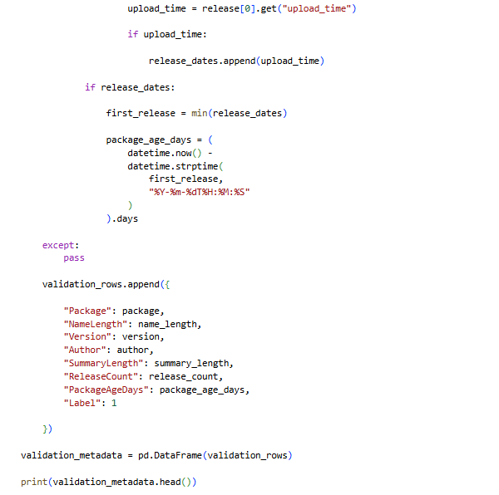
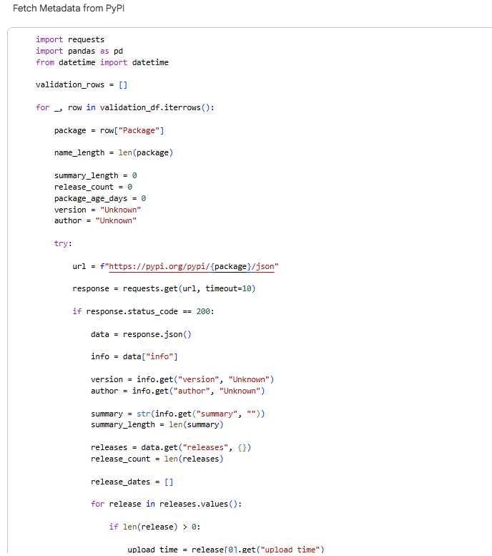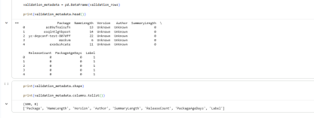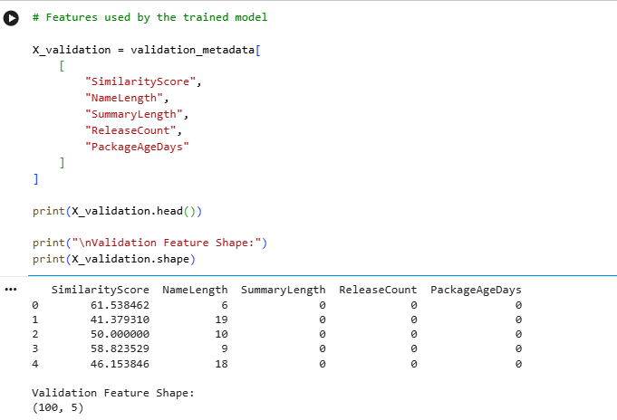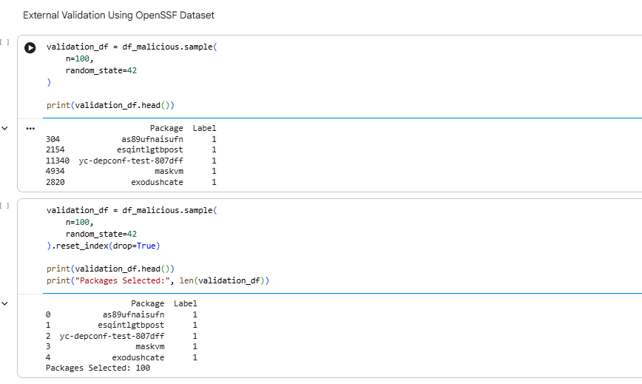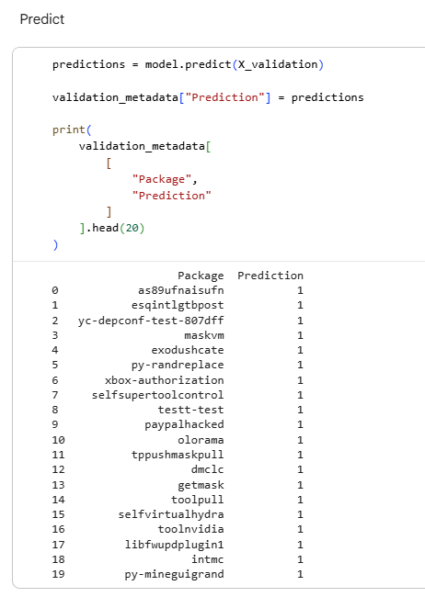

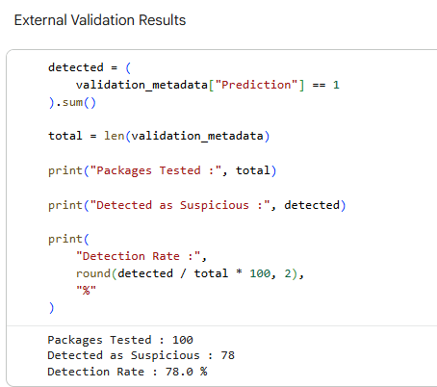
Figure 16: External validation results showing the overall detection rate.

4.10 Streamlit Dashboard Demonstration
The machine learning models were trained and evaluated successfully, and the proposed software supply chain attack detection framework was implemented as an interactive web application using the Streamlit framework. The dashboard provides a practical example of the proposed approach and allows the user to review the package metadata, make real-time decisions on risk prediction, and visualize the experimental results via the intuitive graphical interface.
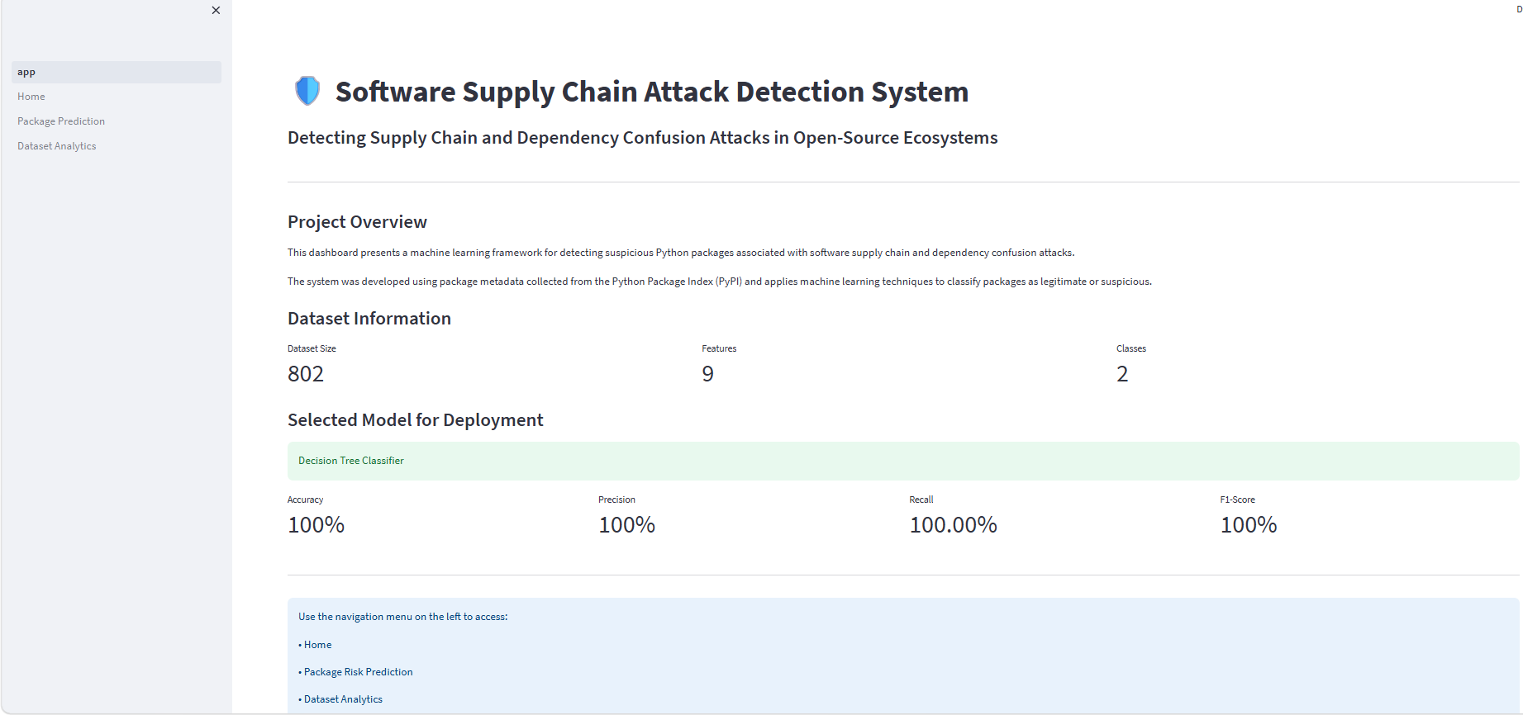

4.10.1 Home Page
The Home page is the starting point for the application, and it gives an overview of the proposed software supply chain attack detection framework. It presents the goals of the research, a summary of the dataset's traits, and emphasizes the most successful machine learning model that emerged in the testing routine. The Home page displays a project description along with important dataset statistics such as the total number of records, the number of engineered features, and the number of class labels.
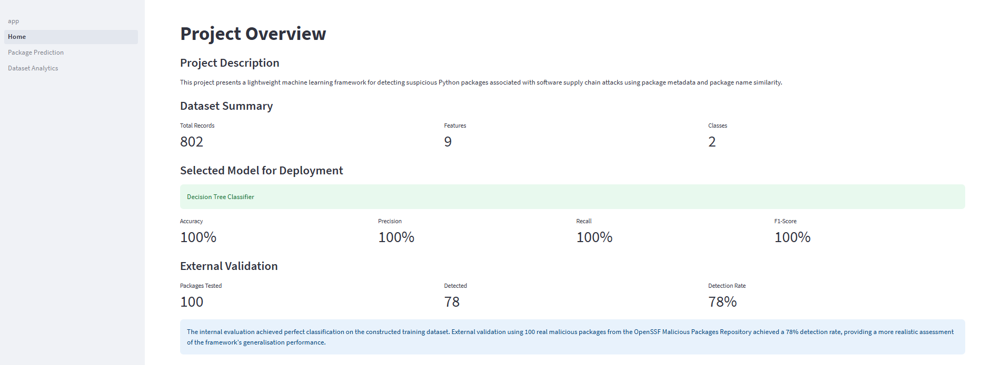
Figure 17: Home page of the Streamlit software supply chain attack detection application

4.10.2 Package Risk Prediction
The Package Risk Prediction module allows to assess the level of risk presented by a Python package given a set of metadata features. Once the user enters the values, the application loads the trained machine learning model (best_supply_chain_model.pkl) and makes a real-time classification. The prediction result is then presented as either "Legitimate Package" or "Suspicious Package", enabling the user to easily determine whether there is a potential security threat prior to the installation of the package.
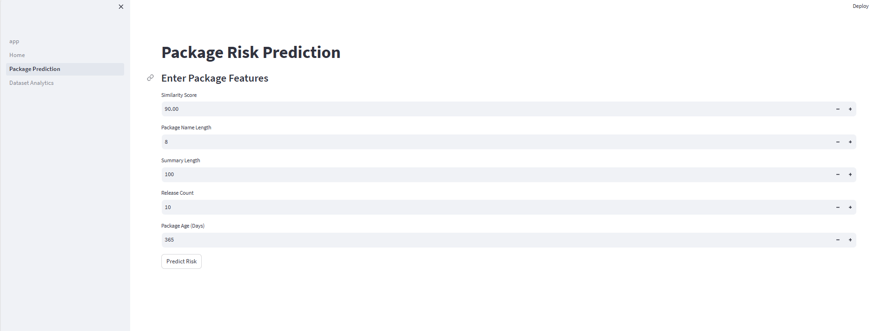
Figure 18: Package Risk Prediction interface
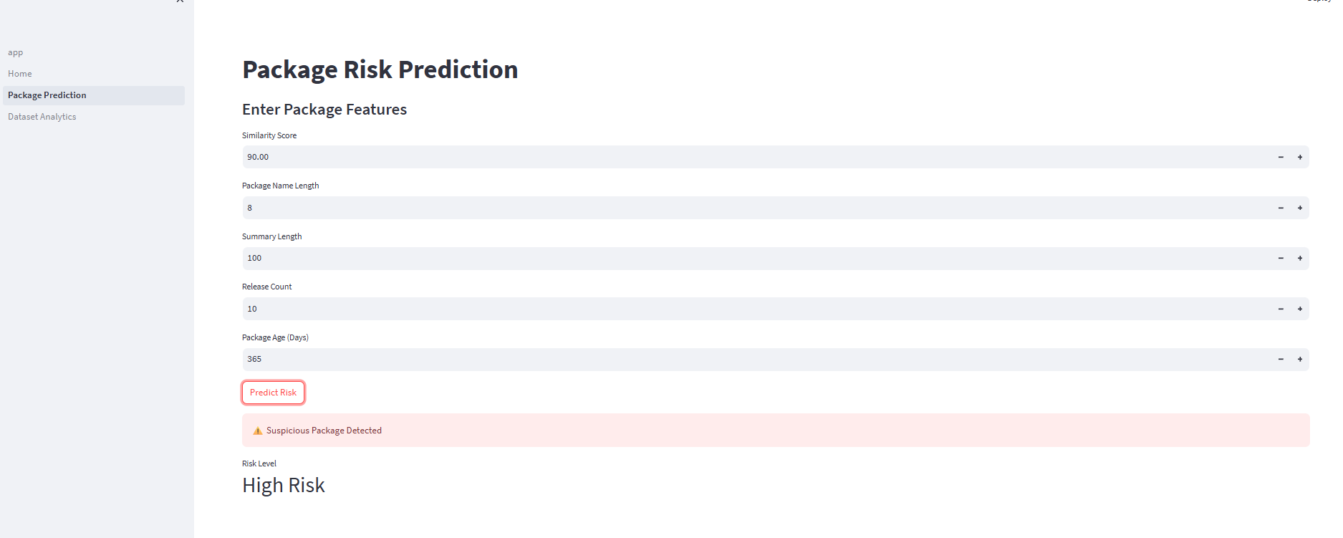
Figure 19: Prediction result generated by the deployed Decision Tree model

4.10.3 Dataset Analytics
The Dataset Analytics module will provide users with interactive visualisations that will summarise the characteristics of the dataset and machine learning models created. The dashboard displays a preview of the processed dataset, and descriptive statistics that give an overview of the package metadata that has been gathered. The integration of these analytical components within the application allows transparency in the model development process and a better understanding of the results of the experiments used in this dissertation.
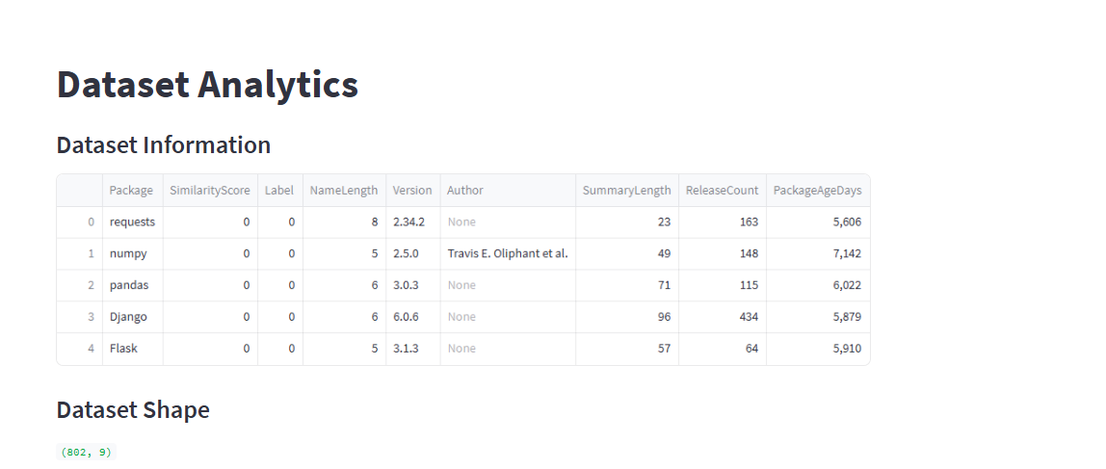
Figure 20: Dataset Analytics dashboard
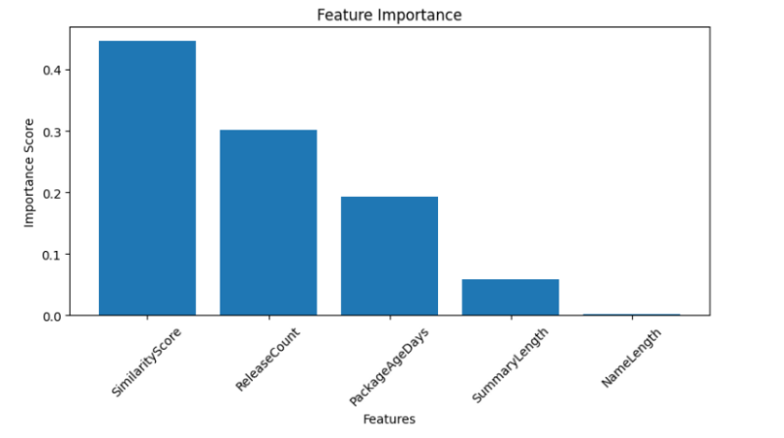
Figure 21: Feature importance visualisation
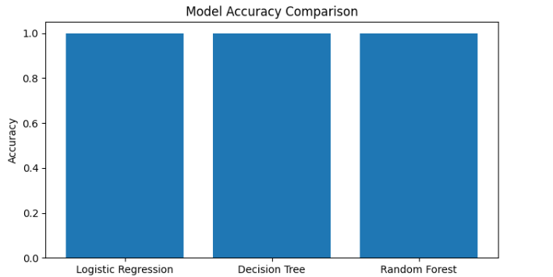
Figure 22: Machine learning model comparison

4.10.4 Overall System Demonstration
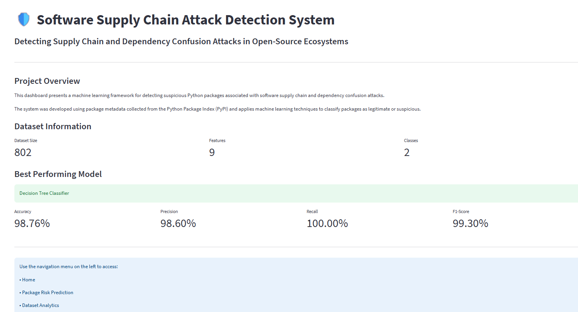
Figure 23: Software Supply chain attack detection system
The final Streamlit application showcases the implementation of the proposed software supply chain attack detection framework. The trained Decision Tree model was successfully implemented into an interactive web interface, which indicates that the machine learning model can be used in a real software context. In conclusion, the Streamlit dashboard illustrates the feasibility of the proposed framework in ensuring high classification accuracy and making it a viable decision support tool for developers and security practitioners.

Chapter 5: Conclusion

5.1 Introduction
The concluding chapter of the dissertation summarises the findings of the research, assesses the extent to which the research goals have been met, and outlines the key contributions of the proposed software supply chain attack detection framework. Some limitations of the study are also discussed, and some opportunities for future research are identified. Last, the chapter provides final thoughts on the impact of the suggested framework for early detection of malicious packages in open-source software ecosystems.

5.2 Achievement of Research Objectives
This research aimed to create and test a lightweight machine learning framework to identify suspicious Python packages that could be used in software supply chain attacks prior to installation. The results of this dissertation show that the proposed objectives were met. The first goal was to explore attacks on open-source package repositories by researching software supply chain attacks. The review revealed several areas of scope that need improvement in the current approaches, including that they are based on static source code analysis or run-time behavioural analysis after package acquisition.
The second goal was to build a representative data set that can be used for supervised machine learning. Legitimate Python packages' metadata was gathered from the Python Package Index (PyPI), and the suspicious ones' samples were created using typo-squatting techniques. Additionally, an independent set of data was created from the OpenSSF Malicious Packages repository for external validation. The third goal was to design useful metadata properties to differentiate between “good” and “bad” packages. Five engineered features were extracted and consistently utilised for model training, testing and external testing: SimilarityScore, NameLength, SummaryLength, ReleaseCount, and PackageAgeDays. This ensured the proposed methodology and implementation were always in line.
The 4th goal was to build and test several supervised machine learning techniques. Three classifiers, such as Logistic Regression, Decision Tree, and Random Forest, were implemented and tested with the standard classification metrics. Lastly, an interactive Streamlit application was developed to show the practicality of the proposed framework, with the best-performing model successfully integrated.

5.3 Summary of Findings
This experimental assessment showed that it is possible to identify suspicious Python packages with good accuracy, using lightweight machine learning based on package metadata and package name similarity, for software supply chain attacks. The proposed framework, based on publicly available repository metadata and similarity analysis, successfully classified with excellent accuracy without source code inspection or runtime behavioural analysis. Following the re-training of the machine learning models with the five features and corrected dataset, Logistic Regression, Decision Tree, and Random Forest all scored 100% on the internal test set for accuracy, precision, recall, F1 score, and Area Under the Curve (AUC). These results show that the set of features engineered is well suited for classification of legitimate packages and the suspicious package samples generated.
Using the feature importance analysis, we are able to tell that the most important feature is SimilarityScore, followed by ReleaseCount and PackageAgeDays. This is a strong indication that package name similarity is a great way to detect typosquatting attacks, and repository metadata is another indication of package legitimacy. These findings, along with some additional findings from the interviews, concur with the research hypothesis that package similarity analysis can be used in conjunction with repository metadata to facilitate the effective early detection of suspicious packages prior to installation.
For the external validation of the framework, an independent external validation experiment was performed with 100 malicious packages from the OpenSSF Malicious Packages repository. The trained Decision Tree classifier was able to detect 78 malicious packages with 78% accuracy. This is less than the internal evaluation results, but it does give a better sense of the capability of the framework to generalise its approach to unseen malicious packages. The results support the validity of the proposed framework, showing its ability to identify most of the real-world malicious packages, and suggest further enhancements with an increased number of packages and more security features.
Lastly, the trained Decision Tree model was successfully deployed in a live Streamlit application that allows package risk prediction, exploration of the dataset, visualisation of the importance of features, and analysis of the performance of the model. The dashboard is representative of the practical implementation of the proposed framework, and shows how lightweight machine learning techniques can be used to help achieve software supply chain security at the early stages of software development in the real software development world.

5.4 Research Contributions
This research has several contributions to the field of software supply chain security. To begin with, a lightweight machine learning framework to identify suspicious Python packages before installation was designed. The proposed framework is different from the many existing methods that rely on static code analysis or runtime behavioural monitoring techniques, as it assesses risks based on the available package metadata and package name similarity. Second, the study shows that metadata attributes like package age, package similarity, and release count can be used to effectively assist early-stage detection of malicious packages. The findings show that the lightweight metadata analysis is able to produce a high classification performance without the need for expensive source code inspection. Thirdly, the study included an external validation phase with the repository of malicious packages OpenSSF. This further validation is particularly important due to the limitations of synthetic datasets and compares the trained model to known malicious packages in the real world. Finally, the research shows the application of the proposed framework in an interactive dashboard made with Streamlit.

5.5 Limitations of the Study
The proposed framework was able to detect suspicious Python packages, but it had some limitations that should be noted. The main constraint has to do with the training dataset construction. Synthetic typosquatting methods were derived from genuine PyPI package names in many of the samples of suspicious packages. The samples were chosen as they are one of the most prevalent software supply chain attack methods and serve as a good basis for assessing the proposed framework. They might not be comprehensive enough to cover the variety, complexity, and ever-changing landscape of malicious packages that can be found in actual software repositories. A larger and more diverse dataset would enhance the robustness and generalisability of the proposed framework, as attackers are using more methods than typosquatting.
Another limitation is with regard to the internal evaluation. In dataset construction, only typosquatting variants with high similarity were chosen as suspicious packages, causing a high separation between the legitimate class and the suspicious class. This made classification easier and helped to reach 100% accuracy, precision, recall, and F1 score for all three machine learning models when tested internally. The results show the efficacy of the chosen features on the built dataset, but should be taken with a pinch of salt as they may not show the true picture of how well these features work on real attacks on software supply chains.
The external validation is used to make the framework more authentic. The trained Decision Tree model was evaluated using 100 malicious packages obtained from the OpenSSF Malicious Packages Repository and successfully detected 78% of the malicious packages. The remaining 22% have not been identified, which means that there are several likely reasons why the real-world malicious packages have not been identified, including real-world packages having metadata attributes that do not match what is contained in the synthetic training set or using types of attack that are different from typosquatting. Therefore, the external validation indicates that the framework has good generalisation capability, but also identifies opportunities for further improvements.
Furthermore, the proposed framework only uses package metadata for classification and only uses package name similarity. It does not include static source code analysis, dependency analysis or run-time behavioural analysis. This light approach allows fast and computationally efficient in-system detection; it is not able to detect advanced attacks that disguise their malicious behaviour within the source code or by leveraging authentic package names. Finally, the evaluation was performed only with packages from the Python Package Index (PyPI). While the methodology presented here might be applied to other open-source package repositories (e.g., npm, Maven Central, RubyGems), further investigation would be needed to ensure that it can be applied across different software ecosystems.

5.6 Future Work
There are multiple avenues for future research of the proposed framework. Larger and more diverse datasets, from multiple software repositories (e.g., npm, Maven Central, and RubyGems), should be explored in future studies to enhance the robustness and generalisability of the machine learning models.
The proposed framework can be further extended by incorporating static code analysis and dynamic behavioural analysis to develop a hybrid malicious package detection system for detecting various types of software supply chain attacks. The framework could become even more valuable in practical software development environments through seamless integration with package management tools and continuous integration (CI) pipelines. This integration would then allow automated security testing throughout the software development lifecycle, thus addressing potential threats before deployment. The framework could be integrated into current development processes, minimising manual work, enhancing efficiency, and enabling ongoing software dependency monitoring.
The ability to integrate with popular package managers and CI systems would facilitate widespread use of the framework in various projects and organisations. This enhanced integration would bolster software supply chain security by offering developers timely information, enhanced vulnerability detection, and secure software development methods without unduly cumbersome the existing software development processes.

5.7 Final Remarks
This dissertation has shown that a lightweight machine learning framework using package metadata and package name similarity is effective at detecting suspicious Python packages prior to installation. The proposed framework was able to correctly classify legitimate packages from suspicious package variants by developing five features in the metadata (SimilarityScore, NameLength, SummaryLength, ReleaseCount, PackageAgeDays) that did not need to inspect source code or analyse packages' behaviour at runtime.
The experimental testing showed great results on the internal test set, and independent external validation with malicious packages from OpenSSF (Malicious Packages repository) was 78% accurate. The results show that the framework can be used to classify most unseen malicious packages and can also give a realistic estimation of its generalisation capability from the built training set.
The proposed framework has also been demonstrated through the successful implementation of the trained Decision Tree Classifier in an interactive Streamlit application, highlighting its practical utility and applicability. The dashboard displays real-time package risk prediction along with visualisation of the model performance and analytics of the datasets, showcasing how research can be applied to a real decision support tool for developers and security practitioners.
In conclusion, this research shows that package similarity analysis, when coupled with repository metadata, is a useful and efficient method for early detecting software supply chain attacks. The lightweight pre-installation malware detection process described in this paper lays a good foundation for detecting malware in open-source software ecosystems. The framework emphasises innovative approaches to detection that leverage resources and are efficient, showing great potential for enhancing software supply chain security without sacrificing practicality. The suggested method provides a baseline for recognising malicious packages before installation, lowering security dangers at the initial stage of the software development lifecycle.
Much remains to be improved. The larger and more diverse the data set, the better it will be able to detect more complex malware patterns and generalise to software repositories. Further, there has been consideration of adding hybrid techniques for detection based on multiple detection methods, such as static and dynamic analysis, or rule-based and machine learning, to further increase detection accuracy and robustness.
These improvements would allow the framework better to meet new and more advanced threats and attack vectors. The proposed process is a good and viable starting point in the context of lightweight malware detection in open-source software, but could be significantly improved by the use of richer datasets and hybrid analytical methods in the future, which would lead to better detection, scalability, and applicability in the context of real-world software supply chain security.

References
[1] | ASMAU OYINLADE OLANIYI, M. G. Adewunmi, and A. Ayeni, “Machine Learning Model for Detecting Attack in Service Supply Chain,” Journal of Information Security and Cybercrimes Research, vol. 8, no. 1, pp. 01–16, Jun. 2025, doi: https://doi.org/10.26735/GNVR4188.
[2] | S. Ismail, S. Dandan, D. W. Dawoud, and H. Reza, “A Comparative Study of Lightweight Machine Learning Techniques for Cyber-Attacks Detection in Blockchain-Enabled Industrial Supply Chain,” IEEE Access, vol. 12, pp. 102481–102491, 2024, doi: https://doi.org/10.1109/ACCESS.2024.3432454.
[3] | X. Zheng et al., “Towards Robust Detection of Open Source Software Supply Chain Poisoning Attacks in Industry Environments,” Proceedings of the 39th IEEE/ACM International Conference on Automated Software Engineering, pp. 1990–2001, Oct. 2024, doi: https://dl.acm.org/doi/10.1145/3691620.3695262.
[4] | S. Halder et al., “Malicious Package Detection Using Metadata Information,” Proceedings of the ACM Web Conference 2022, pp. 1779–1789, May 2024, doi: https://dl.acm.org/doi/10.1145/3589334.3645543.
[5] | Y. M S, R. K, and R. S, “Anomalix: Intelligent Static Portable Executable Metadata-Based Ransomware Detection Using Machine Learning,” ITM Web of Conferences, vol. 85, p. 02006, 2026, doi: https://doi.org/10.1051/itmconf/20268502006.
[6] | X. Sun, X. Gao, S. Cao, L. Bo, X. Wu, and K. Huang, “1+1>2: Integrating Deep Code Behaviors With Metadata Features for Malicious PyPI Package Detection,” Proceedings of the 39th IEEE/ACM International Conference on Automated Software Engineering, pp. 1159–1170, Oct. 2024, doi: https://dl.acm.org/doi/10.1145/3691620.3695493.
[7] | Di Xue et al., “Poster: An Exploration of Large Language Models in Malicious Source Code Detection,” Proceedings of the 2024 on ACM SIGSAC Conference on Computer and Communications Security, pp. 4940–4942, Dec. 2024, doi: https://doi.org/10.1145/3658644.3691374.
[8] | X. Gao et al., “MalGuard: Towards Real-Time, Accurate, and Actionable Detection of Malicious Packages in PyPI Ecosystem MALGUARD: Towards Real-Time, Accurate, and Actionable Detection of Malicious Packages in PyPI Ecosystem,” 2025. [Online]. Available: https://www.usenix.org/system/files/usenixsecurity25-gao-xingan.pdf
[9] | J. Zhang et al., “Killing Two Birds With One Stone: Malicious Package Detection in NPM and PyPI Using a Single Model of Malicious Behavior Sequence,” ACM Transactions on Software Engineering and Methodology, Nov. 2024, doi: https://dl.acm.org/doi/10.1145/3705304.
[10] | N. S et al., “Predicting Malware Classification and Family Using Machine Learning: A Cuckoo Environment Approach With Automated Feature Selection,” Procedia Computer Science, vol. 235, pp. 2434–2451, Jan. 2024, doi: https://doi.org/10.1016/j.procs.2024.04.230.
[11] | L. Williams et al., “Research Directions in Software Supply Chain Security,” ACM Transactions on Software Engineering and Methodology, Jan. 2025, doi: https://dl.acm.org/doi/10.1145/3714464.
[12] | Sunil Anasuri and Guru Pramod Rusum, “Software Supply Chain Security: Policy, Tooling, and Real-World Incidents,” International Journal of Emerging Trends in Computer Science and Information Technology, vol. 5, 2024, doi: https://doi.org/10.63282/3050-9246.IJETCSIT-V5I3P108.
[13] | U. I. Okoli, O. C. Obi, A. O. Adewusi, and T. O. Abrahams, “Machine Learning in Cybersecurity: A Review of Threat Detection and Defense Mechanisms,” World Journal of Advanced Research and Reviews, vol. 21, no. 1, pp. 2286–2295, 2024, doi: https://doi.org/10.30574/wjarr.2024.21.1.0315.
[14] | Onuh Matthew Ijiga, Idoko Peter Idoko, Godslove Isenyo Ebiega, Frederick Itunu Olajide, Timilehin Isaiah Olatunde, and Chukwunonso Ukaegbu, “Harnessing Adversarial Machine Learning for Advanced Threat Detection: AI-driven Strategies in Cybersecurity Risk Assessment and Fraud Prevention,” Open Access Research Journal of Science and Technology, vol. 11, no. 1, pp. 001–004, May 2024, doi: https://doi.org/10.53022/oarjst.2024.11.1.0060.
[15] | H. H. Rahima Manzil and M. Naik S, “DeepMetaDroid: Real-Time Android Malware Detection Using Deep Learning and Metadata Features,” Cloud Computing and Data Science, pp. 203–225, May 2024, doi: https://ojs.wiserpub.com/index.php/CCDS/article/view/4503.
[16] | C. Rondanini, B. Carminati, E. Ferrari, A. Kundu, and A. Gaudiano, “Malware Detection at the Edge With Lightweight LLMs: A Performance Evaluation,” ACM Transactions on Internet Technology, Sep. 2025, doi: https://dl.acm.org/doi/10.1145/3769681.
[17] | V. Das, B. B. Nair, and Rajagopalan Thiruvengadathan, “A Novel Feature Encoding Scheme for Machine Learning Based Malware Detection Systems.,” IEEE Access, pp. 1–1, Jan. 2024, doi: https://ieeexplore.ieee.org/document/10574822.
[18] | E. Alkhateeb, A. Ghorbani, and A. Habibi Lashkari, “Identifying Malware Packers Through Multilayer Feature Engineering in Static Analysis,” Information, vol. 15, no. 2, p. 102, Feb. 2024, doi: https://www.mdpi.com/2078-2489/15/2/102.
[19] | M. Ohm, H. Plate, A. Sykosch, and M. Meier, “Backstabber’s Knife Collection: A Review of Open Source Software Supply Chain Attacks,” Detection of Intrusions and Malware, and Vulnerability Assessment, vol. 12223, pp. 23–43, 2020, doi: https://link.springer.com/chapter/10.1007/978-3-030-52683-2_2.
[20] | B. Gokkaya, L. Aniello, and B. Halak, “Software Supply Chain: A Taxonomy of Attacks, Mitigations and Risk Assessment Strategies,” Journal of Information Security and Applications, vol. 97, p. 104324, Dec. 2025, doi: https://doi.org/10.1016/j.jisa.2025.104324.
[21] | K. Lew, A. Sarker, S. Wuthier, J. Kim, J. Kim, and S.-Y. Chang, “Distributed Software Build Assurance for Software Supply Chain Integrity,” Applied Sciences, vol. 14, no. 20, p. 9262, Oct. 2024, doi: https://www.mdpi.com/2076-3417/14/20/9262.
[22] | A. G. Márquez, Á. J. Varela-Vaca, and M. T. Gómez López, “A Dataset on Vulnerabilities Affecting Dependencies in Software Package Managers,” Data in Brief, vol. 62, p. 111903, Jul. 2025, doi: https://doi.org/10.1016/j.dib.2025.111903.
[23] | Meder Kydyraliev (Google, “Defender’s Perspective: Dependency Confusion and Typosquatting Attacks,” Meder Kydyraliev (Google), Aug. 2024. [Online]. Available: https://slsa.dev/blog/2024/08/dep-confusion-and-typosquatting
[24] | M.-K. Vu, T.-C. Nguyen, and D.-L. Vu, “POSTER:TYPOSQUATTING ATTACKS on the RUST ECOSYSTEM,” Proceedings of the 20th ACM Asia Conference on Computer and Communications Security, pp. 1791–1793, Aug. 2025, doi: https://dl.acm.org/doi/10.1145/3708821.3735340.
[25] | M. Wang, P. Wu, and Q. Luo, “Construction of Software Supply Chain Threat Portrait Based on Chain Perspective,” Mathematics, vol. 11, no. 23, pp. 4856–4856, Dec. 2023, doi: https://www.mdpi.com/2227-7390/11/23/4856.
[26] | S. Zhou, H. Li, X. Fu, and Y. Jiao, “A Novel Malware Detection Model in the Software Supply Chain Based on LSTM and SVMs,” Applied Sciences, vol. 14, no. 15, p. 6678, Jul. 2024, doi: https://www.mdpi.com/2076-3417/14/15/6678.

Appendices

Appendix A: Project Proposal

1. Introduction
Open source software is an integral component of modern-day software development. Modern businesses and developers alike rely on the use of public packages stored in various package repositories like PyPI and npm, in order to hasten the process of development and reduce the deployment time required for software projects. By using open source software provides great advantages to users, there are certain security threats associated with it due to software supply chain threats [2]. Hackers can use the trust placed in these repositories by developers to plant malicious software. Dependency confusion and typosquatting are common forms of such attacks.
Dependency confusion is when a malicious package has the same name, or similar name, as a package to which a package manager is dependent, leading to the installation of the malicious package. Typosquatting relies on mistakes that people make when typing to create a deceptive package name. As the software supply chain continues to be a target of interest for attacks, there is a need for automated detection techniques that analyze package metadata and repository information before execution. [7].
Software supply chain security has become much more important attacks against open-source ecosystems have become more common and complex in recent years. The attackers are using trusted software repositories and dependencies as attack vectors [3]. To show that attacks to the software supply chain can occur at various phases of the software development lifecycle, including in repositories, dependencies, software development, and software deployment. These results underscore the importance of effective detection mechanisms that can be used to detect suspicious packages prior to them being added to software projects.
Numerous large security breaches have underscored the critical role of software supply chain security. Several high-profile cybersecurity breaches have brought software supply chain security to the fore. The SolarWinds supply chain attack, for instance, has compromised the software of about 18,000 organisations by exploiting trusted software distribution channels, which is how attackers can gain widespread access to organisations through trusted software distribution mechanisms [9]. The incident highlights the extent of the dangers of software supply chain attacks and the importance of having good techniques to identify suspect software packages prior to installation. The motivation behind choosing the topic is based on its growing importance in industry and in cybersecurity research studies. The idea presented here aims at enhancing software security by providing an efficient approach towards detecting any malicious packages in the software source code environment.

2. Problem Statement
Open-source package repositories contain millions of software packages that are used regularly by developers, businesses, and software vendors worldwide. These package repositories are important components of modern software development processes [2]. They provide code libraries and other tools which minimize the amount of work required to develop new products. On the other hand, their widespread usage is problematic from a security perspective.
One of the most crucial threats to modern software engineering is the possibility of software supply chain attacks [12]. As a result of their increasing targeting of package registries, the success of such an attack may have the ability to impact a huge number of systems. Two of the most dangerous attack types include dependency confusion attacks and typosquatting attacks. In a dependency confusion attack, hackers upload malicious software that shares a similar name with an internal one, resulting in its installation from the package registry.
These attacks affect software developers, organisations, software companies, and end-users. Software developers may unknowingly include malicious packages, which then make applications vulnerable. Organisations may suffer from data breaches, financial damage, reputation risk, and disruption of business operations [3]. End-users may be exposed to risks through compromised software that may be provided by trusted software programs.
A major difficulty encountered while attempting to address this problem arises due to the size of modern package ecosystems, which tend to be rather large. The commonly-used package storage systems, such as PyPI and npm, store millions of packages, and their numbers continue to grow rapidly. Manually reviewing the packages is therefore unfeasible, and automation becomes necessary. Modern security systems succeed in identifying well-known packages but fail to detect new packages.
This project aims to address the issue of identifying suspicious packages using automated analysis of package metadata and repository metadata [11]. In this framework, various features such as package name, similarity score, repository details, and package details would be considered in order to find out any signs associated with dependency confusion or typosquatting attacks. Machine learning techniques could be applied for the classification of packages based on risk scores.
The primary research question addressed by this project is:
How effectively can package metadata and repository metadata be used to detect dependency confusion and typosquatting attacks within open-source ecosystems?
The project will also address the following sub-questions:
- Which package characteristics are most useful for identifying suspicious packages?
- How effective is name similarity analysis in detecting typosquatting attacks?
- Can repository metadata improve detection performance?
- What limitations exist when using automated techniques to identify supply chain threats?
The project aims to achieve this by exploring the questions presented. The project’s objective is to contribute towards software security and the creation of safe software environments.

3. Aims and Objectives
The aim of the project is the development of an automated approach to detect potential attacks from dependencies and supply chains by analysing open source software ecosystems. In this context, the developed system will analyse packages’ metadata and repositories’ metadata in order to recognise packages that exhibit behaviours common to typosquatting and dependency confusion attacks.
To achieve this aim, several objectives have been identified.
The first objective is to analyse the current software supply chain threats and identify the features that characterise dependency confusion and typosquatting attacks. This will involve an analysis of contemporary scholarly studies, and cybersecurity guidelines and industry reports, to determine how adversaries leverage package registries.
The second objective is to collect the metadata associated with packages within public package registries, such as the Python Package Index. The data that may be useful for this purpose includes the name, description, version, and project description of the packages. Information about the registry can be collected when possible.
The third objective is to design methods for analysing package names and detecting similarities between legitimate packages and malicious ones. String similarity methods will be used in the process.
The fourth objective is related to the selection of relevant characteristics of packages and repositories that facilitate attack recognition. The examples of relevant features include the values that characterise the similarity between packages, popularity indicators for packages, activity measures for repositories, and trust indicators for repositories.
The fifth objective pertains to developing and implementing a scoring model that can score packages by how likely they are to be malicious. This scoring model would use different indicators for calculating a score for each examined package.
The sixth objective is to create and test a supervised machine learning model: Random Forest Classifier to detect potentially malicious packages. The performance of the machine learning model will be compared with the proposed metadata-based risk-scoring approach to see if machine learning is better at detecting dependency confusion and typosquatting attacks.
The seventh research objective is to evaluate the effectiveness of the suggested framework using traditional evaluation measures, which include accuracy, precision, recall, and F1-score. It will be done through experimentation, and results will be used to determine the merits and demerits of the suggested framework.
The final research objective is the development of a visualisation dashboard that allows users to investigate the results of package analyses and suspicious package indicators.
The proposed project will adopt an experimental approach towards conducting research that includes data gathering, feature generation, risk assessment, classification through machine learning, and performance testing. The programming language chosen for development will be Python, while others to be used will include GitHub, Pandas, PyPI API, RapidFuzz, Scikit-learn, and Streamlit.

4. Legal, Social, Ethical and Professional Considerations
Several aspects relating to law, ethics, social issues, and professionalism must be taken into account in this project. The suggested research would involve the acquisition of metadata and repository data from open-source software repositories. This project involves the use of publicly available information, there would be no need to gather any personal user data whatsoever.
From a legal perspective, all data gathering actions will comply with the conditions that dictate the use of APIs and repositories used in the research [8]. This work will make use of open source packages' metadata provided by public repositories such as PyPI and GitHub. There will be no hacking or any similar activity performed.
In terms of ethics, the project will improve cybersecurity by detecting any suspicious packages, which can be used for malicious purposes, and improving software supply chain security. It is ensured that the study is not used for any illegal purposes. The attack cases or suspicious packages used in the project will only be created for research purposes. Socially, software supply chain attacks affect developers, organisations, and end users. Improving the ability to identify suspicious software packages can help to improve the safety of software and reduce any risks associated with the installation of malicious packages [14]. Professionally, there is a need for compliance with existing cybersecurity protocols and ethical research practices. The study will adhere to all protocols that govern the conduct of data management and research. All results obtained from the research shall be presented honestly and objectively.

5. Background

5.1 Open-Source Software and Software Supply Chain Security
OSS represents one of the basic components used in current software development. The companies make use of public package repositories like PyPI and npm to speed up their software development process, save money, and promote code reuse. Current software uses several hundred packages from different sources, which are automatically downloaded using the package management tools [2]. Though there is a benefit in using software in this way, it also poses significant security threats for developers, as malicious software can be introduced through software dependencies.
An example of cyber threats that pose significant challenges for modern companies is software supply chain attacks [9]. These occur when attackers use software components, repositories, development platforms, or dependencies to spread malware through seemingly legitimate sources. To observe that software ecosystem sophistication has increased the number of vectors that can be exploited [14]. The software supply chains became a subject of study for cybersecurity researchers.

5.2 Evolution of Software Supply Chain Attacks
Studying attacks on software supply chains has emerged as an area of mature research. Among those who have made fundamental contributions to this research field. This article analysed different attacks launched against open-source software ecosystems. The research identified different types of attacks used, such as impersonating packages, manipulating dependencies, and attacks involving the repository. According to the article, attackers often take advantage of developers’ reliance on public package repositories in order to distribute their malware.
According to recent studies, the attacks on software supply chains have become frequent and complex. An analysis of software supply chain threats should not focus on individual links but rather take into account a broader perspective due to the potential for vulnerabilities to arise at different stages within the software's life cycle. The authors' threat portrait model explains how cyber criminals exploit dependency, repository, development, and deployment systems within the software supply chain.

5.3 Dependency Confusion and Typosquatting Attacks
The variety of ways in which attackers can use to launch software supply chain attacks includes dependency confusion and typosquatting, among other techniques. Dependency confusion is an instance where attackers release packages whose names are similar to those of their counterparts in a private or internal environment [3]. The package manager prioritises the release of public packages and ends up installing the malicious package instead of the required one. Typosquatting involves creating packages similar to popular ones but with slight differences.
Among the most serious threats currently affecting package ecosystems are dependency confusion and typosquatting. The research illustrates the methods by which adversaries abuse the functionality of packages in order to distribute harmful code [6]. As such threats often masquerade as benign ones at the time of installation, they tend to evade detection. Another confirmation of the persistent dangers associated with typosquatting conducted research on typosquatting attacks in the context of the Rust environment [12]. Their findings show that typosquatters continue to exploit name similarities between different software packages, proving that typosquatting is a consistent problem even in other programming language environments.

5.4 Current Approaches to Malicious Package Detection
The rapid growth in the number of package repositories has made it increasingly difficult to manually review each software package [6]. The public repositories, such as PyPI and npm, contain millions of software packages, with thousands more being added regularly. This has led to the examination of automation methods for identifying malicious packages.
A methodology based on the use of metadata was developed for detecting malicious software packages. The results from their research show that there is useful information about malicious behaviour found in the metadata of a package [19]. Package name, release date, package authors, and description were among the features proven to make significant contributions towards the classification process.
To devised an effective machine learning system that can detect any malicious packages in both the npm and PyPI environments [20]. This was done through behavioural sequence modelling of any malicious behaviour. This study illustrated that machine learning systems are very efficient in the detection of malicious packages within multiple ecosystems based on a single detection model [21]. This clearly indicates that machine learning is an exciting field to explore further.

5.5 Machine Learning and Software Supply Chain Security
Machine Learning has played an increasingly important role in cybersecurity, thanks to its ability to detect complex patterns in large amounts of data. Machine Learning methods have been successfully utilised in the detection of malware, intrusions, and threat intelligence.
To presents a software supply chain malware detection model through the combination of LSTM neural networks and SVM [6]. This research proves that machine learning algorithms are helpful for improving threat detection capabilities by analysing interdependencies between security factors [10]. Although the focus of research is malware detection in general, the results obtained provide solid proof for using machine learning methods in software supply chain security. The growing use of machine learning-powered security solutions is evidence of a wider move beyond the traditional approach relying on rules. Machine learning algorithms are known for their ability to identify threats, evolve with changing attack techniques and adapt to a new environment [22]. This makes them especially suitable for package management environments.

5.6 Supply Chain Integrity, Risk Assessment and Security Assurance
Apart from attack detection, research efforts have also been dedicated to the process of increasing the reliability and resilience of software supply chain processes [8]. The research has been carried out on the effectiveness of distributed software build assurance approaches, which can help increase the reliability of software supply chains.
Risk assessment forms an important part of the security process within the software supply chain. To provide a detailed classification of attacks on the software supply chain and related mitigation approaches [14]. The importance of understanding attack vectors, attackers, and risk factors in formulating security measures is demonstrated in their research [16]. To emphasise the need for systematic processes to model threats and conduct risk assessments within software ecosystems.

5.7 Datasets and Research Resources
Effective detection system development is dependent upon having high-quality datasets available. In this context, to make a contribution in the form of creating a dataset consisting of vulnerability information associated with software package managers [7]. Datasets can be an invaluable tool in the hands of researchers seeking to develop machine learning-based detection systems. They allow for comparison purposes, and enabling the reproduction of research [11]. Publicly available datasets have made it easier to conduct research in the area of software supply chain security.
5.7.1 Evaluation Dataset
The evaluation set will be malicious and legitimate packages from available public sources. Malicious packages will be found that have been identified in the literature and related dependency conflicts, typosquatting and malicious software supply chain attacks will be documented. Well-formed packages will be picked up from public package repositories like PyPI. The gathered packages will be identified as malicious or legitimate, and will be represented by package metadata, repository metadata, and similarity-based features. This labelled dataset will be used for training and evaluating the proposed detection framework. The assessment of the performance will be done based on accuracy, precision, recall and f1-score.

5.8 Research Gap and Relationship to the Proposed Project
Previous studies have made great strides in software supply chain security. Various studies have addressed attacks on the software supply chain, threat modelling, detecting malicious packages using metadata and machine learning techniques in open-source software supply chains [3]. But very little research has been published on dependency confusion and typosquatting attacks that has been performed using the concurrent analysis of package metadata, repository metadata and package-name similarity features [14].
Numerous available methods are also behaviour dependent and can only be used after installation or execution [6]. There is therefore a need for lightweight, scalable package detection solutions that can detect suspicious packages prior to installation [9]. This project aims to fill that void with a risk-scoring model that incorporates publicly available meta-data elements, and a machine learning model.

Appendix B: Project Management

B.1 Project Management Approach
A structured and iterative development process was used to manage this project [14]. The entire work was segmented into several stages such as literature review, data collection, feature engineering, machine learning model development, external validation, Streamlit application development, testing, evaluation and dissertation writing [16]. The progress was followed on a regular basis through meetings with the project supervisor, who provided feedback to improve technical implementation and the written Dissertation.

B.2 Project Timeline
Table 24: Project Timeline
Phase | Activities Completed
Phase 1 | Literature review and problem definition
Phase 2 | Collection of legitimate package metadata from PyPI
Phase 3 | Generation of synthetic typosquatting packages
Phase 4 | Feature engineering and metadata extraction
Phase 5 | Data preprocessing, train-test split, SMOTE, and feature scaling
Phase 6 | Training and evaluation of Logistic Regression, Decision Tree, and Random Forest models
Phase 7 | External validation using the OpenSSF Malicious Packages Repository
Phase 8 | Development of the Streamlit web application
Phase 9 | Dissertation writing, revision, and final project documentation

B.3 Supervisor Feedback and Improvements
During the project, regular feedback from the supervisor was done to enhance both the project implementation as well as the dissertation. The following improvements were made:
- Check the external validation pipeline for consistency with the trainings.
- Verified that the five engineered features that were used to train the models, viz., SimilarityScore, NameLength, SummaryLength, ReleaseCount, and PackageAgeDays, were also used in the external validation dataset.
- Recreated the external validation dataset and re-evaluated with the new features.
- Examined the optimal internal evaluation performance using train-test splits, the implementation of SMOTE, confusion matrices, and classification reports.
- Increased the chapter covering the assessment, that explains the difference between internal testing and external validation, and the chapter covering the limitations.
- Made corrections where typographical errors were found and standardized feature names across the dissertation.
- Checked and updated the reference list to make sure that all cited sources were covered.
- Cleaned up the GitHub repository by adding the complete project code, datasets, trained model, Streamlit application, notebook and documentation.

B.4 Tools Used
Table 25: Development Tools and Their Purposes
Tool | Purpose
Google Colab | Machine learning model development and experimentation
Visual Studio Code | Streamlit application development
GitHub | Source code management and project repository
Python | Programming language
Streamlit | Web application development
Scikit-learn | Machine learning algorithms
RapidFuzz | Package name similarity calculation
Pandas | Data manipulation
Matplotlib | Data visualisation
Joblib | Model saving and loading
PyPI API | Collection of package metadata
OpenSSF Malicious Packages Repository | External validation dataset

B.5 Project Deliverables
The final project resulted in the following products:
MSc dissertation report.
- A Google Colab notebook with the entire machine learning pipeline.
- A web application built using Streamlit for package risk prediction.
- This is the best_supply_chain_model.pkl trained model.
- Enhanced detections (enhanced_final_detection_dataset.csv).
- Malicious packages external validation dataset based on OpenSSF.
- The full source code, documentation and supporting files for the project are stored in this GitHub repository.

B.6 Reflection
The project was a success in terms of technical implementation and sustained evaluation and improvement. The feedback from the supervisors had a great impact in the development of consistency of the feature engineering process, the evaluation methodology, and the overall quality of the dissertation. Finally, examining the gap between the internal evaluation scores of all models and the external validation scores also confirmed the value of evaluating the generalisation ability of machine learning models using independent data sets.

Appendix C: Artefact / Dataset

C.1 Project Artefact
This project shall be implemented fully on the below GitHub repository.
GitHub Repository:
https://github.com/shivani-burma/Supply-Chain-Attack-Detection
The repository contains:
- This should be copied to Google Colab notebook (Supply_Chain_Detection.ipynb).
- Streamlit application (app.py)
- The best_supply_chain_model.pkl is a trained Decision Tree model.
- Dataset files
- Designed, created, and displayed figures and plots.
- Project documentation (README.md)
- This is for installing dependencies, requirements.txt.

C.2 Dataset
The project uses two main data sources:
Training Dataset
The training dataset was created using:
- These are all packages that have been sourced from the Python Package Index (PyPI) in a way that abides by the rules.
- The packages are all collected from the Python Package Index (PyPI) in a legal manner.
- Synthetic typosquatting package variants that are created during implementation
Engineered metadata features:
- SimilarityScore
- NameLength
- SummaryLength
- ReleaseCount
- PackageAgeDays
Final dataset file: enhanced_final_detection_dataset.csv

External Validation Dataset
- External validation was done with actual malicious packages from the OpenSSF Malicious Packages Repository.
- The trained model was tested with a random sample of 100 malicious packages.

C.3 How to Run the Project
Google Colab
- Open Google Colab.
- Upload the notebook:
- Supply_Chain_Detection f.ipynb
- Run all cells sequentially.
- The notebook performs:
- Dataset generation
- Feature engineering
- Data preprocessing
- Machine learning training
- Model evaluation
- External validation
- Model saving
Streamlit Application
- Clone the GitHub repository:
git clone https://github.com/shivani-burma/Supply-Chain-Attack-Detection.git
- Open the project folder in Visual Studio Code.
- Install the required libraries:
pip install -r requirements.txt
- Run the application:
streamlit run app.py
- Open the application in a web browser:
http://localhost:8501

C.4 Repository Contents
The GitHub repository contains:
- Source code
- Jupyter notebook
- Streamlit application
- Machine learning model
- Training dataset
- Validation dataset
- Project documentation
- Generated plots and figures

Appendix D :Screencast
https://youtu.be/OTpUftPrR7w

