Object Oriented Programming Using C++

- C++ is a middle-level language, as it encapsulates both high and low level language features.

- C++ is a middle-level programming language developed by Bjarne Stroustrup starting in 1979 at Bell Labs.

- C++ runs on a variety of platforms, such as Windows, Mac OS, and the various versions of UNIX.

- C++ was originally called ‘C with classes,’ and was built as an extension of the C language. Its name reflects its origins; C++ literally means ‘increment C by 1.’

- It was renamed C++ in 1983, but retains a strong link to C, and will compile most C programs.

- Compared to C, C++ added object-oriented features to C such as classes, abstraction, and inheritance.

UNIT-I
Different paradigms for problem solving:

A programming paradigm is a model of programming based on distinct concepts that shapes the way programmers design, organize and write programs.
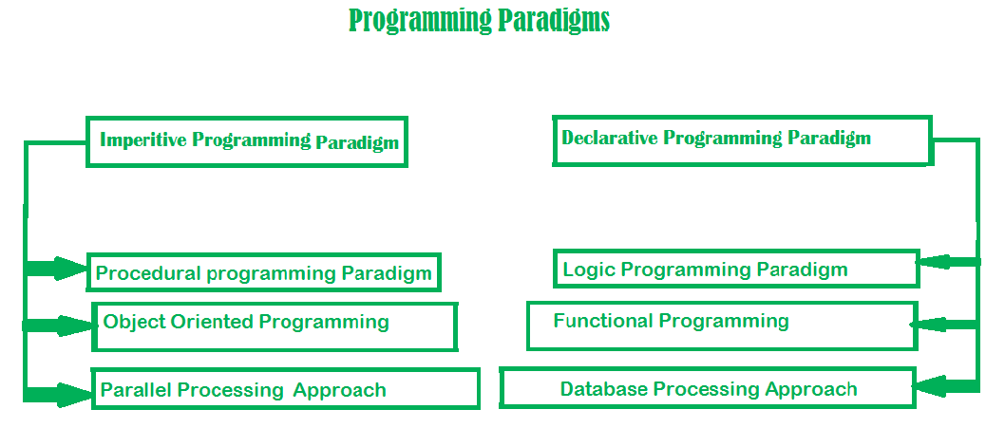
This is the only difference between imperative (how to do) and declarative (what to do) programming paradigms.
- Imperative programming is divided into three broad categories: Procedural, OOP and parallel processing. These paradigms are as follows:
  - Procedural programming paradigm –
Procedural programming (which is also imperative) allows splitting those instructions into procedures.
NOTE: Procedures aren't functions. The difference between them is that functions return a value, and procedures do not.
A great example of procedures would be the well known for loop. The for loop's main purpose is to cause side effects and it does not return a value.
To illustrate, let's find the Factorial of a number in the procedural paradigm approach.

#include <iostream>
using namespace std;
int main()
{
int i, fact = 1, num;
cout << "Enter any Number: ";
cin >> number;
for (i = 1; i <= num; i++) {
fact = fact * i;
}
cout << "Factorial of " << num << " is: " << fact << endl;
return 0;
}

1.2. Object oriented programming –
The program is written as a collection of classes and object which are meant for communication. More emphasis is on data rather procedure.
Examples of Object Oriented programming paradigm:
Java, c++,Visual Basic .NET, Python : developed by Guido van Rossum

import java.io.*;

class GFG {
public static void main(String[] args)
{
System.out.println("GfG!");
Signup s1 = new Signup();
s1.create(22, "riya", "riya2@gmail.com", 'F', 89002);
}
}

class Signup {
int userid;
String name;
String emailid;
char sex;
long mob;

public void create(int userid, String name,
String emailid, char sex, long mob)
{
System.out.println("Welcome to Gmail \nLets create your account\n");
this.userid = 132;
this.name = "Radha";
this.emailid = "radha.89@gmail.com";
this.sex = 'F';
this.mob = 900558981;
System.out.println("your account has been created");
}
}

1. 3. Parallel processing approach –
Parallel processing is the processing of program instructions by dividing them among multiple processors. A parallel processing system posses many numbers of processor with the objective of running a program in less time by dividing them. This approach seems to be like divide and conquer. Examples are NESL (one of the oldest one) and C/C++ also supports because of some library function.
2. Declarative programming paradigm:
It is divided as Logic, Functional, Database. In computer science the declarative programming is a style of building programs that expresses logic of computation without talking about its control flow. The focus is on what needs to be done rather how it should be done basically emphasize on what code code is actually doing. It just declare the result we want rather how it has be produced.
2.1. Logic programming paradigms –
It can be termed as abstract model of computation. It would solve logical problems like puzzles, series etc. In logic programming we have a knowledge base which we know before and along with the question and knowledge base which is given to machine, it produces result. In normal programming languages, such concept of knowledge base is not available but while using the concept of artificial intelligence, machine learning we have some models like Perception model which is using the same mechanism.
In logical programming the main emphasize is on knowledge base and the problem. The execution of the program is very much like proof of mathematical statement, e.g., Prolog
sum of two number in prolog:

predicates
sumoftwonumber(integer, integer)
clauses

sum(0, 0).
sum(n, r):-
n1=n-1,
sum(n1, r1),
r=r1+n
2.2. Functional programming paradigms –
The functional programming paradigms has its roots in mathematics and it is language independent. The key principal of this paradigms is the execution of series of mathematical functions.Data are loosely coupled to functions.The function hide their implementation. Function can be replaced with their values without changing the meaning of the program.
Example: perl, javascript, python mostly uses this paradigm
2.3. Database/Data driven programming approach –
This programming methodology is based on data and its movement. A database program is the heart of a business information system and provides file creation, data entry, update, query and reporting functions. There are several programming languages that are developed mostly for database application. For example SQL.
CREATE DATABASE databaseAddress;
CREATE TABLE Addr (
PersonID int,
LastName varchar(200),
FirstName varchar(200),
Address varchar(200),
);

Need for OOP paradigm:
Object-oriented programming (OOP) is a programming paradigm based upon objects (having both data and methods) that aims to incorporate the advantages of modularity and reusability. Objects, which are usually instances of classes, are used to interact with one another to design applications and computer programs.
The important features of object–oriented programming are −
- Bottom–up approach in program design
- Programs organized around objects, grouped in classes
- Focus on data with methods to operate upon object’s data
- Interaction between objects through functions
- Reusability of design through creation of new classes by adding features to existing classes
Some examples of object-oriented programming languages are C++, Java, Smalltalk, Delphi, C#, Perl, Python, Ruby, and PHP.

Differences between POP and OOP
Difference between Procedural Programming and Object Oriented Programming:
Procedural Oriented Programming | Object Oriented Programming
In procedural programming, program is divided into small parts called functions. | In object oriented programming, program is divided into small parts called objects.
Procedural programming follows top down approach. | Object oriented programming follows bottom up approach.
There is no access specifier in procedural programming. | Object oriented programming have access specifiers like private, public, protected etc.
Adding new data and function is not easy. | Adding new data and function is easy.
Procedural programming does not have any proper way for hiding data so it is less secure. | Object oriented programming provides data hiding so it is more secure.
In procedural programming, overloading is not possible. | Overloading is possible in object oriented programming.
In procedural programming, function is more important than data. | In object oriented programming, data is more important than function.
Procedural programming is based on unreal world. | Object oriented programming is based on real world.
Examples: C, FORTRAN, Pascal, Basic etc. | Examples: C++, Java, Python, C# etc.

C vs C++
No. | C | C++
1) | C follows the procedural style programming. | C++ is multi-paradigm. It supports both procedural and object oriented.
2) | Data is less secured in C. | In C++, you can use modifiers for class members to make it inaccessible for outside users.
3) | C follows the top-down approach. | C++ follows the bottom-up approach.
4) | C does not support function overloading. | C++ supports function overloading.
5) | In C, you can't use functions in structure. | In C++, you can use functions in structure.
6) | C does not support reference variables. | C++ supports reference variables.
7) | In C, scanf() and printf() are mainly used for input/output. | C++ mainly uses stream cin and cout to perform input and output operations.
8) | Operator overloading is not possible in C. | Operator overloading is possible in C++.
9) | C programs are divided into procedures and modules | C++ programs are divided into functions and classes.
10) | C does not provide the feature of namespace. | C++ supports the feature of namespace.
11) | Exception handling is not easy in C. It has to perform using other functions. | C++ provides exception handling using Try and Catch block.

Class
A class is a blueprint for the object.
We can think of class as a sketch (prototype) of a house. It contains all the details about the floors, doors, windows etc. Based on these descriptions we build the house. House is the object.
As, many houses can be made from the same description, we can create many objects from a class.
A Class is a user defined data-type which has data members and member functions.
Data members are the data variables and member functions are the functions used to manipulate these variables and together these data members and member functions defines the properties and behavior of the objects in a Class.
Object
An Object is an instance of a Class. When a class is defined, no memory is allocated but when it is instantiated (i.e. an object is created) memory is allocated.

Defining Class and Declaring Objects
A class is defined in C++ using keyword class followed by the name of class. The body of class is defined inside the curly brackets and terminated by a semicolon at the end.
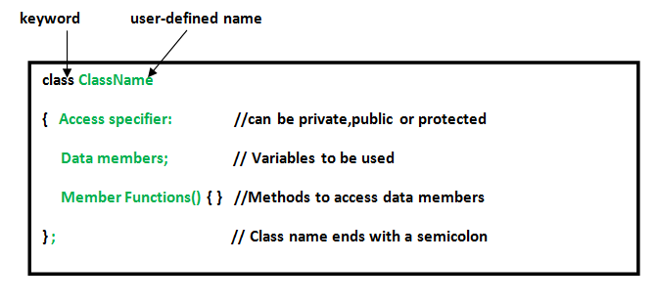

class Test
{
private:
int data1;
float data2;
public:
void function1()
{

data1 = 2;
}
float function2()
{
data2 = 3.5;
return data2;
}
};
int main()
{
Test o1, o2;
}

Object Oriented Programming Concepts
Object Oriented programming is a programming style that is associated with the concept of Class, Objects and various other concepts revolving around these two, like Inheritance, Polymorphism, Abstraction, Encapsulation etc.
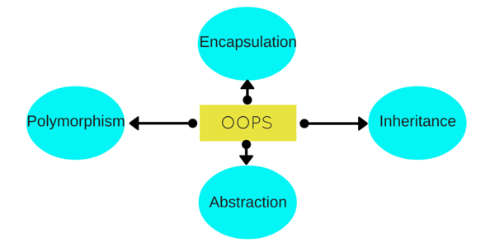

a. Abstraction is a process of hiding irrelevant details from user. For example, When you send an sms you just type the message, select the contact and click send, the phone shows you that the message has been sent, what actually happens in background when you click send is hidden from you as it is not relevant to you.

b. Encapsulation (Binding (or wrapping) code and data together into a single unit is known as encapsulation. For example: capsule, it is wrapped with different medicines.)

Encapsulation is a process of combining data and function into a single unit like capsule. This is to avoid the access of private data members from outside the class. To achieve encapsulation, we make all data members of class private and create public functions, using them we can get the values from these data members or set the value to these data members.
c. Inheritence (child class acquires the properties of parent class)
When one object acquires all the properties and behaviours of parent object i.e. known as inheritance.The class which is inherited is called the Base class & the class which inherits is called the Derived class. They are also called parent and child class.
So when, a derived class inherits a base class, the derived class can use all the functions which are defined in base class, hence making code reusable.

d. Polymorphism
It is a feature, which lets us create functions with same name but different arguments, which will perform different actions. That means, functions with same name, but functioning in different ways.
Function overloading and Operator overloading are examples of polymorphism.
Polymorphism is a feature using which an object behaves differently in different situation.
In function overloading we can have more than one function with same name but different numbers, type or sequence of arguments.

Structure of a C+ + Program

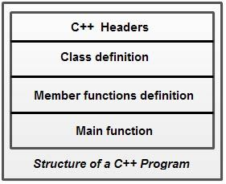

C++ program structure is divided into various sections, namely, headers, class definition, member functions definitions and main function.C++ provides the flexibility of writing a program with or without a class and its member functions definitions. A simple C++ program (without a class) includes comments, headers, namespace, main() and input/output statements.
/*
* Multiple line
* comment
*/
#include<iostream>

//Single line comment
using namespace std;

//This is where the execution of program begins
int main()
{
// displays Hello World! on screen
cout<<"Hello World!";

return 0;
}
Compile :
g++ filename.cpp
Run:
./a.out
Comments are a vital element of a program that is used to increase the readability of a program and to describe its functioning. Comments are not executable statements and hence, do not increase the size of a file.
/ / An example to demonstrate single line comment It can also be written as

/* An example to demonstrate
multiline comment */
Headers: Generally, a program includes various programming elements like built-in functions, classes, keywords, constants, operators, etc., that are already defined in the standard C++ library. In order to use such pre-defined elements in a program, an appropriate header must be included in the program
#include<iostream> – This statements tells the compiler to include iostream file. This file contains pre defined input/output functions that we can use in our program.

using namespace std; – A namespace is like a region, where we have functions, variables etc and their scope is limited to that particular region. Here std is a namespace name, this tells the compiler to look into that particular region for all the variables, functions, etc
• By specifying the using directive
using namespace std;
cout<<"Hello World";
• By specifying the full member name
std: :cout<<"Hello World";
• By specifying the using declaration
using std:: cout;
cout<<"Hello World";

C++ Variable
A variable is a name of memory location. It is used to store data. Its value can be changed and it can be reused many times.
It is a way to represent memory location through symbol so that it can be easily identified.
type variable_list;
The example of declaring variable is given below:
- int x;
- float y;
- char z;
Here, x, y, z are variables and int, float, char are data types.
We can also provide values while declaring the variables as given below:
- int x=5,b=10; //declaring 2 variable of integer type
- float f=30.8;
- char c='A';

Rules for defining variables
A variable can have alphabets, digits and underscore.
A variable name can start with alphabet and underscore only. It can't start with digit.
No white space is allowed within variable name.
A variable name must not be any reserved word or keyword e.g. char, float etc.
Valid variable names:
- int a;
- int _ab;
- int a30;
Invalid variable names:
- int 4;
- int x y;
- int double;

C++ Data Types
A data type specifies the type of data that a variable can store such as integer, floating, character etc.

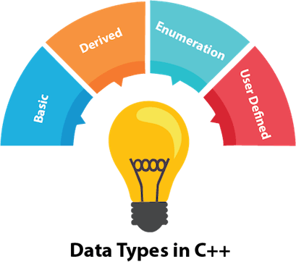

There are 4 types of data types in C++ language.
Types | Data Types
Basic Data Type | int, char, float, double, etc
Derived Data Type | array, pointer, etc
Enumeration Data Type | Enum
User Defined Data Type | Structure

Basic Data Types
The basic data types are integer-based and floating-point based. C++ language supports both signed and unsigned literals.
The memory size of basic data types may change according to 32 or 64 bit operating system.
Data Type | Size | Description
int | 4 bytes | Stores whole numbers, without decimals
float | 4 bytes | Stores fractional numbers, containing one or more decimals. Sufficient for storing 7 decimal digits
double | 8 bytes | Stores fractional numbers, containing one or more decimals. Sufficient for storing 15 decimal digits
boolean | 1 byte | Stores true or false values
char | 1 byte | Stores a single character/letter/number, or ASCII values

Ex:

#include<iostream>
using namespace std;
int main()
{
cout<<"size of int"<<sizeof(int);
cout<<"size of longint"<<sizeof(long int);
cout<<"size of float"<<sizeof(float);
cout<<"size of double"<<sizeof(double);
cout<<"size of char"<<sizeof(char);
}
output:
size of int 4
size of longint 8
size of float 4
size of double 8
size of char 1

C++ Operators
An operator is simply a symbol that is used to perform operations. There can be many types of operations like arithmetic, logical, bitwise etc.
There are following types of operators to perform different types of operations in C language.
- Arithmetic Operators
- Assignment Operator
- Relational Operators
- Logical Operators
- Bitwise Operators
- Unary operator
- Ternary or Conditional Operator

Arithmetic operators ( +, -, *, /, % )
#include <iostream>
using namespace std;
int main(){
int num1 = 240;
int num2 = 40;
cout<<"num1 + num2: "<<(num1 + num2)<<endl;
cout<<"num1 - num2: "<<(num1 - num2)<<endl;
cout<<"num1 * num2: "<<(num1 * num2)<<endl;
cout<<"num1 / num2: "<<(num1 / num2)<<endl;
cout<<"num1 % num2: "<<(num1 % num2)<<endl;
return 0;
}

Assignment Operators
=, +=, -=, *=, /=, %=
#include <iostream>
using namespace std;
int main(){
int num1 = 240;
int num2 = 40;
num2 = num1;
cout<<"= Output: "<<num2<<endl;
num2 += num1;
cout<<"+= Output: "<<num2<<endl;
num2 -= num1;
cout<<"-= Output: "<<num2<<endl;
num2 *= num1;
cout<<"*= Output: "<<num2<<endl;
num2 /= num1;
cout<<"/= Output: "<<num2<<endl;
num2 %= num1;
cout<<"%= Output: "<<num2<<endl;
return 0;
}

Relational operators
==, !=, >, <, >=, <=
#include <iostream>
using namespace std;
int main(){
int num1 = 240;
int num2 =40;
if (num1==num2) {
cout<<"num1 and num2 are equal"<<endl;
}
else{
cout<<"num1 and num2 are not equal"<<endl;
}
if( num1 != num2 ){
cout<<"num1 and num2 are not equal"<<endl;
}
else{
cout<<"num1 and num2 are equal"<<endl;
}
if( num1 > num2 ){
cout<<"num1 is greater than num2"<<endl;
}
else{
cout<<"num1 is not greater than num2"<<endl;
}
if( num1 >= num2 ){
cout<<"num1 is greater than or equal to num2"<<endl;
}
else{
cout<<"num1 is less than num2"<<endl;
}
if( num1 < num2 ){
cout<<"num1 is less than num2"<<endl;
}
else{
cout<<"num1 is not less than num2"<<endl;
}
if( num1 <= num2){
cout<<"num1 is less than or equal to num2"<<endl;
}
else{
cout<<"num1 is greater than num2"<<endl;
}
return 0;
}

Logical Operators
&&, ||, !
Let’s say we have two boolean variables b1 and b2.
b1&&b2 will return true if both b1 and b2 are true else it would return false.
b1||b2 will return false if both b1 and b2 are false else it would return true.
!b1 would return the opposite of b1, that means it would be true if b1 is false and it would return false if b1 is true.

Example of Logical Operators
#include <iostream>
using namespace std;
int main(){
bool b1 = true;
bool b2 = false;
cout<<"b1 && b2: "<<(b1&&b2)<<endl;
cout<<"b1 || b2: "<<(b1||b2)<<endl;
cout<<"!(b1 && b2): "<<!(b1&&b2);
return 0;
}
Output:
b1 && b2: 0
b1 || b2: 1
!(b1 && b2): 1

Bitwise Operators
&, |, ^, ~, <<, >>

Example of Bitwise Operators
#include <iostream>
using namespace std;
int main(){
int num1 = 11; /* 11 = 00001011 */
int num2 = 22; /* 22 = 00010110 */
int result = 0;
result = num1 & num2;
cout<<"num1 & num2: "<<result<<endl;
result = num1 | num2;
cout<<"num1 | num2: "<<result<<endl;
result = num1 ^ num2;
cout<<"num1 ^ num2: "<<result<<endl;
result = ~num1;
cout<<"~num1: "<<result<<endl;
result = num1 << 2;
cout<<"num1 << 2: "<<result<<endl;
result = num1 >> 2;
cout<<"num1 >> 2: "<<result;
return 0;
}
Output:
num1 & num2: 2
num1 | num2: 31
num1 ^ num2: 29
~num1: -12
num1 << 2: 44 num1 >> 2: 2

Ternary Operator
This operator evaluates a boolean expression and assign the value based on the result.
Syntax:
variable num1 = (expression) ? value if true : value if false

Example of Ternary Operator
#include <iostream>
using namespace std;
int main(){
int num1, num2; num1 = 99;
/* num1 is not equal to 10 that's why
* the second value after colon is assigned
* to the variable num2
*/
num2 = (num1 == 10) ? 100: 200;
cout<<"num2: "<<num2<<endl;
/* num1 is equal to 99 that's why
* the first value is assigned
* to the variable num2
*/
num2 = (num1 == 99) ? 100: 200;
cout<<"num2: "<<num2;
return 0;
}
Output:
num2: 200
num2: 100

Unary Operators
These are the operators which work on only one operand. There are many unary operators, but increment ++ and decrement -- operators are most used.
#include <iostream>
using namespace std;
int main(){
int num1 = 240;
int num2 = 40;
num1++; num2--;
cout<<"num1++ is: "<<num1<<endl;
cout<<"num2-- is: "<<num2;
return 0;
}
Output:
num1++ is: 241
num2-- is: 39

Scope resolution operator in C++
Scope resolution operator (::) in C++ programming language is used to define a function outside a class or when we want to use a global variable but also has a local variable with the same name.

C++ programming code
#include <iostream>

- using namespace std;

- char c = 'a'; // global variable

- int main() {
- char c = 'b'; //local variable

- cout << "Local variable: " << c << "\n";
- cout << "Global variable: " << ::c << "\n"; //using scope resolution operator

- return 0;
- }
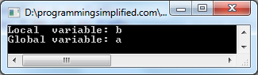

Scope resolution operator in class
#include <iostream>
using namespace std;

class programming {
public:
void output(); //function declaration
};

// function definition outside the class

void programming::output() {
cout << "Function defined outside the class.\n";
}

int main() {
programming x;
x.output();

return 0;
}

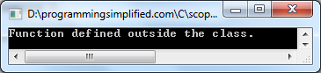

Miscellaneous Operators
There are few other operators in C++ such as Comma operator and sizeof operator

sizeof
This operator accepts one parameter, which can be either a type or a variable, and returns the size in bytes of that type or object:
x = sizeof (char);
Here, x is assigned the value 1, because char is a type with a size of one byte.
From greatest to smallest priority, C++ operators are evaluated in the following order:
Level | Precedence group | Operator | Description | Grouping
1 | Scope | :: | scope qualifier | Left-to-right
2 | Postfix (unary) | ++ -- | postfix increment / decrement | Left-to-right
2 | Postfix (unary) | () | functional forms | Left-to-right
2 | Postfix (unary) | [] | subscript | Left-to-right
2 | Postfix (unary) | . -> | member access | Left-to-right
3 | Prefix (unary) | ++ -- | prefix increment / decrement | Right-to-left
3 | Prefix (unary) | ~ ! | bitwise NOT / logical NOT | Right-to-left
3 | Prefix (unary) | + - | unary prefix | Right-to-left
3 | Prefix (unary) | & * | reference / dereference | Right-to-left
3 | Prefix (unary) | new delete | allocation / deallocation | Right-to-left
3 | Prefix (unary) | sizeof | parameter pack | Right-to-left
3 | Prefix (unary) | (type) | C-style type-casting | Right-to-left
4 | Pointer-to-member | .* ->* | access pointer | Left-to-right
5 | Arithmetic: scaling | * / % | multiply, divide, modulo | Left-to-right
6 | Arithmetic: addition | + - | addition, subtraction | Left-to-right
7 | Bitwise shift | << >> | shift left, shift right | Left-to-right
8 | Relational | < > <= >= | comparison operators | Left-to-right
9 | Equality | == != | equality / inequality | Left-to-right
10 | And | & | bitwise AND | Left-to-right
11 | Exclusive or | ^ | bitwise XOR | Left-to-right
12 | Inclusive or | | | bitwise OR | Left-to-right
13 | Conjunction | && | logical AND | Left-to-right
14 | Disjunction | || | logical OR | Left-to-right
15 | Assignment-level expressions | = *= /= %= += -=  >>= <<= &= ^= |= | assignment / compound assignment | Right-to-left
15 | Assignment-level expressions | ?: | conditional operator | Right-to-left
16 | Sequencing | , | comma separator | Left-to-right

Example 1:
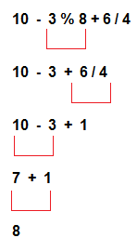

Example 2:
- Example 2:
- 17-8/4*2+3- ++a
- Assume a=5
- ++a=6
- 17-8/4*2+3-6
- 8/4 = 2
- 17-2*2+3-6
- 2*2=4
- 17-4+3-6
- 17-4=13
- 13+3-6
16-6 = 10

Type Conversion in C++
A type cast is basically a conversion from one type to another. There are two types of type conversion:
- Implicit Type Conversion Also known as ‘automatic type conversion’.
- Done by the compiler on its own, without any external trigger from the user.
- Generally takes place when in an expression more than one data type is present. In such condition type conversion (type promotion) takes place to avoid lose of data.
- All the data types of the variables are upgraded to the data type of the variable with largest data type.
bool -> char -> short int -> int ->

unsigned int -> long -> unsigned ->

long long -> float -> double -> long double
It is possible for implicit conversions to lose information, signs can be lost (when signed is implicitly converted to unsigned), and overflow can occur (when long long is implicitly converted to float).
Example of Type Implicit Conversion:
#include <iostream>
using namespace std;

int main()
{
int x = 10; // integer x
char y = 'a'; // character c

// y implicitly converted to int. ASCII
// value of 'a' is 97
x = x + y;

// x is implicitly converted to float
float z = x + 1.0;

cout << "x = " << x << endl
<< "y = " << y << endl
<< "z = " << z << endl;

return 0;
}
output:
x = 107
y = a
z = 108
Explicit Type Conversion:
This process is also called type casting and it is user-defined. Here the user can typecast the result to make it of a particular data type.
- Converting by assignment: This is done by explicitly defining the required type in front of the expression in parenthesis. This can be also considered as forceful casting.
Syntax:
(type) expression
where type indicates the data type to which the final result is converted.
Example:
#include <iostream>
using namespace std;

int main()
{
double x = 1.2;

// Explicit conversion from double to int
int sum = (int)x + 1;

cout << "Sum = " << sum;

return 0;
}

Output:
Sum = 2
Flow control statements:
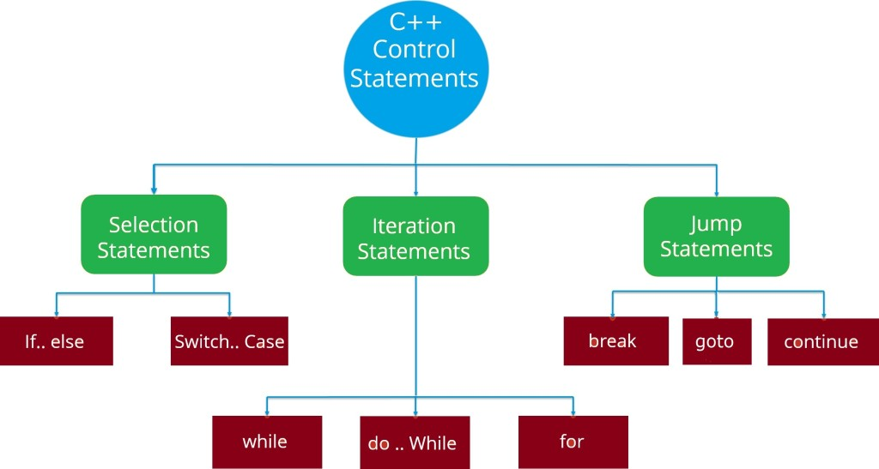

C++ if-else
In C++ programming, if statement is used to test the condition. There are various types of if statements in C++.

- if statement
if(condition)
{
//code to be executed
}

Ex:
#include <iostream>
using namespace std;

int main () {
int num = 10;
if (num % 2 == 0)
{
cout<<"It is even number";
}
return 0;
}

IF-else Statement
if(condition)
{
//code if condition is true
}
else
{
//code if condition is false
}

Ex:
#include <iostream>
using namespace std;
int main () {
int num;
cout<<"Enter a Number: ";
cin>>num;
if (num % 2 == 0)
{
cout<<"It is even number"<<endl;
}
else
{
cout<<"It is odd number"<<endl;
}
return 0;
}

IF-else-if ladder Statement
if(condition1){
//code to be executed if condition1 is true
}else if(condition2){
//code to be executed if condition2 is true
}
else if(condition3){
//code to be executed if condition3 is true
}
...
else{
//code to be executed if all the conditions are false
}
Ex:
#include <iostream>
using namespace std;
int main () {
int num;
cout<<"Enter a number to check grade:";
cin>>num;
if (num <0 || num >100)
{
cout<<"wrong number";
}
else if(num >= 0 && num < 50){
cout<<"Fail";
}
else if (num >= 50 && num < 60)
{
cout<<"D Grade";
}
else if (num >= 60 && num < 70)
{
cout<<"C Grade";
}
else if (num >= 70 && num < 80)
{
cout<<"B Grade";
}
else if (num >= 80 && num < 90)
{
cout<<"A Grade";
}
else if (num >= 90 && num <= 100)
{
cout<<"A+ Grade";
}
}

switch
switch(expression){
case value1:
//code to be executed;
break;
case value2:
//code to be executed;
break;
......

default:
//code to be executed if all cases are not matched;
break;
}
Ex:
#include <iostream>
using namespace std;
int main () {
int num;
cout<<"Enter a number to check grade:";
cin>>num;
switch (num)
{
case 10: cout<<"It is ten"; break;
case 20: cout<<"It is twenty"; break;
case 30: cout<<"It is thirty"; break;
default: cout<<"Not 10, 20 or 30"; break;
}
}

For Loop
for(initialization; condition; incr/decr){
//code to be executed
}
Ex:
#include <iostream>
using namespace std;
int main() {
for(int i=1;i<=10;i++){
cout<<i <<"\n";
}
}

While loop
while(condition){
//code to be executed
}
Ex:
#include <iostream>
using namespace std;
int main() {
int i=1;
while(i<=10)
{
cout<<i <<"\n";
i++;
}
}

Do-While Loop
do{
//code to be executed
}while(condition);

Ex:
#include <iostream>
using namespace std;
int main() {
int i = 1;
do{
cout<<i<<"\n";
i++;
} while (i <= 10) ;
}

Break
The C++ break is used to break loop or switch statement. It breaks the current flow of the program at the given condition.
This example jumps out of the loop when i is equal to 5:

Example
#include <iostream>
using namespace std;
int main() {
for (int i = 1; i <= 10; i++)
{
if (i == 5)
{
break;
}
cout<<i<<"\n";
}
}
Output:
1
2
3
4

Continue Statement
The C++ continue statement is used to continue loop. It continues the current flow of the program and skips the remaining code at specified condition. In case of inner loop, it continues only inner loop.
Ex:
#include <iostream>
- using namespace std;
- int main()
- {
- for(int i=1;i<=10;i++){
- if(i==5){
- continue;
- }
- cout<<i<<"\n";
- }
- }
output:
1
2
3
4
6
7
8
9
10

Goto Statement
The C++ goto statement is also known as jump statement. It is used to transfer control to the other part of the program.
Ex:
#include <iostream>
using namespace std;
int main()
{
ineligible:
cout<<"You are not eligible to vote!\n";
cout<<"Enter your age:\n";
int age;
cin>>age;
if (age < 18){
goto ineligible;
}
else
{
cout<<"You are eligible to vote!";
}
}
output:
You are not eligible to vote!
Enter your age:
16
You are not eligible to vote!
Enter your age:
7
You are not eligible to vote!
Enter your age:
22
You are eligible to vote!

Strings
A string variable contains a collection of characters surrounded by double quotes:
string greeting = "Hello";

Example 1: C++ String to read a word
C++ program to display a string entered by user.
#include <iostream>
using namespace std;
int main()
{
char str[100];
cout << "Enter a string: ";
cin >> str;
cout << "You entered: " << str << endl;
cout << "\nEnter another string: ";
cin >> str;
cout << "You entered: "<<str<<endl;
return 0;
}
Output
Enter a string: C++
You entered: C++

Enter another string: Programming is fun.
You entered: Programming
Notice that, in the second example only "Programming" is displayed instead of "Programming is fun".
This is because the extraction operator >> works as scanf() in C and considers a space " " has a terminating character.

Example 2: C++ String to read a line of text
C++ program to read and display an entire line entered by user.
#include <iostream>
using namespace std;
int main()
{
char str[100];
cout << "Enter a string: ";
cin.get(str, 100);
cout << "You entered: " << str << endl;
return 0;}
Output
Enter a string: Programming is fun.
You entered: Programming is fun.
To read the text containing blank space, cin.get function can be used. This function takes two arguments.
First argument is the name of the string (address of first element of string) and second argument is the maximum size of the array.
In the above program, str is the name of the string and 100 is the maximum size of the array.
String functions using char array
strlen(str)- length of the str
strcmp(str1, str2)==0 - both the strs are equal
strcpy(str2,str1) – copy string1 to string2
strcat(str1,str2)- combine two strings str1 and str2, result will be in str1

string Object
In C++, you can also create a string object for holding strings.
Unlike using char arrays, string objects has no fixed length, and can be extended as per your requirement.

Example 3: C++ string using string data type
#include <iostream>
using namespace std;
int main()
{ // Declaring a string object
string str;
cout << "Enter a string: ";
getline(cin, str);
cout << "You entered: " << str << endl;
return 0;
}
Output
Enter a string: Programming is fun.
You entered: Programming is fun.
In this program, a string str is declared. Then the string is asked from the user.
Instead of using cin>> or cin.get() function, you can get the entered line of text using getline().
getline() function takes the input stream as the first parameter which is cin and str as the location of the line to be stored.
compare(string_to_compare ) :-
It is used to compare two strings. It returns the difference of second string and first string in integer.
// C++ program to demonstrate use of compare()
#include<iostream>
#include<string>
using namespace std;
int main()
{
string str("c++ program");
string str1("cpp program");

// Comparing strings using compare()
if ( str.compare(str1) == 0 )
cout << "Strings are equal";
else
cout << "Strings are unequal";
return 0;
}
Output :
Strings are unequal
String concatenation ( + operator)
#include <iostream>
#include <string>
using namespace std;
int main () {
string firstName;// = "John ";
string lastName;//= "Doe";
string fullName;// = firstName + lastName;
getline(cin,firstName);
getline(cin,lastName);
fullName=firstName+lastName;
cout << fullName;
return 0;
}

String Length
Length()-length of the str
#include <iostream>
#include <string>
using namespace std;
int main()
{
string txt = "ABCDEFGHIJKLMNOPQRSTUVWXYZ";
cout << "The length of the txt string is: " << txt.length();
return 0;
}

Access Strings
#include <iostream>
#include <string>
using namespace std;
int main() {
string myString = "Hello";
cout << myString[1];
return 0;
}

o/p- e

Change String Characters
#include <iostream>
#include <string>
using namespace std;

int main() {
string myString = "Hello";
myString[0] = 'C';
cout << myString;
return 0;
}
o/p-
Cello
string substr(int pos,int n)-
It creates a new string object of n characters.

// CPP program to illustrate substr()
#include <string.h>
#include <iostream>
using namespace std;

int main()
{
// Take any string
string s1 = "MGITCSE";

// Copy three characters of s1 (starting
// from position 4)
string r = s1.substr(4, 3);

// prints the result
cout << "String is: " << r;

return 0;
}
output:
String is: CSE
get sub-string after a character
In this a string and a character is given and you have to print the sub-string followed by the given character.
Extract everything after the “:” in the string “mgit:cse”.

// CPP program to illustrate substr()
#include <string.h>
#include <iostream>
using namespace std;

int main()
{
// Take any string
string s = "mgit:cse";

// Find position of ':' using find()
int pos = s.find(":");

// Copy substring after pos
string sub = s.substr(pos + 1);

// prints the result
cout << "String is: " << sub;

return 0;
}

Output:
String is: cse

String replace()
This function replaces the portion of string that begins at character position pos and spans len characters.

Syntax
Consider two strings str1 and str2.
Syntax would be:
str1.replace(pos,len,str2);
#include<iostream>
- using namespace std;
- int main()
- {
- string str1 = "This is C language";
- string str2 = "C++";
- cout << "Before replacement, string is :"<<str1<<'\n';
- str1.replace(8,1,str2);
- cout << "After replacement, string is :"<<str1<<'\n';
- return 0;
- }
Output:
Before replacement , string is This is C language
After replacement, string is This is C++ language
Storage Classes in C++
Storage classes are used to specify the scope, visibility and lifetime of variables.
Syntax:
storage_class var_data_type var_name;

Following are the storage classes, which can be used in a C++ Program
- auto
- register
- static
- extern

auto Storage Class
The auto storage class is the default storage class for all local variables.
{
int mount;
auto int month;
}
The example above defines two variables with the same storage class, auto can only be used within functions, i.e., local variables.

register Storage Class
The register storage class is used to define local variables that should be stored in a register instead of RAM
{
register int miles;
}
The register should only be used for variables that require quick access such as counters. It should also be noted that defining 'register' does not mean that the variable will be stored in a register. It means that it MIGHT be stored in a register depending on hardware and implementation restrictions.
- #include <iostream>
- using namespace std;
- int main()
- {
- cout << "Demonstrating register class\n";
- // declaring a register variable
- register string s = "c++";
- // printing the register variable 's'
- cout << "Value of the variable s:"<<s;
- return 0;
- }

Static
Static variables are the variables which are initialized & allocated storage only once at the beginning of program execution, no matter how many times they are used and called in the program. A static variable retains its value until the end of program.

#include<iostream>

using namespace std;

void fun()

{

static int i = 10;

i++;

cout <<"static i= "<<i<<endl;

}

void fun_nonstatic()

{

int i = 10;

i++;

cout<<"nonstatic i="<<i<<endl;

}

int main()

{

fun();fun();fun();

fun_nonstatic();fun_nonstatic();fun_nonstatic();

return 0;

}

o/p

static i= 11

static i= 12

static i= 13

nonstatic i=11

nonstatic i=11

nonstatic i=11

Extern Variables
This keyword is used to access variable in a file which is declared & defined in some other file, that is the existence of a global variable in one file is declared using extern keyword in another file.
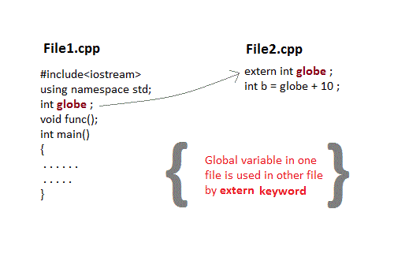
Ex: Save file as main1.cpp
#include <iostream>
extern int count;
void write_extern(void)
{
std::cout << "Count is " << count << std::endl;
}
Ex: save file as support.cpp
#include <iostream>
extern int count;
void write_extern(void)
{
std::cout << "Count is " << count << std::endl;
}
Compile:
$g++ main1.cpp support.cpp -o write
Run:
$./write
Output:
5

Arrays:
Array in C++ is a group of similar types of elements that have contiguous memory location.
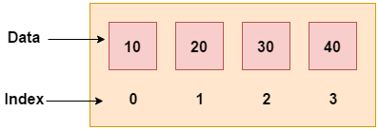

array index starts from 0. We can store only fixed set of elements in C++ array.
Syntax:
type arrayName [ arraySize ];

ex:
int a[10];

initialize arrays:
int a[5]={1,2,3,4,5};

string cars[4];
string cars[4] = {"Volvo", "BMW", "Ford", "Swift"};
cout << cars[0];
// Outputs Volvo

Single Dimensional Array
#include <iostream>
using namespace std;
#include <iomanip>
using std::setw;
int main ()
{
int n[ 5 ];
for ( int i = 0; i < 5; i++ ) {
n[ i ] = i + 10;
}
cout << "Element" << setw( 13 ) << "Value" << endl;
// output each array element's value
for ( int i = 0; i < 5; i++ ) {
cout<<setw(4)<<i<<setw(13)<<n[i ]<<"\n";
}
return 0;
}
output:
Element Value
0 10
1 11
2 12
3 13
4 14

Two-Dimensional Arrays

Defined as Array of Arrays

It Can also represent a Matrix

Each element is represented as a[row][col], Where a[][] is a 2-D array

Initializing Two-Dimensional Arrays
Multidimensioned arrays may be initialized by specifying bracketed values for each row. Following is an array with 3 rows and each row have 4 columns.
int a[3][4] = {
{0, 1, 2, 3} , /* initializers for row indexed by 0 */
{4, 5, 6, 7} , /* initializers for row indexed by 1 */
{8, 9, 10, 11} /* initializers for row indexed by 2 */
};
The following initialization is equivalent to previous example −
int a[3][4] = {0,1,2,3,4,5,6,7,8,9,10,11};
#include <iostream>
using namespace std;
int main () {
// an array with 5 rows and 2 columns.
int a[5][2] = { {0,0}, {1,2}, {2,4}, {3,6},{4,8}};
// output each array element's value
for ( int i = 0; i < 5; i++ )
for ( int j = 0; j < 2; j++ ) {
cout << "a[" << i << "][" << j << "]: ";
cout << a[i][j]<< endl;
}
return 0;
}
output:
a[0][0]: 0
a[0][1]: 0
a[1][0]: 1
a[1][1]: 2
a[2][0]: 2
a[2][1]: 4
a[3][0]: 3
a[3][1]: 6
a[4][0]: 4
a[4][1]: 8

Pointers
A pointer is a variable whose value is the address of another variable. Like any variable or constant, you must declare a pointer before you can work with it. The general form of a pointer variable declaration is −
type *var_name;
Ex:
int *ip; // pointer to an integer
double *dp; // pointer to a double
float *fp; // pointer to a float
char *ch // pointer to character
Advantage of pointer
1) Pointer reduces the code and improves the performance, it is used to retrieving strings, trees etc. and used with arrays, structures and functions.
2) We can return multiple values from function using pointer.
3) It makes you able to access any memory location in the computer's memory.

#include <iostream>
using namespace std;
int main () {
int i = 20; // actual variable declaration.
int *p;
// pointer variable
p = &i; // store address of var in pointer variable
float f=3.23;
float *f1;
f1=&f;
string coll = "MGIT"; // A coll variable of type string
string* ptr = &coll; // A pointer variable, with the name ptr, that stores the address of coll

cout << "Value of integer variable i is: ";
cout << i << endl;
// print the address stored in p pointer variable
cout << "Address stored in p variable: ";
cout << p << endl;
// access the value at the address available in pointer
cout << "Value of *p variable: ";
cout << *p << endl<<endl;
cout << "Value of float variable f is: ";
cout << f << endl;
// print the address stored in p pointer variable
cout << "Address stored in f1 variable: ";
cout << f1 << endl;
// access the value at the address available in pointer
cout << "Value of *f1 variable: ";
cout << *f1 << endl<<endl;
cout << "Value of string variable coll is: ";
cout << coll << endl;
// print the address stored in p pointer variable
cout << "Address stored in *ptr variable: ";
cout << ptr << endl;
// access the value at the address available in pointer
cout << "Value of *ptr variable: ";
cout << *ptr << endl;
return 0;
}
output:
Value of integer variable i is: 20
Address stored in p variable: 0x61fdf0
Value of *p variable: 20

Value of float variable f is: 3.23
Address stored in f1 variable: 0x61fdec
Value of *f1 variable: 3.23

Value of string variable coll is: MGIT
Address stored in *ptr variable: 0x61fdc0
Value of *ptr variable: MGIT

Ex:
Swapping of 2 numbers without using 3rd variable
#include<iostream>
using namespace std;
int main()
{
int *p1,*p2,a=10,b=20;
//cout<<"enter a and b vals";
//cin>>a>>b;
p1=&a;
p2=&b;
cout<<"before swapping"<<*p1<<"\t"<<*p2;
*p1=*p1+*p2;
*p2=*p1-*p2;
*p1=*p1-*p2;
cout<<"after swapping"<<*p1<<"\t"<<*p2;
}

output:
before swapping 10 20
after swapping 20 10

Pointers and Arrays
Pointers are the variables that hold address. Not only can pointers store address of a single variable, it can also store address of cells of an array.
Consider this example:
int* ptr;
int a[5];
ptr = &a[2]; // &a[2] is the address of third element of a[5].

C++ Program to display address of elements of an array using both array and pointers
#include <iostream>
using namespace std;
int main()
{
float arr[5];
float *ptr;
cout << "Displaying address using arrays: " << endl;
for (int i = 0; i < 5; ++i)
{
cout << "&arr[" << i << "] = " << &arr[i] << endl;
}
// ptr = &arr[0]
ptr = arr;
cout<<"\nDisplaying address using pointers: "<< endl;
for (int i = 0; i < 5; ++i)
{
cout << "ptr + " << i << " = "<< ptr + i << endl;
} return 0;
}
Output
Displaying address using arrays:
&arr[0] = 0x7fff5fbff880
&arr[1] = 0x7fff5fbff884
&arr[2] = 0x7fff5fbff888
&arr[3] = 0x7fff5fbff88c
&arr[4] = 0x7fff5fbff890

Displaying address using pointers:
ptr + 0 = 0x7fff5fbff880
ptr + 1 = 0x7fff5fbff884
ptr + 2 = 0x7fff5fbff888
ptr + 3 = 0x7fff5fbff88c
ptr + 4 = 0x7fff5fbff890
Ex:
&arr[0] is equivalent to arr
&arr[1] is equivalent to arr + 1
&arr[2] is equivalen to arr + 2

C++ Pointer and Array
C++ Program to insert and display data entered by using pointer notation.
#include <iostream>
using namespace std;
int main()
{
float arr[5]; // Inserting data using pointer notation
cout << "Enter 5 numbers: ";
for (int i = 0; i < 5; ++i)
{
cin >> *(arr + i) ;
}
// Displaying data using pointer notation
cout << "Displaying data: " << endl;
for (int i = 0; i < 5; ++i)
{ cout << *(arr + i) << endl ;
}
return 0;
}
Output
Enter 5 numbers: 2.5
3.5
4.5
5
2
Displaying data:
2.5
3.5
4.5
5
2
Structures
C++ Structure is a collection of different data types
Syntax :
struct structure_name
{
// member declarations.
}

Instance of Structure
Structure variable can be defined as:
Student s;
Here, s is a structure variable of type Student. When the structure variable is created, the memory will be allocated.

Struct Example
Let's see a simple example of struct Rectangle which has two data members width and height.
#include <iostream>
using namespace std;
struct Rectangle
{
int width, height;

};
int main(void) {
struct Rectangle rec;
rec.width=8;
rec.height=5;
cout<<"Area of Rectangle is: "<<(rec.width * rec.height)<<endl;
return 0;
}

Struct Example:

Using Constructor(constructor in C++ is a special method that is automatically called when an object of a class is created.) and Method
#include<iostream>
using namespace std;
struct rec
{
int width,height;
rec(int w,int h)
{
width=w;
height=h;
}
void area()
{
cout<<"area="<<(width*height);
}
};
int main()
{
struct rec r=rec(5,6);
r.area();
return 0;
}
output
area=30

Structure v/s Class
Structure | Class
If access specifier is not declared explicitly, then by default access specifier will be public. | If access specifier is not declared explicitly, then by default access specifier will be private.
Syntax of Structure:  struct structure_name  {  // body of the structure.  } | Syntax of Class:  class class_name  {  // body of the class.  }
The instance of the structure is known as "Structure variable". | The instance of the class is known as "Object of the class".

References in C++
When a variable is declared as reference, it becomes an alternative name for an existing variable. A variable can be declared as reference by putting ‘&’ in the declaration.
#include<iostream>
using namespace std;
int main()
{
int x = 10;
// ref is a reference to x.
int &ref = x;
// Value of x is now changed to 20
ref = 20;
cout << "x = " << x << endl ;
// Value of x is now changed to 30
x = 30;
cout << "ref = " << ref << endl ;
return 0;
}
output:
x = 20
ref = 30

Difference between Reference and Pointer
References | Pointers
Reference must be initialized when it is created. | Pointers can be initialized any time.
Once initialized, we cannot reinitialize a reference. | Pointers can be reinitialized any number of time.
You can never have a NULL reference. | Pointers can be NULL.
Reference is automatically dereferenced. | * is used to dereference a pointer.

C++ Functions
A function is a block of code which only runs when it is called.
You can pass data, known as parameters, into a function.
Functions are used to perform certain actions, and they are important for reusing code: Define the code once, and use it many times.
Create a function:
return-type function-name(parameter1, parameter2, ...)
{
// function-body
}
- return-type: suggests what the function will return. It can be int, char, some pointer or even a class object. There can be functions which does not return anything, they are mentioned with void.
- Function Name: is the name of the function, using the function name it is called.
- Parameters: are variables to hold values of arguments passed while function is called. A function may or may not contain parameter list.
Ex:
#include <iostream>
using namespace std;

void myFunction() {
cout << "I just got executed!";
}

int main() {
myFunction();
return 0;
}

Ex:
#include <iostream>
using namespace std;
void sum(int x, int y)
{
int z;
z = x + y;
cout << z;
}

int main()
{
int a = 10;
int b = 20;
// calling the function with name 'sum'
sum (a, b);
}

Ex: protype declaration
#include < iostream>
using namespace std;
//declaring the function
int sum (int x, int y);
int main()
{
int a = 10;
int b = 20;
int c = sum (a, b); //calling the function
cout << c;
}
//defining the function
int sum (int x, int y)
{
return (x + y);
}
Ex: to illustrate static in functions
#include <iostream>
using namespace std;
void func()
{
static int i=0; //static variable
int j=0; //local variable
i++;
j++;
cout<<"i=" << i<<" and j=" <<j<<endl;
}
int main()
{
func();
func();
func();
}
Output:
i= 1 and j= 1
i= 2 and j= 1
i= 3 and j= 1
Built in functions
Built-in functions are also known as library functions. We need not to declare and define these functions as they are already written in the C++ libraries such as iostream, cmath etc. We can directly call them when we need.
#include <iostream>
#include <cmath>
using namespace std;
int main(){
/* Calling the built-in function
* pow(x, y) which is x to the power y
* We are directly calling this function
*/
cout<<pow(2,5);
return 0;
}
output:
32

Call by Value
In this calling technique we pass the values of arguments which are stored or copied into the formal parameters of functions. Hence, the original values are unchanged only the parameters inside function changes.
#include<iostream>
using namespace std;
void calc(int);
int main()
{
int x = 10;
calc(x);
cout<<"x="<<x;
}

void calc(int x)
{
x = x + 10 ;
}
output:10

Call by reference in C++
In call by reference, original value is modified because we pass reference (address).
Here, address of the value is passed in the function, so actual and formal arguments share the same address space. Hence, value changed inside the function, is reflected inside as well as outside the function.
#include<iostream>
using namespace std;
void calc(int *);

int main()
{
int x = 10;
calc(&x);
cout<<"x="<<x;
}

void calc(int *p)
{
*p = *p + 10 ;
}

Ex: swapping of two numbers
#include<iostream>
using namespace std;
void swap(int *x, int *y)
{
int swap;
swap=*x;
*x=*y;
*y=swap;
}
int main()
{
int x=500, y=100;
swap(&x, &y);
cout<<"Value of x is: "<<x<<endl;
cout<<"Value of y is: "<<y<<endl;
return 0;
}
output:
Value of x is: 100
Value of y is: 500

C++ Recursion
The function which calls the same function, is known as recursive function.

Ex: Factorial of a number using recursion
#include <iostream>
using namespace std;
//Factorial function
int f(int n){
/* This is called the base condition, it is
* very important to specify the base condition
* in recursion, otherwise your program will throw
* stack overflow error.
*/
if (n <= 1)
return 1;
else
return n*f(n-1);
}
int main(){
int num;
cout<<"Enter a number: ";
cin>>num;
cout<<"Factorial of entered number: "<<f(num);
return 0;
}
output:
Enter a number: 5
Factorial of entered number: 120
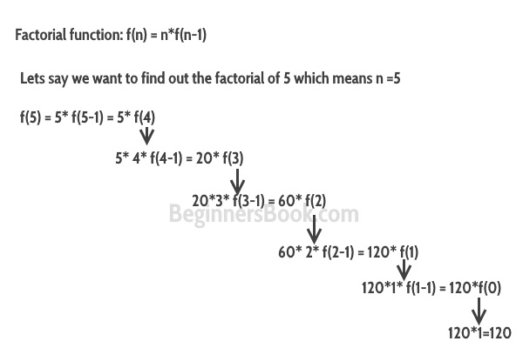

Default Arguments in C++
A default argument is a value provided in a function declaration that is automatically assigned by the compiler if the caller of the function doesn’t provide a value for the argument with a default value.
Ex:
#include<iostream>
using namespace std;

// A function with default arguments, it can be called with
// 2 arguments or 3 arguments or 4 arguments.
int sum(int x, int y, int z=0, int w=0)
{
return (x + y + z + w);
}

/* Driver program to test above function*/
int main()
{
cout << sum(10, 15) << endl;
cout << sum(10, 15, 25) << endl;
cout << sum(10, 15, 25, 30) << endl;
return 0;
}

Output:
25
50
80
- Default arguments are different from constant arguments as constant arguments can’t be changed whereas default arguments can be overwritten if required.
- Default arguments are overwritten when calling function provides values for them. For example, calling of function sum(10, 15, 25, 30) overwrites the value of z and w to 25 and 30 respectively.
- During calling of function, arguments from calling function to called function are copied from left to right. Therefore, sum(10, 15, 25) will assign 10, 15 and 25 to x, y, and z. Therefore, the default value is used for w only.
- Once default value is used for an argument in function definition, all subsequent arguments to it must have default value. It can also be stated as default arguments are assigned from right to left. For example, the following function definition is invalid as subsequent argument of default variable z is not default.
// Invalid because z has default value, but w after it
// doesn't have default value
int sum(int x, int y, int z=0, int w)

Inline Function
Inline function is a function that is expanded in line when it is called. When the inline function is called whole code of the inline function gets inserted or substituted at the point of inline function call. This substitution is performed by the C++ compiler at compile time. Inline function may increase efficiency if it is small.
The syntax for defining the function inline is:
inline return-type function-name(parameters)
{
// function code
}
Remember, inlining is only a request to the compiler, not a command. Compiler can ignore the request for inlining. Compiler may not perform inlining in such circumstances like:
1) If a function contains a loop. (for, while, do-while)
2) If a function contains static variables.
3) If a function is recursive.
4) If a function return type is other than void, and the return statement doesn’t exist in function body.
5) If a function contains switch or goto statement.
Ex:
#include <iostream>
using namespace std;
inline int cube(int s)
{
return s*s*s;
}
int main()
{
cout << "The cube of 3 is: " << cube(3) << "\n";
return 0;
}
output:
The cube of 3 is: 27

Ex:
#include <iostream>

using namespace std;

inline int Max(int x, int y) {
return (x > y)? x : y;
}

// Main function for the program
int main() {
cout << "Max (20,10): " << Max(20,10) << endl;
cout << "Max (0,200): " << Max(0,200) << endl;
cout << "Max (100,1010): " << Max(100,1010) << endl;

return 0;
}
output:
Max (20,10): 20
Max (0,200): 200
Max (100,1010): 1010

Pointers to Functions in C++
Like normal data pointers (int *, char *, etc), we can have pointers to functions.
#include <iostream>
using namespace std;
void (*fun_ptr)(int);
void fun(int a)
{
cout<<"Value of a is "<<a;
}
int main()
{
fun_ptr = &fun;

// Invoking fun() using fun_ptr
(*fun_ptr)(10);

return 0;
}
output:
Value of a is 10

Dynamic memory allocation

We can dynamically allocate memory required during runtime using new and delete operator in C++.
Dynamic memory allocation means creating memory at runtime. For example, when we declare an array, we must provide size of array in our source code to allocate memory at compile time.
But if we need to allocate memory at runtime we must use new operator followed by data type. If we need to allocate memory for more than one element, we must provide total number of elements required in square bracket[ ]. It will return the address of first byte of memory.
Dynamically allocated memory is allocated on Heap and non-static and local variables get memory allocated on Stack

new operator
The new operator denotes a request for memory allocation on the Heap. If sufficient memory is available, new operator initializes the memory and returns the address of the newly allocated and initialized memory to the pointer variable.
- Syntax to use new operator:
To allocate memory of any data type, the syntax is:
pointer-variable = new data-type;
Here, pointer-variable is the pointer of type data-type. Data-type could be any built-in data type including array or any user defined data types including structure and class.

Syntax of new operator
ptr = new data-type;
//allocte memory for one element

ptr = new data-type [ size ];
//allocte memory for fixed number of element

C++ delete operator
Delete operator is used to deallocate the memory created by new operator at run-time. Once the memory is no longer needed it should by freed so that the memory becomes available again for other request of dynamic memory.

Syntax of delete operator
delete ptr;
//deallocte memory for one element
delete[] ptr;
//deallocte memory for array
Ex:
#include <iostream>
using namespace std;
int main ()
{
int *ptr1;
ptr1 = new int; //memory allocation
float *ptr2 = new float(223.324);//memory allocation
*ptr1 = 28;
cout << "Value of pointer variable 1 : " << *ptr1 << endl;
cout << "Value of pointer variable 2 : " << *ptr2 << endl;
delete ptr1;//deallocating the memory
delete ptr2;//deallocating the memory
}

output:

Value of pointer variable 1 : 28

Value of pointer variable 2 : 223.324

Ex:
#include<iostream>
using namespace std;
int main()
{
int size,i;
int *ptr;

cout<<"\n\tEnter size of Array : ";
cin>>size;

ptr = new int[size];
//Creating memory at run-time and return first byte of address to ptr.

for(i=0;i<5;i++) //Input arrray from user.
{
cout<<"\nEnter any number : ";
cin>>ptr[i];
}
for(i=0;i<5;i++) //Output arrray to console.
cout<<ptr[i]<<", ";

delete[] ptr;
//deallocating all the memory created by new operator
return 0;
}
output:
Enter size of Array : 5
Enter any number : 1
Enter any number : 2
Enter any number : 3
Enter any number : 4
Enter any number : 5
1, 2, 3, 4, 5,

Preprocessor Directives:
The preprocessors are the directives, which give instructions to the compiler to preprocess the information before actual compilation starts.
All preprocessor directives begin with #, and only white-space characters may appear before a preprocessor directive on a line. Preprocessor directives are not C++ statements, so they do not end in a semicolon (;).
We already have seen a #include directive in all the examples. This macro is used to include a header file into the source file.
There are 4 main types of preprocessor directives:
- Macros
- File Inclusion
- Conditional Compilation
- Other directives
->Macros: Macros are piece of code in a program which is given some name. Whenever this name is encountered by the compiler the compiler replaces the name with the actual piece of code. #define - directive is used to define a macro.
#undef – is used to undefine a macro
Ex:
#include<iostream>
using namespace std;
#define limit 5
int main()
{
for(int i=0;i<=limit;i++)
cout<<i<<endl;
}
Output:
0
1
2
3
4
5
Macros with arguments (functions like macros): We can also pass arguments to macros. Macros defined with arguments works similarly as functions
Ex:
#include <iostream>
using namespace std;
#define MIN(a,b) (((a)<(b)) ? a : b)
int main ()
{
int i, j;
i = 100;
j = 30;
cout <<"The minimum is " << MIN(i, j) << endl;
return 0;
}
output:
The minimum is 30
#undef
Ex:
#include<iostream>
using namespace std;
#define pi 3.14
int main()
{
int a,l,b;
cout<<"pi="<<pi<<endl;
#undef pi
cout<<"pi="<<pi<<endl;
}
output:
ex4.cpp:9:14: error: ‘pi’ was not declared in this scope
cout<<"pi="<<pi<<endl;

-> File Inclusion:

Inclusion Directive
This category has only one directive, which is called #include. This inclusion directive is used to include files into the current file. The inclusion directive can be used as follows:
Ex: #include <iostream> //includes cpp class library header iostream
-> Conditional Compilation Directives:

#if-#else-#endif Preprocessor Directive
#if(condition)
- - - - - - - - - -
- - - - - - - - - -
#else
- - - - - - - - - -
- - - - - - - - - -
#endif
Ex:
#include<iostream>
using namespace std;
#define MAX 45
int main()
{
#if MAX > 40
cout << "Yes, MAX is greater then 40.";
#else
cout << "No, MAX is not greater then 40.";
#endif
return 0;
}
output:
Yes, MAX is greater then 40

#elif Preprocessor Directive
#if(condition)
- - - - - - - - - -
- - - - - - - - - -
#elif(condition)
- - - - - - - - - -
- - - - - - - - - -
#elif(condition)
- - - - - - - - - -
- - - - - - - - - -
#else
- - - - - - - - - -
- - - - - - - - - -
#endif
Ex:
#include<iostream>
using namespace std;
#define MKS 65
int main()
{
#if MKS>=78
cout << "\nGrade A";
#elif MKS>=50
cout << "\nGrade B";
#elif MKS>=25
cout << "\nGrade C++";
#else
cout << "\nGrade D";
#endif
return 0;
}
output:
Grade B

#ifdef Preprocessor Directive
#ifdef preprocessor directive is used to check whether the macro-name is previously defined or not, if defined then the statements given between #ifdef and #else will get execute.
#ifdef macro-name
- - - - - - - - - -
- - - - - - - - - -
#else
- - - - - - - - - -
- - - - - - - - - -
#endif
Ex:
#include<iostream>
using namespace std;
#define MKS 65
int main()
{

#ifdef MONTH
cout << "\nMONTH is defined.";

#else
cout << "\nMONTH is not defined.";

#endif
return 0;
}

Output :
MONTH is not defined.

#ifndef Preprocessor Directive
#ifndef preprocessor directive is used to check whether the macro-name is previously defined or not, if not defined then the statements given between #ifndef and #else will get execute.
#ifndef macro-name
- - - - - - - - - -
- - - - - - - - - -
#else
- - - - - - - - - -
- - - - - - - - - -
#endif
Ex:
#include<iostream>
using namespace std;
#define MKS 65
int main()
{

#ifndef MAX
cout << "\nMAX is not defined.";
#else
cout << "\nMAX is defined.";
#endif
return 0;
}

Output :

MAX is not defined.
Note: The #ifdef and #ifndef can not use the #elif preprocessor directive.

#line Preprocessor Directive
The #line preprocessor directive is used to overwrite the default value of pre-defined macro-names __LINE__ and __FILE__. By defalut __LINE__ displays the current line number and __FILE__ displays the current filename.
#include<iostream>
using namespace std;
int main()
{
cout << "\nLine number " << __LINE__;
cout << "\nFile name " << __FILE__<<endl;
return 0;
}
output:
Line number 5
File name F:\cpp-progs\ex8.cpp

