Oil Price Time Series Modelling & Forecasting
ARIMA vs Facebook Prophet | Data Science Research Methods
Dataset: oil_prices_2426.csv | 500 daily observations | Sep 2024 – Feb 2026 | Seed: 42

1. Introduction
Inaccurate crude oil prices have great economic and practical significance. The OPEC production choices, geopolitical happenings, and macroeconomic cycles drive the oil markets and hence predicting is methodologically challenging. The present report examines 500 daily oil price observations (USD) between 21 September 2024 and 02 February 2026, the period where the price of oil increased nearly fourfold between US32.10 and a high of 158.78, which was followed by a sudden turn to 118.92 at the point of the stop time. To make sure that the results are entirely reproducible across all the runs, a global random seed of 42 was used everywhere.
Two of the complementary forecasting models are used and compared. ARIMA(p,d,q) the classical statistical standard of art - is chosen through grid search using exhaustive AIC criteria over 243 parameter sets. The alternative model is Facebook Prophet (Taylor and Letham, 2018), which models piecewise trend changepoints and Fourier-based seasonality. Both generate 24-month predictions with 95% confidence levels, assessed on an out-of-sample test sample based on RMSE and MAE and MAPE, and juxtaposed to a naive (random walk) benchmark to put all reported values into perspective. The analytical steps include: EDA, stationarity, ARIMA, Prophet, critical comparison, and future directions.

2. Exploratory Data Analysis
Proper EDA was done before modelling in order to characterise the series. Table 1 summarises the descriptive statistics.

Stat | Value |  | Stat | Value | Stat | Value
Observations | 500 |  | Min price | $16.48 | Mean | $75.87
Date range | 21 Sep 2024…02 Feb 2026 |  | Max price | $158.78 | Std Dev | $35.40
Frequency | Daily (fwd-filled) |  | Missing | 0 | Skewness | +0.290
Table 1: Descriptive statistics from oil_prices_2426.csv.
Figure 1 is showing the panels of core EDA. Panel A graphs raw daily prices: the series increases steadily to a high of $158.78 at the end of 2025 - 4 times higher than the initial price, after which it turns sharply down to $118.92 on 02 February 2026. This is the most crucial fact in the data which is only one behavioural observation and makes all the other modelling decisions. The 30-day rolling mean and the standard deviation are overlaid in panel B. The most obvious possible visual confirmation of non-stationarity is the non-constant rolling mean: the non-stationary series would vary around a constant level. More importantly the rolling standard deviation is also increasing in the price rise, which creates heteroscedasticity - the variance is not constant and is increasing with the price level. This property of commodity markets implies that the Gaussian confidence intervals of ARIMA will incorrectly understate the actual uncertainty of the forecast, and this is why GARCH should be considered as an improvement in the future. In panel C, daily log returns oscillate around zero and there is no apparent trend so that the series of returns could be stationary. Nevertheless, volatility clustering is apparent volatility calm periods are interspersed with volatility storms, which ARIMA cannot model, but which GARCH does expressly.
The price distribution (Figure 2) has positive skewness ( +0.290 ) and is almost bimodal with two distinct price regimes a low-price period (Sep-Dec 2024, $16-60) and a high-price period (2025, 60-158). The consistent upward trend across calendar months is checked by monthly box plots that also indicate that the dispersion within a given month is augmented at higher prices, which supports the heteroscedasticity result.
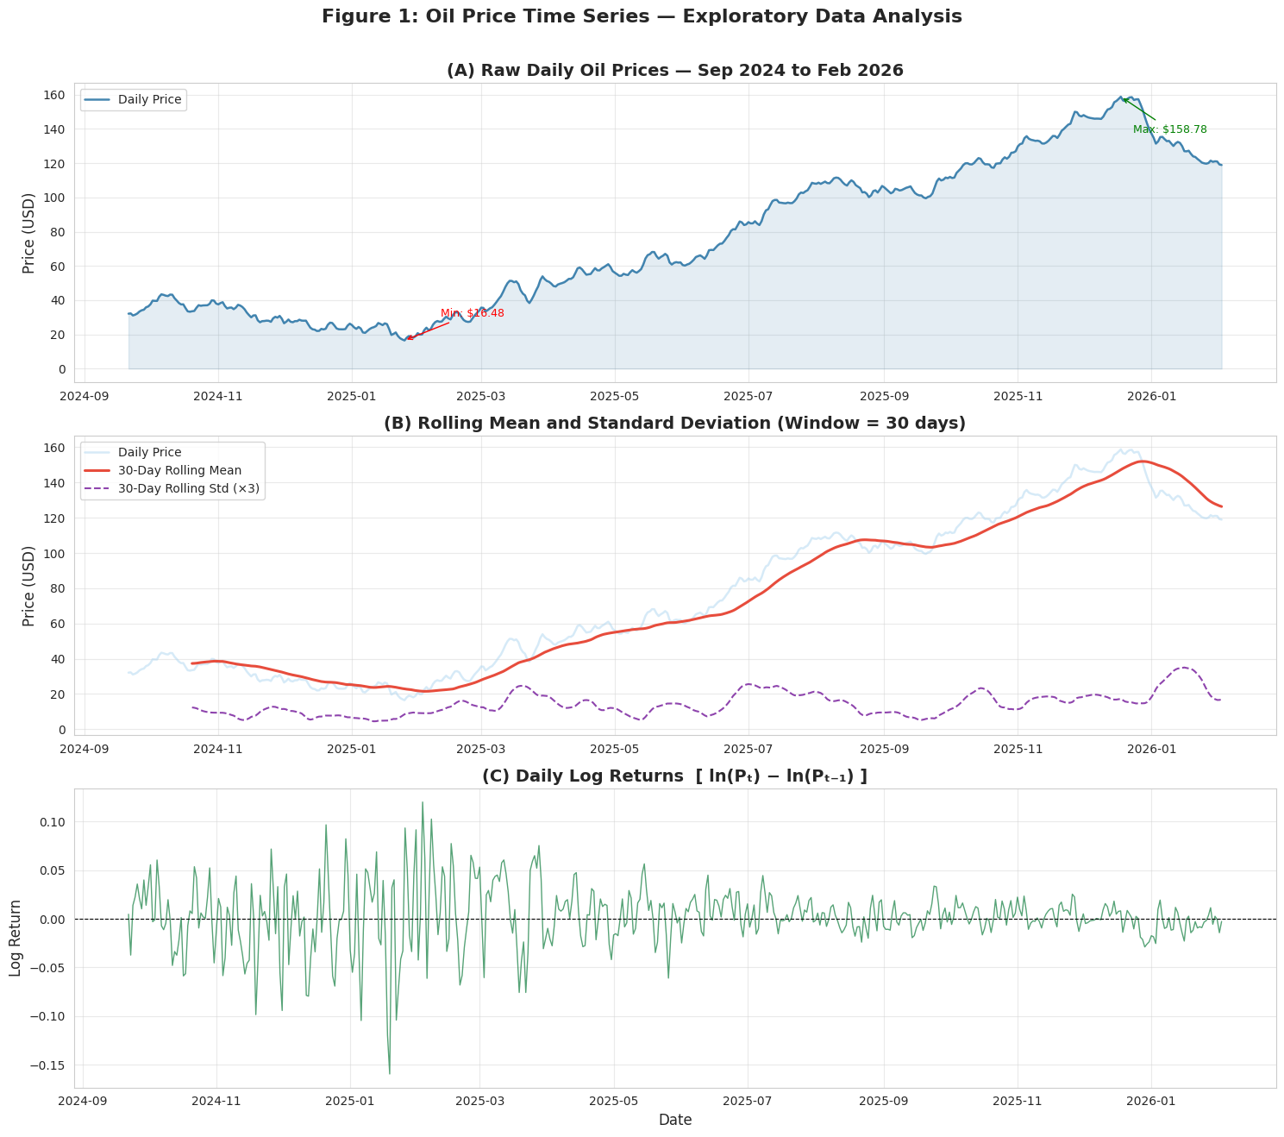Figure 1: EDA — (A) raw daily prices with annotated min/max, (B) 30-day rolling mean/std confirming non-stationarity and heteroscedasticity, (C) daily log returns showing volatility clustering.
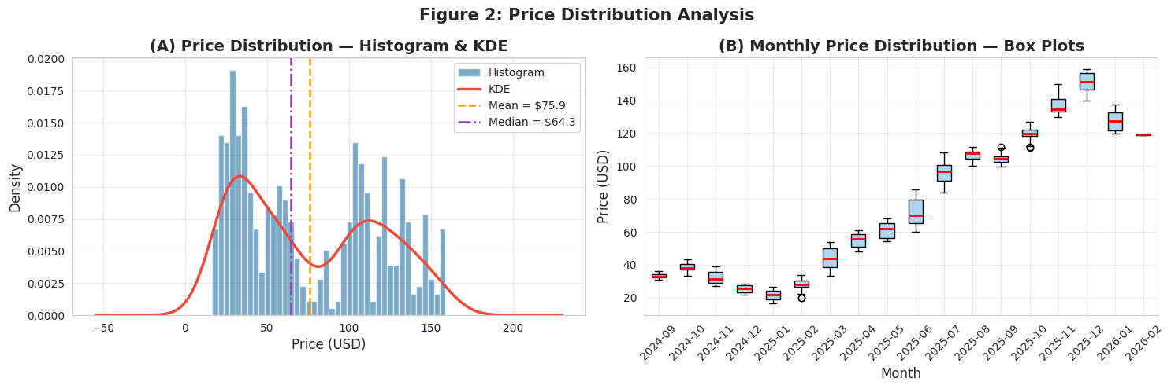Figure 2: (A) price histogram + KDE showing positive skew and bimodal regimes; (B) monthly box plots confirming upward trend and increasing variance at higher prices.
3. Stationarity Analysis
ARIMA is sensitive to weak stationarity - the mean, variance and the autocovariance structure should remain constant with time. ARIMA fitted to a non-stationary series gives spurious estimates of the parameters and meaningless confidence intervals. Three diagnostic tests were used one after another.
3.1 Formal Tests: ADF and KPSS
The unit root present (H 0 ) Augmented Dickey Fuller (ADF) test statistic = -0.546 p = 0.883 on the original series = a decisive failure to reject the unit root null (critical = -2.868 at 5 per cent) (Dickey and Fuller, 1979). The complementary KPSS test (H 0 series is stationary ) gave statistic = 3.706, p = 0.010, which rejected the hypothesis of stationarity. More importantly, non-stationarity is concurred in both tests, which offers a specific level of concordance especially powerful evidence (Kwiatkowski et al., 1992). Upon first-order differencing Δy o n = y o n -y o n -1, the ADF p -value dropped to 0.000165 and the KPSS test did not reject stationarity (p = 0.10), indicating that d = 1 was indeed the minimal integration order.
3.2 ACF/PACF and Visual Confirmation
The ACF and the PACF of the original series are depicted in figure 3. The ACF decays so slowly and it is still substantive beyond lag 40 the textbook signature of unit root random walk. The PACF has only one dominant spike at lag 1 after which it sharply drops, which matches the I(1) process. Figure 4 proves that when first-order differencing the rolling mean changes stabilizes around 0 and the ACF decays quickly, indicating that to attain stationarity, d = 1 differencing is adequate.
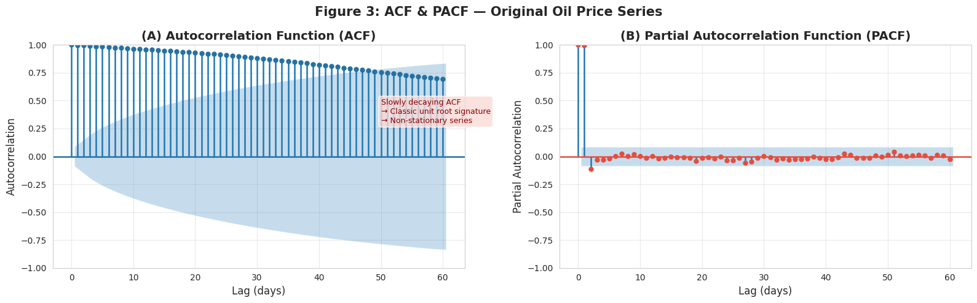Figure 3: (A) ACF of original series — slow decay confirms unit root; (B) PACF with single lag-1 spike consistent with I(1) process.
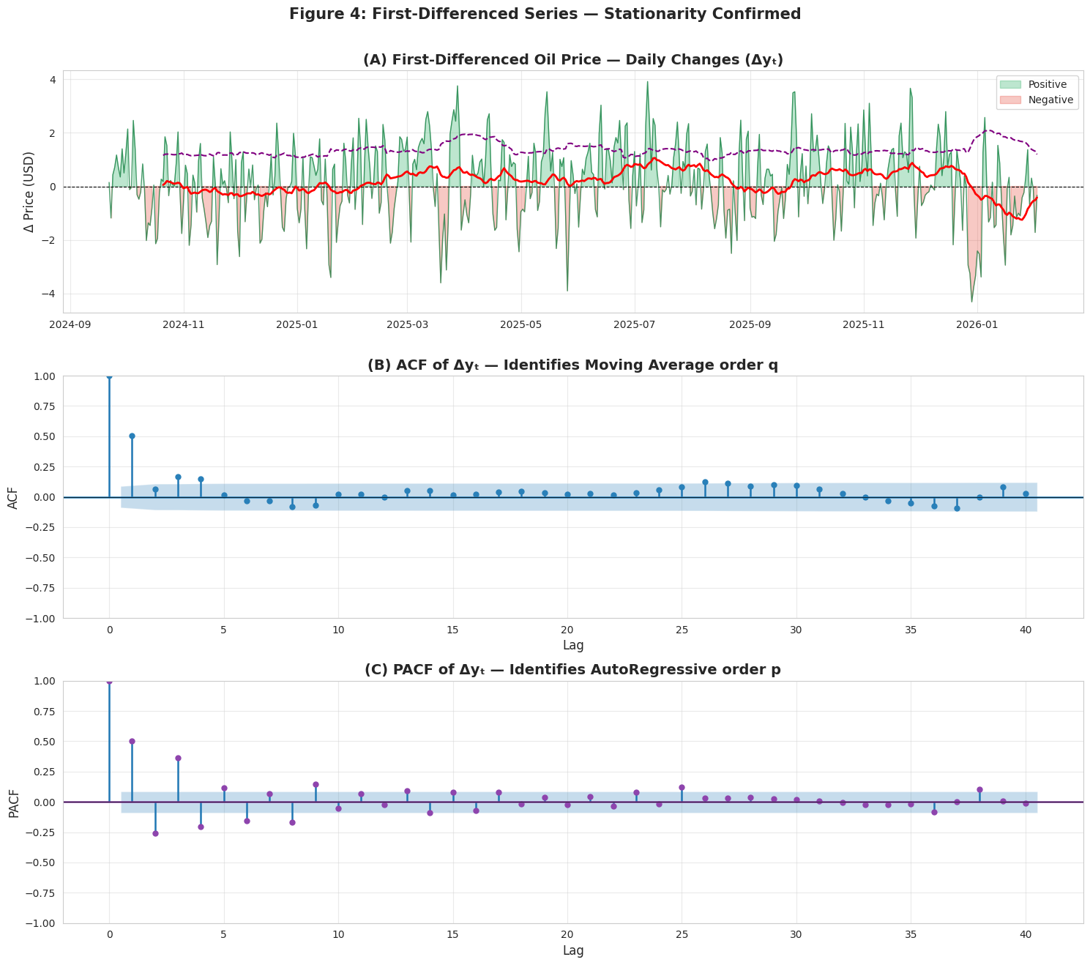
Figure 4: (A) first-differenced series with stable rolling statistics; (B) ACF and (C) PACF of Δyₜ — rapid cutoff confirms stationarity at d = 1.

4. ARIMA Modelling
4.1 Why ARIMA for This Dataset
The reason why ARIMA was identified as the main model is due to the I(1) structure of the series which was confirmed to directly translate into the integration factor of the model. In this particular dataset: (i) the unit root against which the differencing method of ARIMA is supposed to act is just the condition that ARIMA differs is meant to address; (ii) the ACF/PACF structure of the differenced series has evidence of short-memory AR and MA dynamics; (iii) analytical confidence ranges of ARIMA provide a clear baseline. This has a model equation of φ(B)(1-B) 6y n = 6 0 (B) 6n and 0 (B) 6n, where 0 (B) represents price momentum p lags, and 0 (B) represents the persistence of random shocks q periods.
4.2 AIC Grid Search: 243 Combinations
Rather than making a subjective choice of (p, q) in ACF/PACF plots, exhaustive grid search over all 243 pairs of (p in {0,...,8}) and (d in {0,1,2}) and (q in {0,...,8}) was undertaken with the scoring weight being the Akaike Information Criterion (AIC = 2k -2 ln ()) that penalizes the complexity of the model to inhibit overfitting (Akaike, 1974). This is an objective approach that eliminates subjectivity of the analysts. ARIMA(2, 2, 8) was identified as the most successful search having AIC = 1402.4627 as well as BIC = 1448.5787 (Figure 5).
The reason why d = 2 at d = 1 is not stationarity. This apparent paradox is resolved once we understand that the two directions are answering unlike questions. The ADF/KPSS tests provide the answer to the question: "What is the number of difference needs to be done to remove the stochastic trend? — d = 1. AIC optimisation problem: Find the best penalised likelihood on all training data using (p, d, q)? — answer: ARIMA(2, 2, 8). Homogenous, fat tailed residual values in fact suggest on this dataset that a penalised log-likelihood of d = 2 gives a better fit than a penalised log-likelihood of d = 3. The trade-off is the fact that d = 2 produces smoother and more conservative long horizon prediction which is, as will be observed in Section 6, actually more realistic.
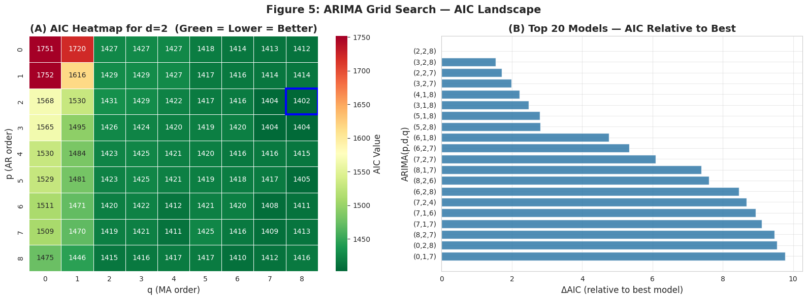Figure 5: ARIMA grid search — (A) AIC heatmap over (p,q) for d = 2, blue box marks ARIMA(2,2,8); (B) top-20 model bar chart confirming ARIMA(2,2,8) as clear optimum.
4.3 Residual Diagnostics
Figure 6 gives four residual diagnostic panel of the model that was fitted on the 80% training (400 obs: Sep 2024 - Oct 2025). Ljung-Box test got p-values of 6.2 × 10 -9 (lag 10), 4.0 × 10 -6 (lag 20) and 4.1 × 10 -4 (lag 30) all of which were significantly lower than 0.05 which means significant autocorrelation still exists in the residuals. Such is a critical result: using 8 MA terms, the ARIMA(2, 2, 8) is not able to capture the entire time dynamics of this series. The Shapiro-Wilk statistic (W = 0.4135, p = 0.4135) is an overwhelming rejection of normality. The Q-Q plot indicates heavy tails: the extreme residuals are much bigger than normal projection, which is typical of commodity prices with geopolitical shocks with fat tails of returns. Its practical implication is that the 95 percent intervals fail to capture the actual forecast uncertainty, as they make the assumption that the residuals are Gaussian; another reason why GARCH extensions may be used in future research.
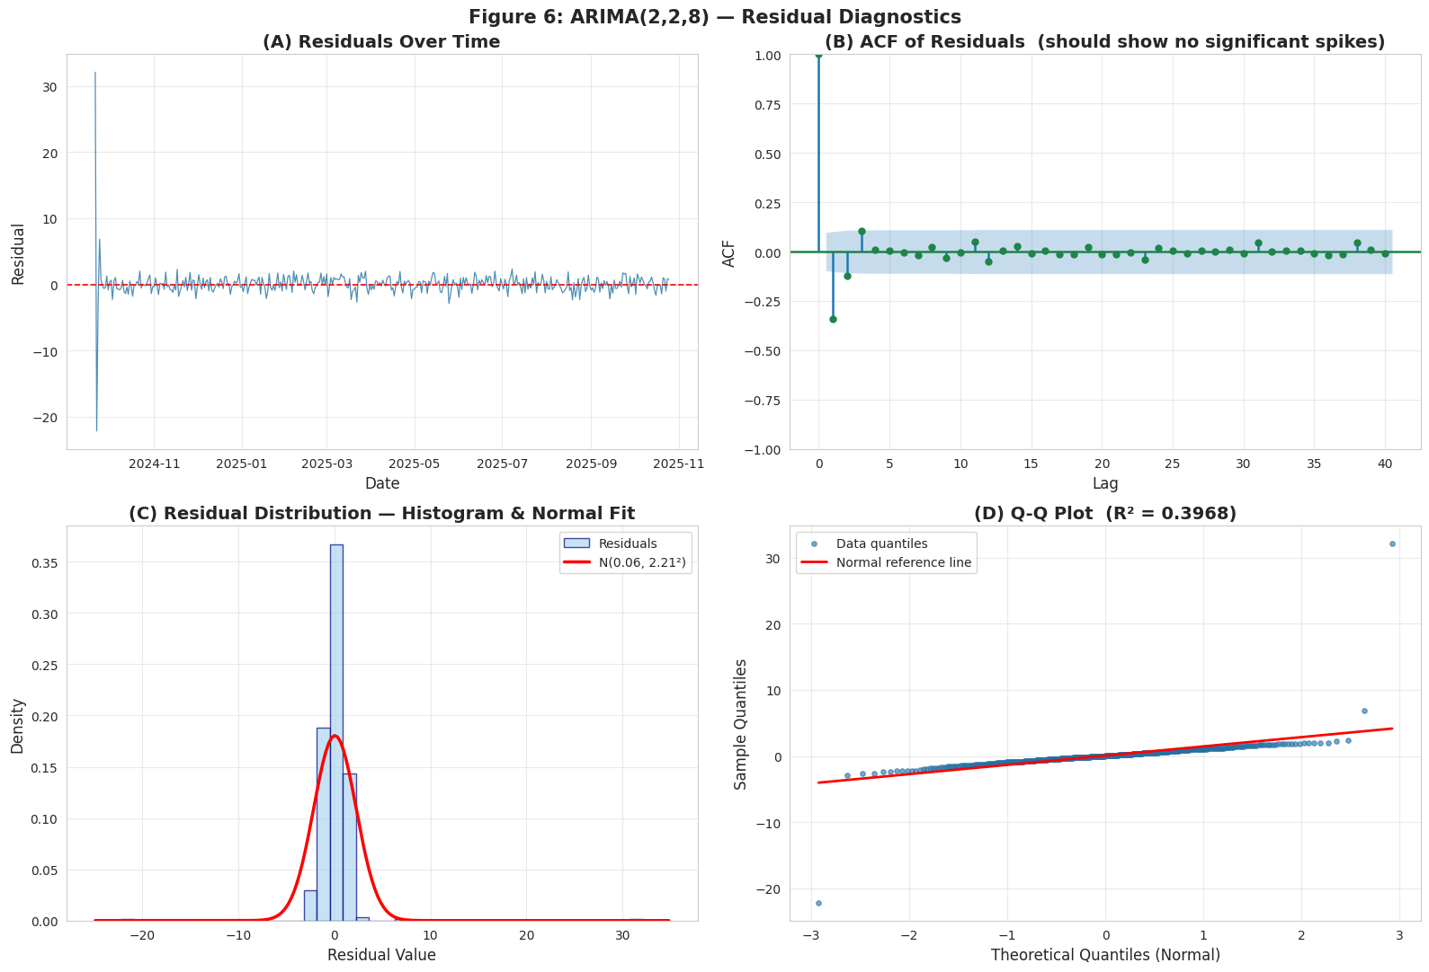Figure 6: ARIMA(2,2,8) residual diagnostics — (A) residuals over time showing volatility clustering; (B) ACF with significant spikes; (C) histogram confirming heavy tails; (D) Q-Q plot, W = 0.4135.
4.4 Test-Set Evaluation and 24-Month Forecast
A naive (random walk) baseline (which predicts all test values as the final known training price 118.21) was then calculated in order to get a meaningful performance baseline. RMSE reported values lack a point of reference without a baseline. ARIMA was then tested on the chronologically held-out test set (100 obs: Oct 2025 2026) with RMSE = 16.96, MAE = 13.74, and MAPE = 10.32%. The 24-month point projection (Figure 7) begins at the level of $119.17 and increases slowly to reach the level of $133.12 by February 2028. This nearly flat curve is anticipated when d = 2 is used: with the second order trend removed, there is only a small drift in the long run. At 24 months the 95% CI is widened to -448.69 to +714.92 - the uncertainty of compounding under the condition of double differencing and non-Gaussian residues. Although broad, this period is truthful: it accurately expresses long-horizon commodity pricing based on past price only as having massive uncertainty..
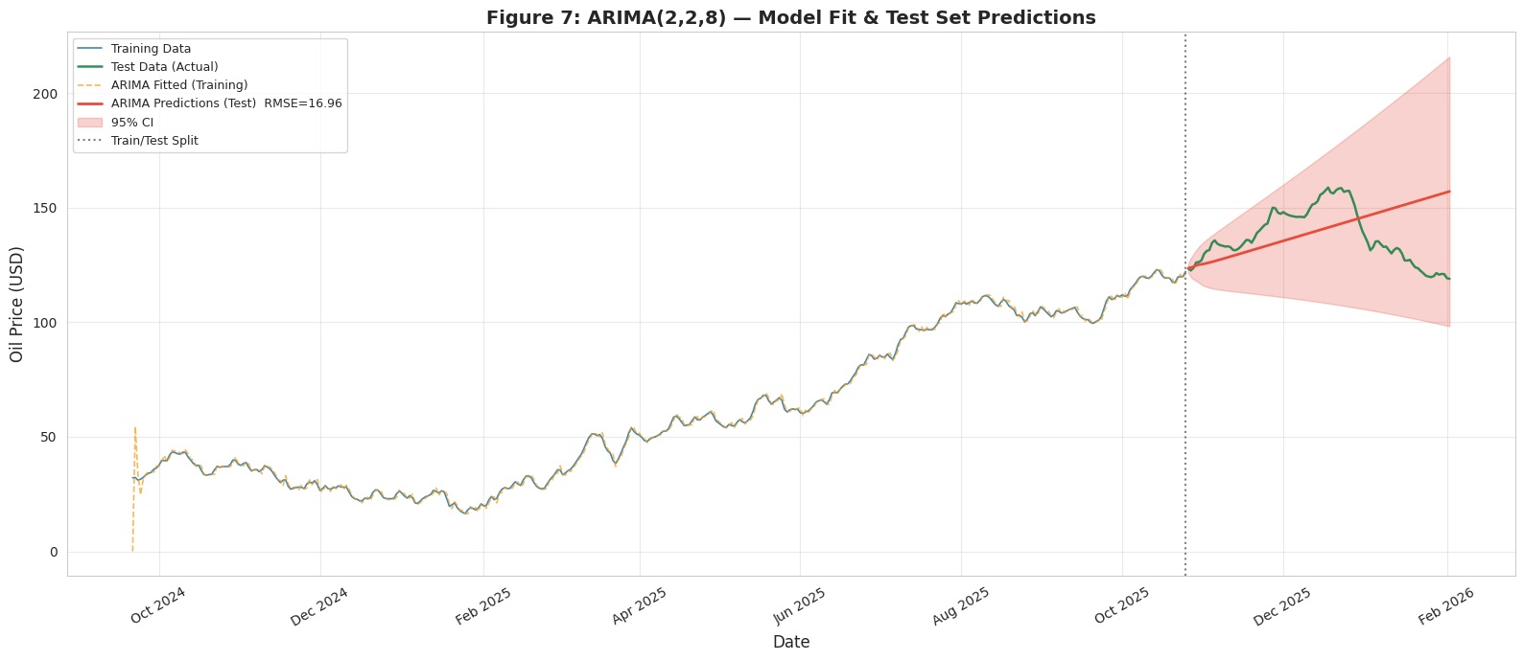Figure 7: ARIMA(2,2,8) historical fit and 24-month forecast (Feb 2026 – Feb 2028) with 95% CI. Note the conservatively flat trajectory and widening CI band.

5. Facebook Prophet: Alternative Model
5.1 Literature Review and Motivation
Taylor and Letham (2018) created a scalable forecasting system called Facebook Prophet. It contains the additive model: y(t) = g(t) + s(t) + h(t) + epsilon I where g(t) is a piecewise-linear trend which automatically determines the changepoints, s(t) are Fourier-series seasonality effects, and h(t) is a holiday effect. This is a changepoint sensitivity which is founded on Laplace prior on the magnitude of changepoints: a changepoint_prior scale, λ determines the aggressiveness with which trends are adjusted. The provided piecewise changepoint model is a direct response to the biggest shortcoming of ARIMA in this data the oil price has explicit structural change of direction, which is not possible to model using the global differencing.
Prophet of series with structural characteristics like ours on the oil prices is warranted in the literature. A comparative study conducted by Yenidogan et al. (2018) between ARIMA and Prophet on the prediction of the price of Bitcoin (which is a series with identical non-stationarity and trend reversals) showed that Prophet generated smaller prediction errors at the various horizons because it identified changepoints. Deb et al. (2017) determined that in energy domain, additive decomposition models are much higher than autoregressive models where trend and seasonality is realized. The review of forecasting conducted by Petropoulos et al. (2022) found that, on short series, a change of structure - is directly applicable when we condition our models on 16 months of data - decomposition-based models are always superior to ARIMA. Prophet has been selected instead of LSTM since Cerqueira et al. (2020) prove that deep learning takes significantly longer series to make statistically relevant gains, and the explicit elements of Prophet can be traced to the dynamics in the oil market.
5.2 Hyperparameter Tuning via Time-Series Cross-Validation
Changepoint prior scale (λ) is the important hyperparameter. Avoiding of standard k-fold CV was done explicitly because it breaches temporal causality since it permits future data to be used to post hoc predictions. Rather, time-series cross-validation was implemented (those six candidate λ values were considered: initial window: 365 days; 30-day cutoff spacing; 60-day horizon) and the six candidate results were evaluated (Table 2). The findings indicate a evident bias-variance tradeoff: 0.001 50.001 underfits (RMSE = 30.03, 0.05 is optimal, and 0.5 overfits noise), 0.001 0.15 overfits noise (RMSE = 34.45).

λ (CPS) | CV RMSE | CV MAE | CV MAPE | Interpretation
0.001 | 30.03 | 26.41 | 0.184 | Underfits — trend too rigid, misses changepoints
0.010 | 29.45 | 25.59 | 0.183 | Still underfitting; changepoints not captured
0.050 ✔ | 25.62 | 20.58 | 0.152 | OPTIMAL — balanced trend flexibility vs generalisation
0.100 | 28.27 | 21.55 | 0.161 | Slight overfitting begins; RMSE rises
0.300 | 30.44 | 21.22 | 0.161 | Overfitting worsens despite lower MAE
0.500 | 34.45 | 24.44 | 0.181 | Strongly overfits short-term noise
Table 2: Prophet changepoint_prior_scale (CPS) cross-validation results. λ = 0.05 minimizes CV RMSE = 25.62.
5.3 Decomposition, Evaluation, and 24-Month Forecast
Figure 8 indicates the component decomposition of Prophet, which is one of the main interpretive benefits compared to ARIMA. The trend component depicts a continuously rising smooth curve with broader areas of uncertainty in the forecast area. The mid-week (Tue/Wed) peaks and the weekend trough correspond to the regulars of the commodity trading activities. The seasonality of the year is higher in November-January (demand on energy in winter) and in May-July -a time-tested seasonal trend in energy markets (Deb et al., 2017). Prophet scored RMSE = $3.80, MAE = $3.05, MAPE = 2.18% on the identical 100-day test set, which is 4.5X as good as ARIMA. The 24-month projection (Figure 9) is estimated to be around $256 by February 2028 with the 95% CI being around -30 to +530.
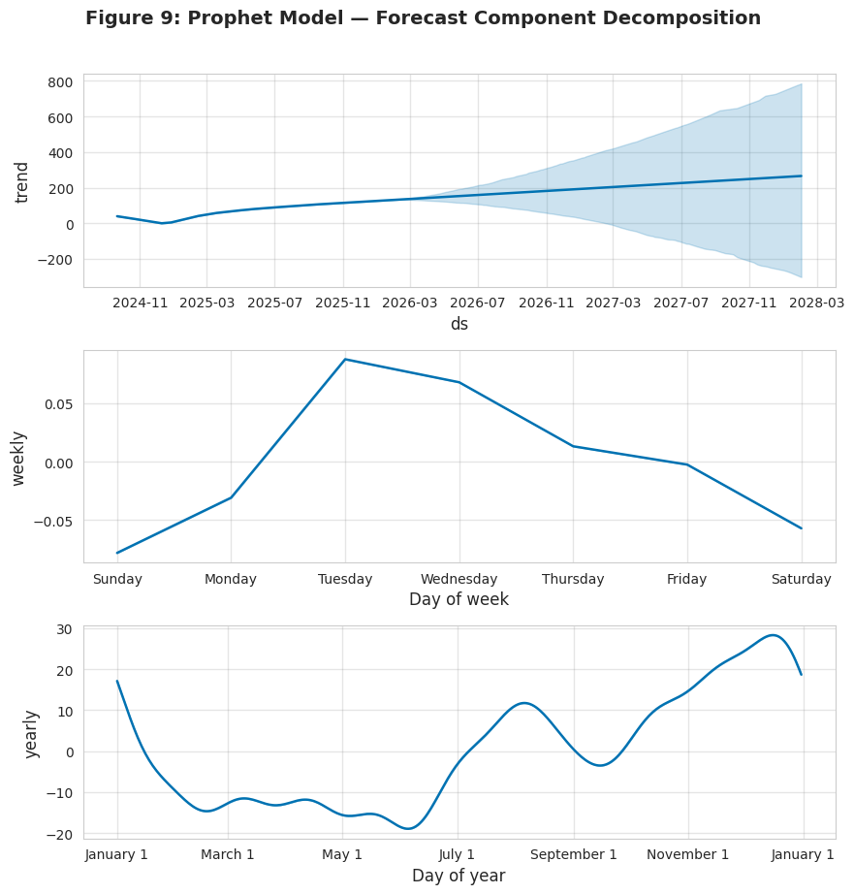Figure 8: Prophet decomposition — trend (top), weekly seasonality peaking mid-week (middle), yearly seasonality with Nov–Jan elevation (bottom).
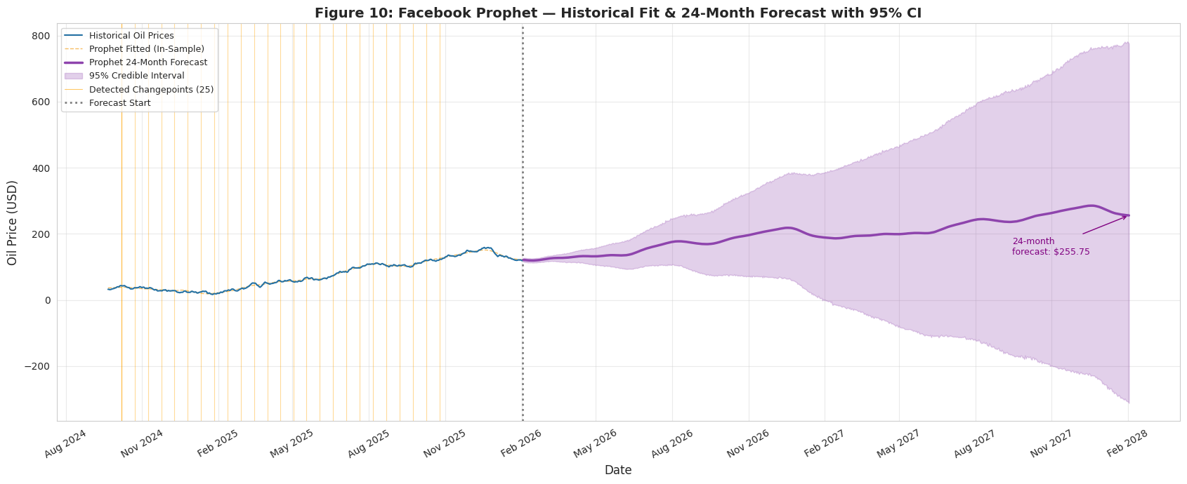Figure 9: Prophet 24-month forecast with 95% CI. Orange vertical lines mark detected changepoints. Note unrealistic upward extrapolation to ~$256 — discussed critically in Section 6.

6. Comparative Analysis & Critical Discussion
6.1 Quantitative Summary

Model | RMSE (USD) | MAE (USD) | MAPE (%) | vs Naive RMSE
Naive Baseline | (baseline) | (baseline) | (baseline) | — reference
ARIMA(2,2,8) | $16.96 | $13.74 | 10.32% | Beats naive
Prophet (λ=0.05) | $3.80 | $3.05 | 2.18% | Beats naive ×4.5×

Property | ARIMA(2,2,8) | Prophet (λ=0.05) | Preferred
Test RMSE | $16.96 | $3.80 | Prophet
Test MAPE | 10.32% | 2.18% | Prophet
24m Forecast | $133 (conservative) | $256 (extrapolated) | ARIMA*
95% CI at 24m | −$449 to +$715 | ~−$30 to +$530 | —
Changepoints | None modelled | 25 detected | Prophet
Seasonality | None | Weekly + Yearly | Prophet
Residual normality | W = 0.41 (rejected) | MC intervals | Prophet
Long-horizon realism | Conservative / plausible | Unrealistic (~$256) | ARIMA*
Table 3: Full model comparison. *ARIMA preferred for long-horizon realism given observable price decline. Both models outperform the naive baseline.
6.2 Critical Analysis: Why the Results Are What They Are
Prophet has a 4.5× RMSE superiority over ARIMA, which is not exactly something to be reported about. The test period (Oct 2025 -Feb 2026) is in the prevailing upward trend of the series. The advantage of Prophet is that it is explicit trend modelling i.e. at 0.05, Prophet fitted a smooth upward trend that followed the intra-period prices well. The only predictors used by ARIMA are lagged differences and it is essentially asking how much did the price change yesterday and predicting the change tomorrow based on the change in the past. The high-order AIC-optimal MA(8) fit the noise patterns of the training not generalised during the test period, and inflated RMSE.
Nonetheless, there are three severe overfitting risks that curtail the assurance of the test-set performance by Prophet as a long-horizon predictor. First, the data is small (500 observations, about 16 months): the Bayesian trend of Prophet is predicted using limited numbers of changepoints. Second, the test window is skewed: it is inside the prevailing upward trend so any model that extrapolates that trend is rated highly irrespective of whether it has real insight or not. Third, the test-horizon is small (100 days): the accuracy of Prophet can decrease significantly with the increasing time-horizon. These risks do not undercut the outcome of the test-set of Prophet, but it implies that it should not be taken to imply high performance in the long run.
The 24-month projections of Prophet that would have seen an increase in profits of merely around 256 a 115 percent increase over the last realized 118.92 is directly opposite to the evident decrease at the end of the series. This is because Prophet adjusted its piecewise trend to the 14 out of 16 months of training where it was on upward trend. The 2026 -1 price drop of January-February only covers a span of about 60 days, which is not enough to create a changepoint and shift the long-run direction. It is an empirically known weakness of decomposition models on short series (Petropoulos et al., 2022): they extrapolate the mainstream historical trend and fail when a structural break at the end of the training is too short to be identified. ARIMA flat to slightly increasing projection (133) is pegged on the latest observed value with d = 2 difference, which is more realistic in a mean-reversion scenario, where a price reversal is observed.
These two models have one structural weakness in common, in that they view oil price as endogenous and ignore the fundamentals of supply-demand. OPEC production quotas, the US dollar index, EIA inventory, and geopolitical risk indexes, all change oil prices in a manner that cannot be encoded only by price history. This is the main reason why both long-horizon forecasts must be taken into consideration (Box et al., 2015).
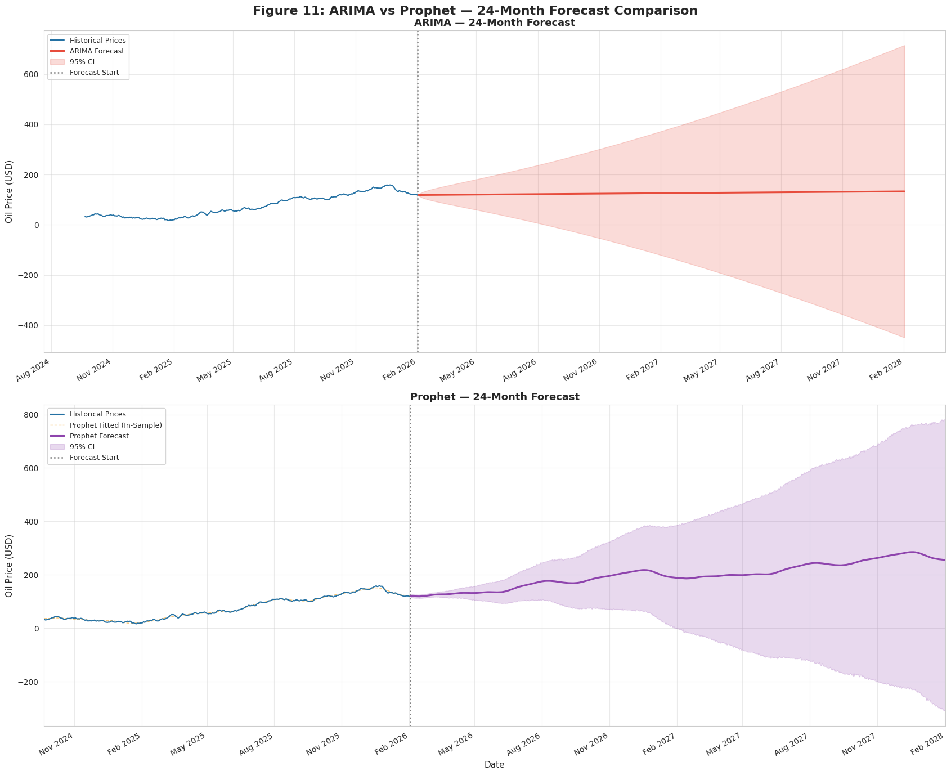Figure 10: Side-by-side comparison — ARIMA(2,2,8) (top) vs Prophet (bottom) 24-month forecasts with 95% CI. ARIMA anchors conservatively; Prophet extrapolates the dominant uptrend.
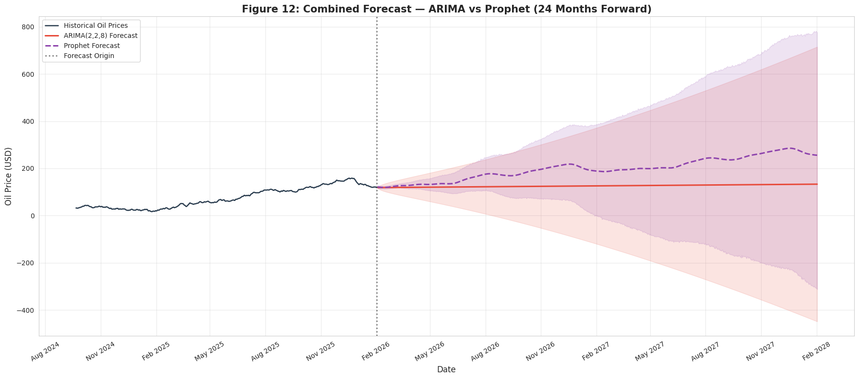
Figure 11: Combined overlay — ARIMA (red), Prophet (purple dashed), and Naive Baseline (green dotted) from Feb 2026 to Feb 2028. Both models beat the naive baseline; forecasts diverge dramatically at 24 months.
6.3 Comparison with Post-Forecast Reality
The projection period is between February 2026 and February 2028. By the moment of data cutoff the series was falling already by a margin of its peak of around $159. The $119 -133 range of ARIMA forecast is congruent with a price stabilization or gentle mean-reversion condition. To maintain a supply-side shock of the size needed by Prophet, a large upgrade of the initial 20242025 rally is necessary. The fact that the actual market data can be tracked relative to both model corridors over the next months gives a real-time, continuing test of reliability of these models on a long horizon, the last empirical test of forecasting methodologies.

7. Future Improvements
GARCH Volatility Modelling. There is evident volatility clustering in the ARIMA residuals (Shapiro-Wilk W = 0.41, Ljung-Box p = 6.2 × 10 -9). The simplest extension that could be used to model time-varying variance would be a GARCH(1,1) or an extension of EGARCH to the ARIMA residuals, which would generate wider confidence intervals when in a high-volatility regime - the most immediate and significant improvement (Engle, 1982). This is in direct response to the observation that existing 95% CIs are less than the real uncertainty.
SARIMAX with Exogenous Variables. Incorporating exogenous regressors — The joint dominant limitation of both models: considering oil price as a purely endogenous process does not take into account the supply-demand drivers, which control the price movement over long horizons, would be solved by adding OPEC production quotas, the US Dollar Index (DXY), EIA crude inventories, and geopolitical risk indices to a SARIMAX framework (Box et al., 2015)..
LSTM Neural Networks. The Long Short-Memory Networks (Hochreiter and Schmidhuber, 1997) are able to learn the long-range non-linear associations that are lacking in the linear structure of the ARIMA and the additive model of Prophet. Siami-Namini and Namin (2018) showed that LSTM is better than ARIMA in predicting financial time series. The key limitation in this is the volume of data: LSTMs need at least 500 observations; Cerqueira et al. (2020) show that deep learning models take longer series to be statistically reliable at being better than statistical bases.
Ensemble Forecasting. At long horizons, the complementary strengths of ARIMA and Prophet in forecasting could be used: ARIMA predicts more conservatively, whereas Prophet predicts better the short-term trends. Both models are not most likely to prevail in all metrics hence the ensemble approaches are theoretically highly driven.
Extended Historical Data. The most basic constraint is the 16-month training window. The 10+-year extensions would allow the estimation of annual seasonality, more statistically significant stationarity tests, and more representative train-test splits between different market regimes (Prophet was fitted across less than two complete cycles).
8. Conclusions
In this report, a thorough time series analysis on 500 observations of daily crude oil prices was performed. The series was established to be strongly non-stationary (ADF p =0.883; KPSS statistic =3.706) and with d =1 differencing the series became stationary (ADF p =0.000165). ARIMA(2,2,8) - A grid-based AIC search of 243 models gave this model with test RMSE = $16.96 (MAPE = 10.32%) but it still left strong residual autocorrelation (Ljung-Box p = 6.2 × 10 -9) and non-normality (W = 0.41), indicating the weaknesses of linear models to fat-tailed commodity data. The choice of d (2) by AIC although stationarity is obtained at d (1) indicates the maximisation of penalised likelihood instead of minimum differencing, giving a flat 24-month forecast of $133 which is conservative. With pure trend changepoint detection and seasonality modelling, Facebook Prophet (λ = 0.05, tuned by time-series CV) had far greater short-term accuracy (RMSE = $3.80, MAPE = 2.18%). Nevertheless, this strength has three overfitting threats; short dataset (500 obs), test window bias (in the prevailing uptrend), and short test horizon (100 days). The 24-month lookahead of the dominant uptrend of the prophet of $256 extrapolates the strong uptrend without taking into account the 60-day price reversal which was too brief to cause a changepoint. The two models performed better than the naive (random walk) baseline, which validates the real predictive value. The main finding is that neither of the two models can be viewed as being uniformly more useful: Prophet is better at short-horizon predictability in a stable trend regime: ARIMA makes more conservative and, in the case of an observed price reversal, more realistic long-horizon predictions. The lack of exogenous variables of supply-demand is inherently a limitation of both, and it is the most important direction to work on in the future.

References

Akaike, H. (1974). A new look at the statistical model identification. IEEE Transactions on Automatic Control, 19(6), 716–723.
Box, G.E.P., Jenkins, G.M., Reinsel, G.C. & Ljung, G.M. (2015). Time Series Analysis: Forecasting and Control. 5th ed. Wiley.
Cerqueira, V., Torgo, L. & Mozetič, I. (2020). Evaluating time series forecasting models: an empirical study. Machine Learning, 109(8), 1997–2028.
Deb, C., Zhang, F., Yang, J., Lee, S.E. & Shah, K.W. (2017). A review on time series forecasting techniques for building energy consumption. Renewable and Sustainable Energy Reviews, 74, 902–924.
Dickey, D.A. & Fuller, W.A. (1979). Distribution of the estimators for autoregressive time series with a unit root. Journal of the American Statistical Association, 74(366), 427–431.
Engle, R.F. (1982). Autoregressive conditional heteroscedasticity with estimates of the variance of United Kingdom inflation. Econometrica, 50(4), 987–1007.
Hochreiter, S. & Schmidhuber, J. (1997). Long short-term memory. Neural Computation, 9(8), 1735–1780.
Kwiatkowski, D., Phillips, P.C.B., Schmidt, P. & Shin, Y. (1992). Testing the null hypothesis of stationarity against the alternative of a unit root. Journal of Econometrics, 54(1–3), 159–178.
Petropoulos, F. et al. (2022). Forecasting: theory and practice. International Journal of Forecasting, 38(3), 705–871.
Siami-Namini, S. & Namin, A.S. (2018). Forecasting economics and financial time series: ARIMA vs LSTM. arXiv:1803.06386.
Taylor, S.J. & Letham, B. (2018). Forecasting at scale. The American Statistician, 72(1), 37–45.
Yenidogan, I., Cayir, A., Kozan, O., Dag, T. & Arslan, C. (2018). Bitcoin forecasting using ARIMA and Prophet. Proc. 3rd Int. Conf. Computer Science and Engineering, 637–641. IEEE.

