Uploading and creating dataframe

scala> val df =sqlContext.read.format("com.databricks.spark.csv").option("header", "true").option("delimiter", ",").load("/user/datafiles/casestudy.csv")

scala> case class buses(year:String,run_type:String,bus_no:String,route_no:String,reason:String,occured_on:String,no_of_student:Integer)

scala> val df1 = sc.textFile("/user/datafiles/casestudy.csv").map(_.split(",")).map(p=>casestudy(p(0),p(1),p(2),p(3),p(4),p(5),p(6).trim.toInt)).toDF()

**Use Case 1 - Most common reasons for either a delay or breaking down of the bus**

scala> val query = """Select * from (Select reason,count(Run_Type) as delays from caseData group by Reason) sub order by delays desc"""

scala> val answer1 = spark.sql(query)

scala> answer1.show

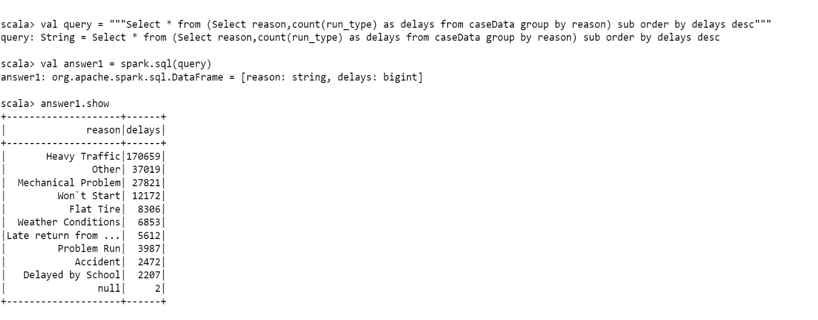

**Use Case 2 - Top five route numbers where the bus was either delayed or broke down**

scala> val query = """Select * from (Select Route_Number,count(Run_Type) as delays from caseData group by Route_No) sub order by delays desc limit 5"""

scala> val answer2 = spark.sql(query)

scala> answer2.show

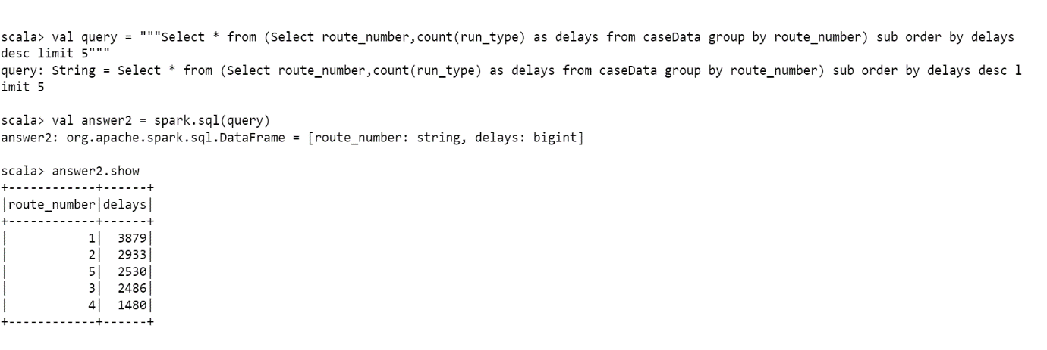

**Use Case 3 - The total number of incidents, year-wise, when the students were**

**3.1** **when students were not in the bus**

scala> val query = """Select School_Year,count(Run_Type) from caseData where Number_Of_Students_In_The_Bus=0 group by School_year"""

scala> val answer3 = spark.sql(query)

scala> answer3.show

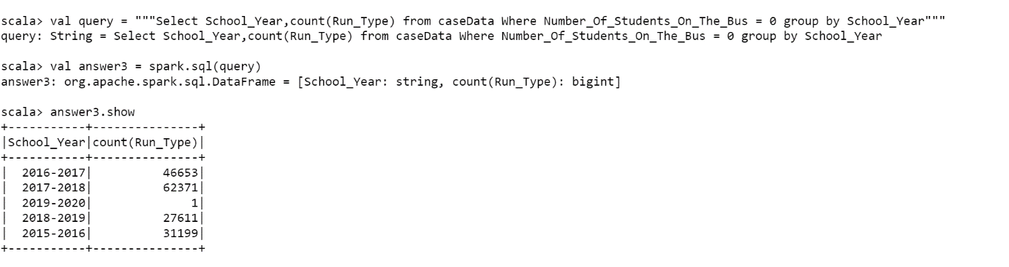

**3.2** **when students were in the bus**

scala> val query = """Select School_Year,count(Run_Type) from caseData where Number_Of_Students_In_The_Bus!=0 group by School_year"""

scala> val answer3 = spark.sql(query)

scala> answer3.show

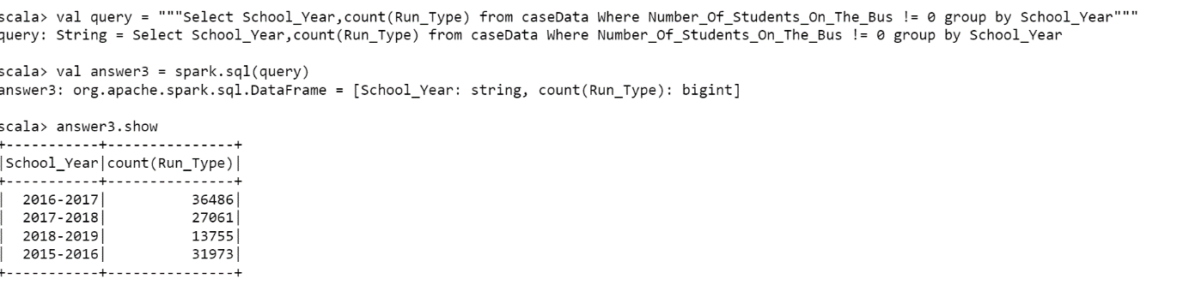

**Use Case 4 -** **The year in which accidents were less**

scala> val query = """ Select * from (Select School_year,count(run_type) as count_of_accidents from caseData where Reason="Accident" group by School_year) sub order by count_of_accidents """

scala> val answer4 = spark.sql(query)

scala> answer4.show

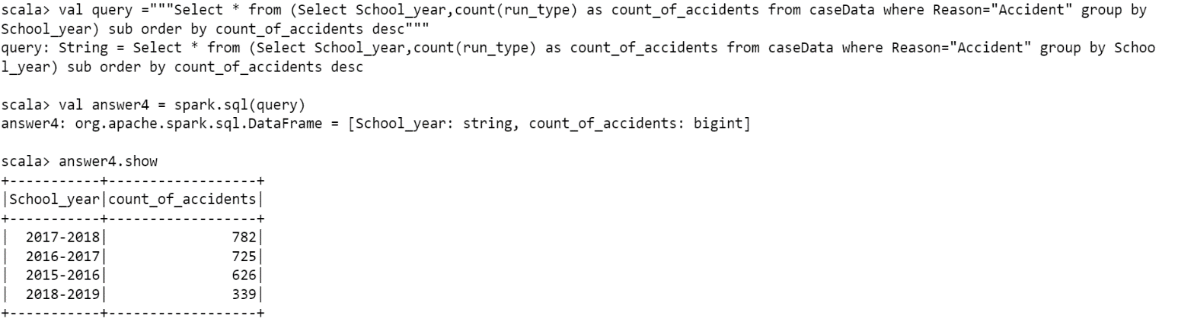

**JAVA Program**

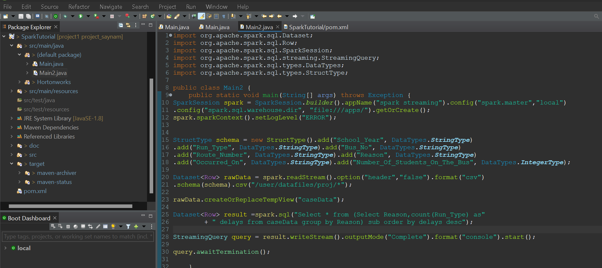

**Execution**

