IST 659- Week 10

By Shivani Sanjay Mahaddalkar

# Questions

Write the following as SQL programs. For each, include the SQL as a screenshot with the output of the query.

1. In the **TinyU** database,
   1. Write an SQL Stored procedure called **p_upsert_major** which given a major_code (business key) and a major_name does an Upsert, which is the following:
      1. Check if the major_code exists in the table already.
      2. If yes, update the table and make the major_name match the new major name.
      3. If no, insert the new major_name and major_code into the table. HINT: major_id is not a surrogate key so you will need to determine the next ID yourself in code!
   2. Test your stored procedure by executing it to make these changes
      1. change : CSC – Computer Sciences to CSC – Computer Science and
      2. add: FIN – Finance.

Make sure your screenshot captures all up/down code in 1.a AND another screen shot captures 1.b the output of your code execution to show that it works. SELECT the table before and after!  
1. a. Up/down code for the stored procedure  
1.b. Calling the stored procedure with the arguments  
One row gets updated and another gets added to the table

1. In the **TinyU** database,
   1. write a user-defined function called **f_concat** which combines the any two varchars @a and @b together with a one-character @sep in between.   
      For example:  
        
      Graphical user interface, text, application

      Description automatically generated
   2. Now create a view called **v_students** which displays the student_id student name (first last), student name (last, first), gpa, and name of major. You should call the function you created in 2.a. After you create the view, execute it with a SELECT statement.

Make sure your screenshot captures all up/down code in 2.a AND another screen shot captures 2.b along with the output of the SELECT statement on the view (first few rows is fine).   
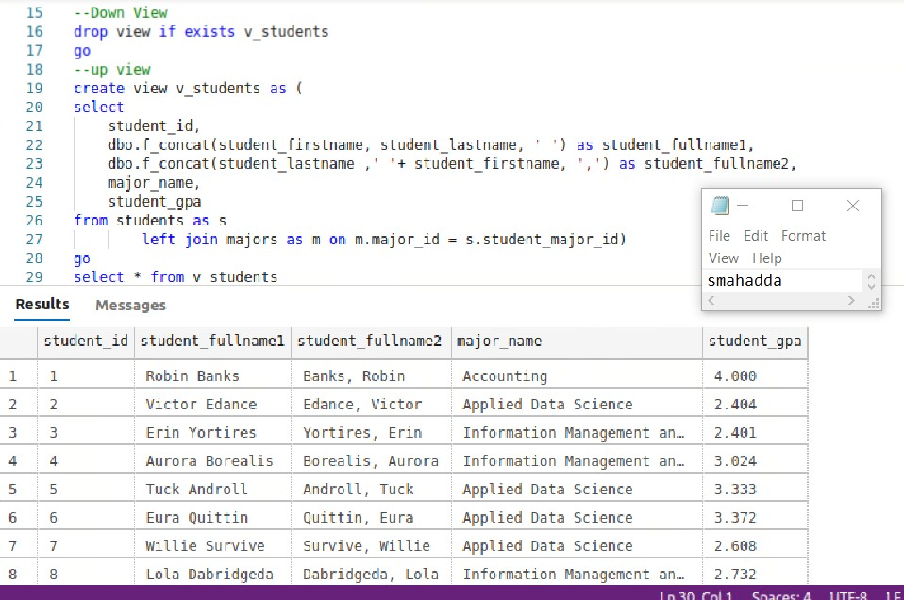

1. In the **TinyU** database,
   1. Write a query on the **majors** table so that the major_name is broken up into keywords one per row. HINT: you must use string_split() with cross apply.   
      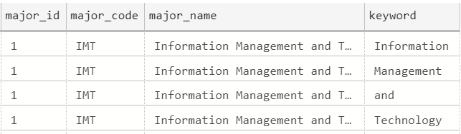

* 1. Then use the query in 3.a to create a table-valued function **f_search_majors** which allows you to search the majors by keyword. Demonstrate calling the TVF by querying all majors with the ‘Science’ keyword.

Your screenshot should include the query in 3.a Another screenshot should show the TVF in 3.b and the sample output from the SELECT statement calling the TVF.

1. In the **TinyU** database,
   1. Alter the **students** table and add the following columns:
      1. student_active char(1) default (‘Y’) not null
      2. student_inactive_date date null

* 1. Create a trigger on the **students** table which when there is an student_inactive_date set will set student_active to ‘N’, whenever there is not a student_inactive_date then student_active is set to ‘Y’.

* 1. Write SQL code to deactivate all the ‘Graduate’ students with a date of ‘2020-08-01’

* 1. Write SQL code to re-activate all the ‘Graduate’ students.

Provide a screenshot of your code from 4.a. and 4.b working. Provide another screenshot demonstrating 4.c worked. Then a final screenshot of code and demonstration of 4.d working.