IST 659- Week 03

By Shivani Sanjay Mahaddalkar

# Questions

1. Add the **contractors** table as defined in the overview section to your SQL script at the bottom of your --UP Metadata section. Include columns, indexes (pk/unique) in the create table statement. Provide a screenshot of the SQL code.  
   A screenshot of a cell phone

   Description automatically generated
2. Add the reverse command to the --DOWN section of your SQL script, dropping the table. Provide a screenshot of the code.  
   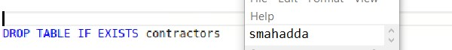
3. Alter the **contractors** table adding a foreign key over the **contractor_state** column, **fk_contractors_contractor_state.** Add it to the --UP Metadata portion of the script. Provide a screenshot of the SQL code.  
   A screenshot of a cell phone

   Description automatically generated
4. Add the reverse command to the DOWN section of your SQL script, dropping the foreign key. It should be a soft delete as with the other foreign key in the walkthrough. Provide a screenshot of the code.  
   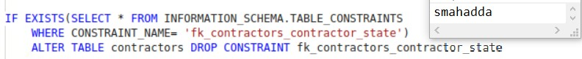
5. At the bottom of the --UP Data section, insert the following contractor data.  
   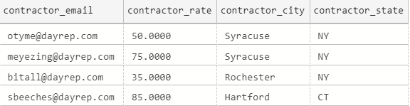 Add a select statement to the –Verify section. Provide evidence your script works to this point by including a screenshot of the table outputs.  
   A screenshot of a social media post

   Description automatically generated
6. Create the **jobs table** with pk and check constraints. Add it to the appropriate section of the script and provide a screenshot of the SQL code.  
   A screenshot of a cell phone

   Description automatically generated
7. Add the drop table statement for the **jobs table**, add it to the appropriate section of the script and provide a screenshot of the SQL code.  
   A screenshot of a cell phone

   Description automatically generated
8. Add the two foreign key constraints to the **jobs table.** Add it to the appropriate section of the script and provide a screenshot of the SQL code.  
   A screenshot of a cell phone

   Description automatically generated
9. Add code to softly remove the foreign key constraints from the **jobs** table. (should be two separate checks for drops). Add it to the appropriate section of the script and provide a screenshot of the SQL code.  
   A screenshot of a cell phone

   Description automatically generated
10. Write SQL code to insert the following jobs to the **jobs table**.  
    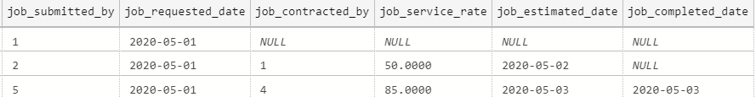  
    Provide evidence the entire script works by including a screenshot off all 4 tables with data in them.  
    Ans. The tables did not fit in a single pane, I have uploaded to images for this answer, but all 4 tables were the output after running the whole script.  
    A screenshot of a cell phone

    Description automatically generated  
    