IST 659- Week 05

By Shivani Sanjay Mahaddalkar

# Questions

1. How many item types are there? Perform an analysis of each item type. For each item type, provide the count of items in that type, the minimum, average, and maximum item reserve prices for that type. Sort the output by item type.   
   Table

   Description automatically generated
2. Perform an analysis of each item in the “Antiques” and “Collectables” item types. For each item display the name, item type and item reserve. Include the min, max and average item reserve over each item type so that the current item reserve can be compared to these values.  
   Table

   Description automatically generated
3. Write a query to include the names, counts (number of ratings) and average seller ratings (as a decimal) of users. For reference, User Carrie Dababbbi has 4 seller ratings and an average rating of 4.75.   
   Table

   Description automatically generated
4. Create a list of “Collectable” item types with more than 1 bid. Include the name of the item and the number of bids making sure the item with the most bids appear first.  
   A picture containing graphical user interface

   Description automatically generated
5. Generate a valid bidding history for any given item of your choice. Display the item id, item name a number representing the order the bid was placed, the bid amount and the bidder’s name. Here’s an example showing the first 3 bids on item 11.   
   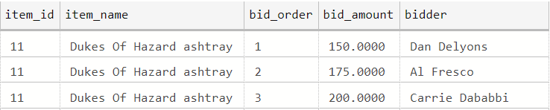  
   Ans. Displaying the first 3 bids on item 18. The bids with same time of bid have been further sorted by the ascending bid amount.  
    Table

   Description automatically generated
6. Re-Write your query in the previous question to include the names of the next and previous bidders, like this example again showing the first 3 bids for item 11.  
   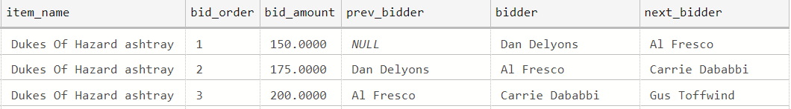  
   Ans . Displaying the first 3 bids on item 18. The bids with same time of bid have been further sorted by the ascending bid amount.  
   Table

   Description automatically generated
7. Find the names and emails of the users who give out the worst ratings (lower than the overall average rating) to either buyers or sellers (no need to differentiate whether the user rated a buyer or seller), and only include those users who have submitted more than 1 rating.  
   Ans. I have used aliased a table with users who have submitted more than 1 rating as active_raters. I used left join to join the ratings given by each of the active user and it is then filtered for ratings lower than average.   
   Table

   Description automatically generated
8. Produce a report of the KPI (key performance indicator) user bids per item. Show the user’s name and email total number of valid bids, total count of items bid upon and then the ratio of bids to items. As a check, Anne Dewey’s bids per item ratio is 1.666666  
   Table

   Description automatically generated
9. Among items not sold, show highest bidder name and the highest bid for each item. Make sure to include only valid bids.  
   Table

   Description automatically generated
10. Write a query with output similar to question 3, but also includes the overall average seller rating, and the difference between each user’s average rating and the overall average. For reference, the overall average seller rating should be 3.2.  
    Ans. To assign a column the overall average seller rating, I created a dummy view with 0 as an entry in dummy column and found the average by using partition over the dummy column. I created another view with the output of question 3 and joined both of them to find the delta average.  
      
    The code for creating the two views:  
    Graphical user interface, text, application, email

    Description automatically generated  
      
    The code for joining the two views to get the output:  
    Table

    Description automatically generated