IST 659- Week 06

By Shivani Sanjay Mahaddalkar

# Questions

Write the following as SQL queries. If the query is ambiguous, fill in the gaps yourself and justify your reasoning. For each, include the SQL as a screenshot with the output of the query.

1. The GIS department would like to get a list of latitudes and longitudes of those vBay users who

make valid bids on items and review users also. These are considered active participants in the platform and they would like to plot them on a map for a real-time dashboard.  
A. I haven taken the intersection of the group of users who have made valid bids and have reviewed users. The intersection is then joined with the zip code table to get the latitude and longitude of these active users.

1. Northwind Traders would like to send out holiday cards to its Employees, Customers and Suppliers. Create a single mailing list from these sources. The mailing address should have 4 lines:   
   0) a label of the source of the address: Employee, Customer, or Supplier

1) customer name and title,   
2) company,   
3) address, City, Region, Country, postal code   
A. I used the union command to find all the customers, suppliers and employer details with a label column to indicate which group it belongs to. I combined the address, City, Region, Country, postal code into a single column ‘MailingAddress’. The address, City, Region, Country or postal code columns were first converted to a string with 0 characters when the entry was NULL by using the isnull(column, ‘’) command. I added a CompanyName column with ‘Northwind Traders’ as the value in the employee table before the union to make sure the number of columns for all the three tables in the union are same.  
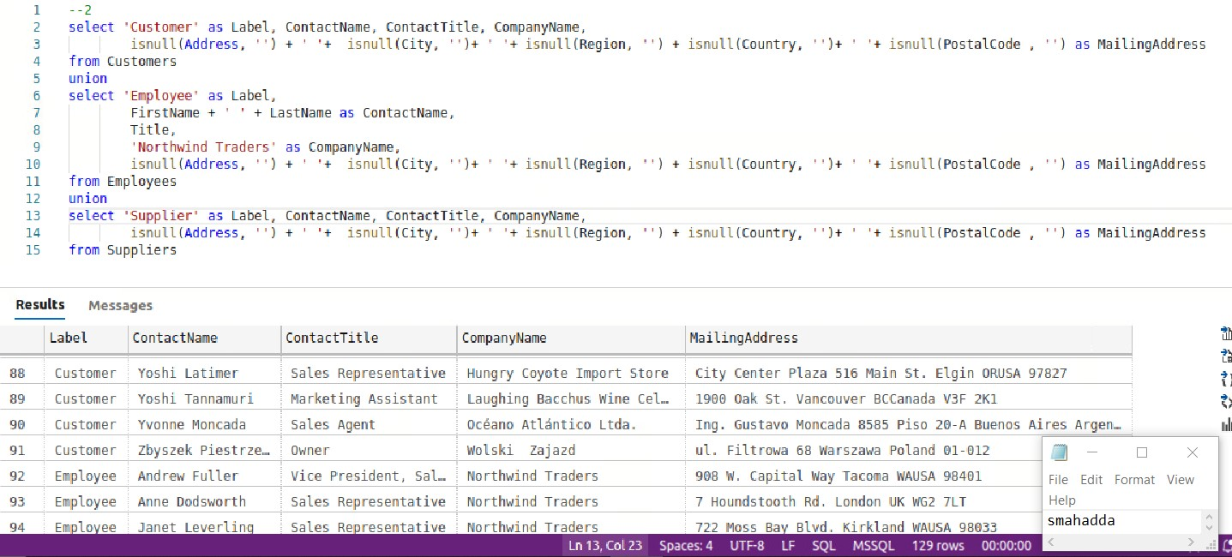

1. vBay would like a list of items with item id name and type along with a count of bids with bid

type (ok, low_bid, item_seller). There should be a column for each of the bid types.

1. Northwind traders has 3 different shippers. For each customer ID and CompanyName list the total amount of shipping freight paid for each of the three different shippers. There should be a column for each shipper.  
   A. I joined the orders, customers and shippers table and used pivot on the shipper’s company name using the sum aggregate to find the total of shipping freight paid to the three different shipper by the customer.  
   Table

   Description automatically generated
2. Unpivot all the dates in the Northwind orders table, creating a table output with three columns: order id, type of date (ship date, require date, order date) and the date itself.  
   A. I unpivoted from a table having only the order id and the three types of dates in three columns.  
   Graphical user interface, table

   Description automatically generated
3. Unpivot the FudgeFlix titles which are just Movies so that is it easier to query titles which are available in different formats such as instant, DVD, and Blu-ray. Flatten these three columns into a single column with types, but only include a row when the value is 1 in the column.   
   A. From the with clause, taking only the title id, name and the three column types and with Movie as the type of title, I unpivoted the three columns into one column with the type of availability and whether it is available or not.   
   Table

   Description automatically generated
4. Get a list of the employees from the payroll database as they were on May 31, 2018.  
   A. The as of clause gives the employees as they were on May 31, 2018  
   Table

   Description automatically generated
5. Produce a report of Gus Toffwind's pay increases from the payroll database. Include the id, name SSN of the employee along with pay rate, previous pay rate and pay increase (difference between the current and previous pay rates).  
   A. 118 columns were displayed for the 118 weeks Gus Toffwind got their paycheck.  
   Table

   Description automatically generated