IST 659- Week 07

By Shivani Sanjay Mahaddalkar

# Questions

Answer these questions using the problem set submission template. You will need to provide a screen shot for each answer. Please follow the guidelines for submitting a screenshot.

1. Provide a screenshot of your completed E-R Diagram (ERD) from Walkthrough Part 3.   
   Diagram

   Description automatically generated
2. Provide a screenshot of your E-R data requirements from Walkthrough Part 4.  
   I am unsure whether we declare the associative entities in the ER-data requirements. I have not listed them under the entities.  
   Graphical user interface, application, table

   Description automatically generated
3. Provide a screenshot of the E-R Diagram (ERD) Walkthrough Part 4.  
   I created a history table which is an associative entity with the date as an attribute. The history table will have the date which user listened to which songs.  
   Diagram

   Description automatically generated
4. Draft an ERD from the following requirements. Try not to let your interpretation of the facts get into the way until **after you’ve drawn the diagram**. Once you have a diagram together, feel free to criticize and comment.
   1. Entities: customer, order, products, order line item
   2. Attributes:
      1. Customer: customer email – unique, required, customer name – composite, required, customer address – composite, required.
      2. Order: order number – unique, required, order date – required, order subtotal – required, order tax – required, order total – derived
      3. Products: product inventory number – required, unique, product name – required, product description, product price – required.
      4. Order Line Item: item product inventory number – required, item product price – required, item quantity – required, item extended price – derived.
   3. Relationships:
      1. A customer places 0 or more orders. An order is placed by 1 and only 1 customer.
      2. An order contains 1 or more line items. A line item belongs to 1 and only 1 order.
      3. A line item contains 1 and only 1 product, a product appears on 0 or more line items
   4. Other facts:
      1. You cannot have a line item without a product and an order.

The order line item is an associative entity. It can be added after establishing the entity relationships between the other three entities.

1. In this next example, I give you a list of data requirements, but they are not organized into entities, relationships, and attributes. You may have to make some assumptions to complete E-R Model.
   1. A car is made by only one manufacturer, but a manufacturer makes a lot of cars.
   2. A car has a make, model, vehicle identification number (vin), msrp, and color.
   3. A manufacturer has a name (which is unique and not always the same as the make).
   4. A manufacturer has several plants where the cars are made. A plant is owned by just one manufacturer.
   5. A car is produced at just one single plant. And a plan produces several cars.
   6. A Plant has a name and address.
   7. Only cars of a certain make are produced at certain plants. For example, plant “A” might produce makes “X”, “Y”, and “Z”, while plant “B” might produce makes “W” and “Z” only.

Use a copy of the **Empty-ER-Data-Requirements** spreadsheet, provided with this lab, to enter your data requirements. Provide a screenshot of your data requirements.  
Ans. The point g, according to me falls out of the scope of conceptual data modeling.  
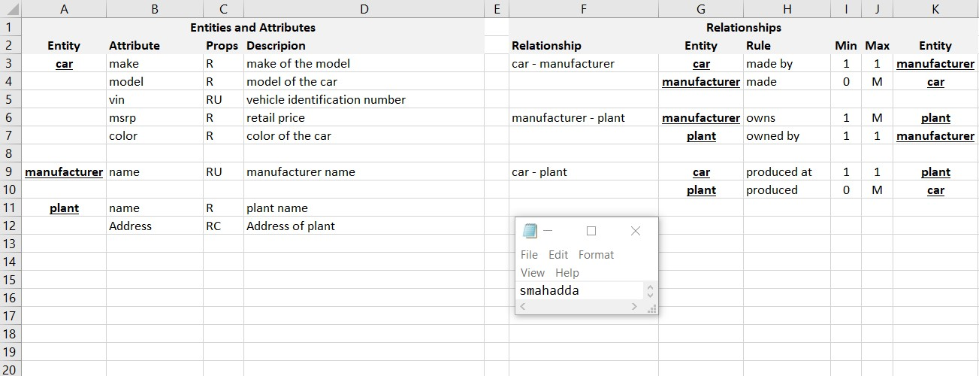

1. Draw an ER Diagram based on the data requirements you identified in the previous question.  
   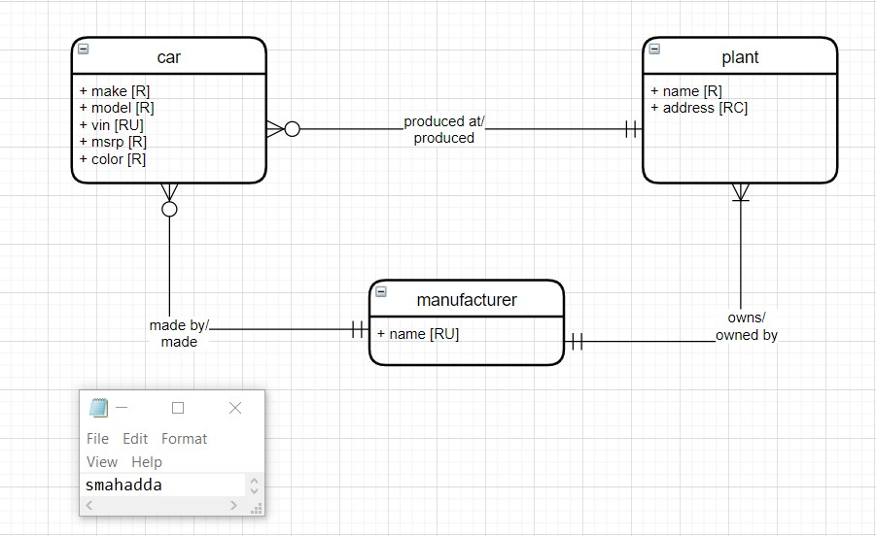
2. In this last example, read the following paragraphs, identify the data requirements. Once more use a copy of the **Empty-ER-Data-Requirements** spreadsheet, provided with this lab, to enter your data requirements.

The XYZ consulting firm handles project management for its customers.

Customers have a name, address, phone, and one or more contacts (people who work for the company). Customers interact with XYZ through projects.

For any project there should be the name of the project the estimated cost, estimated hours, and an agreed-to billable hourly rate. There should also be an optional description for the project. There should be one customer contact assigned to the project.

Each project is broken down into tasks. Tasks have a name, estimated time to completion, actual time to completion, and assigned employee to the task. One employee is assigned to the project as the project manager. Tasks also contain a list of required skills to complete the tasks. An example of those skills might be database, systems admin, project management, web design, or programming to name a few.

XYZ employees have a name, email, set of skills (like the ones in tasks), and billable hourly rate. The estimated and actual billable amounts are derived from the employee’s hourly rate and the task’s estimated and actual time to completion these values should be stored with the task. Employees can work on more than one task and can be assigned to different tasks at the same time.

1. Draw an ERD based on the data requirements you identified in the previous question.  
   Diagram

   Description automatically generated