IST 659- Week 08

By Shivani Sanjay Mahaddalkar

# Questions

Answer these questions using the problem set submission template. You will need to provide a screen shot for each answer. Please follow the guidelines for submitting a screenshot.

1. Provide a screenshot of your completed logical model from Walkthrough Step 2.  
   Diagram

   Description automatically generated
2. Provide a screenshot of your completed logical model from Walkthrough Step 3.  
   Diagram, schematic

   Description automatically generated
3. Map this conceptual model to a logical model.   
   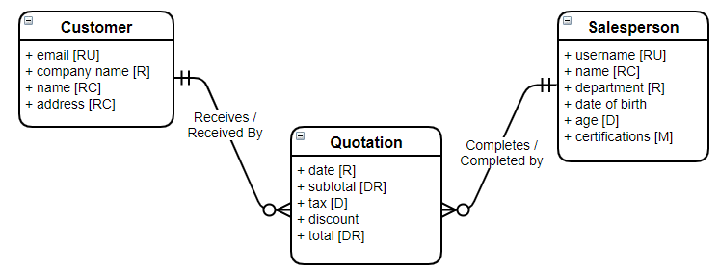  
   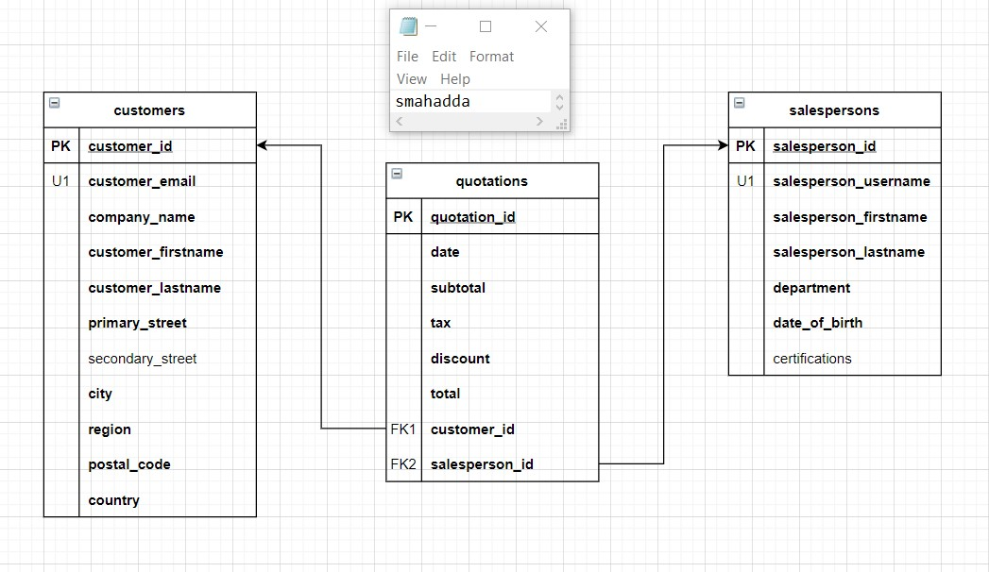
4. Map this conceptual Model to a logical Model  
   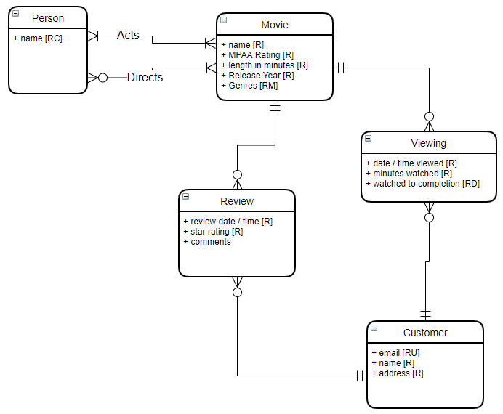  
   Diagram

   Description automatically generated
5. Map this conceptual model to a logical data model  
   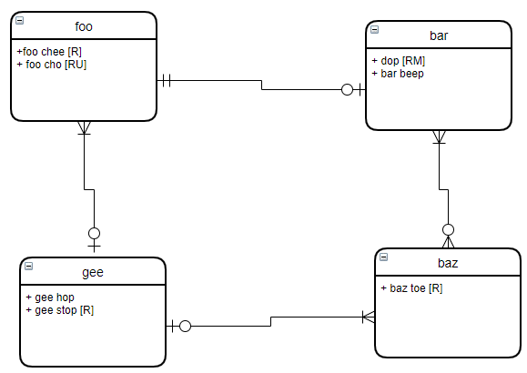  
   Diagram

   Description automatically generated
6. Write an SQL Up/Down script to create the tables, keys and constraints for the logical model you created in question 1. Create the tables first with table constraints. Then alter the tables and add the FK constraints. The down part of your script should do this in reverse.   
   Graphical user interface, text, application

   Description automatically generated  
   Graphical user interface, text, application, email

   Description automatically generated