Homework- 2  
Shivani S Mahaddalkar

Each of 5 schools (A, B, C, D and E) is implementing the same math course this semester, with 35 lessons. There are 30 sections total. The semester is about 3/4 of the way through.

For each section, we record the number of students who are:

• very ahead (more than 5 lessons ahead)

• middling (5 lessons ahead to 0 lessons ahead)

• behind (1 to 5 lessons behind)

• more behind (6 to 10 lessons behind)

• very behind (more than 10 lessons behind)

• completed (finished with the course)

What’s the story (or stories) in this data? Find it, and tell it visually and, above all, truthfully.

* On inspection the column Very Ahead+5 was all zeroes. We ran the code to check if that is the case. The output of the column indicates that no student in any of the 5 schools are *Very Ahead* in the syllabus. So we dropped the column from the data set.
* The first step was to take an overall look at the sum of the students across sections grouped by schools. The following R code was run:  
  
* On transposing and changing the data types, we get this as our data-frame.  
  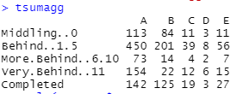
* After transforming according to the z scores, the scaling indicates that across all the schools, the largest group of students is falling behind(1-5 lessons). The table below shows the z-score transformation.  
  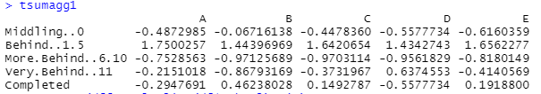
* The schools D and E only have one section of students, so the following observations on them are redundant. However, figuring the section with minimum and maximum students in each group can be insightful.  
  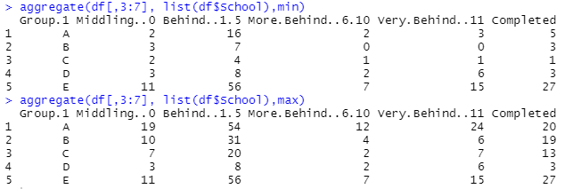  
  The table indicating the minimum numbers of students in each group across sections shows that in schools 1,2 and 3 there is a section that has 2, 0 and 1 students each who are more behind. That can be taken as a good sign that no school is particularly problematic in their administrative duties and the maximum values in this group will indicate that the interactions between the section teachers and the students need to be inspected.  
  The maximum values indicate that there are 24, 6 and 7 students in a section who are very behind. There are 54, 31 and 20 students in a section who are behind(1-5) lessons. As seen in the z score transformation, this finding is not surprising. There are sections with 20, 19 and 13 students in the completed group.   
  Both the tables show that there are not a lot of students in the more behind section. This could indicate that the students who are Very Behind may have extra ordinary circumstances for falling behind in school. It could mean that they require special attention and care.
* A lot of students fall in the middling and the behind(1-5) category. This could mean that the expected pace of lessons could be a little faster for the students to catch up to.