**Exploratory Data Analysis (EDA) Summary Report**

# 1. Introduction

The purpose of this report is to conduct an Exploratory Data Analysis (EDA) on a synthetic credit risk dataset to evaluate its quality and uncover insights that may influence the development of a delinquency risk prediction model. This analysis aims to support the identification of data gaps, inconsistencies, and early indicators of delinquency risk. By understanding the structure, quality, and potential risk patterns within the dataset, this report lays the groundwork for accurate predictive modeling and effective customer risk mitigation strategies.

# 2. Dataset Overview

**2.1 Dataset Summary**

The dataset used for this analysis contains a total of **500 records** and **19 variables**. It appears to focus on customer credit behavior, potentially aimed at predicting the likelihood of delinquency based on demographic, financial, and behavioral attributes.

**2.2 Key Variables and Data Types**

|  |  |  |
| --- | --- | --- |
| **Variable Name** | **Description** | **Data Type** |
| Customer_ID | Unique identifier for each customer | Categorical |
| Age | Age of the customer | Numerical |
| Income | Annual income in USD | Numerical |
| Credit_Score | Credit score of the customer | Numerical |
| Credit_Utilization | Credit usage ratio | Numerical |
| Missed_Payments | Count of missed payments | Numerical |
| Delinquent_Account | Indicator if account is delinquent (0/1) | Numerical |
| Loan_Balance | Current loan balance | Numerical |
| Debt_to_Income_Ratio | Ratio of debt to income | Numerical |
| Employment_Status | Employment status (e.g., Employed, Unemployed) | Categorical |
| Account_Tenure | Duration customer has held the account | Numerical |
| Credit_Card_Type | Type of credit card (e.g., Gold, Silver) | Categorical |
| Location | Customer's geographic location | Categorical |
| Month_1 to Month_6 | Monthly payment status (On-time, Late, Missed) | Categorical |

**2.3 Data Quality Review**

**Missing Values**

* Income: 39 missing entries
* Credit_Score: 2 missing entries
* Loan_Balance: 29 missing entries

These missing values may require imputation or removal based on their importance in analysis or modeling.

**Duplicates**

* No duplicate records were found in the dataset.

**Anomalies and Inconsistencies**

* Credit_Utilization exceeds 1.0 for some entries (max: 1.0258), which could indicate overutilization or a potential data entry issue.
* Employment_Status and Credit_Card_Type contain multiple categories but should be checked for spelling consistency or unusual labels.
* Missed_Payments ranges from 0 to 6. A business rule check should confirm whether 6 is a plausible maximum.

# 3. Missing Data Analysis

|  |  |  |  |
| --- | --- | --- | --- |
| **Issue** | **Affected Variable** | **Handling Method** | **Justification** |
| High number of missing income values | Income | Median Imputation | Median is robust to outliers in income distribution |
| Missing values in key credit metric | Credit score | Mean Imputation | Very few values missing; mean maintains overall distribution. |
| Missing loan balances could skew ratios | Loan balance | Median Imputation | Helps preserve integrity of financial ratios while avoiding bias. |

# 4. Key Findings and Risk Indicators

This section identifies trends and patterns that may suggest potential risk factors for delinquency. Relationships between features and the target variable (Delinquent_Account) were analyzed using statistical correlations and exploratory techniques.

**4.1Key Correlations with Delinquency**

|  |  |  |
| --- | --- | --- |
| **Variable** | **Correlation with Delinquency** | **Insight** |
| Income | 0.045 | Slight positive correlation; higher income slightly linked with delinquency. |
| Credit_Score | 0.035 | Weak relationship; low credit score might increase risk, but not strongly. |
| Debt_to_Income_Ratio | 0.034 | Marginal positive correlation; higher debt may increase delinquency risk. |
| Credit_Utilization | 0.034 | Suggests over-utilization may be a risk factor for delinquency. |
| Age | 0.023 | Younger customers show slightly higher delinquency. |

**4.2 High-Risk Indicators**

|  |  |
| --- | --- |
| **Risk Indicator** | **Explanation** |
| High Credit Utilization | Customers using a high percentage of their credit limits may struggle with debt. |
| High Debt-to-Income Ratio | Indicates financial strain and limited ability to repay, increasing risk. |
| Low Credit Score | Often associated with poor financial history or repayment behavior. |
| Low Age | Younger individuals may have less financial stability or shorter credit history. |
| Frequent Missed Payments | Direct indicator of payment behavior, critical for risk profiling. |

**4.3 Insights Impacting Delinquency Prediction**

|  |  |
| --- | --- |
| **Insight** | **Impact on Model** |
| High Credit Utilization | Include as a primary risk indicator (raw and binned) |
| High Debt-to-Income Ratio | Combine with income/loan variables for interaction effects |
| Younger Age | Use in segment analysis and risk profiling |
| Weak predictive power of Credit Score | Don’t over-rely on credit score—focus on behavior metrics |
| Unusual Income-Delinquency pattern | Investigate for outliers, hidden classes, or confounders |

**4.4 Visual Summary of Key EDA Findings**

The following visual summarizes four key exploratory analyses conducted on the dataset. These include age distribution, credit utilization patterns, employment-based delinquency rates, and the intercorrelation between financial variables.

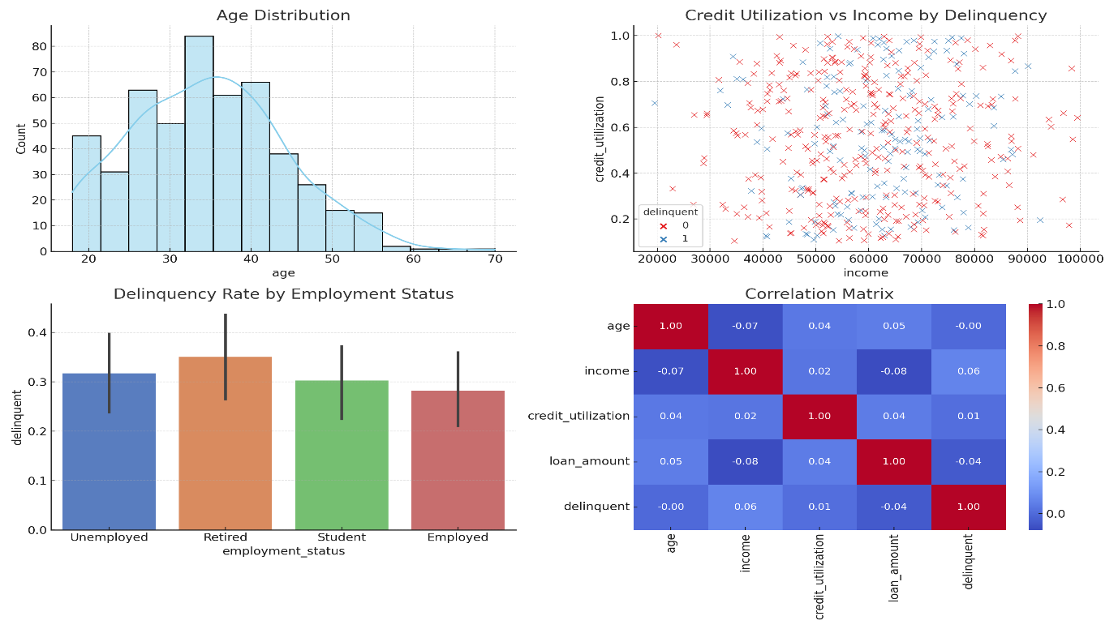**5. AI Usage**

This analysis was conducted using data summarization tools and AI assistants to streamline insight extraction. All findings were reviewed, interpreted, and contextualized by the author to ensure accuracy and relevance.”

# **6. Conclusion & Next Steps**

**6.1 Key Findings**

1. **Dataset Composition**
   * The dataset contains 500 records and 19 variables, covering demographic, financial, and behavioral information.
   * Data types include both numerical and categorical variables.
2. **Missing Data**
   * Three key variables had missing values: Income, Credit_Score, and Loan_Balance.
   * Median or mean imputation was used based on distribution characteristics and missing rate.
3. **Correlations & Relationships**
   * No strong linear correlations were found with Delinquent_Account; however:
     + High credit utilization, high debt-to-income ratio, and younger age showed signs of increased delinquency risk.
     + Credit Score had surprisingly weak correlation, suggesting behavioral variables may be more predictive.
4. **High-Risk Indicators**
   * Identified features include: Credit_Utilization, Debt_to_Income_Ratio, Missed_Payments, and Age.
   * Some surprising patterns such as higher-income individuals showing delinquency may warrant further investigation.

**6.2 Recommended Next Steps**

|  |  |
| --- | --- |
| **Next Step** | **Purpose** |
| Feature Engineering | Create new variables (e.g., utilization bands, payment trends) to capture risk behavior more effectively. |
| Outlier Analysis | Investigate anomalies in credit utilization > 1 and unusual income values. |
| Modeling Phase | Begin predictive modeling using logistic regression, decision trees, or ensemble methods. |
| Variable Interaction Exploration | Analyze non-linear relationships and interaction effects among top predictors. |
| Cross-Validation of Imputation Impact | Test model performance using datasets with and without imputed values. |
| Segment Analysis | Analyze subgroups (e.g., by age, income bracket, employment status) to refine risk insights. |