Terrain Classification for Autonomous Robot Navigation Using Lightweight CNNs
Abstract
This project investigated terrain classification for autonomous robot navigation using lightweight convolutional neural networks (CNNs). A dataset of 5,160 robot-camera images was collected across four terrain classes: flat ground, uphill slope, rough terrain, and hazard. Three lightweight architectures (MobileNetV3, SqueezeNet, and EfficientNet-B0) were evaluated at two input resolutions (128×128 and 224×224), producing six model configurations. MobileNetV3 at 224×224 achieved the highest validation accuracy (91.1%) and was used in the live navigation demo, where it achieved 98.5% classification accuracy. SqueezeNet at 128×128 provided the best latency–accuracy trade-off, achieving 90.6% validation accuracy with only 9.8 ms inference latency (102 FPS).

Dataset
The dataset consisted of 5,160 images captured from a simulated robot camera in PyBullet terrain environments. Four terrain classes were used: flat_ground, uphill_slope, rough_terrain, and hazard. Images were collected using multiple randomized terrain seeds to improve generalization and reduce overfitting to specific environments.
The training set contained 3,612 images and the validation set contained 774 images. Data augmentation techniques such as random brightness/contrast adjustment, horizontal flipping, and minor geometric transformations were applied to improve robustness. Aggressive augmentations that significantly altered terrain appearance were avoided because they could distort important visual cues required for classification.
The dataset distribution was approximately balanced across the four terrain classes, ensuring that no class dominated the training process.

Results Table
Model | Parameters | Resolution | Validation Accuracy | Latency (ms) | FPS | Real-Time?
MobileNetV3 | 1,521,956 | 128×128 | 88.8% | 10.61 | 94.3 | Yes
MobileNetV3 | 1,521,956 | 224×224 | 91.1% | 14.58 | 68.6 | Yes
EfficientNet-B0 | 4,013,952 | 128×128 | 90.3% | 22.41 | 44.6 | Yes
EfficientNet-B0 | 4,013,952 | 224×224 | 90.1% | 34.11 | 29.3 | Yes
SqueezeNet | 742,564 | 128×128 | 90.6% | 9.79 | 102.1 | Yes
SqueezeNet | 742,564 | 224×224 | 90.7% | 21.58 | 46.3 | Yes

Pareto Chart
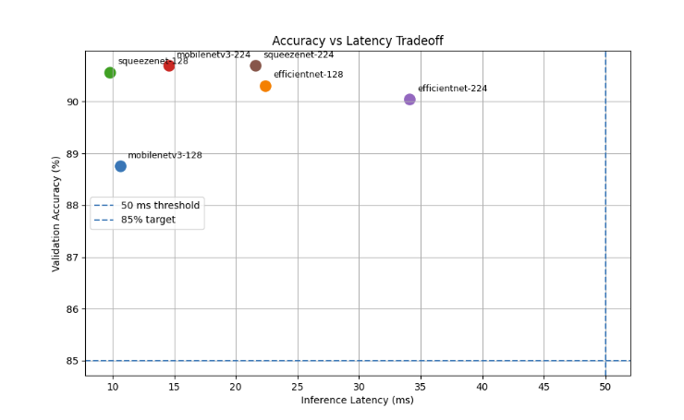

Resolution Chart
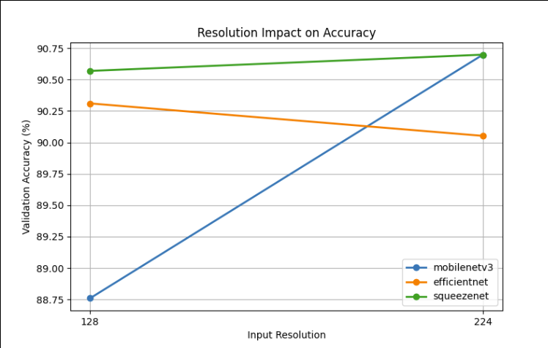

Key Findings
- MobileNetV3 benefited the most from increased resolution, improving from 88.8% accuracy at 128×128 to 91.1% accuracy at 224×224.
- SqueezeNet achieved nearly identical accuracy at both resolutions (90.6% vs 90.7%), suggesting that higher-resolution inputs provide little additional information for this architecture.
- EfficientNet-B0 did not significantly outperform the lighter architectures despite having substantially more parameters and higher inference latency.
- SqueezeNet at 128×128 delivered the best deployment trade-off, achieving over 90% accuracy while maintaining the lowest latency (9.8 ms) and highest frame rate (102 FPS).
- The live navigation demo achieved 98.5% overall terrain classification accuracy, with only three misclassifications occurring on rough terrain.

Recommendation
If maximum classification performance is the priority, MobileNetV3 at 224×224 should be deployed because it achieved the highest validation accuracy (91.1%) and demonstrated excellent performance during the live navigation simulation. However, for deployment on a resource-constrained platform such as a Raspberry Pi, SqueezeNet at 128×128 is the preferred choice because it offers nearly identical accuracy while providing significantly lower latency and higher throughput. This configuration achieves the best balance between accuracy, computational efficiency, and real-time operation.

