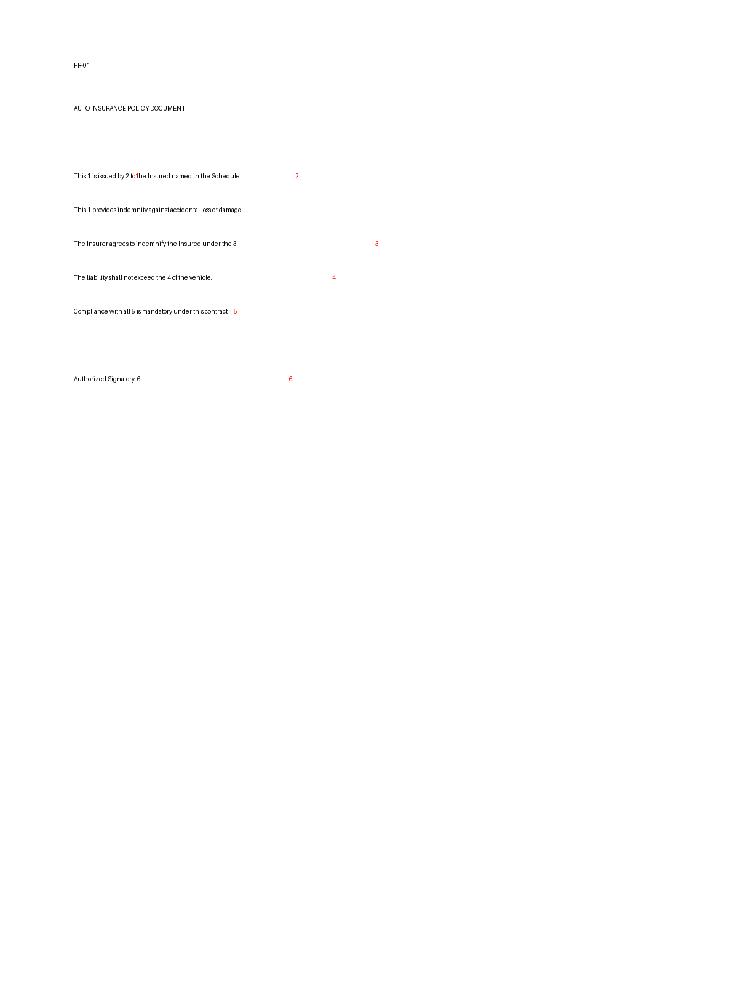
Position | Tag Name | JSON Path
1 | policyName | data.policy.policyName
2 | insurerName | data.policy.insurerName
3 | governingAct | data.policy.governingAct
4 | insuredDeclaredValue | data.policy.insuredDeclaredValue
5 | regulatoryCompliance | data.policy.regulatoryCompliance
6 | authorizedSignatory | data.policy.authorizedSignatory

