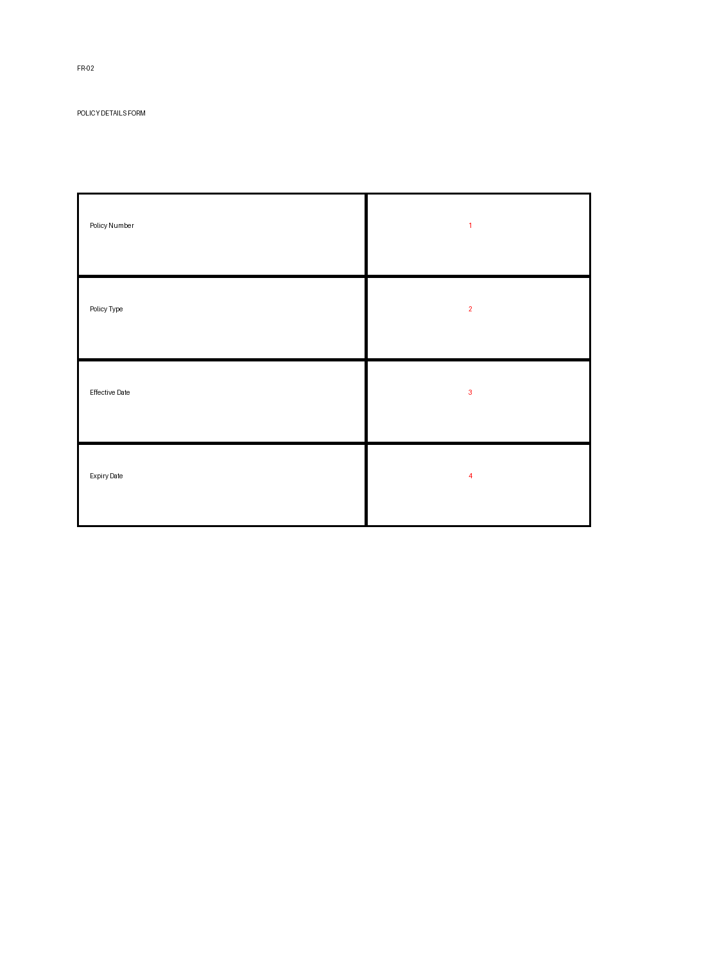
Position | Tag Name | JSON Path
1 | policyNumber | data.policy.policyNumber
2 | policyType | data.policy.policyType
3 | effectiveDate | data.policy.effectiveDate
4 | expiryDate | data.policy.expiryDate

