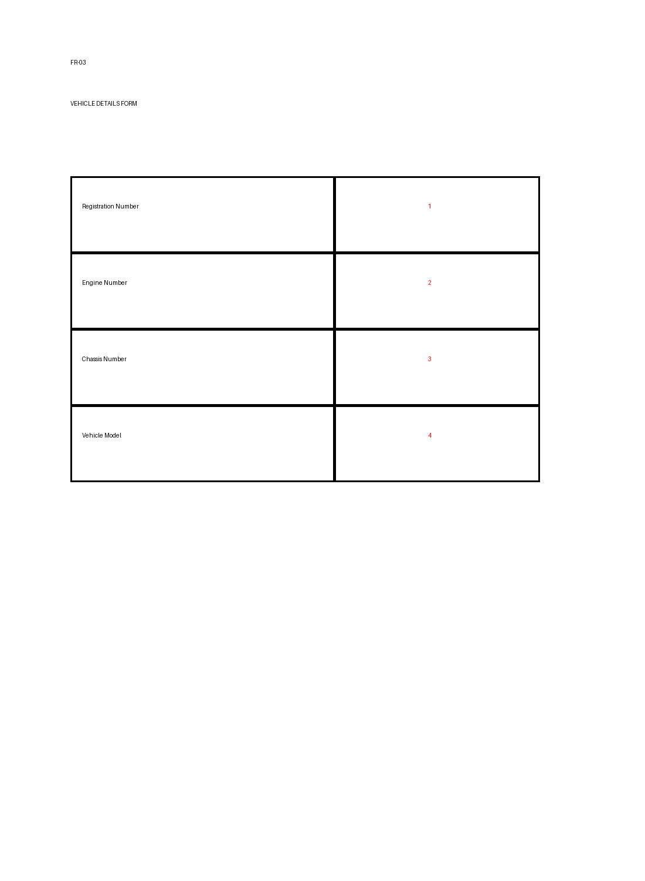
Position | Tag Name | JSON Path
1 | registrationNumber | data.vehicle.registrationNumber
2 | engineNumber | data.vehicle.engineNumber
3 | chassisNumber | data.vehicle.chassisNumber
4 | vehicleModel | data.vehicle.model

