FR-34 PRINT SPEC – VEHICLE & RIDER DETAILS
Template Image (Actual values replaced with numeric markers)
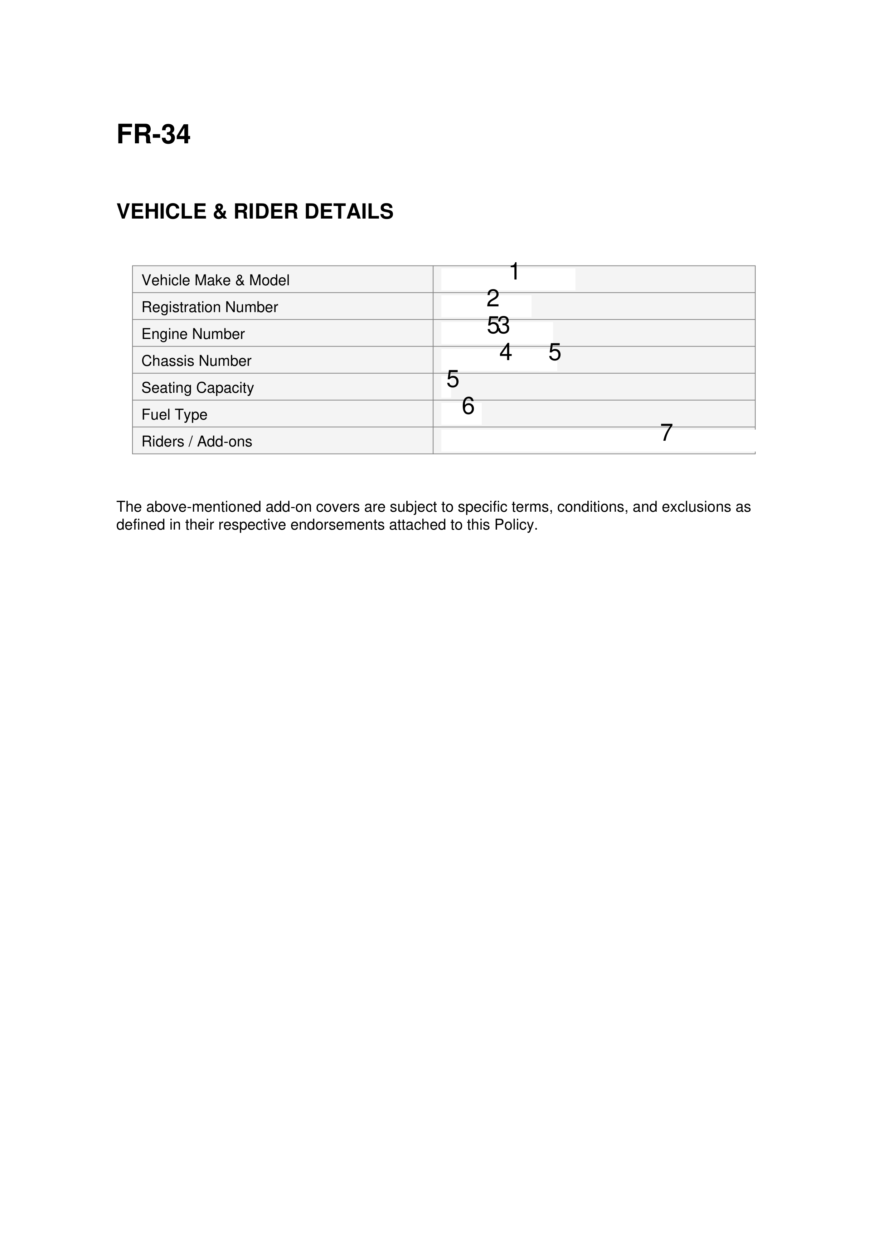

Field Mapping Table
Position | Field Label | JSON Path
1 | Vehicle Make & Model | data.vehicle.makeModel
2 | Registration Number | data.vehicle.registrationNumber
3 | Engine Number | data.vehicle.engineNumber
4 | Chassis Number | data.vehicle.chassisNumber
5 | Seating Capacity | data.vehicle.seatingCapacity
6 | Fuel Type | data.vehicle.fuelType
7 | Riders / Add-ons | data.policy.riders

