Layout Spec – JKL890
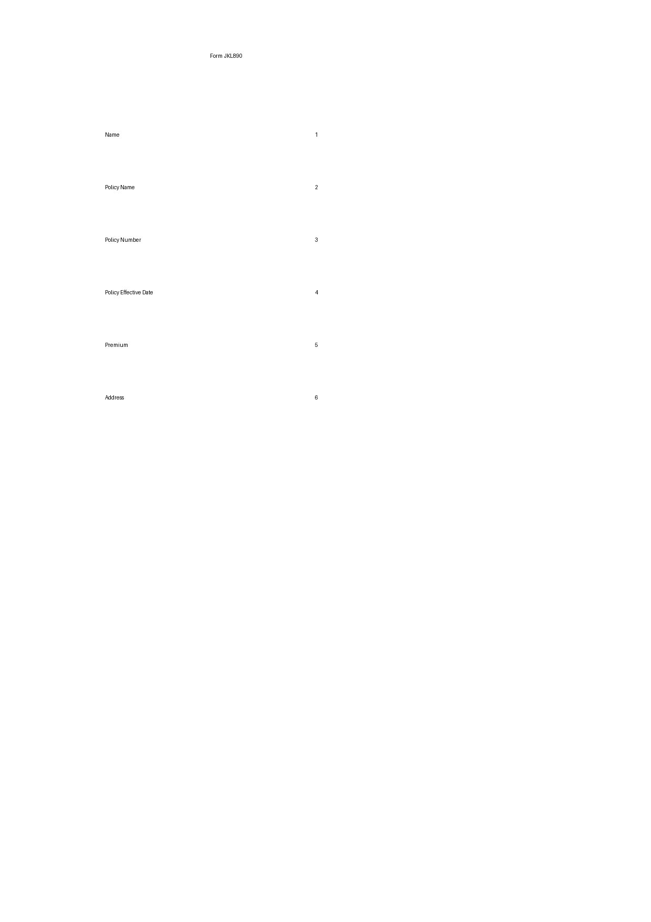
Position | JSON Path
1 | customer.name
2 | policy.name
3 | policy.number
4 | policy.effective_date
5 | policy.premium.amount
6 | customer.address.home

